Scientific Poster (125 Points)

Examples of several scientific posters are hanging on the walls around the room. Take time to walk around and look at different posters for organization, presentation of material, and visual appeal. Take notes about what you like and work with your group to decide the main subheadings on your poster and what data should be presented.

Scientific Posters:
Scientific posters are a visual communication tool that aid in conveying a main idea and engaging others in conversation. Your goal is to convey a clear message and support it with a compelling combination of images and short blocks of text. The message in the poster the results of your experimental work. You should also provide context for the work. Explain why the analysis you performed is relevant.
An effective poster is
Focused: focused on a single message
Graphic: let’s graphs and images tell a story and uses text sparingly
Ordered: has a logical sense of order.
Many ineffective posters suffer from easy-to-fix problems, including;
objective(s) and main point(s) hard to find, text too small, poor graphics, poor organization

Poster Layout

Your poster should ...
- use visual grammar to guide readers to the important parts of your poster.
- use a column format to make your poster easier to read in a crowd.
- use organization cues to guide readers through your poster.
- use "reader gravity" which pulls the eye from top to bottom and left to right
- use headings intelligently to help readers find your main points and key information.
- balance the placement of text and graphics to create visual appeal.
- use white space creatively to help define the flow of information.
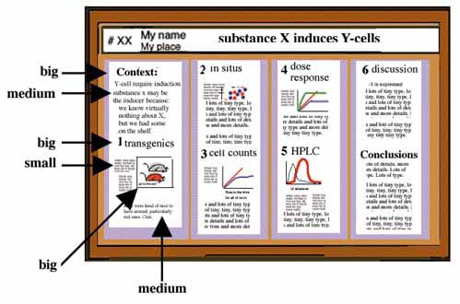

- Use a graphic hierarchy that visually reflects the relative importance of components.
- If it’s important, make it BIG. Use type size proportional to importance.
- Show, don’t tell. No need to write down every detail. You can fill in details in person.
- Use simple figures and images, which should dominate the poster visually.
- Make all graphic elements large enough to be visible easily from one meter away.

Headings:
Headings (including the title, section titles, and figure captions ) should ...
Summarize: Use headings as opportunities to summarize your work in large letters. A hurried reader should be able to get the main points from the headings alone.
Organize: Good headings are part of the visual grammar that helps move readers through your poster.
Emphasize: The more important the point, the larger the type.

Note how headings convey the message - viewers in a hurry need not read further.

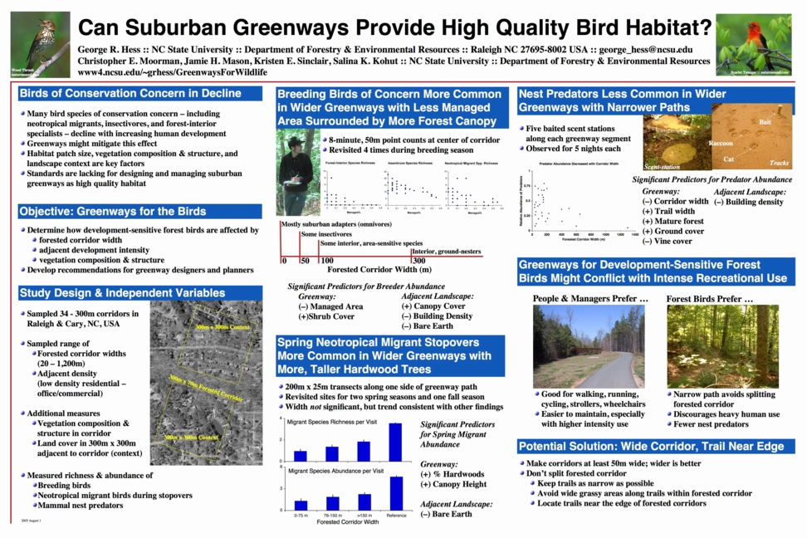

Graphics:

Good graphics - graphs, illustrations, photos - are the centerpiece of your poster.
- Good graphs communicate relationships clearly.
- Graphs should be simple and clean.
- Write explanations directly on figures, instead of referencing from elsewhere.
- Use simple 2-dimensional line graphs, bar chargs, pie charts.
- Text on graphs must follow same guidelines as all other text so that it will be visible.
- Use photos that help deliver your message.
- Use spot art - but not too much - to attract attention.

Text:

Posters are visual medium.
- Minimize text - use images and graphs instead.
- Keep text elements to 50 words or fewer.
- Use phrases rather than full sentences.
- Use an active voice.
- Avoid jargon
- Left-justify text; avoid centering and right-justifying text.
- Use a serif font (e.g., Times) for most text - easier to read.
- Sans-serif font (e.g., Helvetica) OK for titles and headings
- Text should be at least 24 point in text, 36 for headings.
- Pay attention to text size in figures - it must also be large.
- Title should be at least 5cm tall.
Color:
Use color to attract attention, organize, and emphasize - but don't overdo it.

- Use a light color background and dark color letters for contrast.
- Avoid dark backgrounds with light letters - very tiring to read.
- Stick to a theme of 2 or 3 colors - much more will overload and confuse viewers.
- If you use multiple colors, use them in a consistent pattern - otherwise viewers will spend their time wondering what the pattern is rather than reading your poster.
- Overly bright colors will attract attention - and then wear out readers' eyes.

Software:
MicroSoft PowerPoint is a relatively easy-to-use tool for creating posters.
Setting up PowerPoint Note: These instructions might vary a bit among versions of PowerPoint.
First, open a new file and choose the blank page as your layout.

To design a large poster, you must tell PowerPoint (or whichever program you're using) how large the paper is. You can do this by going to the Design/ Page Setup menu -- just enter the width ( 4 ft.) and height (3 ft.) you want. It should choose Portrait or Landscape automatically, based on the height and width you enter. You should now be facing a blank page in the appropriate dimensions. If the rulers are turned on, you'll see that it's the size you asked for.

Creating Your Poster
You can treat this extra large page just like a PowerPoint slide -- write text, import images and graphs. The difference is that for all but the largest font sizes, you will have to zoom in on the section you want to work with. Depending on which version of PowerPoint you have, zooming in may cause a "Slide Miniature" to appear -- this gives you an overview of your page. There's really no difference between what you've done before on standard sized slides and what you can do here -- there's just more space to do it on.

Printing a Small Version
To see how your poster looks on paper, you can actually scale it to fit on a standard 8.5x11 inch sheet of paper. I recommend that you do this, because
- it's a good way to print and check your work, without wasting a huge sheet of paper
- if you can't read it on the 8.5x11 page, your font is too small
- it makes a great handout.
To scale to 8.5x11, go to File / Print ...
PC: Make sure your regular printer is selected. Click on “Full Page Slide” and at the bottom of the dialog box is a checkbox that says Scale to fit paper -- check it and go.
Printing your Poster:
4 ft. x 3 ft. posters can be printed for $10 in at the UITS help desk in the Information Commons on the 1st floor of the West Tower of the Wells Library. This service is open 24 hrs.

YOU SHOULD NOT WAIT UNTIL 1 HOUR BEFORE YOUR LAB SECTION TO PRINT YOUR POSTER!!! YOU MUST BE PRESENT DURING THE PRINTING AND IT IS SOMEWHAT SLOW. I HIGHLY RECOMMEND GETTING YOUR POSTER PRINTED ONE DAY BEFORE THE POSTER SESSION.

Reference: The instructions for creating a poster were adapted from the following website:http://www.ncsu.edu/project/posters/NewSite/

