- Instructor Notes
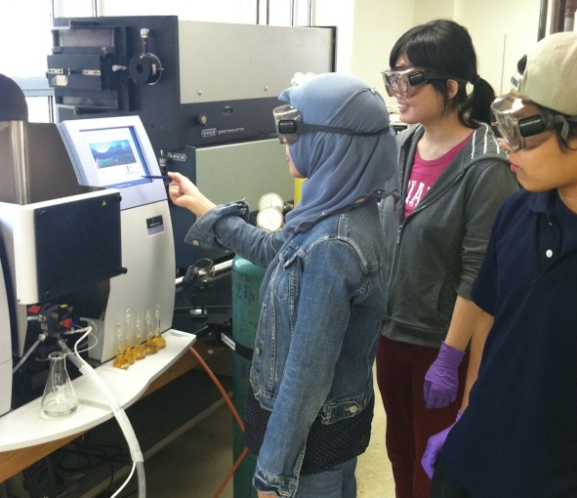
Contents:
  - Rationale for Changing from a Traditional Curriculum
  - Project Based Learning (PBL) Pedagogy
    - Definition of PBL
    - PBL Process
  - Implementation Strategies for Large Courses
    - Instructor-Selected Projects and Budgeting
    - Team Selection and Grading
    - Communication Between Student Groups
    - TA Training
  - Example Supply List

3.1 Rationale for Changing from a Traditional Curriculum
After teaching the Instrumental Analysis Laboratory course for several years, I identified shortcomings in learning outcomes that could be addressed through a project based learning (PBL) pedagogy. Specifically, I wanted to address students’ ability to achieve accurate results, troubleshoot experimental difficulties, communicate scientific results, and learn instrumentation in greater depth.
Accuracy: One course objective is that students must learn to perform an analysis with a high level of accuracy and precision. However, student motivation to perform a careful analysis may not be high if the result is not of real interest to anyone. In addition, course surveys indicate that many students do not have a high level of confidence that they can analyze an unknown amount correctly. The brewery project provides a strong incentive for students to work diligently in order to obtain the best possible results. Students become highly motivated when they directly interact with the brewery staff relying on their answer. In addition to motivation, multi-week projects allow time for procedures to be repeated if mistakes are made.
Troubleshooting: Frequently experimental difficulties arise and troubleshooting should occur to address problems encountered along the way. A great deal of learning can occur by making careful observations followed by adjustments. In a traditional setting with “cookbook” experiments, many students finish as quickly as possible and feel they can address poor results by discussing sources of error in their write-up. Many errors can be corrected if the student had time to repeat or adapt the procedure. This kind of flexibility is not typically built into a schedule where experiments are performed each week. Open ended, multi-week projects give students time to discuss problems, suggest solutions, and test new procedures.
Scientific Communication: Another course objective is the clear communication of experimental theory, procedures, and results. Analytical chemistry students frequently write journal-style lab reports, but many do not take the time think deeply about the best way to represent data in tables and graphs. Although I tried to address this problem through peer review, course discussions on writing, and short writing assignments, there was still room for improvement. I believe that motivation is an obstacle in this course objective as well. Many students do not care that much about a report that is only going to be read by their TA. Other than a grade, there is no incentive to really struggle to find the best way to communicate their results and conclusions. If the information in the report was of real use to someone, then students would be more inclined to produce high quality work.
Instrumentation: In a traditional analytical chemistry laboratory experience, students may not gain much exposure to operating and troubleshooting modern instrumentation. Due to large number of students and time constraints, often the TA tests the experiment and makes any adjustments to ensure the instrument is working properly. If problems occur, students frequently sit back while the TA fixes them. The addition of multi-week projects where students must operate and fix problems with the instruments on their own would address this deficiency. I have found that students are initially frustrated when they encounter instrument difficulties, but are thrilled when they can solve the problem. Since the projects were introduced, students routinely optimize instrument settings for their specific analysis, fix problems such as clogged AA burners, and perform general maintenance such as cleaning electrodes and changing a capillary in the CE.

3.2 Project-Based Learning (PBL) Pedagogy
3.2.1 Definition of PBL

Lack of motivation and engagement could be barriers to learning if the importance of the work is not clear to the student. Incorporation of project-based laboratories is a potential solution, as these types of laboratory experiences require students to independently work through the steps necessary to answer a real-world question. According to the Buck Institute for Education (http://www.bie.org/), project-based learning (PBL) is defined as

“a systematic teaching method that engages students in learning essential knowledge and life enhancing skills through an extended, student-influenced inquiry process structured around complex, authentic questions and carefully designed products and tasks.”

Figure 3.1 shows the essential components of the PBL pedagogy. The projects are designed to teach both course content as well as 21st Century Skills such as teamwork, collaboration, professional presentations, and computer skills. These strategies are primarily used in K-12 education, but can easily be adapted to higher education to facilitate a transition from a traditional lecture or laboratory format to a student-centered environment.

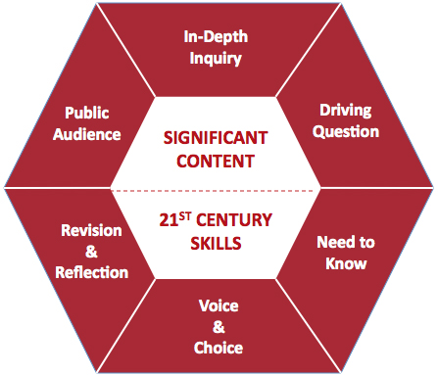

Figure 3.1: Essential Components of Project Based Learning Pedagogy as reported by the Buck Institute. (http://www.bie.org/)

3.2.2 PBL Process

Step 1: Defining Essential Skills in a Project

The first step in developing a project is to determine the set of skills that will be addressed. The goal is to teach both fundamental course content and skills needed in the workplace including collaboration, professional presentations, and computer proficiency. Many of these essential skills can also be found in the learning objectives and a representative list is shown below.

Table 3.1 Analytical Chemistry Content Skills and Professional Skills in Brewery Project
Analytical Chemistry Skills | Professional Skills
- Literature searching using SciFinder Scholar  - Evaluating pros and cons of different methods  - Choosing the most appropriate calibration method  - Adapting published procedures for sample and standard preparation  - Troubleshooting procedural and instrumental difficulties  - Analyzing and presenting data in tables and figures  - Reporting uncertainty in results | - Communicating progress within team and with other student teams  - Collaborating with team on important decisions to advance the project  - Communicating scientific results with non-scientist  - Creating and presenting a scientific poster  - Ordering supplies and budgeting

Step 2: Development of a Driving Question

Another key component is to develop an authentic driving question for the project. An important aspect is to arrange a community partner (i.e. local microbrewery) interested in the final product of the students’ work. Authenticity greatly increases engagement as students are not doing the work because it is simply a class assignment that is good for them. This focuses and deepens students’ learning by showing them how their work is useful in the real world. The answer to the question must be of genuine interest to a community partner, who is typically involved in evaluation of the final product. The hope is that students will take extra pride in their work and perform careful and accurate laboratory work because someone is counting on their answer. The instructor’s role changes from someone who lectures and gives grades to a facilitator or consultant in the project.

Driving Question: “What is the concentration of important flavor and aroma substances in beer from the Upland Brewery?”

Step 3: Introducing the Project (The Entry Event)

The entry event is an introduction to the project and provides students with motivation for their work along with the requirements of the final product. The event can take many forms, such as an invited speaker, field trip, letter, video conference, or Skype conversation. The head brewmaster from the Upland Brewery came to our class and gave some background about his career path, the brewery, and why he wanted the different components of beer analyzed. For example, he discussed the importance of alpha and beta acids in bitter flavor and oxalate concentration in foam properties and “beer stones.” He brought in samples of different types of hops and malts and explained the brewing process. He finished by summarizing the analyses he would like the class to perform and the final product- a scientific poster that will displayed in the brewery laboratory. Typically a brief letter or handout that summarizes what the community partner would like is given to the student. The instructor writes the letter to ensure that it contains language specifying the course content that should be included and then the community partner signs it. (Refer to “Assignments and Rubrics” section for a copy of the letter used.)

Step 4: Student-Centered Learning (Know and Need to Know List)

The next step is critical in creating a student-centered learning environment. Using the content-specific language in the entry letter as a basis, students will create a “Know and Need-to-Know” list which sets the direction for future instruction in the course. For example, in the Upland Brewing letter, it is indicated that “the most suitable calibration method (external standards, standard addition, or internal standards) should be utilized.” The instructor can anticipate that students will have the question “How do I choose which calibration method is best?” and plan how to address this question in future classes. First, students work in small groups and then a comprehensive list is generated during a class discussion. It is important for the instructor to serve simply as a scribe during this discussion so that students know all their contributions are valid and important.
Once the list has been generated, some simple questions can be answered immediately, whereas other questions can be addressed in more detail later through various methods, including class instruction, group discussions, and readings. The table below includes some items on the original “Know and Need to Know” list. Topics are covered as students need them, and the list is dynamic, with items being removed as they are addressed or added as needed. Students are much more engaged and receptive to learning when an instructor presents information that they know is essential for finishing their work.

This format is the reverse of traditional instruction in which all the essential information is given up front and then students use it to complete a project. In this case, it is the vision of the final product that drives student learning.

Table 3.2. Representative Know and Need to Know List
Know | Need to Know
- Goal of the project- analyze for the concentration of substance in beer  - Poster and scientific paper are the final product  - Proper use of pipets and micropipets  - Serial dilution to make standards  - How to make a calibration curve, calculate R², and use it to find the concentration of an unknown.  - How to use various types instrumentation  - Calculating standard deviation  - Use of standard addition calibration | To answer immediately:  - How many times can the test be run?  - Is the final report group or individual?  - What if I can’t find a procedure specific for beer sample?  Addressed through future lecture, reading, or small group discussion.  - How to search the scientific literature for a published procedure?  - What should be included in a scientific poster?  - How to make scientific poster?  - What is the best way to report uncertainty?  - How to choose the best calibration method?

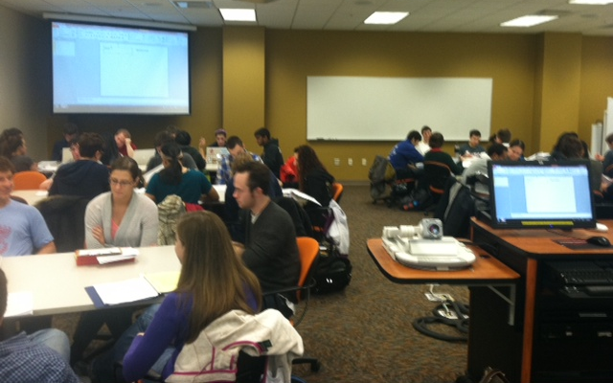
Students working in groups to develop a “Know and Need to Know” list

Step 6: Project Implementation
Two key components of the PBL pedagogy must be utilized during implementation of the project. Voice and choice ensures that students are empowered to make their own decisions and learn from their mistakes. There must also be time for revision and reflection so that they can think deeply about how to improve their laboratory work and final product. A brief description of how these critical components were incorporated is provided.

Voice and choice: Students become much more vested in their work when they have made their own decisions about how they will solve the problem. Student teams independently decide which method they will use for analysis of their assigned compound. Once they have decided a certain technique is the best choice, they work hard to achieve success. As we all know experimental difficulties are frequently encountered and students are required to solve them on their own. Of course they can consult with the instructor or the TA, but ultimately the decision on how to proceed is their own. This led to different investigations such as the effect of incubation time on signal or the effect of signal averaging on precision. Students indicated they greatly enjoyed the freedom to do real science in an end-of-project survey. As an instructor, I observed big improvements in motivation and creative problem solving as a result of students making their own choices.

Revision and Reflection: There must also be time dedicated to reviewing and revising the final product since it will be given to the community partner. The goal is to provide accurate and precise results that are presented in a clear and professional manner. This was accomplished through a peer review session (during lab lecture) of the final poster. In addition, there must be reflection about the success of the project and how it could be improved in the future. The end of project evaluation was used for this purpose and is available in the “Assignments and Rubrics” section.
Step 7: Presentation to Public Audience
Ideally, the community partner should attend a poster session at the end of the semester to hear the students’ presentations and assist in the evaluation of their work. However, this was not possible in my case. Poster sessions were held during regularly scheduled lab times and lasted for about 2.5 hours. Since there were five lab sections in my course, it would have been too much to ask for the brewery staff to come over to campus every afternoon. Instead a smaller group of students volunteered to go over to the brewery one evening to present their results. However, the poster sessions were attended by the instructor and several present and past TA’s from the class. The graduate students and other faculty frequently enjoy the opportunity to discuss science with undergraduates.
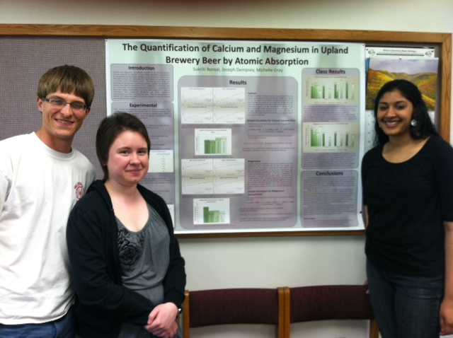
  - Implementation Strategies for Project-Based Learning Large Courses
3.3.1 Instructor Selected Projects and Budgeting
Small analytical chemistry courses frequently allow students to pick a project idea on the basis of their own interests. However, in large classes it is necessary for the instructor to select the driving question because the logistics and cost of numerous projects would be prohibitive. The use of a community partner for whom the work is being done lends credibility to an instructor selected topic. For example, five different compounds were chosen for analysis in the beer and each laboratory section performed these same five tests. In addition, all five student groups doing the same analysis selected only one procedure to minimize the cost of reagents and materials. Each group found a literature method as a homework assignment and during class time the teams met and decided on the best one. This was an excellent exercise in discussing the advantages and disadvantages of different techniques. The method was approved by the instructor approximately one month before the project start date to allow sufficient time for students to generate their own supply list. All orders were approved by the instructor. Refer to the “Assignments and Rubrics” section for the Literature Searching Assignment and Choosing the Best Method Group Assignment.
3.3.2 Team Selection and Grading

Students work in groups of three, and teams are selected by simply requiring students to work with individuals they have not worked with before. The responsibility of team management and distribution of duties lies with the students, although no formal roles are assigned. A contract outlining expectations for work ethic and shared responsibilities is developed by the group, and there have not been any major issues with teamwork. The group contract from can be found in the “Assignments and Rubrics” section. The same grade is given to each member of the group for the final product (scientific poster), as this best represents how teams function in the workplace. The students are also asked to evaluate each member of the group using a percentage score to indicate their contribution to the entire project. In most cases, the students agree that the work has been equally divided within a few percent. If this is the case, then everyone gets the same grade. If there is a larger discrepancy, certain group members receive a higher score than others. If there was a very large difference in the reported contribution, I would call these students in for a meeting to best understand the situation. Thus far, I have not had to do this.

3.3.3 Communication Between Student Groups Working on the Same Compound
In contrast to many small schools where students have open access to the laboratory, instrument use was limited to regularly scheduled laboratory sessions and collaboration between groups was essential to complete the project in a timely fashion. Troubleshooting time was decreased by communicating progress and solutions to problems between groups working on the same compound. For example, in a high-performance liquid chromatography analysis, the four substances did not completely separate even though the column and mobile phase were identical to those specified in the literature. Throughout the week, different mobile phase gradients were tested on the basis of results from earlier groups. The sharing of chromatograms greatly decreased the amount of time for method development and all groups contributed to the solution. A notebook for each different analysis was kept in the lab, and procedures and results were recorded every day. One team even set up a Facebook page so that information could be easily viewed by all members at any time! Students could readily appreciate the benefits of complete and thorough record keeping and became frustrated when other groups did not provide clear and helpful information. This type of collaboration occurs until the problems are worked out and then each group performs the analysis of samples on its own.

Furthermore, class time was used for sharing information and preparing the group portion of progress reports. A typical progress report requires each group to contribute data along with a brief discussion of the meaning. The groups working on the same compound then combine to summarize what was accomplished over the course of the week, describe experimental difficulties and how they were solved, identify which issues are still problematic, andplan future experiments. Each student gets a grade for his or her team’s individual contribution of data as well as a grade for the large-group questions.

    - TA Training
The extra instruction given to TA’s during the projects was minimal. The overall goal was to have the TA’s serve as mentors and share their expertise, yet step back and let students work out issues on their own. They were instructed not to jump in and solve the problem themselves, but to first ask students to come up possible reasons for the difficulty and potential solutions. Only then would they become part of the discussion and ultimately students would decide how to proceed. The TA is still the expert and would often need to assist students if they were performing instrument maintenance or a making a change in components or settings.
Another important aspect of TA mentoring is to make sure they are supportive as panic and frustration can result when progress is not occurring at a rapid pace. Students who are used to performing weekly experiments in which all the troubles have already been worked out feel they are failing when things do not go smoothly. It is important to reassure them that unexpected obstacles frequently arise in the lab and the main goal is learn from them. They must know that if their project takes a slightly different direction that is OK. The troubleshooting usually generates data and this can be presented on the poster. For example, the effect of signal averaging on noise or development of a new solvent program can be presented. If they do not have time to perform many replicate analyses due to experiment difficulties, this is acceptable as long as they have used their time well. There has never been a case where a group does not acquire enough data for a nice poster.
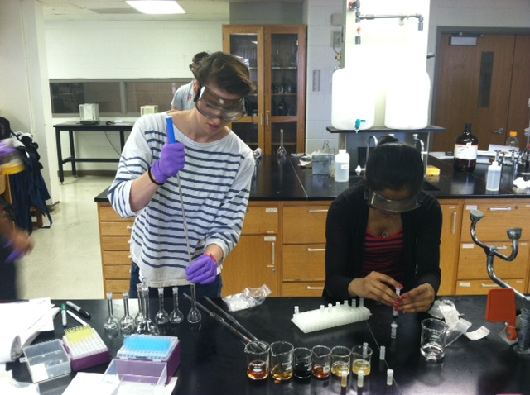

  - Example Supply List
Group 1: % Alcohol and Diacetyl by GC-MS
Item Cat. No. Supplier Cost
Inlet liner SPME direct 2637501 Sigma $52.00
SPME manual fiber holder 57330-U Sigma $410.00
CAR-PDMS fiber assembly 57318 Sigma $418.00
Headspace vial kit (10 mL PTFE butyl septa) 27304-U Sigma $88.30
Ethanol (ACS reagent) 459844-500 mL Sigma $49.50
1-propanol 402893-500mL Sigma $42.80
2,3, butanedione (ACS reagent) 11038-5 mL Sigma $67.50
2,3 pentanedione 241962-25g Sigma $24.90
NaCl (reagent grade) 310166-1KG Sigma $32.20

Column: SPB-5 capillary column 60 m x 0.32 mmx 1.0 um film thickness
Hand crimper for 10 mL vials

Group 2: Ca and Mg by Flame AA
Item Cat. No. Supplier Cost
Hydrochloric acid 84415-100mL Sigma $44.70
Lanthanum Oxide 289205-100g Sigma $244.50
Magnesium ribbon 13103-25 g Sigma $52.80
Calcium carbonate 202932-5g Sigma $46.70

Group 3: Chloride and Oxalate Ion by CE
Item Cat. No. Supplier Cost
Basic anion buffer 5064-8209 Agilent $74.07
NaCl (reagent plus) S9625-500 g Sigma $29.30
Sodium oxalate 71800-100g Sigma $38.30
50 um id straight capillary G1600-64211 Agilent $94.57
(id = 50 um, l = 104 cm, L = 112.5 cm)

Group 4: Polyphenols (Spectrophotometic and HPLC)
Method 1: Spectrophotometric

Item Cat. No. Supplier Cost
Ammonium ferric citrate (green) 09713-50g Sigma $29.60
Concentrated ammonia 320145-500mL Sigma $38.60
Carboxymethylcellulose C5678-500g Sigma $68.30
(CMC/EDTA)-low viscosity

Method 2: HPLC

Item Cat. No. Supplier Cost
Hydrochloric acid (37%)
NaCl (ACS reagent) S9888-25 g Sigma $28.00
ethyl acetate 676810-1L Sigma $80.60
Methanol (HPLC grade) 439193-4L Sigma $108
Water (HPLC grade) 95304-2.5L Sigma $62.20
Formic acid (ACS reagent) 399288-100mL Sigma $36.00
Discovery DPA-6s SPE Tube (1g) 52629-U Sigma $100.50
ferulic acid 128708-5G Sigma $35.50
caffeic acid C0625-5g Sigma $57.10
p-coumaric acid C9008-5g Sigma $21.80

Supplies in lab room:
50 mL centrifuge tubes, Shaker, Centrifuge, C18 column (Hypersil BDS C18 column) (5 um particle size, 250 x 4.6 mm i.d.)

Group 5: Bitterness Units (Spectrophotometric and HPLC)

Item Cat. No. Supplier Cost
International calibration standards ICE-3 American Society of $160
Brewing Chemists
DSC-8 SPE tube 52714-U Sigma $93.80
Formic acid (ACS reagent) 399288-100mL Sigma $36.00
Methanol (HPLC grade) 439193-4L Sigma $108
Water (HPLC grade) 95304-2.5L Sigma $62.20
Phosphoric acid (85% wt.) W290017-sample-K Sigma $40.00
C18 column (Hypersil BDS C18 column) (5 um particle size, 250 x 4.6 mm i.d.)

