Project-Based Learning in Instrumental Analysis
Quality Control Analysis for a Local Brewery

- Brewery Project Description

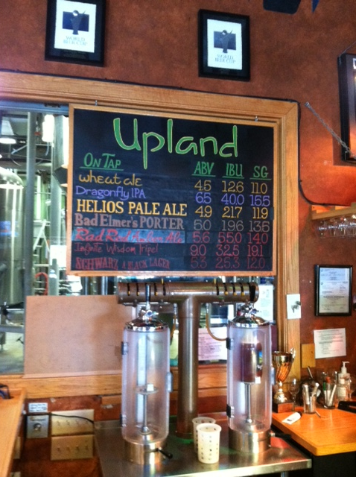
Course Description: Quality control analysis for a local brewery was used as a real world project in an instrumental analysis laboratory course at Indiana University. The course consists of chemistry, biochemistry, biotechnology, and environmental science majors. Pre-requisites are general chemistry, organic chemistry I, and their respective laboratory courses. There is a 50 minute lecture period and a 4 hour laboratory period each week. The sixty students in the class are divided into 5 lab sections with 12 students per section. Each laboratory period is led by a graduate student TA.
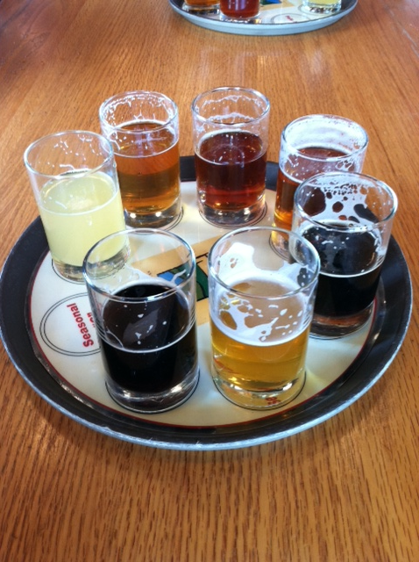
Project Description: The brewery project was designed so that each student group (2-3 students per group) would use different instrumentation, thus solving the practical problem of shared instrument time. Students did not know what type of instrumentation they would use at the start of the project, but as an instructor I knew that each analysis could best be performed using a certain technique. To develop the projects, typical quality assurance tests performed at large breweries and contract laboratories were researched. The Seibel Institute of Technology is a leader in brewery education, and its Analytical Services Catalog provides a comprehensive list of tests performed on beer. This list is a great source for adapting the project or providing variation from year to year. A partial listing from the catalog is given in Table 1. The substances analyzed were chosen based consultation with the Upland Brewery (head brewmaster and quality control technician) as well as the instrumentation available. Table 2 shows the compounds tested in our class, the corresponding analytical technique, and reference papers used by students. There are frequently several possible methods and this table is a representative example of instrumentation used.

Table 1. Partial List of Chemical Tests in Quality Assurance of Beer

Beer and Wort Individual Services | Price per analysis in catalog
Acetaldehyde | $62
Acidity (total), pH | $23
Alcohol by Volume | $25
Bitterness Units | $38
Carbohydrates (total) | $64
Carbohydrate Sugar Profile by HPLC (Dextrins, Maltriose, Maltose, Glucose, Glycerol) | $64
Diacetyl | $88
Dimethyl Sulfide | $156
Dissolved Oxygen | $26
Free Amino Nitrogen | $67
Alpha and Beta Acids (HPLC) | $67
Total Polyphenols | $51
Protein (total) | variable
Anions (Chloride, Oxalate, etc.) | variable
Metals and Minerals (Magnesium, Calcium, Iron, Sodium, Lead, etc.) | variable

From Siebel Institute of Technology Analytical Services Catalog 2012.
Complete list can be found at http://www.siebelinstitute.com/media/downloads. Accessed 5 Aug 2012

Table 2. Chemical Analyses Performed on Beer Samples in Instrumental Analysis Course
Group  Number | Chemical Analysis | Technique | Reference
1 | Calcium and Magnesium in Beer and Tap Water from the Brewery | Flame Atomic Absorption | American Society of Brewing Chemists (2009) Beer-38 . In:  Methods of analysis, 13th edn. http://www.asbcnet.org. Accessed  5 Aug 2012  Bellido-Milla D, Moreno-Perez J, Hernandez-Artiga M, (2000) Spectrochem. Acta Part B: At. Spec. 55:855.
2 | Chloride and Oxalate Ion | Capillary Electrophoresis | Soga T, Imaizumi M, (2001) Electrophoresis 22:3418.  Soga T, (1999) Agilent Technologies application note, publication no. 5968-7715E
3 | Bitterness Units  (Alpha and Beta Acids) | Spectrophotometric  HPLC | Danenhower T, Force L, Peterson D, Betts T (2008) J Chem Educ 85:954  American Society of Brewing Chemists (2009) Beer-23. In: Methods of analysis, 13th edn. http://www.asbcnet.org. Accessed 5 Aug\2012
4 | Percent Alcohol and Diacetyl | GC-MS (SPME) | Pinho O, Ferreira I, Santos L (2006) J Chrom A 1121:145
5 | Polyphenols (Total and Individual) | Spectrophotometric  HPLC | American Society of Brewing Chemists (2009) Beer-35. In:  Methods of analysis, 13th edn. http://www.asbcnet.org.  Accessed 5 Aug 2012  Leitao C, Marchioni E, Bergaentzle M, Zhao M, Diderjean L, Taidi B, Ennahar S, (2011) J Agr. Food Chem 59:1249
Note: A. The polyphenol and bitterness units groups both used HPLC, but methods employed the same column and mobile phases. The instrument also had an autosampler enabling many runs outside of laboratory time. B. It was found that it was too much work for one group to measure both percent alcohol and diacetyl. One compound should be assigned per group.

