In-class Questions: General Background on Molecular Spectroscopy

Electromagnetic Radiation
- What is the relationship between the energy (E) and frequency (ν) of electromagnetic radiation?

- What is the relationship between the energy and wavelength (λ) of electromagnetic radiation?

- Write the types of radiation observed in the electromagnetic spectrum going from high to low energy. Also include what types of processes occur in atoms or molecules for each type of radiation.

Beer’s Law
- What factors influence the absorbance that you would measure for a sample? Is each factor directly or inversely proportional to the absorbance?

- If you wanted to measure the concentration of a particular species in a sample, describe the procedure you would use to do so.

- Suppose a small amount of stray radiation (P_{S}) always leaked into your instrument and made it to your detector. This stray radiation would add to your measurements of P_{o} and P. Would this cause any deviations to Beer's law? Explain.

- The derivation of Beer's Law assumes that the molecules absorbing radiation don't interact with each other (remember that these molecules are dissolved in a solvent). If the analyte molecules interact with each other, they can alter their ability to absorb the radiation. Where would this assumption break down? Guess what this does to Beer's law?

- Beer's law also assumes purely monochromatic radiation. Describe an instrumental set up that would allow you to shine monochromatic radiation on your sample. Is it possible to get purely monochromatic radiation using your set up? Guess what this does to Beer's law.

- Is there a disadvantage to reducing the slit width?

- Consider the relative error that would be observed for a sample as a function of the transmittance or absorbance. Is there a preferable region in which to measure the absorbance? What do you think about measuring absorbance values above 1?

- What are some examples of matrix effects and what undesirable effect could each have that would compromise the absorbance measurement for a sample with an unknown concentration?
Out-of-class Questions: Instrumental Setup of a Spectrophotometer

Sources
- Describe the desirable features of a radiation source for a spectrophotometer.

- Plot the relative intensity of light emitted from an incandescent light bulb (y-axis) as a function of wavelength (x-axis). This plot is a classic observation known as blackbody radiation. On the same graph, show the output from a radiation source that operated at a hotter temperature.

- Examining the plots above, what does this suggest about the power that exists in radiation sources for the infrared portion of the spectrum?

- Explain the advantages of a dual- versus single-beam spectrophotometer.

Lasers
- Why is it impossible to create a 2-level laser?

- Using your understanding of a 2-level system, explain what is meant by a 3-level and 4-level system. 3- and 4-level systems can function as a laser. How is it possible to achieve a population inversion in a 3- and 4-level system?

- Which of the two (3- or 4-level system) is generally preferred in a laser and why?

Monochromators
- Explain in general terms the mechanism in a prism and grating that leads to the attainment of monochromatic radiation. Compare the advantages and disadvantages of each type of device. What is meant by second order radiation in a grating? Describe the difference between a grating that would be useful for the infrared region of the spectrum and one that would be useful for the ultraviolet region of the spectrum.

- Explain the significance of the slit width of a monochromator. What is the advantage(s) of making the slit width smaller? What is the disadvantage(s) of making the slit width smaller?

Detectors
- Explain how a photomultiplier tube works. What are any advantages or disadvantages of a photomultiplier tube?

- Describe a photodiode array detector. What advantages does it offer over other detection devices?

In-class Questions: Ultraviolet/Visible Absorption Spectroscopy

General aspects of UV/VIS absorption spectra
- Compare and contrast the absorption of ultraviolet (UV) and visible (VIS) radiation by an atomic substance (something like helium) with that of a molecular substance (something like ethylene).

- Do you expect different absorption peaks or bands from an atomic or molecular substance to have different intensities? If so, what does this say about the transitions?

- Compare a molecular absorption spectrum of a dilute species dissolved in a solvent at room temperature versus the same sample at 10K.

- Are there any other general processes that contribute to broadening in an absorption spectrum?

- Compare the UV absorption spectrum of 1-butene to 1,3-butadiene.
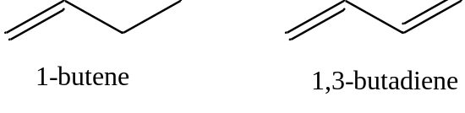
- Using representations of the p-orbitals in which the dark color indicates the positive region of the wave function and a light color indicates the negative region of the wave function, draw all of the possible ways in which the wave functions of the four p-orbitals can overlap with each other.

Rank these from high to low energy.

- Compare the UV absorption spectrum of benzene and pyridine.

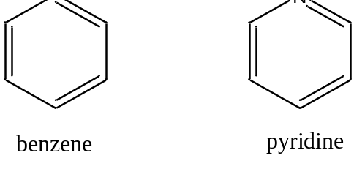

- The peaks in the 320-380 nm portion of the UV absorption spectrum of pyridine shift noticeably toward the blue (high energy) portion of the spectrum on changing the solvent from hexane (C₆H₁₄) to methanol (CH₃OH). Account for this change.

- The peaks in the UV spectrum of benzene shift slightly toward the red (low energy) portion of the spectrum on changing the solvent from hexane (C₆H₁₄) to methanol (CH₃OH). Account for this change.
In-class Questions: Ultraviolet/Visible Absorption Spectroscopy

UV/VIS spectroscopy as a qualitative and quantitative tool
- Is UV/VIS spectroscopy useful as a qualitative tool?

- Is UV/VIS spectroscopy useful as a quantitative tool?

- If you were using UV spectroscopy for quantitative analysis, what criteria would you use in selecting a wavelength for the analysis?

- What variables influence the recording of UV/VIS absorption spectra and need to be accounted for when performing qualitative and quantitative analyses?

- Provided the UV/VIS absorption spectra of HA and A– differ from each other, describe a method that you could use to measure the pKa of the acid.

In-class Questions: Molecular Luminescence

Energy level diagrams for organic molecules
- Draw an energy level diagram for a typical organic compound with π and π * orbitals and indicate which orbitals are filled and which are empty.

- Now consider the electron spin possibilities for the ground and excited state. Are there different possible ways to orient the spins (if so, these represent different spin states).

- Do you think these different spin states have different energies?

- Which one do you expect to be lower in energy?

- If the spin state is defined as (2S + 1) where S represents the total electronic spin for the system, try to come up with names for the ground and possible excited states for the system that are based on their spin state.

- Draw a diagram of the energy levels for such a molecule. Draw arrows for the possible transitions that could occur for the molecule.

- What do you expect for the lifetime of an electron in the T₁ state?

- Why is phosphorescence emission weak in most substances?

- Which transition (π*-π or π*-n) would have a higher fluorescent intensity? Justify your answer.

In-class Questions: Molecular Luminescence

Instrumental considerations for luminescence measurements
- What would constitute the basic instrumental design of a fluorescence spectrophotometer?

- What would be the difference between an excitation and emission spectrum in fluorescence spectroscopy?

- Draw representative examples of the excitation and emission spectrum for a molecule.

- Describe a way to measure the phosphorescence spectrum of a species that is not compromised by the presence of any fluorescence emission.

- If performing quantitative analysis in fluorescence spectroscopy, which wavelengths would you select from the spectra you drew in the problem above?

- Which method is more sensitive, absorption or fluorescence spectroscopy?

Variables that influence fluorescence measurements
- What variables influence fluorescence measurements? For each variable, describe its relationship to the intensity of fluorescence emission.

- Consider the reaction shown below for the dissociation of 2-naphthol. This reaction may be either slow (slow exchange) or fast (fast exchange) on the time scale of fluorescence spectroscopy. Draw the series of spectra that would result for an initial concentration of 2-naphthol of 10⁻⁶ M if the pH was adjusted to 2, 8.5, 9.5, 10.5, and 13 and slow exchange occurred. Draw the spectra at the same pH when the exchange rate is fast.
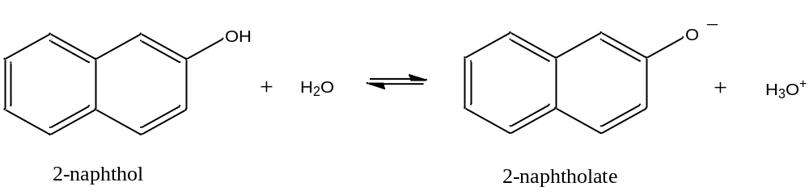

- Devise a procedure that might allow you to determine the pKa of a weak acid such as 2-naphthol.

- Which compound will have a higher quantum yield: anthracene or diphenylmethane?

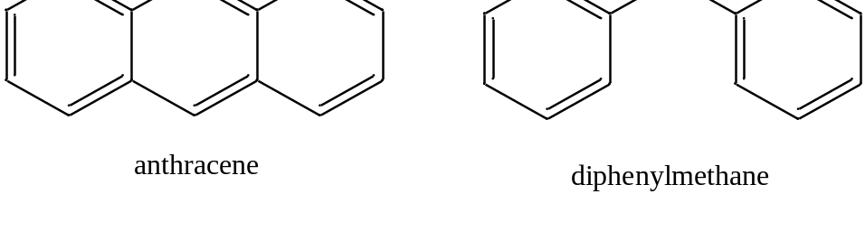

In-class Questions: Infrared Spectroscopy

Background information
- Can infrared spectra be recorded in air? If so, what does this say about the major constituents of air?

- Why don’t the major constituents of air absorb infrared radiation? It might be worth noting that a molecule such as hydrogen chloride (HCl) does absorb infrared light.

- Describe the vibrations of carbon dioxide (CO₂) and determine which ones absorb infrared radiation.

Specialized techniques
- One technique is called non-dispersive infrared (NDIR) spectroscopy. NDIR is usually used to measure a single constituent of an air sample. Think what the name implies and consider how such an instrument might be designed.

Fourier-transform Infrared Spectroscopy
- Consider the light path for a Michelson interferometer and plot the intensity of radiation at the sample versus the position of the moveable mirror for monochromatic radiation of wavelength x, 2x or 4x.

- What are the advantages of FT-IR spectrophotometers over conventional IR spectrophotometers that use a monochromator?

In-class Questions: Raman Spectroscopy

- Consider the molecular vibrations of carbon dioxide and determine whether or not they are Raman active.

- Which set of lines, Stokes or anti-Stokes, is weaker?

- What effect would raising the temperature have on the intensity of Stokes and anti-Stokes lines?

- What would be the ideal source to use for measuring Raman spectra?

- The molecule carbon tetrachloride (CCl₄) has three Raman-active absorptions that occur at 218, 314 and 459 cm⁻¹ away from the laser line. Draw a representation of the Raman spectrum of CCl₄ that includes both the Stokes and anti-Stokes lines.

- Why do the anti-Stokes lines of carbon tetrachloride have the following order of intensity: 219 > 314 > 459 cm⁻¹?

