MOLECULAR AND ATOMIC SPECTROSCOPY

1. General Background on Molecular Spectroscopy 3
1.1. Introduction 3
1.2. Beer’s Law 5
1.3. Instrumental Setup of a Spectrophotometer 12
1.3.1. Radiation Sources 13
1.3.2. Monochromators 18
1.3.3. Detectors 20

2. Ultraviolet/Visible Absorption Spectroscopy 23
2.1. Introduction 23
2.2. Effect of Conjugation 28
2.3. Effect of Non-bonding Electrons 34
2.4. Effect of Solvent 37
2.5. Applications 39
2.6. Evaporative Light Scattering Detection 41

3. Molecular Luminescence 42
3.1. Introduction 42
3.2. Energy States and Transitions 42
3.3. Instrumentation 49
3.4. Excitation and Emission Spectra 50
3.5. Quantum Yield of Fluorescence 52
3.6. Variables that Influence Fluorescence Measurements 54
3.7. Other Luminescent Methods 60

4. Infrared Spectroscopy 62
4.1. Introduction 62
4.2. Specialized Infrared Methods 65
4.3. Fourier-Transform Infrared Spectroscopy 68

5. Raman Spectroscopy 73

6. Atomic Spectroscopy 79
6.1. Introduction 79
6.2. Atomization sources 80
6.2.1. Flames 80
6.2.2. Electrothermal Atomization – Graphite Furnace 83
6.2.3. Specialized Atomization Methods 85
6.2.4. Inductively Coupled Plasma 86
6.2.5. Arcs and Sparks 89

6.3. Instrument Design Features of Atomic Absorption
Spectrophotometers 89
6.3.1. Source Design 89
6.3.2. Interference of Flame Noise 92
6.3.3. Spectral Interferences 94
6.4. Other Considerations 95
6.4.1. Chemical Interferences 95
6.4.2. Accounting for Matrix Effects 96

1. GENERAL BACKGROUND ON MOLECULAR SPECTROSCOPY

1.1. Introduction

Molecular spectroscopy relates to the interactions that occur between molecules and electromagnetic radiation. Electromagnetic radiation is a form of radiation in which the electric and magnetic fields simultaneously vary. One well known example of electromagnetic radiation is visible light. Electromagnetic radiation can be characterized by its energy, intensity, frequency and wavelength.

What is the relationship between the energy (E) and frequency (ν) of electromagnetic radiation?

The fundamental discoveries of Max Planck, who explained the emission of light by a blackbody radiator, and Albert Einstein, who explained the observations in the photoelectric effect, led to the realization that the energy of electromagnetic radiation is proportional to its frequency. The proportionality expression can be converted to an equality through the use of Planck’s constant.
E = hν

What is the relationship between the energy and wavelength (λ) of electromagnetic radiation?

Using the knowledge that the speed of electromagnetic radiation (c) is the frequency times the wavelength (c = λν), we can solve for the frequency and substitute in to the expression above to get the following.
E = hc/λ

Therefore the energy of electromagnetic radiation is inversely proportional to the wavelength. Long wavelength electromagnetic radiation will have low energy. Short wavelength electromagnetic radiation will have high energy.

Write the types of radiation observed in the electromagnetic spectrum going from high to low energy. Also include what types of processes occur in atoms or molecules for each type of radiation.

High E, high ν, short λ: γ-rays – Nuclear energy transitions
X-rays – Inner-shell electron transitions
Ultraviolet – Valence electron transitions
Visible – Valence electron transitions
Infrared – Molecular vibrations
Microwaves – Molecular rotations, Electron spin transitions
Low E, low ν, long λ: Radiofrequency – Nuclear spin transitions

Atoms and molecules have the ability to absorb or emit electromagnetic radiation. A species absorbing radiation undergoes a transition from the ground to some higher energy excited state. A species emitting radiation undergoes a transition from a higher energy excited state to a lower energy state. Spectroscopy in analytical chemistry is used in two primary manners: (1) to identify a species and (2) to quantify a species.

Identification of a species involves recording the absorption or emission of a species as a function of the frequency or wavelength to obtain a spectrum (the spectrum is a plot of the absorbance or emission intensity as a function of wavelength). The features in the spectrum provide a signature for a molecule that may be used for purposes of identification. The more unique the spectrum for a species, the more useful it is for compound identification. Some spectroscopic methods (e.g., NMR spectroscopy) are especially useful for compound identification, whereas others provide spectra that are all rather similar and therefore not as useful. Among methods that provide highly unique spectra, there are some that are readily open to interpretation and structure assignment (e.g., NMR spectra), whereas others (e.g., infrared spectroscopy) are less open to interpretation and structure assignment. Since molecules do exhibit unique infrared spectra, an alternative means of compound identification is to use a computer to compare the spectrum of the unknown compound to a library of spectra of known compounds and identify the best match. In this case, identification is only possible if the spectrum of the unknown compound is in the library.

Quantification of a species using a spectroscopic method involves measuring the magnitude of the absorbance or intensity of the emission and relating that to the concentration. At this point, we will focus on the use of absorbance measurements for quantification.

Consider a sample through which you will send radiation of a particular wavelength as shown in Figure 1.1. You measure the power from the radiation source (P_{o}) using a blank solution (a blank is a sample that does not have any of the absorbing species you wish to measure). You then measure the power of radiation that makes it through the sample (P).

Figure 1.1. Block diagram of a spectrophotometer

The ratio P/P_{o} is a measure of how much radiation passed through the sample and is defined as the transmittance (T).

T = P/P_{o} and %T = (P/P_{o})x100

The higher the transmittance, the more similar P is to P_{o}. The absorbance (A) is defined as:

A = –logT or log(P_{o}/P).

The higher the absorbance, the lower the value of P, and the less light that makes it through the sample and to the detector.

1.2. Beer’s Law

What factors influence the absorbance that you would measure for a sample? Is each factor directly or inversely proportional to the absorbance?

One factor that influences the absorbance of a sample is the concentration (c). The expectation would be that, as the concentration goes up, more radiation is absorbed and the absorbance goes up. Therefore, the absorbance is directly proportional to the concentration.

A second factor is the path length (b). The longer the path length, the more molecules there are in the path of the beam of radiation, therefore the absorbance goes up. Therefore, the path length is directly proportional to the concentration.

When the concentration is reported in moles/liter and the path length is reported in centimeters, the third factor is known as the molar absorptivity (ε). In some fields of work, it is more common to refer to this as the extinction coefficient. When we use a spectroscopic method to measure the concentration of a sample, we select out a specific wavelength of radiation to shine on the sample. As you likely know from other experiences, a particular chemical species absorbs some wavelengths of radiation and not others. The molar absorptivity is a measure of how well the species absorbs the particular wavelength of radiation that is being shined on it. The process of absorbance of electromagnetic radiation involves the excitation of a species from the ground state to a higher energy excited state. This process is described as an excitation transition, and excitation transitions have probabilities of occurrences. It is appropriate to talk about the degree to which possible energy transitions within a chemical species are allowed. Some transitions are more allowed, or more favorable, than others. Transitions that are highly favorable or highly allowed have high molar absorptivities. Transitions that are only slightly favorable or slightly allowed have low molar absorptivities. The higher the molar absorptivity, the higher the absorbance. Therefore, the molar absorptivity is directly proportional to the absorbance.

If we return to the experiment in which a spectrum (recording the absorbance as a function of wavelength) is recorded for a compound for the purpose of identification, the concentration and path length are constant at every wavelength of the spectrum. The only difference is the molar absorptivities at the different wavelengths, so a spectrum represents a plot of the relative molar absorptivity of a species as a function of wavelength.

Since the concentration, path length and molar absorptivity are all directly proportional to the absorbance, we can write the following equation, which is known as the Beer-Lambert law (often referred to as Beer’s Law), to show this relationship.

A = εbc

Note that Beer’s Law is the equation for a straight line with a y-intercept of zero.

If you wanted to measure the concentration of a particular species in a sample, describe the procedure you would use to do so.

Measuring the concentration of a species in a sample involves a multistep process.

One important consideration is the wavelength of radiation to use for the measurement. Remember that the higher the molar absorptivity, the higher the absorbance. What this also means is that the higher the molar absorptivity, the lower the concentration of species that still gives a measurable absorbance value. Therefore, the wavelength that has the highest molar absorptivity (λ_{max}) is usually selected for the analysis because it will provide the lowest detection limits. If the species you are measuring is one that has been commonly studied, literature reports or standard analysis methods will provide the λ_{max} value. If it is a new species with an unknown λ_{max} value, then it is easily measured by recording the spectrum of the species. The wavelength that has the highest absorbance in the spectrum is λ_{max}.

The second step of the process is to generate a standard curve. The standard curve is generated by preparing a series of solutions (usually 3-5) with known concentrations of the species being measured. Every standard curve is generated using a blank. The blank is some appropriate solution that is assumed to have an absorbance value of zero. It is used to zero the spectrophotometer before measuring the absorbance of the standard and unknown solutions. The absorbance of each standard sample at λ_{max} is measured and plotted as a function of concentration. The plot of the data should be linear and should go through the origin as shown in the standard curve in Figure 1.2. If the plot is not linear or if the y-intercept deviates substantially from the origin, it indicates that the standards were improperly prepared, the samples deviate in some way from Beer’s Law, or that there is an unknown interference in the sample that is complicating the measurements. Assuming a linear standard curve is obtained, the equation that provides the best linear fit to the data is generated.

Figure 1.2. Standard curve for an absorbance measurement.

Note that the slope of the line of the standard curve in Figure 1.2 is (εb) in the Beer’s Law equation. If the path length is known, the slope of the line can then be used to calculate the molar absorptivity.

The third step is to measure the absorbance in the sample with an unknown concentration. The absorbance of the sample is used with the equation for the standard curve to calculate the concentration.

Suppose a small amount of stray radiation (P_{S}) always leaked into your instrument and made it to your detector. This stray radiation would add to your measurements of P_{o} and P. Would this cause any deviations to Beer's law? Explain.

The way to think about this question is to consider the expression we wrote earlier for the absorbance.

A = log(P_{o}/P)

Since stray radiation always leaks in to the detector and presumably is a fixed or constant quantity, we can rewrite the expression for the absorbance including terms for the stray radiation. It is important to recognize that P_{o,} the power from the radiation source, is considerably larger than P_{S}. Also, the numerator (P_{o} + P_{s}) is a constant at a particular wavelength.

A = log(P_{o} + P_{s})/(P + P_{s})

Now let’s examine what happens to this expression under the two extremes of low concentration and high concentration. At low concentration, not much of the radiation is absorbed and P is not that much different than P_{o}. Since P_{o} >> P_{S}, P will also be much greater than P_{S}. If the sample is now made a little more concentrated so that a little more of the radiation is absorbed, P is still much greater than P_{S}. Under these conditions the amount of stray radiation is a negligible contribution to the measurements of P_{o} and P and has a negligible effect on the linearity of Beer’s Law.

As the concentration is raised, P, the radiation reaching the detector, becomes smaller. If the concentration is made high enough, much of the incident radiation is absorbed by the sample and P becomes much smaller. If we consider the denominator (P + P_{S}) at increasing concentrations, P gets small and P_{S} remains constant. At its limit, the denominator approaches P_{S}, a constant. Since P_{o} + P_{S} is a constant and the denominator approaches a constant (P_{s}), the absorbance approaches a constant. A plot of what would occur is shown in Figure 1.3.

Figure 1.3. Plot of ideal (linear) and actual (curved) measurements when substantial amounts of stray radiation are present.

The ideal plot is the straight line. The curvature that occurs at higher concentrations that is caused by the presence of stray radiation represents a negative deviation from Beer’s Law.

The derivation of Beer's Law assumes that the molecules absorbing radiation don't interact with each other (remember that these molecules are dissolved in a solvent). If the analyte molecules interact with each other, they can alter their ability to absorb the radiation. Where would this assumption break down? Guess what this does to Beer's law?

The sample molecules are more likely to interact with each other at higher concentrations, thus the assumption used to derive Beer’s Law breaks down at high concentrations. The effect, which we will not explain in any more detail in this document, also leads to a negative deviation from Beer’s Law at high concentration.

Beer's law also assumes purely monochromatic radiation. Describe an instrumental set up that would allow you to shine monochromatic radiation on your sample. Is it possible to get purely monochromatic radiation using your set up? Guess what this does to Beer's law.

Spectroscopic instruments typically have a device known as a monochromator. There are two key features of a monochromator. The first is a device to disperse the radiation into distinct wavelengths. You are likely familiar with the dispersion of radiation that occurs when radiation of different wavelengths is passed through a prism. The second is a slit that blocks the wavelengths that you do not want to shine on your sample and only allows λ_{max} to pass through to your sample as shown in Figure 1.4.

Figure 1.4. Utilization of a prism and slit to select out specific wavelengths of radiation.

An examination of Figure 1.4 shows that the slit has to allow some “packet” of wavelengths through to the sample. The packet is centered on λ_{max}, but clearly nearby wavelengths of radiation pass through the slit to the sample. The term effective bandwidth defines the packet of wavelengths and it depends on the slit width and the ability of the dispersing element to divide the wavelengths. Reducing the width of the slit reduces the packet of wavelengths that make it through to the sample, meaning that smaller slit widths lead to more monochromatic radiation and less deviation from linearity from Beer’s Law.

Is there a disadvantage to reducing the slit width?

The important thing to consider is the effect that this has on the power of radiation making it through to the sample (P_{o}). Reducing the slit width will lead to a reduction in P_{o} and hence P. An electronic measuring device called a detector is used to monitor the magnitude of P_{o} and P. All electronic devices have a background noise associated with them (rather analogous to the static noise you may hear on a speaker and to the discussion of stray radiation from earlier that represents a form of noise). P_{o} and P represent measurements of signal over the background noise. As P_{o} and P become smaller, the background noise becomes a more significant contribution to the overall measurement. Ultimately the background noise restricts the signal that can be measured and detection limit of the spectrophotometer. Therefore, it is desirable to have a large value of P_{o}. Since reducing the slit width reduces the value of P_{o}, it also reduces the detection limit of the device. Selecting the appropriate slit width for a spectrophotometer is therefore a balance or tradeoff of the desire for high source power and the desire for high monochromaticity of the radiation.

It is not possible to get purely monochromatic radiation using a dispersing element with a slit. Usually the sample has a slightly different molar absorptivity for each wavelength of radiation shining on it. The net effect is that the total absorbance added over all the different wavelengths is no longer linear with concentration. Instead a negative deviation occurs at higher concentrations due to the polychromicity of the radiation. Furthermore, the deviation is more pronounced the greater the difference in the molar absorbtivity. Figure 1.5 compares the deviation for two wavelengths of radiation with molar absorptivities that are (a) both 1,000, (b) 500 and 1,500, and (c) 250 and 1,750. As the molar absorptivities become further apart, a greater negative deviation is observed.

Figure 1.5. Deviation from linearity of Beer’s law for two wavelengths where the molar absorptivities are (a) both 1,000, (b) 500 and 1,500, and (c) 250 and 1,750.

Therefore, it is preferable to perform the absorbance measurement in a region of the spectrum that is relatively broad and flat. The hypothetical spectrum in Figure 1.6 shows a species with two wavelengths that have the same molar absorptivity. The peak at approximately 250 nm is quite sharp whereas the one at 330 nm is rather broad. Given such a choice, the broader peak will have less deviation from the polychromaticity of the radiation and is less prone to errors caused by slight misadjustments of the monochromator.

Figure 1.6. Hypothetical spectrum with a sharp and broad absorption peak.

Consider the relative error that would be observed for a sample as a function of the transmittance or absorbance. Is there a preferable region in which to measure the absorbance? What do you think about measuring absorbance values above 1?

It is important to consider the error that occurs at the two extremes (high concentration and low concentration). Our discussion above about deviations to Beer’s Law showed that several problems ensued at higher concentrations of the sample. Also, the point where only 10% of the radiation is transmitted through the sample corresponds to an absorbance value of 1. Because of the logarithmic relationship between absorbance and transmittance, the absorbance values rise rather rapidly over the last 10% of the radiation that is absorbed by the sample. A relatively small change in the transmittance can lead to a rather large change in the absorbance at high concentrations. Because of the substantial negative deviation to Beer’s law and the lack of precision in measuring absorbance values above 1, it is reasonable to assume that the error in the measurement of absorbance would be high at high concentrations.

At very low sample concentrations, we observe that P_{o} and P are quite similar in magnitude. If we lower the concentration a bit more, P becomes even more similar to P_{o}. The important realization is that, at low concentrations, we are measuring a small difference between two large numbers. For example, suppose we wanted to measure the weight of a captain of an oil tanker. One way to do this is to measure the combined weight of the tanker and the captain, then have the captain leave the ship and measure the weight again. The difference between these two large numbers would be the weight of the captain. If we had a scale that was accurate to many, many significant figures, then we could possibly perform the measurement in this way. But you likely realize that this is an impractical way to accurately measure the weight of the captain and most scales do not have sufficient precision for an accurate measurement. Similarly, trying to measure a small difference between two large signals of radiation is prone to error since the difference in the signals might be on the order of the inherent noise in the measurement. Therefore, the degree of error is expected to be high at low concentrations.

The discussion above suggests that it is best to measure the absorbance somewhere in the range of 0.1 to 0.8. Solutions of higher and lower concentrations have higher relative error in the measurement. Low absorbance values (high transmittance) correspond to dilute solutions. Often, other than taking steps to concentrate the sample, we are forced to measure samples that have low concentrations and must accept the increased error in the measurement. It is generally undesirable to record absorbance measurements above 1 for samples. Instead, it is better to dilute such samples and record a value that will be more precise with less relative error.

Another question that arises is whether it is acceptable to use a non-linear standard curve. As we observed earlier, standard curves of absorbance versus concentration will show a non-linearity at higher concentrations. Such a non-linear plot can usually be fit using a higher order equation and the equation may predict the shape of the curve quite accurately. Whether or not it is acceptable to use the non-linear portion of the curve depends in part on the absorbance value where the non-linearity starts to appear. If the non-linearity occurs at absorbance values higher than one, it is usually better to dilute the sample into the linear portion of the curve because the absorbance value has a high relative error. If the non-linearity occurs at absorbance values lower than one, using a non-linear higher order equation to calculate the concentration of the analyte in the unknown may be acceptable.

One thing that should never be done is to extrapolate a standard curve to higher concentrations. Since non-linearity will occur at some point, and there is no way of knowing in advance when it will occur, the absorbance of any unknown sample must be lower than the absorbance of the highest concentration standard used in the preparation of the standard curve. It is also not desirable to extrapolate a standard curve to lower concentrations. There are occasions when non-linear effects occur at low concentrations. If an unknown has an absorbance that is below that of the lowest concentration standard of the standard curve, it is preferable to prepare a lower concentration standard to ensure that the curve is linear over such a concentration region.

Another concern that always exists when using spectroscopic measurements for compound quantification or identification is the potential presence of matrix effects. The matrix is everything else that is in the sample except for the species being analyzed. A concern can occur when the matrix of the unknown sample has components in it that are not in the blank solution and standards. Components of the matrix can have several undesirable effects.

What are some examples of matrix effects and what undesirable effect could each have that would compromise the absorbance measurement for a sample with an unknown concentration?

One concern is that a component of the matrix may absorb radiation at the same wavelength as the analyte, giving a false positive signal. Particulate matter in a sample will scatter the radiation, thereby reducing the intensity of the radiation at the detector. Scattered radiation will be confused with absorbed radiation and result in a higher concentration than actually occurs in the sample.

Another concern is that some species have the ability to change the value of λ_{max}. For some species, the value of λ_{max} can show a pronounced dependence on pH. If this is a consideration, then all of the standard and unknown solutions must be appropriately buffered. Species that can hydrogen bond or metal ions that can form donor-acceptor complexes with the analyte may alter the position of λ_{max}. Changes in the solvent can affect λ_{max} as well.

1.3. Instrumental Setup of a Spectrophotometer

A spectrophotometer has five major components to it, a source, monochromator, sample holder, detector, and readout device. Most spectrophotometers in use today are linked to and operated by a computer and the data recorded by the detector is displayed in some form on the computer screen.

1.3.1. Radiation sources

Describe the desirable features of a radiation source for a spectrophotometer.

An obvious feature is that the source must cover the region of the spectrum that is being monitored. Beyond that, one important feature is that the source has high power or intensity, meaning that it gives off more photons. Since any detector senses signal above some noise, having more signal increases what is known as the signal-to-noise ratio and improves the detection limit. The second important feature is that the source be stable. Instability on the power output from a source can contribute to noise and can contribute to inaccuracy in the readings between standards and unknown samples.

Plot the relative intensity of light emitted from an incandescent light bulb (y-axis) as a function of wavelength (x-axis). This plot is a classic observation known as blackbody radiation. On the same graph, show the output from a radiation source that operated at a hotter temperature.

Figure 1.7. Output from blackbody radiatiors at different temperatures.

As shown in Figure 1.7, the emission from a blackbody radiator has a specific wavelength that exhibits maximum intensity or power. The intensity diminishes at shorter and longer wavelengths. The output from a blackbody radiator is a function of temperature. As seen in Figure 1.7, at hotter temperatures, the wavelength with maximum intensity moves toward the ultraviolet region of the spectrum.

Examining the plots in Figure 1.7, what does this suggest about the power that exists in radiation sources for the infrared portion of the spectrum?

The intensity of radiation in the infrared portion of the spectrum diminishes considerably for most blackbody radiators, especially at the far infrared portions of the spectrum. That means that infrared sources do not have high power, which ultimately has an influence on the detection limit when using infrared absorption for quantitative analysis.

Blackbody radiators are known as continuous sources. An examination of the plots in Figure 1.7 shows that a blackbody radiator emits radiation over a large continuous band of wavelengths. A monochromator can then be used to select out a single wavelength needed for the quantitative analysis. Alternatively, it is possible to scan through the wavelengths of radiation from a blackbody radiator and record the spectrum for the species under study.

Explain the advantages of a dual- versus single-beam spectrophotometer.

One way to set up a dual-beam spectrophotometer is to split the beam of radiation from the source and send half through a sample cell and half through a reference cell. The reference cell has a blank solution in it. The detector is set up to compare the two signals. Instability in the source output will show up equally in the sample and reference beam and can therefore be accounted for in the measurement. Remember that the intensity of radiation from the source varies with wavelength and drops off toward the high and low energy region of the spectrum. The changes in relative intensity can be accounted for in a dual-beam configuration.

A laser (LASER = Light Amplification by Stimulated Emission of Radiation) is a monochromatic source of radiation that emits one specific frequency or wavelength of radiation. Because lasers put out a specific frequency of radiation, they cannot be used as a source to obtain an absorbance spectrum. However, lasers are important sources for many spectroscopic techniques, as will be seen at different points as we further develop the various spectroscopic methods. What you probably know about lasers is that they are often high-powered radiation sources. They emit a highly focused and coherent beam. Coherency refers to the observation that the photons emitted by a laser have identical frequencies and waves that are in phase with each other.

A laser relies on two important processes. The first is the formation of a population inversion. A population inversion occurs for an energy transition when more of the species are in the excited state than are in the ground state. The second is the process of stimulated emission. Emission is when an excited state species emits radiation (Figure 1.8a). Absorption occurs when a photon with the exact same energy as the difference in energy between the ground and excited state of a species interacts with and transfers its energy to the species to promote it to the excited state (Figure 1.8c). Stimulated emission occurs when an incident photon that has exactly the same energy as the difference in energy between the ground and excited state of a transition interacts with the species in the excited state. In this case, the extra energy that the species has is converted to a photon that is emitted. In addition, though, the incident photon also is emitted. One final point is that the two photons in the stimulated emission process have their waves in phase with each other (are coherent) (Figure 1.8b). In absorption, one incident photon comes in and no photons come out. In stimulated emission, one incident photon comes in and two photons come out.

Figure 1.8. Representation of (a) emission of a photon, (b) stimulated emission and (c) absorption. The waves represent photons.

Why is it impossible to create a 2-level laser?

A 2-level laser involves a process with only two energy states, the ground and excited state. In a resting state, the system will have a large population of species in the ground state (essentially 100% as seen in Figure 1.9) and only a few or none in the excited state. Incident radiation of an energy that matches the transition is then applied and ground state species absorb photons and become excited. The general transition process is illustrated in Figure 1.9a.

Figure 1.9. Representation of (a) absorption of a photon by a ground state molecule where all species are in the ground state and (b) a 2-level energy system where the population in the ground and excited states are equal.

Species in the excited state will give up the excess energy either as an emitted photon or heat to the surroundings. We will discuss this in more detail later on, but for now, it is acceptable to realize that excited state species have a finite lifetime before they lose their energy and return to the ground state. Without worrying about the excited state lifetime, let’s assume that the excited species remain in that state and incident photons can continue to excite additional ground state species into the excited state. As this occurs, the number of species in the excited state (e.g., the excited state population) will grow and the number in the ground state will diminish. The key point to consider is the system where 50% of the species are in the excited state and 50% of the species are in the ground state, as shown in Figure 1.9b.

For a system with exactly equal populations of the ground and excited state, incident photons from the radiation source have an equal probability of interacting with a species in the ground or excited state.

If a photon interacts with a species in the ground state, absorption of the photon occurs and the species becomes excited. However, if another photon interacts with a species in the excited state, stimulated emission occurs, the species returns to the ground state and two photons are emitted. The net result is that for every ground state species that absorbs a photon and becomes excited there is a corresponding excited species that undergoes stimulated emission and returns to the ground state. Therefore it is not possible to get beyond the point of a 50-50 population and never possible to get a population inversion. A 2-level system with a 50-50 population is said to be a saturated transition.

Using your understanding of a 2-level system, explain what is meant by a 3-level and 4-level system. 3- and 4-level systems can function as a laser. How is it possible to achieve a population inversion in a 3- and 4-level system?

The diagrams for a 3-level and 4-level laser system are shown in Figures 1.10 and 1.11, respectively.

Figure1.10. Representation of the energy levels in a 3-level laser system.

Figure 1.11. Representation of the energy levels in a 4-level laser system.

There are certain important features that are necessary to have something function as a 3- or 4-level laser. One is that there has to be a favorable relaxation process in which the species converts or transitions between the second and third levels in the diagrams. The transition from level 2 to level 3 must be more favorable than a transition from level 2 to level 1. Another relates to the relative lifetimes of the excited state levels. It must be the case that the lifetime of the species in level 3 is longer than the lifetime of the species in level 2.

Assuming the two features described above are met, it is now possible to excite species from level 1 to level 2 using the radiation source. Species then transition to level 3 but, because of the longer lifetime, are effectively “stuck” there before returning back to the ground state (level 1). For the 3-level system, If they are stuck in level 3 long enough, it may be possible to deplete enough of the population from level 1 such that the population in level 3 is now higher than the population in level 1. The level 3 to level 1 transition is the lasing transition and note that the incident photons from the source have a different energy than this transition so no stimulated emission occurs. When the population inversion is achieved, a photon emitted from a species in level 3 can interact with another species that is excited to level 3, causing the stimulated emission of two photons. These emitted photons can interact with additional excited state species in level 3 to cause more stimulated emission and the result is a cascade of stimulated emission. This large cascade or pulse of photons all have the same frequency and are coherent. The process of populating level 3 in either the 3- or 4-level system using energy from the incident photons from the radiation source is referred to as pumping.

For the 4-level laser, the lasing transition is from level 3 to level 4, meaning that a population inversion is needed between levels 3 and 4 and not levels 3 and 1.

Which of the two (3- or 4-level system) is generally preferred in a laser and why?

Since the population of level 4 is much lower than the population of level 1, it is much easier to achieve a population inversion in a 4-level laser compared to a 3-level laser. Therefore, the 4-level laser is generally preferred and more common than a 3-level laser.

1.3.2. Monochromators

The two most common ways of achieving monochromatic radiation from a continuous radiation source are to use either a prism or a grating.

Explain in general terms the mechanism in a prism and grating that leads to the attainment of monochromatic radiation. Compare the advantages and disadvantages of each type of device. What is meant by second order radiation in a grating? Describe the difference between a grating that would be useful for the infrared region of the spectrum and one that would be useful for the ultraviolet region of the spectrum.

A prism disperses radiation because different wavelengths of radiation have different refractive indices in the material that makes up the prism. That causes different angles of refraction that disperse the radiation as it moves through the prism (Figure 1.12).

Figure 1.12. Dispersion of radiation by a prism.

A grating is a device that consists of a series of identically shaped, angled grooves as shown in Figure 1.13.

Figure 1.13. Representation of a reflection grading. A and B represent beams of radiation.

The grating illustrated in Figure 1.13 is a reflection grating. Incoming light represented as A and B is collimated and appears as a plane wave. Therefore, as seen in Figure 1.13a, the crest of the wave for A strikes a face of the grating before the crest of the wave for B strikes the adjoining face. Light that strikes the surface of the grating is scattered in all directions, one direction of which is shown in Figure 1.13b for A and B. An examination of the paths for A and B in Figure 1.13 shows that B travels a further distance than A. For monochromatic radiation, if B travels an integer increment of the wavelength further than A, the two constructively interfere. If not, destructive interference results. Diffraction of polychromatic radiation off the grating leads to an interference pattern in which different wavelengths of radiation constructively and destructively interfere at different points in space.

The advantage of a grating over a prism is that the dispersion is linear (Figure 1.14). This means that a particular slit width allows an identical packet of wavelengths of radiation through to the sample. The dispersion of radiation with a prism is non-linear and, for visible radiation, there is less dispersion of the radiation toward the red end of the spectrum. See Figure 1.14 for a comparison of a glass and quartz prism. Note, the glass prism absorbs ultraviolet radiation in the range of 200-350 nm. The non-linear dispersion of a prism means that the resolution (ability to distinguish two nearby peaks) in a spectrum will diminish toward the red end of the spectrum. Linear dispersion is preferable. The other disadvantage of a prism is that it must transmit the radiation, whereas gratings usually rely on a reflection process.

Figure 1.14. Comparison of the dispersion of a grating, glass prism and quartz prism from 200-800 nm.

An important aspect of a grating is that more than one wavelength of radiation will exhibit constructive interference at a given position. Without incorporating other specific design features into the monochromator, all wavelengths that constructively interfere will be incident on the sample. For example, radiation with a wavelength of 300 nm will constructively interfere at the same position as radiation with a wavelength of 600 nm. This is referred to as order overlap. There are a variety of procedures that can be used to eliminate order overlap, details of which can be found at the following: http://www.asdlib.org/learningModules/AtomicEmission/S-Diffraction_gratings.html.

The difference between gratings that are useful for the ultraviolet and visible region as compared to those that are useful for the infrared region involves the distance between the grooves. Gratings for the infrared region have a much wider spacing between the grooves.

Explain the significance of the slit width of a monochromator. What is the advantage(s) of making the slit width smaller? What is the disadvantage(s) of making the slit width smaller?

As discussed earlier, the advantage of making the slit width smaller is that it lets a smaller packet of wavelengths through to the sample. This improves the resolution in the spectrum, which means that it is easier to identify and distinguish nearby peaks. The disadvantage of making the slit width smaller is that it allows fewer photons (less power) through to the sample. This decreases the signal-to-noise ratio and raises the detection limit for the species being analyzed.

1.3.3. Detectors

Explain how a photomultiplier tube works. What are any advantages or disadvantages of a photomultiplier tube?

A photomultiplier tube is commonly used to measure the intensity of ultraviolet and visible radiation. The measurement is based initially on the photoelectric effect and then on the amplification of the signal through a series of dynodes (Figure 1.15). The initiation of the detection process involves radiation striking the surface of a photoactive surface and dislodging electrons. Electrons dislodged from this surface are accelerated toward the first dynode. This acceleration is accomplished by having the first dynode at a high voltage. Because of the acceleration, each electron released from the photoactive surface dislodges several electrons when it strikes the surface of the first dynode. Electrons emitted from the first dynode are accelerated toward the second dynode, etc. to eventually create a cascade of electrons that causes a large current.

Figure 1.15. Representation of a photomultiplier tube.

The advantage of the photomultiplier tube is its ability to measure relatively small amounts of electromagnetic radiation because of the amplification process that occurs. A disadvantage is that any spurious signal such as stray radiation is also amplified in the process, leading to an enhancement of the noise. The noise can be reduced by cooling the photomultiplier tube, which is done with some instruments. A caution when using a photomultiplier tube is that it must not be exposed to too high an intensity of radiation, since high intensity radiation can damage the photoelectric surface.

Photomultiplier tubes are useful for the measurement of radiation that produces a current through the photoelectric effect – primarily ultraviolet and visible radiation. It is not useful for measuring the intensity of low energy radiation in the infrared and microwave portion of the spectrum.

Describe a photodiode array detector. What advantages does it offer over other detection devices?

A photodiode array detector consists of an array or series of adjacent photosensitive diodes (Figure 1.16). Radiation striking a diode causes a charge buildup that is proportional to the intensity of the radiation. The individual members of the array are known as pixels and are quite small in size. Since many pixels or array elements can be fit onto a small surface area, it is possible to build an array of these pixels and shine dispersed light from a monochromator onto it, thereby measuring the intensity of radiation for an entire spectrum. The advantage of the photodiode array detector is the potential for measuring multiple wavelengths at once, thereby measuring the entire spectrum of a species at once. Unfortunately, photodiode arrays are not that sensitive.

Figure 1.16. Representation of a diode array detector.

A more sensitive array device uses a charge-transfer process. These are often two-dimensional arrays with many more pixels than a photodiode array. Radiation striking pixels in the array builds up a charge that is measured in either a charge-injection device (CID) or charge-coupled device (CCD).

2. ULTRAVIOLET/VISIBLE ABSORPTION SPECTROSCOPY

2.1. Introduction

Compare and contrast the absorption of ultraviolet (UV) and visible (VIS) radiation by an atomic substance (something like helium) with that of a molecular substance (something like ethylene).

Do you expect different absorption peaks or bands from an atomic or molecular substance to have different intensities? If so, what does this say about the transitions?

UV/VIS radiation has the proper energy to excite valence electrons of chemical species and cause electronic transitions.

For atoms, the only process we need to think about is the excitation of electrons, (i.e., electronic transitions), from one atomic orbital to another. Since the atomic orbitals have discrete or specific energies, transitions among them have discrete or specific energies. Therefore, atomic absorption spectra consist of a series of “lines” at the wavelengths of radiation (or frequency of radiation) that correspond in energy to each allowable electronic transition. The diagram in Figure 2.1 represents the energy level diagram of any multielectron atom.

Figure 2.1. Energy level diagram of a multielectron atom.

The different lines in the spectrum will have different intensities. As we have already discussed, different transitions have different probabilities or different molar absorptivities, which accounts for the different intensities. The process of absorption for helium is shown in Figure 2.2 in which one electron is excited to a higher energy orbital. Several possible absorption transitions are illustrated in the diagram.

Figure 2.2. Absorption transitions of helium.

The illustration in Figure 2.3 represents the atomic emission spectrum of helium and clearly shows the “line” nature of an atomic spectrum.

Figure 2.3. Atomic emission spectrum of helium.

For molecules, there are two other important processes to consider besides the excitation of electrons from one molecular orbital to another. The first is that molecules vibrate. Molecular vibrations or vibrational transitions occur in the infrared portion of the spectrum and are therefore lower in energy than electronic transitions. The second is that molecules can rotate. Molecular rotations or rotational transitions occur in the microwave portion of the spectrum and are therefore lower in energy than electronic and vibrational transitions. The diagram in Figure 2.4 represents the energy level diagram for a molecule. The arrows in the diagram represent possible transitions from the ground to excited states.

Figure 2.4. Energy level diagram for a molecule showing electronic, vibrational and rotational states. Arrows represent possible absorption transitions.

Note that the vibrational and rotational energy levels in a molecule are superimposed over the electronic transitions. An important question to consider is whether an electron in the ground state (lowest energy electronic, vibrational and rotational state) can only be excited to the first excited electronic state (no extra vibrational or rotational energy), or whether it can also be excited to vibrationally and/or rotationally excited states in the first excited electronic state. It turns out that molecules can be excited to vibrationally and/or rotationally excited levels of the first excited electronic state, as shown by arrows in Figure 2.4. Molecules can also be excited to the second and higher excited electronic states. Therefore, we can speak of a molecule as existing in the second excited rotational state of the third excited vibrational state of the first excited electronic state.

One consequence in the comparison of atomic and molecule absorption spectra is that molecular absorption spectra ought to have many more transitions or lines in them than atomic spectra because of all the vibrational and rotational excited states that exist.

Compare a molecular absorption spectrum of a dilute species dissolved in a solvent at room temperature versus the same sample at 10K.

The difference to consider here is that the sample at 10K will be frozen into a solid whereas the sample at room temperature will be a liquid. In the liquid state, the solute and solvent molecules move about via diffusion and undergo frequent collisions with each other. In the solid state, collisions are reduced considerably.

What is the effect of collisions of solvent and solute molecules? Collisions between molecules cause distortions of the electrons. Since molecules in a mixture move with a distribution of different speeds, the collisions occur with different degrees of distortion of the electrons. Since the energy of electrons depends on their locations in space, distortion of the electrons causes slight changes in the energy of the electrons. Slight changes in the energy of an electron means there will be a slight change in the energy of its transition to a higher energy state. The net effect of collisions is to cause a broadening of the lines in the spectrum. The spectrum at room temperature will show significant collisional broadening whereas the spectrum at 10K will have minimal collisional broadening. The collisional broadening at room temperature in a solvent such as water is significant enough to cause a blurring together of the energy differences between the different rotational and vibrational states, such that the spectrum consists of broad absorption bands instead of discrete lines. By contrast, the spectrum at 10K will consist of numerous discrete lines that distinguish between the different rotationally and vibrationally excited levels of the excited electronic states. The diagrams in Figure 2.5 show the difference between the spectrum at room temperature and 10K, although the one at 10K does not contain nearly the number of lines that would be observed in the actual spectrum.

Figure 2.5. Comparison of the absorption spectrum of a molecule in a solvent at room temperature and at 10 K.

Are there any other general processes that contribute to broadening in an absorption spectrum?

The other general contribution to broadening comes from something known as the Doppler Effect. The Doppler Effect occurs because the species absorbing or emitting radiation is moving relative to the detector. Perhaps the easiest way to think about this is to consider a species moving away from the detector that emits a specific frequency of radiation heading toward the detector. The frequency of radiation corresponds to that of the energy of the transition, so the emitted radiation has a specific, fixed frequency. The picture in Figure 2.6 shows two species emitting waves of radiation toward a detector. It is worth focusing on the highest amplitude portion of each wave. Also, in Figure 2.6, assume that the detector is on the right side of the diagram and the right side of the two emitting spheres. The emission process to produce the wave of radiation requires some finite amount of time. If the species is moving away from the detector, even though the frequency is fixed, to the detector it will appear as if each of the highest amplitude regions of the wave is lagging behind where they would be if the species is stationary (see the upper sphere in Figure 2.6). The result is that the wavelength of the radiation appears longer, meaning that the frequency appears lower. For visible radiation, we say that the radiation from the emitting species is red-shifted. The lower sphere in Figure 2.6 is moving towards the detector. Now the highest amplitude regions of the wave are appearing at the detector faster than expected. This radiation is blue-shifted. In a solution, different species are moving in different directions relative to the detector. Some exhibit no Doppler shift. Others would be blue-shifted whereas others would be red-shifted and the degree of red- and blue-shift varies among different species. The net effect would be that the emission peak is broadened. The same process occurs with the absorption of radiation as well.

Figure 2.6. Representation of the Doppler effect on the wavelength of radiation measured by a detector.

The emission spectrum in Figure 2.7 represents the Doppler broadening that would occur for a gas phase atomic species where the atoms are not moving (top) and then moving with random motion (bottom).

Figure 2.7. Effect of Doppler broadening on the emission from a gas phase atomic substance.

A practical application of the Doppler Effect is the measurement of the distance of galaxies from the earth. The universe is expanding away from a central point. Hubble’s Law and the Hubble effect is an observation that the further a galaxy is from the center of the universe, the faster it moves. There is also a precise formula that predicts the speed of movement relative to the distance from the center of the universe. Galaxies further from the center of the universe therefore show a larger red shift in their radiation due to the Doppler Effect than galaxies closer to the center of the universe. Measurements of the red-shift are used to determine the placement of galaxies in the universe.

2.2. Effect of Conjugation

Compare the UV absorption spectrum of 1-butene to 1,3-butadiene.

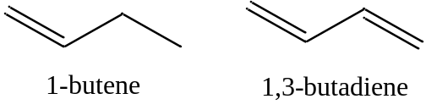
A comparison of the two spectra involves a consideration of the molecular orbitals involved in the compounds and energy transitions. Organic compounds have a network of σ-bonds and then a set of associated σ* anti-bonding orbitals. 1-Butene has one double bond so therefore has a single π and π* orbital. The representations in Figure 2.8 show the sign of the p-orbital wave functions (dark is positive, white is negative) used in creating the π and π* orbitals. In the π-orbital, the two wave functions have the same sign and therefore positive overlap. In the π*-orbital, the two wave functions have the opposite sign and therefore negative overlap.

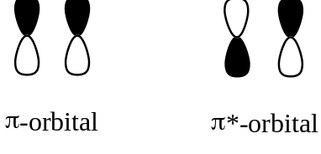

Figure 2.8. Representation of overlap of p-orbitals of a double bond.

In organic compounds, the bonding orbitals are almost always filled and the anti-bonding orbitals are almost always empty. The important consideration becomes the ordering of the molecular orbitals in an energy level diagram. Figure 2.9 shows the typical ordering that would occur for an organic compound with π orbitals.

Figure 2.9. Energy level diagram for a compound with a π- and π*-orbital.

The most important energy transition to consider in Figure 2.9 is the one from the highest occupied molecular orbital (HOMO) to the lowest unoccupied molecular orbital (LUMO). This will be the lowest energy transition. In the case of 1-butene, the lowest energy transition would be the π-π* transition. The UV/VIS absorption spectrum for 1-butene is shown in Figure 2.10. The λ_{max} value has a value of about 176 nm, which is in the vacuum ultraviolet portion of the spectrum.
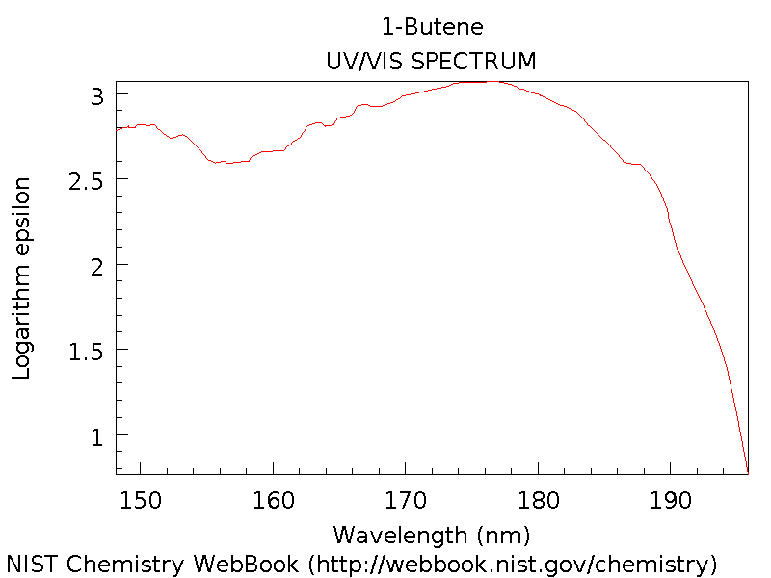

Figure 2.10. Ultraviolet absorption spectrum of 1-butene.

1,3-Butadiene has two double bonds and is said to be a conjugated system. There are two ways we could consider what happens in butadiene. The first, shown Figure 2.11, is to consider each double bond separately showing how the p-orbitals overlap to form the π and π* orbitals (Figure 2.11a). Each of these double bonds and energy level diagrams is comparable to the double bond in 1-butene. However, because of the conjugation in 1,3-butadiene, you can think of the π and π* orbitals from each double bond as further overlapping to create the energy level diagram in the bottom picture (Figure 2.11b).

Figure 2.11 Energy level diagram for (a) two adjacent π-bonds in 1,3-butadiene and (b) the orbitals when the two adjacent π- and π*-orbitals are conjugated.

Because of the additional overlap, the lowest energy transition in butadiene is lower than that in 1-butene. Therefore, the spectrum is expected to shift toward the red.

A better way to consider the situation is to examine all the possible orientations of the p-orbitals in 1,3-butadiene. The picture in Figure 2.12 provides a representation of 1.3-butadiene showing how the four p-orbitals are all positioned side-by-side to overlap with each other.

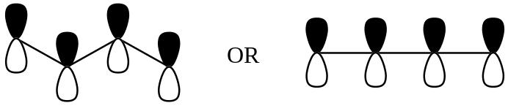

Figure 2.12. Representation of the four p-orbitals in 1,3-butadiene.

Using representations of the p-orbitals in which the dark color indicates the positive region of the wave function and a light color indicates the negative region of the wave function, draw all of the possible ways in which the wave functions of the four p-orbitals can overlap with each other.

The four pictures in Figure 2.13 represent the possible alignments of the signs of the wave functions in 1,3-butadiene. In Figure 2.13a, all four p-orbitals constructively overlap with each other. In Figure 2.13b, two adjacent pairs of p-orbitals constructively overlap with each other. In Figure 2.13c, only the pair of p-orbitals in the center has constructive overlap. In Figure 2.14d, there is no constructive overlap and only destructive overlap occurs.

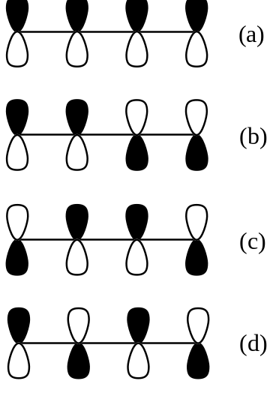

Figure 2.13. Possible alignments of the signs of the wave functions of the p-orbitals in 1,3-butadiene.

Rank these from high to low energy.

The orbital in which all four p-orbitals overlap would be the lowest in energy (Figure 2.14). The next has two regions of overlap. The third has only one region of overlap and the highest energy orbital has no regions of overlap. Because there are four electrons to put in the orbitals (one from each of the contributing p-orbitals), the bottom two orbitals are filled and the top two are empty.
Figure 2.14. Energy level diagram and representation of the π- and π*-molecular orbitals in 1,3-butadiene.

The lowest energy HOMO to LUMO transition will be lower than observed in 1-butene. The UV/VIS spectrum of 1,3-butadiene is shown in Figure 2.15. In this case, the λ_{max} value is at about 292 nm, a significant difference from the value of 176 nm in 1-butene. The effect of increasing conjugation is to shift the spectrum toward longer wavelength (lower frequency, lower energy) absorptions.
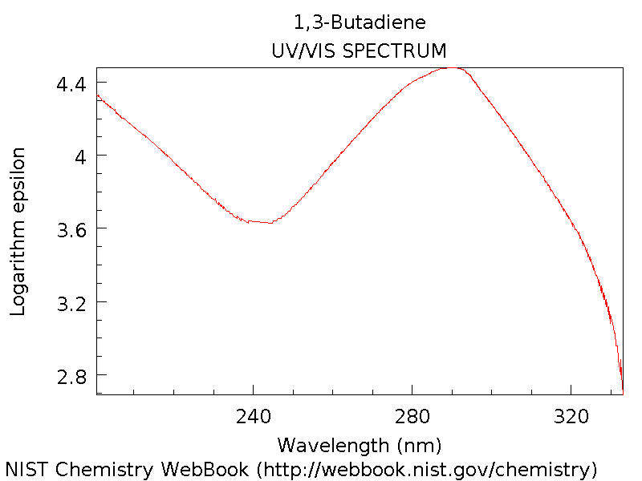

Figure 2.15. Ultraviolet absorption spectrum of 1,3-butadiene.
Another comparative set of conjugated systems occurs with fused ring polycyclic aromatic hydrocarbons such as naphthalene, anthracene and pentacene.

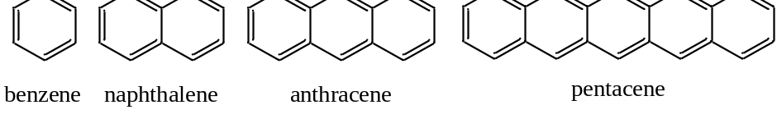

The spectra in Figure 2.16 are for benzene, naphthalene, anthracene and pentacene. Note that as more rings and more conjugation are added, the spectrum shifts further toward and into the visible region of the spectrum.

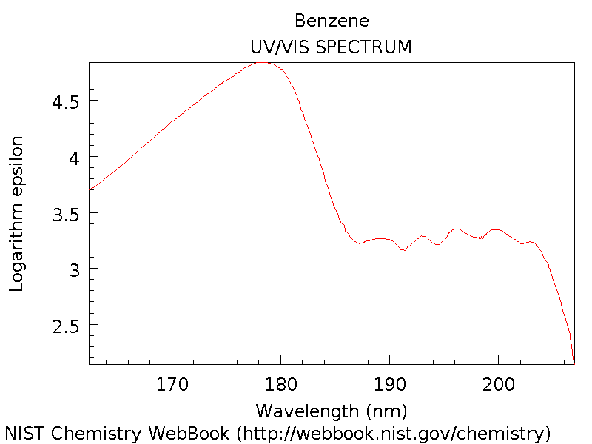

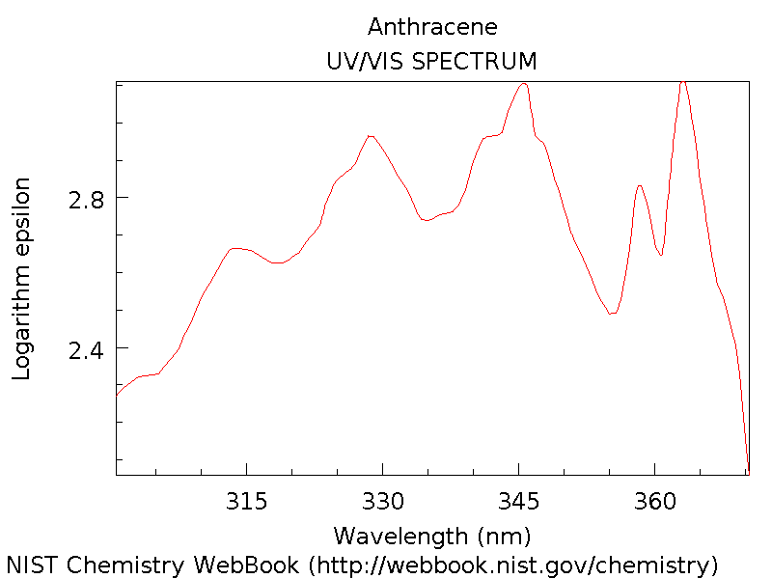
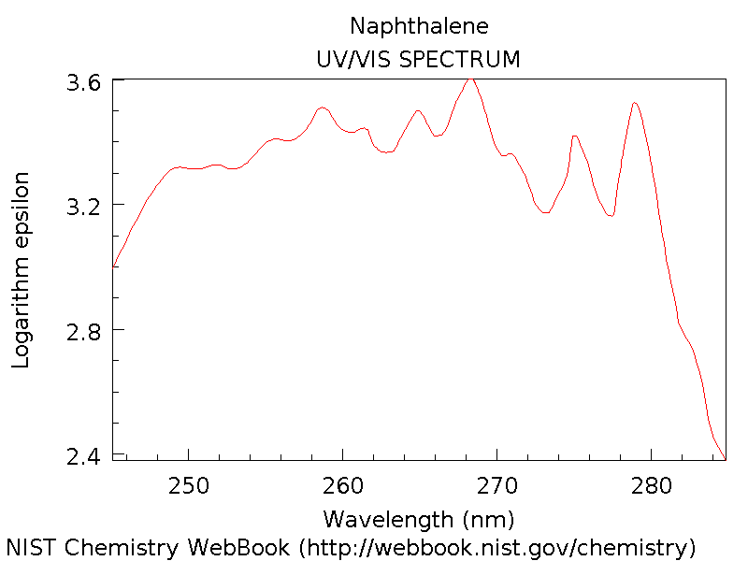

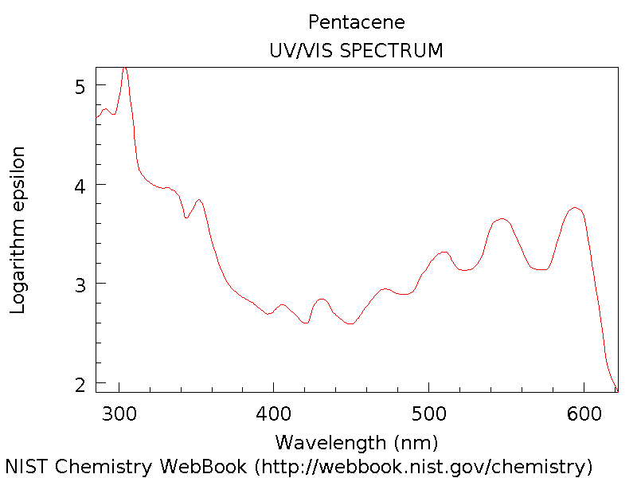

Figure 2.16. UV/VIS absorption spectra of benzene, naphthalene, anthracene and pentacene.

2.3. Effect of Non-bonding Electrons

Compare the UV absorption spectrum of benzene and pyridine.

Benzene has a set of conjugated π-bonds and the lowest energy transition would be a π-π* transition as shown in Figure 2.17.

Figure 2.17. Representation of the lowest energy transition in benzene.

The UV/VIS absorption spectrum for benzene is shown in Figure 2.18.

Figure 2.18. Ultraviolet absorption spectrum of benzene.

Benzene absorbs radiation in the vacuum ultraviolet over the range from 160-208 nm with a _{max} value of about 178 nm. Pyridine has a similar conjugation of double bonds comparable to what occurs in benzene.

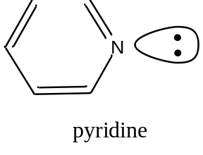

An important distinction with pyridine involves the extra lone pair of electrons on the nitrogen atom that are non-bonding electrons. As non-bonding electrons, their energy is not all that different from the value that would occur in the nitrogen atom. As such, the non-bonding electrons usually reside in orbitals that fall in between the π and π* orbitals. The generalized diagram in Figure 2.19 shows filled bonding molecular orbitals (BMOs), empty anti-bonding molecular orbitals (ABMOs) and the location of non-bonding electrons.

Figure 2.19. Representation of the relative energies of bonding molecular orbitals (BMOs), anti-bonding molecular orbitals (ABMOs) and non-bonding electrons.

For pyridine, the lowest energy transition involves the n-π* orbitals and this will be much lower in energy than the π-π* transition in pyridine or benzene. The UV/VIS absorption spectrum of pyridine is shown in Figure 2.20.

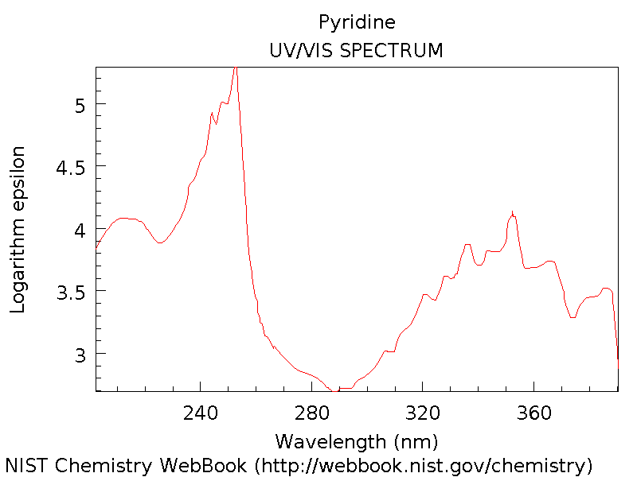

Figure 2.20. UV/VIS absorption spectrum of pyridine.

The shift toward higher wavelengths when compared to benzene is quite noticeable in the spectrum of pyridine, where the peaks from 320-380 nm represent the n-π* transition and the peak at about 240 nm is a π-π* transition. Note that intensity and therefore the molar absorptivity of the n-π* transition is lower than that of the π-π* transition. This is usually the case with organic compounds.

Dye molecules absorb in the visible portion of the spectrum. They absorb wavelengths complementary to the color of the dye. Most π-π* transitions in organic molecules are in the ultraviolet portion of the spectrum unless the system is highly conjugated. Visible absorption is achieved in dye molecules by having a combination of conjugation and non-bonding electrons. Azo dyes with the N=N group are quite common, one example of which is shown in Figure 2.21.

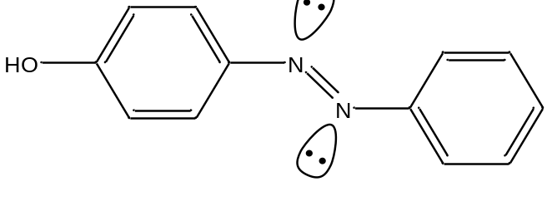

Figure 2.21. Structure of yellow azo dye.

2.4. Effect of Solvent

The peaks in the 320-380 nm portion of the UV absorption spectrum of pyridine shift noticeably toward the blue (high energy) portion of the spectrum on changing the solvent from hexane to methanol. Account for this change.

These are the lowest energy peaks in the spectrum and correspond to the n-π* transition in pyridine. Hexane (C₆H₁₄) is a non-polar hydrocarbon. Methanol (CH₃OH) is a polar solvent with the ability to form hydrogen bonds. For pyridine, the hydrogen atom of the hydroxyl group of methanol will form hydrogen bonds with the lone pair on the nitrogen atoms, as shown in Figure 2.22. Hexane cannot form such hydrogen bonds.

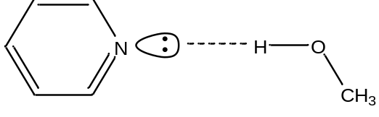

Figure 2.22. Hydrogen bond between methanol and pyridine.

In order to account for the blue-shift in the spectrum, we need to consider what, if anything, will happen to the energies of the n, π, and π* orbitals. Bonding between two atomic orbitals leads to the formation of a bonding and anti-bonding molecular orbital, one of which drops in energy and the other of which rises in energy. The electrostatic attraction between a positively charged hydrogen atom and negatively charged lone pair of electrons in a hydrogen-bond (as illustrated in Figure 2.22 for methanol and pyridine) is a stabilizing interaction. Therefore, the energy of the non-bonding electrons will be lowered.

The picture in Figure 2.23 shows representations of a π- and π*-orbital.

Figure 2.23. Representations of the π- and π*-molecular orbitals.

Electrons in a π-orbital may be able to form a weak dipole-dipole interaction with the hydroxyl hydrogen atom of methanol. This weak interaction may cause a very slight drop in energy of the π-orbital, but it will not be nearly as pronounced as that of the non-bonding electrons. Similarly, if an electron has been excited to the π*-orbital, it has the ability to form a weak dipole-dipole interaction with the hydroxyl hydrogen atom of methanol. This weak interaction will cause a drop in energy of the π*-orbital, but it will not be nearly as pronounced as that of the non-bonding electrons. However, the drop in energy of the π*-orbital will be larger than that of the π-orbital because the π*-orbital points out from the C=C bond and is more accessible to interact with the hydroxyl hydrogen atom of methanol than the π-orbital. The diagram in Figure 2.24 shows the relative changes in the energies of the n, π, and π* orbitals that would occur on changing the solvent from hexane to methanol with stabilization occurring in the order n > π* > π.

Figure 2.24. Relative changes in energies of the n, π, and π* orbitals that occurs on changing the solvent from hexane to methanol.

An examination of the relative energies between hexane and methanol shows that both the n and π* levels drop in energy, but the drop of the n level is greater than the drop of the π* level. Therefore, the n-π* transition moves to higher energy, hence a blue-shift is observed in the peaks in the spectrum in the 320-380 nm range of pyridine. The blue-shift that is observed is referred to as a hypsochromic shift.

The peaks in the UV spectrum of benzene shift slightly toward the red (low energy) portion of the spectrum on changing the solvent from hexane to methanol. Account for this change.

The absorption in benzene corresponds to the π-π* transition. Using the diagram in Figure 2.24, the drop in energy of the π*-orbital is more than that of the π-orbital. Therefore, the π-π* transition is slightly lower in energy and the peaks shift toward the red. The red-shift is referred to as a bathochromic shift.

Note as well that the change in the position of the peak for the π-π* transition of benzene would be less than that for the n-π* transition of pyridine because the stabilization of the non-bonding electrons is greater than the stabilization of the electrons in the π*-orbital.

2.5. Applications

Is UV/VIS spectroscopy useful as a qualitative tool?

The answer depends in part of what type of system you are examining. Ultraviolet-absorbing organic molecules usually involve n-π* and π-π* transitions. Since UV/VIS absorption spectra are usually recorded at room temperature in solution, collisional broadening leads to a blurring together of all of the individual lines that would correspond to excitations to the different vibrational and rotational states of a given electronic state. As such, UV/VIS absorption spectra of organic compounds are not all that different and distinct from each other. Whereas we can reliably assign unique structures to molecules using the spectra that are obtained in NMR spectroscopy, the spectra in UV/VIS spectroscopy do not possess enough detail for such an analysis. Therefore, UV/VIS spectroscopy is not that useful a tool for qualitative analysis of organic compounds.

However, a particular organic compound does have a specific UV/VIS absorption spectrum as seen in the various examples provided above. If the spectrum of an unknown compound exactly matches that of a known compound (provided both have been recorded under the same conditions – in the same solvent, at the same pH, etc.), it is strong evidence that the compounds are the same. However, because of the featureless nature of many UV/VIS spectra, such a conclusion must be reached with caution. The use of a UV-diode array detector as a liquid chromatographic detection method is quite common. In this case, the match of identical spectra with the match in retention time between a known and unknown can be used to confirm an assignment of the identity of the compound.

Many transition metal ions have distinct UV/VIS absorption spectra that involve d-d electron transitions. The position of peaks in the spectra can vary significantly depending on the ligand, and there is something known as the spectrochemical series that can be used to predict certain changes that will be observed as the ligands are varied. UV/VIS spectroscopy can oftentimes be used to reliably confirm the presence of a particular metal species in solution. Some metal species also have absorption processes that result from a charge transfer process. In a charge transfer process, the electron goes from the HOMO on one species to the LUMO on the other. In metal complexes, this can involve a ligand-to-metal transition or metal-to-ligand transition. The ligand-to-metal transition is more common and the process effectively represents an internal electron transfer or redox reaction. Certain pairs of organic compounds also associate in solution and exhibit charge-transfer transitions. An important aspect of charge transfer transitions is that they tend to have very high molar absorptivities.

Is UV/VIS spectroscopy useful as a quantitative tool?

We have the ability to sensitively measure UV/VIS radiation using devices like photomultiplier tubes or array detectors. Provided the molar absorptivity is high enough, UV/VIS absorption is a highly sensitive detection method and is a useful tool for quantitative analysis. Since many substances absorb broad regions of the spectrum, it is prone to possible interferences from other components of the matrix. Therefore, UV/VIS absorption spectroscopy is not that selective a method. The compound under study must often be separated from other constituents of the sample prior to analysis. The coupling of liquid chromatography with ultraviolet detection is one of the more common analysis techniques. In addition to the high sensitivity, the use of UV/VIS absorption for quantitative analysis has wide applicability, is accurate, and is easy to use.

If you were using UV spectroscopy for quantitative analysis, what criteria would you use in selecting a wavelength for the analysis?

The best wavelength to use is the one with the highest molar absorptivity (λ_{max}), provided there are no interfering substances that absorb at the same wavelength. If so, then there either needs to be a separation step or it may be possible to use a different wavelength that has a high enough molar absorptivity but no interference from components of the matrix.

What variables influence the recording of UV/VIS absorption spectra and need to be accounted for when performing qualitative and quantitative analyses?

We have discussed several of these already in the unit. The solvent can have an effect and cause bathochromic and hypsochromic shifts. Species in the matrix that may form dipole-dipole interactions including hydrogen bonds can alter the spectra as well. Metal ions that can form donor-acceptor complexes can have the same effect. Temperature can have an effect on the spectrum. The electrolyte concentration can have an effect as well. As discussed above, the possibility that the sample has interferences that absorb the same radiation must always be considered.

Finally, pH can have a pronounced effect because the spectrum of protonated and deprotonated acids and bases can be markedly different from each other. In fact, UV/VIS spectroscopy is commonly used to measure the pKa of new substances. The reaction below shows a generalized dissociation of a weak acid (HA) into its conjugate base.

HA + H₂O = A– + H₃O⁺

Provided the UV/VIS absorption spectra of HA and A– differ from each other, describe a method that you could use to measure the pKa of the acid.

This rate of dissociation represented above is slow on the time scale of absorption (the absorption of a photon occurs over the time scale of 10⁻¹⁴ to 10⁻¹⁵ seconds). Because the reaction rate is slow, this means that during the absorption of a photon, the species is only in one of the two forms (either HA or A–). Therefore, if the solution is at a pH where both species are present, peaks for both will show up in the spectrum. To measure the pKa, standards must first be analyzed in a strongly acidic solution, such that all of the species is in the HA form, and a standard curve for HA can be generated. Then standards must be analyzed in a strongly basic solution, such that all of the species is in the A– form, to generate a standard curve for A–. At intermediate pH values close to the pKa, both HA and A– will be present and the two standard curves can be used to calculate the concentration of each species. The pH and two concentrations can then be substituted into the Henderson-Hasselbalch equation to determine the pKa value.

pH = pKa + log([A–]/[HA])

2.6. Evaporative Light Scattering Detection

Evaporative light scattering detection is a specialized technique in which UV radiation is used to detect non-UV-absorbing compounds separated by liquid chromatography. The column effluent is passed through a heated chamber that evaporates the mobile phase solvent. Non-volatile analyte compounds, which is usually the case for compounds separated by liquid chromatography, form solid particulates when the solvent is evaporated. The solid particulates scatter UV radiation, which will lead to a reduction in the UV power at the detector (i.e., photomultiplier tube) when a compound elutes from the chromatographic column. The method is more commonly used to determine the presence and retention time of non-UV-absorbing species in a chromatographic analysis rather than their concentration. It is common in liquid chromatographic separations to employ a buffer to control the pH of the mobile phase. Many buffers will form particulates on evaporation of the solvent and interfere with evaporative light scattering detection.

Evaporative light scattering detection is encompassed more broadly within a technique known as turbidimetry. In turbidometric measurements, the detector is placed in line with the source and the decrease in power from scattering by particulate matter is measured. Nephelometry is another technique based on scattering, except now the detector is placed at 90º to the source and the power of the scattered radiation is measured. Turbidmetry can be measured using a standard UV/VIS spectrophotometer; nephelometry can be measured using a standard fluorescence spectrophotometer (discussed in Chapter 3). Turbimetry is better for samples that have a high concentration of scattering particles where the power reaching the detector will be significantly less than the power of the course. Nephelometry is preferable for samples with only low concentration of scattering particles. Turbidimetry and nephelometry are widely used to determine the clarity of solutions such as water, beverages, and food products.

3. MOLECULAR LUMINESCENCE

3.1. Introduction

Luminescent methods refer to a family of techniques in which excited state species emit electromagnetic radiation. Among luminescent methods are various sub-categories that include the processes of fluorescence, phosphorescence, chemiluminescence, bioluminescence and triboluminescence. Among these different sub-categories, fluorescence spectroscopy is by far the most common technique used for analysis purposes. You are no doubt familiar with fluorescent lights. This unit will allow you to understand how such a light works.

3.2. Energy States and Transitions

Fluorescence only occurs after a chemical species has first been excited by electromagnetic radiation. The emission of radiation by a solid object heated in a flame (e.g., a piece of iron) is not fluorescence because the excitation has occurred thermally rather than through the absorption of electromagnetic radiation. Fluorescence can occur from species that have been excited by UV/VIS radiation. To consider what happens in the process of fluorescence, we need to think of the possible energy states for a ground and excited state system.

Draw an energy level diagram for a typical organic compound with π and π * orbitals.

Figure 3.1 represents the energy levels for a typical organic compound in which the π orbitals are full and the π* orbitals are empty.

Figure 3.1. Energy level diagram for π- and π*-orbitals of a typical organic compound.

Now consider the electron spin possibilities for the ground and excited state. Are there different possible ways to orient the spins (if so, these represent different spin states).

The ground state, which is shown on the left in Figure 3.1, has two electrons in the π-orbital. These two electrons must have opposite spins or else they would have the same four quantum numbers. Therefore, there is only one possible way to align the spins of the two electrons in the π-orbital.

The excited state has one electron in the π-orbital and one electron in the π*-orbital as shown in Figure 3.1. In this case, there are two possible ways we might align the spins. In one case, the electron in the π*-orbital could have the opposite spin of the electron in the π-orbital (e.g., the electrons have paired spins, even though they are in different orbitals – see Figure 3.2, middle diagram). In the other case, the electron in the π*-orbital could have a spin that is parallel with the electron in the π-orbital (see Figure 3.2 – far right diagram). In both cases, it does not matter which electron has spin-up and which has spin-down, the only important point is that in one case the two spins are opposite and in the other they are parallel. The energy level diagram in Figure 3.2 shows representations for the two possibilities.

Figure 3.2. Representations of possible spin states for ground and excited state systems.

Do you think these different spin states have different energies?

Since they are different from each other (i.e., spins parallel versus spins paired), it makes sense that they would have different energies.

Which one do you expect to be lower in energy?

To answer this question, we have to think back to a rule we established with placing electrons into atomic or molecular orbitals that have the same energy (i.e., are degenerate). We learned that electrons go into degenerate orbitals with parallel spins and only pair up their spins when forced to do so (e.g., an atomic p³ configuration has three unpaired electrons with parallel spins; only when we added a fourth electron to make a p⁴ configuration do two of the electrons have paired spins). The rationale we gave for this observation is that configurations with parallel spins in degenerate orbitals are lower in energy than configurations with paired spins (i.e., it took energy to pair up electron spins). Applying this general concept to the situation above, we can reason that the configuration in which the electrons in the π- and π*-orbitals have parallel spins is lower in energy than the configuration in which the two electrons have paired spins. The energy level diagrams in Figure 3.3 show the lower energy of the configuration where the electrons have parallel spins.

Figure 3.3. Relative energies of excited state systems with paired and unpaired spins.

If the spin state is defined as (2S + 1) where S represents the total electronic spin for the system, try to come up with names for the ground and possible excited states for the system that are based on their spin state.

Remember that spin quantum numbers are either +½ or –½. S, the total electronic spin for the system, is the sum of the individual spin quantum numbers for all of the electrons.

In the case of the ground state, for every electron with a spin of +½ there is an electron with a spin of –½. Therefore, the value of S is zero. The spin state, which is 2S + 1, would have a value of 1.

In the case of the excited state in which the electrons have paired spins (+½ and –½), the value of S is also zero. Therefore, the spin state, which is 2S + 1, would have a value of 1.

In the case of the excited state in which the electrons have parallel spins (+½ and +½; by convention, we use the positive value of the spin for parallel spins when determining the spin state), the value of S is now one. Therefore, the spin state, which is 2S + 1, would have a value of 3.

The name we use to signify a system with a spin state of one is a singlet state. The name we use to signify a system with a spin state of three is a triplet state. Note that the ground state is a singlet state and that one of the excited states is a singlet state as well. We differentiate these by denoting the energy level with a number subscript. So the ground singlet state is denoted as S₀ whereas the first excited state is denoted as S₁. It is possible to excite a molecular species to higher electronic states so that higher energy S₂, S₃, etc. singlet states exist as well. The triplet state would be denoted as T₁. There are also T₂, T₃, etc. as well. Now we can draw a more complex energy diagram for the molecule that shows different singlet and triplet levels (Figure 3.4).

Draw a diagram of the energy levels for such a molecule. Draw arrows for the possible transitions that could occur for the molecule.

Figure 3.4. Energy level diagram for a molecular species.

Note in Figure 3.4 how a triplet state is slightly lower in energy than the corresponding singlet state. Note as well that there are vibrational and rotational levels superimposed within the electronic states as we observed before when considering UV/VIS spectroscopy. The energy level diagram in Figure 3.4 shows the transitions that can occur within this manifold of energy states for an organic molecule. The transitions are numbered to facilitate our discussion of them.

Transition 1 (Absorption)
The transitions labeled with the number (1) in Figure 3.4 represent the process of absorption of incident radiation that promotes the molecule to an excited electronic state. The diagram shows the absorption process to the S₁ and S₂ states. It is also possible to excite the molecule to higher vibrational and rotational levels within the excited electronic states, so there are many possible absorption transitions. The following are equations that show the absorption of different frequencies of radiation needed to excite the molecule to S₁ and S₂.

S₀ + hν = S₁
S₀ + hν’ = S₂

It is reasonable at first to think that there is an absorption transition that goes directly from the S₀ to the T₁ state. This is a transition that involves a spin-flip and it turns out that transitions that involve a spin-flip or change in spin state are forbidden, meaning that they do not happen (although, as we will soon see, sometimes transitions that are forbidden do happen). What is important here is that you will not get direct excitation from the S₀ level to a higher energy triplet state. These transitions are truly forbidden and do not happen.

Transition 2 (Internal Conversion)
Internal conversion is the process in which an electron crosses over to another electronic state of the same spin multiplicity (e.g., singlet-to-singlet, triplet-to-triplet). The internal conversion in Figure 3.4 is from S₂ to S₁ and involves a crossover into a higher energy vibrational state of S₁. It is also possible to have internal conversion from S₁ to a higher vibrational level of S₀.

Transition 3 (Radiationless decay – loss of energy as heat)
The transitions labeled with the number (3) in Figure 3.4 are known as radiationless decay or external conversion. These generally correspond to the loss of energy as heat to surrounding solvent or other solute molecules.

S₁ = S₀ + heat
T₁ = S₀ + heat

Note that systems in S₁ and T₁ can lose their extra energy as heat. Also, systems excited to higher energy vibrational and rotational states also lose their extra energy as heat. The energy diagram level in Figure 3.4 shows systems excited to higher vibrational levels of S₁ and all of these will rapidly lose some of the extra energy as heat and drop down to the S₁ level that is only electronically excited.

An important consideration that effects the various processes that take place for excited state systems is the lifetimes of the different excited states. The lifetime of a particular excited state (e.g. the S₁ state) depends to some degree of the specific molecular species being considered and the orbitals involved, but measurements of excited state lifetimes for many different compounds allows us to provide ballpark numbers of the lifetimes of different excited states.

The lifetime of an electron in an S₂ state is typically on the order of 10⁻¹⁵ second.

The lifetime of an electron in an S₁ state depends on the energy levels involved. For a π-π* system, the lifetimes range from 10⁻⁷ to 10⁻⁹ second. For a n-π* system, the lifetimes range from 10⁻⁵ to 10⁻⁷ second. Since π-π* molecules are more commonly studied by fluorescence spectroscopy, S₁ lifetimes are typically on the order of 10⁻⁸ second. While this is a small number on an absolute scale of numbers, note that it is a large number compared to the lifetimes of the S₂ state.

The lifetime of a vibrational state is typically on the order of 10⁻¹² second. Note that the lifetime of an electron in the S₁ state is significantly longer than the lifetime of an electron in a vibrationally excited state of S₁. That means that systems excited to vibrationally excited states of S₁ rapidly lose heat (in 10⁻¹² second) until reaching S₁, where they then “pause” for 10⁻⁸ second.

Transition 4 (Fluorescence)
The transition labeled (4) in Figure 3.4 denotes the loss of energy from S₁ as radiation. This process is known as fluorescence.

S₁ = S₀ + hν

Therefore, molecular fluorescence is a term used to describe a singlet-to-singlet transition in a system where the chemical species was first excited by absorption of electromagnetic radiation. Note that the diagram in Figure 3.4 does not show molecular fluorescence occurring from the S₂ level. Fluorescence from the S₂ state is extremely rare in molecules and there are only a few known systems where it occurs. Instead, what happens is that most molecules excited to energy states higher than S₁ quickly (10⁻¹⁵ second) undergo an internal conversion to a high energy vibrational state of S₁. They then rapidly lose the extra vibrational energy as heat and “pause” in the S₁ state. From S₁, they can either undergo fluorescence or undergo another internal conversion to a high energy vibrational state of S₀ and then lose the energy as heat. The extent to which fluorescence or loss of heat occurs from S₁ depends on particular features of the molecule and solution that we will discuss in more detail later in this unit.

An important aspect of fluorescence from the S₁ state is that the molecule can end up in vibrationally excited states of S₀, as shown in the diagram above. Therefore, fluorescence emission from an excited state molecule can occur at a variety of different wavelengths. Just like we talked about with absorbance and the probability of different transitions (reflected in the magnitude of the molar absorptivity), fluorescent transitions have different probabilities as well. In some molecules, the S₁-to-S₀ fluorescent transition is the most probable, whereas in other molecules the most probable fluorescent transition may involve a higher vibrational level of S₁. A molecule ending up in a higher vibrational level of S₁ after a fluorescent emission will quickly lose the extra energy as heat and drop down to S₀.

So how do fluorescent light bulbs work? Inside the tube that makes up the bulb is a gas comprised of argon and a small amount of mercury. An electrical current that flows through the gas excites the mercury atoms causing them to emit light. This light is not fluorescence because the gaseous species was excited by an electrical current rather than radiation. The light emitted by the mercury strikes the white powdery coating on the inside of the glass tube and excites it. This coating then emits light. Since the coating was excited by light and emits light, it is a fluorescence emission.

Transition 5 (Intersystem crossing)
The transition labeled (5) in Figure 3.4 is referred to as intersystem crossing. Intersystem crossing involves a spin-flip of the excited state electron. Remember that the electron has “paused” in S₁ for about 10⁻⁸ second. While there, it is possible for the species to interact with things in the matrix (e.g. collide with a solvent molecule) that can cause the electron in the ground and/or excited state to flip its spin. If the spin flip occurs, the molecule is now in a vibrationally excited level of T₁ and it rapidly loses the extra vibrational energy as heat to drop down to the T₁ electronic level.

What do you expect for the lifetime of an electron in the T₁ state?

Earlier we had mentioned that transitions that involve a change in spin state are forbidden. Theoretically that means that an electron in the T₁ state ought to be trapped there, because the only place for it to go on losing energy is to the S₀ state. The effect of this is that electrons in the T₁ state have a long lifetime, which can be on the order of 10⁻⁴ to 100 seconds.

There are two possible routes for an electron in the T₁ state. One is that another spin flip can occur for one of the two electrons causing the spins to be paired. If this happens, the system is now in a high-energy vibrational state of S₀ and the extra energy is lost rapidly as radiationless decay (transition 3) or heat to the surroundings.

Transition 6 (Phosphorescence)
The other possibility that can occur for a system in T₁ is to emit a photon of radiation. Although, theoretically a forbidden process, it does happen for some molecules. This emission, which is labeled (6) in Figure 3.4, is known as phosphorescence. There are two common occasions where you have likely seen phosphorescence emission. One is from glow-in-the-dark stickers. The other is if you have ever turned off your television in a dark room and observed that the screen has a glow that takes a few seconds to die down. Phosphorescence is usually a weak emission from most substances.

Why is phosphorescence emission weak in most substances?

One reason why phosphorescence is usually weak is that it requires intersystem crossing and population of the T₁ state. In many compounds, radiationless decay and/or fluorescence from the S₁ state is preferable to intersystem crossing and not many of the species ever make it to the T₁ state. Systems that happen to have a close match between the energy of the S₁ state and a higher vibrational level of the T₁ state may have relatively high rates of intersystem crossing. Compounds with non-bonding electrons often have higher degrees of intersystem crossing because the energy difference between the S₁ and T₁ states in these molecules is less. Paramagnetic substances such as oxygen gas (O₂) promote intersystem crossing because the magnetic dipole of the unpaired electrons of oxygen can interact with the magnetic spin dipole of the electrons in the species under study, although the paramagnetism also diminishes phosphorescence from T₁ as well. Heavy atoms such as Br and I in a molecule also tend to promote intersystem crossing.

A second reason why phosphorescence is often weak has to do with the long lifetime of the T₁ state. The longer the species is in the excited state, the more collisions it has with surrounding molecules. Collisions tend to promote the loss of excess energy as radiationless decay. Such collisions are said to quench fluorescence or phosphorescence. Observable levels of phosphorescent emission will require that collisions in the sample be reduced to a minimum. Hence, phosphorescence is usually measured on solid substances. Glow-in-the-dark stickers are a solid material. Chemical substances dissolved in solution are usually cooled to the point that the sample is frozen into a solid glass to reduce collisions before recording the phosphorescence spectrum. This requires a solvent that freezes to a clear glass, something that can be difficult to achieve with water as it tends to expand and crack when frozen.

Which transition (π*-π or π*-n) would have a higher fluorescent intensity? Justify your answer.

There are two reasons why you would expect the π*-n transition to have a lower fluorescent intensity. The first is that the molar absorptivity of n-π* transitions is less than that of π-π* transitions. Fewer molecules are excited for the n-π* case, so fewer are available to fluoresce. The second is that the excited state lifetime of the n-π* state (10⁻⁵-10⁻⁷ second) is longer than that of the π-π* state (10⁻⁷-10⁻⁹ second). The longer lifetime means that more collisions and more collisional deactivation will occur for the n-π* system than the π-π* system.

Now that we understand the transitions that can occur in a system to produce fluorescence and phosphorescence occurs, we can examine the instrumental setup of a fluorescence spectrophotometer.

3.3. Instrumentation

What would constitute the basic instrumental design of a fluorescence spectrophotometer?

In many ways the design of a fluorescence spectrophotometer is similar to an UV/VIS absorption spectrophotometer. We need a source of radiation and a monochromator to select out the desired wavelength of light. The device needs a sample holder and a detector to measure the intensity of the radiation.

Just like UV/VIS absorption spectroscopy, radiation is used to excite the sample. Unlike absorption spectroscopy, a fluorescent sample emits radiation, and the emission goes from the S₁ level to either the S₀ level or higher vibrational states of the S₀ level. Since fluorescence involves an excitation and emission process, and the wavelengths that these two processes occur at will almost always be different, a fluorescence spectrophotometer requires an excitation and emission monochromator. Also, since the emitted radiation leaves the sample in all directions, the detector does not need to be at 180º relative to the source as in an absorption instrument. Usually the detector is set at 90º to the incident beam and mirrors are placed around the sample cell 180º to the source and 180º to the detector to reflect the source beam back through the sample and to reflect emitted radiation toward the detector. A diagram of the components of a fluorescence spectrophotometer is shown in Figure 3.5.

Figure 3.5. Diagram of the components of a fluorescence spectrophotometer.

3.4. Excitation and Emission Spectra

What would be the difference between an excitation and emission spectrum in fluorescence spectroscopy?

In an excitation spectrum, the emission monochromator is set to some wavelength where the sample is known to emit radiation and the excitation monochromator is scanned through the different wavelengths. The excitation spectrum will look similar if not identical to the absorption spectrum obtained in UV/VIS spectroscopy.

In an emission spectrum, the excitation monochromator is set to some wavelength known to excite the sample and the emission monochromator is scanned through the different wavelengths.

Draw representative examples of the excitation and emission spectrum for a molecule.

The important point to realize is that the only peak that overlaps between the excitation and emission spectrum is the S₀-S₁ transition. Otherwise, all the excitation peaks occur at higher frequencies or shorter wavelengths and all of the emission peaks occur at lower frequencies or longer wavelengths. The spectra in Figure 3.6 show the excitation and emission spectra of anthracene. Note that the only overlap occurs at 380 nm, which corresponds to the S₀-S₁ transition.
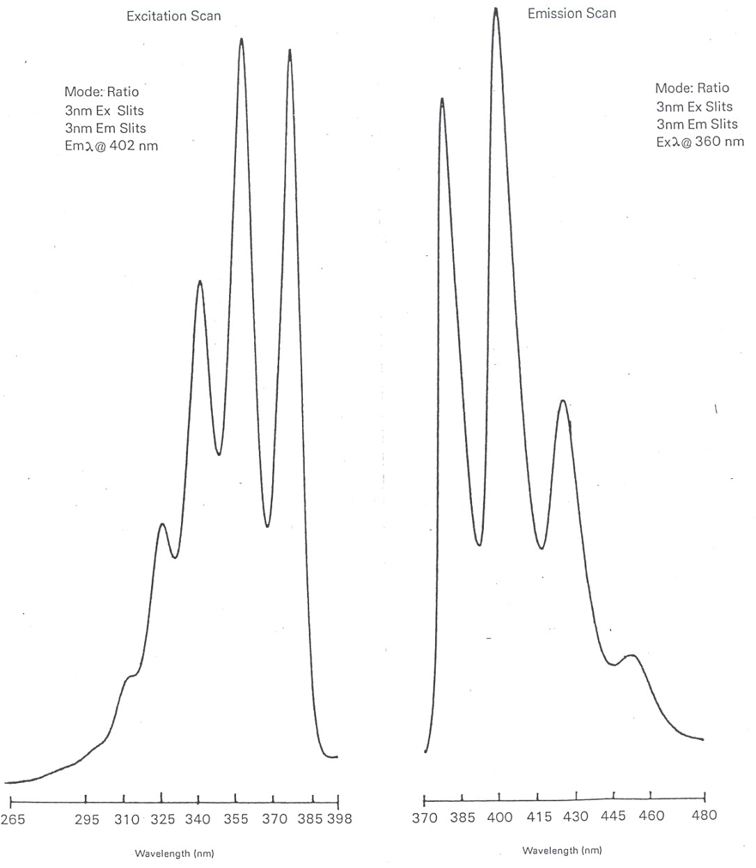
Figure 3.6. Fluorescence excitation (left) and emission (right) spectra of anthracene.

Describe a way to measure the phosphorescence spectrum of a species that is not compromised by the presence of any fluorescence emission.

The important thing to consider in addressing this question is that the lifetime of the S₁ state from which fluorescence occurs is approximately 10⁻⁸ second whereas the lifetime of the T₁ state from which phosphorescence occurs is on the order of 10⁻⁴ to 100 seconds. Because of these different lifetimes, fluorescence emission will decay away rather quickly while phosphorescence emission will decay away more slowly. The diagram in Figure 3.7 shows representations for the decay of fluorescence versus phosphorescence as a function of time if the radiation source was turned off. The two can be distinguished by using a pulsed source. A pulsed source is turned on for a brief instant and then turned off. Many fluorescent spectrophotometers use a pulsed source. The electronics on the detector can be coordinated with the source pulsing. When measuring fluorescence, the detector reads signal when the pulse is on. When measuring phosphorescence, a delay time during which the detector is turned off occurs after the pulse ends. Then the detector is turned on for some period of time, which is referred to as the gate time. Figure 3.7 also shows where the delay and gate times might be set for the sample represented in the decay curves. The proper gate time depends in part on how slow the phosphorescence decays. You want a reasonable length of time to measure enough signal, but if the gate time is too long and weak to no phosphorescence occurs at the end, the detector is mostly measuring noise and the signal-to-noise ratio will be reduced.

Figure 3.7. Fluorescence and phosphorescence decay profiles after a pulse of radiation.

If performing quantitative analysis in fluorescence spectroscopy, which wavelengths would you select from the spectra you drew in the problem above?

The two best wavelengths would be those that produced the maximum signal on the excitation and emission spectra. That will lead to the most sensitivity and lowest detection limits in the analysis. For the spectra of anthracene drawn in Figure 3.6, that would correspond to an excitation wavelength of 360 nm and emission wavelength of 402 nm. The one exception is if the S₀-S₁ transition is the maximum on both spectra, which would mean having the excitation and emission monochromators set to the same wavelength. The problem that occurs here is that the excitation beam of radiation will always exhibit some scatter as it passes through the sample. Scattered radiation appears in all directions and the detector has no way to distinguish this from fluorescence. Usually the excitation and emission wavelengths must be offset by some suitable value (often 30 nm) to keep the scatter to acceptable levels.

3.5. Quantum Yield of Fluorescence (ϕ_{F})

The quantum yield (ϕ_{F}) is a ratio that expresses the number of species that fluoresce relative to the total number of species that were excited. Earlier we said that anything that reduces the number of excited state species that undergo fluorescence is said to quench the fluorescence. The expression for the quantum yield will depend on the rate constants for the different processes that can occur for excited state species. Referring back to our original drawing of the different processes that can occur, we can write the following expression for the quantum yield, where k_{F} is the rate constant for fluorescence, k_{IC} is the rate constant for internal conversion, k_{EC} is the rage constant for external conversion, k_{ISC} is the rate constant for intersystem crossing and k_{C} is the rate constant for any other competing processes and includes photodecomposition of the sample. Excited state species sometimes have sufficient energy to decompose through processes of dissociation or predissociation. In dissociation, the electron is excited to a high enough vibrational level that the bond ruptures. In predissociation, the molecule undergoes internal conversion from a higher electronic state to an upper vibrational level of a lower electronic state prior to bond rupture. When putting a sample into a fluorescence spectrophotometer, it is usually desirable to block the excitation beam until just before making the measurement to minimize photodecomposition.

ϕ_{F} = (k_{F})/(k_{F} + k_{IC} + k_{EC} +k_{ISC} + k_{C})

Since this is a ratio, the limits of ϕ_{F} are from 0 to 1. Species with quantum yields of 0.01 or higher (1 out of 100 excited species actually undergo fluorescence) are useful for analysis purposes.

Which method is more sensitive, absorption or fluorescence spectroscopy?

On first consideration it might seem reasonable to think that absorption spectroscopy is more sensitive than fluorescence spectroscopy. As stated above, for some compounds that we measure by fluorescence, only one of the 100 species that is excited undergoes fluorescence emission. In this case, 100 photons are absorbed but only one is emitted. The answer though requires a different consideration.

The measurement of absorption involves a comparison of P to P_{o}. At low concentrations, these two values are large and similar in magnitude. Therefore, at low concentrations, absorption involves the measurement of a small difference between two large signals. Fluorescence, on the other hand, is measured at 90º to the source. In the absence of fluorescence, as in a blank solution, there ought to be no signal reaching the detector (however, there is still some scattered and stray light that may reach the detector as noise). At low concentrations, fluorescence involves the measurement of a small signal over no background. For comparison, suppose you tried to use your eyes to distinguish the difference between a 100 and 99 Watt light bulb and the difference between complete darkness and a 1 Watt light bulb. Your eyes would have a much better ability to determine the small 1 Watt signal over darkness than the difference between two large 100 and 99 Watt signals. The same occurs for the electronic measurements in a spectrophotometer. Therefore, because emission involves the measurement of a small signal over no background, any type of emission spectroscopy has an inherent sensitivity advantage of one to three orders of magnitude over measurements of absorption. Fluorescence spectroscopy is an especially sensitive analysis method for those compounds that have suitable quantum yields.

3.6. Variables that Influence Fluorescence Measurements

What variables influence fluorescence measurements? For each variable, describe its relationship to the intensity of fluorescence emission.

There are a variety of variables that influence the signal observed in fluorescence spectroscopy. As seen in the original diagram showing the various energy levels and transitions that can occur, anything that can quench the fluorescent transition will affect the intensity of the fluorescence.

When discussing absorption spectroscopy, an important consideration is Beer’s Law. A similar relationship exists for fluorescence spectroscopy, as shown below, in which I is the fluorescence intensity, ε is the molar absorptivity, b is the path length, c is the concentration, and P_{o} is the source power.

I = 2.303K’εbcP_{o}

Not surprisingly, fluorescence intensity varies linearly with the path length and with the concentration. K’ is a constant that is dependent on the geometry and other factors and includes the fluorescence quantum yield. Since ϕ_{F} is a constant for a given system, K’ is defined as K”ϕ_{F}. Of particular interest is that the fluorescence intensity relates directly to the source power. It stands to reason that the higher the source power, the more species that absorb photons and become excited, and therefore the more that eventually emit fluorescence radiation. This suggests that high-powered lasers, provided they emit at the proper wavelength of radiation to excite a system, have the potential to be excellent sources for fluorescence spectroscopy.

The equation above predicts a linear relationship between fluorescence intensity and concentration. However, the utility of this equation breaks down at absorbance values of 0.05 or higher leading to a negative deviation of the standard curve.

Something else that can possibly occur with fluorescence or other emission processes is that emitted photons can be reabsorbed by ground state molecules. This is a particular problem if the S₁-S₀ emission transition is the one being monitored. In this situation, at high concentrations of analyte, the fluorescence intensity measured at the detector may actually start to drop as shown in the standard curve in Figure 3.8.

Figure 3.8. Standard curve for fluorescence showing re-absorption of emitted photons at higher concentrations.

Any changes in the system that will affect the number and force of collisions taking place in the solution will influence the magnitude of the fluorescence emission. Collisions promote radiationless decay and loss of extra energy as heat, so more collisions or more forceful collisions will promote radiationless decay and reduce fluorescence emission. Therefore, fluorescent intensity is dependent on the temperature of the solution. Higher temperatures will speed up the movement of the molecules (i.e., higher translational energy) leading to more collisions and more forceful collisions, thereby reducing the fluorescent intensity. Insuring that all the measurements are done at the same temperature is important. Reducing the temperature of the sample will also increase the signal-to-noise ratio.

Another factor that will affect the number of collisions is the solvent viscosity. More viscous solutions will have fewer collisions, less collisional deactivation, and higher fluorescent intensity.

The solvent can have other effects as well, similar to what we previously discussed in the section on UV/VIS absorption spectroscopy. For example, a hydrogen-bonding solvent can influence the value of λ_{max} in the excitation and emission spectra by altering the energy levels of non-bonding electrons and electrons in π* orbitals. Other species in the solution (e.g., metal ions) may also associate with the analyte and change the λ_{max} values.

Many metal ions and dissolved oxygen are paramagnetic. We already mentioned that paramagnetic species promote intersystem crossing, thereby quenching the fluorescence. Removal of paramagnetic metal ions from a sample is not necessarily a trivial matter. Removing dissolved oxygen gas is easily done by purging the sample with a diamagnetic, inert gas such as nitrogen, argon or helium. All solution-phase samples should be purged of oxygen gas prior to the analysis.

Another concern that can distinguish sample solutions from the blank and standards is the possibility that the unknown solutions have impurities that can absorb the fluorescent emission from the analyte. Comparing the fluorescent excitation and emission spectra of the unknown samples to the standards may provide an indication of whether the unknown has impurities that are interfering with the analysis.

The pH will also have a pronounced effect on the fluorescence spectrum for organic acids and bases. An interesting example is to consider the fluorescence emission spectrum for the compound 2-naphthol. The hydroxyl hydrogen atom is acidic and the compound has a pKa of 9.5. At a pH of 1, the compound exists almost exclusively as the protonated 2-naphthol. At a pH of 13, the compound exists almost exclusively as the deprotonated 2-naphtholate ion. At a pH equal to the pKa value, the solution would consist of a 50-50 mixture of the protonated and deprotonated form.

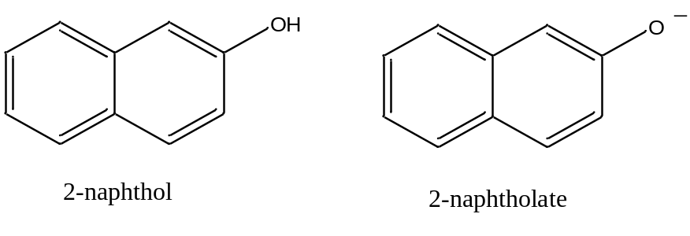

The emission spectra of an aqueous solution of 2-naphthol at pH 2 and 13 are shown in Figure 3.9.

Figure 3.9. Fluorescence emission spectra of 2-naphthol at pH 2 and pH 13.

The most obvious thing to note is the large difference in the _{max} value for the neutral 2-naphthol (355 nm) and the anionic 2-naphtholate ion (415 nm). The considerable difference between the two emission spectra occurs because the presence of more resonance forms leads to stabilization (i.e., lower energy) of the excited state. As shown in Figure 3.10, the 2-naphtholate species has multiple resonance forms involving the oxygen atom whereas the neutral 2-naphthol species only has a single resonance form. Therefore, the emission spectrum of the 2-naphtholate ion is red-shifted relative to that of the 2-naphthol species.

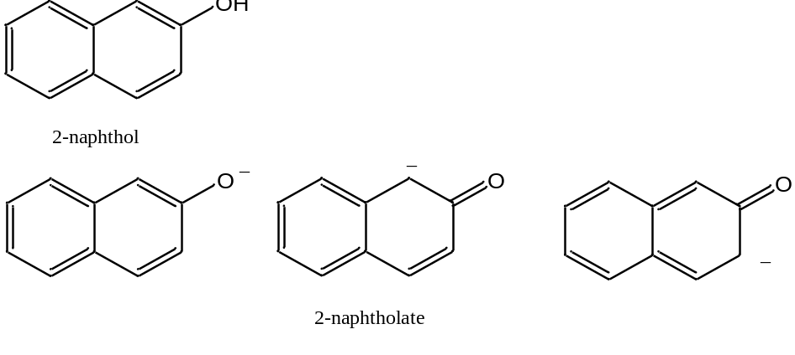

Figure 3.10. Resonance forms involving the oxygen atom of 2-naphthol and 2-naphtholate.

Consider the reaction shown below for the dissociation of 2-naphthol. This reaction may be either slow (slow exchange) or fast (fast exchange) on the time scale of fluorescence spectroscopy. Draw the series of spectra that would result for an initial concentration of 2-naphthol of 10⁻⁶ M if the pH was adjusted to 2, 8.5, 9.5, 10.5, and 13 and slow exchange occurred. Draw the spectra at the same pH when the exchange rate is fast.

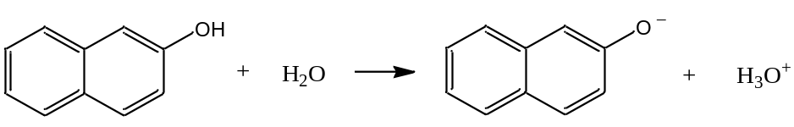

If slow exchange occurs, an individual 2-naphthol or 2-naphtholate species stays in its protonated or deprotonated form during the entire excitation-emission process and emits its characteristic spectrum. Therefore, when both species are present in appreciable concentrations, two peaks occur in the spectrum for each of the individual species. On the left side of Figure 3.11, at pH 2, all of the species is in the neutral 2-naphthol form, whereas at pH 13 it is all in the anionic 2-naphtholate form. At pH 9.5, which equals the pKa value, there is a 50-50 mixture of the two and the peaks for both species are equal in intensity. At pH 8.5 and 10.5, one of the forms predominates. The intensity of each species is proportional to the concentration.

Figure 3.11. Representation of fluorescent emission spectrum of 2-naphthol as a function of pH under the conditions of slow (left) and fast (right) exchange.

If fast exchange occurs, as seen on the right side of Figure 3.11, a particular species rapidly changes between its protonated and deprotonated form during the excitation and emission process. Now the emission is a weighted time average of the two forms. If the pH is such that more neutral 2-naphthol is present in solution, the maximum is closer to 355 nm (pH = 8.5). If the pH is such that more anionic 2-naphtholate is present in solution, the maximum is closer to 415 nm (pH = 10.5). At the pKa value (9.5), the peak appears in the middle of the two extremes.

What actually happens – is the exchange fast or slow? The observation is that the exchange of protons that occurs in the acid-base reaction is slow on the time scale of fluorescence spectroscopy. Remember that the lifetime of an excited state is about 10⁻⁸ second. This means that the exchange rate of protons among the species in solution is slower than 10⁻⁸ second and the fluorescence emission spectrum has peaks for both the 2-naphthol and 2-naphtholate species.

Devise a procedure that might allow you to determine the pKa of a weak acid such as 2-naphthol.

The pKa value of an acid is incorporated into an expression called the Henderson-Hasselbalch equation, which is shown below where HA represents the protonated form of any weak acid and A– is its conjugate base.

pH = pKa + log ([A–]/[HA])

If a standard curve was prepared for 2-naphthol at a highly acidic pH and 2-naphtholate at a highly basic pH, the concentration of each species at different intermediate pH values when both are present could be determined. These concentrations, along with the known pH, can be substituted into the Henderson-Hasselbach equation to calculate pKa. As described earlier, this same process is used quite often in UV/VIS spectroscopy to determine the pKa of acids, so long as the acid and base forms of the conjugate pair have substantially different absorption spectra.

If you do this with the fluorescence spectra of 2-naphthol; however, you get a rather perplexing set of results in that slightly different pKa values are calculated at different pH values where appreciable amounts of the neutral and anionic form are present. This occurs because the pKa of excited state 2-naphthol is different from the pKa of the ground state. Since the fluorescence emission occurs from the excited state, this difference will influence the calculated pKa values. A more complicated set of calculations can be done to determine the excited state pKa values. UV/VIS spectroscopy is therefore often an easier way to measure the pKa of a species than fluorescence spectroscopy.

Because many compounds are weak acids or bases, and therefore the fluorescence spectra of the conjugate pairs might vary considerably, it is important to adjust the pH to insure all of either the protonated or deprotonated form.

Which compound will have a higher quantum yield: anthracene or diphenylmethane?

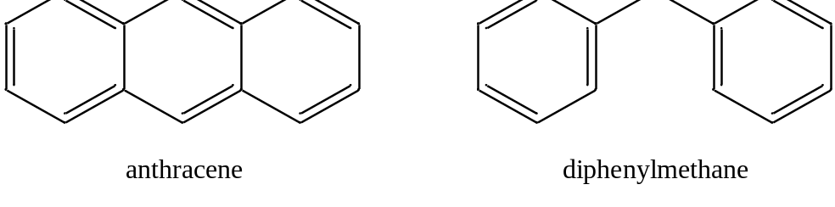

Answering this question involves a consideration of the effect that collisions of the molecules will have in causing radiationless decay. Note that anthracene is quite a rigid molecule. Diphenylmethane is rather floppy because of the methylene bridge between the two phenyl rings. Hopefully it is reasonable to see that collisions of the floppy diphenylmethane are more likely to lead to radiationless decay than collisions of the rigid anthracene molecules. Another way to think of this is the consequences of a crash between a Greyhound bus (i.e., anthracene) and a car towing a boat (i.e., diphenylmethane). It might be reasonable to believe that under most circumstances, the car would suffer more damage in the collision.

Molecules that are suitable for analysis by fluorescence spectroscopy are therefore rigid species, often with conjugated π systems, that undergo less collisional deactivation. As such, fluorescence spectroscopy is a much more selective method than UV/VIS absorption spectroscopy. In many cases, a suitable fluorescent chromophore is first attached to the compound under study. For example, a fluorescent derivatization agent is commonly used to analyze amino acids that have been separated by high performance liquid chromatography. The advantage of performing such a derivatization step is because of the high sensitivity of fluorescence spectroscopy. Because of the high sensitivity of fluorescence spectroscopy, it makes it all the more important to control the variables described above as they will then have a more pronounced effect with the potential to cause errors in the measurement.

3.7. Other Luminescent Methods

Two other important forms of luminescence are chemiluminescence and bioluminescence. Chemiluminescence refers to a process in which a chemical reaction forms a product molecule that is in an excited state. The excited state product then emits radiation. The classic example of a chemiluminescent process involves the reaction of luminol with hydrogen peroxide (H₂O₂) in the presence of a catalyst as shown below. The reaction generates 3-aminophthalate in an excited state and it emits a bluish light. The luminal reaction is used in forensics to detect the presence of blood. In this case, the iron from the hemoglobin serves as the catalyst.

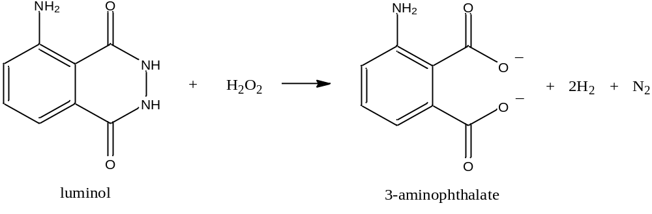

Another important example of a chemiluminescent reaction involves the reaction of nitric oxide (NO) with ozone (O₃) to produce excited state nitrogen dioxide (NO₂*) and oxygen gas. Nitric oxide is an important compound in atmospheric chemistry and, with the use of an ozone generator, it is possible to use the chemiluminescent reaction as a sensitive way of measuring NO.

NO = O₃ = NO₂* + O₂
NO₂* = NO₂ + hν

An important feature of both chemiluminescent reactions above is that peroxide and ozone, which are strong oxidants, have an unstable or energetic chemical bond. Chemiluminescence is a rare process only occurring in a limited number of chemical reactions.

Bioluminescence refers to a situation when living organisms use a chemiluminescent reaction to produce a luminescent emission. The classic example is fireflies. There are also a number of bioluminescent marine organisms.

Triboluminescence is a form of luminescence caused by friction. Breaking or crushing a wintergreen-flavored lifesaver in the dark produces triboluminescence. The friction of the crushing action excites sugar molecules that emit ultraviolet radiation, which is triboluminescence but cannot be seen by our eyes. However, the ultraviolet radiation emitted by the sugar is absorbed by fluorescent methyl salicylate molecules that account for the wintergreen flavor. The methyl salicylate molecules emit the light that can be seen by our eyes.

Finally, light sticks also rely on a fluorescent process. Bending the light stick breaks a vial that leads to the mixing of phenyl oxalate ester and hydrogen peroxide. Two subsequent decomposition reactions occur, the last of which releases energy that excites a fluorescent dye. Emission from the dye accounts for the glow from the light stick.

4. INFRARED SPECTROSCOPY

4.1. Introduction

Infrared radiation is the proper energy to excite vibrations in molecules. The IR spectrum consists of near (4,000-12,800 cm⁻¹), mid (200-4,000 cm⁻¹) and far (10-200 cm⁻¹) regions. The mid-IR region is most commonly used for analysis purposes. Vibrational excitations correspond to changes in the internuclear distances within molecules. You have likely recorded infrared spectra in your organic chemistry course. Thinking back to the instrument you used to record the spectrum, consider the following question.

Can infrared spectra be recorded in air? If so, what does this say about the major constituents of air?

Thinking back to the instrument you used in your organic chemistry course, you presumably realize that no attempt was made to remove air from the system. The beam of infrared radiation passed through the air, indicating that the major constituents of air (nitrogen gas, N₂, and oxygen as, O₂) either do not absorb infrared radiation or absorb in another region of the spectrum. You likely know that double and triple bonds have strong absorptions in the mid-IR region of the spectrum. N₂ and O₂ have triple and double bonds, respectively, so it turns out that N₂ and O₂ do not absorb infrared radiation. There are certainly minor constituents of the air (e.g. carbon dioxide) that do absorb infrared radiation, and these are accounted for by either using a dual beam configuration on a continuous wave infrared spectrophotometer or by recording a background spectrum on a fourier transform infrared spectrophotometer.

Why don’t the major constituents of air absorb infrared radiation? It might be worth noting that a molecule such as hydrogen chloride (HCl) does absorb infrared light.

In order for a vibration to absorb infrared radiation and become excited, the molecule must change its dipole moment during the vibration. Homonuclear diatomic molecules such as N₂ and O₂ do not have dipole moments. If the molecule undergoes a stretching motion as shown in Figure 4.1, where the spheres represent the two nuclei, there is no change in the dipole moment during the vibrational motion, therefore N₂ and O₂ do not absorb infrared radiation.

Figure 4.1. Representation of the stretching vibration of a homonuclear diatomic molecule.
HCl does have a dipole moment. Stretching the HCl bond leads to a change in the dipole moment. If we stretched the bond so far as to break the bond and produce the two original neutral atoms, there would be no dipole moment. Therefore, as we lengthen the bond in HCl, the dipole moment gets smaller. Because the dipole moment of HCl changes during a stretching vibration, it absorbs infrared radiation.

Describe the vibrations of carbon dioxide (CO₂) and determine which ones absorb infrared radiation.

The number of possible vibrations for a molecule is determined by the degrees of freedom of the molecule. The degrees of freedom for most molecules are (3N – 6) where N is the number of atoms. The degrees of freedom for a linear molecule are (3N – 5). Carbon dioxide is a linear molecule so it has four degrees of freedom and four possible vibrations.

One vibration is the symmetrical stretch (Figure 4.2). Each bond dipole, which is represented by the arrows, does change on stretching, but the overall molecular dipole is zero throughout. Since there is no net change in the molecular dipole, this vibration is not IR active.

Figure 4.2. Representation of the IR inactive symmetric stretch of carbon dioxide. The arrows represent bond dipoles.

A second vibration is the asymmetrical stretch (Figure 4.3). Each bond dipole does change on stretching and the molecule now has a net dipole. Since the molecular dipole changes during an asymmetrical stretch, this vibration is IR active.

Figure 4.3. Representation of the IR active asymmetric stretch of carbon dioxide. Arrows represent bond dipoles.

The third vibration is the bending vibration (Figure 4.4). There are two bending vibrations that occur in two different planes. Both are identical so both have the same energy and are degenerate. The bending motion does lead to a net molecular dipole. Since the molecular dipole changes during the bending motion, these vibrations are IR active.

Figure 4.4. Representation of the IR active bending vibration of carbon dioxide. Arrows represent bond dipoles.

An atomic stretching vibration can be represented by a potential energy diagram as shown in Figure 4.5 (also referred to as a potential energy well). The x-axis is the internuclear distance. Note that different vibrational energy levels, which are shown on the diagram as a series of parallel lines, are superimposed onto the potential well. Also note that, if the bond gets to too high a vibrational state, it can be ruptured.

Figure 4.5. Potential energy well for a covalent bond. Parellel lines in the well represent vibrational energy levels.

IR spectra are recorded in reciprocal wavenumbers (cm⁻¹) and there are certain parts of the mid-IR spectrum that correspond to specific vibrational modes of organic compounds.

2700-3700 cm⁻¹: Hydrogen stretching
1950-2700 cm⁻¹: Triple bond stretching
1550-1950 cm⁻¹: Double bond stretching
700 -1500 cm⁻¹: Fingerprint region

An important consideration is that as molecules get complex, the various vibrational modes get coupled together and the infrared (IR) absorption spectrum becomes quite complex and difficult to accurately determine. Therefore, while each compound has a unique IR spectrum (suggesting that IR spectroscopy ought to be especially useful for the qualitative analysis – compound identification – of compounds), interpreting IR spectra is not an easy process. When using IR spectra for compound identification, usually a computer is used to compare the spectrum of the unknown compound to a library of spectra of known compounds to find the best match.

IR spectroscopy can also be used for quantitative analysis. One limitation to the use of IR spectroscopy for quantitative analysis is that IR sources have weak power that enhances the noise relative to signal and reduces the sensitivity of the method relative to UV/Visible absorption spectroscopy. Also, IR detectors are much less sensitive than those for the UV/VIS region of the spectrum. IR bands are narrower than observed in UV/VIS spectra so instrumental deviations to Beer’s Law (e.g., polychromatic radiation) are of more concern. Fourier transform methods are often used to enhance the sensitivity of infrared methods, and there are some specialized IR techniques that are used as well.

4.2. Specialized Infrared Methods

One technique is called non-dispersive infrared (NDIR) spectroscopy. NDIR is usually used to measure a single constituent of an air sample. Think what the name implies and consider how such an instrument might be designed.

The word non-dispersive implies that the instrument does not use a monochromator. The design of a NDIR is illustrated in Figure 4.6. Common things that are often measured using NDIR are the amounts of carbon monoxide and hydrocarbons in automobile exhaust.

Figure 4.6. Diagram of the components of a non-dispersive infrared spectrophotometer.

The device either splits the beam or uses two identical sources, one of which goes through a reference cell and the other of which goes through the sample cell. The sample of air (e.g., auto exhaust) is continually drawn through the sample cell during the measurement. The reference cell is filled with a non-absorbing gas. The detector cell is filled with the analyte (i.e., carbon monoxide, which has an IR absorption band in the region from 2050-2250 cm⁻¹). If the system is designed to measure carbon monoxide, the reference cell does not absorb any radiation from 2050-2250 cm⁻¹. The sample cell absorbs an amount of radiation from 2050-2250 cm⁻¹ proportional to the concentration of carbon monoxide in the sample. The two detector cells, which are filled with carbon monoxide, absorb all of the radiation from 2050-2250 cm⁻¹ that reaches them. The infrared energy absorbed by the detector cells is converted to heat, meaning that the molecules in the cell move faster and exert a greater pressure. Because the reference cell did not absorb any of the radiation from 2050-2250 cm⁻¹, the detector cell on the reference side will have a higher temperature and pressure than the detector cell on the side with the sample. A flexible metal diaphragm is placed between the two cells and forms part of an electronic device known as a capacitor. Note that the capacitor has a gap between the two metal plates, and the measured capacitance varies according to the distance between the two plates. Therefore, the capacitance is a measure of the pressure difference of the two cells, which can be related back to the amount of carbon monoxide in the sample cell. The device is calibrated using a sealed sample cell with a known amount of carbon monoxide. When measuring hydrocarbons, methane (CH₄) is used for the calibration since it is a compound that has a C-H stretch of similar energy to the C-H stretching modes of other hydrocarbons. Another common application of NDIR would be as a monitoring device for lethal levels of carbon monoxide in a coal mine.
Another specialty application is known as attenuated total reflectance spectroscopy (ATR). ATR involves the use of an IR transparent crystal in which the sample is either coated or flows over both sides of the crystal. A representation of the ATR device is shown in Figure 4.7.

Figure 4.7. Representation of a device for measuring attenuated total reflectance spectra.

The radiation enters the crystal in such a way that it undergoes a complete internal reflection inside the crystal. The path is such that many reflections occur as the radiation passes through the crystal. At each reflection, the radiation slightly penetrates the coated material and a slight absorption occurs. The reason for multiple reflections is to increase the path length of the radiation through the sample. The method can be used to analyze opaque materials that do not transmit infrared radiation.

An inconvenience when recording IR spectra is that glass cells cannot be used since glass absorbs IR radiation. Liquid samples are often run neat between two salt plates. Since solvents absorb IR radiation, IR cells usually have rather narrow path lengths to keep solvent absorption to acceptable levels. Solid samples are often mixed with KBr and pressed into an IR transparent pellet.

Another way to record an IR spectrum of a solid sample is to perform a diffuse reflectance measurement. The beam strikes the surface of a fine powder and as in ATR some of the radiation is absorbed. Suitable signal-to-noise for diffuse reflectance IR usually requires the use of Fourier transform IR methods.

4.3 Fourier-transform Infrared Spectroscopy (FT-IR)

Up until this point, when recording a spectrum, we have described methods in which a monochromator is used to systematically scan through the different wavelengths or frequencies while recording either the absorbance or emission intensity. Spectra recorded in such a mode are said to be in the frequency domain. Fourier transform methods are designed in such a way that they record the spectra in the time domain. The plot in Figure 4.8 represents a particular wavelength or frequency of radiation in its time domain. What we observe in the time domain is the oscillation of the amplitude of the wave as a function of time.

Figure 4.8. Representation of a wave or frequency of radiation in the time domain.

The waveform drawn above has a certain amplitude as well as a single, specific frequency. If a species in a sample could absorb this particular frequency of radiation, we would observe that the amplitude of this wave diminishes. We could then convert this to a frequency domain spectrum, which would consist of a single line as shown in Figure 4.9.

Figure 4.9. Frequency domain spectrum.

The frequency domain spectrum would have a single line at the same frequency as before, but its amplitude would be reduced.

Suppose we have a frequency domain spectrum that consisted of two single lines, each with a different frequency. The time domain spectrum of this would now consist of two waves, one for each of the frequencies. The net time domain spectrum would be the addition of those two waves. If there were many frequencies, then the time domain wave form would be a complex pattern. A Fourier transform (FT) is a mathematical procedure that can be used to determine the individual frequency components and their amplitudes that are used to construct a composite wave. The Fourier transform allows you to convert a time domain spectrum to a frequency domain spectrum.

Note that time domain spectra are difficult to interpret for either qualitative or quantitative analysis. Frequency domain spectra are more readily interpreted and used for qualitative and quantitative analysis. Yet there are certain advantages to recording a spectrum in the time domain using FT methods. The two most common spectroscopic techniques that are done in an FT mode are IR and NMR spectroscopy. These are two methods that are not the most sensitive among the various spectroscopic techniques that are available, and one advantage of FT methods is that they can be used to improve the signal-to-noise ratio.

Recording an FT-IR spectrum requires a process in which the radiation from the source is somehow converted to the time domain. The most common way of achieving this with IR radiation is to use a device known as a Michelson interferometer. A diagram of a Michelson interferometer is shown in Figure 4.10.

Figure 4.10. Diagram of a Michelson interferometer.

In the Michelson interferometer, radiation from the source is collimated and sent to the beam splitter. At the splitter, half of the radiation is reflected and goes to the fixed mirror. The other half is transmitted through and goes to the moveable mirror. The two beams of radiation reflect off of the two mirrors and meet back up at the beam splitter. Half of the light from the fixed mirror and half of the light from the moveable mirror recombines and goes to the sample. When the moveable mirror is at position 0, it is exactly the same distance from the beam splitter as the fixed mirror. Knowing an exact location of the 0-position is essential to the proper functioning of a Michelson interferometer. The critical factor is to consider what happens to particular wavelengths of light at the moveable mirror is moved to different positions.

Plot the intensity of radiation at the sample versus the position of the moveable mirror for monochromatic radiation of wavelength x, 2x or 4x.

An important thing to recognize in drawing these plots is that, if the mirror is at –½x, the radiation that goes to the moveable mirror travels an extra distance x compared to the radiation that goes to the fixed mirror (It travels an extra ½x to get to the moveable mirror and an extra ½x to get back to the zero position). If the two beams of radiation recombine at the beam splitter in phase with each other, they will constructively interfere. If the two beams of radiation recombine at the beam splitter out of phase with each other, they will destructively interfere. Using this information, we can then determine what mirror positions will lead to constructive and destructive interference for radiation of wavelengths x, 2x and 4x. The plots that are obtained for wavelength x, 2x and 4x are shown in Figure 4.11.

Figure 4.11. Intensity of radiation of λ = x, 2x and 4x at the sample as a function of the position of the moveable mirror in a Michelson interferometer.

There are two important consequences from the plots in Figure 4.11. The first is that for each of these wavelengths, the intensity of the radiation at the sample oscillates from full amplitude to zero amplitude as the mirror is moved. In a Michelson interferometer, the moveable mirror is moved at a fixed speed from one extreme (e.g., +x extreme) to the other (e.g., –x extreme). After the relatively slow movement in one direction, the moveable mirror is then rapidly reset to the original position (in the example we are using, it is reset back to the +x extreme), and then moved again to record a second spectrum that is added to the first. Because the mirror moves at a set, fixed rate, the intensity of any one of these three wavelengths varies as a function of time. Each wavelength now has a time domain property associated with it.

The second important consequence is that the time domain property of radiation with wavelengths x, 2x and 4x is different. An examination of the plots in Figure 4.11 shows that the pattern of when the radiation is at full and zero amplitude is different for the radiation with wavelength x, 2x or 4x. The aggregate plot of all of these wavelengths added together is called an interferogram. If a sample could absorb infrared radiation of wavelength x, the intensity of light at this wavelength would drop after the sample and it would be reflected in the interferogram.

The usual process of recording an FT-IR spectrum is to record a background interferogram with no sample in the cell. The interferogram with a sample in the cell is then recorded and subtracted from the background interferogram. The difference is an interferogram reflecting the radiation absorbed from the sample. This time domain infrared spectrum can then be converted to a frequency domain infrared spectrum using the Fourier transform.

It is usually common to record several interferograms involving repetitive scans of the moveable mirror and then adding them together. An advantage of using multiple scans is that the signal of each scan is additive. Noise is a random process so adding together several scans leads to a reduction due to cancelling out of some of the noise. Therefore, adding together multiple scans will lead to an improvement in the signal-to-noise ratio. The improvement in the signal-to-noise ratio actually goes up as the square root of the number of scans. This means that recording twice as many scans, which takes twice as long, does not double the signal-to-noise ratio. As such, there are diminishing returns to running excessively large numbers of scans if the sample has an especially weak signal (e.g., due to a low concentration) because the time for the experiment can become excessive.

Two important characteristics of an FT-IR spectrophotometer are to have an accurate location of the zero position and a highly reproducible movement of the mirror. Identifying the exact location of the zero position and controlling the mirror movement is usually accomplished in FT-IR spectrophotometers using a laser system. With regards to mirror movement, since the position is equated with time, it is essential that the mirror move with exactly the same speed over the entire scan, and that the speed remain identical for each scan. More expensive FT-IR spectrophotometers have better control of the mirror movement.

What are the advantages of FT-IR spectrophotometers over conventional IR spectrophotometers that use a monochromator?

We have already mentioned one, which is the ease of recording multiple spectra and adding them together. Whereas a conventional scanning spectrophotometer that uses a monochromator takes several minutes to scan through the wavelengths, the mirror movement in an FT-IR occurs over a few seconds.

Another advantage is that an FT-IR has no slits and therefore has a high throughput of radiation. Essentially all of the photons from the source are used in the measurement and there are no losses of power because of the monochromator. Since IR sources have weaker power than UV and visible sources, this is an important advantage of FT-IR instruments. This is especially so in the far IR region where the source power drops off considerably.

The ability to add together multiple scans combined with the higher throughput of radiation leads to a significant sensitivity advantage of FT-IR over conventional IR spectrophotometers that use a monochromator. As such, FT-IR instruments can be used with much lower concentrations of substances.

An FT-IR will also have much better resolution than a conventional scanning IR, especially if there is reproducible movement of the mirror. Resolution is the ability to distinguish two nearby peaks in the spectrum. The more reproducible the mirror movement, the better the resolution. Distinguishing nearby frequencies is more readily accomplished by a Fourier transform of a composite time domain wave than it is using a monochromator comprised of a grating and slits.

5. RAMAN SPECTROSCOPY

Raman spectroscopy is an alternative way to get information about the infrared transitions within a molecule. In order for a vibrational transition to be Raman active, the molecule must undergo a change in polarizability during the vibration. Polarizability refers to the ease of distorting electrons from their original position. The polarizability of a molecule decreases with increasing electron density, increasing bond strength, and decreasing bond length.

Consider the molecular vibrations of carbon dioxide and determine whether or not they are Raman active.

The symmetric stretch of carbon dioxide is not IR active because there is no change in the net molecular dipole (Figure 5.1). Since both bonds are stretched (i.e., lengthened), both bonds are more easily polarizable. The overall molecular polarizability changes and the symmetric stretch is Raman active.

Figure 5.1. Representation of the Raman active symmetric stretch of carbon dioxide.

The asymmetric stretch of carbon dioxide is IR active because there is a change in the net molecular dipole (Figure 5.2). In the asymmetric stretch, one bond is stretched and is now more polarizable while the other bond is compressed and is less polarizable. The change in polarizability of the longer bond is exactly offset by the change in the shorter bond such that the overall polarizability of the molecule does not change. Therefore, the asymmetric stretch is not Raman active.

Figure 5.2. Representation of the Raman inactive asymmetric stretch of carbon dioxide.

The bending motion of carbon dioxide is IR active because there is a change in the net molecular dipole (Figure 5.3). Since the bending motion involves no changes in bond length, there is no change in the polarizability of the molecule. Therefore, the bending motion is not Raman active.

Figure 5.3. Representation of the Raman inactive bending vibration of carbon dioxide.

Note that the IR active vibrations of carbon dioxide (asymmetric stretch, bend) are Raman inactive and the IR inactive vibration (symmetric stretch) is Raman active. This does not occur with all molecules, but often times, the IR and Raman spectra provide complementary information about many of the vibrations of molecular species. Raman spectra are usually less complex than IR spectra.

An intriguing aspect of Raman spectroscopy is that information about the vibrational transitions is obtained using visible radiation. The process involves shining monochromatic visible radiation on the sample. The visible radiation interacts with the molecule and creates something that is known as a virtual state. From this virtual state it is possible to have a modulated scatter known as Raman scatter. Raman scatter occurs when there is a momentary distortion of the electrons in a bond of a molecule. The momentary distortion means that the molecule has an induced dipole and is temporarily polarized. As the bond returns to its normal state, the radiation is reemitted as Raman scatter.

One form of the modulated scatter produces Stokes lines. The other produces anti-Stokes lines. Stokes lines are scattered photons that are reduced in energy relative to the incident photons that interacted with the molecule. The reductions in energy of the scatter photons are proportional to the energies of the vibrational levels of the molecule. Anti-Stokes lines are scattered photons that are increased in energy relative to the incident photons that interacted with the molecule. The increases in energy of the scatter photons are proportional to the energies of the vibrational levels of the molecule.

The energy level diagram in Figure 5.4 shows representations for IR absorption, Rayleigh scatter, Stokes Raman scatter and anti-Stokes Raman scatter. For Stokes lines, the incident photons interact with a ground state molecule and form a virtual state. The scattered photons come from molecules that end up in excited vibrational states of the ground state, thereby explaining why they are lower in energy than the incident photons. For anti-Stokes lines, the incident photons interact with a molecule that is vibrationally excited. The virtual state produced by this interaction has more energy than the virtual state produced when the incident photon interacted with a ground state molecule. The scattered photons come from molecules that end up in the ground state, thereby explaining why they are higher in energy than the incident photons.

Figure 5.4. Energy level diagram showing the origin or infrared absorption, Rayleigh scatter, Stokes Raman scatter, and anti-Stokes Raman scatter.

It is important to recognize that, while the processes in Figure 5.4 responsible for Raman scatter might look similar to the process of fluorescence, the process in Raman spectroscopy involves a modulated scatter that is different from fluorescence. How do we know this? One reason is that Raman scatter occurs when the incident radiation has energy well away from any absorption band of the molecule. Therefore, the molecule is not excited to some higher electronic state but instead exists in a virtual state that corresponds to a high energy vibrational state of the ground state. Another is that Raman scatter has a lifetime of 10⁻¹⁴ second, which is much faster than fluorescent emission.

Which set of lines, Stokes or anti-Stokes, is weaker?

The anti-Stokes lines will be much weaker than the Stokes lines because there are many more molecules in the ground state than in excited vibrational states.

What effect would raising the temperature have on the intensity of Stokes and anti-Stokes lines?

Raising the temperature would decrease the population of the ground state and increase the population of higher energy vibrational states. Therefore, with increased temperature, the intensity of the Stokes lines would decrease and the intensity of the anti-Stokes lines would increase. However, the Stokes lines would still have higher intensity than the anti-Stokes lines.

Because scatter occurs in all directions, the scattered photons are measured at 90º to the incident radiation. Also, Raman scatter is generally a rather unfavorable process resulting in a weak signal.

What would be the ideal source to use for measuring Raman spectra?

The more incident photons sent in to the sample, the more chance there is to produce molecules in the proper virtual state to produce Raman scattering. Since the signal is measured over no background, this suggests that we want a high power source. That means that a laser would be preferable as a source for measuring Raman spectra. The highly monochromatic emission from a laser also means that we can more accurately measure the frequency of the Stokes lines in the resulting spectrum. Also an array detector is preferable as it enables the simultaneous measurement of all of the scattered radiation.

The molecule carbon tetrachloride (CCl₄) has three Raman-active absorptions that occur at 218, 314 and 459 cm⁻¹ away from the laser line. Draw a representation of the Raman spectrum of CCl₄ that includes both the Stokes and anti-Stokes lines.

The spectrum in Figure 5.5 shows a representation of the complete Raman spectrum for carbon tetrachloride and includes the Stokes and anti-Stokes lines. The laser line undergoes an elastic scattering known as Rayleigh scatter and a complete spectrum has a peak at the laser line that is far more intense than the Raman scatter. Note that the anti-Stokes lines are lower in intensity and higher in energy than the Stokes lines. Note as well that the two spectra appear as mirror images of each other with regards to the placement of the bands at 218, 314 and 459 cm⁻¹ away from the Rayleigh scatter peak.

Figure 5.5. Complete Raman spectrum of carbon tetrachloride (CCl₄).

The energy level diagram in Figure 5.6 shows the origin of all of the lines and inspection of it should rationalize why the placement of the Stokes and anti-Stokes lines are mirror images of each other. The relative intensity of the three Stokes lines depends on the probability of each scatter process and is something we could not readily predict ahead of time.

Figure 5.6. Energy level diagram showing the origin of Stokes and anti-Stokes lines in the Raman spectrum of carbon tetrachloride (CCl₄).
Why do the anti-Stokes lines of carbon tetrachloride have the following order of intensity: 219 > 314 > 459 cm⁻¹?

The intensity of the three anti-Stokes lines drops going from the 218 to 314 to 459 cm⁻¹ band. Anti-Stokes scatter requires an interaction of the incident photon with vibrationally excited molecules. Heat in the system causes some molecules to be vibrationally excited. The drop in intensity is predictable because, as the vibrational levels increase in energy, they would have lower populations and therefore fewer molecules to produce Raman scatter at that transition.

Raman spectroscopy is an important tool used in the characterization of many compounds. As we have already seen, because the selection rules for Raman (change in polarizability) are different than infrared (change in the dipole moment) spectroscopy, there are some vibrations that are active in one technique but not the other. Water is a weak Raman scatterer and, unlike infrared spectroscopy, where water has strong absorptions, water can be used as a solvent. Glass cells can be used with the visible laser radiation, which is more convenient that the salt plates that need to be used in infrared spectroscopy. Because Raman spectroscopy involves the measurement of vibrational energy states with visible light, it is especially useful for measurements of vibrational processes that occur in the far IR portion of the spectrum. Finally, since Raman spectroscopy involves a scattering process, it can be used for remote monitoring such as atmospheric monitoring. A pulsed laser can be passed through the atmosphere or effluent from a smoke stack and Raman scattered radiation measured by remote detectors.

One disadvantage of Raman spectroscopy is that Raman scatter is an unfavorable process and the signals are weak compared to many other spectroscopic methods. There are two strategies that have been found to significantly increase the probability of Raman scatter and lower the detection limits.

One is a technique known as surface-enhanced Raman spectroscopy (SERS). It is observed that compounds on surfaces consisting of roughened silver, gold or copper have much higher probability of producing Raman scatter.

The other involves the use of resonance Raman spectroscopy. If the molecule is excited using a laser line close to an electronic absorption band, large enhancements in the Raman bands of symmetrical vibrations occur. As noted earlier, the lifetime of 10⁻¹⁴ second of Raman scatter indicates that the increased signal is not from a fluorescent transition.

6. ATOMIC SPECTROSCOPY

6.1. Introduction

It is likely that most people studying chemistry have seen a demonstration where a solution of a metal salt was sprayed into a Bunsen burner and gave off a color that depended on the particular metal in the salt. Metal salts are used to create the different colors observed in firework displays. Analysis of the emission from the flame using a device called a spectroscope would further show the characteristic line emission spectrum of the metal species. The atomic emission observed in the flame involves a process whereby the metal ions in the salt are converted into neutral, excited atoms. These atoms then emit electromagnetic radiation corresponding to valence electron transitions.

Earlier we discussed the difference between atomic spectra, which only consist of electronic transitions and therefore appear as sharp lines, and molecular spectra, which because of the presence of lower energy vibrational and rotational energy states appear as a broad continuum. Provided we have atoms present in a sample, it is possible to analyze them spectroscopically using either absorption or emission measurements. One problem is that most samples we analyze do not consist of atoms but instead consist of molecules with covalent or ionic bonds. Therefore, performing atomic spectroscopy on most samples involves the utilization of an atomization source, which is a device that has the ability to convert molecules to atoms.

It is also important to recognize that the absorption or emission spectrum of a neutral atom will be different than that of its ions (e.g., Cr⁰, Cr³⁺, Cr⁶⁺ all have different lines in their absorption or emission spectra). Atomic absorbance measurements are performed on neutral, ground-state atoms. Atomic emission measurements can be performed on either neutral atoms or ions, but are usually performed on neutral atoms as well. It is important to recognize that certain metal species exist in nature in various ionic forms. For example, chromium is commonly found as its +3 or +6 ion. Furthermore, Cr³⁺ is relatively benign, whereas Cr⁶⁺ is a carcinogen. In this case, an analysis of the particular chromium species might be especially important to determine the degree of hazard of a sample containing chromium. The methods we will describe herein cannot be used to distinguish the different metal species in samples. They will provide a measurement of the total metal concentration. Metal speciation would require a pre-treatment step involving the use of suitable chemical reagents that selectively separate one species from the other without altering their distribution. Metal speciation is usually a complex analysis process and it is far more common to analyze total metal concentrations. Many environmental regulations that restrict the amounts of metals in samples (e.g., standards for drinking water, food products and sludge from wastewater treatment plants) specify total metal concentrations instead of concentrations of specific species.

The measurement of atomic absorption or emission requires selection of a suitable wavelength. Just like the selection of the best wavelength in molecular spectroscopic measurements, provided there are no interfering substances, the optimal wavelength in atomic spectroscopic measurements is the wavelength of maximum absorbance or emission intensity.
6.2. Atomization Sources

There are a variety of strategies that can be used to create atoms from molecular substances. The three main methods involve the use of a flame, a device known as a graphite furnace or a plasma. These three atomization methods are commonly used with liquid samples. While there are various plasma devices that have been developed, only the most common one – the inductively coupled plasma – will be discussed herein. Some specialized techniques that have been designed for especially important elements (e.g., mercury, arsenic) will be described as well. Since many samples do not come in liquid form (e.g., soils, sludges, foods, plant matter), liquid samples suitable for introduction into flames, furnace or plasma instruments are often obtained by digestion of the sample. Digestion usually involves heating the sample in concentrated acids to solubilize the metal species. Digestion can be done in an appropriate vessel on a hotplate or using a microwave oven. Microwave digesters are specialized instruments designed to measure the temperature and pressure in sealed chambers so that the digestion is completed under optimal conditions. In some cases it is desirable to measure a sample its solid form. There are arc or spark sources that can be used for the analysis of solid samples.

6.2.1. Flames

As alluded to earlier, flames can be used as an atomization source for liquid samples. The sample is introduced into the flame as an aerosol mist. The process of creating the aerosol is referred to as nebulization. Common nebulizer designs include pneumatic and ultrasonic devices, the details of which we will not go into here. The most common flame atomization device, which is illustrated in Figure 6.1, is known as a laminar flow or pre-mix burner. Note the unusual design of the burner head, which instead of having the shape of a common Bunsen burner, has a long, thin flame that is 10 cm long. Radiation from the course passxes through the 10 cm distance of the flame. Often the monochromator is placed after the flame and before the detector. If atomic emission is being measured, there is no light source. The burner design provides a much longer path length to increase the sensitivity of the method.

Figure 6.1. Illustration of a laminar flow or pre-mix burner.
A flame requires a fuel and oxidant. In the laminar flow burner, the fuel and oxidant are pre-mixed at the bottom of a chamber. The force created by the flowing gases draws sample up through a thin piece of tubing where it is nebulized into the bottom of the chamber. The chamber has a series of baffles in it that creates an obstructed pathway up to the burner head. The purpose of the baffles is to allow only the finest aerosol particles to reach the flame. Larger particles strike the baffles, collect and empty out by the drain tube. Even using the best nebulizers that have been developed, only about 2% of the sample actually makes it through the baffles and to the flame. The remaining 98% empties out the drain.

At first it might seem counterintuitive to discard 98% of the sample and instead seem preferable to introduce the entire sample into the flame, but we must consider what happens to an aerosol droplet after it is created and as it enters the flame. Remembering that the solution has molecules but we need atoms, there are several steps required to complete this transformation. The first involves evaporating the solvent (Eq 1). Many metal complexes form hydrates and the next step involves dehydration (Eq. 2). The metal complexes must be volatilized (Eq 3) and then decomposed (Eq. 4). Finally, the metal ions must be reduced to neutral atoms (Eq. 5). Only now are we able to measure the absorbance by the metal atoms. If the measurement involves atomic emission, then a sixth step (Eq. 6) involves the excitation of the atoms.

ML(aq) = ML.xH₂O (s) (1)
ML.xH₂O (s) = ML(s) (2)
ML(s) = ML(g) (3)
ML(g) = M⁺ + L⁻ (4)
M⁺ + e- = M (5)
M + heat = M* (6)

The problem with large aerosol droplets is that they will not make it through all of the necessary steps during their lifetime in the flame. These drops will contribute little to the signal, but their presence in the flame will create noise and instability in the flame that will compromise the measurement. Hence, only the finest aerosol droplets will lead to atomic species and only those are introduced into the flame.

The various steps outlined in Equations 1-6 also imply that there will be a distinct profile to the flame. Profiles result because of the efficiency with which neutral and excited atoms are formed in a flame. Therefore, a specific section of the flame will have the highest concentration of ground state atoms for the metal being analyzed. The absorbance profile that shows the concentration of ground state atoms in the flame is likely to be different than the emission profile that shows the concentration of excited state atoms in the flame.

Figure 6.2 shows representative absorption profiles for chromium, magnesium and silver. Magnesium shows a peak in its profile. The increase in the lower part of the flame occurs because exposure to the heat creates more neutral ground state atoms. The decrease in the upper part of the flame occurs due to the formation of magnesium oxide species that do not absorb the atomic line. Silver is not as easily oxidized and its concentration continually increases the longer the sample is exposed to the heat of the flame. Chromium forms very stable oxides and the concentration of ground state atoms decreases the longer it is exposed to the heat of the flame.

Figure 6.2. Representation of the flame profiles for chromium, magnesium and silver.

When performing atomic absorbance or emission measurements using a flame atomization source, it is important to measure the section of the flame with the highest concentration. There are controls in the instrument to raise and lower the burner head to insure that the light beam passes through the optimal part of the flame.

An important factor in the characteristics of a flame is the identity of the fuel and oxidant. Standard Bunsen burner flames use methane as the fuel and air as the oxidant and have a temperature in the range of 1,700-1,900ºC. A flame with acetylene as the fuel and air as the oxidant has a temperature in the range of 2,100-2,400ºC. For most elements, the methane/air flame is too cool to provide suitable atomization efficiencies for atomic absorbance or emission measurements, and an acetylene/air flame must be used. For some elements, the use of a flame with acetylene as the fuel and nitrous oxide (N₂O) as the oxidant is recommended. The acetylene/nitrous oxide flame has a temperature range of about 2,600-2,800ºC. There are standard reference books on atomic methods that specify the type of flame that is best suited for the analysis of particular elements.

It is also important to recognize that some elements do not atomize well in flames. Flame and other atomization methods are most suitable for the measurement of metals. Non-metallic elements rarely atomize with enough efficiency to permit analysis of trace levels. Metalloids such as arsenic and selenium have intermediate atomization efficiencies and may require specialized atomization methods for certain samples with trace levels of the elements. Mercury is another atom that does not atomize well and often requires the use of a specialized atomization procedure. Flame methods are usually used for atomic absorbance measurements because most elements do not produce high enough concentrations of excited atoms to facilitate sensitive detection based on atomic emission. Alkali metals can be measured in a flame by atomic emission. Alkaline earth metals can possibly be measured by flame emission as well provided the concentration is high enough.

6.2.2. Electrothermal Atomization – Graphite Furnace

The graphite furnace, which is pictured in Figure 6.3, is a small, hollow graphite tube about 2 Inches long by ¼ inch in diameter with a hole in the top. Graphite furnaces are used for atomic absorbance measurements. Radiation from the source shines through the tube to the detector. A small volume of sample (typically 0.5 to 10 ul) is introduced through the hole into the tube either through the use of a micropipette or a spray system. The entire furnace system is maintained under an argon atmosphere.

Figure 6.3. Illustration of a graphic furnace atomization device.

After introduction of the sample into the furnace, a three step heating process is followed. The first step (heating to about 100ºC) evaporates the solvent. The second (heating to about 800ºC) ashes the sample to a metal power or metal oxide. The third (heating to between 2,000-3,000ºC) atomizes the sample. The first two steps are on the order of seconds to a minute. The third step occurs over a few milliseconds to seconds. The atomization step essentially creates a “puff” of gas phase atoms in the furnace and the absorbance is measured during this time, yielding a signal similar to what is shown in Figure 6.4. This “puff” of atoms only occurs over a second or so before the sample is swept from the furnace. The area under the curve is integrated and related back to the concentration through the use of a standard curve.

Figure 6.4. Absorbance signal from a graphic furnace measurement.

What are the relative advantages and disadvantages of using a flame or furnace as an atomization source?

Sample size: One obvious difference is the amount of sample needed for the analysis. Use of the flame requires establishing a steady state system in which sample is introduced into the flame. A flame analysis usually requires about 3-5 ml of sample for the measurement. Triplicate measurements on a furnace require less than 50 ul of sample. In cases where only small amounts of sample are available, the furnace is the obvious choice.

Sensitivity: The furnace has a distinct advantage over the flame with regards to the sensitivity and limits of detection. One reason is that the entire sample is put into the furnace whereas only 2% of the sample makes it into the flame. Another is that the furnace integrates signal over the “puff” of atoms whereas the flame involves establishment of a steady state reading. A disadvantage of the flame is that atoms only spend a brief amount of time (about 10⁻⁴ seconds) in the optical path. Finally, for certain elements, the atomization efficiency (what percentage of the elements end up as ground state atoms suitable for absorption of energy) is higher for the furnace than the flame.

Reproducibility: The flame has a distinct advantage over the furnace in terms of reproducibility of measurements. Remember that more reproducible measurements mean that there is better precision. One concern is whether the amount of sample being introduced to the atomization source is reproducible. Even though we often use micropipettes and do not question their accuracy and reproducibility, they can get out of calibration and have some degree of irreproducibility from injection to injection. Introduction of the sample into the flame tends to be a more reproducible process.

Another concern with atomic methods is the presence of matrix effects. The matrix is everything else in the sample besides the species being analyzed. Atomic methods are highly susceptible to matrix effects. Matrix effects can enhance or diminish the response in atomic methods. For example, when using a flame, the response for the same concentration of a metal in a sample where water is the solvent may be different when compared to a sample with a large percentage of alcohol as the solvent (e.g., a hard liquor). One difference is that alcohol burns so it may alter the temperature of the flame. Another is that alcohol has a different surface tension than water so the nebulization efficiency and production of smaller aerosol particles may change. Another example of a matrix effect would be the presence of a ligand in the sample that leads to the formation of a non-volatile metal complex. This complex may not be as easy to vaporize and then atomize. While it is somewhat sample dependent, matrix effects are more variable with a furnace than the flame. An issue that comes up with the furnace that does not exist in the flame is the condition of the interior walls of the furnace. These walls “age” as repeated samples are taken through the evaporation/ash/atomize steps and the atomization efficiency changes as the walls age. The furnace may also exhibit memory effects from run to run because not all of the material may be completely removed from the furnace. Evaporation of the solvent in the furnace may lead to the formation of salt crystals that rupture with enough force to spew material out the openings in the furnace during the ashing step. This observation is why some manufacturers have developed spray systems that spread the sample in a thinner film over more of the interior surface than would occur if adding a drop from a micropipette. These various processes that can occur in the furnace often lead to less reproducibility and reduced precision (relative precision on the order of 5-10%) when compared to flame (relative precision of 1% or better) atomization.

6.2.3. Specialized Atomization Methods

There are a few elements where the atomization efficiencies with other sources are diminished to the point that trace analysis sometimes requires specialized procedures. The most common element where this is done is mercury. Mercury is important because of its high toxicity. The procedure is referred to as a cold vapor method. One design of a cold vapor system consists of a closed loop where there is a pump to circulate air flow, a reaction vessel, and a gas cell. The sample is placed in the reaction vessel and all of the mercury is first oxidized to the +2 state through the addition of strong acids. When the oxidation is complete, tin(II)chloride is added as a reducing agent to reduce the mercury to neutral mercury atoms. Mercury has sufficient vapor pressure at room temperature that enough atoms enter the gas phase and distribute throughout the system including the gas cell. A mercury hollow cathode lamp shines radiation through the gas cell and absorbance by atomic mercury is measured.

Two other toxic elements that are sometimes measured using specialized techniques are arsenic and selenium. In this process, sodium borohydride is added to generate arsine (AsH₃) and selenium hydride (SeH₂). These compounds are volatile and are introduced into the flame. The volatile nature of the complexes leads to a much higher atomization efficiency.

Commercial vendors sell special devices that have been developed for the cold vapor or hydride generation processes.

6.2.4. Inductively Coupled Plasma

A plasma is a gaseous mixture in which a significant proportion of the gas-phase species are ionized. An illustration of an inductively coupled plasma (ICP) is shown in Figure 6.5. The device consists of a quartz tube (about ¾ inch in diameter), the end of which is wrapped in a high power radiofrequency (RF) induction coil. Argon gas flows down the quartz tube at a high rate (about 15 liters/minute). A current of electricity is run through the RF coil, which produces a magnetic field inside the end of the quartz tube. Sparking the argon creates some Ar⁺ ions, which are now paramagnetic and absorb energy from the magnetic field. The argon ions absorb enough energy that a plasma is created in the area of the tube covered by the RF induction coil. The nature of the magnetic field causes the plasma to flow in a closed annular path (basically a donut shape). What is especially impressive is that enough energy is absorbed from the magnetic field to heat the plasma up to a temperature of about 6,000 K. As a comparison, this temperature is about the same as the temperature of the surface of the sun. The hot temperature means that new argon flowing into the plasma is ionized, which maintains the plasma. The plasma is kept from melting the walls of the quartz tube by an additional tangential flow of argon along the walls of the tube. Finally, the sample is nebulized and sprayed as an aerosol mist into the center of the plasma.

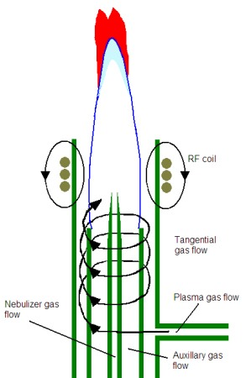

Figure 6.5. Illustration of an inductively coupled plasma. From: http://www.asdlib.org/learningModules/AtomicEmission/index.html
An ICP offers several advantages over flame and furnace atomization sources. One is that it is so hot that it leads to a more complete atomization and leads to the formation of many excited state atoms. Because sufficient numbers of atoms are excited, they can be detected by emission instead of absorbance. The illustration in Figure 6.5 shows the plume that forms in an ICP above the RF coil. Above the plasma is a zone in which argon regeneration occurs. A continuum background emission is given off in this zone. Above this zone in the plume, there are excited atoms that emit the characteristic lines of each particular element in the sample. In our discussion of fluorescence spectroscopy, we learned that emission methods have an inherent sensitivity advantage over absorbance methods. This occurs because emission entails measuring a small signal over no background and absorbance entails measuring a small difference between two large signals. This same sensitivity advantage exists for measurements of atomic emission over atomic absorbance. Light emitted by atoms in the plume can be measured either radially (off to the side of the plume) or axially (looking down into the plume. Axial measurements are often more sensitive because of the increase in path length. However, in some cases, depending on the element profile in the plasma, radial measurements may be preferable. Instruments today often allow for either axial or radial measurements.

A second advantage of an ICP is that all of the elements can be measured simultaneously. All metals in the sample will be atomized at the same time and all are emitting light. Some instruments measure elements in a sequential arrangement. In this case, the operator programs in the elements to be measured, and the monochromator moves one-by-one through the specific wavelengths necessary for the measurement of each element. Other instruments use an array detector with photoactive pixels that can measure all of the elements at once. Array instruments are preferable as the analysis will be faster and less sample is consumed. Figure 6.6 shows the printout of the pixels on a array detector that include and surround the lead emission that occurs at 220.353 nm. The peak due to the lead emission from the four different samples is apparent. Also note that there is a background emission on the neighboring pixels and the intensity of this background emission must be subtracted from the overall emission occurring at the lead wavelength.
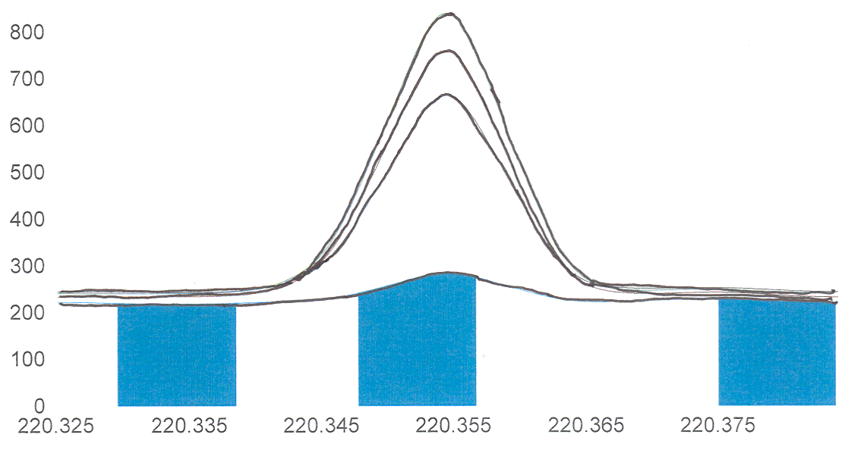
Figure 6.6. Array elements showing the lead-220.353 nm emission line.
An observation with emission spectroscopy to be aware of is the possibility of self-absorption. We already discussed this in the unit on fluorescence spectroscopy. Self-absorption refers to the situation in which an excited state atom emits a photon that is then absorbed by another atom in the ground state. If the photon was headed toward the detector, then it will not be detected. Self-absorption becomes more of a problem at higher concentrations as the emitted photons are more likely to encounter a ground state atom. The presence of self-absorption can lead to a diminishment of the response in a calibration curve at high concentrations as shown in Figure 6.7. Atomic emission transitions always correspond with absorption transitions for the element being analyzed so the likelihood of observing self-absorption is higher in atomic emission spectroscopy than in fluorescence spectroscopy. For a set of samples with unknown concentrations of analyte, it may be desirable to test one or two after dilution to insure that the concentration decreases by a proportional factor and that the samples are not so high in concentration to be out in the self-absorption portion of the standard curve.

Figure 6.7. Calibration curve for atomic emission showing self-absorption at higher concentration.

Another advantage is that the high number of Ar⁺ ions and free electrons suppress the ionization of other elements being measure, thereby increasing the number of neutral atoms whose emission is being measured. The argon used to generate the plasma is chemically inert compared to the chemical species that make up a flame, which increases the atomization efficiency. The inductively coupled plasma tends to be quite stable and reproducible. The combination of high temperature with chemically inert environmental reduces matrix effects in the plasma relative to other atomization sources, but it does not eliminate them and matrix effects must always be considered. Some elements (e.g., mercury, arsenic, phosphorus) that are impractical to analyze on a flame or furnace instrument without specialized atomization techniques can often be measured on an ICP.

A final advantage of the plasma is that there are now methods to introduce the atoms into a mass spectrometer (MS). The use of the mass spectrometer may further reduce certain matrix effects. Also, mass spectrometry usually provides more sensitive detection than emission spectroscopy.

6.2.5. Arcs and Sparks

Arc and spark devices can be used as atomization sources for solid samples. Figure 6.8 illustrates the setup for an arc device. A high voltage applied across a gap between two conducting electrodes causes an arc or spark to form. As the electrical arc or spark strikes the positively charged electrode, it can create a “puff” of gas phase atoms and emission from the atoms can be measured. The arc also creates a plasma between the two electrodes. Depending on the nature of the solid material to be measured, it can either be molded into an electrode or coated onto a carbon electrode.
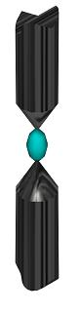
Figure 6.8. Illustration of an arc atomization source with a plasma (shown in blue). From: http://www.asdlib.org/learningModules/AtomicEmission/index.html

6.3. Instrument Design Features of Atomic Absorption Spectrophotometers

6.3.1. Source Design

While ICP devices do offer certain advantages over flame atomic absorption (AA) spectrophotometers, flame AAs are still widely used for measurement purposes. They are cheaper to purchase and operate than an ICP and, for someone only needing to measure a few specific elements on a regular basis, a flame AA may be the better choice. There are a variety of instrumental design features on AA spectrophotometers that are worth consideration.

One of these concerns the radiation source. Atomic absorption spectrophotometers require a separate source lamp, called a hollow cathode lamp, for each individual element that you wish to measure. An illustration of a hollow cathode lamp is shown in Figure 6.9. The hollow cathode is coated with the element you wish to measure. The interior is filled with a relatively low pressure (1 Torr) of an inert gas such as argon or helium. A voltage is applied across the anode and cathode. The filler gas (e.g., argon) is ionized to Ar⁺ at the anode. The Ar⁺ ions are drawn toward the cathode and when they strike the surface, sputter off some of the coated atoms into the gas phase. In the sputtering process, some of the atoms are excited and emit the characteristic lines of radiation of the atoms. Hollow cathode lamps cost about $200 a piece, so buying lamps for many elements can get a bit expensive.

Figure 6.9. Illustration of a hollow cathode lamp.

Why is the cathode designed with a hollow configuration?

There are two reasons for the hollow cathode design. One is that the configuration helps to focus the light beam allowing a higher intensity of photons to be directed toward the flame or furnace. The second is that it helps prolong the lifetime of the lamp. It is desirable to have sputtered atoms coat back onto the cathode, since it is only those atoms that can be excited by collisions with the Ar⁺ ions. Over time the number of atoms coated onto the cathode will diminish and the intensity of the lamp will decrease. The lamps also have an optimal current at which they should be operated. The higher the current, the more Ar⁺ ions strike the cathode. While a higher current will provide a higher intensity, it will also reduce lamp lifetime. (Note: There is another reason not to use high currents that we will explore later after developing some other important concepts about the instrument design). The lifetime of a hollow cathode lamp run at the recommended current is about 500 hours. The need to use a separate line source for each element raises the following question.

Why is it apparently not feasible to use a broadband continuum source with a monochromator when performing atomic absorption spectroscopy?

One thing you might consider is whether continuum lamps have enough power in the part of the electromagnetic spectrum absorbed by elements.

In what part of the electromagnetic spectrum do most atoms absorb (or emit) light?

Recollecting back to the emission of metal salts in flames, or the light given off in firework displays, it turns out that atoms emit, and hence absorb, electromagnetic radiation in the visible and ultraviolet portions of the spectrum.

Do powerful enough continuum sources exist in the ultraviolet and visible region of the spectrum?

Yes. We routinely use continuum sources to measure the ultraviolet/visible spectrum of molecules at low concentrations, so these sources certainly have enough power to measure corresponding concentrations of atomic species.

Another thing to consider is the width of an atomic line. What are two contributions to the broadening of atomic lines? (Hint: We went over both of these earlier in the course).

Earlier in the course we discussed collisional and Doppler broadening as two general contributions to line broadening in spectroscopic methods. When these contributions to line broadening are considered, the width of an atomic line is observed to be in the range of 0.002-0.005 nm.

Using information about the width of an atomic line, explain why a continuum source will not be suitable for measuring atomic absorption.

The information provided above indicates that atomic lines are extremely narrow. If we examine the effective bandwidth of a common continuum ultraviolet/visible source/monochromator system, it will be a wavelength packet on the order of 1 nm wide. Figure 6.10 superimposes the atomic absorption line onto the overall output from a continuum source. What should be apparent is that the reduction in power due to the atomic absorbance is only a small fraction of the overall radiation emitted by the continuum source. In fact, it is such a small portion that it is essentially non-detectable and lost in the noise of the system.

Figure 6.10. Atomic absorption line superimposed onto the overall output of a continuum source/monochromator system.

What is the problem with reducing the slit width of the monochromator to get a narrower line?

The problem with reducing the slit width is that it reduces the number of photons or source power reaching the sample. Reducing the slit width on a continuum source to a level that would provide a narrow enough line to respond to atomic absorption would reduce the power so that it would not be much above the noise. Therefore, hollow cathode lamps, which emit intense narrow lines of radiation specific to the element being analyzed, are needed for atomic absorption measurements.

With this understanding we can ask why the hollow cathode lamp has a low pressure of argon filler gas.

The pressure of the argon is low to minimize collisions of argon atoms with sputtered atoms. Collisions of excited state sputtered atoms with argon atoms will lead to broadening of the output of the hollow cathode lamp and potentially lead to the same problem described above with the use of a continuum source. A low pressure of argon in the lamp insures that the line width from the hollow cathode lamp is less than the line width of the absorbing species.

6.3.2. Interferences of Flame Noise

Background signal from the flame is measured at the detector and is indistinguishable from the source power. Flame noise in the form of emission from the flame or changes in the flame background as a sample is introduced can cause a significant interference in atomic methods.

Can you design a feature that could be incorporated into a flame atomic absorption spectrophotometer to account for flame noise?

We can account for flame noise and changes in the flame noise by using a device called a chopper. A chopper is a spinning wheel that alternately lets source light through to the flame and then blocks the source light from reaching the flame. Figure 6.11 illustrates several chopper designs.

Figure 6.11. Illustration of several chopper designs.

Figure 6.12 shows the output from the detector when using a chopper. When the chopper blocks the source, the detector only reads the background flame noise. When the chopper lets the light through, both flame noise and source noise is detected. The magnitude of Po and P is shown on the diagram. By subtracting the combined source/flame signal from only the flame background it is possible to measure the magnitudes of Po and P and to determine whether the introduction of the sample is altering the magnitude of the flame background.

Figure 6.12. Output at the detector of a flame AA when using a chopper.

6.3.3. Spectral Interferences

Particulate matter in a flame will scatter light from the hollow cathode lamp. Some metals are prone to forming solid refractory oxides in the flame that scatter radiation. Organic matter in a flame may lead to carbonaceous particles that scatter radiation. This is a problem since the detector cannot distinguish the difference between light that is scattered and light that is absorbed.

Similarly, molecular species in a flame exhibit broadband absorption of light. Figure 6.13 shows a plot of an atomic absorption line superimposed over molecular absorption. As with scattered radiation, the detector cannot distinguish broadband absorption from molecular species from line absorption by atomic species.

Figure 6.13. Plot showing an atomic absorption line superimposed over molecular absorption.

Can you design a feature that could be incorporated into an atomic absorption spectrophotometer than can account for both scattered light and light absorbed by molecular species?

To address this question, we need to think back to the previous discussion of the source requirement for atomic absorption spectrophotometers. Earlier we saw that it was not possible to use a continuum source with a monochromator since the atomic absorption was so negligible as to be non-detectable. However, a continuum source will measure molecular absorption and will respond to any scattered radiation. The answer is to alternately send the output from the hollow cathode lamp and a continuum source (the common one used in AA instruments is a deuterium lamp) to the flame. The output of the hollow cathode lamp will be diminished by atomic absorption, molecular absorption and scatter. The continuum lamp will only be diminished by molecular absorption and scatter, since any contribution from atomic absorption is negligible. By comparing these, it is possible to correct the signal measured when the hollow cathode lamp passes through the flame for scattered radiation and molecular absorption. In atomic absorption spectroscopy, this process is referred to as background correction.

An alternative way of getting a broadened source signal to pass through the flame is known as the Smith-Hieftje method (named after the investigators who devised this method). The Smith-Hieftje method only uses a hollow cathode lamp. Earlier, when we discussed hollow cathode lamps, we learned that the argon pressure inside the lamp was kept low to avoid collisional broadening. We also learned that the current was not set to a high value because it would sputter off too many atoms and shorten the lamp lifetime. Another observation when running a hollow cathode lamp at a high current is that the lamp emission lines broaden. This occurs because, at a high current, so many atoms get sputtered off into the hollow cathode that they collide with each other and broaden the wavelength distribution of the emitted light. The Smith-Hieftje method relies on using a pulsed lamp current. For most of the time, the lamp is run at its optimal current and emits narrow lines that would diminish when passing through the flame due to atomic absorption, molecular absorption and scatter. For a brief pulse of time, the current is set to a very high value such that the lamp emits a broadened signal. When this broadened signal passes through the flame, atomic absorption is negligible and only molecular absorption and scatter decrease the intensity of the beam.

A third strategy is to use what is known as the “two-line” method. This can be used in a situation where you have a source that emits two narrow atomic lines, one of which is your analysis wavelength and the other of which is close by. Looking back at Figure 13, the analysis wavelength is diminished in intensity by atomic absorption, molecular absorption and scattering. A close by line does not have any atomic absorption and only is reduced in intensity by molecular absorption and scattering. While it might at first seem difficult to see how it is possible to get nearby atomic lines for many elements, there is something known as the Zeeman Effect that can be used for this purpose. Without going into the details of the Zeeman Effect, what is important to know is that exposing an atomic vapor to a strong magnetic field causes a slight splitting of the energy levels of the atom causing a series of closely spaced lines for each electronic transition. The neighboring lines are about 0.01 nm from each other, making them ideal for monitoring background molecular absorption and scatter. Corrections using the Zeeman Effect are more reliable than those using a continuum source. The magnetic field can be applied either to the hollow cathode lamp or the atomization source. The method is useful in flame and graphite furnace measurements.

6.4. Other Considerations

6.4.1. Chemical Interferences

It is also possible to have chemical processes that interfere with atomic absorption and emission measurements. It is important to realize that the chemical interferences described herein can potentially occur in flame, furnace and plasma devices. One example of a chemical interference occurs for metal complexes that have low volatility. These are often difficult to analyze at trace concentrations because the atomization efficiency is reduced to unacceptably low levels.

Can you devise a strategy or strategies for eliminating the problem of a non-volatile metal complex?

One possibility is to use a higher temperature flame. Switching from an acetylene/air flame to an acetylene/nitrous oxide flame may overcome the volatility limitations of the metal complex and produce sufficient atomization efficiencies.

Another strategy is to add a chemical that eliminates the undesirable metal-ligand complex. One possibility is to add a ligand that preferentially binds to the metal to form a more volatile complex. This is referred to as a protecting agent. The sensitivity of calcium measurements is reduced by the presence of aluminum, silicon, phosphate and sulfate. Ethylenediaminetetraacetic acid (EDTA) complexes with the calcium and eliminates these interferences. The other strategy is to add another metal ion that preferentially binds to the undesirable ligand to free up the desired metal. This is known as a releasing agent. The presence of phosphate ion decreases the sensitivity of measurements of calcium. Excess strontium or lanthanum ions will complex with the phosphate and improve the sensitivity of the calcium measurement.

Another potential problem that can occur in flames and plasmas is to have too high a concentration of the analyte metal exist in an ionic form. Since neutral atoms are usually being measured (sometimes when using an ICP it may actually be preferable to measure emission from an ionic species), the presence of ionic species reduces the sensitivity and detection limits.

Can you devise a strategy to overcome unwanted ionization of the analyte?

One possibility might be to use a cooler atomization source, although there are limitations on the range to which this is feasible. The RF power used in an inductively coupled plasma does influence the temperature of the plasma, and there are recommendations for specific elements about the recommended source power. Similarly, changes in the fuel/oxidant ratio cause changes in the temperature of a flame.

A more common strategy is to add something to the sample known as an ionization suppression agent. An ionization suppressor is something that is easily ionized. Common ionization suppressors would include alkali metals such as potassium. Thinking of Le Chatlier’s principle, ionization of the suppressor forms more electrons and greater charges of positive ions that suppress the ionization of the analyte species.

6.4.2. Accounting for Matrix Effects

Flame noise, spectral interferences and chemical interferences are all examples of matrix effects. Atomic methods are among the most sensitive of all analysis methods to matrix effects. The previous sections have described ways of trying to account for the possibility of some types of matrix effects. Even with these methods, there is still the possibility that some aspect of the matrix (remember that the matrix is everything except what is being analyzed) either enhances or decreases the signal measured at the detector. A concern is that standard solutions often have a different matrix than the unknowns that are being analyzed.

Devise a general method that can be used to account for the presence of unknown matrix effects.

A process called standard addition can often be used to assess whether a sample has a matrix effect. If the sample does have a matrix effect, the standard addition procedure will provide a more accurate measurement of the concentration of analyte in the sample than the use of a standard curve. The process involves adding a series of small increments of the analyte to the sample and measuring the signal. The assumption is that the additional analyte experiences the same matrix effects as the species already in the sample. The additional increments are kept small to minimize the chance that they swamp out the matrix and no longer experience the same matrix effects.

The signal for each increment is plotted against the concentration that was added as shown in Figure 6.14. Included in Figure 6.14 are plots for two different samples, both of which have the exact same concentration of analyte. One of the samples has a matrix that enhances the signal relative to the other. An examination of the plots shows that the sample with an enhancing matrix produces a linear plot with a higher slope than the linear plot obtained for the other sample. The plot is then extrapolated back to the X-intercept, which indicates the concentration of analyte that would need to be added to the matrix to obtain the signal measured in the original sample.
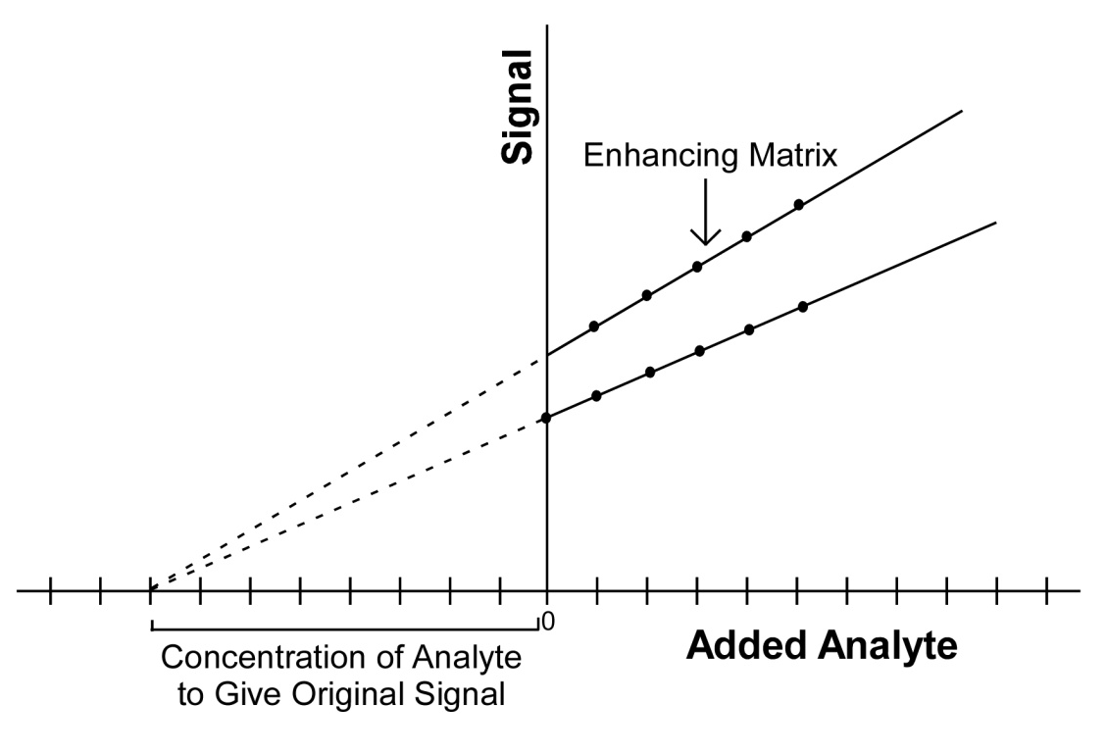
Figure 6.14. Standard addition plot for two samples with the same concentration. The sample with the higher slope has a matrix that enhances the signal.

The experimental steps involved in conducting a standard addition are more complex than those involving the use of a standard curve. If someone is testing a series of samples with similar properties that have similar matrices, it is desirable to use the standard addition procedure on one or a few samples and compare the concentration to that obtained using a standard curve. If the two results are similar, then it says that the matrix effects are minimal and the use of a standard curve is justified.

