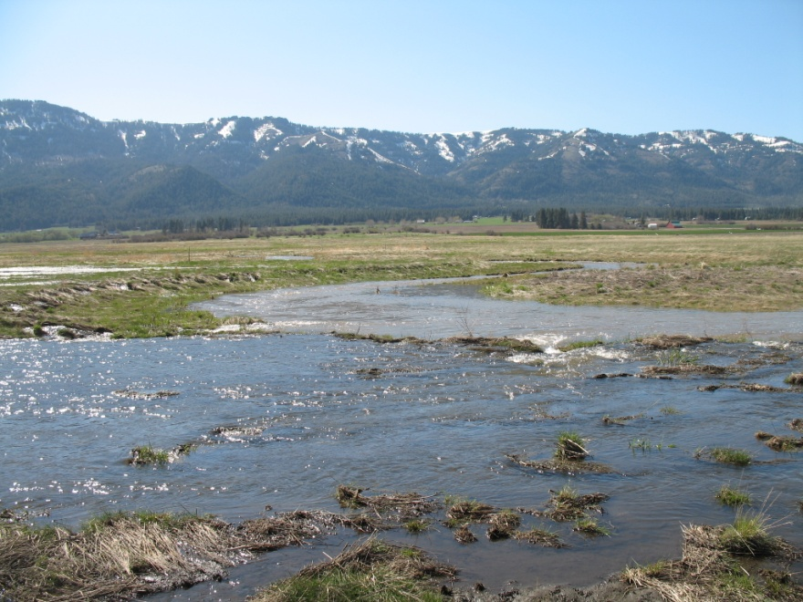
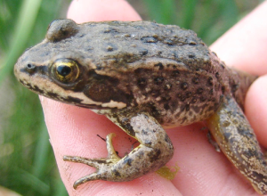
End Creek spotted frogs and aquatic snails
A qualitative investigation of
cations and anions
Anna Cavinato and Karen Antell
Eastern Oregon University
Adapted from “A Study of Onondaga Lake Water” – Chemistry in Context: Applying Chemistry to Society Lab Manual
The End Creek Wetland Restoration Project is located 15 km north of La Grande, in Union County, Oregon. The approximately 550 acre restored wetland embodies many qualities of high value to the community. The wetland is the only natural grassland/floodplain area of any size at the north end of the Grande Ronde Valley. It forms a natural corridor between the Blue Mountains and the Grande Ronde River as it transects through extensive, uninterrupted agricultural lands. Consequently, it protects a rare island of habitat for mammals, fish, amphibians, and reptiles and is an important harbor for threatened, endangered, or sensitive plant and animal species. The wet meadows and ponds provide stopover sites for migratory waterfowl traveling north and south through the intermountain west, and nesting and feeding habitat for those that stay. Drained and converted to agricultural land by the end of the last century and operated as a dairy farm until the mid-50s, the property became part of the Wetland Reserve Program in 2005. In 2006 plans began to restore the creek to its original sinuosity with the goals of improving fish habitat and restoring original vegetation. Creek restoration helped rebuild the water table and feed natural ponds. In 2008 Columbia Spotted Frogs were discovered in one of the ponds and a breeding population study began. However, over the following years this population has dwindled down and research shows no correlation to water quality parameters. We will therefore focus our research on aquatic snails. Three families of aquatic snails were identified but their distribution differs between ponds and seasonally. In this investigation, you will learn how to identify some metal ions and anions that are connected to water quality. The presence of these ions may play a role as to why certain ponds provide a more suitable habitat for certain types of aquatic snails. The ultimate goal will be for you to determine whether any significant difference exists in the water composition across three different ponds that may justify differences in snail populations.
The question to be answered is:
Are there differences in water chemistry that influence snail family distributions in the ponds at End Creek?
Background
You will be investigating the presence of positive and negative ions in water samples using a variety of chemical and physical tests. Presence of ionic species in solution will influence the conductivity. Higher concentrations of ions will result in a higher conductivity. Flame tests can be used to qualitatively identify the presence of specific ions. Much like in fireworks, when metal ions are heated in a flame, electrons from lower energy levels absorb energy and are promoted to higher levels. When these electrons relax back to the ground state, they emit light of characteristic wavelength. By observing the color emitted by known solutions of metal ions, the presence of metals can be determined in an unknown sample.
You will also make use of chemical reactions to identify ions based on the formation of insoluble salts or highly colored compounds. You will first investigate different reagents and determine which reagent is best suited for the identification of a specific ion. Once you have developed your own analytical scheme on a set of known positive and negative ions, you will use the same chemical reactions to analyze water sampled at End Creek and determine whether there are differences in the chemical composition of the three ponds.
Overview
- Test the electrical conductivity of water from the three End Creek ponds.
- Use the flame test to test for presence of Na⁺, Ca²⁺ and Fe³⁺ in standard samples.
- Use the flame test to test for presence of Na⁺, Ca²⁺ and Fe³⁺ in the End Creek ponds.
- Conduct chemical tests on samples of known composition to identify best reagents to analyze for presence of Ca²⁺ and Fe³⁺.
- Once you have identified the best reagents, test the End Creek pond water for presence of Ca²⁺ and Fe³⁺.
- Conduct chemical tests on samples of known composition to identify best reagents to analyze for presence of Cl⁻, SO₄²⁻ and PO₄³⁻.
- Once you have identified the best reagents, test the End Creek pond water for presence of Cl⁻, SO₄²⁻ and PO₄³⁻.
Materials Needed
Chemicals | Equipment
Dropper bottles with dilute solutions of:  - Sodium chloride  - Calcium chloride  - Iron (III) chloride  - Sodium oxalate  - Potassium thiocyanate  - Sodium sulfate  - Sodium hydrogen phosphate  - Silver nitrate  - Barium nitrate | - Plastic well plates  - Small stirring rods  - Disposable pipets  - Ni-Cr wire for flame test  - Conductivity tester  - Bunsen burner

Experimental procedure
- Test for conductivity
- Place a small amount of water from each pond in a well plate well. Immerse the two leads of the conductivity tester in each water sample making sure the two wires do not touch. Record your observations.
- Flame test for metal ions
- Using separate, clean wells, place a few drops each of sodium chloride, calcium chloride, and iron (III) chloride.
- Light the Bunsen burner and adjust the flame so to obtain a bright blue inner cone (instructor will demonstrate). Wash the Ni-Cr wire with deionized water and bring wire into the flame. If the wire is clean, no color should be emitted.
- Dip the wire in the calcium chloride solution and position it right above the inner blue cone where the hottest part of the flame is located. Observe the color emitted from calcium and record your observations.
- Clean the wire and then repeat flame test with sodium chloride and iron (III) chloride. Compare the colors and record your observations.
- Using clean wells, place a few drops each of the pond water samples. Make sure your Ni-Cr wire is clean! Dip the wire in each water sample and bring the wire into the flame. Do you observe any color? Record your results.

- Chemical test for positive ions
- In this investigation you will discover which reagent is best suited to analyze a water sample for presence of sodium, calcium and iron ions. Available reagents are sodium oxalate (Na₂C₂O₄) and potassium thiocyanate (KSCN). A suitable reagent is one that will uniquely react with the analyte of interest. Signs of chemical reactions include change of color, precipitation, evolution of gasses, etc.
- Using the well plate, standard solutions of sodium chloride, calcium chloride and iron (III) chloride, devise a strategy to identify the most suitable reagent that can be used to identify presence of sodium, calcium and iron ions. Jot down an experiment design and check with the instructor before proceeding.
- Once you have identified the best reagents for the identification of metal ions in water, test the three pond water samples. Record your observations. Based on these results, decide whether any metal ions are present in any of the three ponds.
- Clean up: empty any contents of the well plates into proper disposal bottle located under the hood. Rinse well plate and shake to remove any residual water.

- Chemical test for negative ions
- In this investigation you will discover which reagent is best suited to analyze a water sample for presence of anions such as sulfate, chloride and phosphate. Available reagents are silver nitrate (AgNO₃), barium nitrate (Ba(NO₃)₂) and calcium chloride (CaCl₂). Again, look for signs of chemical reactions which may include change of color, precipitation, evolution of gasses, etc.
- Using the well plate and standard solutions of sodium sulfate, sodium chloride and sodium hydrogen phosphate, devise a strategy to identify the most suitable reagent that can be used to identify presence of sulfate, chloride and phosphate ions in water. Jot down an experiment design and check with the instructor before proceeding.
- Once you have identified the best reagents for the identification of anions in water, test the three pond water samples. Record your observations. Based on these results, decide whether any anions are present in any of the three ponds.
- Clean up: empty any contents of the well plates into proper disposal bottle located under the hood. Rinse well plate.

- Questions to be answered after completing experiment
- What do the results of the conductivity test indicate about what is present in the End Creek water samples? Is there a difference in the conductivity of the three samples?
- What color do sodium, calcium and iron ions produce in the flame? Based on the results from the flame test, which of these ions are present in the pond water samples?
- Describe which reagent you chose, respectively, for the analysis of calcium and iron ions and write the balanced chemical reaction for each test. Based on your results, which metal ions are present in the pond water?
- Research the solubility rules for anions and cations. Was any reagent suitable for testing for sodium ion? Based on solubility rules, why would it be hard to devise a test for sodium based on the formation of a precipitate?
- Describe which reagent you chose respectively for the analysis of sulfate, chloride and phosphate and write the balanced chemical reaction for each test. Based on your results, which anions are present in the pond water?
- Review all the results gathered through this exploration. Based on these results, are there any differences in water composition among the ponds at End Creek? Summarize your conclusions.

