Laboratory Project – Introduction

Analysis of Phosphorus Concentrations in a Natural Water System

For this project, you will be exploring aspects of the chemistry of phosphorus in a natural freshwater system. More specifically, you will (1) compare two spectrophotometric methods for the determination of total phosphorus, (2) measure the concentration of total phosphorus in a Lake Mendota water sample, and (3) design an experiment in which you use one of the methods of analysis to answer a question you ask about concentrations of phosphorus in freshwater systems. Our goals for this project are for you to:
- Learn quantitative analysis in the context of a real-life environmental problem.
- Learn how to apply the scientific method as you develop hypotheses, design your experiments, and develop your own interpretation – in short, how to be a scientist!
- Understand some of the complexities and uncertainties associated with scientific measurement, especially when working with complex systems and the natural environment.
- Gain practice and experience in the skills required for successful collaborative group work.
- Learn how to effectively communicate your scientific results, both orally and in writing.

BACKGROUND

Eutrophication and Phosphorus

Why do we care about phosphorus in natural waters? Eutrophication is one of the leading problems facing the nation’s lakes. Eutrophication is an increase in the concentration of nutrients in a lake or other body of water, often caused by the runoff of nutrients in animal waste, fertilizers or sewage from the watershed. Increased nutrients lead to an increase in primary production, which is the production of organic compounds from carbon dioxide through photosynthesis. The presence of both phosphorus and nitrogen is necessary for eutrophication to occur. However, because the concentration of phosphorus is almost always lower than that of nitrogen, the growth of algae and the onset of eutrophication is usually controlled by the amount of phosphorus present in the water. If this is the case, the concentration of phosphorus is said to be ‘limiting’.

The effect of phosphorus on lake health has been well documented (Schindler, 1977; Schindler et al 2008). Eutrophic lakes frequently experience noxious algal blooms, increased aquatic plant growth, and oxygen depletion, leading to degradation of their ecological, economic, and aesthetic value by restricting use for fisheries, drinking water, industry and recreation. One of the most objectionable symptoms of eutrophication has been the appearance of floating algal blooms. In freshwaters, these surface blooms are often of nitrogen-fixing cyanobacteria, also known as blue-green algae. In addition to coating shorelines and boat hulls with foul-smelling scum, cyanobacteria produce toxins that are dangerous to other organisms, including humans. It is widely accepted that most effective method to mitigate eutrophication and to reduce harmful algal blooms is to reduce the loading of phosphorous into fresh waters.

Phosphorus in Water and Soil

Phosphorus occurs in natural waters almost solely as phosphates, a chemical form in which each phosphorus atom is surrounded by four oxygen atoms. These are classified as orthophosphates, condensed phosphates, and organically bound phosphates. Orthophosphate, the simplest phosphate, has the chemical formula PO₄³⁻. In natural waters, orthophosphate mostly exists as dihydrogen phosphate, H₂PO₄⁻ and hydrogen phosphate, HPO₄²⁻. Condensed phosphates are polyphosphates such as pyrophosphate, P₂O₇⁴⁻, and metaphosphate, (PO₃⁻)_{n}. Phosphates may be in solution or a component of suspended particles; however, most phosphates are bound to soil or sediment particles or tightly conserved by organisms. Phosphorus in the environment is converted between its organic and inorganic forms due to the action of bacteria and plants in much the same way nitrogen is. Orthophosphate, the form of phosphorus used by most living things, is converted to organic phosphorus by plants and microorganisms. Organic phosphorus, in turn, is converted to inorganic phosphorus by the action of bacteria on the waste products and dead bodies of plants and animals.

Phosphorus enters the biosphere by the natural weathering of rock and from a variety of human related activities. Major sources of phosphorus include human and animal wastes, soil erosion, detergents, septic systems and runoff from farmland or lawns. Phosphorus can enter a lake either externally, from run-off or groundwater, or internally, from nutrient rich sediments on the bottom of the lake. Freshwater lakes usually contain relatively low concentrations of dissolved or soluble orthophosphate since phosphate ions react by adsorbing to soil particles or by combining with elements in sediment such as calcium, aluminum, and iron to form insoluble compounds. Adsorption is the binding of molecules or particles to a solid surface. An analysis of phosphorus often includes both soluble (dissolved) reactive phosphorus (SRP) and total phosphorus (TP). Soluble reactive phosphorus dissolves in the water and its concentration varies widely in most lakes over short periods of time as plants take it up and release it. Total phosphorus includes soluble phosphorus and the phosphorus in plant and animal fragments suspended in lake water. Total phosphorus is considered a better indicator of a lake's nutrient status because its levels remain more stable than soluble reactive phosphorus.
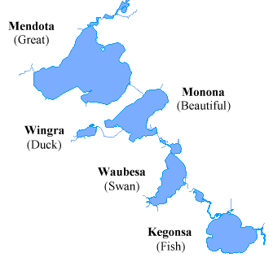Figure 1: The Yahara River lake system includes four large lakes connected via the Yahara River.

Lake Mendota and its Watershed

The Yahara River winds through Dane County, connecting four Madison area lakes – Mendota, Monona, Waubesa and Kegonsa (Figure 1), and finally joins the Rock River in Rock County. The land area draining to the lakes, the Yahara watershed spans 359 square miles. While most of this region remains in agricultural zoning, the watershed includes all or parts of five cities, seven villages and sixteen towns and is home to about 350,000 people. Madison spans the isthmus between Lake Mendota and Monona, the two largest lakes of the Yahara River lake system. The lakes surrounding Madison are valued by visitors and residents as a great physical resource and are highlighted as one of the reasons Madison is such a great place to live or visit.

The Yahara lakes are classified as eutrophic. Lakes are classified as oligotrophic, mesotrophic or eutrophic based on their trophic state, where trophic state is defined as the total weight of biomass in the water body. Carlson’s trophic index, which uses algal biomass as an objective classifier of a lake's trophic status, is the most commonly used trophic index (Carlson, 1977). Chlorophyll pigments, total phosphorus and Secchi depth are used to calculate the Carlson Index.

Table 1: Trophic classification based on chlorophyll, water clarity measurements, and total phosphorus values. (Carlson and Simpson, 1996)
Trophic class | Total Phosphorus  (μg/L) | Chlorophyll  (μg/L) | Secchi Depth  (m)
Oligotrophic | < 12 | < 2.6 | > 4
Mesotrophic | 12-24 | 2.6-7.3 | 2-4
Eutrophic | > 24 | > 7.3 | < 2

Chlorophyll is a measure of the amount of algae present. Sechi depth, determined by slowly lowering a Secchi disk into the water until the pattern on the disk is no longer visible, is related to water turbidity. Chlorophyll, total phosphorus and Secchi depth for Lake Mendota, Lake Monona and Lake Wingra are given in Table 2. Low levels of phosphorus are associated with low levels of algae (chlorophyll), which are associated with high Secchi disk readings.

Table 2: Madison Lake Characteristics
Characteristic | Lake Mendota | Lake Wingra | Lake Monona
Area (ha) | 3938 | 140 | 1324
Mean Depth (m) | 12.8 | 2.7 | 8.2
Maximum Depth (m) | 25.3 | 6.7 | 22.5
Shoreline Length (km) | 33.8 | 5.9 | 20.9
Duration of ice cover (days) | 119 | 120 | 107
Water Temperature (°C) | 22.4 | 23.9 | 23.3
pH | 8.4 | 8.5 | 8.5
Total P (µg/L) | 109.5 | 40.3 | 73.5
Total N (µg/L) | 860 | 933 | 845
Secchi Depth (m) | 3.0 | 0.7 | 2.4
Chlorophyll (µg/L) | 4.8 | 10.5 | 8.1
Water temperature (0 – 2 m) and secchi from June 1 – August 31. pH and conductivity from the average of spring and fall mixis sampling. Total P and total N from spring mixis sampling. Chlorophyll (surface) from open water season. (http://lter.limnology.wisc.edu/about/lakes )

Oligotrophic lakes have low primary productivity and often have very clear waters with good water quality. The bottom waters of oligotrophic lakes typically have ample oxygen. These lakes often support many fish species, such as lake trout, that require cold, well-oxygenated waters. Mesotrophic lakes are lakes with an intermediate level of productivity. Eutrophic lakes have high primary productivity due to high concentrations of nutrients and are subject to algal blooms resulting in poor water quality. The bottom waters of such eutrophic lakes are commonly deficient in oxygen, ranging from hypoxic (inadequate oxygen) to anoxic (no oxygen).

Lake Mendota is one of the most studied lakes in the world (Lathrop, 2007). Blue-green algal blooms have commonly occurred during the summer in Lake Mendota since the late 1880s (Birge, 1898; Lathrop, 2007); however, algal blooms did not become a concern until the mid 1940s, when sewage effluents from upstream communities increased and farmers began using larger quantities of commercial fertilizers. Water quality problems in Lake Mendota became severe in the 1960s as the amount of treated wastewater and agricultural and urban nonpoint pollution increased. In 1971, wastewater effluents from upstream communities were finally connected to the Madison Metropolitan Sewage District treatment plant, (Sonzogni and Lee, 1974); however, water quality did not substantially improve. Agricultural and urban nonpoint source pollution continues to be a problem in Lake Mendota today (Lathrop et al., 1998).

Lake Mendota’s watershed remains largely agricultural, although urban development is expanding rapidly. As in many watersheds, agricultural activities, including application of excess fertilizer and manure to crop fields, are a major source of nonpoint phosphorus input to lakes. A phosphorus budget for the Lake Mendota watershed (Bennett et al., 1999) estimated total phosphorus input to be 1,307,000 kg P yr⁻¹ and total output to be 732,000 kg P yr⁻¹. Out of the net 575,000 kg P yr⁻¹ that is being added to the watershed yearly, 34,000 kg P yr⁻¹ is washing into Lake Mendota. Efforts have been made by the Dane County Board and various environmental groups to reduce phosphorus runoff and to regulate the application of fertilizers in the Yahara watershed region.

Surface water concentrations of total phosphorus have been shown to be highly variable in Lake Mendota during the summer months, with concentrations ranging from 15 to 120 μg/L. Since most of this phosphorus is in the particulate phase, the total phosphorus concentrations are highly correlated to algal biomass (Lathrop, 2007). The average total phosphorus concentration in Wisconsin lakes is 25 μg/L (Lillie et al., 1983). Most harmful algal blooms occur in warm, slow moving, eutrophic waters in mid June through late September and are formed by photosynthetic cyanobacteria. Figure 2 on the next page shows concentrations of cyanobacteria in Lake Mendota in the summer of 2008.

Lake Mendota is the largest and deepest lake of the Yahara lakes. With a maximum depth of approximately 25 meters, Lake Mendota stratifies during the summer and mixes in the spring and fall. Thermal stratification occurs in lakes due to the large differences in density of warm and cold water. As the sun warms the lake surface in spring and early summer, the temperature difference between surface and deeper waters increases. If the lake is deep enough, the temperature difference creates a physical force strong enough to resist the wind’s mixing forces, and the lake stratifies into three layers. The warm, well-mixed upper layer is the epilimnion. The middle layer, a transitional zone that is resistant to wind mixing, where temperatures rapidly change, is called the metalimnion. The bottom layer is the colder, and relatively undisturbed hypolimnion. Summer stratification continues until fall, when surface waters begin to cool and sink. When the whole lake reaches a similar temperature, wind forces mix the lake from top to bottom in a process called fall turnover. As the surface water cools even more, it becomes less dense and floats on the top of the lake, forming
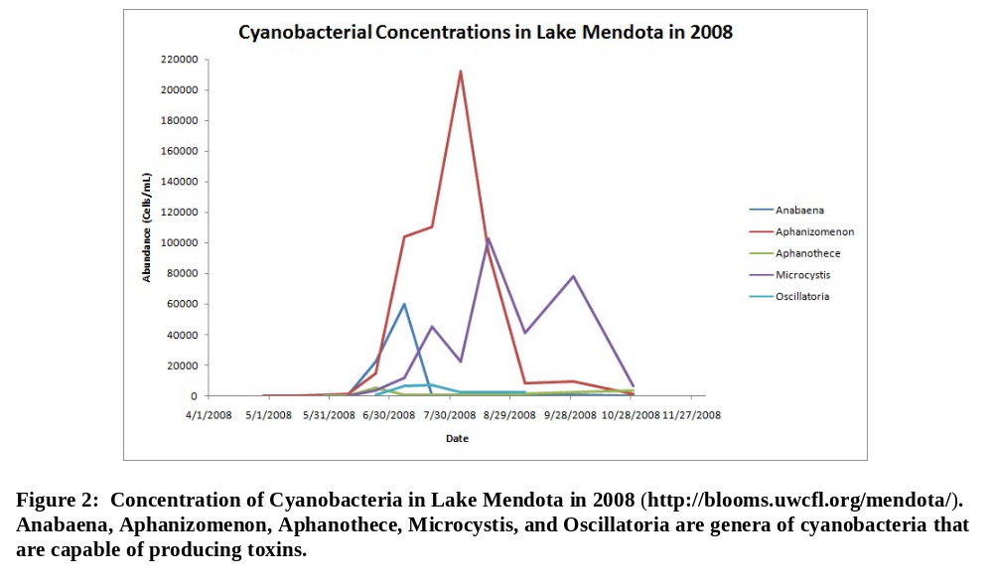
ice. In spring, the ice melts and the surface water warms. The higher density of the warming water, along with wind action, causes the surface water to sink and mix with the deeper water in a process called spring turnover.

The hypolimnion is well-oxygenated after spring turnover. However, once summer stratification is established, the hypolimnion is cut off from oxygen exchange with the atmosphere and it is often too dark for algae and plants to grow and produce oxygen by photosynthesis. As the summer progresses, oxygen is consumed by bacteria and other bottom-dwelling organisms and the hypolimnion of eutrophic lakes becomes anoxic. Under anoxic conditions, phosphate, iron, manganese and sulfur become increasingly soluble and are released from bottom sediments into the hypolimnion. Sonzogni (1974) has shown that dissolved phosphorus builds up in the hypolimnion of Lake Mendota during summer stratification and is transferred and diluted throughout the entire lake at fall turnover.

Factors Controlling Phosphorus Concentrations in the Water Column

The release of phosphorus from lake sediments into the water column increases with warmer water temperature, lowered dissolved oxygen, and either higher or lower pH. When water temperatures increase during the summer, microbial activity increases decomposition at the sediment water interface, which releases organic bound phosphorus (Holdren and Armstrong, 1980). Fluctuations in oxygen concentrations and pH may occur diurnally (within a daily cycle) and seasonally. Oxygen from the water column is consumed through microbial activity and organic decomposition. Algae are net producers of oxygen via photosynthesis during daylight hours but net consumers of oxygen through respiration during darkness. The oxygen concentration in the water is therefore very high during the day and low at night. This daily cycle can also be observed in the pH of the water body which also varies widely. This variation is due to the fact that algae consume acidic carbon dioxide gas during the day and release it at night.

Phosphate forms insoluble precipitates with calcium, iron, and aluminum. In hard water areas of Wisconsin, where limestone is dissolved in the water, marl (calcium carbonate) precipitates and falls to the bottom. Marl formations adsorb phosphate, reducing its overall concentration as well as algae growth. Aquatic plants with roots in the marl bottom still can get phosphorus from sediments. Hard water lakes often have clear water, but may be weedy. In the sediment, the CaCO₃ may also act as a barrier to diffusive transport of phosphorus and reduce release rates from the sediment. The coprecipitation or adsorption of phosphorus on calcium carbonate is favored by an increase in pH (Otsuki and Wetzel, 1972; House, 1990).

Studies have shown that if sediments contain iron, large amounts of phosphorus trapped in the bottom sediments may be released when the overlying water becomes anoxic (Mortimer, 1971). This process is called internal nutrient loading or recycling. Phosphorus is released from the sediments under anoxic conditions that occur when a lake stratifies and oxygen is depleted from the lower layer. Even when external sources of phosphorus have been curtailed, this internal cycling of phosphorus can continue to support explosive algal growth. In stratified lakes with an anoxic hypolimnion, phosphorus release can become an extremely large source of internal phosphorus for a lake (Nurnberg, 1984). Under oxic conditions, iron is in the Fe(III) state. The current thinking is that Fe(III) occludes phosphorus indirectly, so what forms in the lake is not ferric phosphate, but a mix of ferric oxides and hydroxides that the phosphate adsorbs onto. In the hypolimnion of an oxic lake, a layer of these ferric precipitates forms at the top of the sediment and acts as a barrier that retains any phosphorus released from the underlying anoxic sediments. When the hypolimnion becomes anoxic, the iron is reduced to Fe(II) and dissolves, releasing the previously retained phosphorus into the water column. Sediments that contain iron have also been shown to release phosphorus as pH increases. This is attributed to desorption of phosphate from iron(III) hydroxide by the replacement of phosphate with hydroxide (Jensen and Andersen, 1992; Boers, 1991).

The amount of iron that might react with phosphorus varies widely in Wisconsin lakes. Lakes in the southern part of the state are often low in iron due to a higher pH and more sulfur, both of which limit iron solubility. This in turn affects whether phosphorus mixed into lakes during fall turnover precipitates or stays in solution during the winter. Lakes with low iron and insufficient calcium to form marl are most likely to retain phosphorus in solution once it is released from sediments or brought in from external sources. These lakes are the most vulnerable to naturally occurring phosphorus or to phosphorus loading from human activities because the phosphorus remains dissolved in the water and is not pulled down into the sediments.

Phosphorus control has been attempted in some lakes by using alum (aluminum sulfate) to precipitate phosphate (Wisconsin DNR, 2003). This is the same process used by sewage treatment plants to remove phosphorus. On contact with water, alum forms a fluffy aluminum hydroxide precipitate called floc. The aluminum hydroxide binds with phosphate to form an aluminum phosphate compound, which is insoluble in water under most conditions. As the floc settles, it also carries suspended particles in the water down to the lake bottom leaving the lake noticeably clearer. On the bottom of the lake, the floc forms a layer that acts as a barrier. As phosphate is released from anoxic sediments, the phosphate binds to the floc. Aluminum phosphate, unlike iron phosphate, is not redissolved when oxygen is depleted.

Quantification of Phosphorus

Quantification of phosphorus requires the conversion of phosphorus to dissolved orthophosphate followed by colorimetric determination of the dissolved orthophosphate. The analysis of different forms of phosphorus is obtained by various pretreatment steps. “Total phosphorus” is the total amount of phosphorus contained, regardless of its form. Filtration through a 0.45 μm pore diameter membrane separates total phosphorus (TP) into “soluble phosphorus” and “particulate phosphorus”. Analyses are usually conducted on the unfiltered and filtered samples, and particulate fractions are determined by difference.

Each of these fractions, soluble and particulate phosphorus, may be divided analytically into “reactive phosphorus”, “acid-hydrolyzable phosphorus” and “total phosphorus”. The “reactive phosphorus” fraction contains phosphates that respond to colorimetric tests without hydrolysis or oxidative digestion. Reactive phosphorus is largely a measure of orthophosphate. Acid hydrolysis converts soluble and particulate condensed phosphates to dissolved orthophosphate. The “acid-hydrolyzable” fraction contains orthophosphates and condensed phosphates. In order to measure the amount of organically bound phosphorus, the sample must be oxidized (digested) to convert organic phosphorus to orthophosphate. Organic phosphorus can be digested using perchloric acid, nitric acid-sulfuric acid, or persulfate. The perchloric acid method, which was designed for sample matrixes difficult to digest such as soil and sediments, is very time-consuming and requires special facilities and safety precautions. The acid-sulfuric acid method is widely recommended for most sample matrixes; however, the persulfate oxidation method is by far the safest and least time consuming. The “total phosphorus” fraction contains orthophosphates, condensed phosphates, and organic phosphorus. Figure 3 shows the analytical scheme for the differentiation of different phosphorus forms. In the first two parts of the project, you will be measuring total phosphorus (TP).

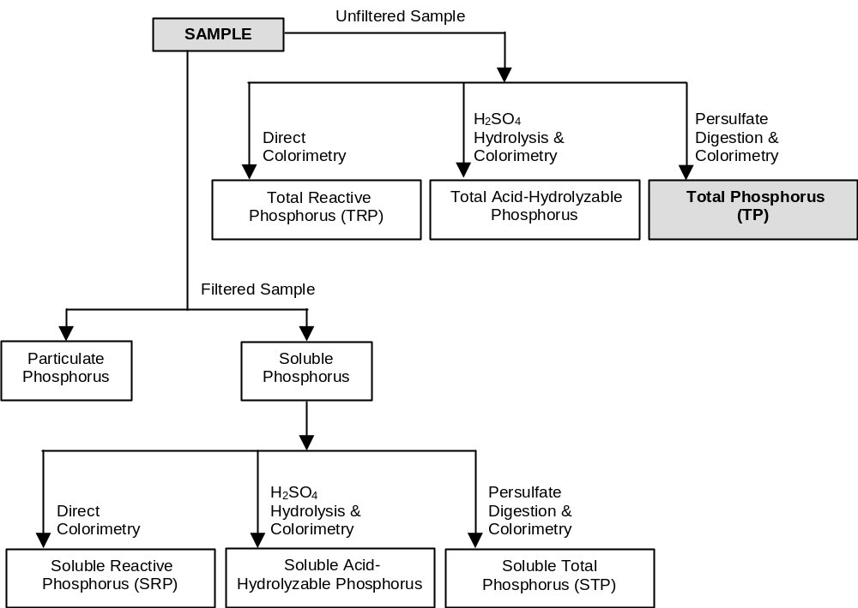

Figure 3: Analytical scheme for the differentiation of phosphorus forms.

Three techniques for the colorimetric analysis of phosphorus are described in Standard Methods for the Examination of Water and Wastewater: the vanadomolybdophosphoric method, the stannous chloride method, and the ascorbic acid method (Eaton et al., 2005). The technique most commonly used is the ascorbic acid method. In this method, ammonium molybdate (NH₄)₆Mo₇O₂₄·4H₂O) and antimony potassium tartrate (K(SbO)C₄H₄O₆·½H₂O) react in an acid medium with dilute solutions of orthophosphate to form an intensely colored antimony-phospho-molybdate complex. This complex is reduced to an intensely blue-colored complex by ascorbic acid (Murphy and Riley, 1977). The complex is not stable and thus analysis must be performed within 30 minutes of adding the combined reagents to the sample.

Another spectrophotometric method of analysis has been by developed by Van Veldhoven and Mannaerts (1986) in which molybdophosphate is reacted with the dye malachite green to produce a colored complex. The malachite green method is reported to have better sensitivity, better color development, and to be less sensitive to changes in heating, reagent addition or reaction time than the widely used ascorbic acid method (Rao et al., 1997). Since both methods are based on the production of a molybdophosphoric acid, they both measure a similar fraction of dissolved reactive phosphorus.

Sampling and Storage Methods for Water and Sediments

Phosphorus analysis methods are highly sensitive to trace amounts of contamination commonly present in tap water, distilled water, on fingers, in soap and some detergents, in buffer solutions and other reagents. Contaminants from containers may leach into samples. Similarly, sample analytes may adsorb onto the walls of containers. All glassware and sample bottle used should be rinsed with warm, dilute 1 M HCl, then rinsed several times with Milli-Q water (highly purified and deionized water). In the lab, gently heat 1 M HCl on a hot plate until it is warm. Rinse all of the glassware and plastic bottles you use in your experiments with several small aliquots of warm 1 M HCl followed by three rinses with Milli-Q water. Likewise, when you prepare your solutions, make sure that you use the Milli-Q water provided in the lab.

Grab samples are single samples collected at a specific spot at a site over a short period of time that represent a "snapshot" in both space and time. When collecting a grab sample from the lake, avoid surface scum. Rinse your sample bottles out three times with the water being collected, fill the bottles completely, and cap tightly. Once you have collected your Lake Mendota water samples, bring them back to the lab and digest them the same day. Once the samples are digested, they should be stored in the refrigerator until you are ready to analyze them for total phosphorus.

If you need a Lake Mendota sediment sample for the third part of the project, you can collect a sediment grab sample from one of the piers using an Ekman dredge. An Ekman dredge is a hinged bucket that closes when it is raised. The Ekman dredge is set with the jaws cocked open and lowered over the dock until it is resting on the sediment. At this point, slackening of the line activates the mechanism and the jaws are released. The dredge should be pulled up slowly to allow time for the jaws to close and to minimize turbulence that will result in the loss of surface sediments. Once the sampler is back on the dock, a shallow pan is placed beneath it and the sediment is released and transferred into a sample container.

Method Detection Limit

The method detection limit (MDL) is the minimum concentration of an analyte that can be measured and reported with a 99 percent confidence that the analyte concentration is greater than zero. The method must be well-defined and the method detection limit depends on the instrument, the sample matrix and the analyst. The MDL is based on the variability or precision between seven or more replicate samples run at identical concentrations. MDLs are typically calculated using reagent water spiked with the analyte of interest. The concentration of the spike should be close to detection limit, or about 1 to 5 times the MDL. Hence, one needs to somehow estimate the detection limit before it is actually measured. The spiked samples must be prepared and processed exactly as a sample would be in the analytical method, including any extractions or digestions.

When calculating the MDL, the same calibration curve that would be used for a typical analysis must be used, with the lowest calibration standard approximately equal to the limit of quantitation (LOQ). The LOQ is defined as equal to 10 times the standard deviation of the results for the series of replicates that were used to determine the detection limit.

analysis of Phosphorus Concentrations

You will compare two spectrophotometric methods used to determine the concentration of total phosphorus in natural water systems. In the first part of the project you will determine and compare the linear range and the method detection limits of the two methods. In the second part of the project, you will use the best method to determine the concentration of total phosphorus in Lake Mendota. And in the third part of the project, you will use the best method of phosphorus analysis to answer a question you ask about the concentration of phosphorus in a freshwater system. Throughout the project, you will design, test and refine your experimental procedures so that you can obtain meaningful results from which you can learn something about the analysis of phosphorus in environmental samples and the chemistry of phosphorus in freshwater systems.

Experimental Objectives

Part 1: Compare two spectrophotometric methods of analysis for total phosphorus

- Compare the ascorbic acid method as described in Standard Methods for the Analysis of Water and Wastewater (Eaton et al., 2005) to the malachite green method proposed by Van Veldhoven and Mannaerts (1986).
- Make an absorption spectrum for each method and verify that the wavelengths given for each analysis is appropriate.
- Calculate the absorptivity constant for each method.
- Determine the linear range for both methods.
- Calculate the method detection limit for both methods using the U.S. EPA Method Detection Limit procedure outlined in Title 40 Code of Federal Regulations Part 136 (40 CFR, appendix B, revision 1.11). Use the persulfate method for sample digestion. The “EPA Method Detection Limit Procedure” is posted on our webpage on Learn@UW.
- Use appropriate quality assurance measures in your analyses.
- Compare the two methods based on reproducibility, linear range and method detection limit. Given the typical concentrations of total phosphorus found in freshwater lakes, is one method better than the other for determining concentrations in lake water?

Part 2: Measure total phosphorus in a Lake Mendota water sample
- Collect a grab water sample from Lake Mendota.
- Choose the best method from Part 1 to determine the concentration of total phosphorus in the Lake Mendota water sample. Use the persulfate method to digest your sample.
- Use appropriate quality assurance measures in your analyses.
- Experimentally test for matrix effects in the method chosen for analysis.

Part 3: Design and carry out an experiment in which you use one of the methods of analysis to answer a question you ask about concentrations of phosphorus in a freshwater system

- Possible variables to consider include: pH, oxygen, calcium, iron, aluminum, form of phosphorus, and algal growth (chlorophyll).
- Calcium, iron, and aluminum can easily be measured using Inductively Coupled Plasma Atomic Emission Spectroscopy (ICP-AES).
- Chlorophyll a is a characteristic algal pigment constituting 1-2% dry weight of algal biomass that can be extracted using 90% acetone/10% water solution and measured spectrophotometrically.
- You will not be able to measure the concentration of phosphorus in lake sediment because the digestion method for sediments requires special equipment and safety precautions; however, you can (and probably should) use sediment in your experiments. Sediment samples can be collected from Lake Mendota off one of the piers using an Ekman dredge.
- If using sediment samples in your experiments, you will need to know the mass of dry sediment. Before weighing, first let the sample air dry for several days and then dry it in the oven at 105°C.

PROJECT DESCRIPTION

Introductory Assignment and Project Design

You will be receiving a "Getting Started" handout with further instructions for the Introductory Assignment. Before coming to lab, you will need to read the "Getting Started" handout in addition to the two papers that describe each of the analytical methods you will be using. These documents will all be posted on our course website. As you work through the project, you will likely need to consult other resources or articles that are related to the project. Some articles listed in the reference section of this document may be helpful.

To begin your project design, you will meet with your group to address a set of questions related to the project and to discuss your ideas. Try to get everyone in the group to participate in the discussions. It is important to build good team skills, not only for this course but also for your future. Good team skills are one of the most important qualities that employers look for and one of the keys to success. In a healthy group discussion, everyone should feel comfortable expressing their ideas. You won't always agree with each other and that is okay; you can disagree respectfully, exchange ideas and come up with a better plan based on input from everyone.

Begin Collecting Data

Research is an investigative and iterative process. Your group may make several attempts at getting the experiments to work before obtaining results that make sense. This may seem frustrating at first, but you will be learning analytical chemistry and the scientific method as you work through this project, and the rewards will be there in the end. Some of what you do will not have a “right” or a “wrong” answer that we are expecting – your goal is to be a scientist in the truest sense. Be patient and persistent! Keep in mind that your group needs to plan and organize. Every member needs to participate and be productive. Although everyone should be knowledgeable about all aspects of the project, tasks should be delegated to increase efficiency. Having one person preparing solutions and three people watching is not a good use of your resources!

Progress Reports

During the course of the project, you will submit two written progress reports in which you summarize your progress in a concise, scientific fashion. Suitable materials include: brief outlines of experimental procedures, plots of your experimental results, and a brief summary of results and future plans.

Final Written Report

After completing your experiments you will write and submit a final report. The format should be similar to a scientific paper; more specific information will be provided later. The ACS Style Guide (Coghill and Garson, 2006) is a good resource for scientific writers.

Oral Presentation

Your group will also discuss your results with the instructors in an oral presentation at the end of the semester. Your group should plan on a brief presentation (~5 minutes) where you highlight your experimental method and anything of particular interest about the data. The presentation will be followed by approximately 15 minutes of questions. The questions will, in general, be posed to specific individuals. You may “handoff” the question to another group member, but remember that all group members should be aware of what was done with all aspects of the project. The primary goals of the questions are to determine your knowledge of the project itself and your analysis of your data.

GRADING

The project counts for a total of 90 points toward your final grade. These 90 points are broken down into the following categories:

Introductory Assignment 10 pts
First Progress report 10 pts
Second Progress report 10 pts
Final report 35 pts
TA work distribution/efficiency grade 10 pts
Oral presentation 15 pts

Note that grades for the first four categories are assigned to the group as a whole. Grades for the last two categories are assigned individually.

(Example) DUE DATES

Introductory Assignment: Monday, March 12 (at beginning of lab)

First Progress Report: Wednesday, March 21 (at beginning of lecture)

Second Progress Report: Friday, March 30 (at discussion)

Final Written Report: Monday, April 30 (at beginning of lab)

Oral Presentations: Monday, May 7

ACKNOWLEDGEMENTS

This Design Project was developed by Dr. Pamela Doolittle*, Dr. Linda Zelewski, Dr. Cheri Barta and Patrick Robichaux.

*Please direct questions about this project to Dr. Pamela Doolittle, U.W. Madison Chemistry, 1101 University Avenue, Madison WI, 53706. pssemrad@wisc.edu

GLOSSARY

adsorption: adhesion of molecules or ions on a surface.

alum: potassium aluminum sulfate dodecahydrate, KAl(SO₄)₂12H₂O

anoxic: no oxygen. Anoxic waters are areas of natural waters that are depleted of dissolved oxygen.

chlorophyll: green pigment present in all plant life and necessary for photosynthesis. The amount present in lake water depends on the amount of algae and is therefore used as a common indicator of water quality.

colorimetry: quantitative chemical analysis using color (visible spectroscopy).

coprecipitation: precipitation of substances normally soluble under the conditions employed. There are three main mechanisms of coprecipitation: inclusion, occlusion, and adsorption. Inclusion occurs when the impurity occupies a lattice site in the crystal structure of the carrier. Occlusion occurs when an adsorbed impurity gets physically trapped inside the crystal as it grows. Adsorption is an impurity that is weakly bound (adsorbed) to the surface of the precipitate.

cyanobacteria: phylum of bacteria that obtain energy through photosynthesis (also known as blue-green algae).

epilimnion: the top-most layer in a thermally stratified lake, occurring above the deeper hypolimnion. It is warmer and typically has a higher pH and dissolved oxygen concentration than the hypolimnion during the summer.

eutrophic: a eutrophic body of water, commonly a lake or pond, has high primary productivity due to excessive nutrients and is subject to algal blooms resulting in poor water quality. The bottom waters of such bodies are commonly deficient in oxygen, ranging from hypoxic to anoxic.

eutrophication: the process by which lakes are enriched with nutrients, increasing the production of rooted aquatic plants and algae. The extent to which this process has occurred is reflected in a lake’s trophic classification: oligotrophic (nutrient poor), mesotrophic (moderately productive), and eutrophic (very productive).

fall and spring turnover: fall cooling and spring warming of surface water increases density, and gradually makes temperature and density uniform from top to bottom. This allows wind and wave action to mix the entire lake. Mixing allows bottom waters to contact the atmosphere, raising the
water’s oxygen content.

hypolimnion: the dense, bottom layer of water in a thermally-stratified lake. Being at depth, it is isolated from surface wind-mixing during summer, and usually receives insufficient light for photosynthesis to occur.

hypoxic: oxygen depleted. In an aquatic environment, a state in which the dissolved oxygen concentration is so low, it is detrimental to aquatic organisms living in the system.

limiting factor: the nutrient or condition in shortest supply relative to plant growth requirements. Plants will grow until stopped by this limitation. Phosphorus is typically limiting in summer, and temperature or light is limiting in fall or winter.

marl: white to gray accumulation on lake bottoms caused by precipitation of calcium carbonate (CaCO₃) in hard water lakes. Marl may contain many snail and clam shells, which are also calcium carbonate. While it gradually fills in lakes, marl also precipitates phosphorus, resulting in low algae populations and good water clarity

mesotrophic: mesotrophic lakes have an intermediate level of productivity, greater than oligotrophic lakes, but less than eutrophic lakes.

Milli-Q water: water that has been purified and deionized to a high degree by a water purification system manufactured by Millipore Corporation.

nonpoint source (NPS) pollution: pollution affecting a water body from many diffuse sources. NPS pollution is caused by rainfall or snowmelt moving over and through the ground. As the runoff moves, it picks up and carries away natural and human-made pollutants, depositing them into lakes and other natural waters. These pollutants include excess fertilizers from agricultural lands and residential areas; sediment from improperly managed construction sites, crop lands, and eroding streambanks; and bacteria and nutrients from livestock, pet wastes, and faulty septic systems.

occlusion: coprecipitation where an adsorbed impurity gets physically trapped inside the crystal as it grows.

oligotrophic: oligotrophic lakes have low nutrient levels and low primary productivity.

point source pollution: a single, identifiable localized source of pollution, such as pollution released from industrial plants, commercial businesses or wastewater treatment plants.

primary productivity: the production of organic compounds from atmospheric or aquatic carbon dioxide, principally through the process of photosynthesis.

Secchi disk: an 8-inch diameter plate with alternating quadrants painted black and white that is used to measure water clarity (light penetration). The disk is lowered into water until it disappears from view. It is then raised until just visible. An average of the two depths, taken from the shaded side of the boat, is recorded as the Secchi disk reading.

stratification: the layering of water due to differences in density. Water’s greatest density occurs at 4°C. As water warms during the summer, it remains near the surface while colder water remains near the bottom. Wind mixing determines the thickness of the warm surface water layer (epilimnion), which usually extends to a depth of about 20 feet. The narrow transition zone between the epilimnion and cold bottom water (hypolimnion) is called the metalimnion or thermocline.
REFERENCES

Bennett E.M.; Reed-Anderson T.; Houser, J.N.; Gabriel, J.R.; Carpenter S.R. A Phosphorus Budget for the Lake Mendota Watershed. Ecosystems 1999, 2, 69-75.

Birge, E.A. Plankton studies on Lake Mendota: II. the Crustacea of the plankton from July 1894 to December 1896. Trans. Wis. Acad. Sci. Art Lett. 1898, 11, 274-448.

Boers, P. The influence on pH on phosphate release from lake sediments. Water Res. 1991, 25, 309-311.

Carlson, R.E. A trophic state index for lakes. Limnol. Oceanogr. 1977, 22, 361-369.

Carlson, R.E.; Simpson J. A Coordinator’s Guide to Volunteer Lake Monitoring Methods. North American Lake Management Society, 1996.

Coghill, A.M.; Garson, L.R., Eds., The ACS Style Guide: Effective Communication of Scientific Information, 3rd ed.; American Chemical Society: Washington, 2006.

Eaton, A.D.; Clesceri L.S.; Rice E.W.; Greenberg A.E.; Franson M.H., Eds., Standard Methods for the Examination of Water and Wastewater: 21st ed.; American Public Health Association: Washington, DC, Water Environment Federation: Alexandria, VA, and American Water Works Association: Denver, CO, 2005.

Harmful Algal Blooms, http://blooms.uwcfl.org/mendota/ (accessed 25 September 25, 2010).

Holdren G.C.; Armstrong D.E. Factors affecting phopshorus release from intact sediment cores. Environ. Sci. Technol. 1980, 14, 79-87.

House, W. A. Predication of phosphate coprecipitation with calcite in freshwaters. Water Res. 1990, 24, 1017-1023.

Jensen, H.S.; Andersen, F.O. Importance of temperature, nitrate, and pH on phosphorus release from aerobic sediments in four shallow, eutrophic lakes. Limnol. Oceanogr. 1992, 37, 577-589.

Lathrop, R.C. Perspectives on the eutrophication of the Yahara lakes. Lake and Reservoir Management, 2007, 23, 345-365.

Lathrop R.C.; Carpenter S.R.; Stow C.A.; Sorrano P.A.; Panuska J.C. Phosphorus loading reductions needed to control blue-green algal blooms in Lake Mendota. Can. J. Fish. Aquat. Sci. 1998, 55, 1169-78.

Lillie R.A.; Mason J.W.; Hine R.L., Eds., Limnological characteristics of Wisconsin lakes, Technical bulletin, Wisconsin Dept. of Natural Resources, No. 138 Madison, Wisconsin: Wisconsin Department of Natural Resources, 1983.

Mortimer C. H. Chemical exchanges between sediments and water in Great Lakes – speculations on probable regulatory mechanisms. Limnol. Oceanogr. 1971, 16, 387-404

Murphy, J.; Riley, J.R. A modified single solution method for the determination of phosphate in natural waters. Anal. Chem. 1977, 27, 31-36.

Nurnberg, G.K. The prediction of internal phosphorus loads in lake with hypolimnetic anoxia. Limnol. Oceanogr. 1984, 29, 111-124.

Otsuki A.; Wetzel R.G. Coprecipitation of phosphate with carbonates in a marl lake. Limnol. Oceanogr. 1972, 17, 763-767.

Rao A.S.; Reddy K.S.; Takkar P.N. Malachite green method compared to ascorbic acid for estimating small amounts of phosphorus in water, 0.01 M calcium chloride, and olsen soil extracts Commun. Soil Sci. Plant Anal. 1997, 28, 589-601.

Schindler, D.W. Evolution of Phosphorus Limitation in Lakes, Science, 1977, 195, 260-262.

Schindler D.W.; Hecky R.E.; Findlay D.L.; Stainton M.P.; Parker B.R.; Paterson M.J.; Beaty K.G.; Lyng M.; Kasian S.E.M. Eutrophication of lakes cannot be controlled by reducing nitrogen input: Results of a 37-year whole-ecosystem experiment. Proc. Natl. Acad. Sci. USA 2008, 105, 11254–11258.

Sonzogni W.C. Effect of nutrient input reduction on the eutrophication of the Madison lakes. Ph.D. Dissertation, University of Wisconsin, Madison, WI, 1974.

Sonzogni W.C.; Lee G.F. Diversion of wastewaters from Madison Lakes. J. Environ. Eng. 1974, 100, 153-170.

Van Veldhoven, P.P.; Mannaerts, G.P. Inorganic and Organic Phosphate Measurements in the Nanomolar Range. Anal. Biochem. 1986, 161, 45-48.

Wisconsin Department of Natural Resources. Alum Treatments to Control Phosphorus in Lakes, 2003, http://www.dnr.state.wi.us/org/water/fhp/papers/alum_brochure.pdf (accessed September 25, 2010).

