ASDL Learning Module - Lithia Water Springs
(Chemical Equilibria/Water Analysis)
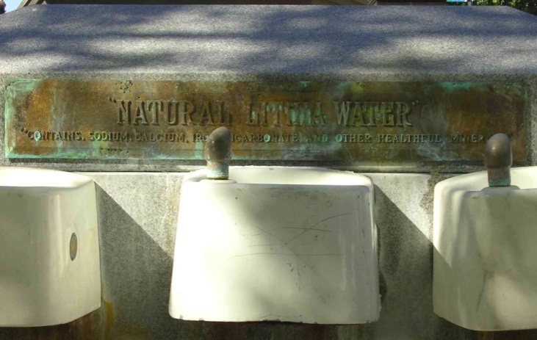
Statement of the Problem
The discovery of natural springs in the vicinity of Ashland, Oregon sparked the pursuit of a “spa economy” during the 1910s and 1920s. The lithium concentration in this spring, which is the second highest in the U.S., was a marketing point for town leaders in the early 20th century. Envisioning flocks of tourists searching for rest cures and treatments for various ailments, bond measures were passed to fund the system of pipes used to transport Lithia water several miles to downtown Ashland. Although this approach to economic development has largely been supplanted by the Oregon Shakespeare Festival, the consumption of Lithia water is still seen as a “rite of passage” for first-time tourists. There are also those who still put faith in the curative powers of Lithia water, especially since lithium salts have more recently been prescribed as a drug for chemical depression.
Figure 1. Lithia fountain pedestal in Ashland's Plaza circa Summer 2006
What are the major inorganic components dissolved in Lithia water and how do they contribute to the characteristics of this spring water? How much lithium is in Ashland’s Lithia water, and can one safely consume enough Lithia water to ingest a therapeutically significant dose? The understanding and use of stoichiometry, equilibria and statistics can bring to light the nature of this naturally effervescent spring water.
The problem for this group of analytical chemistry students is:
- Can the most prevalent inorganic ions be determined in Lithia water using a representative cross-section of analytical techniques (e.g. titrimetry, potentiometry, UV-Visible spectroscopy)?
- Can univariate statistics be used to support the claim that the most prevalent inorganic ions have been determined?
To answer these questions, it is necessary to review additional background information about Lithia water and understand general guidelines for the analysis of inorganic ions in water samples.
Definitions of Analyte Levels and Choice of Analytical Methods
An analyte is a component in a mixture that is of interest to the analyst, and the sample matrix is the rest of the sample. For example, when an analyst determines the concentration of lithium in Lithia water, lithium is the analyte and the remaining components comprise the sample matrix. An analyte can be classified based on the analyte concentration as shown in Table 1.
Table 1. Suggested analyte classification table for Lithia water analysis. See Analytical Chemistry 2.0 (Chapter 3D.6, p. 51) on the Analytical Sciences Digital Library website for additional information.
Analyte Classification | Concentration Range (%(w/w) & (ppm)) | Appropriate Analytical Techniques | Analyte Amount (mg)  Based on 25 mL sample size
Major | 1 - 100  (10000 - 1000000) | Titrimetry, Gravimetry | 250 – 25000
Minor | 0.01 – 1.00  (100 - 10000) | Titrimetry, Potentiometry, Spectroscopy | 2.5 – 250
Trace | 1 x 10⁻⁷ – 0.01  (10 ppb – 100 ppm) | Potentiometry (to low ppm) Spectroscopy (entire range) | 0.00025 –2.5

If the analyst has an idea of the concentration of a given analyte, then appropriate analytical methods can be suggested and analytical procedures can be developed for the determination of that analyte. Because this project is focused on the determination of inorganic constituents in Lithia water, students should complete the questions in the Major Inorganic Constituents, Origins of Lithia Water, and Sample Handling and Treatment sections in this module. The questions of interest in the Sample Handling and Treatment section of this module requires students to refer to another module entitled Chemical Equilibria & Sample Preparation.

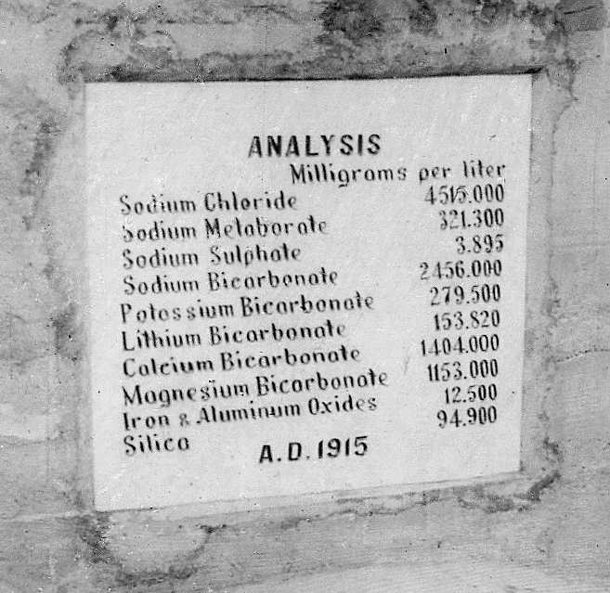
Major Inorganic Constituents
Purpose: The purpose of this section is to understand the various ways of expressing solute concentrations in a solution.
Learning Objectives: Upon completion of this assignment, students will be able to:
- Use the stoichiometric composition of compounds to convert between mass/volume concentrations and molar solute concentrations
- Identify appropriate analytical techniques for the determination of inorganic analytes in Lithia water based on analyte concentration
Figure 2. Plaque representing a 1915 analysis of Lithia water from Ashland, OR

The plaque in Figure 2 contains the results of a historic analysis of inorganic compounds from one of Ashland’s Lithia water springs. Notice that the concentration of each inorganic constituent is expressed as a salt or combination of salts. If the composition of the Lithia water is stable over time, one can estimate the concentration for each cation and anion in Lithia water prior to working in the laboratory.
For the questions below, assume that the soluble form of silica solely exists as the silicate ion (SiO₃²⁻).
Q1. Which cations and anions are represented by a single salt and which are represented by multiple salts?
Q2. Of those analytes listed on the plaque, are there any cation or anion concentrations that are unknowns based on the information provided? How can you tell?
Q3. Based on the analysis engraved on the plaque above, how would you calculate the concentration of each ion represented by a single salt? Complete these calculations, and express the solute concentration in milligrams per liter (mg L⁻¹) and in moles per liter (M).
Q4. How does your approach to calculating ion concentrations represented by multiple salts differ from expressing ion concentrations represented by a single salt? Complete these calculations, and express the solute concentration in milligrams per liter (mg L⁻¹) and in moles per liter (M).
Q5. Determine the number of milligrams of each analyte present in 25.00 mL of Lithia water from the 1915 analysis, assuming that the composition of Lithia water has not changed since 1915. Using these analyte quantities, determine appropriate analytical techniques based on the classification scheme in Table 1.
Q6. Once the appropriate analytical technique(s) for each analyte have been identified based on the classification scheme in Table 1, consider, discuss, and identify additional criteria that would be important in the selection of an appropriate method for each analyte in Lithia water. An appropriate starting point for this discussion would be to read Chapter 3D in Analytical Chemistry 2.0.
Q7. Lithium carbonate is often prescribed to control manic depression. A typical dosage is 900 mg day⁻¹ of lithium carbonate. How many liters of Lithia water would someone have to drink to ingest lithium equivalent to a prescribed dose of lithium carbonate? Based on the volume of Lithia water you calculated in the previous question, use any electronic or hard-copy resources to determine whether there are health related issues that could arise due to the ingestion of other ions present in Lithia water.

Origins of Lithia Water
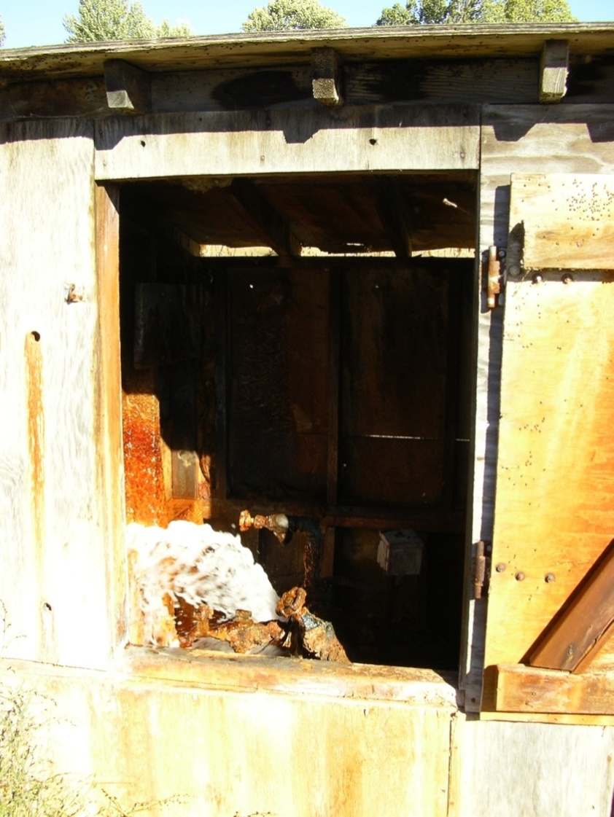
The Lithia water that is pumped to downtown Ashland originates from a chain of soda water (carbonated) springs called Lithia Springs, which are three miles east of Ashland near Emigrant Creek Road. The pumphouse for the Lithia water that is pumped to Ashland is currently on a site maintained by the Ashland Gun Club. The ground surrounding the pumphouse for the soda water spring contains deposits of tufa, which is a porous and impure limestone deposit. Although limestone is not known to be present in the underlying rocks, carbon dioxide emissions are associated with volcanic activity, and the soda spring water may be moving through coal and volcanic bedrock to finally emerge at Lithia Springs.¹
Figure 3. Pumphouse used to pump Lithia water to downtown Ashland
Lithia water has an acidic effervescence, and its taste is salty and bitter, much like Alka-Seltzer tablets. Freshly collected Lithia water also has a slight sulfurous odor and taste.
References:
- Wagner, N. S. Natural Sources of Carbon Dioxide in Oregon. Oregon Geology 1959, 21, 103-113.
Questions:
Q8. If the Lithia spring water was to leach ions from limestone deposits to form soda springs, what primary cations and anions would you expect to have dissolved in the spring water due to such leaching action?
Q9. Soda springs are characterized by significant levels of CO₂. If the pH of a recently obtained sample of Lithia water is 6.4, draw a ladder diagram for carbonic acid, and predict the predominant form of carbonic acid in this sample of Lithia water.

Sample Handling & Treatment
Sometimes, freshly obtained samples need to be immediately treated with a reagent prior to chemical analysis in order to minimize changes in analyte concentration during sample storage. Long-term changes in analyte concentration may be due to physical considerations such as evaporation, but short-term changes in analyte concentration are often a result of a chemical reaction. Oxidation-reduction reactions change the oxidation state of an analyte, and can lead to a decrease in the concentration of an analyte via precipitation of less soluble compounds.
Q10. Answer Q1 – Q13 in the Chemical Equilibria and Sample Preparation document of the Lithia water module. After completing these questions, go online to the U.S. Environmental Protection Agency website (www.epa.gov) and search for documentation regarding the preservation of inorganic analytes in water samples.
Q11. Based on your search results on the U.S. EPA website and your answer to question 13 in the Chemical Equilibria and Sample Preparation document, develop a sampling plan for Lithia water so that all significant analytes can be determined.
Activity 1. At this point, if you are going to have your students analyze some of the constituents of a local water source, it would be an appropriate time to have them collect the samples. If students are interested in investigating changes in sample appearance upon standing, students should obtain a small, clean Nalgene bottle (60 – 250 mL capacity) and rinse it thoroughly with the water sample. After rinsing, fill the bottle completely with water and cap it tightly. Students should record any observations regarding the appearance of the water immediately after collection and a day or two afterwards. They should measure the pH of the water sample and record that value in their laboratory notebook. If students have already developed a sampling plan, appropriate steps should be taken to properly clean sample containers and preserve samples as needed.

