INSTRUCTOR MANUAL
End Creek: spotted frogs and aquatic snails in wetlands
Table of Contents
Page #
Overview on the use of this module 1
Answers to questions
Identifying the Problem 2
Sampling 3
Sample pretreatment 10
Choosing the method of analysis 13
Analysis of cations by atomic spectroscopy 15
Analysis of anions by spectrophotometry 18
Statistical data analysis 29
Experimental procedure 34

OVERVIEW ON THE USE OF THIS MODULE
This module is designed to guide students to investigate the role that water quality may have on the survival of aquatic species such as frogs and snails. It is developed based on water monitoring activities conducted in wetlands areas in eastern Oregon that were recently reclaimed and restored after many years of agricultural usage. Through this module, students are introduced to fundamental concepts related to sampling as well as analytical methods for the determination of cations and anions in water such as spectrophotometry, atomic absorption spectroscopy, and ion selective electrodes. These materials are designed to be modular in their format and used relatively independently. They can also be implemented at different levels of guidance to students. For example, instructors in a general chemistry course could use the module to introduce the research question but provide students with an already developed sampling plan and detailed instructions to conduct experiments. Alternatively, in a more advanced analytical course, students could be asked to develop and implement the sampling plan as well as research the most appropriate methodologies of analysis. A complete dataset is available that can be used for learning as simple tasks as constructing a calibration curve and predicting the concentration of an analyte in an unknown sample or more advanced statistical data analysis.
These materials could also be used in the classroom as active learning exercises or used as supplement to laboratory experiences, as a prelab for existing experiments or a drylab where the relevant instrumentation is not available.

ANSWERS TO QUESTIONS
Identifying the Problem
This module provides background information about the Columbia Spotted frogs and aquatic snails found at the End Creek Wetland Restoration area. Surveys data are provided suggesting a decline in frog population and different distributions of aquatic snails in different ponds.
Q1. What are some possible water quality parameters that could affect invertebrate and amphibian populations in a fresh water environment? You may want to research if any information is available on recommended levels of specific ions that may positively or negatively impact these populations.
This question could be posed to students before any further information is provided. They could be guided to research the effect that nutrients such as nitrogen and phosphorous, pH, dissolved oxygen, levels of calcium and magnesium and dissolved solids could have on amphibians and invertebrates. An initial awareness of EPA regulations for some of these parameters could also be developed at this point. A great resource is the EPA Volunteer Stream Monitoring: A Methods Manual (http://water.epa.gov/type/rsl/monitoring/stream_index.cfm).
The main research questions that will guide all subsequent modules are:
- Is water quality at the End Creek ponds potentially responsible for the decrease observed in spotted frog population?
- Are there differences in water chemistry that influence snail family distribution in the ponds at End Creek?
Like most real scientific questions, these are complex ones! To our knowledge there are no definite answers and there may in fact be a variety of contributing factors that affect these populations. Even if only one or two of the modules will be used in your course, it would probably be useful to start with the Identifying the Problem unit to provide a context for the other sections.
Identifying Possible Analysis Methods
It is useful to have students explore the possible analytical methods that might be used to measure cations and anions involved in water quality assessment.
If this exercise is used in general chemistry, the experimental procedures (see experimental procedures section) may be made available to students. If the module is covered toward the end of an analytical chemistry course, students may be asked to go back through each method that was covered in the course and explain whether or not it might work for the analysis of the species in question.
An alternative is to ask students to go to the scientific literature and find possible methods for the analysis. In this format, it is probably best to divide the class into groups and give each group one of the cations or anions to analyze. After completion of the assignment, each group can report their findings to the rest of the class. This can lead to a useful discussion of the strengths and weaknesses of the various methods they identify. This discussion may turn up methods that are not covered or emphasized in the course and lead to the introduction of other analysis methods that are usually not discussed.
Sampling
After discussing the Identifying the Problem module and the first page of the Sampling section, students can work in groups on the questions that are provided. The answers to the questions are provided below.
Q1. What key questions must be considered when designing a sampling plan?
Students should be given time to brainstorm on key issues to consider when designing a sampling plan. The instructor may want to provide the answers listed below only after the students may have had a chance to come up with their own answers. Eventually students should be guided to consider issues such as:
1. Where in the ponds should we collect water samples?
2. What type of samples should we collect?
3. When should we collect the sample?
4. What is the minimum amount of sample for each analysis?
5. How many samples should we analyze?
6. How can we minimize the overall variance for the analysis?
Q2. Pick eight random samples from the grid laid out above. How do you ensure you sampling is random?


One way to get random samples is to use Excel. To get 8 random grids label the boxes 1-8, row 1, 9-16, row 2, etc. for 64 boxes. Then use Excel to generate 8 random numbers between 1 and 64; for example: 63, 35, 25, 46, 7, 53, 43, 5.
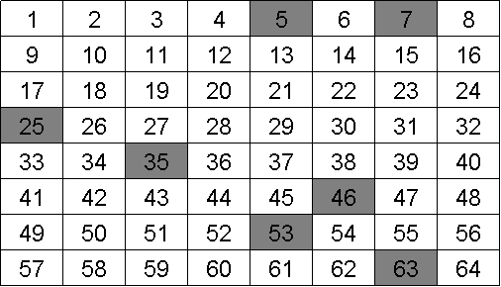
You might ask the students to discuss whether they think a random approach represents the best way to sample. They may realize that the answer depends in part on what you may already know about the system you are sampling. If there is a specific or point source of the chemical, then random sampling might not be the best option.
Now take a look at the following grids with the analyte of interest identified (colored squares).
 | 1 | 2 | 3 | 4 | 5 | 6 | 7 | 8
1
2
3
4
5
6
7
8
Grid A
 | 1 | 2 | 3 | 4 | 5 | 6 | 7 | 8
1
2
3
4
5
6
7
8
Grid B

Q3. Would you consider the samples above to be heterogeneous or homogeneous?
The analyte is heterogeneous because it is not evenly distributed throughout the entire grid.
Q4. Did your random sampling affect the potential accuracy or precision of your measurement of the analyte for the samples in grid A or grid B? If so how?
The random sampling would have been better for grid B because the analyte is more spread out than in grid A where the analyte is confined or stratified.
Q5. Each of the previous grids is an example of one of these cases. Can you identify which sample is which?
Sample B exhibits constitutional heterogeneity while Sample A exhibits distributional heterogeneity.
Q6. How does distribution heterogeneity affect accuracy and precision?
The answer to Q6 is included with the answer to Q7 below.
Q7. How does constitutional heterogeneity affect accuracy and precision?
When you overlay the sampling scheme with Sample A and Sample B neither sampling scheme is effective, as shown below. The analyte in sample “A” was sampled once (35) as it was in Sample “B” (53). With either sample, unless the sampling scheme could take this heterogeneity into account, the accuracy and precision of the measurement would be compromised.
A. Distributional Heterogeneity B. Constitutional Heterogeneity
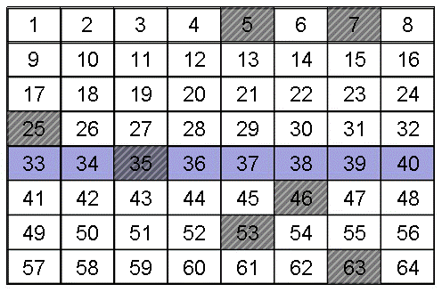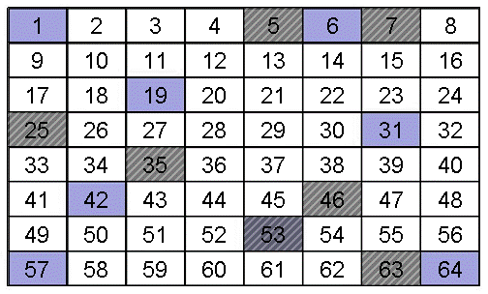
Q8. Do you see a scenario where distribution heterogeneity could be magnified by mixing and/or sampling?
Sampling is often by weight or by “grab”. In this case settling may alter the sample composition.
Q9. What is the advantage of implementing judgmental sampling over random sampling if one knows the point source for the discharge an analyte into a system?
The advantage is that you can get larger number of relevant samples which should decrease the standard deviation of the average value measured for that sample. The cost should also decrease.
Q10. Assume you have chosen a selective sampling plan to evaluate pollution from a point source into a pond. Use the diagram below and words to describe your sampling plan.
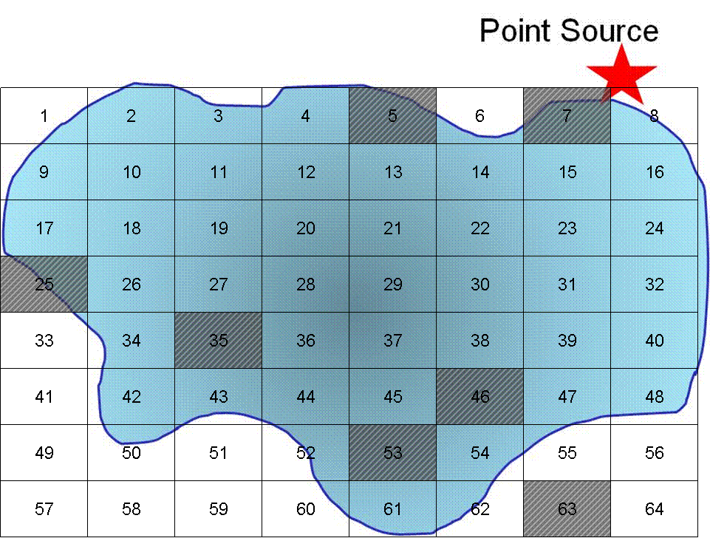
If we use a purely random grid over the pond we will be unable to tell what the effect of the point source is because we would have sampled only once at the source.
A selective method might be the following:
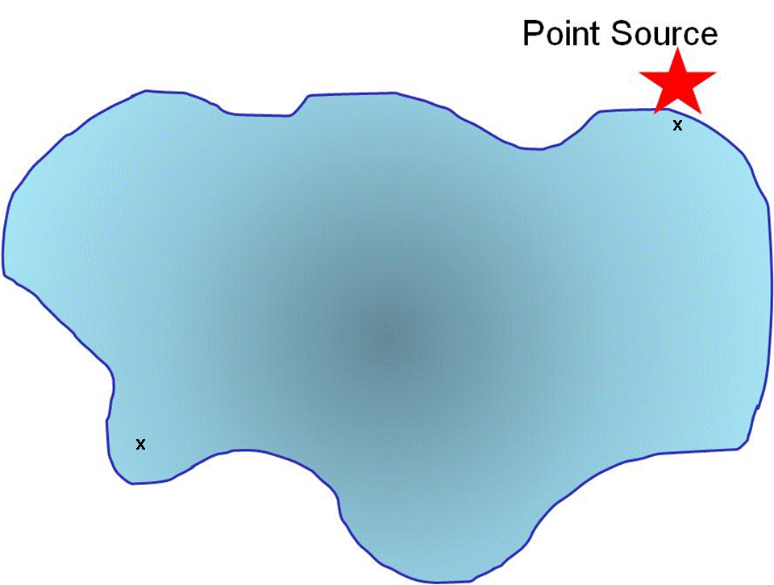
A sample is taken at the point source and for comparison a sample is taken at a distance from the point source.
Q11. Use a grid design (as we have previously done) to show how you would conduct systematic sampling (regular intervals in space and time) of the pollutant. Is there an advantage to what you might learn using this sampling method? What are the disadvantage(s)?
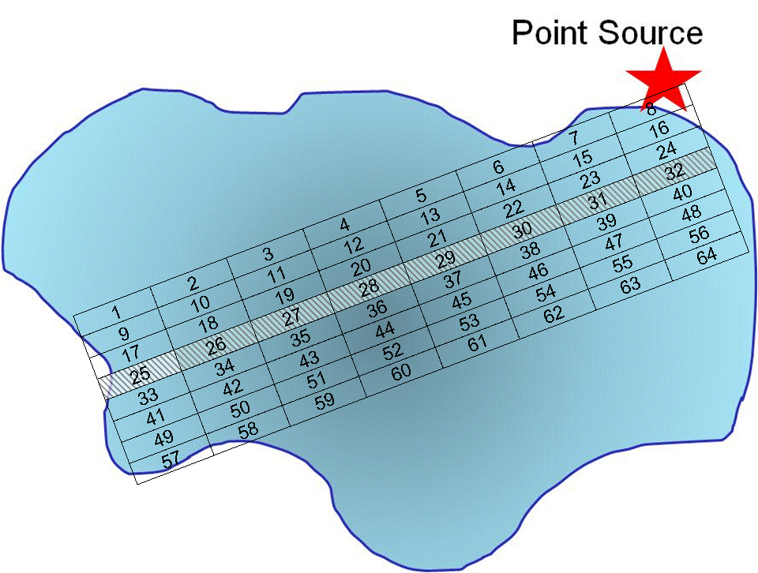
Here we have set up a grid along regular intervals. Because we collect only 8 samples, we may or may not collect a representative sample from within each grid point as we are only collecting one sample.
Q12. Describe how stratified sampling (random sampling within sub populations) might be applied to evaluate the pollutant in the lake? In general, what is the advantage of stratified sampling over cluster sampling?
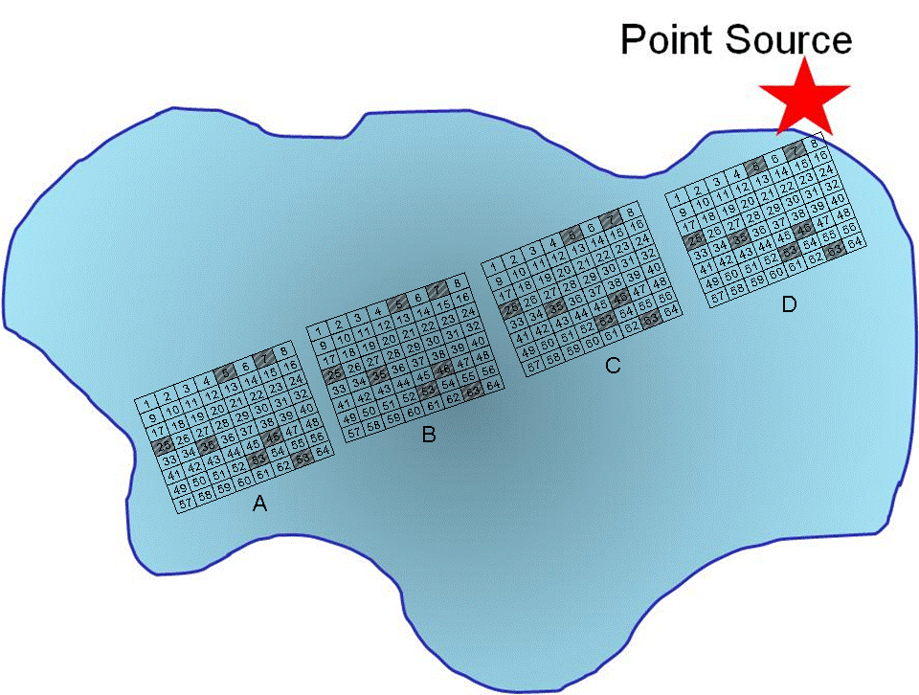
In this example the trajectory along the longest distance from the point source is sampled a total of four times, with random grabs to be co-joined into a single sample.
Q13. What is the main disadvantage of grab and composite samples?
You cannot use them continuously for real time in situ monitoring.
Q14. Can you think of any control studies you might want to include when compositing samples?
You might want to retain portions of the grabs and analyze them separately.
Q15. Does the EPA Volunteer Stream Monitoring web site suggest a particular sampling method?
The EPA Volunteer Stream Monitoring web site does not describe a particular sampling method because each sampling plan must be designed for the specific analytical question being addressed.
Q16. Based on the graph above, describe a sampling procedure that would allow you to obtain a representative sample.
A strategy would be to collect multiple samples at regular intervals of time during a 24-hour span of time.
Q17. Is there any systematic pattern to the data in the graph above?
There is not a systematic pattern although spikes in pH appear more prominent in late fall and winter and early summer months.
Q18. Can you think of some event(s) that may account for the acidic spikes in the pH?
Spikes may be due to acidic snow or rain fall.
Q19. How would this pH data affect when you might choose to sample a site to assess if acid rain is impacting the ecosystem?
Sampling would have to be conducted at regular intervals to account for known fluctuations. If historical data are available, they may aid in better understanding the impact of any changes in pH.
Q20. Describe what else you would need to know to determine when to perform your sample collection if you are addressing whether acid rain is impacting a site. What other data might you need to look up or consider that would contribute to the changes in pH? Would this data affect when you choose to sample?
One consideration is the natural pH functions due to changes in CO₂. In the early morning CO₂ levels tends to be higher due to respiration that occurs during night time. As sun rises, plants and algae begin photosynthesis thereby consuming CO₂ and causing the pH to rise (more basic) as the day progresses. Algae blooms can significantly increase this effect.
Q21. What physical or chemical processes might contribute to the pH fluctuations? How might this affect your sampling plan?
As stated above, CO₂ functions may affect pH. Water temperature affects solubility of gasses, thus changing the amount of CO₂ dissolved in water.
Q22. Another factor to consider is the sample handling time. Can you think of ways in which the sampling handling time may impact the concentration of species in a sample?
Some analytes may precipitate or degrade over time if the sample is not properly handled. For example, calcium and magnesium tend to precipitate as hydroxides. Therefore, sample pH will have to be adjusted below 2 if the analysis is not conducted right away. Nitrates are quickly degraded by bacteria, so concentration of nitrates may change over time if the sample is not refrigerated.
Q23. It is known from analyses conducted in 2008 that the % relative sampling error for water hardness by EDTA titration is 0.8%. How many samples should you collect to limit the relative standard deviation for sampling to 1.0% within the 95% confidence level? Is this a feasible task?
Answering this question requires reading Harvey, specifically section 7.B4.
The minimum number of samples can be calculated using the equation:
n_{samp} = t²s² _{samp}
e²
where t is the value for the t test which depends on the confidence level, s_{samp} is the relative standard deviation for sampling, and e is the percent relative sampling error.
Because the value of t depends on n_{samp}, the solution is found iteratively. We start for a value of n = ∞ and t (0.05, ∞) = 1.960.
n_{samp} = (1.960)²(1.0)² = 6.0
(0.8)²
Letting n_{samp} = 6, t (0.05, 6) = 2.447
n_{samp} = (2.447)²(1.0)² = 9
(0.8)²
Letting n_{samp} = 9, t (0.05, 9) = 2.262
n_{samp} = (2.262)²(1.0)² = 8
(0.8)²
Letting n_{samp} = 8, t (0.05, 8) = 2.306
n_{samp} = (2.306)²(1.0)² = 8
(0.8)²
Because two successive calculations give the same value for s_{samp}, we have an iterative solution to the problem. We need at least 8 samples to achieve a percent relative sampling error of ±0.80% at the 95% confidence level.
Q24. If the cost of collecting a sample is $20 and the cost of analyzing a sample is $50 what budget should you allocate for the project and what sampling strategy would be most effective for the given number of samples?
If we have 8 samples, the cost of collecting will be $160 and cost of analysis $400, for a total of $560. Most effective sampling plan would be judgmental.

Q25. Below is a picture of one of the three ponds at End Creek. Design your sampling plan. Think about random, systematic, clustering, etc. sample strategies. Will you take grab samples or pool samples together?
One way to use this question is to have the students discuss these questions in groups and put together a final plan. The plans could either be presented to the class or turned in as a graded written assignment.
The last part of this module discusses proper preparation of sampling containers. The procedures included within this guide adhere to EPA guidelines for water monitoring.
Q26. Why are different procedures recommended? For which analytes is acid washing required and why? What is the purpose of using a phosphate-free detergent?
To answer this question, students may be directed to the EPA Monitoring and Assessing Water Quality website (http://water.epa.gov/type/rsl/monitoring/vms50.cfm). Acid washing is required for nitrate and phosphate analyses. Obviously, phosphate-free detergent is necessary to eliminate any possible contributions of phosphate that may have adhered to the container during washing. Acid washing will remove any traces of nitrates or phosphates from containers.
Q27. For some analytes such as phosphorous, plastic containers made of either high-density polyethylene or polypropylene might be preferable to glass. Why would this be the case? In addition, the EPA states that all containers and glassware must be “dedicated” to a specific analysis. What would be the drawback of reusing glassware for a different analysis?
Glass and some types of plastic containers have positive ion-exchange sites that can interact with negative ions in solution. Phosphate can therefore adhere to the surface of glass and be lost. Phosphorous is also known to leach out of glass containers. Rinsing containers with dilute HCl helps saturate the sites and minimize losses due to adsorption.
Since most of the analyses are performed at trace level, dedicated containers should be used to avoid cross contamination.

Sample Pretreatment
Q1. Under what conditions should the water samples be stored and within what time frame should the samples be analyzed?
Students should be encouraged to research guidelines for sample storage and time frame within which analyses need to be completed before the sample degrades. They will soon realize that conditions vary dramatically depending on the analyte. For example, metals solutions, once acidified, are stable for several months, while, as in the case of nitrate, analysis needs to be completed immediately if possible but no later than 48 hours. The table included in the module may be a good starting point for a discussion.
Q2. What changes could take place that would cause sample degradation?
Many physical and chemical changes can occur if a sample is not stored properly. Temperature, light exposure or pH conditions may contribute to sample degradation. For example, metals can precipitate as hydroxides if the sample is not acidified. Ammonia can be lost from samples that are not refrigerated or acidified.
Q3. No preservation method is required for nitrates. However, a water sample can only be stored for up to 48 hours. What possible degradation could occur over an extended period of time? What chemical preservative could be added to prolong the life of the sample? How could you devise an experiment to test whether compositional changes for nitrates occur over time?
Natural waters contain bacteria that will use nitrates as nitrogen source. Refrigeration will slow down nitrate degradation and acidification of the sample also prolongs the sample over a longer period of time. Students can be guided to design an experiment where the concentration of nitrates is measured at regular intervals of time to determine the degradation rate. Students should also consider that such rate will vary depending on the specific bacteria population and other parameters such was water temperature and pH.
Q4. Cr(VI) must be analyzed within 24 hours. What might happen to compromise the analysis of Cr(VI) if the samples were held only longer before completing the analysis?
Chromium (VI) is a strong oxidizing agent. That means that it will readily react with any species and be reduced to chromium (V) or chromium (III).
Q5. Preservation of water samples for metals analysis requires acidification with nitric acid below pH 2. Why is this procedure required for analysis of calcium and magnesium?
Calcium and magnesium will form hydroxides. In the next question students are asked to compare the solubility of Ca(OH)₂ and Mg(OH)₂ at pH 2 and pH 8. They may be further asked to evaluate an ideal pH value where the solubility becomes large enough to not pose a problem of potential precipitation.
Q6. Compare the solubility of Ca(OH)₂ and Mg(OH)₂ at pH 2 and pH 8. What could happen to the Ca²⁺ and Mg²⁺ ions stored over time if the pH was not adjusted to an acidic value?
The solubility equilibrium established in a saturated solution of Ca(OH)₂ is:
Ca(OH)₂ (s) ↔ Ca²⁺ (aq) + 2 OH⁻ (aq)
The equilibrium constant expression for Ca(OH)₂ is:
K_{sp} = [Ca²⁺] [OH⁻]²
The molar solubility of Ca(OH)₂ can be defined as [Ca²⁺] because dissolving one mole of Ca(OH)₂ provides one mole of calcium ions. Solving for the molar solubility of Ca(OH)₂ may be accomplished using the following steps.
For pH = 2
[H⁺] = 10^{-pH} = 10⁻² = 0.01 M

[OH⁻] = K_{w} = 1.0 x 10⁻¹⁴ = 1.0 x 10⁻¹² M
[H⁺] 0.01 M
[Ca²⁺] = K_{sp} = 6.5 x 10⁻⁶ = 6.5 x 10¹⁸ M
[OH⁻]² (1.0 x 10⁻¹² M)²
For pH = 8
[H⁺] = 10^{-pH} = 10⁻⁸ = 1.0 x 10⁻⁸ M
[OH⁻] = K_{w} = 1.0 x 10⁻¹⁴ = 1.0 x 10⁻⁶ M
[H⁺] (1.0 x 10⁻⁸ M)
[Ca²⁺] = K_{sp} = 6.5 x 10⁻⁶ = 6.5 x 10⁶ M
[OH⁻]² (1.0 x 10⁻⁶ M)²
Similar calculations can be carried out for magnesium.
The table below summarizes the solubilities of calcium and magnesium hydroxides at pH 2 and 8.
 |  | Molar Solubility (M)
Salt | K_{sp} | pH 8 | pH 2
Ca(OH)₂ | 6.5 x 10⁻⁶ | 6.5 x 10² | 6.5 x 10¹⁸
Mg(OH)₂ | 7.1 x 10⁻¹² | 7.1 | 7.1 x 10¹²

One can observe that the solubility of metal hydroxides increases with decreasing pH. In fact, metal hydroxides that have a cation with an oxidation state of +2 exhibit a one hundred-fold increase in their solubility for every unit decrease in pH. Metal hydroxides that have a cation with an oxidation state of +3 exhibit a one thousand-fold increase in their solubility for every unit decrease in pH. Therefore, acidification of the samples is needed to keep calcium and magnesium dissolved in water samples from precipitating over times as hydroxides, thus decreasing the actual amount of these ions and providing an inaccurate estimate of their concentration.
Note that for salts having a relatively large K_{sp} or under acidic conditions, the predicted molar solubility and mass solubility are unrealistically large. In these cases, the solubility is no longer dependent on the solubility equilibrium but on the number of moles of solvent required to interact with each mole of solute. The molarity of water is 55.6 M, and each ion would be surrounded by several molecules of water. It is, therefore, unreasonable to expect that the solute concentration under low pH conditions would exceed several moles per liter.

Choosing the method of analysis
Q1: What general criteria would you consider when selecting an appropriate analysis method?

Students should be given the time to brainstorm and then research criteria that will aid in selecting the appropriate method of analysis. Some of these considerations include: accuracy, precision, sensitivity, selectivity, robustness, ruggedness, scale of operation, analysis time, availability of equipment, and cost. Depending on the level of students, this may be a simple review of concepts already learned in an analytical course or may require a more in depth discussion before proceeding to the next assignment.

The following questions are part of an assignment where students divided in groups are assigned a specific analyte (calcium and magnesium, phosphates or nitrates) and are asked to research the literature and identify an appropriate method of analysis. Therefore, answers to the following questions are specific to the assigned analyte and the method students end up identifying.
Q2: What analytical methods are best suited to provide the information about your analyte?
Here students would have to consider whether the identified method works well with the physical and chemical state of the sample. Most importantly, they would have to consider the possible concentration range of the analyte in the sample and whether the method is sensitive enough to grant detection. Accuracy and precision will also be a factor and whether one would want a rough estimate of the concentration or a very accurate determination.
Q3: Of these, which techniques/instruments are available for the analysis?
This practical consideration is very important if the analysis is actually carried out as part of the laboratory experience. Students may soon realize that they may have to opt for less desirable methods if a certain piece of equipment is not available.
Q4: Are there cost or timing issues that will influence the choice of method?
Again, this practical consideration is very important, particularly if students are expected to perform the analyses. They may want to research cost of reagents and estimate analysis time. They should develop a clear picture of all that is involved before starting any experiments.
Q5: Do the available methods have sufficient selectivity for the type of sample
that will be analyzed?
Students may be unfamiliar with concepts of interference. They should be guided to research the selectivity of a given method and identify whether possible interferents in the sample could affect the analysis outcome.
Q6: What sample pretreatment will be required?
In general, water samples for analysis of cations and anions do not require extensive sample pretreatment. However, students should consider some simple, yet necessary strategies such as filtering the water sample, particularly if large amounts of suspended solids or debris are present.
Q7: What sample size (mass or volume) is needed, and can that be feasibly collected?
Usually, published methods of analysis will specify the amount of sample to collect. If students complete the “sampling” unit of this module, and have been asked to develop a sampling plan, these considerations may have already been discussed.
Q8: What is the anticipated range of analyte concentrations?
It may be difficult for students to answer this question if they are unfamiliar with typical concentrations of the specific analyte in the sample. For water monitoring a good starting point are the EPA regulations which state the concentration limits for compliance.
Q9: What is the limit of detection of the method and is its dynamic range appropriate for the range of concentrations of the analyte?
Answering this question may require a review of the limit of detection and dynamic range concepts. Again, the EPA regulations may aid in deciding whether the method is suitable for the expected concentration of the analyte.
Q10: What is the precision of the method?
A published method will indicate the attainable precision. This question may also be used to spur a discussion about the precision needed in the results. Is the analysis being used to develop a rough idea of the analyte concentration or is a high level of precision needed?
Q11: Is there a target concentration that is important for regulatory purposes?
This question ties well with questions 8 and 9. If students reviewed the EPA regulations for that particular analyte, they may be already aware of limits imposed by the agency and have identified a target concentration.
Q12: Is the analyte in a form (solid, liquid, gas) suitable for the analytical method
that you have selected?
Liquid samples, as those collected for water monitoring purposes, are amenable to analysis by multiple techniques. However, samples in the solid or gas phase may pose additional challenges that students may be guided to consider.
Q13: How will the method be validated?
The concept of method validation is very important as validation is required by Good Laboratory Practices (GLP). Validation ensures that the method provides accurate and precise results at a given confidence level. Typically, a method will be validated by analyzing a standard that closely matches the analyte of interest. Alternatively, the method can be validated by comparing the results with those provided by a different method whose accuracy is known.
Q14: What type of calibration will be used?
This question may be used to review or introduce different calibration approaches, including external standard and standard addition methods.
Q15: Do any of the reagents used need to be standardized?
Standardization is paramount in the success of an analysis. Students may be asked to research how to obtain a standard such as buying it from a commercial supplier or preparing it in lab. A discussion of primary vs. secondary standards may be appropriate.
Q16: Can a reference standard be used to ensure accuracy?
Appropriate reference standards are indeed what is used to check the accuracy of a given method.

Analysis of Cations by Atomic Spectroscopy
The focus of this unit is on basic concepts of atomic spectroscopy. The unit could be used to introduce the technique as an active learning classroom activity or assigned as supplemental material in preparation of the lab experiment involving the determination of calcium and magnesium in water samples.
Q1: Based on the description above, draw a block diagram and label the parts of a flame atomic absorption spectrophotometer.
A simple diagram may look like:
Radiation source
Atomizer
flame or graphite furnace

Detector
Signal
Processor
Wavelength
Selector

Q2. Write the electron configuration for calcium (Ca, element number 20). In what atomic orbital do the electrons with the most energy reside?

The electronic configuration of calcium is 1s²2s²2p⁶3s²3p⁶4s². The electrons with most energy are located in the 4s orbital.

Q3. Calcium atoms undergo atomic absorption in the flame of the AA. Which electrons absorb the energy from the source?
Most likely the electrons in the 4s orbitals are responsible for absorbing the energy from the source.

Q4. Identify some possible absorption transitions for calcium.

Upon absorption of radiation, electrons in the 4s orbitals will be promoted to higher energy levels such as 3d, 4p and 5p. For example, the main calcium transition at 422.7 nm is due to electrons being promoted to the 5p orbital.

Q5. Given that the energy difference between the ground state and the first excited electronic state (ΔE) for the calcium atom is 4.687 × 10⁻¹⁹ J, calculate the frequency, ν, corresponding to a photon possessing this energy. Next, calculate the wavelength (in nm) for this photon.

Using Planck’s equation ΔE = hν where h is 6.626 x 10⁻³⁴ J s one can calculate the frequency ν:

ν = (4.687 × 10⁻¹⁹ J) / (6.626 x 10⁻³⁴ J s) = 7.07 x 10¹⁴ s⁻¹

The wavelength associated with this photon will be:
λ = c/ν λ = (2.99 x 10⁸ m/s) / (7.07 x 10¹⁴ s⁻¹) = 4.23 x 10⁻⁷ m or 423 nm

Q6. Why do you think a “slot” burner is used instead of the configuration of a traditional Bunsen burner?
A slot burner allows for a longer optical path length and a stable flame. Since atomic absorptions measurements are based on Beer’s law (A = ε b c where b is the path length), any increase of path length will increase the strength of the signal and therefore the sensitivity of the analysis. A stable flame minimizes uncertainty due to fluctuations in the flame.
Q7 - Do calcium and magnesium absorb at the same wavelength?
No, calcium absorbs in the visible range at 422.7 nm while magnesium absorbs in the UV at 285.2 nm
Q8 – How will this affect the ability to determine both metals simultaneously?
Atomic absorption spectrophotometry will not allow for the simultaneous determination of calcium and magnesium. Hollow cathode lamps that emit both calcium and magnesium lines are available but the spectrophotometer will have to be tuned to the absorption wavelength of one metal, then calibrated and eventually used to determine the concentration of the metal in the unknown sample. To measure the other metal, the same procedure will have to be conducted at a different wavelength.
Q9: How would this type of relationship help you in determining the concentration of Ca²⁺ and Mg²⁺ in an unknown water sample?
Using Beer’s law a separate calibration can be developed for each metal in the proper concentration range. The calibration equation will be of the form A = mx + b where A is the absorbance, m is the slope of the calibration line, x is the concentration of the metal, and b is the intercept. Once the calibration equation is known, the concentration of any of the two metals in the unknown sample can be determined by plugging the absorption and solving for the concentration:
x = (A – b)/ m
Q10: What wavelength would you use to measure Ca²⁺? What wavelength would you use to measure Mg²⁺?
Typically, calcium is measured at 422.7 nm while magnesium is measured at 285.2 nm.
Q11: If you wanted to measure Mg²⁺ concentrations, what instrumental parameters would you need to know?
The wavelength and the monochromator’s slit width are two fundamental parameters. One would also need to research what type of gasses to use and their respective flow rates. Horizontal and vertical adjustments of the slot burner are also crucial. Horizontal adjustments ensure that the flame is aligned properly with the instrument optical path. Vertical adjustments adjust the height within the flame from which absorbance is monitored. This is important because two competing processes affect the concentration of free atoms in the flame. The more time the analyte spends in the flame, the greater the atomization efficiency; thus, the production of free atoms increases with height. On the other hand, a longer residence time allows more opportunity for the free atoms to combine with oxygen to form a molecular oxide. For an easily oxidized metal, such as Cr, the concentration of free atoms is greatest just above the burner head. For metals, such as Ag, which are difficult to oxidize, the concentration of free atoms increases steadily with height. Other atoms show concentration profiles that maximize at a characteristic height.
Q12: If you know that the concentration of calcium and magnesium in you water sample is approximately 5 to 10 ppm, suggest a strategy to appropriately calibrate the spectrophotometer for such an analysis.
This question is good to introduce the concept that, in order to use the calibration for prediction of the unknown concentration, such concentration has to fall within the concentration of the standards. Therefore, if the concentration of calcium and magnesium is expected to fall within 5 to 10 ppm, calibrations standards ranging from 1 to 20 ppm could be used. For example, a calibration curve could be constructed using standards at 1.0, 2.5, 5.0, 7.5, 10.0 and 15 ppm.
Q13: If the absorbance of an unknown water sample is found to be greater than the absorbance of the highest calcium standard used to calibrate the spectrophotometer, what steps would you take to ensure that the analysis is providing accurate results?
One cannot assume that the calibration will be linear beyond the highest standard used in the calibration. Therefore, to ensure accurate results, the sample would have to be diluted appropriately so that its absorption falls within the range measured on the calibration standards.
Q14: Considering that the sample is introduced into the flame through a very thin capillary, what step would you have to take before analyzing a surface water sample that may have small amounts of detritus?
The sample will need to be filtered to eliminate any possibility of clogging the capillary that introduces the sample in the slot burner. 0.45 μ filters are a suitable choice.

Analysis of Anions by Spectrophotometry
Q1: Draw a block diagram of the components of a spectrophotometer.
A simple diagram may look like:
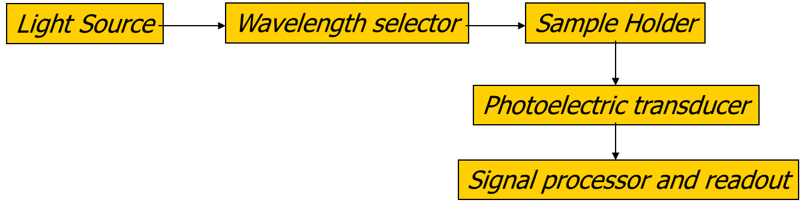
Q2: What molecular properties must a compound have in order to absorb UV-VIS radiation?
The compound must have electrons that absorb light in the UV-VIS range. For example, in organic molecules, this is due to electronic transitions from a bonding or non-bonding orbital to an empty anti-bonding. The following diagram summarizes possible absorption transitions.
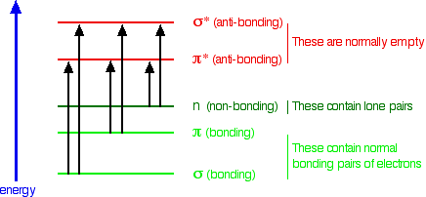
Q3: Do you think phosphate ions have the ability to absorb UV or visible radiation? Justify your answer.
Phosphate might be able to absorb light in the UV or visible range but this transition may not be very specific and therefore may not be useful for analytical determinations.

The next activity can be performed in lab using a spectrophotometer and solutions of red and blue dyes or can be simulated using the simulator at the following website http://web.mst.edu/~gbert/ColorScan/Spectrophotometry.HTML
Prepare solutions of red dye and blue dye and record their spectra between 400 and 700 nm.
- At which wavelength does the blue dye absorb the most? This wavelength is referred to as λ_{max}

The blue dye has a maximum absorption peak at approximately 630 nm.

- At which wavelength does the red dye absorb the most?

The red dye has a maximum absorption peak at approximately 520 nm.

- What is the value of the transmittance at λ_{max} for each dye? What is the value of the absorbance?

The blue dye has an absorbance at λ_{max} of approximately 0.88 and 13% transmittance.
The red dye has an absorbance at λ_{max} of approximately 1.0 and 10% transmittance.

- What wavelength would you choose to quantitatively determine the concentration of the red dye? Why did you choose this wavelength?

Since one wants to achieve the best sensitivity for the analysis, λ_{max} is the best choice. For quantitative determinations of the red dye, one would want to tune the spectrophotometer to 520 nm.

- What wavelength would you choose to quantitatively determine the concentration of blue dye? Why did you choose this wavelength?

For the same reason explained above, one would want to work at 630 nm to determine the concentration of blue dye.
Q4: Is it possible to determine the concentration of the blue dye if it is contaminated with some of the red dye?
When observing the absorption spectrum of the red dye, one can see that its absorbance at 630 nm is basically zero. Therefore, it is possible to determine the concentration of blue dye in presence of red dye because there is not an overlap of the two absorptions at λ_{max} . Beer’s law allows to calculate simultaneously the concentration of multiple analytes as long as the contribution from one component to the absorbance at the analytical wavelength of the other component is known and accounted for.
Q5: When does it become possible to selectively measure the blue dye in presence of the red dye?
When the contribution to the absorbance by the red dye at 630 nm is very small.
Q6: Draw a representative plot of A versus c if the spectrophotometer is set to λmax.
A general plot of Absorbance vs. Concentration (expressed in parts per million) will look like:

Q7: How could you use this plot to determine the concentration of an unknown?
The best fit line through the experimental points provides a calibration equation y = 0.5054x + 0.001. The concentration of any unknown can be calculated by measuring its absorbance and plugging the value in the calibrating equation and solving for the concentration (x). For example, if the absorbance of the unknown is 0.0663, the concentration would be:
$$x= \frac{0.0663-0.001}{0.5054}=0.21 ppm$$
8: What wavelength would you choose to quantitatively determine orthophosphate by the molybdenum blue method?
Looking at the absorbance spectrum, the maximum absorbance peak is between 850 and 900 nm. More specifically, a wavelength around 880 nm seems the most appropriate choice.
Q9: What potential interferences would limit the measurement of orthophosphate using the molybdenum blue method?
If there were other species that absorbed at the same wavelength, they would create an interference. However, the sample would appear blue so one would know right away that the method would not be appropriate. Another possible interference could be caused by components in the sample that would react with either ascorbic acid or ammonium paramolybdate, thus preventing the formation of the “molybdenum blue” complex.
Q10: What steps could you take in the sample preparation to decrease the chances of interfering species in the orthophosphate analysis?
If the sample was blue colored to begin with, the method could not be applied unless the blue interferent were removed by some extraction procedure. Cleaning the glassware, such as acid washing, ensure that contaminations are minimized. Other possible interferences such as suspended solids or debris that can compromise the analysis can be removed by filtration.
Q11: Looking at the interferences listed in EPA method 365.1 will any of these affect the way you will analyze your sample for orthophosphate?
According to EPA method 365.1 a potential interferent to the analysis of phosphate is iron in large concentrations. Iron can precipitate phosphate causing loss of analyte. Arsenates are also determined similarly to phosphorus and should be considered when present in concentrations higher than phosphorus. Sample turbidity should be removed by filtration prior to analysis. Any sample color in the same range as that produced by the “molybdenum blue” complex will interfere with the analysis.
Q12: Given that a stock solution of 3 mg/L phosphate (PO₄³⁻) is equivalent to a concentration of 1 mg/L of elemental phosphorous (P), how many milliliters will you have to pipette to prepare 25.00 mL of the following six standards?
Since a 0.04 mg/L concentration in elemental P is equivalent to a 0.12 mg/L PO₄³⁻ we would need:
$$3 mg/L*x=0.12 mg/L *25.00 mL$$
$$x= \frac{0.12 mg/L *25.00 mL}{3 mg/L}=1 mL$$
Similar calculations can be made to determine the volume of stock solution needed to prepare each standard. The table below provides the calculated amounts.

Standard concentration  (mg P/L) | Milliliters of phosphate standard to pipette
0.00 | 0
0.04 | 1
0.08 | 2
0.12 | 3
0.15 | 3.75
0.20 | 5

Q13: What is the purpose of preparing the standard at 0.00 mg/L P? How is it used in the analysis?
The 0.00 mg/L standard is used as the blank in the analysis to zero the response of the spectrophotometer.
Q14: The second standard is 0.04 mg P/L. How many parts per million (ppm) of P does this correspond to?
For dilute solutions mg/L is the same as parts per million. Therefore a 0.04 mg P/L is the same as a 0.04 ppm P solution.
Q15: What relationship do you observe between absorbance and concentration?
The standard calibration curve looks like:

A linear relationship between absorbance and concentration can be observed.
Q16: What parameter allows us to determine whether there is a good fit between absorbance and phosphate concentration?
The correlation coefficient, R². The closer the value to 1, the better the fit.
Q17: What is the average concentration of phosphate (expressed in mg P/L) in the pond water?
In order to calculate the average concentration of phosphate in the pond water, we need to use the calibration equation, y = 0.5054x – 0.001
For an absorbance of 0.025
$$0.025=0.5054 x-0.001$$
$$x= \frac{0.025+0.001}{0.5054}=0.051 mg P/L$$
For an absorbance of 0.027
$$0.027=0.5054 x-0.001$$
$$x= \frac{0.027+0.001}{0.5054}=0.055 mg P/L$$
For an absorbance of 0.023
$$0.023=0.5054 x-0.001$$
$$x= \frac{0.023+0.001}{0.5054}=0.047 mg P/L$$

The average of the measurement is 0.051 mg P/L
Q18: What parameter allows you to assess if the measurement above is reproducible?
The standard deviation is a measure of the reproducibility of the measurement. In the case outlined above, the standard deviation is ±0.004. A small standard deviation indicates that the result is reproducible.
Q19: How would do determine the average signal and the associated standard deviation of the method blank using the UV-VIS spectrophotometer?
A blank can be prepared that contains all reagents except for the analyte (in this case phosphate). The blank is scanned multiple times (typically 30 or above) and the average and standard deviation of all the scans is calculated.
Q20: If you determined that the average signal from the method’s blank is 0.0081 and the standard deviation is 0.0017, what is the minimum distinguishable analytical signal of the method? What is the detection limit?
The minimum distinguishable analytical signal can be calculated from the average method’s blank and its standard deviation:
(S)_{DL} = S_{mb} + 3s_{mb}
From here, the limit of detection c _{DL} can be estimated:
$$c_{DL}= \frac{S_{DL}-S_{mb}}{m}$$

In the particular case, (S)_{DL} = 0.0081 + 3(0.0017) = 0.0132
If the calibration equation is y = 0.5054x – 0.001,
$$c_{DL}= \frac{0.0132-0.0081}{0.5054}=0.01 ppm$$

Q21: Would you be able to detect phosphate in the pond water mentioned above if the absorbance of an unknown sample was 0.003?
No, it would not be possible to detect phosphate in a water sample with an absorbance of 0.003 since it falls below the minimum distinguishable analytical signal.
Q22: What are the likely advantages of automating a method?
An automated sampling method would allow a person to process many samples rapidly and with good reproducibility.

Analysis of cations and anions by Ion-Selective Electrodes (ISEs)

Q1: Will a more acidic sample displace more, the same or less Na⁺ from the hydrated gel layer?

Because H⁺ binds more strongly than Na⁺ to the –SiO⁻ function in glass, the H⁺ will displace more Na⁺. As the sample becomes more acidic, there are more H⁺ present. This greater H⁺ concentration will displace more Na⁺ from the hydrated gel.

Q2: What do you think is meant by mobility of ions?

Students will usually consider mobility to mean how well something moves around. The mobility of ions can be defined as the rate at which ions move in an applied electric field.

Q3: In a hydrated membrane, which ion do you think has a higher mobility, H⁺ or Na⁺?
The smaller an object is the more mobile it will tend to be. For ions, the mobility is inversely proportional to their effective ionic diameter. In a hydrate membrane the H₃O⁺, being larger than Na⁺, will have a smaller mobility.

Q4: Do you think other cations (e.g., Li⁺. K⁺) may have some ability to migrate into the hydrated gel layer of a pH electrode? If so, is this a problem?

Small cations such as Li⁺, Na⁺, and K⁺ can migrate into the gel layer replacing hydrogen ions and giving rise to a higher membrane potential. Hydrogen ions are replaced with sodium ions (decreasing the hydrogen ion activity), thereby artificially suppressing the true pH value. Since lithium ions are rarely present in solution and interference from the potassium ion is minimal due its larger size, sodium ions present the largest interference. This effect is therefore known as the sodium error in pH measurements.

Q5: Consider a solution that has some Na⁺ and very high concentrations of K⁺Cl⁻. What effect do you think this might have on the activity of Na⁺ in the solution?

The high concentration of K⁺Cl⁻ will affect the ionic strength of the solution, and, in turns, affect the activity coefficient of Na⁺. This effect can be calculated more formally using the extended Debye-Huckel equation (Equation 6.63 in the Harvey Analytical 2.0 text).

Q6: If the indicator electrode potential under standard conditions is -0.100 V, what is the indicator electrode potential at 298 K if the activity of the sodium ion is 0.10 M?

To answer this question, we can use the Nernst equation as in (4):

$E_{ind}= E_{ind}^{o}- \frac{RT}{nF}ln\left(\frac{1}{a_{Na}}\right)$ (4)

where E° is the indicator electrode potential under standard conditions (298 K, 1.00 M Na⁺), R is the molar gas constant (8.314 J K⁻¹ mol⁻¹) , T is the absolute temperature (K) , n is the number of moles of electrons in the half-reaction, and F is Faraday’s constant (96485 C mol⁻¹). In this particular case
$$Eind= -0.100V-\frac{\frac{8.314J}{Kmol}*298K}{1mol e-*\frac{96485C}{mol}} ln ⁡(\frac{1}{0.1M})$$

Therefore E_{ind} = -0.1591 V

Q7: How does the indicator electrode potential change in the previous question if the temperature is increased by 10 degrees?

$$Eind= -0.100V-\frac{\frac{8.314J}{Kmol}*308K}{1mol e-*\frac{96485C}{mol}}ln⁡(\frac{1}{0.1M})$$
Therefore E_{ind} = -0.1611 V
Thus, the measured potential is dependent on the temperature. Because of this temperature effect, most meters have an automatic temperature correction.

Q8: How would you go about calibrating a sodium ion selective electrode?

In order to calibrate the electrode, its response to changes in concentration is measured and recorded. There are several practical ways to accomplish this. Most ISEs are standardized by the standard addition method, where a known volume of distilled water and ionic strength adjuster is spiked with increasing concentrations of a standard solution of the analyte. The potential after each addition is recorded. The calibration is constructed by plotting the electrode potential as a function of the logarithmic transformation of the standard concentration at each addition.

The electrode could be also be calibrated using different solutions of known concentration (similar to how the pH electrode is calibrated using at least two solutions of known pH).

Q9: Can you think of a way to mitigate possible effects of ionic strength to insure that your calibration procedure and sample analysis provide an accurate measurement of the concentration of Na⁺ in the unknown?

The ionic strength needs to be rather constant, so the ionic strength is adjusted using the addition of an ionic strength adjuster solution. This solution contains a high concentration of ions that do not interfere or mask the indicator electrode response.

Q10: In the potentiometric determination of sodium ion of a mineral water sample, indicate if either of the following supporting electrolytes can be used for ionic strength adjustment: a 4.0M NH₃ – NH₄Cl buffer (pH 10) or 4.0M NaCl.

The 4.0 M NaCl would introduce sodium ions into the solution, which affects the concentration of what we are trying to measure. Therefore the ammonia buffer solution would be a better choice as ionic strength adjuster.

Q11: What would be the general criteria you would need to use in selecting a suitable supporting electrolyte for an analysis using an ion selective electrode?

One would want a supporting electrolyte that:
- is different than the analyte.
- will not interfere with the concentration of the analyte (it does not react or bind with the analyte)
- it will not mask the presence of the analyte
- the indicator electrode does not respond to it.
- it will not foul the electrode or any electrode junction.

Q12: Based on the relationship in eq 6, how would you construct a calibration that links the changes in electrode potential to changes in the concentration of the sodium ion?

In the Nernst equation (eq 6) the cell potential varies with the log of the activities. The measured electrode potential is plotted versus the log of the concentration. The line of best fit is linear. The equation of the line of best fit is used to determine the concentration of the unknown.

Q13: What is the expected slope of a potentiometric calibration curve for sodium at 35°C? What effect does temperature have on the slope of a potentiometric calibration curve?

$$Eind= E^{0}-\frac{\frac{8.314J}{Kmol}*308K}{1mol e-*\frac{96485C}{mol}} 2.303 log⁡({Na}^{+})$$

If one plots the potential as a function of logarithm in base ten (log) concentration, then the slope would be 0.0611 since ln x = 2.303 log x

Q14: If a sample has a sodium concentration of 1.0 x 10⁻³ M, and the sodium ISE has a selectivity coefficient of K_{Na,H} = 30, what sample pH would cause a 1% error in the sodium ISE response?

First calculate the E_{ind} for the solution of 1.0 x 10⁻³ M

$$E_{ind}=-.100V- \frac{0.05915}{1mol}log\left\{1x{10}^{-3}\right\}$$

$$E_{ind}=0.07745V$$

A 1% error in the response would give a$$E_{ind}=0.07822V$$

Putting this back into the original equation
$$0.07822V=-.100V- \frac{0.05915}{1mol}log\left\{x\right\}$$

Thus x = 9.70 x 10⁻⁴ M which represents the apparent sodium ion concentration due to 1% error.

Putting this into equation 8:

$K_{Analyte,Interferent}=\frac{a_{Analyte}}{{\left(a_{Interferent}\right)}^{{n_{Analyte}}/{n_{Interferent}}}}$ (8)

$$9.70 x {10}^{-4}=\left\{ K_{Analyte,Interferent}{\left(a_{Interferent}\right)}^{{n_{Analyte}}/{n_{Interferent}}}\right\}$$

$$9.70 x {10}^{-4}=\left\{ 30{\left(a_{Interferent}\right)}^{1}\right\}$$

Leads to an H⁺ concentration of 3.2 x 10⁻⁵ M, or pH 4.5

Q15: Evaluate whether it is best to use alkaline or acidic conditions to determine the sodium ion concentration by ISE?

Alkaline conditions are preferred, as in acidic conditions, a higher H⁺ activity leads to a higher % error.

Q16: The table below contains sodium ISE calibration data. If the cell potential measured in a sample is -0.115 V, determine the sodium concentration (mol L⁻¹) in this sample.

[Na⁺] (M) | E_{cell} (V vs SCE)
1.0 x 10⁻⁴ | -0.221
1.0 x 10⁻³ | -0.164
1.0 x 10⁻² | -0.107
1.0 x 10⁻¹ | -0.048

In Excel the graph would look like:

The best fit line is -0.115V = 0.0576x +0.009
The log of Na⁺ is -2.152
Thus the concentration of Na⁺ is 7.0 x 10⁻³ M

Q17: In the previous question, the sample was prepared by pipetting 5.00 mL of the original water sample and 2.00 mL of an ionic strength adjustment buffer into a 100 mL volumetric flask and diluting to the mark with distilled water. Determine the sodium concentration (mol L⁻¹) in the original water sample.

$$C_{1}*5.00mL= 7.0x{10}^{-3}M*100mL$$

Thus the original concentration is 0.14M.

STATISTICAL DATA ANALYSIS
This Excel file contains real data collected during actual experiments that can be used for the purpose of conducting a dry lab or practicing calibration and statistical data analysis. The file is organized in folders, each one containing data respectively for nitrate, phosphate, calcium and magnesium and pH. Within each folder, first a calibration set is provided so that students, using Excel or similar software, can calculate the best fit line and correlation coefficient.
Next, replicate measurements for that analyte at three different locations (North, South and East ponds) are provided so that specific concentrations can be calculated for each location.
Finally, ten independent measurements of the analyte at the three locations are provided so that mean and standard deviation can be calculated and tests of significance conducted to determine whether the results at each location are comparable.
Following are answers to some fundamental calculations:
- Nitrate (by Ion Selective Electrode)
Ion selective calibration data
Nitrate (N) concentration (mg/L) | Electrode Potential (mV)
0.1 | 144.8
0.2 | 131.0
0.4 | 115.5
0.6 | 105.2
1.0 | 93.5
2.9 | 65.8
4.7 | 52.7

Calibration equation: y = -55.504x + 91.826
R² = 0.9975
The table below shows predicted nitrate (N) concentrations based on the above calibration:
 | Electrode potential (mV) | Nitrate (N) concentration (mg/L)
North Pond | 72.6 | 2.2
North Pond | 75.1 | 2.0
North Pond | 71.5 | 2.3
South Pond | 80.1 | 1.6
South Pond | 79.2 | 1.7
South Pond | 81.5 | 1.5
East Pond | 110.6 | 0.5
East Pond | 106.1 | 0.6
East Pond | 107.3 | 0.5

These data can be used to show how to calculate the concentration in an unknown sample from the electrode potential and the calibration equation. Additional data are provided (ten independent measurements on each pond water) so that students can calculate the average and standard deviation nitrogen concentration in the three ponds. Following is a table summarizing the results.
Nitrate (N) concentrations (mg/L) as determined by ten independent measurements
North pond | South pond | East pond
2.0 ± 0.3 | 1.7 ± 0.4 | 0.7 ± 0.2

Since the original research question was to determine whether differences in water quality among different ponds affect frog and snails survival, the means obtained above could be compared using tests of significance such as an unpaired t-test.
For a more in-depth review of tests of significance, please review Chapter 4, section 4F in Analytical Chemistry 2.0 by David Harvey.
As an example, let’s compare the nitrate concentration in the North pond (2.0 ± 0.3) with the nitrate concentration in the East pond (0.7 ± 0.2). In order to run an unpaired t-test, the F-test needs to be applied first to determine whether we can pool the variances of the two sets. Since we have 10 replicate measurements in each set, we have 9 degrees of freedom (df) for each set.
F_{exp} = 0.3²/0.2² = 2.25
From Appendix 5 (Analytical Chemistry 2.0), the critical value for F(0.05,9,9) is 3.179. Since F_{exp} < F(0.05,9,9), there is no significant difference between the variances of the two datasets so we can apply the t-test.
The results of the t-test show a t_{exp} = 9.7. From Appendix 4 (Analytical Chemistry 2.0), the critical value for t(0.05,18) is 2.101. Since t_{exp} = 9.7 >than the critical value for t(0.05,18), the two means are significantly different at the 95% confidence level.
- Phosphate (by Spectrophotometry)
Phosphate (P) calibration data
Phosphate (P) concentration (mg/L) | Absorbance
0.00 | 0.0000
0.05 | 0.0164
0.10 | 0.0421
0.20 | 0.0758
0.30 | 0.1257
0.40 | 0.1657

The calibration equation is: y = 0.4184x - 0.0023
R² = 0.9974
The table below shows predicted phosphorous (P) concentrations based on the above calibration:
 | Absorbance | Phosphorous (P) concentration (mg/L)
North Pond | 0.0372 | 0.094
North Pond | 0.0375 | 0.095
North Pond | 0.0337 | 0.086
South Pond | 0.0299 | 0.077
South Pond | 0.0248 | 0.065
South Pond | 0.0258 | 0.067
East Pond | 0.0534 | 0.133
East Pond | 0.0395 | 0.100
East Pond | 0.0406 | 0.103

These data can be used to show how to calculate the concentration in an unknown sample from the absorbance measured on unknown samples and the calibration equation. Additional data are provided (ten independent measurements on each pond water) so that students can calculate the average and standard deviation phosphorous concentration in the three ponds. Following is a table summarizing the results.
Phosphorous (P) concentrations (mg/L) as determined by ten independent measurements
North pond | South pond | East pond
0.08 ± 0.02 | 0.08 ± 0.02 | 0.11 ± 0.02

These results could be used to determine whether differences in phosphorous concentrations exist among the three ponds using tests of significance, much as demonstrated for nitrogen measurements.
- Calcium and Magnesium (by Atomic Absorption Spectrophotometry)
Calcium calibration data
Calcium concentration (mg/L) | Absorbance
0.00 | 0.0000
0.50 | 0.0278
1.25 | 0.0688
2.50 | 0.1336

The calibration equation is: y = 0.0534x + 0.0009
R² = 0.9997
Magnesium calibration data
Magnesium concentration (mg/L) | Absorbance
0.00 | 0.0000
0.50 | 0.3518
1.25 | 0.8469
2.50 | 1.5068

The calibration equation is: y = 0.5997x + 0.0392
R² = 0.9953
The table below shows predicted calcium and magnesium concentrations based on the above calibrations:
 | Calcium Absorbance | Calcium  Concentration  (mg/L) | Magnesium Absorbance | Calcium concentration (mg/L)
North Pond | 0.1290 | 2.4 | 0.7992* | 2.5
North Pond | 0.1243 | 2.3 | 0.7812* | 2.5
North Pond | 0.1276 | 2.4 | 0.8089* | 2.6
South Pond | 0.0725* | 2.7 | 1.1786* | 3.8
South Pond | 0.0731* | 2.7 | 1.1688* | 3.8
South Pond | 0.0711* | 2.6 | 1.1899* | 3.8
East Pond | 0.0329 | 0.60 | 1.1187 | 1.8
East Pond | 0.0345 | 0.63 | 1.1089 | 1.8
East Pond | 0.0377 | 0.69 | 1.1198 | 1.8
* water sample was diluted 1:1 prior to analysis
Again, these data can be used to show how to calculate the concentration of calcium and magnesium in an unknown sample from the absorbance measured on the unknown sample and the calibration equation. Additional data are provided (ten independent measurements on each pond water) so that students can calculate the average calcium and magnesium concentration along with the standard deviation in samples collected at the three ponds. Following is a table summarizing the results.
Calcium and magnesium concentrations (mg/L) as determined by ten independent measurements
 | North pond | South pond | East pond
Calcium | 2.37 ± 0.05 | 2.70 ± 0.05 | 0.11 ± 0.02
Magnesium | 2.62 ± 0.04 | 3.80 ± 0.05 | 0.62 ± 0.03

These results could be used to determine whether differences in calcium and magnesium concentrations exist among the three ponds using tests of significance, much as demonstrated for nitrogen measurements.
- pH (electrode)
Following is a table summarizing the results of pH measurements:
pH as determined by ten independent measurements
North pond | South pond | East pond
7.44 ± 0.05 | 7.61 ± 0.03 | 7.03 ± 0.04

These results could be used to determine whether differences in pH exist among the three ponds using tests of significance.

EXPERIMENTAL PROCEDURES
The following procedures can be shared with students depending on the level of autonomy the instructor wishes to implement in lab. As stated at the beginning of this instructor manual, I share these procedures in the general chemistry lab since most students have not previously conducted analyses at this level. If the module is used in an upper division analytical course, students should be given the opportunity to research the methods of analysis and present a proposal to the instructor prior to its implementation.
Please keep in mind that the details of each experiment will have to be modified for the specific model of instrumentation used and for the concentration of each analyte in the samples.

Analysis of Nitrate by Ion Selective Electrode (ISE)
Low-level measurement procedure
Overview
In this experiment, your team will determine, quantitatively, the amount of nitrate (NO₃⁻) present in your water sample using a method based on a nitrate ion selective electrode.
Introduction
The nitrate ion is commonly found in natural aquatic ecosystems. Nitrates are a source of nitrogen that are essential for plant nutrients. However, too much nitrate can lead to significant water quality problems. Sources of pollution that may produce abnormally high nitrate concentrations include runoff from fertilizer and animal manure in agricultural areas, and certain industrial processes leading to production of corrosion-resistant metals. According to the EPA, the natural concentration of nitrates is typically less than 1 mg/L; however, in a polluted stream, the concentration can be as high as 30 mg/L.
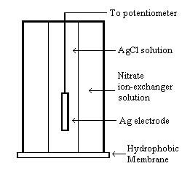
Because nitrate is such a ubiquitous ion, care must be taken to handle glassware and other containers very carefully, to prevent inadvertent contamination of natural water samples with nitrates found in the lab. All glassware must be acid-washed before it comes in contact with any nitrate standard or water sample.

To determine quantitatively the amount of nitrates present in a water sample, we will use the nitrate electrode method. A schematic of the electrode is presented in Figure 1. This method relies on a difference in concentration between nitrate inside and outside the electrode chamber. A hydrophobic (“water-hating”) membrane, saturated with a nitrate ion-exchanging compound, bring nitrate ions from the analyte solution into contact with the reference Ag/AgCl electrode. The membrane must not be allowed to “dry out,” otherwise the electrode will no longer function. Therefore, the electrode must always be immersed in a solution, either a storage solution or a solution to be measured.
Figure 1. Schematic of a nitrate ion-selective electrode.
Because the concentration of nitrate inside the electrode chamber and in the ion-exchange membrane are different, a potential difference (voltage) is established, which can be measured with a potentiometer. The voltage depends on the concentration of nitrate in the membrane, which in turn depends on the concentration of nitrate in the water sample. Empirically, it is found that the potential difference (E) is linearly proportional to the logarithm of the concentration of nitrate in the water sample (c_{nitrate}), according to Equation (1).
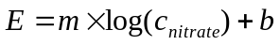 (1)
In this equation, m is the slope of the line, and b is the y-intercept. To determine the values of m and b, the voltages for a set of nitrate standards must first be measured. The plot of E vs. log(c_{nitrate}) from these measurements is a calibration curve. Then, upon measuring the voltage of the water sample, we can use the calibration curve to determine the concentration of nitrate.
Unfortunately, there are many complications to the successful use of the nitrate ion-selective electrode. First, the electrode works best in a pH range between 3 and 9, but the pH must be held constant. Second, many other anions interfere with nitrate; these are nitrite, cyanide, sulfide, bromide, iodide, chlorate, perchlorate, carbonate, and bicarbonate. Of these, nitrite is the most severe, as it may be oxidized fairly easily to nitrate. If any of these ions are also present in the water sample, they might be detected as if they were nitrate, and lead to a reading that is too high. Third, many bacteria use nitrate ions as a source of food; if these bacteria are present, the concentration of nitrates will slowly decline over time, as they digest their food. Finally, nitrates can serve as an oxidizing agent; if there are organic acids around, nitrates may react with them instead of being detected by the electrode. Before analyzing your water sample, therefore, a special nitrate buffer solution must be added. This buffer solution has a pH of 3.0, and contains reagents that will diminish (but not completely eliminate) the influence of these other complications. The nitrate buffer solution contains aluminum sulfate, silver (I) sulfate, boric acid, sulfamic acid (H₂NSO₃H), and sodium hydroxide.
The silver (I) sulfate precipitates out any interfering bromide, iodide, sulfide or cyanide that may be present.
Ag⁺(aq) + Br⁻(aq) AgBr(s)
Ag⁺(aq) + I⁻(aq) AgI(s)
2 Ag⁺(aq) + S²⁻(aq) Ag₂S(s)
Ag⁺(aq) + CN⁻(aq) AgCN(s)
The sulfamic acid reacts with nitrite ion to produce bisulfate, nitrogen gas, and water.
NO₂⁻(aq) + H₂NSO₃H(aq) HSO₄⁻(aq) + N₂(g) + H₂O(l)
The boric acid acts as a preservative, killing any bacteria present so that they don’t consume any more of the nitrates. Aluminum ion complexes with any organic acids present, so that they don’t react with nitrate. Finally, the sodium hydroxide is added to create a boric acid/sodium borate buffer with a final pH of 3.0. The pH is chosen to be acidic because under acidic conditions, carbonate and bicarbonate will react to form carbon dioxide gas and water. We can’t eliminate chlorate and perchlorate, but these are not normally found in natural waters anyway.
Materials and Equipment
- Water sample
- One nitrate ion-selective electrode connected to a potentiometer
- Nitrate ion-selective electrode storage solution
- 100 ppm nitrate standard solution
- Nitrate buffer solution
- 150-mL beakers
- Glass pipettes and pipette bulb
- 10% HCl solution

Procedure
NOTE: Use latex gloves when handling glassware and in all subsequent steps, for your protection and to prevent contamination of the glassware with nitrates from your hands.
The outline of the procedure is as follows:
- Acid wash all glassware.
- Prepare the nitrate calibration curve by measuring the voltage after addition of given amounts of 100 ppm nitrate standards.
- Measure the voltage of the water sample.
- Determine the concentration of nitrate using the measured voltage and the calibration curve.

Procedure for Acid Washing of Glassware
For each piece of glassware you will be using for this analysis, perform steps 1-4.
- Wash with a clean brush and phosphate-free detergent.
- Rinse three times with cold tap water.
- Rinse with a solution of 10% HCl.
- Rinse three times with deionized water.

Procedure for Preparation of the Nitrate Calibration Curve

Be sure you wear latex gloves to prevent contamination, and that you use only acid-washed glassware.
- Using a 100-mL volumetric flask, measure 100.00 mL of distilled water into 150-mL beaker. Using a pipette, add 1.00 mL low-level ISA solution and gently stir.
- Lower the nitrate ion-selective electrode into the solution, stir thoroughly, and record the voltage (in mV).
- Add increments of the 100.0 ppm standard to the beaker using steps outlined in the Table 1.

Table 1. Directions for preparing the calibration curve for nitrate analysis
Step | Graduated pipet size | Added volume (mL) | Concentration ppm N
1 | 1 mL | 0.1 | 0.1
2 | 1 mL | 0.1 | 0.2
3 | 1 mL | 0.2 | 0.4
4 | 1 mL | 0.2 | 0.6
5 | 1 mL | 0.4 | 1.0
6 | 2mL | 2.0 | 2.9
7 | 2mL | 2.0 | 4.7

- Once you have all of the data recorded in your lab notebook, using Excel or comparable program, prepare a calibration curve by plotting E (voltage), in mV, on the y-axis and log(c_{nitogen}) on the x-axis. At high concentrations, the data should resemble a straight line, but at low concentrations the curve may bend a little bit.

- For the region on the graph that appears linear, fit the data to a straight line and record the slope and intercept in your lab notebook. Print out the calibration curve and tape it into your lab notebook.

The slope and intercept from the calibration curve depend on temperature, concentrations of certain other ions present, and other lab conditions. Thus, if you decide to measure other water samples at different times, you first should check to make sure that the calibration of the electrode is still accurate. To do this, measure the voltage of two of your standards, the 4.7 mg/L standard and the 0.4 mg/L standard. The new voltages should be within the error range of the values that were originally measured for these two standards. If they aren’t, the entire calibration curve must be shifted upwards or downwards in order to accommodate the new values.

Procedure for the Determination of the Concentration of Nitrate in the Water Sample

- Analyze water for one site in triplicate.
- Prepare your water samples by measuring 100.00 mL of sample into the 150-mL beaker. Using a pipette, add 1.00 mL low-level ISA solution and gently stir. Be sure to record any observations (e.g., precipitation, evolution of gas, temperature changes).
- Lower the nitrate electrode in the first water sample and record the voltage measured. Repeat the measurement on the two remaining samples.
- From the calibration curve previously measured, determine the concentration of nitrate in your water sample. Express the final result as the mean and standard deviation of the three replicate measurements.

Analysis of Phosphate by Visible Spectrophotometry
Overview
In this experiment, your team will determine, quantitatively, the amount of phosphate
(PO₄³⁻) present in your water sample using an ascorbic acid/spectrophotometric-based method.

Introduction
The phosphate ion is an essential plant nutrient, and is also essential to life. However, it is often depleted in soil, and hence phosphorus is the main component in most fertilizers. Runoff from fertilizer in aquatic ecosystems may thus lead to abnormally high phosphate levels, leading to a pollution hazard.
The chemistry of phosphate is much more complicated than that of most polyatomic ions. There are many different forms of phosphorus as an ion, so the simplest one, PO₄³⁻, is termed orthophosphate. The amount of orthophosphate present may be determined by the ascorbic acid/molybdenum blue method. In this method, ammonium paramolybdate, (NH₄)₆Mo₇O₂₄∙4H₂O, reacts with orthophosphate in acidic solution and in the presence of potassium antimonyl tartrate, C₈H₄K₂O₁₂Sb₂, to produce phosphomolybdic acid, H₃[P(Mo₃O₁₀)₄]. This acid, in turn, is reduced by ascorbic acid, C₆H₈O₆, to produce intensely colored molybdenum blue. “Molybdenum blue” is actually not a single compound, but a complex mixture of polyoxomolybdate (POM) ions. The role of potassium antimonyl tartrate is as a catalyst.
12 Mo₇O₂₄⁶⁻(aq) + 7 PO₄³⁻(aq) + 93 H⁺(aq) 7 H₃[P(Mo₃O₁₀)₄](aq) + 36 H₂O(l)
H₃[P(Mo₃O₁₀)₄](aq) + C₆H₈O₆(aq) “molybdenum blue” + C₆H₆O₆(aq)
Once each orthophosphate sample has been converted into molybdenum blue, your team will then use UV/Visible spectrophotometry to measure the concentration of molybdenum blue. Recall that the absorbance (A) of a colored sample is directly related to the molar concentration (c) of the colored species according to Beer’s Law.
A = εbc (1)
In Equation (1), ε is the molar absorptivity, characteristic of a particular species, and b is the path length of the cuvette. The molar absorptivity depends on the wavelength used; for molybdenum blue, an optimal wavelength is 880 nm. To determine ε, your team will measure the absorbances of a series of standards with known orthophosphate concentration, and construct a calibration curve between the absorbance of molybdenum blue and the concentration of orthophosphate. Then, using the calibration curve, your team will determine the amount of orthophosphate present in the water sample.

Sounds simple enough, right? If only life were so simple! Aqueous phosphorus chemistry is very diverse. Under acidic conditions, orthophosphate may react to form long chains of phosphate-like ions. The simplest of these is the reaction of two orthophosphate ions to form pyrophoshate.
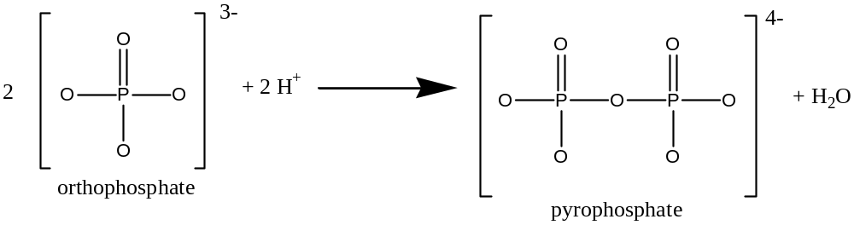
This process can be repeated to produce longer and longer phosphate-like chains. For example:
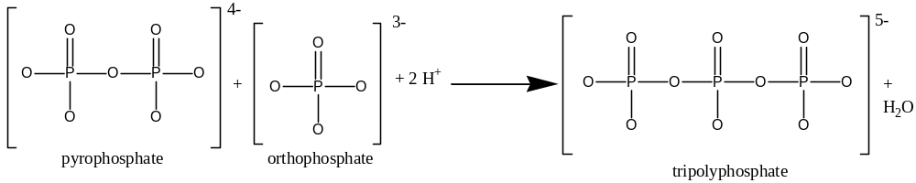To complicate matters even more, orthophosphate can also react to form ring-like structures, such as metaphosphate.
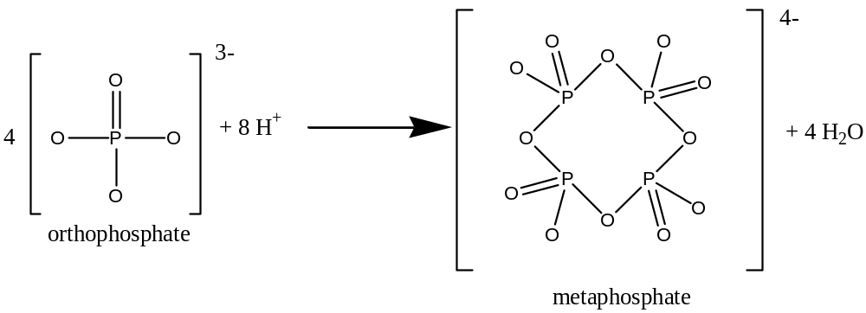
These larger chains and rings of orthophosphate-like ions don’t react with ammonium paramolybdate to form molybdenum blue, and so they won’t be detected by this method.
An additional complication arises when one considers that there are many biological processes by organisms in natural waters which can convert orthophosphate into organic forms of phosphorus, such as adenosine monophosphate (AMP). These organophosphorus compounds are unable to react with ammonium paramolybdate and form molybdenum blue, and so these as well won’t be detected by this method.

As if things weren’t bad enough, many orthophosphate compounds are insoluble, and hence remain suspended in aqueous solution. These insoluble particulates will have to be filtered out prior to analysis, and so these phosphates won’t be detected either.
Because phosphate is such a ubiquitous ion, care must be taken to handle glassware and other containers very carefully, to prevent inadvertent contamination of natural water samples with phosphates found in the lab. All glassware must be acid-washed before it comes in contact with any phosphate standard or water sample.
Materials and Equipment (provided to students)
- Water sample
- Five orthophosphate standards (expressed as mg/L P): 0.04 mg/L, 0.08 mg/L, 0.12 mg/L, 0.16 mg/L, 0.20 mg/L.
- 5 M H₂SO₄
- Phenolphthalein indicator solution
- Potassium antimonyl tartrate solution
- Ammonium molybdate solution (20 g ammonium paramolybdate tetrahydrate/500 mL water)
- Ascorbic acid solution (0.1 M)
- 10% HCl solution

Procedure
NOTE: Use latex gloves when handling glassware and in all subsequent steps, for your protection and to prevent contamination of the glassware with phosphates from your hands.
The outline of the procedure is as follows:
- Acid wash all glassware.
- Prepare the molybdenum blue reagent.
- For the water sample and for each of the five orthophosphate standards, perform the spectrophotometric analysis of molybdenum blue. This result will yield the amount of total dissolved reactive phosphorus.
- Using the data from the standards, construct a calibration curve relating absorbance to concentration of orthophosphate.
- From the calibration curve, determine the concentration of orthophosphate in the water sample.

Procedure for Acid Washing of Glassware

For each piece of glassware you will be using for this analysis:
- Wash with a clean brush and phosphate-free detergent.
- Rinse three times with cold tap water.
- Rinse with a solution of 10% HCl.
- Rinse three times with deionized water.

Procedure for the Preparation of the Molybdenum Blue Reagent with Ascorbic Acid

Using a graduated cylinder, measure 17.5 mL of molybdenum blue reagent w/o ascorbic acid and transfer to a beaker. Add 7.5 mL deionized water to the pre-weighed ascorbic acid (0.132 g). Mix well and add to the previously measured molybdenum blue reagent. You should have a total of 25.0 mL of reagent.
This solution is only stable for 4 hours. Thus, you must act quickly after preparing this reagent!

Procedure for Spectrophotometric Analysis of Orthophosphate

- Analyze water from one site at least in triplicate measurement.
- Prepare nine dry 50-mL Erlenmeyer flasks.
- Label one flask “blank” and using the 10.0 mL volumetric pipette, transfer 10.00 mL of deionized water.
- Label five flasks with the concentration of the five phosphate standards and pipette 10.00 mL of each standard in each designated flask.
- Label the remaining three flasks as “water sample” and transfer 10.00 mL of water from a specific site collected at Ladd Marsh.
- Add 1 drop of phenolphthalein indicator. If the solution turns pink, add 5 M H₂SO₄ dropwise to just discharge the color. (Make sure the eyedropper has also been acid-washed!)
- Using a pipette, add exactly 1.60 mL of molybdenum blue reagent to every flask and mix thoroughly.
- After at least 10 minutes, but not longer than 30 minutes, measure the absorbance of the solution at 880 nm.

Once you have all of the data recorded in your lab notebook, use Excel or comparable program to prepare a calibration curve by plotting A (absorbance) on the y-axis and c_{P} (concentration of P in mg/L) on the x-axis for the orthophosphate standard solutions. Fit the data to a straight line and record the slope and intercept in your lab notebook. Print out the calibration curve and tape it into your lab notebook.
Using the calibration curve, determine and report the concentration of phosphate in mg/L P in the water samples. Calculate the mean of the replicate measurements for each water sample and also report the standard deviation.
The slope and intercept from the calibration curve depend on temperature, concentrations of certain other ions present, and other lab conditions. Thus, if you decide to measure other water samples at different times, you first should check to make sure that the calibration curve is still accurate. To do this, measure the absorbance of two of your standards, the least concentrated standard and the most concentrated standard. The new absorbances should be within the error range of the values that were originally measured for these two standards. If they aren’t, the entire calibration curve must be shifted upwards or downwards in order to accommodate the new values.
Analysis of Calcium and Magnesium in Water Samples
By Atomic Absorption Spectrophotometry

Introduction
In this experiment the amount of calcium and magnesium in water samples from the End Creek ponds will be determined using an Atomic Absorption Spectrophotometer. The results of the analysis will be reported in mg/L or parts per million (ppm) calcium, magnesium and calcium carbonate. The results will be compared to those obtained by field testing. The instrument used is Flame Atomic Absorption Spectrophotometer. Before analyzing the samples, each metal will be calibrated using a series of standards.
For a tutorial on Atomic Absorption spectroscopy, please visit http://slc.umd.umich.edu/slconline/ADVAA/AdvAA.swf
Experimental
Calcium standards. Three calcium standards are provided: 2.5 ppm, 1.25 ppm and 0.5 ppm. Use these solutions to run the calibration program, and use 0.5% nitric acid as the blank.
Magnesium standards. Three magnesium standards are provided: 2.5 ppm, 1.25 ppm and 0.5 ppm solutions. Use these solutions to run the calibration program, and use 0.5% nitric acid as the blank.
Analysis of Metals
The first part of the experiment involves becoming familiar with the operation of the instrument. It is important to understand how to change the lamp and analysis program, how to optimize the energy, ignite the flame, and run the calibration program. When running the instrument, it is critical to record the lamp energy, wavelength, slit, fuel to air ratios, and absorbance. Three different samples will be analyzed. A detailed procedure of how to operate the instrument will be provided in lab.
PROCEDURE:
The following tasks will have to be accomplished in order to perform the analysis. The order and details of operation will be specific to the instrument used.
- Load and activate the method ( a different method will have to be used for calcium and magnesium)
- Maximizing the lamp energy
- Set the correct wavelength and slit specified by the method
- Align the lamp until the energy is maximized. Most lamps will give energies in the range of 2.5 to 4.5. A normal reading for calcium is 4.2 and for magnesium is 3.2.
- Ignite the flame (acetylene and air will be used)
- Construct a calibration curve using the provided standards (this will be repeated for each metal)
- Analyze the water samples. Prepare three different water samples from the same sampling site. Aspirate the first sample being analyzed. The instrument display will show the concentration of the metal in the sample in ppm as well as the absorbance of the sample. Record the concentration in ppm. Take at least three readings for each sample. Analyze the other two samples in the same way, by aspirating the sample and taking readings. Press esc when done.
- Aspirate deionized water to clean the lines. Turn the fuel off to extinguish the flame. Run the air with DI water for a few seconds and then turn the air off.
- Analyze the same samples for the presence of other metals.

Once the samples have been analyzed for calcium and magnesium, place the rest of the samples in the proper waste container.
Using Excel or comparable program, construct a calibration curve for calcium and one for magnesium. Print each calibration curve and include in your lab notebook. Use the calibration curve to determine the concentration of each metal in each analyzed sample. Finally, report the average concentration of Ca²⁺, Mg²⁺ and total CaCO₃ in mg/L with the standard deviation. Compare the concentrations obtained by AA with those obtained in the field by Hach kit.
In your report research the different levels of water hardness and determine whether the water from your sampling site can be considered soft, medium hard or hard.

