Out-of-class exercise for Concentration Calibration Modular Unit

Using Flavonoid Content as a way of Predicting Health Benefits of Plant-based Food

Developed by Sandra Barnes

Instructions: Read the following information and answer the questions at the end of the module.

Using Flavonoid Content as a way of Predicting Health Benefits of Plant-based Food
Basic information about flavonoids

- Flavonoids are polyphenolic secondary plant metabolites. They serve a variety of functions in plants, such as protection from UV radiation, signals for pollinators, selective admittance of blue-green and red light for photosynthesis, and plant defense. Thousands of individual flavonoid compounds are known, but the core structure is based on three cyclic rings A, B, and C, as shown below. The A ring is synthesized from the malonate pathway and the B ring and majority of the C ring are synthesized from the Shikimic acid pathway via phenylalanine.
- Flavonoids can be classified as flavonols, flavones, isoflavones, flavanals, procyanidins, tannins, and anthocyanins based mainly on the number and placement of –OH and –OCH3 groups to the core ring structure. The flavonol compound quercetin is the most commonly found and widespread flavonoid in plant-based food; therefore, it is commonly used as a standard compound when analyzing and comparing flavonoid content in plants.

A C B
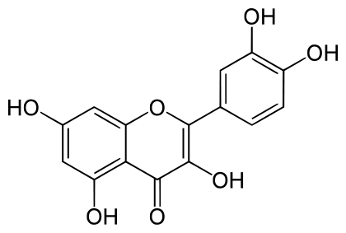
Structure of quercetin indicating the A, B, and C rings

Using Flavonoid Content as a way of Predicting Health Benefits of Plant-based Food
Health benefits of plant flavonoids
Chronic diseases such as cancer and cardiovascular disease are major health issues and are leading causes of death and economic strain for people of the United States and the world. Food scientists and nutritionists have taken great interest in flavonoids because consumption of these compounds have been found to infer long term health benefits to humans. Most flavonoids are reducing agents that act as antioxidants and free-radical scavengers due to their ability to be easily oxidized yet remain stable, while preventing oxidation of biomolecules in the human body. The antioxidant properties of flavonoids protect the human body against oxidative reactions which may damage proteins, DNA, cell membranes and other biocomponents, which may lead to chronic diseases. Flavonoids cannot be synthesized by humans. Therefore, they must be obtained from food sources. Plants offer a wide variety of flavonoids, which are mostly concentrated in the outer parts of plants such as flowers, leaves, fruit peels, seed coats, and bark. The table below shows a representative list of food groups which contain different classes of flavonoids.

FLAVONOID | FOOD GROUP
Flavonols | Vegetables, fruits, herbs, wine, tea
Flavones | Vegetables, herbs, berries
Isoflavones | Legumes (nuts and cereals)
Flavanones | Vegetables, fruits, berries, citrus fruits
Flavanols | Fruits, berries, nuts, cider, cocoa, cereals
Procyanidins | Fruits, berries, nuts, cocoa, wine, cider
Anthocyanins | Colored vegetables, berries, red wine, red onion, red cabbage, red beans
tannins | Nuts and carrot
Information taken from: Laura Bravo and Raquel Mateos, Analysis of Functional Foods and Nutraceuticals, P. 147-206. In Methods of Analysis of Functional Foods and Nutraceuticals, W. Jeffrey Hurst editor, CRC Press second edition, 2008.
Using Flavonoid Content as a way of Predicting Health Benefits of Plant-based Food
General mechanism of action of flavonoids against free-radicals

- Hydroxyl (OH) groups attached to benzene rings become oxidized and donate a hydrogen (H) to the free radical molecule to stabilize the free radical and prevent oxidative damage to biomolecules and cells. The flavonoid compound is stabilized due to resonance hybridization of the benzene ring.

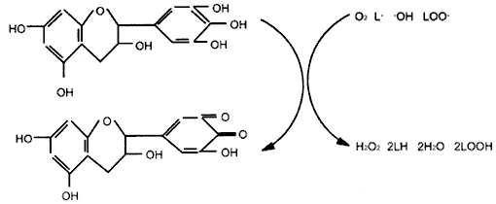
Reduced molecules
Free radical
molecules
Flavonoid molecule

Resonancce stabilized flavonoid molecule

Figure adapted from Pieta P. J. Nat. Prod., 2000, 63, 1035-1042.

Using Flavonoid Content as a way of Predicting Health Benefits of Plant-based Food
Flavonoid Analysis by High Performance Liquid Chromatography (HPLC)

HPLC with UV-Vis detection is the most commonly used method for quantifying individual flavonoid compounds in food*. Flavonoid compounds are first separated using HPLC and then detected spectroscopically. Different HPLC separation methods are required for analysis of compounds in different flavonoid classes.

The HPLC chromatogram shown above is of collard (Brassica oleracea) and corn (Zea mays) samples separated and analyzed by Barnes S. L. et al. 2011 (unpublished).

*Hertog, M.G.L., Hollman, P.C.H., and Venema, D.P., Optimization of a quantitative HPLC determination of potentially anticarcinogenic flavonoids in vegetables and fruits, J. Agric. Food Chem., 40, 1591, 1992.

Using Flavonoid Content as a way of Predicting Health Benefits of Plant-based Food
Flavonoid Analysis by Aluminum Chloride Method

The Aluminum Chloride Method is a method commonly used to quickly determine the total flavonoid content of food. Flavonoid molecules react with Al³⁺ to form a complex which can be detected spectroscopically at 367nm.

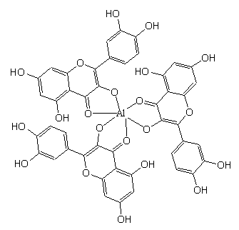

Complexation of the flavonoid quercetin with aluminum

Structure taken from: Jiang Liuyun, Liu Yuming, “Preparation, biological activity and quantum chemistry calculation of quercetin-Aluminum complex”, Chemical Journal on Internet. Dec. 1, 2004, vol. 6 no. 12 P. 87.

Using Flavonoid Content as a way of Predicting Health Benefits of Plant-based Food
Module Questions
- Your employer, “Veggy ways”, is seeking to produce the healthiest vegetables possible. Therefore, the compnay has brought one hundred food samples to your lab and as the food chemist, your job is to determine which foods have the greatest health benefits by measuring the flavonoid content of the samples. Discuss the advantages and disadvantages of using HPLC and Aluminum Chloride method for these tests.
- Based on the introductory information provided in this module, which one of the following plant-based foods would you predict to contain the highest amount of total flavonoids: Corn (Zea mays), squash (Cucurbita spp.), or collard greens (Brassica oleracea)?
- Based on the aluminum chloride data provided for each food sample below, prepare a concentration calibration curve, determine the concentration calibration equation, R² value, calculate the concentration of total flavonoid for each food, and determine which food contains the highest flavonoid content.
Corn Squash Collard
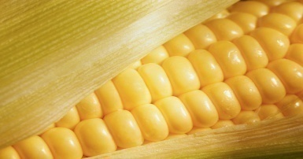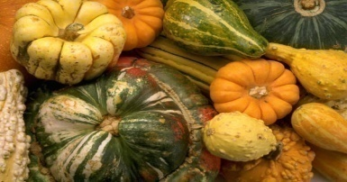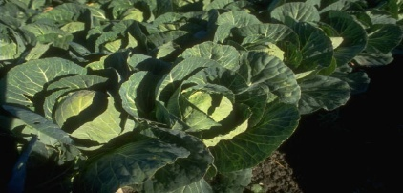

Quercetin Calibration Standard (µg/mLuercetin Calibration Standard (µg/mL)
Quercetin Calibration Standard (µg/mL) | Standard Solution Absorbance @ 367nm (blank corrected) | Food Sample | *Flavonoid Analyte Solution Absorbance @ 367nm (not blank corrected)
12.63 | 0.2001 | Squash | 0.166
31.25 | 0.4198 | Corn | 0.312
62.50 | 0.8244 | Collard | 1.226
125 | 1.6622
*Analyte solutions were diluted by ½ to obtain readings within the range of the calibration standards. The blank reading was 0.001

