Developing an Analytical Method: Instructor’s Guide
Suggested Responses to Investigations & Supplementary Materials
This module introduces students to the process of developing an analytical method using, as a case study, the quantitative analysis of eight analytes in the medicinal plant Danshensu using a combination of a microwave extraction to isolate the analytes and HPLC with UV detection to determine their concentrations. The module is divided into nine parts:
Part I. Context of Analytical Problem
Part II. Separating and Analyzing Mixtures Using HPLC
Part III. Extracting Analytes From Samples
Part IV. Selecting the Solvent, Temperature, and Microwave Power
Part V. Optimizing the Solvent-to-Solid Ratio and the Extraction Time
Part VI. Finding the Global Optimum Across All Analytes
Part VII. Verifying the Analytical Method’s Accuracy
Part VIII. Applying the Analytical Method
Part IX. Closing Thoughts
Interspersed within the module’s narrative are a series of investigations, each of which asks students to stop and consider one or more important issues. Some of these investigations include data sets for students to analyze; for the data in the module’s figures, you may wish to have students use the interactive on-line versions that provide access to a cursor and the ability to pan and zoom (http://bit.ly/YYgWL2). The on-line figures, created using Plotly (https://plot.ly/), also provide access to the underlying data in the form of a spreadsheet.
This exercise is based loosely on work described in the paper
“Simultaneous extraction of hydrosoluble phenolic acids and liposoluble tanshinones from Salvia miltiorrhiza radix by an optimized microwave-assisted extraction method”
the full reference for which is Fang, X.; Wang, J; Zhang, S. Zhao, Q.; Zheng, Z.; and Song, Z. Sep. Purif. Technol. 2012, 86, 149-156 (DOI:10.1016/j.seppur.2011.10.039). Although most of the data in this exercise are drawn directly from or extrapolated from data in the original paper, additional data are drawn from other papers or generated artificially; specific details of differences between the data in the original paper and the data in this case study are discussed below as part of the suggested responses to the cases study’s investigations.
Suggested responses are presented in normal font.
Supplementary materials are in italic font.
Part I. Context of Analytical Problem
Investigation 1. What does it mean to characterize a molecule as hydrophilic or as lipophilic? How do they differ in terms of their chemical or physical properties? Are there structural differences between these two groups of molecules that you can use to classify them as hydrophilic or as lipophilic? Consider the molecules below, both minor constituents of Danshen, and classify each molecule as lipophilic or hydrophilic.
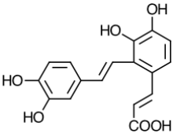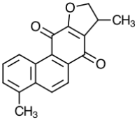
Hydrophilic molecules form hydrogen bonds with water and are soluble in water and other polar solvents; not surprisingly, hydrophilic is derived from Ancient Greek for water loving. Lipophilic molecules, where lipos is Ancient Greek for fat, are soluble in fats, oils, lipids, and non-polar solvents. Hydrophilic molecules are more polar than lipophilic molecules, have more ionizable functional groups, and have more sites for hydrogen bonding.
For the eight constituents of Danshen included in this exercise, those that are hydrophilic are soluble, to varying extents, in water. Each hydrophilic compound has one or more ionizable carboxylic acid groups (–COOH) and, as the pKa values for these carboxylic acid functional groups are in the range 2.9–3.6, they are ionized and carry a negative charge at a neutral pH. The lipophilic constituents of Danshen do not have ionizable groups and they are not soluble in water, although they are soluble, to some extent, in polar organic solvents, such as methanol and ethanol.
Each lipophilic molecule in this exercise has three hydrogen bond acceptors and no hydrogen bond donors; the hydrophilic molecules, on the other hand, have between five (danshensu) and 12 (lithospermic acid) hydrogen bond acceptors, and between four (danshensu) or seven (lithospermic acid and salvianolic acid I) hydrogen bond donors.
Based on the structures of the two additional compounds, the one on the left is hydrophilic and the one on the right is lipophilic; the presence or absence of a carboxylic acid function group provides for a definitive classification. The two compounds are salvianolic acid F (left) and dihydroisototanshinone I (right).
Note: The structures for lithospermic acid and salvianolic acid A in the original paper are incorrect in their stereochemistry around the alkene double bonds, which, as shown in this exercise, are all trans; the original paper shows the alkene double bond in lithospermic acid as cis, and shows one of the two alkene double bonds in salvianolic acid A as cis. The structure for lithospermic acid in the original paper incorrectly shows an –OH group on the five-membered ring; as shown in this exercise, it is a –COOH group.
Part II. Separating and Analyzing Mixtures Using HPLC
Investigation 2. For this study we will use a reverse-phase HPLC equipped with a UV detector to monitor absorbance. What is a reverse-phase separation and how is it different from a normal-phase separation? How does the choice between a reverse-phase separation and a normal-phase separation affect the order in which analytes elute from an HPLC?
In a reverse-phase HPLC separation, the stationary phase is non-polar and the mobile phase is polar. For a normal-phase separation, the stationary phase is polar and the mobile phase is non-polar. Separations in HPLC depend on a difference in the solubility of the analytes in the mobile phase and in the stationary phase. In a reverse-phase separation, for example, analytes of lower polarity are more soluble in the non-polar stationary phase, spending more time in the stationary phase and eluting at a later time than more polar analytes. In a normal-phase separation, the order of elution is reversed, with less polar analytes spending more time in the mobile phase and eluting before more polar analytes.
Investigation 3. Using the data in Figure 1 determine each analyte’s retention time. Based on your answers to Investigation 1 and Investigation 2, does the relative order of elution order make sense? Why or why not?
The retention times for the analytes are:
hydrophilic compounds | tr (min) | lipophilic compounds | tr (min)
danshensu | 4.81 | dihydrotanshinone | 50.50
rosmarinic acid | 27.93 | cryptotanshinone | 55.21
lithospermic acid | 29.44 | tanshinone I | 56.47
salvianolic acid A | 35.80 | tanshinone IIA | 62.60
As seen in Investigation 2, for a reverse-phase HPLC separation, we expect more polar compounds to elute earlier than less polar compounds, a trend we see here as all four hydrophilic compounds elute before the four lipophilic compounds. The trend in retention times within each group is harder to discern, particularly given the changing composition of the mobile phase; however, danshensu is significantly more soluble in water than the other hydrophilic compounds and elutes much earlier.
Note: The data used to create Figure 1 are not drawn directly from the original paper. Instead, the retention times and the relationships between peak height and analyte concentrations, in μg/mL, were determined using the HPLC data in Figure 8b and the corresponding extraction yields, in mg/g, from the first row of Table 3, obtained using a 1.00-g sample of Danshen and 35.0 mL of solvent. The resulting values for k in the equation A = kC were used to generate the data for this chromatogram and for all subsequent chromatograms. Details on the standard used to generate Figure 1 are included in Investigation 7. Although the original paper reports peak areas instead of peak heights, the latter is used in this exercise as it is easier for students to measure.
Investigation 4. Based on Figure 2, are there features in these UV spectra that distinguish Danshen’s hydrophilic compounds from its lipophilic compounds? What wavelength should we choose if our interest is the hydrophilic compounds only? What wavelength should we choose if our interest is the lipophilic compounds only? What is the best wavelength for detecting all of Danshen’s constituents?
The UV spectra for the lipophilic compounds cryptotanshinone and tanshinone I show a single strong absorption band between 240 nm and 270 nm. The hydrophilic compounds danshensu and salvianolic acid A, on the other hand, have strong adsorption bands at wavelengths below 240 nm and at wavelengths above 270 nm. Clearly choosing a single wavelength for this analysis requires a compromise. Any wavelength in the immediate vicinity of 280 nm is an appropriate choice as the absorbance value for salvianolic acid A is strong, and the absorbance values for tanshinone I, cryptotanshinone, and danshensu are similar in magnitude. At wavelengths greater than 285 nm the absorbance of tanshinone I, cryptotanshinone, and danshensu decrease in value, and the absorbance of danshensu decreases toward zero as the wavelength approaches 250 nm. All four compounds absorb strongly at wavelengths below 230 nm, but interference from the many other constituents of Danshen extracts may present problems. The data in the figures that follow were obtained using a wavelength of 280 nm.
Note: The data for Figure 2 are not drawn from the original paper. The UV spectra for cryptotanshinone and for tanshinone I are adapted from “Analysis of Protocatechuic Acid, Protocatechuic Aldehyde and Tanshinones in Dan Shen Pills by HPLC,” the full reference for which is Huber, U. Agilent Publication Number 5968-2882E (released 12/98 and available at https://www.chem.agilent.com/Library/applications/59682882.pdf), and the UV spectra for danshensu and for salvianolic acid A are adapted from “Simultaneous detection of seven phenolic acids in Danshen injection using HPLC with ultraviolet detector,” the full reference for which is Xu, J.; Shen, J.; Cheng, Y.; Qu, H. J. Zhejiang Univ. Sci. B. 2008, 9, 728-733 (DOI:10.1631/jzus.B0820095). These sources also provide UV spectra for tanshinone IIA and for rosmarinic acid, but not for dihydrotanshinone nor for lithospermic acid.
Investigation 5. For a UV detector, what is the expected relationship between peak height and the analyte’s concentration in μg/mL? For the results in Figure 1, can you assume the analyte with the smallest peak height is present at the lowest concentration? Why or why not?
For a UV detector, we expect the absorbance to follow Beer’s law, A = kC, where A is the analyte’s absorbance, C is the analyte’s concentration, and k is a proportionality constant that accounts for the analyte’s wavelength-dependent absorptivity and the detector’s pathlength. Because each analyte has a different value for k, we cannot assume that the analyte with the smallest peak height is also the analyte present at the lowest concentration.
Investigation 6. Calculate the concentration, in μg/mL, for each analyte in the standard sample whose chromatogram is shown in Figure 1. Using this standard sample as a single-point external standard, calculate the proportionality constant for each analyte that relates its absorbance to its concentration in μg/mL. Do your results support your answer to Investigation 5? Why or why not?
The table below shows the absorbance values (in mAU) for each analyte from Figure 1, the analyte’s concentration in the standard sample, and its value for k.
analyte | absorbance (mAU) | C (μg/mL) | k (mAU•mL/μg)
danshensu | 96.3 | 60.0 | 1.605
rosmarinic acid | 125.6 | 143.1 | 0.878
lithospermic acid | 71.4 | 133.1 | 0.536
salvianolic acid A | 66.1 | 41.7 | 1.585
dihydrotanshinone | 442.9 | 15.1 | 2.841
cryptotanshinone | 54.4 | 28.9 | 1.882
tanshinone I | 59.5 | 37.2 | 1.599
tanshinone IIA | 105.2 | 71.7 | 1.467
Using danshensu as an example, concentrations are derived from the data for the stock standard, accounting for its dilution and converting from mg to μg
$$C=\frac{6.00 mg }{10.00 mL}×\frac{1.00 mL}{10.00 mL}×\frac{1000 μg}{mg}=60.0 μg/mL$$
and k is calculated as
$$k=\frac{A}{C}=\frac{96.3 mAU}{60.0 g/mL}=1.605 mAU•mL/g$$
Although dihydrotanshinone is present at the lowest concentration and has the smallest peak height, it has the largest value for k and is the strongest absorbing analyte. If, for example, dihydrotanshinone is present at a concentration of 25.0 μg/mL (a concentration smaller than the other seven compounds), its absorbance of 71.0 mAU will be greater than that for lithospermic acid, salvianolic acid A, cryptotanshinone, and tanshinone I. This is consistent with our expectations from Investigation 5.
Note: See the comments for Investigation 3 for details on the data used in this investigation.
Part III. Extracting Analytes From Samples
Investigation 7. Brewing coffee is nothing more than a simple solvent extraction, which makes it a useful and a familiar model for considering how a solvent extraction works. There are a variety of methods for brewing coffee that differ in how the solvent and the coffee are brought together. Investigate at least five of the following methods for preparing coffee: Turkish, French Press, Aeropress, Chemex, Pour Over, Stovetop, Vacuum Pot, Espresso, and Cold Brew. In what ways are these methods similar to each other and in what ways are they different from each other? What variables in the extraction process are most important in terms of their ability to extract caffeine, essential oils, and fragrances from coffee?
The intention of this investigation is to place solvent extraction in a context more familiar to students. The various methods for brewing coffee generally fall into four groups based on how the coffee grounds and water are brought together: boiling (or decoction), steeping (or infusion), gravity filtration, and pressure.
Whatever the method, there is general agreement that the ideal extraction yield (the percentage, by weight, of the coffee grounds solubilized during brewing) is approximately 20% and that the ideal strength (the amount of dissolved coffee solids per unit volume) varies by geographic region, but is approximately 1.25 mg per 100 mL in the United States. Extraction yields and strength depend on the ratio of coffee and water, the coarseness of the coffee’s grind, the brew temperature, and the brew time. Methods relying on courser grounds, such as French Press, require longer brew times; drip filtration methods use a finer grind and require shorter brew times. Extraction yields that are too high result in bitter-tasting coffee and extraction yields that are too small result in a more acidic-tasting coffee. The greater the strength, the darker, thicker, and oilier the brew.
Investigation 8. Why might a combination of high temperature, a lengthy extraction time, and the need for two extractions be undesirable when working with a medicinal plant such as Danshen?
An extraction at a high temperature runs the risk of destroying some of Danshen’s analytes through thermal degradation; this is a more significant problem at higher temperatures, particularly when using a longer extraction time. The concentration of analytes in the final sample is smaller if we must combine two (or more) extracts of equal volume; if an analyte already is present at a low concentration in Danshen, then its concentration as analyzed may be too small to detect without first concentrating the extract.
Investigation 9. What variables might we choose to control if we want to maximize the microwave extraction of Danshen’s constituent compounds? For each variable you identify, predict how a change in the variable’s value will affect the ability to extract from Danshen a hydrophilic compound, such as rosmarinic acid, and a lipophilic compound, such as tanshinone I.
The intention of this investigation is to have students begin considering how experimental conditions will affect the extraction of hydrophilic and lipophilic analytes from Danshen. As the investigations that follow demonstrate, the variables explored here are not independent of each other, which makes impossible accurate predictions; of course, this is why method development is necessary! The comments below outline important considerations for five possible variables: the solvent; the solvent-to-solid ratio; the extraction temperature; the extraction time; and the microwave’s power.
The choice of solvent must meet two conditions: the analytes of interest must be soluble in the solvent, and the solvent must be able to absorb microwave radiation and convert it to heat. All three options for the solvent included in this study—methanol, ethanol, and water—are effective at absorbing microwave radiation and converting it to heat, although water is better than methanol and ethanol at absorbing microwave radiation and methanol is better than ethanol and water at converting absorbed microwave radiation into heat. In terms of solubility, we cannot predict easily the relative trends in solubility for either the hydrophilic or the lipophilic analytes when using methanol or ethanol as a solvent; however, we expect that the lipophilic analytes will not extract into water. Although the lipophilic analytes may be more soluble in a non-polar solvent, such as hexane, a non-polar solvent cannot absorb microwave radiation.
In general, we expect that increasing the solvent-to-solid ratio will increase extraction efficiency for all analytes; this certainly is the case with conventional extractions. For some microwave extractions, and for reasons that are not always clear, increasing the solvent-to-solid ratio beyond an optimum value decrease extraction efficiency.
For all analytes, extraction efficiency generally increases at higher temperatures for a variety of reasons, including the easier penetration of a solvent into the sample’s matrix as a result of a decrease in the solvent’s viscosity and surface tension. This increase in extraction efficiency with increasing temperature is offset if the analytes are not thermally stable. It is important to note, as well, that for an open-vessel atmospheric pressure microwave extraction, the method used here, the highest possible temperature is the solvent’s boiling point.
In general, we expect that extraction efficiency for all analytes will increase with longer extraction times. As is the case with temperature, however, the increase in extraction efficiency at longer times is offset if the analytes are not thermally stable.
For all analytes, the relationship between microwave power and extraction efficiency is not intuitive. An increase in microwave power results in greater localized heating. In some extractions, the increased localized heating helps break down the sample matrix, increasing extraction efficiency; in other cases, extraction efficiency decreases because the increase in localized heating results in more thermal degradation of the analytes. For other extractions, a change in microwave power has little effect on extraction efficiency.
Part IV. Selecting the Solvent, Temperature, and Microwave Power
Investigation 10. A one-factor-at-a-time optimization is an effective and an efficient algorithm when the factors behave independently, and an effective, although not necessarily an efficient, algorithm when the factors are dependent. What does it mean to say that two factors are independent or dependent? What does it mean to say that an optimization is efficient or effective? Why do dependent factors generally require that we optimize each factor more than once? Although the choice of solvent, temperature, and microwave power are dependent factors, for this case study you will optimize each factor once only. Explain why. For the analysis in this case study, is the order in which these three factors are optimized important? Why or why not?
Two factors are independent if the effect on the response of a change in the level of one factor does not depend on the second factor’s level. In the table below, for example, factors A and B are independent because a change in factor A’s level from 10 to 20 increases the response by 40 both when factor B’s level is 10 (increasing from 40 to 80) and when its level is 40 (increasing from 50 to 90).
level of factor A | level of factor B | response
10 | 10 | 40
20 | 10 | 80
10 | 40 | 50
20 | 40 | 90
For dependent factors, the effect on the response of a change in the level of one factor is not independent of the other factor’s level. For example, in the table below factors A and B are dependent because a change in factor A’s level from 10 to 20 increases the response by 40 (from 40 to 8) when factor B’s level is 10, but it increases the response by 20 (from 50 to 70) when factor B’s level is 40.
level of factor A | level of factor B | response
10 | 10 | 40
20 | 10 | 80
10 | 40 | 50
20 | 40 | 70
An effective optimization is one that correctly finds the system’s global optimum. An optimization is not effective if it finds a local (or regional) optimum instead of the global optimum. An efficient optimization is one that finds the global optimum using as few experiments as possible. The most efficient optimization considers all factors at the same time, or optimizes each factor one time only; a less efficient optimization considers each factor separately and requires that we cycle through each factor multiple times.
When two factors are independent, the optimization of one factor does not depend on the level of the other factor; we can, therefore, find the global optimum by optimizing each factor once. Having optimized factor A, we can optimize factor B without changing the effect on the response of factor A. The optimization is efficient because we need only optimize each factor one time.
For dependent factors, however, the optimization of one factor depends on the other factor’s level. If we optimize factor A and then optimize factor B, the level for factor A is no longer at its optimum value (unless we are extraordinarily lucky!). As a result, to find the global optimum, we must repeat the process of optimizing each factor through additional cycles.
To optimize a factor we change its level along a continuous range of possible values with, perhaps, lower and upper limits. For example, we can set the microwave power to any value between a lower limit of 0 W (no power) to an upper limit equal to the microwave’s maximum power. The initial choice of solvent, however, is not continuous as it is limited to individual pure solvents, in this case pure water, methanol, or ethanol. Because we cannot vary the initial choice of solvent through a continuous range of values, we cannot reasonably cycle through the factors.
The order in which the factors are optimized is solvent, extraction temperature, and microwave power. This order is necessary because the maximum possible temperature depends on the solvent’s boiling point, and the choice of microwave power depends on the solvent’s temperature.
Investigation 11. For the choice of solvent, consider ethanol, methanol, and water, as well as mixtures of water with ethanol or methanol, and predict how effective each is at extracting hydrophilic or lipophilic compounds. Why is a non-polar solvent, such as hexane, not a useful option for a microwave extraction? What limits, if any, might the choice of solvent place on the choice of temperature or microwave power?
Given the structures of the analytes it is reasonable to assume that each is soluble, to some extent, in methanol and ethanol. Although the hydrophilic compounds likely are soluble in water, the lithophilic compounds are insoluble in water. Because water has a greater solvent strength than methanol or ethanol, binary mixtures of methanol/water or of ethanol/water may be more effective solvents for the hydrophilic analytes; it is less clear if this is the case for the lithophilic analytes.
A non-polar solvent is not a useful option because it cannot absorb microwave energy and, therefore, cannot dissipate that energy to the sample in the form of heat.
The choice of solvent places an upper limit on temperature as it cannot exceed the solvent’s boiling point; the choice of solvent, on the other hand, places no limits on the microwave power.
Investigation 12. Consider the data in Figures 3–5 and explain any trends you see in the relative extraction efficiencies of these three solvents. Are your results consistent with your predictions from Investigation 11? Why or why not? Which solvent is the best choice if you are interested in analyzing hydrophilic analytes only? Which solvent is the best choice if you are interested in analyzing lipophilic analytes only? Which solvent is the best choice if you are interested in analyzing both hydrophilic and lipophilic analytes?
The absorbance values for the analytes are summarized here
 | absorbance in mAU using 100%
analyte | methanol | ethanol | water
danshensu | 43.0 | 32.1 | 72.6
rosmarinic acid | 66.7 | 49.9 | 54.6
lithospermic acid | 47.2 | 25.2 | 56.3
salvianolic acid A | 37.3 | 23.2 | 23.3
dihydrotanshinone | 33.9 | 38.2 | 0.0
cryptotanshinone | 67.7 | 71.1 | 0.0
tanshinone I | 82.4 | 80.4 | 0.0
tanshinone IIA | 151.7 | 167.4 | 0.0
If we compare methanol to ethanol we see that extraction yields using methanol are greater than those using ethanol for danshensu, rosmarinic acid, lithospermic acid, and salvianolic acid; that the extraction yields using methanol and ethanol are similar for dihydrotanshinone, cryptotanshinone, and tanshinone I; and that the extraction yield using methanol is smaller than when using ethanol for tanshinone IIA. Water is a useful solvent for the hydrophilic compounds—indeed, it is the best solvent for danshensu and lithospermic acid—but, as expected, it does not extract the lipophilic compounds.
If we are interested in extracting hydrophilic compounds only, then methanol or water are appropriate options (or, perhaps, a mixture of the two); ethanol is not an unreasonable option, but it does not extract these compounds as efficiently as methanol or water. If we are interested in extracting lipophilic compounds only, then methanol or ethanol are suitable choices, although ethanol has a slight advantage over methanol for tanshinone IIA. Methanol is the best choice for extracting both hydrophilic and lipophilic compounds.
Note: The chromatograms in Figure 3 and Figure 4 are derived from data in the original paper. The chromatogram in Figure 5 uses data from the paper “Simultaneous quantification of six major phenolic acids in the roots of Salvia miltiorrhiza and four related traditional Chinese medicinal preparations by HPLC-DAD method,” the full reference for which is Liu, A; Li, L; Xu, M.; Lin, Y.; Guo, H.; Guo, D. J. Pharm. Biomed. Anal. 2006, 41, 48–56 (DOI:10.1016/j.jpba.2005.10.021). For reasons of simplicity, the chromatograms in this exercise are cleaned up by excluding peaks from other compounds in Danshen extracts and eliminating baseline noise.
Investigation 13. Propose a set of experiments that will effectively and efficiently allow you to determine the optimum mixture of methanol and water to use for this extraction. What range of methanol/water mixtures will you explore? How many samples will you run? Explain the reasons for the range of mixtures and the number of samples you selected. In describing the solvent mixtures, report values as percent methanol by volume (e.g. 55% methanol by volume).
Because the lithophilic analytes are not soluble in water, there is little point in considering mixtures in which water is the predominate solvent; for this reason, it makes sense to limit the mixtures to a lower limit of 50% methanol by volume to an upper limit of 100% methanol by volume. Increasing the percent methanol in steps of 10%, a total of six treatments, provides sufficient information to determine the trend in each analyte’s solubility.
Investigation 14. Consider the data in Figure 6 and explain any trends you see in the relative extraction efficiencies using different mixtures of methanol and water. What is the optimum mixture of methanol and water for extracting samples of Danshen? Are your results consistent with your predictions from Investigation 11 and the data from Investigation 12? Why or why not?
The optimum solvent is 80% methanol and 20% water (by volume). The effect of adding water is not surprising for the hydrophilic compounds, given our observations in Investigations 11 and 12; however, the increased extraction efficiency for lipophilic compounds in the presence of added water is unexpected.
Note: The data in Figure 6 are derived, in part, using data from the original paper and, in part, data from the paper “Simultaneous quantification of six major phenolic acids in the roots of Salvia miltiorrhiza and four related traditional Chinese medicinal preparations by HPLC-DAD method,” the full reference for which is Liu, A; Li, L; Xu, M.; Lin, Y.; Guo, H.; Guo, D. J. Pharm. Biomed. Anal. 2006, 41, 48–56 (DOI:10.1016/j.jpba.2005.10.021). Additional data was synthesized, based on trends in the original data, to extend the data set to a greater range of methanol–water mixtures.
Investigation 15. Propose a set of experiments that will effectively and efficiently allow you to optimize the extraction temperature using the solvent selected in Investigation 14. What range of temperatures will you explore? How many samples will you run? Explain the reasons for the range of temperatures and the number of samples you selected.
The boiling point for a solvent that is 80% methanol and 20% water (by volume) is slightly greater than 70°C; thus, selecting 70°C for an upper limit is a reasonable choice. A lower limit of 50°C and intervals of 5°C will provide sufficient information to determine the trend in each analyte’s solubility.
Investigation 16. Consider the data in Figure 7 and explain any trends you see in the relative extraction efficiencies as a function of temperature. What is the optimum temperature for extracting samples of Danshen? Are your results consistent with your expectations? Why or why not?
The optimum temperature is 70°C, which is consistent with the general expectation that higher temperatures increase extraction yields, assuming no thermal degradation. Interestingly, the effect is somewhat more pronounced for the lipophilic compounds than for the hydrophilic compounds.
Note: The data in Figure 7 are derived, in part, using data from the original paper for temperatures of 50°C, 60°C and 70°C. To extend the data set, additional data were synthesized for temperatures of 55°C and for 65°C based on trends in the original data.
Investigation 17. Propose a set of experiments that will effectively and efficiently allow you to optimize the microwave power using the solvent and temperature selected in Investigation 16. What range of powers will you explore given that the microwave’s power is adjustable between the limits of 0 W and 1000 W? How many samples will you run? Explain the reasons for the range of microwave powers and the number of samples you selected.
Although the effect of microwave power on the extraction yield is not likely significant, it also is unpredictable. For this reason, we might opt for a large range, but with relatively few samples. If the resulting data suggest that extraction yields are particularly sensitive to microwave power, then we can run additional samples as needed. Setting a lower limit of 400 W and an upper limit of 1000 W, with steps of 200 W are reasonable choices and will provide sufficient information to determine the trend in each analyte’s solubility.
Investigation 18. Consider the data in Figure 8 and explain any trends you see in the relative extraction efficiencies as a function of the microwave’s power. What is the optimum power for extracting samples of Danshen using a solvent that is 80% methanol and 20% water by volume and an extraction temperature of 70°C?
Although, as expected, microwave power does not affect significantly the extraction efficiency for most compounds, the extraction efficiency for some lipophilic compounds decreases at 1000 W; for this reason, the optimum microwave power is 800 W.
Note: The data in Figure 8 are derived using data from the original paper.
Part V. Optimizing the Solvent-to-Solid Ratio and the Extraction Time
Investigation 19. When optimizing the choice of solvent, temperature, and microwave power, we used absorbance values taken directly from the HPLC analysis (see Figures 3–8) without first converting them into extraction yields reported in mg analyte/g sample. Why is it possible to use absorbance values for the optimizations in Part IV? Can you use absorbance values when optimizing the solvent-to-solid ratio or the extraction time? Why or why not? Using the optimum conditions from Figure 8 and your results from Investigation 7, report the extraction yield for each analyte as mg analyte/g sample.
It helps to begin by considering how to convert an analyte’s peak height in mAU to the analyte’s extraction yield in mg/g. We know from Investigations 6 and 7 that Beer’s law is A = kC, where A is the analyte’s absorbance, C is the analyte’s concentration in the extracting solvent (in μg/mL), and k is an analyte-specific calibration constant (with units of mAU•mL/μg); thus
$$C=\frac{A}{k}$$
To convert C to the analyte’s extraction yield, EY, we account for the volume of solvent, V, and the mass of sample, m
$$EY\left(\frac{mg}{g}\right)=\frac{C(\frac{g}{mL})×V(mL)}{m (g)}×\frac{1 mg}{1000 g}=\frac{A (mAU)×V(mL)}{k(\frac{ mAU•mL}{g})× m (g)}×\frac{1 mg}{1000 g}$$
When optimizing the choice of solvent, extraction temperature, and microwave power, we maintained a constant solvent-to-solid ratio, using 60.0 mL of solvent and a 3.00-g sample for each experiment. Because V, k, and m, are constants, the analyte’s absorbance and its extraction yield are directly proportional: if the absorbance doubles, we know the extraction yield also doubles. This is why we can use absorbance values when optimizing the choice of solvent, the extraction temperature, and the microwave power.
To optimize the solvent-to-solid ratio we must change the solvent’s volume and/or the sample’s mass, which means we no longer can assume that an increase in the analyte’s absorbance evinces a proportionate increase in the analyte’s extraction yield; instead, we must calculate the analyte’s extraction yield from its absorbance. The following table summarizes the extraction yields for the optimum extraction conditions in Figure 8.
analyte | absorbance (mAU) | k (mAU•mL/μg) | EY (mg/g)
danshensu | 64.4 | 1.605 | 0.802
rosmarinic acid | 98.9 | 0.878 | 2.253
lithospermic acid | 62.2 | 0.536 | 2.320
salvianolic acid A | 42.3 | 1.585 | 0.534
dihydrotanshinone | 65.8 | 2.841 | 0.463
cryptotanshinone | 84.4 | 1.882 | 0.897
tanshinone I | 104.4 | 1.599 | 1.306
tanshinone IIA | 201.9 | 1.467 | 2.752
Investigation 20. We can divide the points in a central-composite design into three groups: a set of points that allow us to explore the effect on the extraction yield of extraction time only; a set of points that allow us to explore the effect on the extraction yield of the solvent-to-solid ratio only; and a set of points that allow us to explore the effect on the extraction yield of the interaction between extraction time and the solvent-to-solid ratio. Explain how each of these is accomplished in this experimental design.
For the points (2.18, 25.0), (5.00, 25.0), and (7.82, 25.0) we are changing the extraction time while maintaining a constant solvent-to-solid ratio; these points allow us to explore the effect of extraction time only. For the points (5.00, 10.9), (5.00, 25.0), and (5.00, 39.1) we are changing the solvent-to-solid ratio while maintaining a constant extraction time; these points allow us to explore the effect of the solvent-to-solid ratio only. Finally, for the points (3.00, 15.0), (7.00, 15.0), (3.00, 35.0), and (7.00, 35.0) we vary both the extraction time and the solvent-to-solid ratio; these points allow us to explore possible interactions between these factors.
Note: In Table 1 of the original paper, the extraction time’s lower limit and upper limit are reported as 2.00 min and 8.00 min, respectively, instead of 2.18 min and 7.82 min, as used in this case study. The original paper also reports the lower limit and the upper limit for the solvent-to-solid ratio as 10.0 mL/g and 40.0 mL/g, respectively, instead of 10.9 mL/g and 39.1 mL/g, as used in this case study. This is the result of an inconsistency in the original paper between the reported actual factor levels and the reported coded factor levels used for building a regression model. If, as the paper indicates, the experimental design’s axial points are ±1.41, then the reported factor levels of 2.00 min, 8.00 min, 10.0 mL/g, and 40.0 mL/g are in error and should be listed as 2.18 min, 7.82 min, 10.9 mL/g, and 39.1 mL/g, respectively. On the other hand, if the reported factor levels of 2.00 min, 8.00 min, 10.0 mL/g, and 40.0 mL/g are correct, then the reported coded factor levels of ±1.41 are in error and should be listed as ±1.50. For the purpose of this case study, we assume the axial point’s coded factor levels are ±1.41 and that 2.18 min, 7.82 min, 10.9 mL/g, and 39.1 mL/g are the actual factor levels for these points. Fortunately, the effect on the regression results of this inconsistency is not important within the context of this case study. See the comments accompanying Investigation 23 for additional details.
Investigation 21. Identify the five trials at the center of central-composite design and, for these trials, calculate the extraction yield’s mean, standard deviation, relative standard deviation, variance, and 95% confidence interval about the mean. What is the statistical meaning for each of these values? Transfer to Figure 9 the extraction yield for each experiment, using the mean extraction yield for the design’s center point. What conclusions can you reach regarding the effect on danshensu’s extraction yield of extraction time and solvent-to-solid ratio? Estimate the optimum conditions for maximizing danshensu’s extraction yield and explain your reasoning?
The center of the central-composite design is an extraction time of 5.00 min and a solvent-to-solid ratio of 25.0 mL/g. The extraction yields for these five trials are 0.790, 0.813, 0.785, 0.801, and 0.773. The mean, which is 0.792 mg/g, is the average value for the five trials and is our best estimate of danshensu’s true extraction yield, μ, in the absence of systematic errors in the analysis. The standard deviation of 0.0153 is one measure of the dispersion about the mean for these five trials. Two other measures of dispersion are the relative standard deviation, the ratio of the standard deviation to the mean, which is 1.93% in this case, and the variance, which is the square of the standard deviation, or 2.34$×$10–4 in this case. The standard deviation, relative standard deviation, and variance each provide a measure of the uncertainty in our results resulting from random error in the extraction and analysis. The 95% confidence interval combines the mean and the standard deviation to estimate danshensu’s true extraction yield when using an extraction time of 5.00 min and a solvent-to-solid ratio of 25 mL/g. Its value is given by
$$μ=\overline{X}±\frac{ts}{\sqrt{n}}$$
where $\overline{X}$ is the mean, s is the standard deviation, n is the number of trials, and t is a value that depends on the confidence level and the degrees of freedom, which is n – 1. The value of t for a 95% confidence interval and n = 5 (four degrees of freedom) is 2.776; the 95% confidence interval is
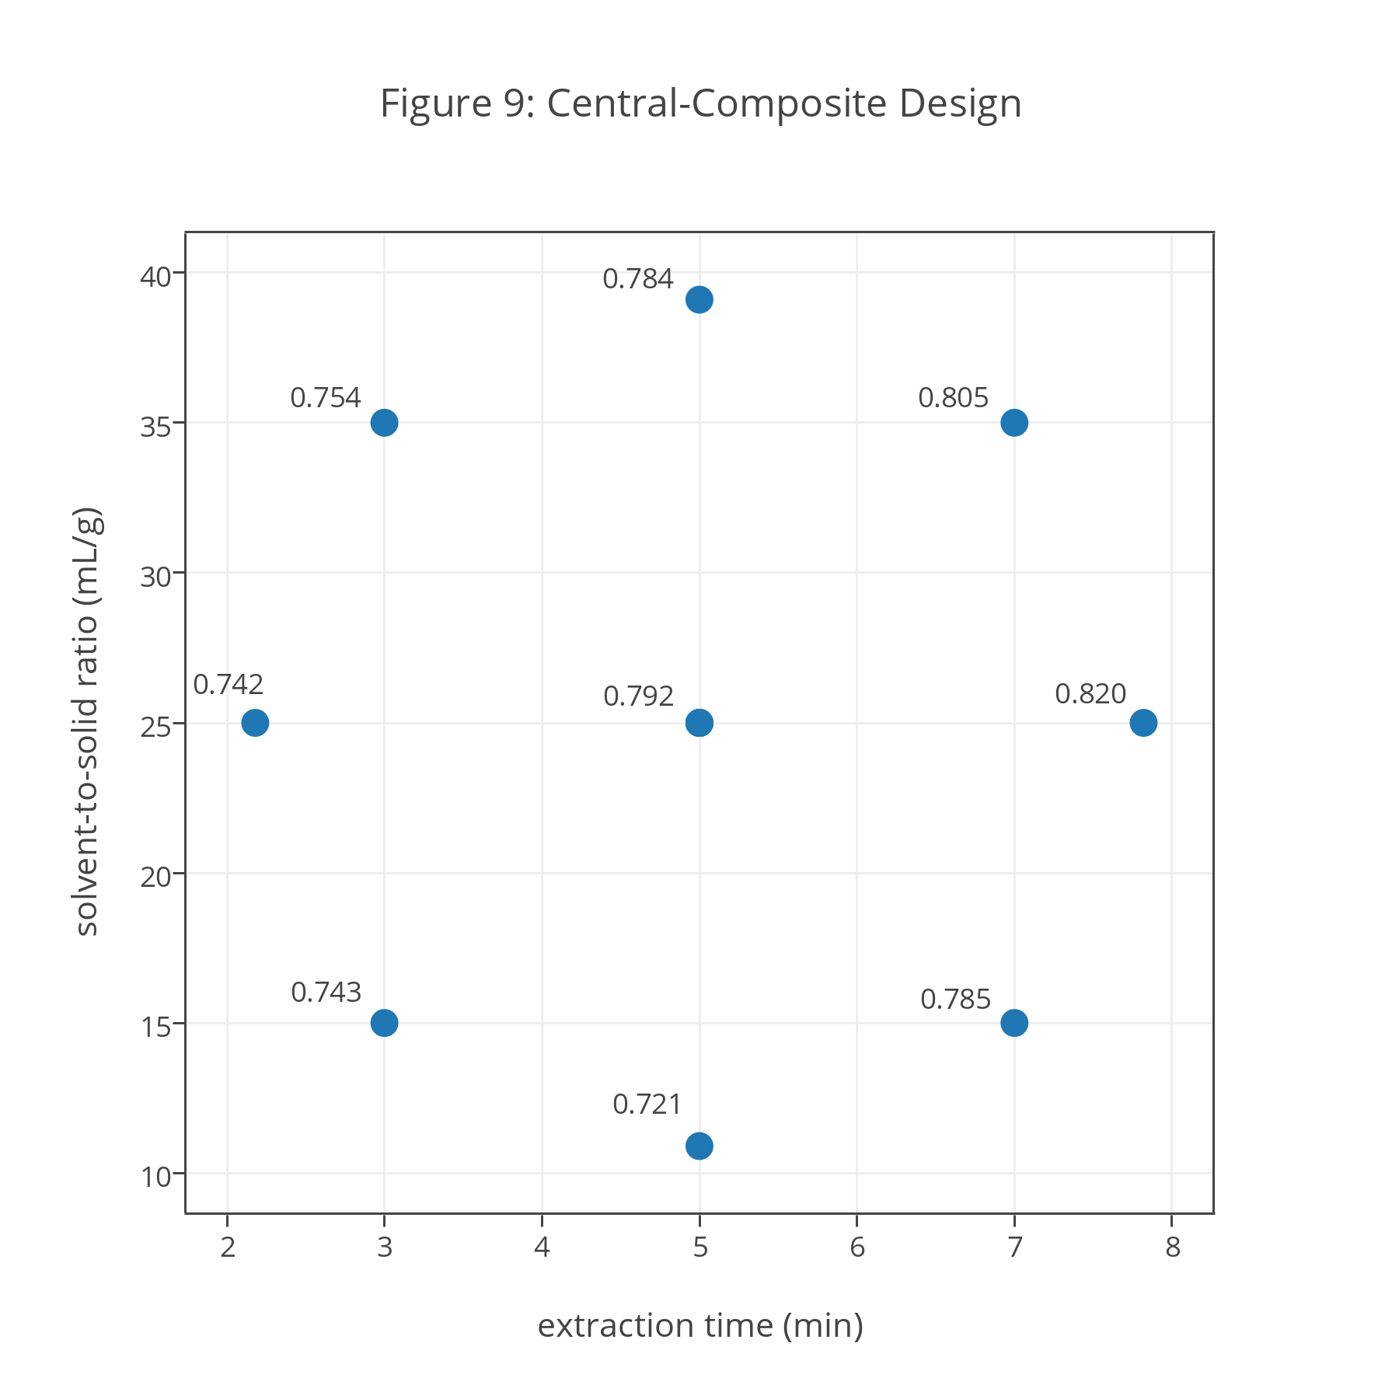
$0792±(2.776×0.0152)/\sqrt{5}=0.792±0.019$
This confidence interval is important because it helps us evaluate whether a change in a factor’s level affects the extraction yield. Consider, for example, the extraction yields of 0.742, 0.792, and 0.820 for the three points that include a change in extraction time only: (2.18, 25.0), (5.00, 25.0), and (7.82, 25.0). If extraction time does not affect the extraction yield, then we expect the extraction yields at (2.18, 25.0) and at (7.82, 25.0) to fall within the 95% confidence interval around the mean value at (5.00, 25.0). The actual yields do not fall with this range, suggesting that extraction time does affect danshensu’s extraction yield, with longer extraction times favoring greater extraction yields.
A similar analysis of the data for the points (5.00, 10.9), (5.00, 25.0), and (5.00, 39.1) suggests that the solvent-to-solid ratio significantly affects the extraction yields, with solvent-to-solid ratios less than 25.0 mL/g resulting in a decrease in the extraction yield. Finally, the data for the points (3.00, 15.0), (7.00, 15.0), (3.00, 35.0), and (7.00, 35.0) suggests that the interaction between the extraction time and the solvent-to-solid ratio is not significant. For example the effect on the extraction yield of a change in extraction time when the solvent-to-solid ratio is 35.0 is
0.805 – 0.754 = 0.051
and the effect on the extraction yield of a change in extraction time when the solvent-to-solid ratio is 15.0 is
0.785 – 0743 = 0.042
The difference between these values
0.051 – 0.042 = 0.009
is smaller than the 95% confidence interval, suggesting that the difference is not significant and that these are independent, not dependent factors (see Investigation 10).
Based on Figure 9, the optimum condition for extracting danshensu is an extraction time of 7.80 min and a solvent-to-solid ratio of 25.0 mL/g as this yields the greatest extraction yield.
Investigation 22. What does it mean to describe a model as empirical instead of theoretical? What are the advantages and the disadvantages of using an empirical model? What is the significance for this empirical model of the coefficients $β_{0}$, $β_{a}$, $β_{b}$, $β_{aa}$, $β_{bb}$, and $β_{ab}$? How does an empirical model that includes the coefficients $β_{aa}$ and $β_{bb}$ differ from a model that does not include these coefficients?
For an empirical model there is no established mathematical relationship between the response and the factors affecting the response. To fit an empirical model to data, we search for a mathematical expression that reasonably fits the data, which means an empirical model is not independent of the data used to build the model. A theoretical model, as its name suggests, is derived from a theoretical understanding of the relationship between the response and the factors affecting the response; as such, a theoretical model is independent of the data we may wish to model. Although a theoretical model can emerge from the understanding engendered by an empirical model, it still must be explained in terms of existing theory. Boyle’s law (PV = constant) is an example of an empirical model that emerged from the careful study of the relationship between a gas’s pressure and its volume. The derivation of Boyle’s law from the kinetic theory of gases transformed Boyle’s law from an empirical model to a theoretical model.
The advantage of an empirical model is that it allows us to model a response, such as an extraction yield, when there is no existing theoretical model that explains the relationship between the response and its factors. The disadvantage of an empirical model is that its utility is limited to the range of factor levels studied. For example, we might use a straight-line
$$y=β_{0}+β_{x}x$$
to successfully model a response, y, over a limited range of levels for a factor, x, even though the relationship between y and x over a wider range of levels is much more complex. If we use the model to predict values of y for values of x within the range modeled, a process we call interpolation, then we are confident in our results; attempting to predict values of y for values of x outside of the range modeled, a process we call extrapolation, is likely to introduce substantial errors into our analysis.
For the empirical model in this exercise the coefficient $β_{0}$ is the intercept, the coefficients $β_{a}$ and $β_{aa}$ provide the first-order and second-order effects on the response of extraction time, the coefficients $β_{b}$ and $β_{bb}$ provide the first-order and second-order effects on the response of the solvent-to-solid ratio, and $β_{ab}$ provides the interaction between the extraction time and the solvent-to-solid ratio. A model that includes the coefficients $β_{aa}$ and $β_{bb}$ allows for curvature in the response surface; a response surface without these coefficients is a flat plane.
Investigation 23. What does it mean to say that the regression analysis is significant at p = 0.0057? Do the results of this regression analysis, as expressed in the model’s coefficients, agree with your results from Investigation 21? Why or why not? What is the meaning of the intercept in this model and how does it affect your understanding of the empirical model’s validity? Use the full regression model to calculate danshensu’s predicted extraction yields for the central-composite design in Table 2. Organize your results in a table with columns for the factor levels, the experimental extraction yields, and the predicted extraction yields. Add a column showing the difference between the experimental extraction yields and predicted extraction yields. Calculate the mean, standard deviation, and the 95% confidence interval for these difference values and comment on your results.
In a linear regression analysis, we want to determine if a factor’s levels affect the response or if the response is independent of the factor’s levels. For each experiment used to build the model, we consider three possible responses: the measured response, $y_{i}$, the response predicted by the model, ${\hat{y}}_{i}$, and the average response over all experiments, $\overline{y}$, which is our best estimate of the response if it is independent of the factors. If the total difference between the experimental responses and the average response, $\sum{{\left(y_{i}-\overline{y}\right)}^{2}}$, is signficantly greater than the total difference between the experimental responses and the predicted responses, $\sum{{\left(y_{i}-{\hat{y}}_{i}\right)}^{2}}$, then we have evidence that random errors in our measurements cannot explain the differences in experimental responses; that is, we have evidence that the response is dependent on the factors. A p value of 0.0057 means there is but a 0.57% probability that random error can account for the differences in the extraction yields reported in Table 2. Note that a regression analysis can not prove that a model is correct, but it does provide confidence that the model does a better job of explaining the experimental data than does random error.
In Investigation 21 we concluded that an increase in extraction time increases the extraction yield and that a decrease in the solvent-to-solid ratio results decreases the extraction yield; both of these conclusions are consistent with the positive values for $β_{a}$ and $β_{b}$, and consistent with their p values. We also concluded that there was no evidence for a significant interaction between the extraction time and the solvent-to-solid ratio, which is consistent with $β_{ab}$ not having a p value less than 0.05 (it actually is >0.7). Interestingly, the model suggests that the solvent-to-solid ratio has a significant second-order effect on the response as the p value for $β_{bb}$ is less than 0.05, a conclusion we did not draw in Investigation 21.
The intercept for this model gives the extraction yield for an extraction time of 0 min and a solvent-to-solid ratio of 0 mL/g. That the intercept is not 0 mg/g and that it is highly significant seems troubling; after all, how we can extract the analyte if we do not use solvent and if we do not carry out the extraction! Here is where we need to recall that we are using an empirical model to explain the relationship between the factors and the response. As noted in Investigation 22, we cannot extrapolate an empirical model outside the range of the factor levels used to build the model. In this case, we cannot safely predict extraction yields for extraction times less than 2.18 min or for solvent-to-solid ratios of less than 10.9 mL/g.
The following table compares the experimental extraction yields from Table 2 with the extraction yields predicted using our model.
extraction time (min) | solvent-to-solid ratio (mL/g) | experimental extraction yield  (mg/g) | predicted extraction yield  (mg/g) | difference (mg/g)
5.00 | 10.9 | 0.721 | 0.741 | –0.020
5.00 | 25.0 | 0.790 | 0.792 | 0.002
3.00 | 15.0 | 0.743 | 0.734 | –0.009
2.18 | 25.0 | 0.742 | 0.747 | 0.005
3.00 | 35.0 | 0.754 | 0.756 | 0.002
5.00 | 25.0 | 0.813 | 0.792 | –0.021
7.00 | 15.0 | 0.785 | 0.780 | –0.005
5.00 | 25.0 | 0.785 | 0.792 | 0.007
5.00 | 39.1 | 0.784 | 0.777 | –0.007
7.00 | 35.0 | 0.805 | 0.810 | 0.005
5.00 | 25.0 | 0.801 | 0.792 | –0.009
5.00 | 25.0 | 0.773 | 0.792 | 0.019
7.82 | 25.0 | 0.820 | 0.817 | –0.003
The mean difference between the predicted extraction yields and the experimental extraction yield is –4.6$×$10–4 with a standard deviation of 0.011 and a 95% confidence interval (t = 2.179 for 12 degrees of freedom) of ±0.0069. The mean difference is small, as we expect if the model explains our data, and there is no evidence that it deviates significantly from 0. For three trials—highlighted above in bold—the differences between the predicted extraction yields and the experimental extraction yields are more than twice the 95% confidence interval; nevertheless, the agreement between the experimental and the predicted extraction yields is encouraging.
Note: The regression models in the original paper are reported using coded factor levels, which normalize each factor’s level so that each factor has the same scale. The equation for the regression model provided in this exercise translates back into the actual factor levels the coded regression model reported in the original paper. A regression analysis of the data in Table 1 of the original paper yields results that are slightly different than those reported in Table 2 of the original paper. This is not a result of uncertainty in the assignment of coded levels for the central-composite design’s axial points, as described in the notes accompanying Investigation 20. As shown here
coefficient | reported in paper using ±1.41 | calculated using ±1.41 | calculated using ±1.5
$$β_{0}$$ | 0.792 | 0.792 | 0.793
$$β_{a}$$ | 0.025 | 0.0254 | 0.0254
$$β_{b}$$ | 0.013 | 0.0150 | 0.0148
$$β_{aa}$$ | –0.005 | –0.0044 | –0.0046
$$β_{bb}$$ | –0.0165 | –0.0187 | 0.0173
$$β_{ab}$$ | 0.002 | 0.0022 | 0.0022
a regression analysis of the extraction yields using coded factor levels of ±1.41 for the axial points and using coded factor levels of ±1.5 give coefficients (in coded form) that look similar to each other, but that are not the same as those reported in Table 2 of the original paper. A more likely explanation is that the reported extraction yields in Table 1 of the original paper are the average of three trials; although not stated, the regression results reported in the original paper presumably uses the full set of individual extraction yields instead of the average extraction yields, as is the case here.
Investigation 24. Does Figure 10 agree with your results from Investigations 21 and 23? Why or why not? Estimate the optimum conditions for maximizing danshensu’s extraction yield and explain your reasoning. How sensitive is the optimum extraction yield to a small change in extraction time? How sensitive is the optimum extraction yield to a small change in the solvent-to-solid ratio?
The shape of the response surface is consistent with our observations from earlier investigations. The contour lines show that the extraction yield increases for longer extraction times (as seen in both Investigations 21 and 23), and shows that the extraction yield decreases both for larger and for smaller solvent-to-solid ratios (as seen in Investigation 23). The contour lines are more spherical than elliptical, which is consistent with a model that does not have a significant interaction between its factors (as seen in Investigations 21 and 23).
In Investigation 21, we concluded that the optimum condition for extracting danshensu is an extraction time of 7.80 min and a solvent-to-solid ratio of 25.0 mL/g with an extraction yield of 0.817. Based on the response surface, the optimum condition for extracting danshensu is an extraction time of 7.80 min and a solvent-to-solid ratio of 35.0 mL/g with an extraction yield of 0.821; the difference in the extraction yields, however, is not significant and is consistent with the response surface’s broad contours at longer extraction times.
The relative sensitivity of a response to a change in a factor’s level is indicated by the steepness of the slope along the direction of that change (consider, for example, the closely spaced contour lines on a topographic map for a deep canyon compared to the widely spaced contour line for a gently sloping field). For danshensu, the optimum extraction yield is equally sensitive to a change in the extraction time and the solvent-to-solid ratio, although the sensitivity is small given that the optimum is on a broad hill with a shallow slope.
Investigation 25. Using Figures 11–15, determine the optimum extraction time and solvent-to-solid ratio for lithospermic acid, salvianolic acid A, cryptotanshinone, tanshinone I, and tanshinone IIA. How sensitive is the extraction of each analyte to a small change in the optimum extraction time and in the optimum solvent-to-solid ratio? Considering your responses here and to Investigation 24, are there combinations of extraction times and solvent-to-solid ratios that will optimize the extraction yield for all six of these analytes?
The following table summarizes the maximum extraction yields and the optimum extraction times and solvent-to-solid ratios from Figures 11–15, with the results for danshensu, from Investigation 24, included as well.
analyte | extraction time (min) | solvent-to-solid ratio (mL/g) | maximum  extraction yield (mg/g)
danshensu | 7.80 | 35.0 | 0.821
lithospermic acid | 7.80 | 39.0 | 2.784
salvianolic acid A | 7.80 | 39.0 | 0.624
cryptotanshinone | 7.80 | 34.5 | 0.920
tanshinone I | 7.80 | 31.5 | 1.353
tanshinone IIA | 6.20 | 34.5 | 2.784
The optimum conditions for extracting cryptotanshinone, tanshinone I, and tanshinone IIA, which sit on plateaus or ridges with shallow slopes, are not particularly sensitive to small changes in the extraction time or the solvent-to-solid ratio. The optimum conditions for extracting lithospermic acid and salvianolic acid A are on more steeply rising slopes and, therefore, are more sensitive to a change in either the extraction time or the solvent-to-solid ratio.
For all six analytes, longer extraction times and larger solvent-to-solid ratios favor a greater extraction yield; however, as the table above shows, the optimum extraction yield for tanshinone IIA has a shorter extraction time than the other five analytes, and the optimum extraction yield for lithospermic acid and for salvianolic acid A favors a larger solvent-to-solid ratio. How to determine a single set of extraction conditions is the subject of Part VI.
Note: Figures 11–15 use the regression results reported in Table 2 of the original paper. The value of $β_{ab}$ for tanshinone I is reported in Table 2 as 0.247 instead of its more likely value of 0.0247, which was used to generate Figure 14; unlike the corrected value, the reported value does not produce a response surface consistent with that shown in Figure 7b of the original paper. As noted in the case study, the regression models are not significant for rosmarinic acid and for dihydrotanshinone; the extraction yields of 2.317 mg/g for rosmarinic acid and 0.424 mg/g for dihydrotanshinone reported in the exercise are the average of the five replicate trials at the center of the central-composite design.
Part VI. Finding the Global Optimum Across All Analytes
Investigation 26. To explore the effect of s on individual desirability, calculate di for responses from 0.0 to 1.0, in steps of 0.1, using an upper limit of 0.75 and a lower limit of 0.25, and values of 0.5, 1.0, and 5.0 for s. Examine your results and comment on any trends you see.
The table and figure below summarize the individual desirability for each response at each value of s.
 | 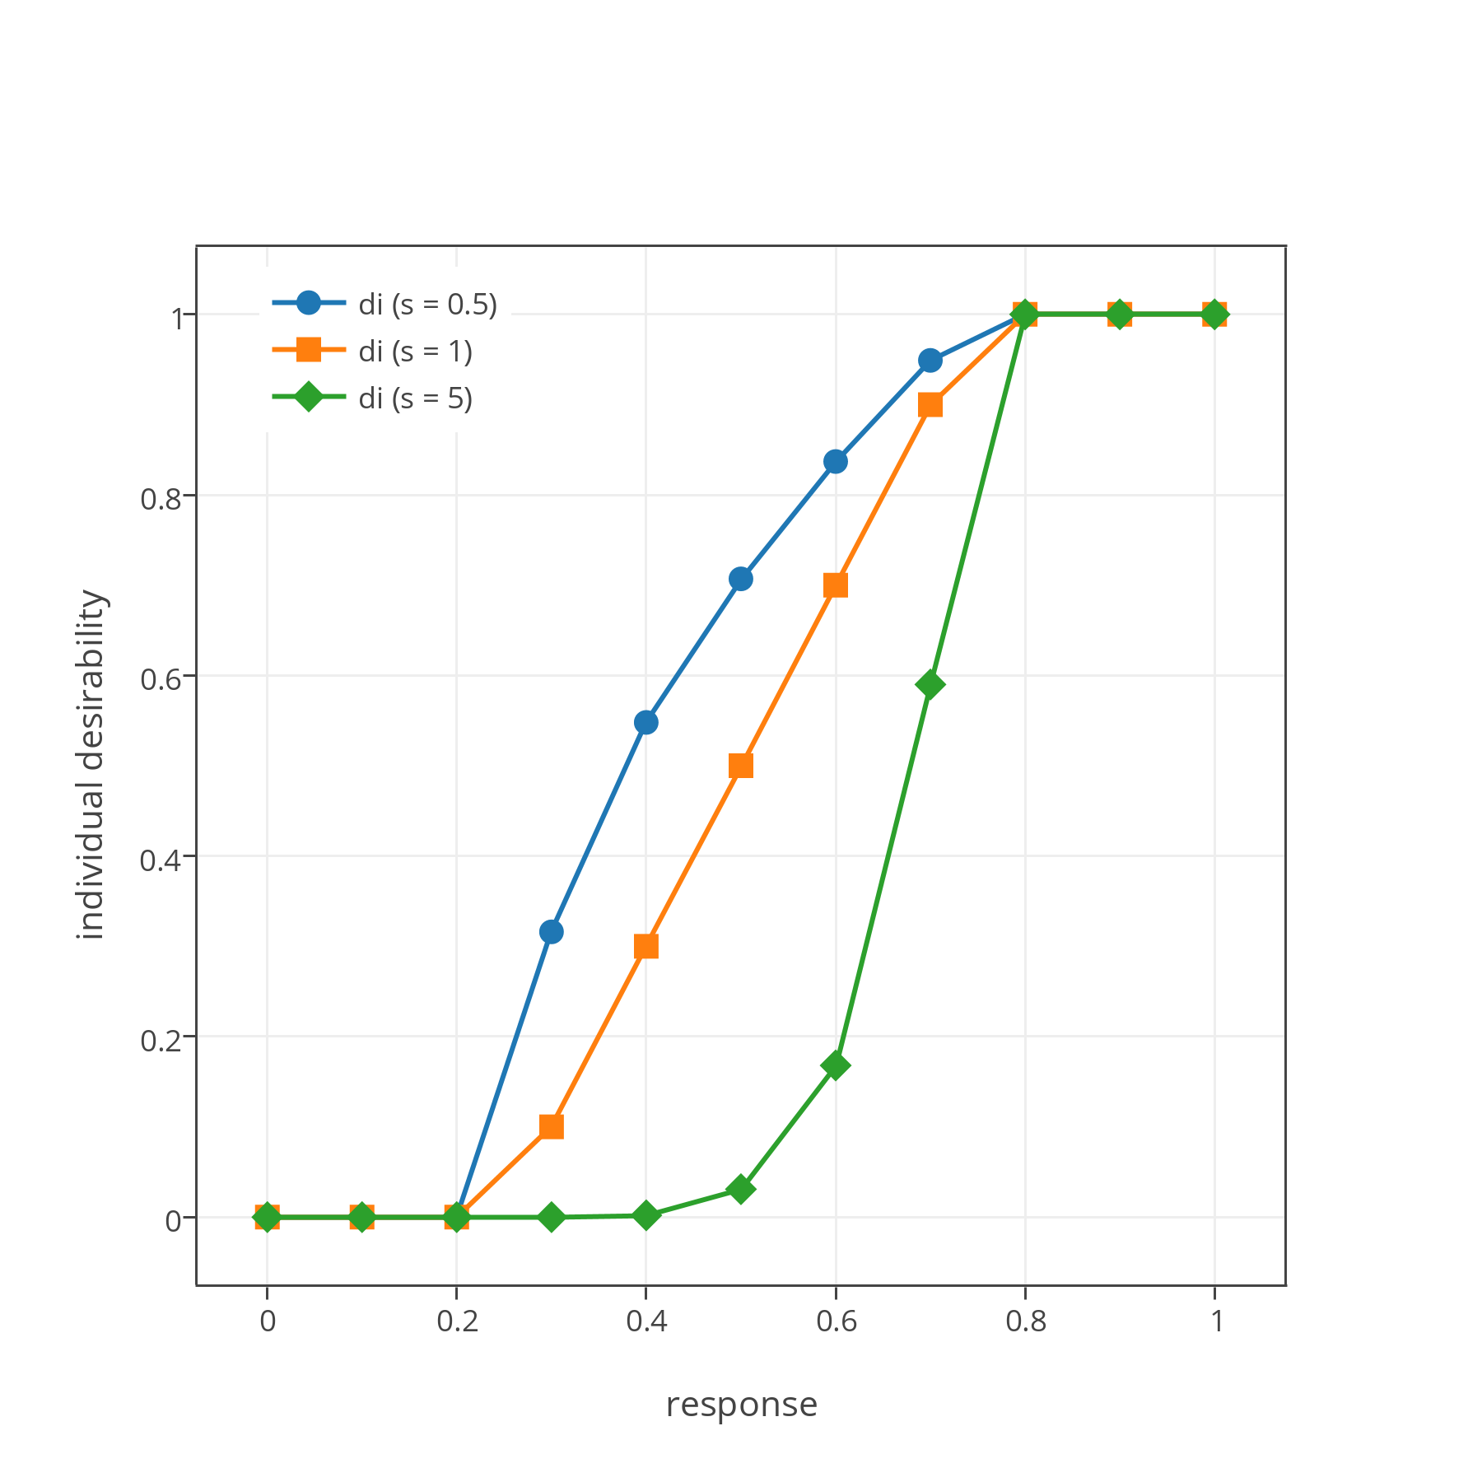
  response | di (s = 0.5) | di (s = 1) | di (s = 5)
  0.0 | 0.000 | 0.000 | 0.000
  0.1 | 0.000 | 0.000 | 0.000
  0.2 | 0.000 | 0.000 | 0.000
  0.3 | 0.316 | 0.100 | 0.000
  0.4 | 0.548 | 0.300 | 0.002
  0.5 | 0.707 | 0.500 | 0.031
  0.6 | 0.837 | 0.600 | 0.168
  0.7 | 0.949 | 0.700 | 0.590
  0.8 | 1.000 | 1.000 | 1.000
  0.9 | 1.000 | 1.000 | 1.000
  1.0 | 1.000 | 1.000 | 1.000
When s = 1 there is a linear relationship between Ri and di for responses between the lower limit and the upper limit. For smaller values of s, the individual desirability increases more quickly than the response, and for larger values of s, the individual desirability increases more slowly than the response. Choosing a value of s greater than 1.0 delays the increase in the individual desirability, giving more weight to those responses closer to the lower limit; choosing a value of s less than 1.0 accelerates the increase in individual desirability, giving more weight to those responses closer to the upper limit.
Investigation 27. Compare the response surface for danshensu’s individual desirability (Figure 16) to its response surface in terms of extraction yield (Figure 10). In what ways are these response surfaces similar and in what ways are they different?
The two response surfaces are similar in showing how a change in extraction time affects the extraction yield, with longer extraction times resulting in greater extraction yields. Both response surfaces show that the extraction yield increases as the solvent-to-solid ratio increases from its lower limit, although the response surface for danshensu’s individual desirability does not show a decrease in the extraction yield for larger solvent-to-solid ratios. The response surface for danshensu’s individual desirability, with its large plateau, shows more clearly that the optimum condition for extracting danshensu is relatively insensitive to a change in the extraction time and the solvent-to-solid ratio.
Investigation 28. To explore the effect on the global desirability of weighting analytes, let’s assume we have four analytes with individual desirabilities of 0.90, 0.80, 0.70, and 0.60. What is the global desirability if you (a) weight the factors evenly by assigning each an r of 1; (b) assign a weight of 3 to the first analyte and a weight of 1 to the other three analytes; (c) assign a weight of 5 to the first analyte and a weight of 1 to the other three analytes; (d) assign a weight of 3 to the last analyte and a weight of 1 to the other three analytes; and (e) assign a weight of 2 to the second and third analytes and a weight of 1 to the first and last analyte? Examine your results and discuss any trends you see.
The global desirabilities are
(a) $D={\left(0.90×0.80×0.70×0.60\right)}^{1/4}=0.742$
(b) $D={\left({\left(0.90\right)}^{3}×0.80×0.70×0.60\right)}^{1/6}=0.791$
(c) $D={\left({\left(0.90\right)}^{5}×0.80×0.70×0.60\right)}^{1/8}=0.817$
(d) $D={\left(0.90×0.80×0.70×{\left(0.60\right)}^{3}\right)}^{1/6}=0.691$
(e) $D={\left(0.90×{\left(0.80\right)}^{2}×{\left(0.70\right)}^{2}×0.60\right)}^{1/6}=0.744$
Let’s use the global desirability of 0.742 in (a) as a reference as in this case we assign an equal importance to each analyte. In (b) we see that increasing the relative importance of the first analyte, which has the largest individual desirability, increases the global desirability; increasing the first analyte’s relative importance further increases the global desirability, as seen in (c). For (d) we see that increasing the relative importance of the last analyte, which has the smallest individual desirability, decreases the global desirability. In (e) we see that increasing the relative importance of the middle two analytes—one with an individual desirability slightly larger than 0.742 and one with an individual desirability slightly smaller than 0.742—yields a global desirability similar to that in (a); it is slightly larger than 0.742 because 0.80 is further from 0.742 than is 0.70.
Investigation 29. A comparison of Figure 16 and Figure 17 shows that the global desirability function has a smaller range of maximum values than does the individual desirability function for danshensu. Which analytes limit the range of optimum values for the global desirability function? Based on Figure 17, what is the range of extraction times and range of solvent-to-solid ratios that result in an optimum global desirability? Given the range of possible values for the extraction time and the solvent-to-solid ratio, what values are the best option? Why?
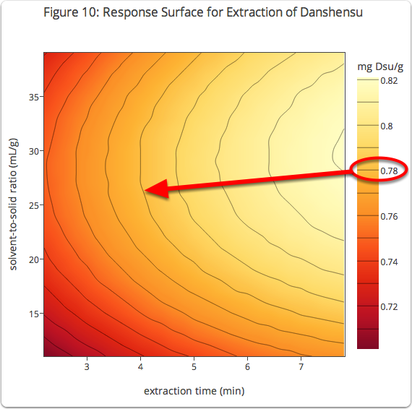
To evaluate the relative importance of an analyte, recall that its individual desirability has a value of 1.00 when its extraction yield is greater than 95% of its maximum extraction yield. As an example, consider the response surface for danshensu, an annotated version of which is shown here. Danshensu’s maximum extraction yield (see Investigation 25) is 0.821 mg/g, and 95% of this value is 0.78 mg/g. From Figure 10, we see that 0.78 mg/g corresponds to the fifth contour line and that everything to the right of this contour line has a individual desirability of 1.00.
A similar analysis for the other analytes shows that cryptotanshinone has an individual desirability of 1.00 when its extraction yield is greater than 0.84 mg/g, that tanshinone I has an individual desirability of 1.00 when its extraction yield is greater than 1.28 mg/g, and that tanshinone IIA has an individual desirability of 1.00 when its extraction yield is greater than 2.65 mg/g; in all three cases, these encompass large portions of their overall response surfaces (see Figures 13, 14, and 15, respectively). This is not the case for lithospermic acid (its individual desirability is 1.00 when its extraction yield exceeds 2.58 mg/g) or for salvianolic acid A (its individual desirability is 1.00 when its extraction yield exceeds 0.59 mg/g); for both analytes, the maximum individual desirability is limited to a small area in the response surface’s upper right corner (see Figures 11 and 12, respectively; thus, lithospermic acid and salvianolic acid A limit the choice of factor levels.
From Figure 17, the area encompassing a global desirability of 1.00 includes the following combinations of extraction times and solvent-to-solid ratios:
7.20 min and 37.0–39.0 mL/g
7.40 min and 34.0–39.0 mL/g
7.60 min and 33.0–39.0 mL/g
7.80 min and 32.0–39.0 mL/g
Any extraction time and solvent-to-solid ratio in this area will work; an extraction time of 7.50 min and a solvent-to-solid ratio of 35.0 mL/g, which is in the center of this area, is a reasonable compromise.
Our final optimized conditions for extracting Danshen are a solvent that is 80% methanol and 20% water (by volume), a temperature of 70°C, a microwave power of 800 W, an extraction time of 7.50 min, and a solvent-to-solid ratio of 35.0 mL/g.
Note: Although this case study does not include salvianolic acid B, which is included in the original paper, the optimized conditions arrived at here are identical to those in the original paper.
Part VII. Verifying the Analytical Method’s Accuracy
Investigation 30. In Part V we found that the empirical model for the extraction of danshensu is
$$EY=0.575+0.0225A+0.00905B-0.00125A^{2}-0.000165B^{2}+0.000100AB$$
where EY is the extraction yield (in mg/g), A is the extraction time (in min), and B is the solvent-to-solid ratio (in mL/g). Using this model, calculate danshensu’s predicted extraction yield for an extraction time of 7.50 min and a solvent-to-solid ratio of 35.0 mL/g. Is your predicted extraction yield consistent with the data in Table 2 and your response to Investigation 25?
Substituting into our empirical model for the extraction of danshensu an extraction time of 7.50 min and a solvent-to-solid ratio of 35.0 mL/g gives a predicted extraction yield of 0.814 μg/g. This results is consistent with the data in Table 2 for danshensu’s central-composite design, which suggests that its extraction yield is between 0.805 μg/g (for an extraction time of 7.00 min and a solvent-to-solid ratio of 35.0 mL/g) and 0.820 μg/g (for an extraction time of 7.82 min and a solvent-to-solid ratio of 25.0 mL/g), with its value closer to 0.805 μg/g.
Investigation 31. Figure 18 shows the chromatogram for a sample of Danshen extracted using the optimized conditions from Part VI. Using this chromatogram, calculate the actual extraction yield for each analyte and report its experimental extraction yield as a percentage of its predicted extraction yield from Table 3. Do your results provide confidence in our analytical method? Why or why not?
From Investigation 19, we know that the extraction yield, EY, is
$$EY\left(\frac{mg}{g}\right)=\frac{A (mAU)×V(mL)}{k(\frac{mAU•mL}{g})× m (g)}×\frac{1 mg}{1000 g}$$
where A is the absorbance, V is the volume of solvent, k is an analyte-specific calibration constant, and m is the sample’s mass. The table below provides the absolute experimental extraction yields, EY, and the experimental extraction yields expressed as a percentage of the predicted extraction yield, %EY, using a volume of 35.0 mL and a sample of 1.000 g.
analyte | absorbance (mAU) | k (mAU•mL/μg) | EY (mg/g) | %EY
danshensu | 36.4 | 1.605 | 0.794 | 97.5
rosmarinic acid | 62.8 | 0.878 | 2.503 | 108.2
lithospermic acid | 39.7 | 0.536 | 2.592 | 97.6
salvianolic acid A | 26.4 | 1.585 | 0.583 | 97.2
dihydrotanshinone | 33.1 | 2.841 | 0.408 | 96.2
cryptotanshinone | 49.6 | 1.882 | 0.922 | 100.5
tanshinone I | 59.4 | 1.599 | 1.300 | 97.3
tanshinone IIA | 115.7 | 1.467 | 2.760 | 99.9
The percent extraction yields range from a low of 96.2% for dihydrotanshinone to a high of 108.2% for rosmarinic acid—the two analytes whose extraction yields could not be modeled—with an average percent extraction yield of 99.3%. These results suggest the empirical models for each analyte’s extraction yield provide a good estimation of the actual extraction yields.
Note: The predicted extraction yields are derived from Table 2 of the original paper. The chromatogram in Figure 18 is derived from Table 3 of the original paper.
Investigation 32. Compare your results from Investigation 31 with the results reported in Table 4. Do these results support a concern that heat-reflux extractions may distort the apparent composition of Danshen? As you consider this question, you may wish to review the chemical structures of these compounds, which are shown in Part I, and the HPLC data in Figure 19 for samples drawn at different times during an extended heat-reflux extraction of Danshen.
The table below reports the extraction yields for the three heat-reflux extractions as a percentage of the extraction yields from Investigation 30. With the exception of danshensu and lithospermic acid using HRE-1, the results for the remaining analytes are significantly less than 100%—suggesting that heat reflux extractions result in the thermal degradation of the analytes—ranging from a low of 62.0% for cryptotanshinone using HRE-1 to a high of 85.9% for dihydrotanshinone using HRE-2. The percentage extraction yield of 101.2% for lithospermic acid using HRE-1 is inconsistent with its results using HRE-2 and HRE-3 and most likely is an outlier.
 | Extraction Yields as % of Extraction Yield for Microwave Extraction
analyte | HRE-1 | HRE-2 | HRE-3
danshensu | 205.3 | 104.8 | 133.5
rosmarinic acid | 81.1 | 80.4 | 64.6
lithospermic acid | 101.2 | 67.6 | 85.7
salvianolic acid A | 76.4 | 76.8 | 79.8
dihydrotanshinone | 85.4 | 85.9 | 71.6
cryptotanshinone | 62.0 | 65.0 | 59.0
tanshinone I | 69.6 | 74.8 | 70.6
tanshinone IIA | 72.1 | 84.2 | 64.2
The results for danshensu require a closer consideration as we need to determine if they represent an underreporting of danshensu when using a microwave-assisted extraction or if they are the result of thermal degradation of other compounds during a heat-reflux assisted extraction. Two observations lead us to the latter possibility. First, the HPLC chromatograms in Figure 19, which focus on danshensu’s peak, show an increase in its peak height and, therefore, an increase in danshensu’s concentration with longer exposures to an elevated temperature; this suggests that the concentration of danshensu may increase as a result of the thermal degradation of other compounds. The structures of rosmarinic acid, lithospermic acid, and salvianolic acid A support this possibility as each compound is an ester, one part of which is danshensu. It seems likely that hydrolysis of the ester bond releases danshensu; thus, as the concentrations of rosmarinic acid, lithospermic acid, and salvianolic acid A decrease, the concentration of danshensu increases. This further supports the concern that a heat-reflux extraction distorts our understanding of Danshen’s composition.
Note: The data in Table 4 is taken from Table 3 of the original paper.
Investigation 33. Explain why analyzing a sample before and after adding a known amount of an analyte allows you to evaluate a method’s accuracy. Figure 20 shows the chromatogram for a sample of Danshen spiked prior to the microwave extraction with known amounts of each analyte, the concentrations of which are shown in Table 5. Using this data and your results for the unspiked sample in Investigation 31, how confident are you in the accuracy of our analytical method?
The process of analyzing a sample before and after adding a known amount of analyte is called a spike recovery. We first analyze a sample and determine the concentration of analyte in the sample. Next, we spike an identical sample with a known amount of analyte and determine the concentration of analyte in the spiked sample. The percent recovery is defined as
$$\frac{C_{spiked}-C_{unspiked}}{C_{spiked}}×100$$
where Cspiked is the analyte’s concentration in the spiked sample and Cunspiked is the analyte’s concentration in the original, unspiked sample. If we lose some analyte to thermal degradation during the extraction, then we will obtain a spike recovery significantly less than 100%, and if a different analyte converts to our analyte during the extraction (as is the case for the data in Table 4 and in Figure 19), then we will obtain a spike recovery significantly greater than 100%. Obtaining a spike recovery of 100% provides confidence that the analytes are not degraded during the extraction.
The table below summarizes results for the spike recoveries. The first column gives the absorbance values extracted from Figure 20. The concentrations of analytes in the spiked sample were calculated as in Investigation 30 and the concentrations of analytes in the unspiked sample are taken from Figure 18 and from Investigation 30. Individual spike recoveries range from a low of 93.7% for tanshinone I to a high of 103.4% for tanshinone IIA. The average spike recovery is 99.6%. With the possible exception of the spike recovery for tanshinone I, which is a bit low, these results provide confidence in our analytical method’s accuracy.
analyte | absorbance (mAU) | Cspiked (mg/g) | Cunspiked (mg/g) | Cadded (mg/g) | % Recovery
danshensu | 59.3 | 1.293 | 0.794 | 0.500 | 99.8
rosmarinic acid | 126.1 | 5.023 | 2.503 | 2.500 | 100.8
lithospermic acid | 78.8 | 5.146 | 2.592 | 2.500 | 102.2
salvianolic acid A | 49.4 | 1.091 | 0.583 | 0.500 | 101.6
dihydrotanshinone | 73.3 | 0.903 | 0.408 | 0.500 | 99.0
cryptotanshinone | 101.5 | 1.888 | 0.922 | 1.000 | 96.6
tanshinone I | 102.2 | 2.237 | 1.300 | 1.000 | 93.7
tanshinone IIA | 224.0 | 5.344 | 2.760 | 2.500 | 103.4
Note: The original paper reports that the spike recoveries range from a low of 94.6% to a high of 106.3%, but do not report the spike recoveries for individual analytes. The data for this investigation were generated artificially.
Part VIII. Applying the Analytical Method
Investigation 34. Calculate the concentration of danshensu and the concentration of tanshinone I in each sample. For each set of samples—wild samples and cultivated samples—calculate the mean, the standard deviation, and the relative standard deviation for each analyte and comment on your results.
The table below reports the concentration of danshensu and tanshinone I in each sample.
Danshen Source | concentration (mg/g) for danshensu | concentration (mg/g) for tanshinone I
Wild Samples (Cities in Shandong Province)
Sanshangou | 0.472 | 2.71
Yuezhuang | 0.224 | 1.21
Dazhangzhuang | 0.257 | 1.48
Pingse | 0.812 | 0.92
Mengyin | 0.217 | 2.89
Cultivated Samples (Lot Number)
020208 | 0.511 | 2.99
020209 | 0.517 | 3.00
020210 | 0.509 | 3.01
020211 | 0.497 | 3.24
020212 | 0.512 | 3.30
For the wild samples of Danshen originating from Shandong Province, the mean concentration for danshensu is 0.396 mg/g with a standard deviation of 0.255 and a relative standard deviation of 64.3%; the mean concentration for tanshinone I is 1.84 mg/g with a standard deviation of 0.899 and a relative standard deviation of 48.8%.
For the cultivated samples of Danshen, the mean concentration for danshensu is 0.509 mg/g with a standard deviation of 0.0074 and a relative standard deviation of 1.5%. The mean concentration for tanshinone I in the cultivated samples is 3.11 mg/g with a standard deviation of 0.150 and a relative standard deviation of 4.8%.
The concentrations of danshensu and tanshinone I in the wild samples of Danshen show substantial variability for plants collected from different locations, as evinced by the large standard deviations and relative standard deviations. The small standard deviations and relative standard deviations for danshensu and for tanshinone I in the cultivated samples show that there is a much smaller variation between plants. These results are not surprising as we might reasonably expect the concentrations of Danshen’s hydrophilic and lipophilic compounds to be sensitive to their local environment and to the consistency in the water and nutrients reaching the plants.
Note: The data in Table 6 are drawn from the paper “Simultaneous Determination of Seven Active Compounds in Radix Salviae Miltiorrhizae by Temperature-Controlled Ultrasound-Assisted Extraction and HPLC,” the full reference for which is Qu, H.; Zhai, X.; Shao, Q.; Cheng, Y. Chromatographa 2007, 66, 21–27. (DOI: 10.1365/s10337-007-0244-4).
Part IX. Closing Thoughts
For instructors interested in building into their laboratory curriculum a method development exercise based on the use of response surfaces, the following experiments from the Journal of Chemical Education may be of interest:
“Introduction to the Design and Optimization of Experiments Using Response Surface Methodology. A Gas Chromatography Experiment for the Instrumentation Laboratory,” Lang, P. L.; Miller, B. I.; Nowak, A. T. J. Chem. Educ., 2006, 83, 280–282.
“Experimental Design and Optimization: Application to a Grignard Reaction,” Bouzidi, N.; Gozzi, C. J. Chem. Educ., 2008, 85, 1544–1547.
“Visualizing the Solute Vaporization Interference in Flame Atomic Absorption Spectroscopy,” Dockery, C. R.; Blew, M. J.; Goode, S. R. J. Chem. Educ., 2008, 85, 854–858.
“Attaining Optimal Conditions: An Advanced Undergraduate Experiment that Introduces Experimental Design and Optimization,” Van Ryswyk, H.; Van Hecke, G. R. J. Chem. Educ., 1991, 68, 878–882.
“Optimization of HPLC and GC Separations Using Response Surfaces: Three Experiments for the Instrumental Analysis Laboratory,” Harvey, D. T.; Byerly, S.; Bowman, A.; Tomlin, J. J. Chem. Educ., 1991, 68, 162–168.
“Central Composite Experimental Designs: Applied to Chemical Systems,” Palasota, J. A.; Deming, S. N. J. Chem. Educ., 1992, 69, 560–563.
“Mixture Design Experiments Applied to the Formulation of Colorant Solutions,” Gozálvez, J. M.; García-Díaz, J. C. J. Chem. Educ., 2006, 83, 647–650.
“Experimental Design, Near-Infrared Spectroscopy, and Multivariate Calibration: An Advanced Project in Chemometrics,” J. Chem. Educ., 2012, 89, 1566–1571.

