Instructor’s Guide

Environmental Analysis: Effects of Acid Rain on Atlantic Salmon Populations

Sections of this overall module
Identifying the problem
Sampling and Sample Preparation
pH / ISE
titrimetry (Acid Neutralizing Capacity - ANC, water hardness)
IC (Ca²⁺ and Mg²⁺)
instructor’s guide

How this module has been used:
There are several different experimental approaches that can be pursued as identified in the different hypotheses.
This project has been used as an analytical problem based project in Environmental Chemistry, and in a Quantitative Analysis leaning Analytical Chemistry course where the students cover the basic analytical methods and then
Collect water samples,
Obtain field pH measurements over time during spring snow melt,
Measure Acid Neutralizing Capacity (ANC) to identify sites where the water system will be sensitive to acid rain impacts
Measure nutrient levels (phosphorus and nitrogen containing compounds)
Measure water hardness (titration) and concentrations of Ca²⁺ and Mg²⁺ via IC

The surface waters in the Machias and East Machias watershed are very low conductivity (often about 20 µS/cm), resulting in needing the trace analysis via ion chromatography (IC) rather than titration. The Ca²⁺ concentrations in these watersheds often run about 2 ppm. IC is used as it was the instrument readily available for undergraduate use. Atomic absorption spectroscopy could readily be used, and this process is described in other modules.
These low ionic strength waters also make measuring pH a challenge and require very careful calibration, validation, and measurements.
There is also a remediation project where clam shells are used as a source of calcium carbonate to buffer smaller streams from episodic acid rain events. This project has been used to obtain upstream and downstream analysis to identify the changes in water chemistry from the dissolving shells.
There is sample data provided so this could also be used as a dry lab for students to walk through the data analysis process.
This module in primarily focused on the first two hypotheses spelled out in the Identifying the Problem section.

Identifying the problem

Facts, Observations and Evidence
The Atlantic salmon is an anadromous fish species, spending most of its adult life in the ocean coming back to spawn in freshwater rivers. The adult creates a redd, where it lays the eggs, in the fall. After hatching the salmon undergo several stages of their lifecycle in the freshwater. The fry leave the spawning grounds in search of food and develop into parr. After two years, the fry undergo the process of smoltification, where their physiology changes so that they can live in salt water. At this stage the smolt leaves the river and heads to the ocean, where most ultimately head to feeding grounds off of Greenland. The salmon usually live in the ocean for 2-3 years before they return to the river they were hatched in.
In the United States, the historical grounds of the Salmon ranged on the northeast coast south to the rivers of Long Island Sound. Currently, remnants survive only in 8 rivers in Maine, the largest of which is the Penobscot River. Historically in Maine, salmon landings were as high as 90 million tons in the late 1800s. (Baum 1997) By the 1940s the commercial fisheries in Maine were closed, and by the 1990s, less than 2000 adult salmon were returning annually to all of the rivers in Maine, despite over 13 million juvenile salmon stocked annually.
To identify the cause of the minimal returns, the mortality in the river and the sea run mortality were determined. To minimize the potential mortality as parr and fry, a number of smolts are stocked shortly before they are set to leave for the sea. Some of the smolts were pit-tagged with radio labels to identify near shore mortality. Data collected demonstrated a significant mortality from the time when the fish reached the estuary and made it to the open ocean. This mortality would correspond to heavy predation in the bay, or failure of the smolt to survive the transition from fresh to salt water.
During the smoltification process, the salmon has significant biological changes in the gill structure for osmoregulatory processes. In fresh water the salmon needs to maintain a higher salt content in its blood as compared to the water it is in. When in seawater, the salmon needs to maintain a lower salt content in the blood compared to the water it is in. During this change in the gill structure, the salmon is most sensitive to stressors or damage to the gill. Studies have shown that gill deformities can be caused by low pH and by high aluminum. In both of these cases the deformities occur as the cation binding to the gill structure.
The National Resource Council in 2004 specifically stated that the effects of acid rain on smolts is one of the most significant factors impeding the recovery of the Atlantic salmon; “The problem of early mortality as smolts transition from freshwater to the ocean and take up residence as post-smolts needs to be solved. If, as seems likely, that the difficulty of the transition is due in part to water chemistry, particularly acidification, the only methods of solving the problem are changing the water chemistry and finding a way for the smolts to bypass the dangerous water.”
The related Brook Trout has had similar extirpation from streams and ponds in many northeast locations due to low pH.

The question to be answered is: What is causing the increased mortality of Atlantic salmon?
Some hypotheses as to possible (and perhaps intertwined) causes include:
Low pH. Salmonids (Atlantic Salmon, Brook Trout, and related species) are known to be sensitive to pH, with stress occurring below pH 5, and mortality below pH 4.5. The pH of the aquatic ecosystem can be lowered due to natural acid inputs, such as dissolved organic carbon (DOC), or through anthropogenic inputs, predominantly acid rain. The acid rain is created from nitrogen oxides and sulfur oxides emissions. These may be episodic or chronic conditions.
High Aluminum. Aluminum will bind to the gills of the salmonids and irreversibly damage the gills, preventing the fish from uptaking oxygen. Aluminum will get into the water systems predominately from leaching from the ground when acid rain impacts a system.
Elevated Temperature Salmonids are temperature sensitive. When stream temperatures reach over 22ºC, salmon are severely compromised. When temperatures reach over 26ºC, mortality often ensues. The temperature of the stream can change due to increases in air temperature, reduction in boreal cover, or reduction in underground cold-water stream inputs.
Increased predation. There are two major predators. As the fish swim to the ocean as smolts, they are met by a host of predators such as cormorants and seals. The populations of both of these predators have increased in recent years. Another predator is humans, and overfishing is of concern. Starting in the 1950s, salmon have been caught in their ocean feeding grounds off of Greenland and Newfoundland. The catch has steadily declined with the decreasing populations.

Identifying Possible Analysis Methods
There are three hypotheses that have been put forward that could be responsible for the decline of the Atlantic Salmon. The purpose of this exercise is to identify analysis methods that could be used to test the chemical species that contribute to each of these hypotheses. Among the various analytical methods you find that may be applicable to this measurement, identify their strengths and weaknesses (e.g., sensitivity, expense, ease of use, reproducibility).

Hypothesis 1. Episodic acid rain events overcome the buffering capacity of the water system and decrease the pH leading to stress and mortality in Atlantic salmon parr and smolts.
Q1. Using available literature and other sources of information, identify possible analytical methods that could be used to monitor acidity.
Hypothesis 2. Acid rain has increased the leaching of calcium from freshwater, reducing the nutrients available for salmonids. This loss of calcium prevents salmon from properly undergoing the smoltification process resulting in mortality when the fish head to the ocean.
Q2. Using available literature and other sources of information, identify possible analytical methods that could be used to detect calcium and measure their levels in components of the water (e.g., free, organic bound).
Hypothesis 3. Acid rain has increased the leaching of aluminum, resulting in a high concentration of free aluminum ion resulting in gill damage, leading to the main cause of mortality of Atlantic Salmon during the smoltification process.
Q3. Using available literature and other sources of information, identify possible analytical methods that could be used to detect aluminum and measure their levels in components of the water (e.g., free, organic bound).
The rest of the module primarily focuses on the first two hypotheses.

References:
Baum, E. T. 1997. Maine Atlantic Salmon: A National Treasure. Atlantic Salmon Unlimited. Hermon, ME
National Research Council, Atlantic Salmon in Maine. The Committee on Atlantic Salmon in Maine, Board on Environmental Studies and Toxicology, Ocean Studies Board, Division on Earth and Life Sciences. National Research Council of the National Academies. National Academy Press. Washington, D.C. 260 pp
U.S. Geological Survey, variously dated, National field manual for the collection of water-quality data: U.S. Geological Survey Techniques of Water-Resources Investigations, book 9, chaps. A1-A9, available online at http://pubs.water.usgs.gov/twri9A.

Instructor’s Guide – Sampling Plan
This section of material is designed to be approached after students read through the Identifying the Problem module (or an analogous scenario), so they have some idea of what analytes and samples sources the sampling program would focus on addressing. This is meant to have students can work in groups on the questions that are provided. The answers to the questions are provided below.
I have used this by giving the question sets to the students with about 10 minutes left in a class period where I had them discussing Q1. Then they did Q2-5 between classes- so they began thinking about the questions on their own. The next class period they worked in small groups of 3-4 to discuss those answers and proceeded through much of the rest of the assignment. This ended up taking about 90 minutes of class time.
Q1. What key questions must be considered when designing a sampling plan?
Students should be given time to brainstorm on key issues to consider when designing a sampling plan. The instructor may want to provide the answers listed below only after the students may have had a chance to come up with their own answers. Eventually students should be guided to consider issues such as:
1. Where in the watershed should we collect water samples?
2. What type of samples should we collect?
3. When should we collect the sample?
4. What is the minimum amount of sample for each analysis?
5. How many samples should we analyze?
6. How can we minimize the overall variance for the analysis?
Q2. Pick eight random samples from the grid laid out above. How do you ensure you sampling is random?


One way to get random samples is to use Excel or other random number generator. To get 8 random grids label the boxes 1-8, row 1, 9-16, row 2, etc. for 64 boxes. Then use Excel to generate 8 random numbers between 1 and 64; for example: 63, 35, 25, 46, 7, 53, 43, 5.
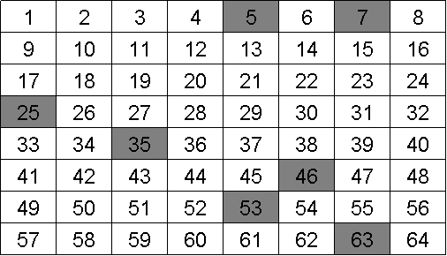
You might ask the students to discuss whether they think a random approach represents the best way to sample. They may realize that the answer depends in part on what you may already know about the system you are sampling. If there is a specific site of concern or point source of the chemical, then random sampling might not be the best option.
Now take a look at the following grids with the analyte of interest identified (colored squares).
 | 1 | 2 | 3 | 4 | 5 | 6 | 7 | 8
1
2
3
4
5
6
7
8
Grid A
 | 1 | 2 | 3 | 4 | 5 | 6 | 7 | 8
1
2
3
4
5
6
7
8
Grid B

Q3. Would you consider the samples above to be heterogeneous or homogeneous?
The analyte is heterogeneous because it is not evenly distributed throughout the entire grid.
Q4. Did your random sampling affect the potential accuracy or precision of your measurement of the analyte for the samples in grid A or grid B? If so how?
The random sampling would have been better for grid B because the analyte is more spread out than in grid A where the analyte is confined or stratified.
Q5. Each of the previous grids is an example of one of these cases. Can you identify which sample is which?
Sample B exhibits constitutional heterogeneity while Sample A exhibits distributional heterogeneity.
Q6. How does distribution heterogeneity affect accuracy and precision?
The answer to Q6 is included with the answer to Q7 below.
Q7. How does constitutional heterogeneity affect accuracy and precision?
When you overlay the sampling scheme with Sample A and Sample B neither sampling scheme is effective, as shown below. The analyte in sample “A” was sampled once (35) as it was in Sample “B” (53). With either sample, unless the sampling scheme could take this heterogeneity into account, the accuracy and precision of the measurement would be compromised.
A. Distributional Heterogeneity B. Constitutional Heterogeneity
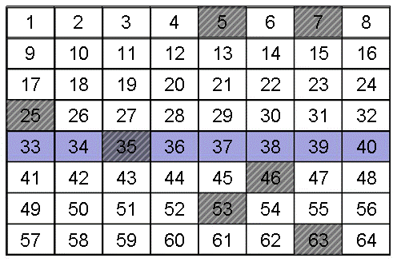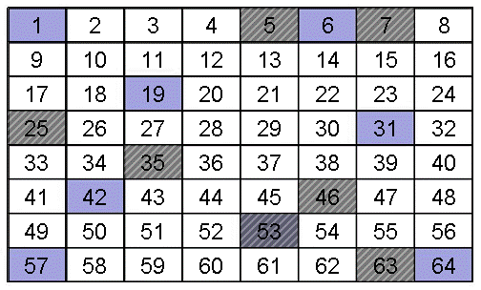
Q8. Do you see a scenario where distribution heterogeneity could be magnified by mixing and/or sampling?
Sampling is often by weight or by “grab”. In this case settling may alter the sample composition.
Q9. What is the advantage of implementing judgmental sampling over random sampling if one knows the point source for the discharge an analyte into a system?
The advantage is that you can get larger number of relevant samples which should decrease the standard deviation of the average value measured for that sample. The cost should also decrease.
Q10. Assume you have chosen a selective sampling plan to evaluate pollution from a point source into a pond. Use the diagram below and words to describe your sampling plan.
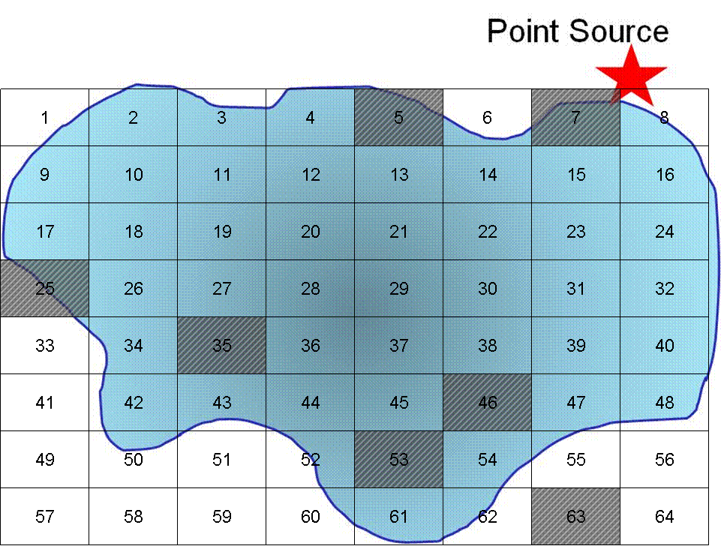
If we use a purely random grid over the pond we will be unable to tell what the effect of the point source is because we would have sampled only once at the source.
A selective method might be the following:
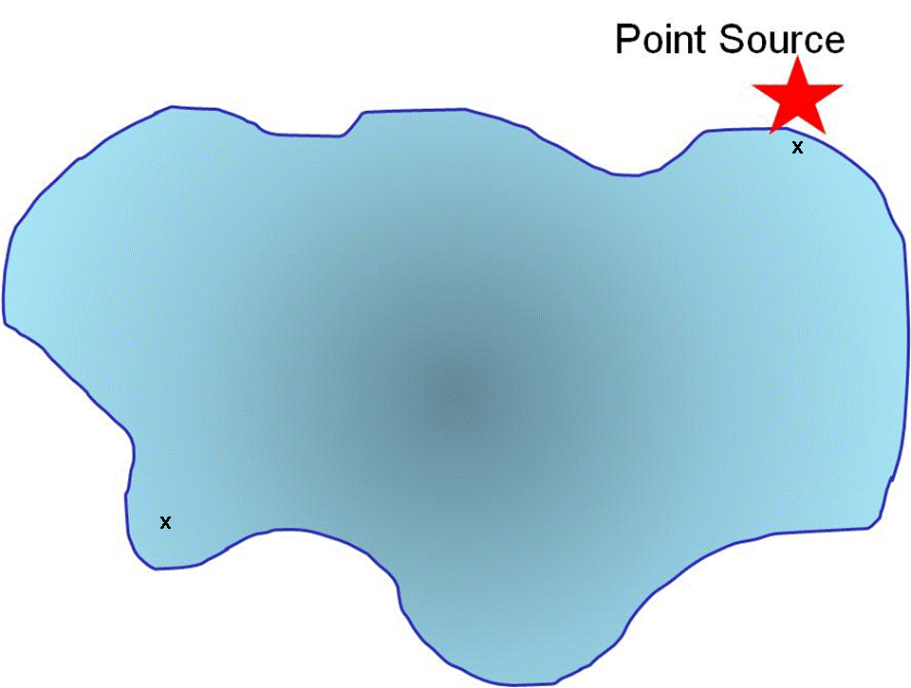
A sample is taken at the point source and for comparison a sample is taken at a distance from the point source.
Q11. Use a grid design (as we have previously done) to show how you would conduct systematic sampling (regular intervals in space and time) of the pollutant. Is there an advantage to what you might learn using this sampling method? What are the disadvantage(s)?
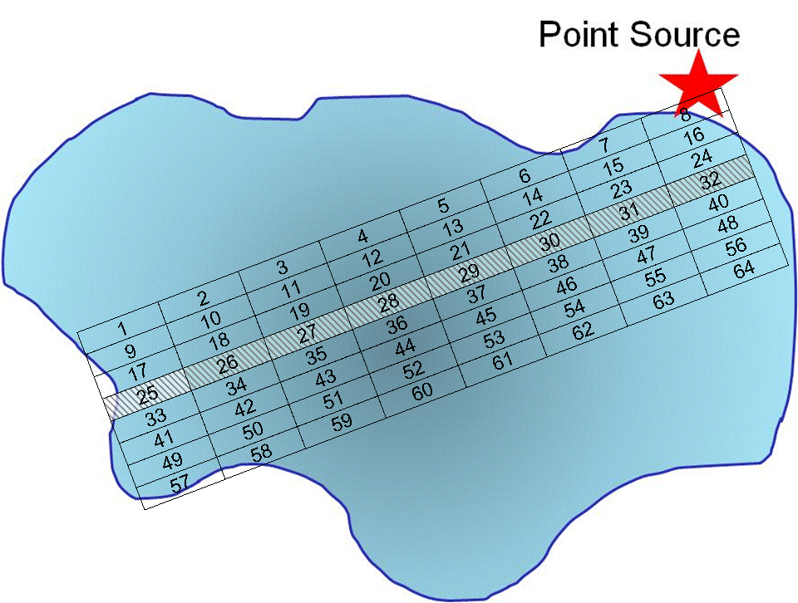
Here we have set up a grid along regular intervals. Because we collect only 8 samples, we may or may not collect a representative sample from within each grid point as we are only collecting one sample.
Q12. Describe how stratified sampling (random sampling within sub populations) might be applied to evaluate the pollutant in the lake? In general, what is the advantage of stratified sampling over cluster sampling?
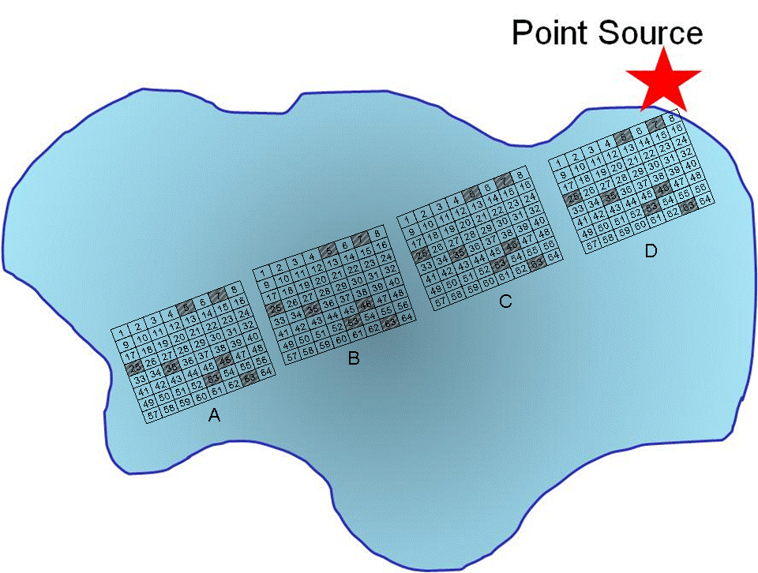
In this example the trajectory along the longest distance from the point source is sampled a total of four times, with random grabs to be co-joined into a single sample.
Q13. What is the main disadvantage of grab and composite samples?
You cannot use them continuously for real time in situ monitoring. If you have an analyte that could vary over time, such as from episodic acid rain, your grab sample may not identify the problem.
Q14. Can you think of any control studies you might want to include when compositing samples?
You might want to retain portions of the grabs and analyze them separately.
Q15. If you are beginning to monitor a site or want to compare your data to a similar source, have there been any standard sampling protocols used for prior monitoring?
This will depend on the project you are initiating. For the water quality monitoring for the Atlantic Salmon project there are some guidelines in EPA standard methods, or regional EPA management protocols to ensure data can be compared. However, most sites such as the EPA Volunteer Stream Monitoring web site does not describe a particular sampling method because each sampling plan must be designed for the specific analytical question being addressed.
Q16. Based on the graph above, describe a sampling procedure that would allow you to obtain a representative sample.
A strategy would be to collect multiple samples at regular intervals of time during a 24-hour span of time.
Q17. Is there any systematic pattern to the data in the graph above?
There is not a systematic pattern although spikes in pH appear more prominent in late fall and winter and early summer months.
Q18. Can you think of some event(s) that may account for the acidic spikes in the pH?
Spikes may be due to acidic snow or rain fall, snowmelt, or other acidic water inputs (flushing of a bog system) that are episodic in nature.
Q19. How would this pH data affect when you might choose to sample a site to assess if acid rain is impacting the ecosystem?
Sampling would have to be conducted at regular intervals to account for known fluctuations. If considering the impact of acid rain, the sampling protocol may focus on sampling around and after rainfall events. If historical data are available, they may aid in better understanding the impact of any changes in pH.
Q20. Describe what else you would need to know to determine when to perform your sample collection if you are addressing whether acid rain is impacting a site. What other data might you need to look up or consider that would contribute to the changes in pH? Would this data affect when you choose to sample?
One consideration is the natural pH functions due to changes in CO₂. In the early morning CO₂ levels tends to be higher due to respiration that occurs during night time. As sun rises, plants and algae begin photosynthesis thereby consuming CO₂ and causing the pH to rise (more basic) as the day progresses. Algae blooms can significantly increase this effect.
You also would need baseline conditions, as some bodies of water are naturally acidic due to dissolved organic matter (e.g. fulvic and humic acids). Thus you would either need historical data to demonstrate a chronic acidification.

Q21. What physical or chemical processes might contribute to the pH fluctuations? How might this affect your sampling plan?
As stated above, CO₂ functions may affect pH. Water temperature affects solubility of gasses, thus changing the amount of CO₂ dissolved in water.
Q22 Another factor to consider is the sample handling time. Can you think of ways in which sample holding time may impact the concentration of different species such as nitrate, pH, and Ca²⁺ in the sample?
Some analytes may precipitate or degrade over time if the sample is not properly handled. For example, calcium and magnesium tend to precipitate as hydroxides. Therefore, sample pH will have to be adjusted below 2 if the analysis is not conducted right away. Nitrates are quickly degraded by bacteria, so concentration of nitrates may change over time if the sample is not refrigerated. pH can change due to processes that change the CO₂ concentration in water system (degasing or increasing solubility of the gas as temperature changes, respiration of organisms in the sample), or some redox processes.
Q23. Why would adjusting the solution pH to below pH 2.0 be needed for preserving samples for metal analysis? How can the solution be adjusted to pH 2 without significantly diluting the sample?
Adjusting the pH to below pH 2.0 would prevent the formation of metal hydroxide precipitates. This concentration of H⁺ can also help limit adsorption to glass surfaces.
Q24. It is known from analyses conducted in 2008 that the % relative sampling error for water hardness by EDTA titration is 0.8%. How many samples should you collect to limit the relative standard deviation for sampling to 1.0% within the 95% confidence level? Is this a feasible task?
Answering this question requires reading Harvey, specifically section 7.B4.
The minimum number of samples can be calculated using the equation:
n_{samp} = t²s² _{samp}
e²
where t is the value for the t test which depends on the confidence level, s_{samp} is the relative standard deviation for sampling, and e is the percent relative sampling error.
Because the value of t depends on n_{samp}, the solution is found iteratively. We start for a value of n = ∞ and t (0.05, ∞) = 1.960.
n_{samp} = (1.960)²(1.0)² = 6.0
(0.8)²
Letting n_{samp} = 6, t (0.05, 6) = 2.447
n_{samp} = (2.447)²(1.0)² = 9
(0.8)²
Letting n_{samp} = 9, t (0.05, 9) = 2.262
n_{samp} = (2.262)²(1.0)² = 8
(0.8)²
Letting n_{samp} = 8, t (0.05, 8) = 2.306
n_{samp} = (2.306)²(1.0)² = 8
(0.8)²
Because two successive calculations give the same value for s_{samp}, we have an iterative solution to the problem. We need at least 8 samples to achieve a percent relative sampling error of ±0.80% at the 95% confidence level.
Q25. If the cost of collecting a sample is $20 and the cost of analyzing a sample is $50 what budget should you allocate for the project and what sampling strategy would be most effective for the given number of samples?
If we have 8 samples, the cost of collecting will be $160 and cost of analysis $400, for a total of $560. Most effective sampling plan would be judgmental.

Q26. Below is an image of the area around Machias, where the confluence of the Machias, Middle, and East Machias Rivers empty into the Machias Bay. Design your sampling plan. Think about random, systematic, clustering, etc. sample strategies. Will you take grab samples or pool samples together?
One way to use this question is to have the students discuss these questions in groups and put together a final plan. The plans could either be presented to the class or turned in as a graded written assignment.
The last part of this module discusses proper preparation of sampling containers. The procedures included within this guide adhere to EPA guidelines for water monitoring.
Q27. Why are different procedures recommended? Why do you think acid washing of the glassware is recommended for some analyses? What is the purpose of using a phosphate-free detergent?
To answer this question, students may be directed to the EPA Monitoring and Assessing Water Quality website (http://water.epa.gov/type/rsl/monitoring/vms50.cfm). Acid washing is required for nitrate and phosphate analyses. Obviously, phosphate-free detergent is necessary to eliminate any possible contributions of phosphate that may have adhered to the container during washing. Acid washing will remove any traces of nitrates or phosphates from containers.
Q28. For some analytes such as phosphorous, plastic containers made of either high-density polyethylene or polypropylene might be preferable to glass. Why would this be the case? In addition, the EPA states that all containers and glassware must be “dedicated” to a specific analysis. What would be the drawback of reusing glassware for a different analysis?
Glass and some types of plastic containers have positive ion-exchange sites that can interact with negative ions in solution. Phosphate can therefore adhere to the surface of glass and be lost. Phosphorous is also known to leach out of glass containers. Rinsing containers with dilute HCl helps saturate the sites and minimize losses due to adsorption.
Since most of the analyses are performed at trace level, dedicated containers should be used to avoid cross contamination.
Additional Resources: For further discussion on sampling amounts see section 7B in Harvey, D. Chapter 7, Collecting and Preparing Samples. (http://collection.asdlib.org/?p=452)

Ion-Selective Electrodes (ISEs) Instructor’s Guide

Q1: Will a more acidic sample displace more, the same or less Na⁺ from the hydrated gel layer?

Because H⁺ binds more strongly than Na⁺ to the –SiO⁻ function in glass, the H⁺ will displace more Na⁺. As the sample becomes more acidic, there are more H⁺ present. This greater H⁺ concentration will displace more Na⁺ from the hydrated gel.

Q2: What do you think is meant by mobility of ions?

Students will usually consider Mobility to mean how well something moves around. The mobility of ions can be defined as the rate at which they move around.

Q3: Which ion do you think has a higher mobility, H⁺ or Na⁺?
The smaller an object is the more mobile it will tend to be. For ions the mobility will be based on its effective ionic radius.

This is a challenging question – based on effective ionic radii in water, Na⁺ is smaller, so it should have a higher mobility in solution, but not necessarily in glass membrane. H⁺ is smaller than Na⁺, so it would have a higher mobility in glass.

Q4: Do you think other cations (e.g., Li⁺. K⁺) may have some ability to migrate into the hydrated gel layer of a pH electrode? If so, is this a problem?

Yes they will be able to migrate into the gel layer. This can cause a problem in that those ions will also displace Na⁺ giving rise to a higher membrane potential. This is a cause of the sodium error in pH measurements.

For the Na⁺ ion selective electrode, the varying junction potential only depends on the concentration of Na⁺.

It should be noted that liquid junction potentials will happen whenever two different electrolytes come in contact. Thus in the combination pH electrode, a potential can arise at the frit between the electrode and the solution. This junction potential arises due to the difference in mobility as the electrolyte moves across the boundary. This potential can be difficult to reproduce or known with any accuracy.
In solutions with a very low ionic strength, e.g. the surface waters of interest in the salmon declines, there is greater driving force for diffusion across the frit. Thus the propensity for junction potential errors becomes important to consider. This junction potential can be unstable, leading to drift; therefore periodic checks of the calibration (often hourly) may be needed. Calibration needs to be with low ionic strength buffers to better reflect the samples of interest, and make it so that the potential across the glass membrane is the only potential that is changing. It can also be important to note that the electrode design is important, therefore there are recommended electrodes for some types of environmental analyses when measuring surface or rain waters of low ionic strength.
This issue generally leads to a validation of the pH measurement by measuring the pH of distilled water that is in equilibrium with air. The pH should be around 5.7, thus pH readings should stabilize rather quickly between 5.6 and 5.8 to demonstrate the pH electrode is responding appropriately.

Q5: Consider a solution that has some Na⁺ and very high concentrations of K⁺Cl⁻. What effect do you think this might have on the activity of Na⁺ in the solution?

The high concentration of K⁺Cl⁻ will affect the ionic strength of the solution, this will affect the activity coefficient of Na⁺. This can be calculated more formally using the extended Debye-Huckel equation (Equation 6.63 in the Harvey Analytical 2.0 text)

The relationship between activity and concentration for sodium is illustrated in Equation 2.

$a_{Na}= γ_{Na}[{Na}^{+}]$ (2)

In eq 2, a_{Na} is the sodium ion activity (mol L⁻¹) , [Na⁺] is the sodium ion concentration (mol L⁻¹), and γ_{Na} is the activity coefficient for the sodium ion. As we just discussed, as the sample ionic strength increases, there is a greater probability that analyte ions will interact with oppositely charged ions from the supporting electrolyte(s) dissolved in the sample. This effectively decreases the concentration of the “free ion”, which is represented by a decrease in the activity coefficient. As the ionic strength of a solution approaches zero, the activity coefficient approaches one, and under infinitely dilute conditions, the analyte activity and analyte concentration are equal. The relationship between the oxidized and reduced forms of sodium written as a reduction reaction can be described in Equation 3.

Na⁺ (aq) + e⁻ → Na (s) (3)

The half-cell potential of the indicator electrode responds to changes in the activity of the analyte as described by the generalized form of the Nernst equation in Equation 4:

$E_{ind}= E_{ind}^{o}- \frac{RT}{nF}ln\left(\frac{1}{a_{Na}}\right)$ (4)

In eq 4, E° is the indicator electrode potential under standard conditions (298 K, 1.00 M Na⁺), R is the molar gas constant (8.314 J K⁻¹ mol⁻¹) , T is the absolute temperature (K) , n is the number of moles of electrons in the half-reaction, and F is Faraday’s constant (96485 C mol⁻¹).

Q6: If the indicator electrode potential under standard conditions is -0.100 V, what is the indicator electrode potential at 298 K if the activity of the sodium ion is 0.10 M?

$$Eind= -0.100V-\frac{\frac{8.314J}{Kmol}*298K}{1mol e-*\frac{96485C}{mol}}ln⁡(\frac{1}{0.1M})$$

Therefore E_{ind} = -0.1591 V

Q7: How does the indicator electrode potential change in the previous question if the temperature is increased by 10 degrees?

$$Eind= -0.100V-\frac{\frac{8.314J}{Kmol}*308K}{1mol e-*\frac{96485C}{mol}}ln⁡(\frac{1}{0.1M})$$
Therefore E_{ind} = -0.1611 V
Thus the measured potential is dependent on the temperature. This temperature effect has led to most meters have an automatic temperature correction.

Q8: How would you go about calibrating a sodium ion selective electrode?

You basically have to measure the response as a function of concentration. There are several practical ways that this is done. Most ISE are standardized by doing standard addition, where you start with distilled water and ionic strength adjuster. You then add increments of the analyte to the solution and measure the potential for each step.

The electrode could be also be calibrated using different solutions of known concentration (similar to how the pH electrode is calibrated using at least two solutions of known pH).

Q9: Can you think of a way to mitigate possible effects of ionic strength to insure that your calibration procedure and sample analysis provide an accurate measurement of the concentration of Na⁺ in the unknown?

The ionic strength needs to be rather constant, so the ionic strength is adjusted using the addition of an ionic strength adjuster solution. This solution contains a high concentration of ions that do not interfere or mask the indicator electrode response.

Q10: Would this proposed way to mitigate possible effects of ionic strength be utilized in pH measurements?

The ionic strength adjustor solution would have to have species that would not affect pH, thus greatly limiting the possible solution. In, practice this does not work well for measuring pH, as most ionic strength adjustments will have trace contamination that will affect pH, or the cations will introduce additional errors when the cation interacts with the glass membrane (the source of the Na⁺ error in pH measurements).
Q11: In the potentiometric determination of sodium ion of a mineral water sample, indicate if either of the following supporting electrolytes can be used for ionic strength adjustment: a 4.0M NH₃ – NH₄Cl buffer (pH 10) or 4.0M NaCl.

The 4.0 M NaCl would introduce sodium ions into the solution, which affects the concentration of what you are trying to measure. Therefore the ammonia buffer solution would be able to be used for the ionic strength adjuster.

Q12: What would be the general criteria you would need to use in selecting a suitable supporting electrolyte for an analysis using an ion selective electrode?

You want a supporting electrolyte that:
- Is different than analyte.
- Will not interfere with the concentration of the analyte (it does not react or bind with the analyte)
- It will not mask the presence of the analyte
- The indicator electrode does not respond to it.
- It will not foul the electrode or any electrode junction.

Q13: Based on the relationship in eq 6, how would you construct a calibration that links the changes in electrode potential to changes in the concentration of the sodium ion?

In the Nernst equation (eq 6) the cell potential varies with the log of the activities. The measured electrode potential is graphed versus the log of the concentration. The line of best fit is linear. The equation of the line of best fit is used to determine the concentration of the unknown.

Q14: What is the expected slope of a potentiometric calibration curve for sodium at 35°C? What effect does temperature have on the slope of a potentiometric calibration curve?

$$Eind= E^{0}-\frac{\frac{8.314J}{Kmol}*308K}{1mol e-*\frac{96485C}{mol}} 2.303 log⁡({Na}^{+})$$
If you plot the potential as a function of log concentration then the slope would be 0.0611 since ln x = 2.303 log x

Q15: If a sample has a sodium concentration of 1.0 x 10⁻³ M, and the sodium ISE has a selectivity coefficient of K_{Na,H} = 30, what sample pH would cause a 1% error in the sodium ISE response?
First calculate the E_{ind} for the solution of 1.0 x 10⁻³ M

$$E_{ind}=-.100V- \frac{0.05915}{1mol}log\left\{1x{10}^{-3}\right\}$$

$$E_{ind}=0.07745V$$
A 1% error in the response would give a$$E_{ind}=0.07822V$$

Putting this back into the original equation
$$0.07822V=-.100V- \frac{0.05915}{1mol}log\left\{x\right\}$$
Thus x = 0.0476

Putting this into
$$0.0476=\left\{a_{Analyte}+ K_{Analyte,Interferent}{\left(a_{Interferent}\right)}^{{n_{Analyte}}/{n_{Interferent}}}\right\}$$

$$0.0476=\left\{1x{10}^{-3}+ 30{\left(a_{Interferent}\right)}^{1}\right\}$$
Leads to an H⁺ concentration of 0.00155, or pH 2.8
Q16: Evaluate whether it is best to use alkaline or acidic conditions to determine the sodium ion concentration by ISE?

You want the alkaline conditions, as in acidic conditions you have a higher H⁺ activity, leading to a higher % error.

Q17: The table below contains sodium ISE calibration data. If the cell potential measured in a sample is -0.115 V, determine the sodium concentration (mol L⁻¹) in this sample.

[Na⁺] (M) | E_{cell} (V vs SCE)
1.0 x 10⁻⁴ | -0.221
1.0 x 10⁻³ | -0.164
1.0 x 10⁻² | -0.107
1.0 x 10⁻¹ | -0.048

In Excel the graph would look like:

The line of best fit is -0.115V = 0.0576x +0.009
The log of Na⁺ is -2.152
Thus the concentration of Na⁺ is 7.0 x 10 ⁻³ M

Q18: In the previous question, the sample was prepared by pipetting 5.00 mL of the original water sample and 2.00 mL of an ionic strength adjustment buffer into a 100 mL volumetric flask and diluting to the mark with distilled water. Determine the sodium concentration (mol L⁻¹) in the original water sample.

$$C_{1}*5.00mL= 7.0x{10}^{-3}M*100mL$$

Thus the original concentration is 0.14M

Titrimetry Instructor’s Guide:

Q1. In an acid-base titration, what is the chemical reaction that is occurring and how would you determine the endpoint, when all of the unknown had reacted with the titrant?
You need some indicator to identify when the endpoint occurs. For an acid-base titration, you can have change in solution color due to acid/base indicator, or you can determine the endpoint by measuring pH as a function of added titrant. The inflection point of this graph will be at the endpoint.

Q2. What might be the difference between using an acid-base indicator and a pH electrode in measuring the endpoint for an acid-base titration?
The indicator changes in the pH range of the indicator, therefore you have to select the correct acid-base indicator. The pH electrode consistently allows pH to be measured, and requires a titration curve be prepared in order to determine the endpoint. An acid/base indicator is much quicker-but you need to know the pH of the endpoint. Following the titration with a pH electrode can give you additional information, such as something about how the solution is buffered, and the pH of the endpoint.

ANC:
Resources:
Rounds, S.A., 2006, Alkalinity and acid neutralizing capacity (ver. 3.0): U.S. Geological Survey Techniques of Water-Resources Investigations, book 9, chap A6, sec 6.6, July 2006, accessed [June 25, 2012], from http://water.usgs.gov/owq/FieldManual/Chapter6/section6.6/ .

Q1. How is ANC different than the pH of a solution?
pH is simply a measure related to the amount of H⁺ in solution. ANC deals with how much acid can be neutralized, therefore it relates to the buffer capacity of the system. The greater the ANC, the less likely that body of water will be affected by acidic inputs.
Q2. What are some likely chemical species present in natural water that would neutralize an added acid?
Carbonate species (HCO₃⁻, CO₃²⁻ ) and partially deprotonated natural organic acids (humic acid, fulvic acids) can both act to buffer natural water systems.
Q3. How could particles filtered out of a water sample neutralize an acid?
Filtering a water sample will remove suspended particles, and natural organic acids can form micelle-like aggregates that are large enough to be filtered, particularly in the presence of metal ions. Therefore filtering can remove some of the deprotonated organic acids.
Q4. If pKa₁ of carbonic acid is 6.352 and pKa₂ is 10.329, what carbonate species would primarily be present at pH 7.0? As you adjust the pH to around 4.5, how would the dominant species change?

At pH 7.0, since this is a little more basic than the pKa₁ of carbonic acid, the primary species would be the HCO₃⁻. As you adjust the pH to 4.5 you will continue to protonate this species, causing the dominant carbonate species to be the carbonic acid.

Q5. For most surface water samples, the method calls for a sample volume of either 50 mL or 100 mL?
Will either use volumetric pipet or some graduated cylinders that are rated TD (to deliver).

Q6. The analysis requires a known concentration of H₂SO₄, usually 0.1600N or lower. How would you prepare and standardize this titrant?

This concentration can either be purchased directly, or prepared by diluting from a more concentrated solution. Since H₂SO₄ has two H⁺, the normality of the acid solution is twice the molarity of the acid solution. The USGS Field Manual has the directions for preparing and standardizing this solution in section 6.6.2

Q7. Sketch an approximate plot of how the pH of a solution of calcium carbonate (a representative weak base) would change as it is titrated with a strong acid. Where is the endpoint of the titration on this plot?

This would be a diprotic acid titration curve with two equivalence points.

The endpoints can be determined by the inflection point method. This works if the sample has a high enough ANC to allow for an accurate determination of the inflection point.

In samples with low alkalinity, such as the salmon rivers in Maine, the ANC can be calculated using a Gran Method rather than an inflection point.

ANC data analysis:
- In Excel enter sample name, volume and pH values between 4.5 and 3.5 with their corresponding titrant volumes added (Vi).
- Calculate Gran F for each pH.
Gran F = (Sample Volume + Vi) x 10^{(4-pH)}
- Perform a data regression to calculate the ANC (milliEQ/L) and R² using Gran F as the X axis and Vi as the Y axis.
The R² value should be greater than or equal to 0.990.
ANC (milliEQ/L) = (Acid Normality X Regression Constant X 1000)/ Sample Volume. A sample plot is presented in the Excel sheet (ANC_samplegranplots) with this learning module)

Alkalinity data analysis:
Alkalinity is a related parameter calculated in mg/L CaCO₃ using the equation:

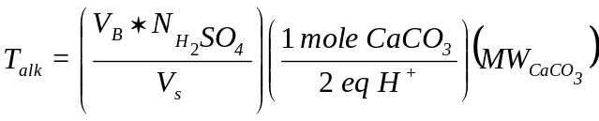

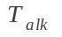: Total alkalinity (mg/L CaCO₃)
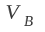: Total titrant volume required to reach bicarbonate equivalence point (L)
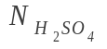: Normality of sulfuric acid (eq/L)
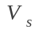: Sample volume titrated (L)
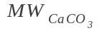:Molecular weight of calcium carbonate (1.00087 x 10⁵ mg/mol)

This analysis makes the assumption that there are low concentrations of other titratable species such as ammonia, silicic acid, or borate.

Additional possible exercises.
If you have measured the concentration of other common cations and anions, you can usually calculate a mass balance once you have calculated alkalinity.

Water Hardness:
Q1. How can you ensure that the four carboxylic acid sites are deprotonated to ensure the ability to bind with Ca²⁺ and Mg²⁺?

You need to have the solution pH above the pKa₄ for EDTA.

Q2. What metals would EDTA likely form stable complexes with in most water samples? How selective is this process?
In most water samples the common cations EDTA would complex with would be Ca²⁺, Mg²⁺, and in some samples Al³⁺, or iron species (Fe²⁺, Fe³⁺)

Q3. The endpoint of a titration is determined using an indicator. What would be the general features of an indicator that could be used to determine the endpoint of a water hardness titration?
The indicator would need to have some aspect where it changes color when a cation is bonded to it. There is a class of indicators that change color as a metal binds to the indicator. For EPA method 130.2 Eriochrome Black T (EBT) is used to determine total water hardness. In the case of EBT, the indicator is wine-red in the presence of metal ions and blue when the indicator does not have a metal bound to it.

Q4. When the EBT is added to your sample, what color would you expect the indicator?
You would expect the indicator to be a wine-red color, as the EBT would have the cations in the water sample to bind to it. (Do note that EBT does degrade when in solution, and thus can only be stored for a couple of weeks before a new indicator solution needs to be prepared.)
As you titrate the solution with EDTA, the EDTA binds with the metal and once it has complexed all of the cations in solution, the EBT will change color as it is not complexed.

Q5. How might raising the pH potentially cause metals to precipitate?
Metals that are not Group 1 metals will precipitate as the hydroxide if the pH is raised high enough.

Q6. The chart below lists the solubility product constants of the hydroxide complexes of several common cations in water. Which metal would precipitate last as its hydroxide complex? This is the metal then available for titration using the HB indicator after you adjusted the solution pH to 12.0.

Cation | Equilibrium | K_{sp}
Al³⁺ | Al(OH)₃ (s) ↔ Al³⁺ (aq) + 3 OH⁻ (aq) | 4.6 x 10⁻³³
Ca²⁺ | Ca(OH)₂ (s) ↔ Ca²⁺ (aq) + 2 OH⁻ (aq) | 6.5 x 10⁻⁶
Fe²⁺ | Fe(OH)₂ (s) ↔ Fe²⁺ (aq) + 2 OH⁻ (aq) | 8 x 10⁻¹⁶
Fe³⁺ | Fe(OH)₃ (s) ↔ Fe³⁺ (aq) + 3 OH⁻ (aq) | 1.6 x 10⁻³⁹
Mg²⁺ | Mg(OH)₂ (s) ↔ Mg²⁺ (aq) + 2 OH⁻ (aq) | 7.1 x 10⁻¹²

Raising the pH above pH 12 will precipitate all of the cations except for Ca²⁺. This process masks the other ions by precipitating them out. After filtering the sample, titration with EDTA is performed. Thus Ca²⁺ is the only species dissolved in solution, and when this solution is titrated with EDTA, the EDTA will only complex with the Ca²⁺. Thus the titration at pH 12 with HB as the indicator will determine just the Ca²⁺.

Q7. If you have measured the total water hardness using EBT as the endpoint and the concentration of the Ca²⁺ using HB as the endpoint, how could you determine the concentration of Mg²⁺?
Since the concentration of the Al³⁺ and the iron species are usually very low to negligible, the Mg²⁺ can be determined by taking the difference in results between the titration with the EBT and the HB analyses.

Q8. Have you made any assumptions in performing up this calculation?

The assumption that the concentrations of Al³⁺ and the iron species are usually very low to negligible compared to either the calcium or magnesium.

Q9. The concentration of the titrant needs to be known when performing a titration. This concentration is determined by standardizing the titrant. How could you standardize the EDTA solution?
The EDTA is standardized by titrating it was a solution of known Ca²⁺ concentration. EBT is usually used as the indicator.
Experimental analysis:
The common procedure for this analysis is:
Solutions needed:
0.00250 M EDTA solution
Eriochrome Black T indicator solution (0.1 g in 25 mL of methanol)
Ammonium Buffer (pH 10): dissolve 67.6 g NH₄Cl in 572 mL of NH₄⁺ and dilute to 1 liter with distilled water.
Hydroxynaphthol blue indicator (solid)
50% NaOH

Waste information:
Neutralize the solutions to between pH 5 and 8, then flush down the drain.
The volume of your sample will depend upon the hardness of the water. Generally a 50.00 mL sample of freshwater is reasonable. Add 3.0 mL of ammonium buffer and 6 drops Eriochrome black T indicator. Titrate with EDTA solution and note when the color changes from wine red to blue. You may want to practice finding the end-point several times using tap water. If the water is rather hard, you may have to increase the EDTA concentration, or you can decrease the sample volume. Save a solution at the endpoint to compare for the titration of your sample.
The water hardness results are usually reported with units of ppm CaCO₃, which you calculate using the following equation:

Calculation of Water Hardness
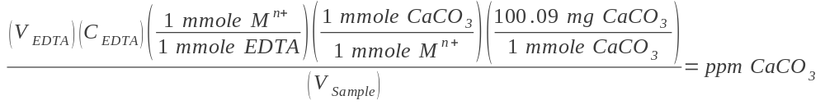
Where:
(V_{EDTA}) is the corrected titration volume of EDTA standard titrated (in liters)
(C_{EDTA}) is the concentration of the EDTA standard (in mM)
(V_{Sample}) is the volume of the water sample (in liters)
Ion Chromatography (IC) Instructor’s Guide
This instructor’s guide includes sample answers to the questions in the IC module, and additional information at times.
I have given this module as a take home assignment for the students to work on and read through, then had them present their answers to each other in small groups. This resulted in the students having discussion on where their answers were different and did well in getting to the underlying principles.
Q1. Write the chemical reaction for the association of A- and B- with the ion exchange resin.
Resin⁺-E⁻ + A⁻ <=> Resin⁺-A⁻ + E⁻
Resin⁺-E⁻ + B⁻ <=> Resin⁺-B⁻ + E⁻
Q2. Write the chemical reaction for the elution of A- and B- from the ion exchange resin.
Resin⁺-A⁻ + E⁻ <=> Resin⁺-E⁻ + A⁻
Resin⁺-B⁻ + E⁻ <=> Resin⁺-E⁻ + B⁻
Q3. Write the equilibrium expression constant for A- and B-. In chromatographic separations, this term (Kc) is referred to as the distribution coefficient.
Q4. Do you think the magnitude of the distribution coefficients are the same for A⁻ and B⁻? Why or why not?
If they are different ions, then they would have different distribution constants, because they would have different affinities for the resins. These differences will arise due to differences in size, charge, and other characteristics.
Q5. If the distribution coefficient of A⁻() is smaller than the distribution coefficient of B⁻(), draw a sketch of the elution process that is similar to the figure in Step 1 but at a point where A⁻ and B⁻ are partway through the column.?
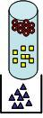

Q6. Suppose B⁻ had a very strong affinity for the resin, what would happen to its elution time?
As the affinity for the resin increases the elution time increases. Thus you could get to a point where the elution time is so long it does not appear to come off the column.
As the sample is injected onto the column, the two different analytes briefly displace the eluent as the counter-ion to the charged resin. The analyte is briefly retained at the fixed charge on the resin surface. The analytes are subsequently displaced by the eluent ions as the eluent is added to the column. The different affinities (see the chemical reactions in the basic process section) are the basis for the separation. The K_{f} value of each reaction is also known as the selectivity coefficient. The greater the difference between the K_{f} values for the two analytes, the more the two analytes will be separated during the ion chromatography process. In reality, the interaction between the solvent and the analyte can also have an impact on the order each analyte is eluted. For a more in-depth analysis of predicting the retention order see the material by Dr. Thomas Wenzel. (http://www.bates.edu/x65385.xml)
Q7. Is this a desirable or undesirable situation if you were trying to analyze A⁻ and B⁻ in a mixture?
You want have a difference in elution times, but you do not want the affinity to be so strong that the ion does not readily come off the column. The longer the elution time the more peak broadening will happen (this links to later brief information on peak broadening.)
Q8. Is there a situation you can think of when it might be desirable for B⁻ to have a very strong affinity for the resin?
Water filtration systems, such as water softeners, usually have an ion exchange resin where the affinities are strong enough to effectively remove ions from the water. The Mg²⁺ or Ca²⁺ displaces the Na⁺ on the resin. The affinity for the Mg²⁺ or Ca²⁺ ions needs to be much stronger than the affinity for Na⁺ in order to effectively soften the water. In sample pretreatment you may want very strong affinities to bind all of the ions and then extract with a different solvent.
Q9. If you want to separate cations, what would be different about the stationary and mobile phases?
The resin would need to be negatively charged, and the mobile phase would be positively charged. The common cation exchange resins are based on either polystyrene-divinylbenzene (PS-DVB) or methacrylate polymers. The surface of these polymers (Figure 1) is functionalized with a negatively charged sulfonated group (-SO₃⁻ ). The cation in the eluent or the analyte of interest is the counter-ion in the vicinity of the charged functional group.
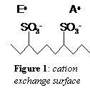
The surface of the polymer is functionalized with a quaternary amine (-N⁺R₃) for anion exchange (see Figure 2). The quaternary amine provides a positive charge to the surface, attracting negatively charged anions in the liquid phase. Just like the cation exchange resin, the anion of the eluent or the analyte of interest exists as the counter-ion in the vicinity of the positive charge residing on the amine.
Q10. Would water flow easily through a column containing very fine particles?
As the resin particle become finer, they pack together closer, leaving less room for the solution to flow through. This, in conjunction with the more resin-solvent interactions, will increase the resistance to flow. You then have to apply pressure to force the solutions through the column.
Q11. If not, how could you get the water through the column?
As the water becomes less likely to flow, you need to apply a force to push the water through the column. This is done with a pump that can handle higher pressures (often 200-1000 psi) such as a double piston high pressure pump to force the mobile phase through the column.
Q12. Considering that the column is packed with very fine particles, what must be done to surface water samples before injecting them onto the column?
If the column particles are very fine, the surface water sample will likely need filtered to remove any detritus that would foul up the column. Surface water samples are filtered through at least 0.45 µm filters but may be filtered through as small as a 0.20 µm, similar to how other solutions are filtered for use in IC. The filter type is one that must not introduce an error.
Q13. Can you think of a way to detect the presence of ionic substances in water?
The most common factor to all ionic substances is that they have a charge, thus a detection method that is based on measuring the charge is frequently used. Ions in solution conduct electricity, so the conductivity of a solution will change as the concentration of ions change. This is the common basic detection. There are other possibilities that are more selective.
Q14. Would this detection method distinguish between Na⁺ and Ca²⁺?
Conductivity would not distinguish between the two ions. Therefore you need the two ions to be separated on the column.
Q15. If you utilize this detection method with the chromatographic separation, how important is the selective response of the detector?
The selectivity in the overall method comes from a good separation of the ions, so the detection method does not need to be very selective. The detection does need to be quantifiable and applicable to a broad range of ions.

Q16. Will the eluent ion respond to the detection method you thought of above to measure the presence of Na⁺ and Ca²⁺.
Yes it will. Thus eluent suppression will usually be used.

Q17. How will the chromatogram change as you increase the concentration of A⁻ and B⁻ injected into the column? Make sure to label the axes of your chromatogram.
x-axis is elution time, y-axis is conductivity. As you increase the concentration of an ion, the height and area of the peak corresponding to that ion will increase.

Q18. Since neither axis in the chromatogram you drew above is concentration, how can we calibrate the detector response to determine the concentration of A⁻ and B⁻?
You have to calibrate the detector by analyzing standard samples with known concentrations of both A⁻ and B⁻. The conductivity is plotted as a function of concentration to determine the response of the detector.

