Electrochemical Methods of Analysis
Thomas Wenzel
Department of Chemistry
Bates College, Lewiston ME 04240
twenzel@bates.edu

The following textual material is designed to accompany a series of in-class problem sets that develop many of the fundamental aspects of electrochemical analytical methods.

TABLE OF CONTENTS

1. Basic Concepts in Electrochemistry 2
2. The Chemical Energy of a System 4
3. Relationship of Chemical Energy to Electrochemical Potential 10
4. Table of Standard State Electrochemical Potentials 12
5. Electrochemical Cells 14
6. Potential of an Electrochemical Cell 20
7. Electrochemical Analytical Methods 24
7.1. Ion-Selective Electrodes 25
7.1.1. pH Electrode 25
7.1.2. Other Glass Electrodes 27
7.1.3. Membrane Electrodes 27
7.1.4. Enzyme Electrodes 28
7.1.5. Solid-State Electrodes 28
7.1.6. Gas-Sensing Electrodes 28
7.2. Electrodeposition/Electrogravimetry 29
7.3. Coulometry 31
7.4. Titrimetric Methods of Analysis 33
7.4.1. “Classical” Redox Titration 33
7.4.2. Coulometric Titration (Controlled Current Coulometry) 33
7.4.3. Amperometric Titration 35
7.4.4. Potentiometric Titration 37
7.5. Voltammetric Methods 44
7.5.1. Anodic Stripping Voltammetry 46
7.5.2. Linear Sweep Voltammetry 49
7.5.3. Differential Pulse Linear Sweep Voltammetry 52
7.5.4. Cyclic Voltammetry 55

1. Basic Concepts in Electrochemistry
Electrochemical processes are commonly used for analytical measurements. There are a variety of electrochemical methods with different degrees of utility for quantitative and qualitative analysis that are included in this unit. The coverage herein is not exhaustive and methods that are most important or demonstrate different aspects of electrochemical measurements are included. Also, in most cases the coverage is designed to provide a broad overview of how the method works and not delve deeply into all of the associated subtleties. There are two free sources of information available through the Analytical Sciences Digital Library for those desiring a more in-depth coverage of particular methods. One is a general textbook on analytical chemistry written by David Harvey.
http://community.asdlib.org/activelearningmaterials/analytical-chemistry-2-0-online-textbook/
The other is a module on electrochemistry written by Richard Kelly.
http://community.asdlib.org/activelearningmaterials/analytical-electrochemistry-the-basic-concepts/

The methods we will explore in this unit rely on one of two different electrochemical phenomena. The first is that many chemical species have the ability to transfer electrons through an oxidation-reduction process. With appropriate design of an electrochemical system, this transfer of electrons can be measured as a current. Since we also know that different species have different oxidation or reduction abilities, electrochemical measurements relying on electron transfer can often be used for the purpose of species identification.

The second method of using electrochemical processes for measurement purposes relies on the measurement of a potential. In particular, we will focus on some methods that rely on something called a junction potential. You likely have some familiarity with electrochemical cells. Such a device consists of electrodes and the design of electrodes creates interfaces or junctions (e.g., a metal electrode in contact with a solution represents a junction). Any junction in an electrochemical system will have a potential associated with it and in certain cases, the magnitude of this junction potential can be related to the concentration of a species in solution. For example, a pH electrode is the best known example of the use of a junction potential for determining the concentration of a species. The key feature of a pH electrode is a thin glass membrane. When placed into an aqueous solution, a junction potential occurs at the glass-solution interface and the magnitude of this potential is determined by the concentration of H⁺ in solution.

Define what is meant by oxidation and reduction.
In a chemical reaction involving a transfer of electrons, one species gains one or more electrons while another species loses one or more electrons. Oxidation refers to the species that loses electrons and reduction to the species that gains electrons. If you have trouble remembering which is which, using the pneumonic “LEO the lion goes GER” can be helpful (LEO = Loss of Electrons is an Oxidation; GER = Gain of Electrons is a Reduction). It is important to remember that both processes must occur simultaneously.

Define what is meant by an oxidizing and reducing agent. Give a good example of each.
An oxidizing reagent promotes the oxidation of another substance so is reduced in the overall electrochemical reaction. Good or strong oxidizing agents are species that really want to be reduced. Fluorine and chlorine are strong oxidizing agents because they very much want to be the fluoride or chloride ion.

A reducing agent promotes the reduction of another substance so is oxidized in the overall electrochemical reaction. Good or strong reducing agents are species that really want to be oxidized. Since alkali metals such as lithium, sodium or potassium want to be oxidized into their cationic forms, they would be good reducing agents.

Define what is meant by a half-reaction.
Overall electrochemical reactions consist of both a reduction and oxidation. Each half of this overall process is represented by an appropriate half reaction. A half-reaction shows the reduced and oxidized form of the species and these two forms are referred to as a redox couple.

Give an example of a half-reaction and determine whether a half-reaction can be an equilibrium expression. Why or why not?
One of many possible half reactions is shown below for the reduction of cadmium ion to cadmium metal.

Cd²⁺(aq) + 2e– = Cd(s)

If we were to try to write an equilibrium constant expression for this reaction, it would need to have the concentration of free electrons in the expression. Since we really cannot weigh out a mass of electrons to use in a reaction and cannot dissolve free electrons into a solution, we cannot write a true equilibrium constant expression for a half reaction.

However, an interesting aspect of electrochemical reactions is that we can design a device known as an electrochemical cell that has each of the half reactions isolated from each other in separate halves of the cell. As we begin to examine electrochemical cells and processes in more detail, we will often focus our attention on only one half of the overall process and will write expressions for half reactions that are essentially an equilibrium constant expression. The expression will not have a term for electrons in it. For the half reaction shown above the expression would be as follows:
$$\frac{1}{{[Cd}^{2+}(aq)]}$$

Just like in equilibrium constant expressions, there is no term for the Cd(s) because a solid will not have a concentration.

2. The Chemical Energy of a System
Before examining something known as the electrochemical potential (Ε), it is useful to explore some aspects of what is known as the chemical energy that you have likely learned about before in general or physical chemistry. The chemical energy of a system is known as the Gibbs energy and is denoted by G.

Suppose we wanted to think about the simplest chemical reaction possible – a situation in which A reacts to produce B.

A , B
One example of an actual chemical reaction of A reacting to produce B would be something known as a keto-enol tautomerism.

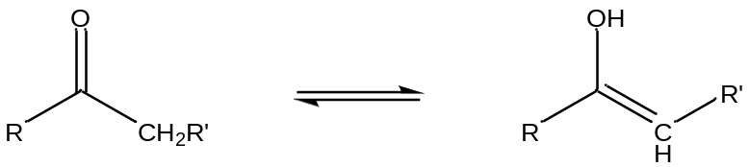

A bottle of pure A has some amount of chemical energy. A bottle of pure B has some amount of chemical energy. A solution of A in water that is 2 Molar has some amount of chemical energy. A solution of B in water that is 2 Molar has some amount of chemical energy.

Do all four examples listed above (pure A, pure B, [A] = 2 M, B = [2 M]) have the same or different chemical energy?
Hopefully it will seem reasonable or intuitive to think that all four of these systems will have different chemical energies. Since the two compounds are different from each other, in their pure forms they likely have different chemical energies. Similarly, a chemical species dissolved in a solvent is now different than the pure compound and the two will have different chemical energies.

How would you measure or determine the absolute chemical energy of those four systems?
This is actually a trick question. We do not have methods available to determine the absolute chemical energy for a system. In reality the best that we can do is measure the difference in chemical energies between two systems. This difference is denoted as ΔG, which is likely something you are familiar with from prior classes you have taken.

Let’s continue to examine the situation in which A reacts to produce B.

A , B
When will the chemical energy (G) of this system achieve its lowest value?
The lowest value of chemical energy for a reaction occurs when it is at equilibrium. For the example above, this means that pure A and pure B must have a higher chemical energy than the equilibrium state of the reaction. It is important to note that chemical systems strive to have the lowest chemical energy as that will be their most stable state.

We will next consider what a plot of G versus the mole fraction of A and B in which the situation

[A] + [B] = 2 Molar

is always satisfied. We can consider what the plot would look like for two different situations:

The reaction of A to produce B has a fairly large equilibrium constant.

The reaction of A to produce B has a fairly small equilibrium constant.

Remember that the equilibrium constant expression is:

$$K= \frac{[B]}{[A]}$$

Since the equilibrium situation will have some concentration of both A and B, the system at equilibrium must have a lower chemical energy than either a 2 M solution of A or a 2M solution of B. That would allow us to draw two possible representations for the situation in which K is large (there is a much higher concentration of B than A) and K is small (there is a much higher concentration of A than B) as seen in Figure 1.

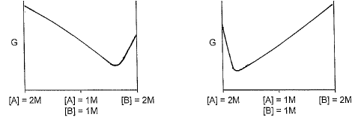
Small K
Large K
Figure 1. Plot of G versus molar quantities of reactant and product for a reaction with a large (left) and small (right) equilibrium constant (K).

Remember that we do not know how to calculate the value of G. What we can possibly do is measure the difference in chemical energy (ΔG) between two different states (e.g., we could possibly measure the difference in chemical energy between a solution in which [A] = 2 M and equilibrium). The plot in Figure 2 indicates ΔG for such a situation when K is large.
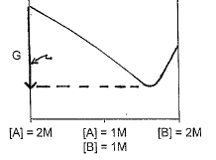
ΔG
Figure 2. Magnitude of ΔG between [A] = 2 M and equilibrium.

Why do we need to define something called the standard state?
Consider an example where every student in a class was asked to perform a laboratory measurement of ΔG for the reaction of A to produce B. If we consider the example where K is large, you could imagine a situation in which one student starts with a solution where the concentration of A is 2 M and B is 0 while another starts with a solution where the concentration of B is 2 M and A is 0. Looking at the plot in Figure 2, both students may measure accurate and correct values for ΔG but the values that the students report will be different. As seen by the plot in Figure 2, the value one would measure for ΔG is dependent on the particular starting point, since each starting point has a different value of G. In order to record ΔG values that can be tabulated and compared, everyone must agree in advance to a uniform set of starting conditions. These agreed upon starting conditions are known as the standard state.

What conditions constitute the standard state?
The standard state is the situation where every reactant and product in the reaction has an activity of 1. Since there are many conditions where we are unable to determine the exact activity of a substance, an approximation is made where the standard state has the concentration of all soluble species in the reaction at 1 Molar, gases at a pressure of 1 atmosphere and a temperature of 25ºC (298 K). For A reacting to produce B, the standard state would be a solution in which [A] = 1 M and [B] = 1 M. The plot in Figure 3 shows the difference in chemical energy between the standard state and equilibrium for the situation in which K is large. The difference in chemical energy between the standard state and equilibrium is given a special designation: ΔGº.

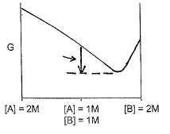
ΔGº
Figure 3. Difference in chemical energy between the standard state and equilibrium (ΔGº) for a reaction with a large equilibrium constant.

You can imagine that it might be difficult to think about how you could actually make a standard state solution and somehow hold it in a suspended state before allowing it to react and achieve equilibrium, thereby allowing a measurement of ΔGº. As we will see further on in this unit, electrochemical cells are actually ideal systems for measurements of ΔGº because it is possible to prepare the two half reactions in separate chambers but prevent the reaction from taking place by not completing all of the circuitry between the two chambers.

What does it mean for the difference in chemical energy (ΔG of ΔGº) to be positive or negative?
In considering this, it is important to examine the two different plots of G for the reaction with a large K and small K. These are shown in Figure 4 and the value of ΔGº is indicated in each plot.
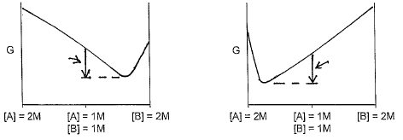
ΔGº
ΔGº
Small K
Large K

Figure 4. ΔGº for a reaction with a large (left) and small (right) equilibrium constant.

Note that in both cases the chemical energy drops as the system goes from the standard state to equilibrium. However, when we think about carrying out a chemical reaction, our usual goal is to have the reaction form products. For this reason, we adopt a convention that says that ΔGº is less than 0 (negative) for a reaction that favors the formation of products. ΔGº is greater than 0 (positive) for a reaction that favors the formation of reactants.
The following equation is something you should have seen before in a unit on thermodynamics in either a general or physical chemistry course.

$${∆G}^{o}= -RTlnK$$

This equation provides the difference in chemical energy between the standard state and equilibrium. Note that if K is large (favors products), lnK is positive and ΔGº is negative. Similarly if K is small (favors reactants), lnK is negative and ΔGº is positive.

Suppose the Starting Conditions are not at the Standard State
There are many situations where you do not want to examine reactions that begin with standard state conditions but instead want to start with a set of non-standard state conditions. The difference in chemical energy between non-standard state conditions and equilibrium is designated as ΔG. The equation that allows us to calculate ΔG is as follows:

$$∆G= -RTlnK+RTlnQ or ∆G= {∆G}^{o}+RTlnQ$$

The term Q is an expression that looks exactly like the equilibrium constant expression except that it is evaluated using the starting non-standard state concentrations. It is important to recognize what each part of this equation is providing.

–RTLnK (denoted as ΔGº) is the difference in chemical energy between the standard state and equilibrium.

RTlnQ is the difference in chemical energy between the non-standard state starting conditions and the standard state.

The plot in Figure 5 shows the placement of these two terms for the example of A reacting to produce B that we have been examining. In this case the non-standard state conditions are further removed from chemical equilibrium than the standard state. Note that with [A] = 1.50 M and [B] = 0.50 M, the value of Q is 0.33.

$$Q= \frac{[B]}{[A]}= \frac{(0.50)}{(1.50)}=0.33$$

With the value of Q below 1, lnQ will be negative and the value of ΔG is more negative than the value of ΔGº.
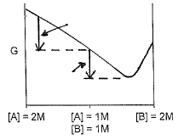
-RTlnK
RTlnQ
Figure 5. Representation of RTlnQ and –RTlnK for a reaction starting in non-standard state conditions. Non-standard state conditions are further from equilibrium than the standard state conditions.

The plot in Figure 6 shows starting non-standard state conditions that are closer to equilibrium than those of the standard state: [A] = 0.50 M; [B] = 1.50 M. In this case the value of Q is 3.0.

$$Q= \frac{[B]}{[A]}= \frac{(1.50)}{(0.50)}=3.0$$

With the value of Q above 1, lnQ is positive and the value of ΔG is less negative than the value of ΔGº.
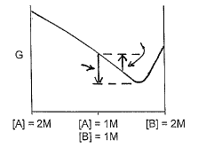
RTlnQ
-RTlnK

Figure 6. Representation of RTlnQ and –RTlnK for a reaction starting in non-standard state conditions. Non-standard state conditions are closer to equilibrium than the standard state conditions.

3. Relationship of Chemical Energy to Electrochemical Potential
Electrochemical reactions have a similar drive toward the lowest possible energy. Instead of referring to G for electrochemical reactions, we refer to the electrochemical potential (Ε). Similar to chemical energy, Εº refers to the difference in electrochemical potential between the standard state and equilibrium. Ε refers to the difference in electrochemical potential between non-standard state conditions and equilibrium. An interesting facet of electrochemical reactions is that with proper design the change in chemical energy can be converted to electrical energy in the form of an electrical current.

The standard state electrochemical potential (Εº) can be related to ΔGº by the following equation:

ΔGº = –nFΕº

In this equation, n is the number of electrons transferred in the overall balanced electrochemical reaction and F is Faraday’s Constant. Faraday’s Constant relates the total charge in Coulombs (C) of a reaction to the amount of product that forms. For a reaction in which n = 1, there are 96,485 C/mole.

The non-standard state electrochemical potential (Ε) can be related to ΔG by the following equation:

ΔG = –nFΕ

There are several important outcomes of the relationship between chemical energy and electrochemical potential. Setting equal and rearranging the two expressions for ΔGº leads to the following:

$${∆G}^{o}= -RTlnK and {∆G}^{o}= -nFE^{o}$$

$$E^{o}= \frac{(RT)}{(nF)}lnK$$

Substituting in the standard state temperature, gas constant and Faraday’s constant and converting the natural log to a base ten log leads to the following expression:

$$E^{o}= \frac{(0.059)}{(n)}logK$$

Setting equal and rearranging the two expressions for ΔG leads to the following:

$$∆G= -RTlnK+RTlnQ and ∆G= -nFE$$

$$E= \frac{(RT)}{(nF)}lnK- \frac{(RT)}{(nF)}lnQ$$

Again, substituting in the standard state temperature, gas constant and Faraday’s constant and converting the natural log to a base ten log leads to the following expression:

$$E= \frac{(0.059)}{(n)}logK- \frac{(0.059)}{(n)}logQ$$

Substituting in for the first expression in this provides:

$$E= E^{0}- \frac{(0.059)}{(n)}logQ$$

This last equation is especially important in electrochemistry and is known as the Nernst Equation. In the Nernst Equation:

$\frac{0.059}{n}logK$ (denoted as Εº) is the difference in electrochemical potential between the standard state and equilibrium.

$\frac{0.059}{n}logQ$ is the difference in electrochemical potential between the non-standard state starting conditions and the standard state.

One last thing worth pointing out is the sign convention of electrochemical potentials and how they relate to whether the reaction favors products or reactants. An examination of the Nernst Equation shows that electrochemical reactions that favor products will have positive values of electrochemical potential. Electrochemical reactions that favor reactants will have negative values of electrochemical potential.

4. Table of Standard State Electrochemical Potentials
It is possible to measure the standard state electrochemical potential for individual half reactions. Doing so requires setting one particular half reaction as a reference point to which all other potentials are compared. The half reaction used as the reference involves reduction of the hydrogen ion (H⁺). This half reaction is arbitrarily assigned a standard state reduction potential of 0.00 Volts.

2H⁺(aq) + 2e– = H₂(g) Εº = 0.00 V

Tables of standard state electrochemical potentials are freely available on the internet. By convention, all of the half reactions are written as reductions. Earlier we mentioned how alkali metals are strong reducing agents as they have a strong driving force to be oxidized. The half reaction and standard state potential for the reduction of Li⁺ is shown below.

Li⁺(aq) + e– = Li(s) Εº = –3.045 V

Note that this reaction has a very large negative standard state potential. Remember from earlier that electrochemical reactions that favor the reactants have negative potentials. An examination of the standard state potentials indicates that the reduction of Li⁺ has the highest value in the table. Therefore it should not be surprising that lithium batteries are in common use today. Also, for those readers who are fans of Star Trek, we can now understand when the Enterprise needed more fuel the call from the bridge was for more dilithium crystals.

We also used fluorine as an example of a powerful oxidizing agent meaning that it has a strong driving force to be reduced. The half reaction and standard state potential for the reduction of fluorine gas is shown below.

F₂(g) + 2e– = 2F–(aq) Εº = 2.87 V

Note that this reaction has a very large positive standard state potential. Remember that electrochemical reactions that favor the products have positive potentials.

Since an overall electrochemical reaction has a reducing and oxidizing half to it, we often work with systems in which two half reactions are paired up. When considering any pair, the one with the more positive Εº value proceeds as a reduction and the one with the less positive value proceeds as an oxidation.

It is worth noting that reactions are usually run under non-standard state conditions. It is possible to take the conditions so far away from the standard state used to generate the values in a table of Εº values that the reaction may actually proceed in the reverse direction from what occurs in the standard state. For example, looking back at the plot of G for a reaction with a large K shown in Figure 1, starting at a very high concentration of B and a very low concentration of A that is to the right of the equilibrium state in the plot would mean that the reaction proceeds toward reactants instead of products. This would be the reverse of the reaction direction predicted by comparing the ΔGº or Εº values of A and B.

One final thing to note is that Εº values do vary with other conditions of the solution. For example, electrochemical reactions with H⁺ in one of the half reactions are highly influenced by the pH. The standard state will have [H⁺] = 1 M (note, this constitutes a pH of 0) and the measured Εº value will often have slightly different values if different acids (e.g., nitric, hydrochloric, perchloric) are used to make the 1 M solution. Another common condition with electrochemical reactions involves the ionic strength of the solution. The ionic strength (μ) is defined as follows:

μ = ½ Σ [C_{i}]Z_{i}²

Where C_{i} is the concentration of each ion and Z_{i} is the charge of each ion. Note that both cations and anions are included in the summation term.

In some cases with electrochemical reactions it is desirable to have a concentration of unreactive ions in the solution as a background electrolyte (e.g., alkali cations paired with halide anions might be such a background electrolyte). Measured Εº values often vary slightly at different ionic strengths.

In some cases it is more common to use formal potentials (Ε^{o’}). A formal potential is the reduction potential that applies to a half reaction under a specified set of conditions (e.g., pH, ionic strength, concentration of complexing agents). One common example is that the formal potential of important biological electrochemical reactions are often measured at pH 7, which is much closer to physiological pH than the standard state pH of 0.

Because Εº values vary slightly with conditions, calculated values for a system you wanted to study obtained using the Nernst equation are often only close approximations of what you would actually obtain as a measured value.

5. Electrochemical Cells
Before developing analytical methods based on electrochemistry, it is worth exploring aspects about electrochemical cells. Concepts needed to comprehend the nature of an electrochemical cell are informative in understanding some of the analytical methods we will develop. From a more practical standpoint, batteries are examples of electrochemical cells.

Describe what you know about an electrochemical cell.
The components of an electrochemical cell are shown in Figure 7.

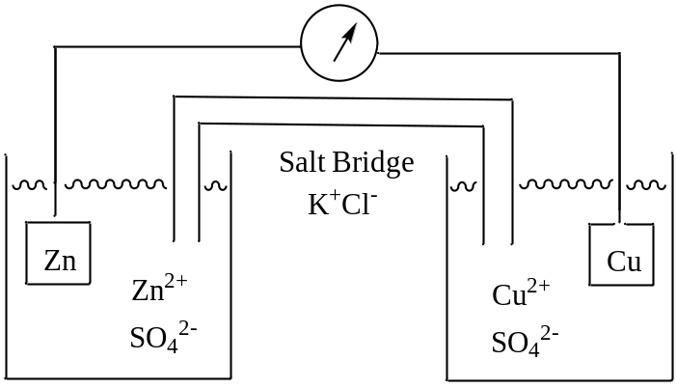

Figure 7. Diagram of the components in an electrochemical cell.

The particular cell shown involves a half reaction with zinc and a half reaction with copper.

Zn²⁺(aq) + 2e– = Zn(s) Εº = –0.763 V

Cu²⁺(aq) + 2e– = Cu(s) Εº = 0.337 V

Based on the two Εº values, the copper ion will be reduced and zinc metal will be oxidized. In an electrochemical cell, the reduction half reaction is referred to as the cathode and the oxidation half reaction is referred to as the anode. By convention, the anode is always put on the left and the cathode on the right in the diagram.

The zinc half-cell consists of a piece of zinc metal in a solution containing zinc ion. The copper half-cell consists of a piece of copper metal in a solution containing copper ion. If a half reaction does not form a solid metallic species (e.g., Fe³⁺ + e– = Fe²⁺) an inert metal such as platinum is used in the cell.

The two half-cells need to be connected to complete the circuitry and allow the reaction to proceed. Two connections are needed for a complete circuit. One is a metal wire that connects the two pieces of metal. The other is something known as a salt bridge that connects the two solutions.

What processes are responsible for conduction of electricity in an electrochemical cell?
The processes responsible for the current flow in an electrochemical cell depend on which part of the cell you are in. For the metallic components (zinc, copper, copper connecting wire), electrons are responsible for the current flow. In the solution, conduction of electricity is caused by migration of ions.

The ability of ions to conduct electricity is the reason why someone should never use a hairdryer while sitting in a bathtub full of water. If a hairdryer is dropped into the water, the water conducts electricity because of ions in it with the end result that the person will be electrocuted. Conductivity is a measurement of the ability of a solution to conduct electricity. The conductivity of a solution directly correlates with the ionic strength of the solution. Many science buildings have a device that is designed to generate highly purified water. One of the goals of these purification systems is to deionize the water. With these systems the conductivity is measured to determine the degree to which the water has been deionized (the reading is reported as a resistance and the higher the resistance, the less conductive the solution).

It is also important to consider the portions of the cell where the metal interfaces with the solution. In the cathode where reduction occurs, electrons must “jump” from the metal to a species in solution. In the anode of the cell represented in Figure 7, zinc atoms need to give up two electrons and a zinc ion is released into the solution. For an anodic half-cell with two water-soluble species (e.g., Fe²⁺ = Fe³⁺ + e–), an electron would need to “jump” from a species in solution to the platinum electrode.

What is the purpose of the salt bridge?
In order to understand the purpose of the salt bridge it is necessary to consider the process taking place in each of the half cells in Figure 7. If each half cell started at standard state conditions, the cathode would begin with a 1 M concentration of a copper salt such as copper sulfate ([Cu²⁺] = 1 M; [SO₄²⁻] = 1 M) and the anode would have a zinc salt such as zinc sulfate ([Zn²⁺] = 1 M; [SO₄²⁻] = 1 M). Note that in both half cells, the sulfate ion is a spectator ion that is not involved and does not change in the electrochemical reaction. As the electrochemical reaction proceeds, Cu²⁺ in the cathode gets reduced and plates out as copper metal. In the other half call, zinc metal gets oxidized to form Zn²⁺. Without any form of intervention, this means that over time [Cu²⁺] < [SO₄²⁻] in the cathode and [Zn²⁺] > [SO₄²⁻] in the anode. The buildup of charge in both of the half cells is an undesirable situation because nature wants to maintain systems that are neutral. If this charge continued to build up, it will inhibit the electrochemical reaction and prevent it from going to its full extent. The purpose of the salt bridge is to act as a source of spectator ions that can migrate into each of the half cells to preserve neutrality. Any charge buildup in the solutions of the two half cells is known as a junction potential. Therefore, the purpose of a salt bridge is to reduce the junction potential between the solution interface of the two half cells.

What would you put inside a salt bridge?
First, it is important to put ionic species into the salt bridge that will not be reduced or oxidized in either of the half cells. Alkali cations and halide anions would be ideal for this purpose. It is also important that the charge balance in each of the half cells facilitated by the ions in the salt bridge occurs at the same rates. That means that the halide anions moving from the salt bridge into the anode to balance out the excess Zn²⁺ ions do so at the same rate as the alkali cations moving from the salt bridge into the cathode to balance out the depletion of Cu²⁺ ions. Ions have a property known as mobility and the mobility of an ion depends on its size. Smaller ions have a higher mobility than larger ions. That means that the ideal species for a salt bridge should have a cation and anion of the same size and charge. Potassium chloride is the ideal species for incorporation into a salt bridge, as K⁺ and Cl– have the same number of electrons and are approximately the same size. Potassium nitrate (K⁺NO₃–) can also be used in a salt bridge. Amazingly, the nitrate ion, which has atoms with second shell electrons, has approximately the same size as a chloride ion, which has atoms with third shell electrons.

Another thing to consider is the concentration of KCl in the salt bridge. It is desirable to have a salt bridge that can overcome the possibility of a large charge buildup. To achieve this and not deplete the ions in the salt bridge over the course of the reaction, the KCl is typically at a high concentration, usually 4 M.

Describe two types of situations that would result in the irreversibility of an electrochemical process.
An interesting aspect of an electrochemical cell is that it can be operated in two directions. If the circuitry is completed and the reaction proceeds in its spontaneous direction toward equilibrium, it is referred to as a voltaic or galvanic cell. In this case a current is drawn from the cell and can be used to perform some sort of work (e.g., light a bulb in a flashlight or operate a cell phone). At some point the cell or battery will “die” as the reaction reaches equilibrium and no more current can be drawn from it. Next time your car battery dies, you may feel better about the situation by remembering that it has just reached equilibrium.

If the cell instead is attached to an external source of power (e.g., plugged into a wall outlet), the reaction can be forced it its reverse direction back away from equilibrium. This is what happens when a battery is recharged. Rechargeable batteries require the use of a reversible reaction. An electrochemical cell being forced in its non-spontaneous direction is referred to as an electrolytic cell.

There are two situations that factor into the reversibility of reactions used in electrochemical cells. One involves chemical reversibility, which relates to the stability of the reactants and products. The other involves electrochemical reversibility, which involves the kinetics of electron transfer and relates to the ability to regenerate or recharge the cell to its initial conditions.

One common misconception is that an electrochemical reaction that produces a gas such as the reduction of hydrogen ion to hydrogen gas is chemically irreversible because the gas escapes.

2H⁺(aq) + 2e– = H₂(g)

However, if the cell is designed properly and is sealed, the gas can be trapped and reversing the potential through the use of an external power source can drive the reaction in the reverse direction. Therefore, electrochemical reactions that produce a gas are not necessarily chemically irreversible.

An example of an electrochemical process that is chemically irreversible occurs if the product rapidly decomposes to something else. In this case, when an external power source is applied to reverse the process, the appropriate species is no longer in solution. In the example below, if the A– species degrades rapidly to B– and C, there is no remaining A– for the chemical regeneration of A.

A + e– = A– = B– + C

The second example of an irreversible electrochemical reaction occurs when there is something known as an overvoltage or overpotential. Since electrons must transfer from one species to another in an electrochemical reaction, the kinetics of the electron transfer must be considered. In cases of slow kinetics, it is possible to have an electrochemically irreversible reaction.

If we consider the reduction of H⁺ to hydrogen gas shown above, there is the key step where the electron must “jump” from the electrode to the hydrogen ion in solution. With some electrochemical reactions, there is a resistance of the electron to making the jump. If one were to apply a potential that in theory was suitably large such that the electrons should complete the jump, it would still not happen. The electron can be forced to “jump” by applying a higher voltage – an overpotential – to the electrode (electrons of higher energy are put onto the electrode until a point is reached where it becomes favorable for an electron to leave the electrode and go to the ion in solution). You are likely familiar with the concept of activation energies in chemical reactions. The occurrence of an overpotential indicates the presence of an activation energy barrier for an electrochemical reaction.

Whether or not a particular half reaction has an overpotential is determined in part by the nature of the electrode material. The reduction of hydrogen ion to hydrogen gas has almost no overpotential with a platinum electrode but has a very high overpotential with mercury and many other electrodes.

As an aside, it is worthwhile to examine two particular half reactions that have practical applications and potential future implications for society. These two reactions are shown below.
2H⁺(aq) + 2e– = H₂(g) Εº = 0.00 V

O₂(g) + 4H⁺(aq) + 4e– = 2H₂O Εº = 1.229 V

Based on the Εº values, the spontaneous reaction involves the oxidation of hydrogen gas and reduction of oxygen gas, as shown in the balanced reaction below.

2H₂(g) + O₂(g) = 2H₂O Εº = 1.229 V

A device that electrochemically combines hydrogen and oxygen gas and uses the transfer of electrons as a source of electricity is known as a fuel cell. One example of the use of this technology as a source of electricity is aboard the International Space Station.

If one considers the reverse reaction shown below, through the application of an external source of power it will be possible to electrochemically convert water to hydrogen and oxygen gas.
2H₂O = 2H₂(g) + O₂(g)

The intriguing aspect of the electrolytic splitting of water into hydrogen and oxygen gas is that hydrogen is a useful fuel for a fuel cell or through combustion. If someone were able to economically carry out this reaction, it would mean that our fuel would come from water, thereby providing a limitless source of fuel. Also, because the reaction is best done under conditions with a relatively high ionic strength, it could be done using ocean water.

There are two problems with economically carrying out the electrolytic splitting of water. One is that it takes energy to do it, since it’s the reverse of the spontaneous direction. Because of losses of efficiency when combusting hydrogen, it would take more energy to split water then you would get in return by using hydrogen as a fuel. A second problem is that both half reactions have overpotentials with many different electrodes meaning that it will cost even more to carry out the reaction.

An active area of research is an attempt to devise electrodes that have two particular features. One is that they are made of materials that do not have high overpotentials toward the two relevant half reactions (Note that two different electrodes are needed: one for the hydrogen half reaction and the other for the oxygen half reaction). The second feature would be a system where sunlight could be used as a source of power to assist the splitting reaction. In the two electrodes, the energy from the sun would be used to promote an electron on the electrode into a higher molecular orbital. With that extra energy it would be much easier for the electron to transfer to the species in solution and then much less costly to split the water. Many of the electrodes being examined in this application are transition metal complexes and while some advances have been made, it is also critical that the electrode be inexpensive enough to make the entire process cost effective. No one has yet to find electrodes with low enough overpotentials and the ability to harness the energy of the sun to facilitate the reactions in a cost effective manner.

Shorthand Notation for an Electrochemical Cell
There is a shorthand notation used to specify the conditions of an electrochemical cell. The notation shows the anode on the left and cathode on the right. The concentrations of important species in each of the half reactions are included. Spectator ions are not included in the notation. Phase boundaries are shown with a single line () and a salt bridge with a double line (). The electrochemical cell described above would have the following notation:

Zn  Zn²⁺ (1 M)  Cu²⁺ (1 M)  Cu

6. Potential of an Electrochemical Cell

Potassium dichromate (K₂Cr₂O₇) reacts with Fe(II) to produce Cr(III) and Fe(III). What is the standard state potential and K for this reaction?
The first step in solving this is to identify the two appropriate half reactions that make up the cell. From a table of Εº values we find the following two reactions:

Fe³⁺(aq) + e– = Fe²⁺(aq) Εº = 0.77 V

Cr₂O₇^{2–}(aq) + 14H⁺(aq) + 6e– = 2Cr³⁺(aq) + 7H₂O Εº = 1.33 V

An examination of the Εº values indicates that the iron reaction proceeds as an oxidation and is the anode and the chromium reaction proceeds as a reduction and is the cathode.

Standard State Potential
The following equation is used when calculating the standard state potential of an electrochemical cell.

Εº_{CELL} = Εº_{CAT} – Εº_{AN}

When using this equation, the Εº values are used directly from the table without changing the sign and without using any coefficients in the balanced overall electrochemical reaction. So even though the anodic reaction is reversed in direction from that in the table, the values in the table are all ranked relative to each other and the minus sign in the equation is accounting for the fact that the anodic reaction occurs in a reverse direction. There is no use of coefficients because Εº values are measured for standard state starting conditions (i.e., all reactants and products beginning at 1 Molar). With the pair in this problem, inequivalent molar amounts of the iron and chromium species will be present when the system achieves equilibrium because six mole equivalents of the iron are used up for each mole equivalent of the chromium.

One final point to note is that Εº_{CELL} will always be positive.

Εº_{CELL} = 1.33 – 0.77 = 0.56 V

Equilibrium Constant
Earlier in the unit we had developed the following equation relating Εº to the equilibrium constant.
$$E^{o} = \frac{0.059}{n}\log{K}$$

This expression can be rewritten as follows:

$$K = {10}^{\left(n\right){(E}^{o})/0.059}$$

n is the number of electrons that are transferred in the balanced electrochemical reaction (6 in this example). Putting numbers in and evaluating this term gives the following:

K = 10^{(6)(0.56)/0.059} = 8.9 x 10⁵⁶

Note that this is an exceptionally large equilibrium constant meaning that the reaction goes nearly toward completion leaving only tiny amounts of reactants at equilibrium.

Cell Potential with the Non-standard State Conditions Given in the Problem

In this example, one half-cell is made up with 1.50 M potassium dichromate and 0.30 M chromium(III)nitrate hexahydrate in 1.00 M nitric acid and the other half cell is made up with 0.050 M iron(III)chloride hexahydrate and 0.10 M iron(II)chloride tetrahydrate?

Using the shorthand notation for an electrochemical cell, we could write the above cell as follows:

Pt  Cr₂O₇²⁻ (1.50 M), Cr³⁺ (0.30 M), H⁺ (1.00 M)  Fe²⁺ (0.050 M), Fe³⁺ (0.10 M)  Pt

There are two ways to solve this problem. One is to use the Nernst equation in the form we previously defined.

$$E_{CELL}= E_{CELL}^{0}- \frac{0.059}{n}logQ$$

When using this method, we first need the complete electrochemical reaction for the cell. Note that n = 6 for this reaction as six electrons were needed to balance out the two half reactions.

Cr₂O₇^{2–}(aq) + 14H⁺(aq) + 6Fe²⁺(aq) = 2Cr³⁺(aq) + 6Fe³⁺(aq) + 7H₂O

We can then write the term for Q:

$$Q= \frac{[{Cr}^{3+}]^{2}[{Fe}^{3+}]^{6}}{[{Cr}_{2}O_{7}^{2-}][H^{+}]^{14}[{Fe}^{2+}]^{6}}$$

$$Q= \frac{(0.30)^{2}(0.050)^{6}}{(1.50)(1.00)^{14}(0.10)^{6}}=9.4 x {10}^{-4}$$

We can now substitute values into the Nernst equation and solve for Ε_{CELL}.

$$E_{CELL}= 0.56 -\frac{0.059}{6}\log\left(9.4 x {10}^{-4}\right)=0.56+0.03=0.59 V$$

Instead of using the Nernst equation, is also possible to use the following equation to calculate the cell potential.
Ε_{CELL} = Ε_{CAT} – Ε_{AN}

When using this equation, each of the half reactions is written and evaluated as a reduction. The minus sign accounts for the fact that the anodic reaction is reversed in the complete, balanced electrochemical reaction. When evaluating each of the two terms, use the associated value of n for each of the individual half reactions.

$$E_{CAT}= E_{CAT}^{0}- \frac{0.059}{n}logQ_{CAT}$$

$$Q_{CAT}=\frac{[{Cr}^{3+}]^{2}}{\left[{Cr}_{2}O_{7}^{2-}\right][H^{+}]^{14}}=\frac{(0.30)^{2}}{(1.50)(1.00)^{14}}=0.060$$

The number of electrons in the cathode reaction is six so n = 6.

$$E_{CAT}= 1.33-\frac{0.059}{6}\log\left(0.060\right)=1.33+0.01=1.34 V$$

The number of electrons in the anode reaction is one so n = 1.

$$E_{AN}= E_{AN}^{0}- \frac{0.059}{n}logQ_{AN}$$

$$Q_{AN}=\frac{[{Fe}^{2+}]}{\left[{Fe}^{3+}\right]}=\frac{(0.10)}{(0.050)}=2.0$$

$$E_{AN}= 0.77-\frac{0.059}{1}\log\left(2.0\right)=0.77-0.02=0.75 V$$

Now we can evaluate the cell potential.

Ε_{CELL} = Ε_{CAT} – Ε_{AN} = 1.342 – 0.75 = 0.59 V

As expected, the use of these two possible methods provides the exact same value for the cell potential.

What is the cell potential if the chromium half-cell were operated at a pH of 7 instead of using 1 M nitric acid?
The point of this problem is to realize that some electrochemical reactions are critically dependent on the pH. The particular reaction in this problem has a stoichiometric coefficient of 14 for the H⁺, meaning that the reaction will be highly dependent on pH. Since only the cathodic half reaction depends on pH, we can evaluate the overall cell potential using the second of the two methods from above.

$$E_{CAT}= E_{CAT}^{0}- \frac{0.059}{n}logQ_{CAT}$$

$$Q_{CAT}=\frac{[{Cr}^{3+}]^{2}}{\left[{Cr}_{2}O_{7}^{2-}\right][H^{+}]^{14}}=\frac{(0.30)^{2}}{(1.50)(1.00 x {10}^{-7})^{14}}=6.0 x {10}^{96}$$

$$E_{CAT}= 1.33-\frac{0.059}{6}\log\left(6.0 x {10}^{96}\right)=1.33- -.95=0.38 V$$

Remember that:

Ε_{CELL} = Ε_{CAT} – Ε_{AN}

and that E_{AN} calculate previously was 0.75 V.

Ε_{CELL} = 0.38 – 0.75 = –0.37 V

It is important to note that Ε_{CELL} in this case is negative. The cell potential is positive for a reaction that proceeds in the forward direction toward products. The fact that this value is negative means that the reaction actually goes in the reverse direction under the conditions provided. Looking again at the overall reaction for this cell provided below, with the concentration of H⁺ so low (1.00 x 10⁻⁷ M) and the coefficient of 14 for the H⁺, it is reasonable to think that the overall reaction will actually proceed toward reactants to establish equilibrium than proceeding toward products.

Cr₂O₇^{2–}(aq) + 14H⁺(aq) + 6Fe²⁺(aq) = 2Cr³⁺(aq) + 6Fe³⁺(aq) + 7H₂O

Similar calculations at pH 1 ([H⁺] = 0.10 M) and pH 3 ([H⁺] = 0.0010 M) give cell potentials of 0.46 V and 0.18 V, respectively. The importance of pH on this particular electrochemical cell is apparent from these data.

7. Electrochemical Analytical Methods
There are a wide variety of analytical methods that are based on the use of electrochemical reactions or processes. Only a subset of all the electrochemical methods will be discussed herein. The simplest electrochemical cell has two electrodes. One of them is sensitive toward the analyte and is referred to as either the working or indicator electrode. The second electrode is referred to as the counter or reference electrode, with the potential of the working electrode measured relative to it. The most common reference electrode is comprised of a
silver-silver chloride (Ag/AgCl) half-cell, with a fill solution that is saturated with KCl and AgCl (Figure 8).

AgCl (s) + e⁻ Ag(s) + Cl⁻(sat) E = +0.197 V

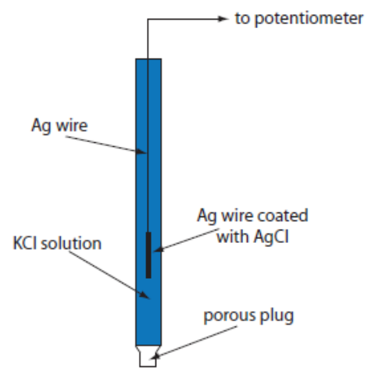

Figure 8. Diagram of a silver-silver chloride reference electrode.
(Figure from Analytical Chemistry 2.0, David Harvey, http://community.asdlib.org/activelearningmaterials/analytical-chemistry-2-0-online-textbook/).

The measurement uses a device known as a potentiostat, which is an electronic component that can run a three electrode cell. The potentiostat maintains the potential of the working electrode at a constant level with respect to the reference electrode. In some cases, it will be important that there be no current running through the reference electrode, which is achieved by having the system at a high impedance.

While a Ag/AgCl electrode is commonly used as a reference so that potentials are measured relative to it, for the purposes of the methods discussed herein, we will use the standard hydrogen electrode (SHE) as the reference electrode. Since the potential of the SHE is 0.00 Volts, this will allow us to use the numbers directly from a table of standard electrode potentials without having to correct for the potential of the reference electrode.

7.1. Ion-Selective Electrodes
As the name implies, ion-selective electrodes are devices that are selective for a particular ionic species. The most well-known and highly used ion-selective electrode is a pH electrode, which is sensitive toward the H⁺ ion. A desirable aspect of ion selective electrodes is their ease of use. Using pH electrodes as an example, after appropriate calibration, it is quite trivial to measure the pH of a solution. pH meters are relatively small devices so that it is easy to transport a battery operated device to remote sites and measure the pH of samples like surface waters.

Ion-selective electrodes are used in a configuration where there is a completed circuit but the system is at equilibrium so there is no current flow. When there is no current flow it is possible to measure a potential. The basis of all ion-selective electrodes involves the measurement of a junction potential. The system is designed in such a way that the magnitude of a particular junction potential in the device depends only on the ion being measured. The design of a pH electrode will be discussed in detail and will exemplify the method by which other ion selective electrodes function.

7.1.1. pH Electrode
The components necessary for the measurement of pH involve internal and external Ag/AgCl reference electrodes and a thin glass membrane (about 50 um thick) (Figure 9). You are probably familiar with pH electrodes and have likely used one at some point to measure the pH of a solution. In all likelihood you used a single electrode system with a glass bulb on the bottom. In actuality, the device you used, and which is commonly in use today, is known as a combination electrode. The design of a combination electrode is shown in Figure 9. The system is an ingenious design that has the two Ag/AgCl reference electrodes incorporated into the single electrode system with appropriate connections to allow for a complete circuit.
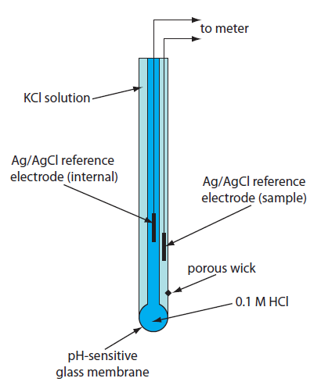
Figure 9. Diagram of a combination pH electrode.
(Figure from Analytical Chemistry 2.0, David Harvey, http://community.asdlib.org/activelearningmaterials/analytical-chemistry-2-0-online-textbook/).
The inside of the glass membrane is filled with a solution consisting of 0.1 M hydrochloric acid (HCl) saturated with silver chloride (AgCl). The external layer of the glass membrane is immersed in the solution whose pH you wish to measure. The complete circuit of a pH electrode has multiple junction potentials, but only one – the potential between the glass membrane and the external solution whose pH is being measured – is important. All the other junction potentials in the system are constant or zero and combined into one cell constant. The membrane potential with the external solution varies with the concentration of H⁺ in the solution, and the two reference electrodes measure the potential difference across the glass membrane.

We need to look in more detail at the nature of the glass to understand how a variable membrane potential forms (Figure 10).

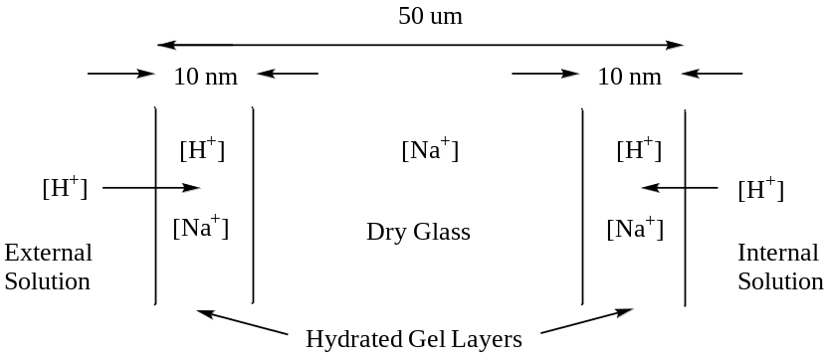

Figure 10. Diagram of the glass membrane in a pH electrode showing the dry glass and hydrated gel layers.

There are many ways to formulate glass. While glasses are based on a silicate framework (i.e., repeating SiO₂ units), there are other impurities within the glass that give it different properties. The glass used in a pH electrode contains sodium (Na⁺) ions. When placed in contact with a solution, a microscopically thin (10 nm thick) hydrated gel layer forms on the surface of the glass. Within this gel layer, hydrogen ions from the solution can migrate a very short distance into the glass and displace sodium ions. The number of H⁺ ions that migrate into the gel layer depends directly on the concentration of H⁺ in the solution. For the internal solution, the concentration of H⁺ is constant so a fixed number of Na⁺ ions are displaced from the gel layer by H⁺ ions. For the external solution, the number of H⁺ ions changes with the pH so the number of Na⁺ ions displaced from the gel layer varies as a function of the pH. The ratio of [H⁺] to [Na⁺] in the outside gel layer influences the magnitude of the membrane potential. The reason the membrane potential varies with the ratio of the two ions is because the smaller H⁺ ions have a higher mobility than the larger Na⁺ ions.

It is important to note that a pH electrode does not inherently know the pH of a solution and must be calibrated against a buffer solution with a known pH. The electrode provides a measurement in mV and the measurement can be related to pH through an appropriate calibration. Therefore, the accuracy of pH measurements is only as reliable as the accuracy of the calibration buffers. Also, the electrode should be calibrated with a buffer that has a pH close to the pH you expect for the final solution. Common pH calibration buffers with pH values of 4, 7 and 10 are commercially available.

Another important consideration with a pH and any other ion-selective electrode is the possibility of interferences. Considering that H⁺ ions can migrate from the external solution into the hydrated gel layer, it should seem reasonable to conclude that other cations can similarly migrate into the gel layer and influence the junction potential. The degree to which other ions may influence the membrane potential depends on the nature of the glass and the concentration of the interfering ions. Many ion-selective electrodes come with instructions that list known interferences and the concentrations at which they become problematic to accurate measurements. For pH electrodes, values below pH 0.5 are unreliable because of what is known as an acid error. Values above pH 9 are less reliable because of alkaline error that is usually due to the relatively high concentration of other cations in solution that migrate into the glass.

The response of a pH electrode is also sensitive to the ionic strength of the solution. In solutions with exceptionally low ionic strength and low conductivity, the reading on a pH meter often takes a long time to stabilize after the pH electrode is inserted into the solution (rainwater is an excellent example of a solution with a low ionic strength – a pH measurement is a convenient way to monitor the acidity in acid rain). In solutions of higher ionic strength, the stabilization of the membrane potential and pH reading occur much faster. Some pH electrodes are designed purposely for the measurement of solutions with low ionic strengths. Such an electrode is designed to leak out some of the ions from the reference electrode to raise the ionic strength and conductivity of the external solution and promote faster establishment of the membrane potential.

Allowing the external gel layer of the glass membrane to completely dry out may prove detrimental to the performance of the electrode. pH electrodes are often capped for storage with a small volume of a pH 7 buffer in the cap. Before using a pH electrode removed from storage for measurements, it is advisable to soak it in a pH 7 buffer for several hours before use.

7.1.2. Other Glass Electrodes
Varying the composition of the glass enables the construction of ion selective electrodes that are sensitive for cations other than H⁺. Glass electrodes sensitive for Na⁺ and Ag⁺ are examples. When using these electrodes, one must always be concerned about interferences from other cations in solution and instructions with the electrode will describe possible interferences and the concentrations at which they become important.

7.1.3. Membrane Electrodes with Organic Polymers
In addition to membranes formed of glass, many membrane electrodes employ a hydrophobic organic polymeric material with appropriate functional groups designed to selectively associate with a certain ion. These functional groups can be anion exchangers, cation exchangers and neutral ionophores that are cavity compounds with the correct size to selectively bind certain metal ions. The ion can migrate into or bind to the polymeric membrane and the membrane potential depends on the concentration of that ion. A noteworthy feature of these membrane electrodes is that they can be designed to measure anionic species such as nitrate (NO₃–) and chloride (Cl–) ions and cationic species such as NH₄⁺ and Ca²⁺. As with other ion-selective electrodes, other anions may interfere with the measurement so care must be taken when using these devices.

7.1.4. Enzyme Electrodes
Enzyme electrodes are constructed similarly to the membrane electrodes described in the previous section except that the active material in the membrane is an enzyme. Typically the desired analyte reacts with the enzyme to produce a product whose concentration is monitored. A virtue of these electrodes is that they are highly selective for the particular substrate that binds to the enzyme. These electrodes are often constructed for use in clinical labs where there is a need to monitor a particular substrate on a regular basis as an indicator of a health issue. Examples of the use of an enzyme electrode are to measure urea or glucose.

7.1.5. Solid-State Electrodes
There are two common solid-state ion-selective electrodes where the active surface consists of a polished crystal of lanthanum fluoride (LaF₃) or silver sulfide (Ag₂S). The electrode is sensitive toward either of the ions that make up the crystal. While there is seldom interest in measuring the concentration of lanthanum, fluoride is often added to municipal water supplies to reduce tooth decay. Fluoride selective electrodes are easy to use on a sample by sample or continuous monitoring basis to insure that the fluoride levels of the water are in the proper range. Similarly, there is usually not much need to measure silver ion in solution but sulfide ion is indicative of the ability to form hydrogen sulfide (H₂S), a toxic, foul-smelling gas. The silver sulfide electrode can also be doped with cadmium, copper and lead to create ion-selective electrodes for these metals.

7.1.6. Gas-Sensing Electrodes
Gas-sensing electrodes are designed to measure water-soluble gases such as carbon dioxide (CO₂), sulfur dioxide (SO₂), nitrogen dioxide (NO₂), ammonia (NH₃). The electrode has a semi-permeable membrane that allows the gas of interest to pass through it into an internal solution. These gases can all react with water to form acids that liberate hydronium ions (CO₂, NO₂ and SO₂) or a base that liberates hydroxide ions (NH₃). The electrode incorporates a pH electrode in contact with the internal solution and the measured pH can be related back to the amount of gas in solution.

7.2. Electrodeposition/Electrogravimetry
Electrodeposition or electrogravimetry are two terms used to describe the same analysis method. The general procedure is to use something like a platinum electrode and apply a constant reducing potential that is sufficient to plate out a solid metal. For example, this method could be used to plate out cadmium metal from solution by the reaction shown below.

Cd²⁺(aq) + 2e– = Cd(s) Εº = – 0.403 V

The platinum is weighed before and after the plating step. The difference in weight is solid cadmium and this amount can be related back to the concentration of cadmium in the original solution.

Because it is essential that all the Cd²⁺ in solution get plated out onto the electrode, it is necessary use large surface area electrodes (on the order of 50 cm²) and to stir the solution to bring the Cd²⁺ up to the electrode. The plating step typically occurs at a potential well above the Eº value and over 30-60 minutes to insure that virtually all the Cd²⁺ has been plated onto the electrode. The plating potential must be well above the Eº value because, as the plating proceeds, the concentration of Cd²⁺ in solution will diminish, thereby raising the reducing potential needed for plating.

Will the presence of Fe²⁺ at 0.0800 M interfere with the electroplating of 99.9% of the Cd²⁺ in a solution in which the cadmium is expected to be present at a concentration of no less than 0.0500 M? Calculate potential values relative to a standard hydrogen electrode.

The first thing to consider is the two relevant half reactions for the metal ions in this problem.

Cd²⁺(aq) + 2e– = Cd(s) Εº = – 0.403 V

Fe²⁺(aq) + 2e– = Fe(s) Εº = – 0.440 V

Because the reduction potential of Cd²⁺ is less negative than that of Fe²⁺, it is easier to plate out the cadmium. This means that it may be possible to apply a reducing potential that is sufficient to plate out cadmium but not large enough to plate out any of the iron.

The next step is to focus on the plating of cadmium. We only need to consider the half reaction for cadmium for this calculation.
$$E= E^{0}- \frac{0.059}{n}log\frac{1}{[{Cd}^{2+}]}$$

In this equation, n = 2. If we substitute in the initial concentration of Cd²⁺ (0.0500 M), we get the following value for Ε.

$$E= -0.403- \frac{0.059}{2}log\frac{1}{0.0500}= -0.403-0.038= -0.441 V$$

Note, this is the potential needed to start the plating of cadmium. As the cadmium plates out, the concentration will be lower than 0.0500 M and that will impact the value of Ε. What we really need to consider is the concentration of Cd²⁺ when 99.9% of it has plated out. That would mean that only 0.1% of it is left in solution. 0.1% of 0.0500 M is 0.0000500 M (5.00 x 10⁻⁵ M). Let’s now reevaluate the potential for this solution.

$$E= -0.403- \frac{0.059}{2}log\frac{1}{0.0000500}= -0.403-0.126= -0.529 V$$

So the potential needed to plate out 99.9% of the cadmium is –0.529 V. Note that as the concentration of Cd²⁺ drops, the potential needed to plate the cadmium becomes more negative (i.e,. the plating of cadmium becomes more difficult and requires a higher potential). Hopefully it seems reasonable that it would take a higher potential to force the cadmium to plate from solution as the concentration of Cd²⁺ becomes smaller.

The question we now need to answer is whether the potential needed to plate out 99.9% of the Cd²⁺ will begin to plate out the Fe²⁺. In this case, we only need to consider the potential that would be needed to start the plating of Fe²⁺, since plating of any iron will interfere with the measurement of cadmium. This requires using the half reaction for iron:

$$E= -0.440- \frac{0.059}{2}log\frac{1}{0.0800}= -0.440-0.032= -0.472 V$$

Since the potential needed to begin plating out iron (– 0.472 V) is less negative than that needed to plate out 99.9% of the cadmium (– 0.529 V), it is not possible to selectively analyze for the cadmium in the presence of iron. The iron will plate out as well and interfere with the method.

Suppose the solution had 0.0800 M Cr³⁺ as a possible interference. Is it possible to plate out 99.9% of the cadmium without any interference from the chromium?
We first need to consider the appropriate half reaction for the reduction of Cr³⁺.

Cr³⁺(aq) + 3e– = Cr(s) Εº = – 0.744 V

Then we can solve for the potential that would just start the plating of chromium.

$$E= -0.744- \frac{0.059}{3}log\frac{1}{0.0800}= -0.744-0.022= -0.766 V$$

Since the potential needed to begin plating out the chromium (– 0.766 V) is more negative than that needed to plate out 99.9% of the cadmium (– 0.529 V), it is possible to selectively plate out the cadmium. Setting the potential somewhere in the window between – 0.529 V and – 0.766 V relative to a standard hydrogen electrode would be necessary for the analysis.
7.3. Coulometry
Coulometry is similar to electrogravimetry in that a constant potential is applied that is sufficient to carry out a particular electrochemical reaction. In this case, instead of plating out a metal and measuring its weight, the current generated through the electrochemical reaction is measured as a function of time. As with electrogravimetry, it is essential that all of the species in solution undergo the electrochemical reaction. To accomplish this, the potential is typically applied to the solution for 30-60 minutes, an electrode with a large area is used and the solution is stirred. The charge (Q) can be related to the number of electrons using Faraday’s Constant, which can then be related to the moles of substance being measured. We can use the reduction of Cd²⁺ to cadmium metal to examine the technique of coulometry.

Draw the plot you would obtain for current (y-axis) versus time (x-axis) if you applied a constant potential high enough to carry out the reduction of Cd²⁺ to cadmium metal.
Just like in electrogravimetry, the concentration of Cd²⁺ is high at the beginning of the analysis and diminishes as it is reduced to cadmium metal. This means that the current starts out high and will diminish with time. That leads to the plot in Figure 11.

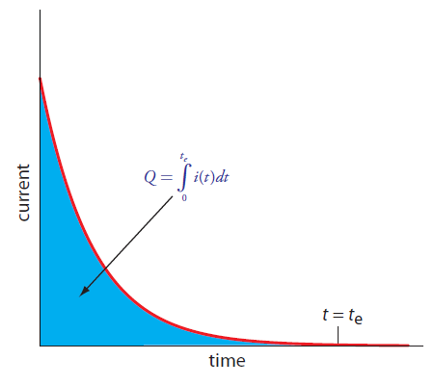
Figure 11. Plot of current versus time in a coulometric analysis.
(Figure from Analytical Chemistry 2.0, David Harvey, http://community.asdlib.org/activelearningmaterials/analytical-chemistry-2-0-online-textbook/).

How would you relate the outcome of the plot in Figure 11 to the concentration of Cd²⁺ in the sample?
What is important to determine here is the total amount of charge that flowed as that can be related using Faraday’s constant to the total number of electrons that were used in reducing Cd²⁺. The total number of electrons can be related to the total moles of cadmium in solution. Determining the total charge would involve integrating the area under the curve in Figure 11.

What advantages does coulometry have over electrogravimetry?
There are several advantages that coulometry has over electrogravimetry.

Since coulometry measures the charge needed to complete the electrochemical reaction instead of the weight of the substance plated out, reactions in which both species are water soluble can be examined (e.g., the half reaction Fe³⁺(aq) + e– = Fe²⁺(aq)).

Electrogravimetry is only useful for reduction processes involving the plating of a metal. Coulometry can be used in either a reduction or oxidation mode, increasing its versatility. The direction in which the electrons flow will be different depending on whether the reaction involves a reduction or oxidation, but that is not a hindrance to measuring the current and obtaining a plot like that in Figure 11.

One last advantage is that coulometry is more sensitive than electrogravimetry. The sensitivity and detection limits in electrogravimetry are limited by the minimum weight that can be measured on a balance – analytical balances typically measure down to 0.0001 gram but a much higher weight is needed for suitable accuracy and precision. We have the ability to measure very small quanities of current and can accurately measure time.

7.4. Titrimetic Methods of Analysis
7.4.1. “Classical” Redox Titration
A “classical” redox titration is one in which a titrant of a known concentration is prepared and standardized versus some appropriate primary standard. Then an accurate volume of an analyte solution with an unknown concentration is measured out. To be suitable for a titration, the analyte and titrant must undergo a rapid redox reaction that has a very large equilibrium constant so that formation of products is highly favored. The titrant is added from a burette and the volume needed to reach the endpoint is determined. The endpoint is identified through the use of an appropriate color-changing indicator. Besides an obvious color change, the criteria for selection of a suitable indicator is that it undergoes a redox reaction with the titrant that is less favored (has a lower equilibrium constant) than that of the analyte so that it only reacts after all of the analyte has reacted away. If the reaction between the titrant (TITR) and analyte (AN) is one-to-one, the following equation can be used to calculate the concentration (C) of the analyte.

C_{TITR} x V_{TITR} = C_{AN} x V_{AN}

If the titrant and analyte react in something other than a one-to-one equivalency, then the above equation needs to be modified to reflect the proper stoichiometry.

7.4.2. Coulometric Titration (Controlled Current Coulometry)
A coulometric titration is an interesting variation on a classical redox titration. Consider the reaction below in which Fe²⁺ is the analyte and Ce⁴⁺ is the titrant. An examination of the two standard potentials for the two half reactions confirms that in this pair cerium will proceed as the reduction and iron as the oxidation.

Fe²⁺(aq) + Ce⁴⁺(aq) = Fe³⁺(aq) + Ce³⁺(aq)

Ce⁴⁺(aq) + e– = Ce³⁺(aq) Εº = 1.61 V

Fe³⁺(aq) + e– = Fe²⁺(aq) Εº = 0.77 V

Rather than performing the titration by adding the Ce⁴⁺ from a burette, an excess of Ce³⁺ is added to an accurately measured volume of the unknown analyte solution. A constant electrochemical potential suitable to convert Ce³⁺ to Ce⁴⁺ is applied to the solution. As Ce⁴⁺ is produced, it immediately reacts with Fe²⁺ and is converted back to Ce³⁺. The result is that the concentration of Ce³⁺ is constant. A plot of the current measured by the generation of Ce⁴⁺ versus time would look like that in Figure 12.
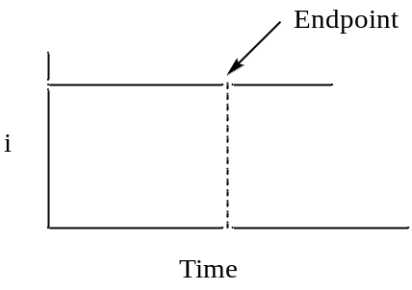

Figure 12. Plot of the current versus time in a coulometric titration.

There is more than one way to determine the endpoint of a coulometric titration. One is to add an indicator that reacts only when all the analyte is used up. In this case, you would measure the time until the color change and integrate the current versus time plot to determine the number of electrons and moles of analyte in the sample. Another possibility is that after the equivalence point, the “titrant” that is electrochemically generated no longer reacts away and there are other ways to measure that both members of the redox couple (Ce³⁺ and Ce⁴⁺ in the example above) are present.

What are some advantages of using a coulometric titration?
There are a number of advantages of a coulometric titration when compared to a classical redox titration.
- A coulometric titration has no burette.
- There is no need to standardize the titrant in a coulometric titration. All one has to do is add sufficient amounts of the titrant to the analyte solution (remember, we don’t actually add the titrant but add the appropriate species that will be converted into the titrant). Faraday’s constant is essentially the standard as it relates charge to the number of electrons and we know Faraday’s constant to a high degree of precision.
- Since we can accurately and precisely measure current and time, coulometric titrations are highly accurate and precise.
- Coulometric titrations are much more sensitive and can often measure lower concentrations than conventional titrations.
- Finally, because the titrant immediately reacts with the analyte after it is produced, it is possible to use an unstable titrant in a coulometric titration. Note that the species added to the solution that is converted into the titrant must be stable.

7.4.3. Amperometric Titration
An amperometric titration is done analogously to a classical titration in which a known volume of an analyte is measured out and a standardized titrant is added using a burette. The difference is that instead of using a color-changing indicator to determine the end point, the ability of the solution to generate a current is measured. It should be pointed out that you do not generate a large amount of current in an amperometric titration so the current generation does not deplete the solution of significant levels of the chemical species. Instead, you merely measure whether and how much current is produced at any given point during the titration.

Analyte + Titrant = Products

A stipulation for monitoring a particular titration reaction amperometrically is that the products can never generate a current at the potential being applied to the system. What is also necessary is that the analyte and/or titrant are able to generate a current. This means that there are the three possible scenarios to consider for an amperometric titration.

Draw the plot of current (y-axis) versus ml of titrant (x-axis) if only the analyte generates a current.
In this case, at the beginning before any titrant is added there is a high concentration of analyte and therefore the current would be high. As titrant is added, it reduces the concentration of analyte leading to the formation of products and the current would drop. Since every similar increment of titrant reacts with the same amount of analyte, the current should decay in a linear manner and go to zero at the endpoint. The result is the plot seen in Figure 13.

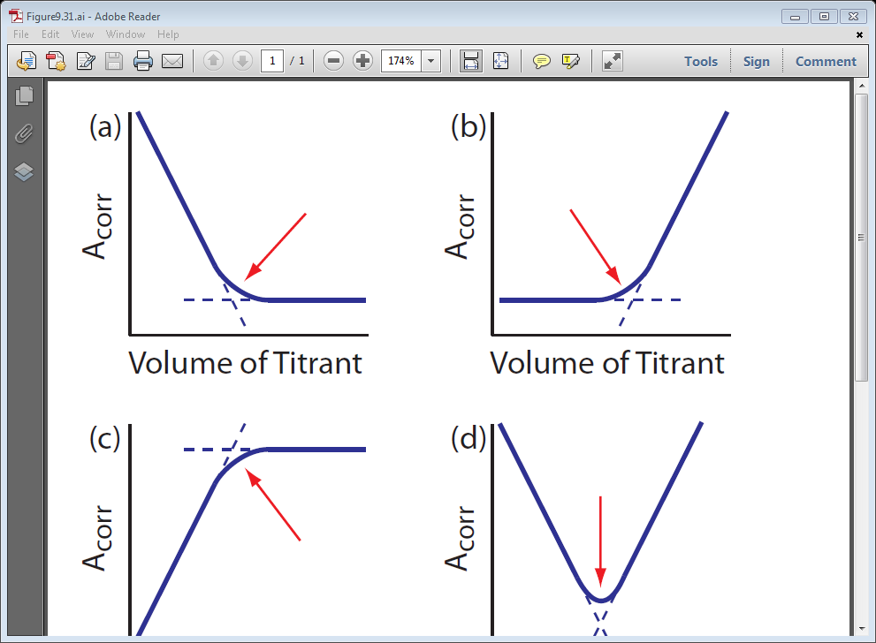
i

Figure 13. Plot of current versis ml of titrant in an amperometric titration when only the analyte produces a current.

Draw the plot of current (y-axis) versus ml of titrant (x-axis) if only the titrant generates a current.
In this case, there is no current at the beginning because the analyte does not generate one. As small amounts of titrant are added, all of the titrant reacts with the analyte to form products so there is still no measureable current. In fact, up until the equivalence point, any added titrant reacts away. Only after the equivalence point and all of the analyte is used up is there extra unreacted titrant in the solution that produces a current. The result is the plot seen in Figure 14.
i

Figure 14. Plot of current versis ml of titrant in an amperometric titration when only the titrant produces a current.

Draw the plot of current (y-axis) versus ml of titrant (x-axis) if both the analyte and titrant generate a current.
The plot in this case is the combination of those in Figures 13 and 14. Prior to the equivalence point, there is analyte and a current is observed but diminishes as more titrant is added. After the equivalence point the concentration of unreacted titrant goes up so the current gets larger. The only point where there is no species in solution capable of generating a current is at the equivalence point. The result is the plot seen in Figure 15.

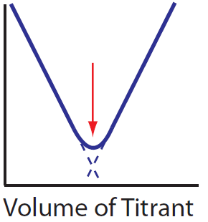
i

Figure 15. Plot of current versis ml of titrant in an amperometric titration when both the analyte and titrant produce a current.

7.4.4. Potentiometric Titration
The final titrimetric method we will examine is known as a potentiometric titration. This is similar to a classical titration as titrant is added from a burette. Instead of determining the endpoint using a color-changing indicator, a junction potential is continuously monitored during the titration. An example of a potentiometric titration that you are likely familiar with is a pH titration. In this case, a pH electrode is placed in the solution and the pH (determined by a membrane potential at the external glass membrane as described earlier in this unit) is measured continuously as titrant is added. The pH is plotted versus the ml of titrant added and there is a characteristic “break” or sharp rise in the plot that occurs at the equivalence point as seen in Figure 16. The plot has an inflection point that occurs at the equivalence point, although it is easier to identify the location of the inflection point by taking either the first or second derivative of the plot shown in Figure 16.

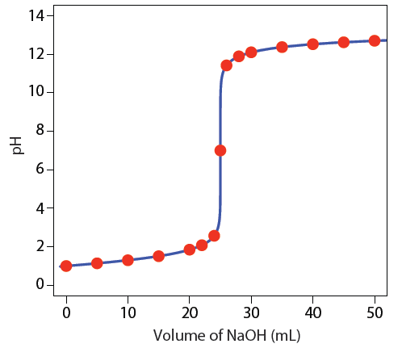
Figure 16. Plot of pH of a strong acid versus ml NaOH in a pH titration. (Figure from Analytical Chemistry 2.0, David Harvey, http://community.asdlib.org/activelearningmaterials/analytical-chemistry-2-0-online-textbook/).

It is also possible to measure the progress of other redox reactions potentiometrically. For example, we could monitor the progress of the titration of a solution of Fe²⁺ using Ce⁴⁺ as the titrant. The products of the reaction are Fe³⁺ and Ce³⁺.

Fe²⁺(aq) + Ce⁴⁺(aq) = Fe³⁺(aq) + Ce³⁺(aq)

The two relevant half reactions are shown below and indicate that the cerium reaction is the cathode and iron reaction is the anode.

Ce⁴⁺(aq) + e– = Ce³⁺(aq) Εº = 1.61 V

Fe³⁺(aq) + e– = Fe²⁺(aq) Εº = 0.77 V

Note that the Εº for the complete reaction is 0.84 V. Using the equation on p. 10 that relates Εº to K, the equilibrium constant for the reaction is greater than 10¹⁴. As with other electrochemical devices, a reference and working electrode is needed to perform the measurement. In this case, a platinum working electrode could be used. Let’s consider the following example to examine what will happen during the course of the titration and how one goes about calculating the potential during the titration.

20 ml of an 0.10 M solution of Fe²⁺ is titrated with 0.10 M Ce⁴⁺. Calculate the potential that would be measured when 5 ml, 10 ml, 20 ml, 30 ml and 40 ml of titrant have been added.

The following steps will allow us to work through the calculation of the junction potentials.

Write an expression for the total electrochemical potential of the titration reaction (this is the Nernst equation for the complete reaction).

$$E_{TOTAL}= E_{TOTAL}^{0}- \frac{0.059}{1}log\frac{\left[{Fe}^{3+}\right][{Ce}^{3+}]}{\left[{Fe}^{2+}\right][{Ce}^{4+}]}$$

Note, the reaction has one electron transferred between the cerium and iron so n = 1.

What is the total electrochemical potential of the titration reaction at any point during a titration? Think carefully about this because your first intuition may not be correct.
One of the criteria for any reaction to be useful in a titration is that the system must rapidly achieve equilibrium. What that means is that the titration above is always at equilibrium. In other words, when a drop of the cerium titrant is added, it immediately reacts with the iron and the system achieves equilibrium. Once past the equivalence point, there is some continuing distribution of species that occurs to establish equilibrium after each increment of titrant is added, but the system is always at equilibrium during all phases of the titration. That means that the total electrochemical potential of the reaction between Fe²⁺ and Ce⁴⁺ is zero at all points of the titration.

If we consider the other way we developed for determining the total electrochemical potential of a system.
Ε_{TOTAL} = Ε_{CATHODE} – Ε_{ANODE}

Remember that when using this form of the equation, both the cathode and anode values are evaluated as reductions. Since we determined that Ε_{Total} = 0 at all steps for the titration reaction, the following relationship is valid throughout the titration:

Ε_{CATHODE} = Ε_{ANODE}

However, there are two reactions to consider. One is the titration reaction and the other is the overall cell reaction. The overall cell reaction includes species in the reference electrode. Whereas the titration reaction goes to completion, the extent of the overall cell reaction is negligible because the voltmeter has high impedance that prevents current flow. The result is that the potential difference measured between the platinum and reference electrode during the titration is either the value Ε_{CATHODE} or Ε_{ANODE} developed above. Since these will both be equal, in theory either one of them could be used to calculate the potential at any point in the titration. However, there are advantages to using one of the half reactions over the other at certain points of the titration.

Which half reaction is easier to use to calculate the junction potential before the equivalence point? Which half reaction is easier to use after the equivalence point?
A way to consider this is to examine the amounts of the different species present at different points in the titration. The chart below shows the amounts of the different species in moles as the titration progresses.

Titrant (ml) Fe²⁺ Ce⁴⁺ Fe³⁺ Ce³⁺
0 0.0020 m 0 m 0 m 0 m
5 ml 0.0015 m 0 m 0.0005 m 0.0005 m
10 ml 0.0010 m 0 m 0.0010 m 0.0010 m
20 ml 0 m 0 m 0.0020 m 0.0020 m
30 ml 0 m 0.0010 m 0.0020 m 0.0020 m
40 ml 0 m 0.0020 m 0.0020 m 0.0020 m

It is important to note that except for the first line when no titrant has been added, the concentrations listed as “0 m” are not actually zero. Because the equilibrium constant for the reaction has a finite value, the concentration of each species must be a finite value. However, the equilibrium constant for this reaction is large (>10¹⁴), so the redistribution or back reaction of species that occurs involves only a small amount. As an example, let’s consider the values at 5 ml.

5 ml Titrant Fe²⁺ Ce⁴⁺ Fe³⁺ Ce³⁺
Initial 0.0015 m 0 m 0.0005 m 0.0005 m
Back reaction 0.0015 + X m X m 0.0005 – X m 0.0005 – X m
Approximation 0.0015 X m 0.0005 0.0005 m

For the line labeled “back reaction”, a small amount (X) of the Fe³⁺ and Ce³⁺ are removed to generate some Ce⁴⁺ and Fe²⁺. However, the value of X is so small relative to 0.00050 and 0.0015 moles (again because K is so large) that it is insignificant and can be ignored. Therefore, the amounts shown in the line labeled “approximation” can be used for any calculations.

An important outcome that arises by examining the amounts in the chart above is that prior to the equivalence point (5 and 10 ml of titrant) there are appreciable amounts of both Fe²⁺ and Fe³⁺. That means it will be preferable to use the iron half reaction in calculating the junction potential before the equivalence point.

Also note that after the equivalence point (30 and 40 ml of titrant) there are appreciable amounts of both Ce³⁺ and Ce⁴⁺. That means it will be preferable to use the cerium half reaction in calculating the junction potential after the equivalence point.

We can now calculate the values before and after the equivalence point.

5 ml
$$E_{Fe}= E_{Fe}^{0}- \frac{0.059}{1}log\frac{[{Fe}^{2+}]}{[{Fe}^{3+}]}$$

$$E_{Fe}=0.77- \frac{0.059}{1}log\frac{\left[0.0015 m\right]}{\left[0.0005 m\right]}=0.74 V$$

There is one other important thing to note in this calculation. Because we have a ratio of [Fe²⁺] to [Fe³⁺] in the log term, the volumes associated with the two concentrations cancel each other out. So using the number of moles of the two species when there are appreciable amounts of both gives the same value as using the concentration.

10 ml
$$E_{Fe}= E_{Fe}^{0}- \frac{0.059}{1}log\frac{[{Fe}^{2+}]}{[{Fe}^{3+}]}$$

$$E_{Fe}=0.77- \frac{0.059}{1}log\frac{\left[0.0010 m\right]}{\left[0.0010 m\right]}=0.77 V$$

Note that in this case, with the concentrations of Fe²⁺ and Fe³⁺ being equal, the log of 1 is zero and the potential is equal to Εº_{Fe}.

30 ml
$$E_{Ce}= E_{Ce}^{0}- \frac{0.059}{1}log\frac{[{Ce}^{3+}]}{[{Ce}^{4+}]}$$

$$E_{Fe}=1.61- \frac{0.059}{1}log\frac{\left[0.0010 m\right]}{\left[0.0020 m\right]}=1.59 V$$

40 ml
$$E_{Ce}= E_{Ce}^{0}- \frac{0.059}{1}log\frac{[{Ce}^{3+}]}{[{Ce}^{4+}]}$$

$$E_{Fe}=1.61- \frac{0.059}{1}log\frac{\left[0.0020 m\right]}{\left[0.0020 m\right]}=1.61 V$$

Note that in this case, with the concentrations of Ce³⁺ and Ce⁴⁺ being equal, the log of 1 is zero and the potential is equal to Εº_{Ce}.

The only item remaining potential to be calculated is at the equivalence point where we cannot easily use either of the two half reactions to calculate the potential. Using the two half reactions and knowledge of the stoichiometric equivalence of the different species at the equivalence point, It is possible to derive the following generalizable equation for the potential that will be measured at the equivalence point. A and B refer to the two half reactions and n_{A} and n_{B} are the number of electrons in each of the half reactions, respectively.

$$E_{Eq.Pt.}= \frac{(n_{A}E_{A}^{0}+ n_{B}E_{B}^{0})}{(n_{A}+ n_{B})}$$

For the reaction in our problem, n_{A} and n_{B} are both 1 so the result is that the equivalence point potential is the average of the two Εº values.

$$E_{Eq.Pt.}= \frac{(0.77+ 1.61)}{(2)}=1.19 V$$

The chart below summarizes the potential measured at different points in the titration.

Titrant (ml) Fe²⁺ Ce⁴⁺ Fe³⁺ Ce³⁺ Potential
5 ml 0.0015 m 0 m 0.0005 m 0.0005 m 0.74 V
10 ml 0.0010 m 0 m 0.0010 m 0.0010 m 0.77 V (Εº_{Fe})
20 ml 0 m 0 m 0.0020 m 0.0020 m 1.19 V
30 ml 0 m 0.0010 m 0.0020 m 0.0020 m 1.59 V
40 ml 0 m 0.0020 m 0.0020 m 0.0020 m 1.61 V (Εº_{Ce})

A plot of the potential (y-axis) versus the ml of titrant (x-axis) is shown in Figure 17.

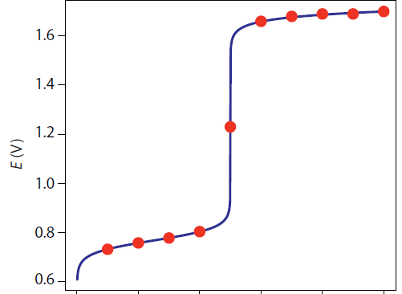
Εº_{Ce}

Εº_{Fe}
Eq.Pt
0 10 20 30 40 ml Titrant

Figure 17. Plot of potential versus ml titrant for the potentiometric titration of Fe²⁺ with Ce⁴⁺. (Figure from Analytical Chemistry 2.0, David Harvey, http://community.asdlib.org/activelearningmaterials/analytical-chemistry-2-0-online-textbook/).

The break in potential that occurs at the equivalence point is apparent in this plot. Note how the general form of this plot is similar to what is observed in a pH titration. This is not surprising since a pH titration is also a potentiometric titration.

One last thing worth examine is the equivalence point potential for a redox reaction where the number of electrons is different in each of the half reactions. For example, suppose Sn²⁺ was titrated with Ce⁴⁺. The two relevant half reactions are shown below.

Ce⁴⁺(aq) + e– = Ce³⁺(aq) Εº = 1.61 V

Sn⁴⁺(aq) + 2e– = Sn²⁺(aq) Εº = 0.154 V

In this case, the balanced reaction needs two equivalents of Ce⁴⁺ for each Sn²⁺ to balance out the electrons being transferred.

Sn²⁺(aq) + 2Ce⁴⁺(aq) = Sn⁴⁺(aq) + 2Ce³⁺(aq)

The equivalence point potential is calculated as follows:

$$E_{Eq.Pt.}= \frac{(n_{A}E_{A}^{0}+ n_{B}E_{B}^{0})}{(n_{A}+ n_{B})}$$

$$E_{Eq.Pt.}= \frac{(E_{Ce}^{0}+ 2E_{Sn}^{0})}{(1+2)}$$

$$E_{Eq.Pt.}= \frac{(1.61+ 2(0.154)}{(3)}=0.639 V$$

The plot of potential versus ml titrant that would be obtained for this titration is shown in Figure 18.
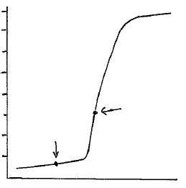
Ε (V)
Equiv.
Point
1.6

1.2

0.8

0.4
Εº_{Sn}
ml Titrant

Figure 18. Plot of potential versus ml titrant for the potentiometric titration of Sn²⁺ with Ce⁴⁺.

It is important to note that the equivalence point in Figure 18 is not symmetrically placed between the two potential plateaus surrounding the Εº value of tin and Εº value of cerium as it was in the reaction of cerium and iron we examined earlier. Instead, the equivalence point potential is weighted toward the Εº value of tin because the tin half reaction requires two electrons whereas the cerium half reaction only requires one.

7.5. Voltammetric Methods
Voltammetry refers to electrochemical methods in which a specific voltage profile is applied to a working electrode as a function of time and the current produced by the system is measured. This is commonly done with an instrument called a potentiostat, which for these measurements is capable of applying variable potentials to the working electrode relative to a reference electrode (like Ag/AgCl) while measuring the current that flows as a result of the electrode reaction. Depending on the particular method, it is possible to apply reducing and/or oxidizing potentials. When a reduction occurs, the current is called a cathodic current. When an oxidation occurs, the current is called an anodic current. Different voltammetric methods involve different voltage profiles. Voltammetric methods are among some of the most common electrochemical methods in use today. There are a variety of voltammetric methods. This unit will only explore three of these methods: anodic stripping voltammetry (ASV), linear sweep voltammetry, and cyclic voltammetry (CV).

Voltammetric methods typically involve the use of microelectrodes that frequently have areas on the order of 0.3-10 cm². Originally it was common to use mercury electrodes often as a hanging mercury drop (HMDE) or as drops through a glass capillary (DME) for voltammetric methods. Mercury had several desirable properties in electrode applications. One advantage of mercury is that it has a high overvoltage toward the reduction of H⁺ so it can be used at high reducing potentials in water without leading to the electrochemical splitting of water into hydrogen and oxygen gas. A second advantage of mercury electrodes is that metals dissolve in mercury by forming amalgams, which improves the measurement of low concentrations of analytes. A concern with electrodes is that mercury can become fouled or the surface of a solid electrode can become poisoned, which significantly alters their properties. This can occur if species in the matrix adsorb to the surface of the electrode. Solid electrodes usually are put through a prescribed polishing procedure before used for measurement purposes, while mercury drops can easily be replaced through a glass capillary.

The use of mercury electrodes has fallen into disfavor today because of the toxicity of the metal and the difficulty of controlling spills of the material when used in electrode applications. Other possible electrodes for use in voltammetric methods include carbon paste, glassy carbon, platinum and gold. In addition, with a glassy carbon electrode it is possible to create a thin film of mercury on the electrode by reducing Hg²⁺. This provides the advantages of mercury electrodes described earlier without the necessity for using large quantities of mercury.

Today, ultramicroelectrodes have been fabricated with dimensions on the um scale or smaller. These are so small they can be inserted into single cells and used in certain voltammetric methods to probe chemical processes taking place inside the cell.

An important consideration in voltammetric methods is the process by which species in solution move up to the surface of the electrode, where if electroactive, they can be oxidized or reduced. There are three general processes by which ions move in solution: diffusion, convection and electrostatic migration. Diffusion involves the random motion of species in solution. Convection is physical movement created by something like a magnetic stir bar. Electrostatic migration results from the attraction of a positive species towards a negatively charged electrode or alternatively the attraction of a negative species toward a positively charged electrode. Diffusion will always occur in a solution. In some methods, it may or may not be desirable to have convective movement or electrostatic migration.

How can electrostatic migration be eliminated in an electrochemical cell?
The key to answering this question is to realize that ions in solution must somehow be shielded from the charge on the electrode. The addition of a large concentration of an inert electrolyte such as potassium chloride will accomplish this goal. For example, for a negatively charged cathode, K⁺ ions will be adjacent to the electrode and throughout the solution. Analyte cations that are in the solution and away from the surface of the electrode will be shielded from the charge on the electrode by all the K⁺ ions in between.

Samples subjected to voltammetric methods are usually purged with nitrogen or other inert gas before the analysis and maintained under an inert atmosphere during the analysis. Why is this done?
Most aqueous solutions have reasonable levels of dissolved oxygen gas (O₂). Oxygen gas has a relatively low reduction potential and if not removed from the solution will generate a current that will interfere with the measurement. An inert gas used to purge the solution will displace the dissolved oxygen. Maintaining the solution under an inert atmosphere will prevent oxygen from the air from dissolving back into the solution.

7.5.1. Anodic Stripping Voltammetry (ASV)
In ASV, a potential sufficient to reduce the metal of interest is applied to the working electrode for 1-30 minutes in the solution being analyzed to plate out or deposit the metals onto the surface of the working electrode. The lower time is used for samples with metal concentrations of 10⁻⁷ M or more. The longer time is used with samples with concentrations as low as 10⁻¹¹ to 10⁻¹² M. After the deposition step, the voltage is scanned towards more positive potentials. The voltage profile for ASV as a function of time is shown in Figure 19. The solution is stirred during the deposition period in ASV to bring the species in solution up to the surface of the electrode to be reduced, but not stirred during the stripping step.

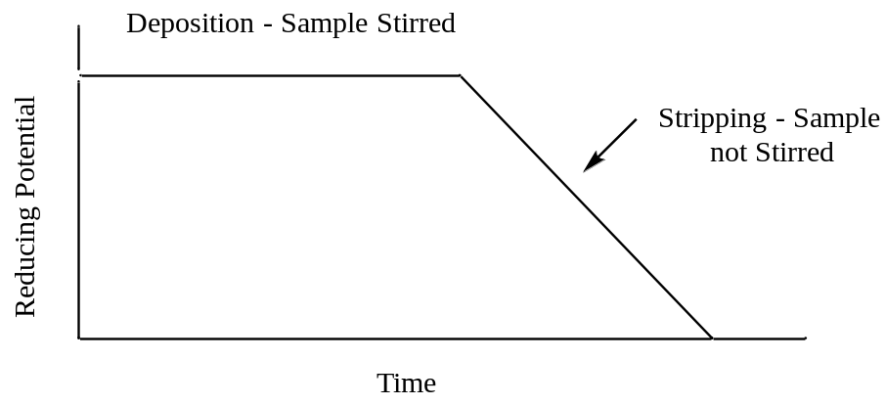

Figure 19. Potential versus time profile used in anodic stripping voltammetry.

Suppose you are analyzing a solution that contains Cd²⁺ and Pb²⁺ using ASV. You apply a potential of –1.0 V for several minutes to plate out both metals. You then scan to more positive potentials in the stripping step. Draw a generalized plot of the current you would observe as a function of time during the deposition step and during the stripping step.
The first thing to consider is the relevant half reactions for the metals being deposited out of solution.
Cd²⁺(aq) + 2e– = Cd(s) Εº = – 0.403 V

Pb²⁺(aq) + 2e– = Pb(s) Εº = – 0.126 V

Note that cadmium, by virtue of its more negative Εº value, is more difficult to reduce and plate out or deposit than lead. However, during the deposition period, the reducing potential should be set negative enough to deposit both metals onto the electrode. In considering what the plot of current versus time would look like during the deposition period, it might first be tempting to consider a situation similar to what we observed in coulometry (Figure 13). In the coulometric experiment, the current starts high and diminishes as the metal ions are deposited from solution. However, coulometry involves the use of large electrodes and a complete deposition or reaction of the species being analyzed. ASV involves microelectrodes so only a small fraction of the total metal ions in solution will be deposited onto the electrode. Provided the solution is stirred, the result is that a constant current occurs during the deposition step of ASV.
At the initial stage of the potential sweep towards more oxidizing values, the potential is still negative enough to deposit both metals. At some point the voltage will approach the Εº value of – 0.403 Volts and which point deposition of the cadmium ends and the cadmium that has been reduced and deposited onto the electrode will be oxidized. In the deposition step, electrons flowed from the electrode to the metal ions in the solution. In the oxidation of cadmium, the electrons flow in the opposite direction. Whereas in the deposition step, metal ions needed to be brought to the electrode to be reduced, in the oxidation step all of the metal is already deposited onto the electrode. This means that all of the deposited cadmium oxidizes almost instantaneously (and is said to be stripped from the electrode). The result is to produce a large peak of current in the oxidation step as seen in Figure 20. As the reducing potential continues to ramp down, it eventually approaches – 0.126 Volts and the lead that has been deposited onto the electrode will oxidize and be stripped from the electrode. This produces a second peak of current as seen in Figure 20.
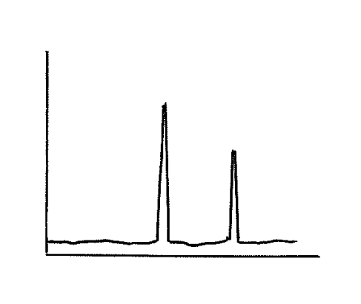
i
Potential
Pb
Cd

Figure 20. Plot of current versus potential for the stripping portion of an anodic stripping voltammogram of a mixture containing cadmium and lead.

What feature of the plot can be related to the concentration of the metal?

The area or height of each peak can be related to concentration using a set of standards.

What advantage(s) does anodic stripping voltammetry offer over coulometry or electroplating?
The most significant advantage of ASV over methods such as coulometry or electroplating is its unprecedented sensitivity. Looking at the plot of current versus time in Figure 20, it is important to recognize that the total area under the two peaks resulting from the two oxidation steps must be equal to the total area under the curve that resulted during the reduction step (since all the electrons that went into reducing Pb²⁺ and Cd²⁺ must be released back during the oxidation step). This means that the current peaks for the two metals will be quite intense, meaning that the method can be used to detect low concentrations of metal ions. The sensitivity can be further increased by using larger electrodes and longer deposition times, effectively concentrating more metal atoms onto the electrode. ASV can be used to measure metal concentrations as low as 10⁻¹² M, which is an exceptionally low level (superior to flame atomic absorption spectroscopy and comparable to graphite furnace atomic absorption spectroscopy). ASV can therefore be used for ultratrace level analysis of certain metal ions.

A second advantage of ASV over coulometry or electroplating is that more than one metal species can be analyzed in a sample. The reducing step used in coulometry, electroplating or ASV does not distinguish between different species unless you are able to select the right potential to only reduce a single species. However, the oxidation step in ASV produces a separate peak for each metal plated onto the electrode.

An advantage that coulometry has over ASV is that it can be used in either a reducing or oxidizing mode and can be used with half reactions where both the reactants and products are soluble species. ASV requires a product that plates onto the electrode so is not as versatile as coulometry.

7.5.2. Linear Sweep Voltammetry
The voltage profile in linear sweep voltammetry involves a linear scan of either a reducing or oxidizing voltage (Figure 21). We will illustrate the features of this method by examining the current that is measured when a reducing potential is applied to a two component mixture.

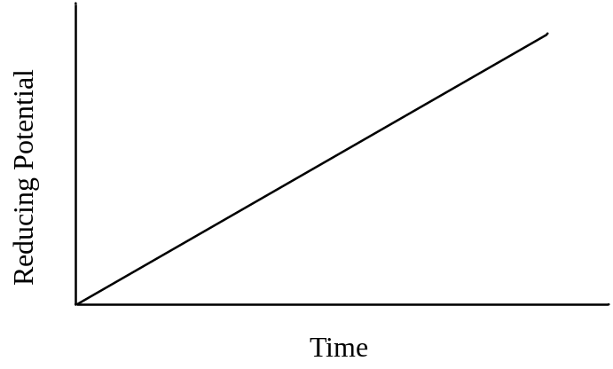
Figure 21. Potential versus time profile used in linear sweep voltammetry.

Draw the current that would be measured for a solution consisting of Cd²⁺ and Zn²⁺ in linear sweep voltammetry. Assume that the concentration of Cd²⁺ is about twice as large as that of Zn²⁺ and that the solution is stirred.
First we need to write the two relevant half reactions that will occur.

Cd²⁺(aq) + 2e– = Cd(s) Εº = – 0.403 V

Zn²⁺(aq) + 2e– = Zn(s) Εº = – 0.763 V

Comparing the Εº values indicates that cadmium is more easily reduced than zinc. As the voltage ramps to more negative values, it will reach a point where any Cd²⁺ species at the surface of the electrode will be reduced and a current will be observed. Because the solution is being stirred, fresh Cd²⁺ will be forced up to the electrode at a constant rate, thereby sustaining the current. Since this technique uses microelectrodes, as previously discussed in ASV, there will be no diminishment of current due to the depletion of Cd²⁺. As the reducing voltage continues to increase, eventually it will reach a value sufficient to reduce the Zn²⁺. Beyond this point, both Cd²⁺ and Zn²⁺ are being reduced at a constant rate and the overall current is the sum of both reductions. The plot of current versus time for the linear sweep voltammogram of this solution is shown in Figure 22.

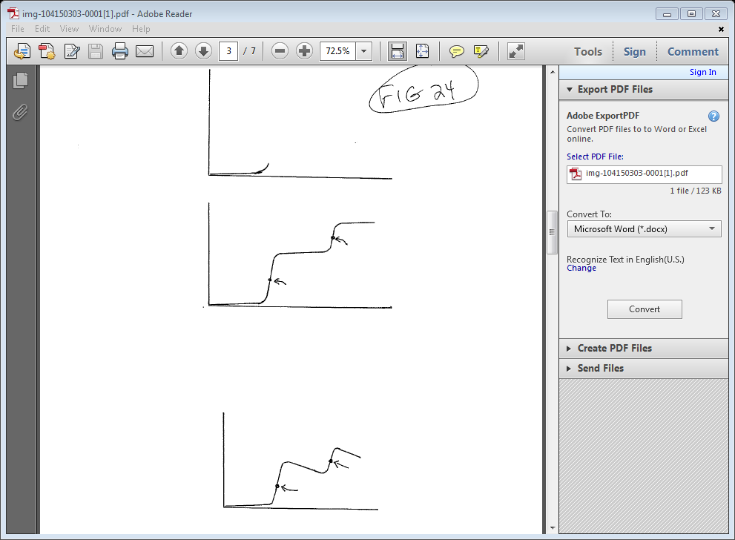
Potential
Ε_{1/2} (Cd)
Ε_{1/2} (Zn)
i

Figure 22. Plot of current versus potential for a linear sweep voltammogram of a mixture containing cadmium and zinc. The solution is stirred.

Something to note in the plot in Figure 22 is that baseline rises slightly as potential is increased before the reduction of Cd²⁺ begins. One reason for the rising baseline is something known as the capacitive current. Capacitive current occurs because cations in solution form a layer adjacent to the negatively charged electrode as shown in Figure 23. The separated layers of charge act as an electronic device known as a capacitor. The more negative the electrode potential becomes, the more positive charge that can be stored at its surface. Another reason a slight rise in the baseline may occur is if there are trace amounts of impurities in solution that undergo an electrochemical reaction.
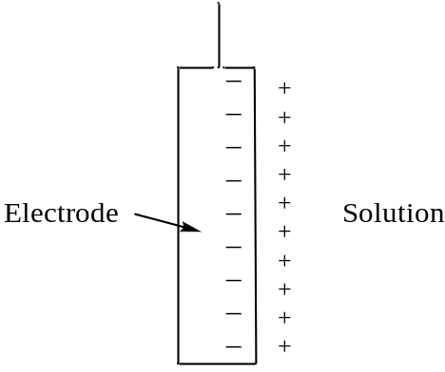

Figure 23. Alignment of cations in solution adjacent to the surface of a negatively charged electrode. The two separated layers of charge form something analogous to a capacitor.

What feature of the plot can be related to concentration?
The magnitude of the current generated for each of the reduction steps, which is seen as the height of the plateau, can be related to the concentration. Because the concentration of Cd²⁺ and Zn²⁺ in the solution was about twice that of zinc and because both are two electron reductions, the height of the plateau for cadmium in Figure 22 is higher than that of zinc. However, the relationship between the height of the plateau and the concentration for each particular species would need to be calibrated against a series of standards with known concentrations of each metal.

What feature of the plot can be used for species identification?
What is important here is that the different species are reduced at different applied potentials. The value used for species identification is known as Ε_{1/2}, which is the potential at the half-way point up the reduction step. The Ε_{1/2} values for the reduction of cadmium and zinc are shown in Figure 22 and occur at an inflection point in the plot.

For the exact same solution of Cd²⁺ and Zn²⁺, draw the current that would be observed if the solution is not stirred.
Stirring the solution insures that ions continue to reach the electrode surface to maintain the current. If the solution is not stirred, when the reduction potential for an ion such as Cd²⁺ is reached, any Cd²⁺ at the electrode surface will be reduced so a rise in current comparable to that in Figure 22 will occur. Once these species are reduced, there are two ways additional Cd²⁺ can make it to the electrode to be reduced. One is through the process of diffusion. The other is that the electrode does have a negative charge and there can be an electrostatic attraction of Cd²⁺ for the electrode.

We already mentioned earlier that electrostatic attraction of species for the electrode can be eliminated by adding a high concentration of a background electrolyte to the solution (e.g., potassium chloride, K⁺+ and Cl–). It is often desirable to run these processes in a manner that is under diffusion control. In such a case, diffusion will not cause enough Cd²⁺ to strike the electrode to maintain a constant current. Therefore the current will begin to drop after the initial reduction step. It will not drop to zero because diffusion of Cd²⁺ does occur and some current is maintained. The plot in Figure 24 shows an example of the plot that would result for a solution of Cd²⁺ and Zn²⁺ if it were run without stirring the sample.
Potential
Ε_{1/2} (Cd)
Ε_{1/2} (Zn)
i

Figure 24. Plot of current versus potential for a linear sweep voltammogram of a mixture containing cadmium and zinc. The solution is not stirred.

7.5.3. Differential Pulse Linear Sweep Voltammetry
In differential pulse linear sweep voltammetry, a voltage profile similar to a linear sweep experiment is applied but then a small, increased voltage pulse is superimposed over the voltage ramp (Figure 25). In this method the current is sampled twice: (1) just before the pulse is applied and (2) just before the pulse ends. The two measurements are subtracted [(2) – (1)] and the difference is plotted.

Reducing Potential
Time

Figure 25. Potential versus time profile used in differential pulse linear sweep voltammetry.

Draw the resulting plot for the same sample shown in Figure 22 (a solution consisting of Cd²⁺ and Zn²⁺; the concentration of Cd²⁺ is about twice that of Zn²⁺, and the solution is stirred).
In order to understand what happens here it is useful to look at the plot in Figure 22 and then consider where the measurements are made for each (1) and (2) in Figure 22. Figure 22 is reproduced as Figure 26a and examples of measurements (1) and (2) for some different pulses are shown on the plot. By applying a short pulse, the measuring of current at point (2) is essentially jumping ahead a little bit on the linear ramp. If we look at the flat portion of the plot early in the ramp, there is no change in current going from (1) to (2) so the difference between the two points is zero. If we look later on during the reduction of Cd²⁺ at the electrode, since there is a large jump in the current, subtracting (1) from (2) gives a large positive value. If we consider a pulse after the inflection point in the curve (Ε_{1/2}) there is still a large difference between the current at points (1) and (2) but it begins to diminish. If we examine the plateau of current between the point where Cd²⁺ is reduced and Zn²⁺ has not yet started to reduce, there is no change in current between points (1) and (2) for a particular pulse so the difference is now back to zero. The plot shown in Figure 26b shows the result that would be obtained using the voltage profile shown in Figure 25. In effect, the measurement done using this profile is taking the derivative of the curve, hence the name differential pulse linear sweep voltammetry.

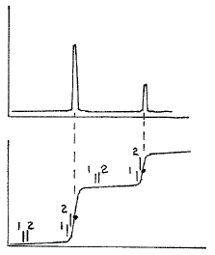
i
i₂ – i₁
(a)
(b)

(a)
Zn
Cd
Ε_{1/2} (Cd)
Ε_{1/2} (Zn)
Potential

Figure 26. Plot of current versus potential for (a) a linear sweep voltammogram and (b) a differential pulse linear sweep voltammogram of a mixture containing cadmium and zinc. The points (1) and (2) indicate some examples of where current readings are taken before and after a pulse.

What advantage(s) does differential pulse linear sweep voltammetry have over conventional linear sweep voltammetry?
There are two important advantages of the differential pulse method over conventional linear sweep voltammetry. The first is that it is much more sensitive. The differential pulse method provides a sharp peak for each species being analyzed and it is much more reliable to measure either the height or area of this peak and relate it to concentration than it is to measure the height of the current in the linear sweep mode. This can be especially appreciated at low concentrations where a small peak in the differential pulse mode would be much easier to measure than only a small change in the height of the current (see Figure 27).

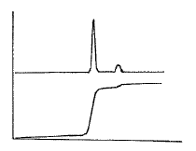
Potential
Linear
Sweep
i₂ – i₁
i
Differential
Pulse

Figure 27. Plot of current versus potential for a linear sweep voltammogram and differential pulse linear sweep voltammogram for a mixture containing a high concentration of one metal and small concentration of another.

The second is that it is much easier to distinguish two species with similar Ε_{1/2} values. An example of this is shown by the linear sweep and differential pulse results in Figures 28, respectively. Whereas the linear sweep method requires a difference of about 0.2 V in the Ε_{1/2} values to distinguish two species, the differential pulse method only requires a difference of about 0.05 V.
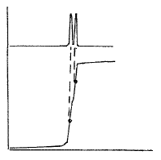
i
i₂ – i₁
Potential
Linear
Sweep
Differential
Pulse

Figure 28. Plot of current versus potential for a linear sweep voltammogram and differential pulse linear sweep voltammogram for a mixture containing two metal ions with similar Ε_{1/2} values.

7.5.4. Cyclic Voltammetry
The last method we will develop is known as cyclic voltammetry (CV). In CV, scan rates can typically range from 10 mV/s to 100,000 V/s with an increase in the applied potential followed by a return back to the starting voltage as shown in Figure 29. This can be performed as an anodic or cathodic scan depending on the system being studied. For the examples herein, we will consider a cathodic scan that causes in the reduction of species in the initial solution.

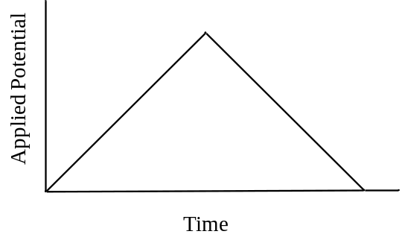
Figure 29. Applied potential vs. time profile used in cyclic voltammetry.

Draw a plot of current (y-axis) versus voltage (x-axis) that you would measure for a solution in which the Fe³⁺ in ferricyanide (Fe(CN)₆^{3–}) is reduced to Fe²⁺ during the reducing phase of the CV voltage profile shown in Figure 29. The half reaction is chemically and electrochemically reversible and the solution is not stirred.
Prior voltammetric methods have given us the ability to understand the plot that will result for CV. The first half of the voltage profile (i.e., the forward sweep of potential) is essentially a linear sweep voltammogram. The second half is similar to the profile used in the latter stripping portion of ASV, although as we will see, the output usually looks quite different than the output in ASV because nothing has plated out of solution. Note, in the example given in the problem, the two species involved in the reaction (Fe²⁺, Fe³⁺) are water soluble and neither deposits out onto the electrode.

During the forward sweep, Fe³⁺ will be reduced to Fe²⁺ and a current (the forward wave) will be produced as the Fe³⁺ at the surface of the electrode is reduced (Location 1 in Figure 30). Beyond this point and since the solution is not stirred, the current falls because Fe³⁺ cannot diffuse up to the electrode fast enough to maintain a constant current (Location 2 in Figure 30). As the potential returns to the initial value it eventually reaches the potential where Fe²⁺ that remains next to the electrode can be oxidized back to Fe³⁺. This process results in an anodic current that appears as the reverse wave (Location 3 in Figure 30). For an electrode reaction that is electrochemically reversible (i.e., fast electron transfer meaning no overpotential), the peak of the forward wave will align with the Ε_{1/2} value of the reverse wave and the peak of the reverse wave will align with the Ε_{1/2} value of the forward wave as seen in Figure 30. The formal potential for a redox couple (Ε’º) can be calculated by taking the average of the peak potentials of the forward and reverse wave. Provided none of the Fe²⁺ formed in the reduction step has been lost in a subsequent chemical reaction (Figure 31), under diffusion controlled conditions where the equilibrium concentrations determined by the Nernst equation are maintained, the reverse wave should have the same peak current as the forward wave.

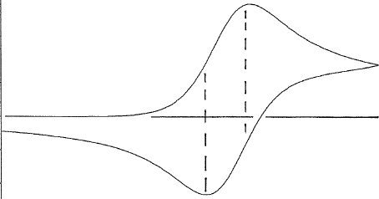
(3)
(2)
(1)
Ε_{1/2}
i
Ε_{1/2}
Potential

Figure 30. Plot of current versus potential for a cyclic voltammogram of a redox couple with an uncomplicated electron transfer and a diffusion-controlled chemically reversible redox reaction.
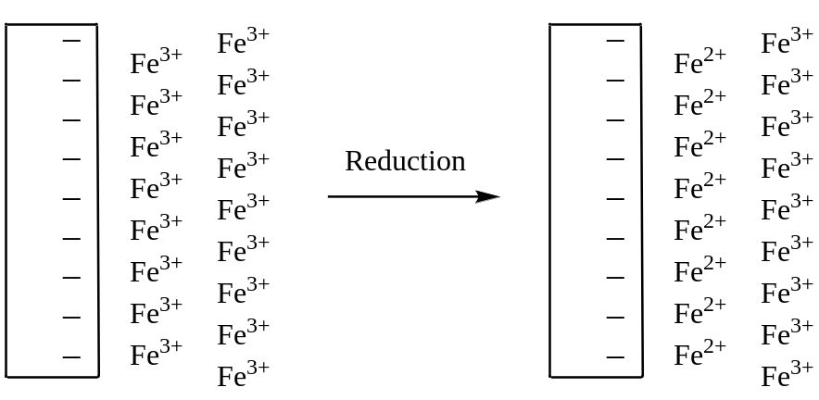
Figure 31. Representation of the solution near the electrode before and after the reduction step in a cyclic voltammogram.

The output from a method such as CV does depend significantly on a number of factors and the magnitude of the peak current is described more fully using what is known as the Randles-Sevcik equation. Factors such as the number of electrons transferred in the redox reaction, the electrode area, the diffusion coefficient for the species being analyzed, the concentration of the species being analyzed and the potential scan rate all influence the peak current. The reader is referred to the following resource for a discussion of the Rangles-Sevcik equation:
http://community.asdlib.org/activelearningmaterials/analytical-electrochemistry-the-basic-concepts/

The value of CV is not so much for quantitative analysis but for the analysis of mechanistic properties of electrochemical reactions. Sometimes it is advantageous to do more than one scan when using CV to examine reaction mechanisms. If we consider the chemically and electrochemically reversible electrode reaction discussed above, a second and third voltage scan would produce plots identical to that shown in Figure 30. However, if the product of the initial electrochemical reaction underwent a further reaction, it may produce an electrochemically inactive product that is not observed in the CV, or an active one that is observed in subsequent scans. Let’s consider some other examples of outcomes of CV.

Draw a plot that could be obtained for an electrochemical reaction that is chemically irreversible and forms an electrochemically inactive product.
In this case, there would be no reverse wave. Assuming the process involved applying a reduction potential, the product of the reduction would not be able to be oxidized as the voltage came back down the ramp. The current vs. potential plot obtained in this situation is shown in Figure 32.
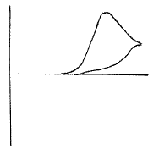
i
Potential

Figure 32. Plot of current versus potential for a cyclic voltammogram of a chemically irreversible redox couple in which the product that is formed is electrochemically inactive.

Draw the plot of current vs. potential that would be obtained for a reversible chemical reaction in which only the reverse reaction has an overpotential, but the potential eventually is sufficient to complete the reverse reaction.
In this case, there would be a reverse wave but because of the overvoltage it would be offset from the forward wave as shown in Figure 33. Another difference is that the slower electron transfer occurring in the case of an electrochemically irreversible reaction would lead to a flatter profile on the reverse wave.
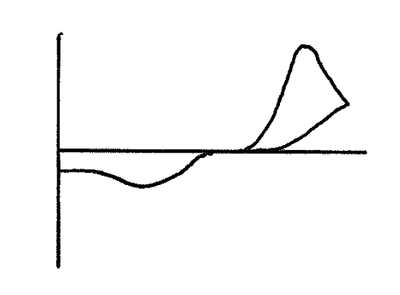
i
Potential
Figure 33. Plot of current versus potential for a cyclic voltammogram of a redox couple that is chemically reversible but electrochemically irreversible because of an overpotential on the reverse reaction.

Propose a reaction mechanism that would explain the following cyclic voltammogram. The first voltage cycle is shown as a solid line. The second voltage cycle is shown as a dotted line. A third voltage cycle gives the same output as the dotted line. Assume that a reducing potential is applied.
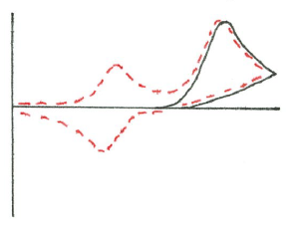
Potential
i

Figure 34. Plot of current versus potential for a cyclic voltammogram. Solid line is the first scan. Dotted line is the second scan.

The first cycle indicates that a species was reduced. However, the reaction is chemically irreversible as there is no reverse wave. The second cycle shows a new species showing up in the cyclic voltammogram. Presumably the product formed from the reduction either decomposed or further reacted to produce some new species. This new species is electrochemically active so a new forward wave shows up in the second cycle. The electrochemical reaction of the new species is reversible so a reverse wave for it also occurs in the second cycle. The new species likely has a smaller wave than the original species in solution because in this case some of the product, which was produced through a chemical reaction, will diffuse away from the electrode.

