INSTRUCTOR’S MANUAL – SEPARATION SCIENCE
CHROMATOGRAPHY UNIT

Thomas Wenzel, Bates College

The problem sets on chromatography can be used in at least two different manners. The primary intent is to use these as a set of in-class, collaborative learning exercises. Groups of 3-4 students work together in discussing and working through the problems. When using the problem sets in this manner, the instructor must actively facilitate and guide students through the material. This manual will guide instructors through each of the problem sets, identifying possible student responses to the questions and the response and activities of the instructor during the progression of the problem.

An alternative to the use of the problems in class is to assign them as out-of-class activities, preferably done as a group activity among students or as a peer-led learning activity. The accompanying text that goes with each problem provides a detailed discussion of each step of the thought process of solving it, such that students could work back and forth between the problem and text on an iterative basis to gain an understanding of the material.

There is no perfect way to assemble groups for such collaborative learning activities. I gather information on the first day of class (year in college, major, prior chemistry courses) and then use this to set groups of 3-4 students that start on the second day of class. I try to make the groups as heterogeneous as possible and they work together for the entire semester. Another strategy is to assign groups for a shorter period of time that might encompass completion of a specific topic or unit, and to then create new groups for the next unit. One other possibility is to have different groups every day of class. Since it is important for groups to work well together, having new groups every day may be less successful than allowing groups to work together for more extended periods of time. I would recommend that the instructor assign groups rather than allowing the students to pick their own. This avoids the potential problem of friends who want to be in the same group but who then do not work well together or stay focused on the assigned task. It also avoids the problem of the student who is left without a group at the end of the selection process, something that can be especially problematic if it is a member of a minority group. When using collaborative groups, it is also important for the instructor to monitor the functioning of the groups and to step in to address either dysfunctional groups or the recalcitrant individual within a group. Peer-evaluation processes are often used by instructors who employ group activities as a way of assessing how well groups are working.

I also expect the groups to meet outside of class for any homework assignments, something that is aided because I am at a residential college. An alternative to this is to schedule a room on the evening before a homework assignment is due and encourage them to come to this place and work in any arrangement they wish on the homework. I have run such sessions for several years now and attend them as a facilitator (one result is that it has cut down considerably the individual traffic to my office seeking help on the homework problems) and it has been an excellent way to promote collaboration among the students.

The instructor has an especially important role to fulfill during such group activities. I have observed that the more engaged that I am in the process in helping to guide the students through the material, the more effective the learning that occurs. In most instances, it seems that the students are initially stumped by the question, that they begin to explore things that they do know that might apply to answering the question, and that help from the instructor either by letting them know that they are on the right track or by suggesting another direction in which to take their thinking is necessary. As they begin a question, I roam around the room listening in on conversations and looking over their shoulders at what might be written in their notebook. If I hear something interesting, I indicate that to the group. If I see that someone has written something interesting and relevant in their notebook, I tell other group members that they ought to talk with this individual about what they have written, and that the individual should explain to the other group members why they wrote that down. If I hear a group going entirely in the wrong direction, I probe them on why they are heading in that way and then offer suggestions about things to consider that will set them off in the right direction. When all groups have realized an important point, I call time out and summarize the concept at the board. Then I send them back to continue with the next part of the problem. Most of the problems are handled in such an iterative manner where the students work through some important part of the problem, I summarize it at the board when they have developed the concept, and then they return to the next part of the problem. Occasionally a group will just not see something, whereas every other group has gotten the point, and it may require a direct intervention from the instructor with that group to explain the concept. Similarly, there are times when I call their attention to the board to summarize a point when one of the groups still has not gotten the concept but waiting would slow down the remainder of the class to an unacceptable level.

When using these materials, I want the students to discuss and discover the concepts inherent in the problems, so they do not have the text when working on the problems. After they have completed a particular problem, I then give them a copy of that portion of the text (everyone is instructed to have a three-ring loose-leaf binder of a certain minimum thickness that will accommodate the entire text that will be passed out in increments as the semester develops). The text thoroughly goes through the thought process for solving each problem and I encourage the students to read it over that evening to reinforce the concepts developed in class that day. I also give homework problems designed to reinforce the concepts developed in class.

In-class Problem Set - Extraction

Before providing students with the problem set, I spend about twenty minutes introducing extraction. This includes a discussion of how extractions are carried out experimentally (most students have probably encountered a separation funnel, although lately I have often had a few first-year students in the course). I also introduce distribution and partition coefficients and talk about how extraction is used for bulk separations of chemicals with similar properties.

1. Devise a way to separate the materials in the following sample by performing an extraction.

The sample consists of water with a complex mixture of trace levels of organic compounds. The compounds can be grouped into broad categories of organic acids, organic bases, and neutral organics. The desire is to have three solutions at the end, each in methylene chloride, one of which contains only the organic acids, the second contains only the organic bases, and the third contains only the neutrals.

Students are also given the following hint to aid in thinking about a solution to this problem.

Remember - Ions are more soluble in water than in organic solvents.
- Neutrals are more soluble in organic solvents than in water.

I point out how the separation of acids, bases and neutrals is a common bulk separation scheme that is often used in areas like the analysis of environmental samples. Groups are then allowed to think about the problem. Often the students think they can just add methylene chloride and extract the neutrals without extracting anything else. Groups often realize that the presence of acids and bases in the same sample then means that neutralization has likely occurred to some degree. At this point I prompt them to write down answers to the following questions.

What do organic acids and bases look like?
After a few minutes the students can identify carboxylic acid groups as acids and amine groups as bases. I then ask them to think about the nature of these chemicals as a function of pH, and more specifically at extremes of pH.

What would these groups look like at a pH of 1? What about at a pH of 14?
It should take the students just a few minutes to correctly draw each of the four cases. They should realize that the key point is that at a low pH amines are protonated and carry a positive charge while at a high pH carboxylic acids are deprotonated and carry a negative charge. At this point I ask them

Can you now devise a scheme for separating these organic molecules?
Give the students five minutes to come up with the scheme. I ask individual groups as I’m circulating through the class what acid and base they would use to adjust the pH, and they immediately respond with hydrochloric acid and sodium hydroxide. Once each group has an acceptable scheme I spent a few minutes going through a scheme at the board to show where each class of molecules is at each step. I also point out that the usual way this is done in practice involves a separation of the acidic compounds from the base/neutral components so only involves two solutions instead of three.

I then ask the students the following question.

Suppose you had metal ions in water. Can you think of a way to extract them into the organic phase?
After completing the equilibrium unit, students talking with their group usually recognize quickly that complexing the metal with a ligand to make a neutral complex will move the metal into the organic layer. I then talk a little about how we can selectively complex metals by varying the pH, so that in some cases it is possible to adjust the pH of the aqueous phase to extract one metal ion in the presence of others.

How would you get the metal ions back into the aqueous phase?
Students should all suggest decreasing the pH in order to protonate the ligand to drive the equilibrium back toward the uncomplexed species.

2. Devise a way to solubilize the organic anion shown below in the organic solvent of a two phase system in which the second phase is water. As a first step to this problem, show what might happen to this compound when added to such a two phase system.

C₁₈H₃₇C(O)O⁻Na⁺

What would happen to this molecule in the two phase system?
The groups often initially think that the species will enter the aqueous layer because it is an ion. I then ask them to consider the non-polar nature of the long carbon chain and where this group would prefer to reside in such a two-phase system. Groups usually then wonder if it is possible for the species to lie right at the interface of the system with the ionic end in the aqueous phase and carbon chain in the organic phase. I indicate that this is what would happen and then briefly talk about the formation of micelles if this salt were to be solely dissolved in water and a reverse micelle if dissolved in an organic phase.

Can you now think of a way to move it to the organic phase?
Students immediately propose lowering the pH as one method, and I challenge the students to think of others. Usually they are stumped by this and I ask them to think about the solubility properties of sodium relative to other possible cations. After a few minutes, I usually have to call the groups’ attention to me and discuss the concept of ion pairing and how the use of a lipophillic organic cation (e.g., quaternary amine with bulky aliphatic groups) would create an organic-soluble ion pair.

Chromatography Unit

At the beginning of this unit, I spend essentially an entire class in a lecture format providing background information on chromatography. This includes some of the history of chromatography beginning with the initial work of Mikhail Tswett, and the introduction of key concepts within chromatography such as the difference between adsorption and partitioning, the distribution constant, the partition coefficient, the selectivity factor, the concept of capacity and the retention factor, the idea of dividing a column into a set of theoretical plates, and retention time. With this background, I then give them the first problem set.

In-class Problem Set #1

1. Consider a plot that has the concentration of analyte in the stationary phase on the y-axis and the concentration of analyte in the mobile phase on the x-axis.

a) Draw an idealized plot as greater concentrations of analyte are injected into the chromatographic column.
If this is all students are presented with, most are confused as to what is being asked. I spend a few minutes thoroughly describing the experiment that will be performed (a series of consecutive injections in which the total amount of analyte is increased for each subsequent injection). I then give the groups about five minutes to consider this problem, but most students will have no idea how to proceed. Some students may draw shapes resembling parabolas; others may draw lines with negative slope. Some may realize that the concentration in the stationary phase divided by the concentration in the mobile phase must be a constant (the distribution coefficient), but not know how to represent this on the graph. After they have had some time to think it through, I then draw the idealized plot on the board and allow them some time to consider it.

b) Draw what you suspect would really happen.
Again, many students probably will not know how to approach this problem, although some usually realize that at some high enough concentration of analyte the stationary phase will become saturated and are able to draw a correct plot. I make sure to point out correct plots to other members of the groups and other groups, hearing that someone has the correct answer, usually try to listen in to see if they can figure out what would occur. We then spend a few minutes talking about what happens when you exceed the capacity of the stationary phase. Introduce the Langmuir isotherm and anti-Langmuir and talk about why they might occur in both liquid chromatography and gas chromatography.

c) What might the peaks look like in the real versus ideal situations?
I have usually mentioned previously mentioned that an ideal chromatographic peak is Gaussian in shape, but if it has not been mentioned, it may be worth asking the students what they think an ideal peak would look like. They usually respond quickly with a Gaussian and then realize that these non-deal behaviors likely introduce some asymmetry in the peak. We then have a discussion of fronting and tailing and which would be observed for the two different types of non-ideal behavior.

2. What term would we use to describe the movement of a molecule in a liquid stationary phase?
Students will probably arrive at the word “diffusion” very quickly, but some students may be under the impression that diffusion must occur across something such as a membrane. I also ask the students what we commonly say about diffusion as it relates to concentration and they readily offer that compounds diffuse from regions of high concentrations to regions of low concentrations. When probed, it is clear that the students have a misconception about this process, believing that the diffusion is almost purposeful (go from high to low) rather than the result of purely random motion and a statistical consideration and comparison of how many molecules are moving from high-to-low (more) versus low-to-high (fewer). Diagramming this on the board with a system restricted to movement in only two directions usually gets the point across, although it make take a few minutes for every student to be comfortable with this concept.

3. What processes would account for the movement of a molecule through a region of interstitial volume in a mobile phase?

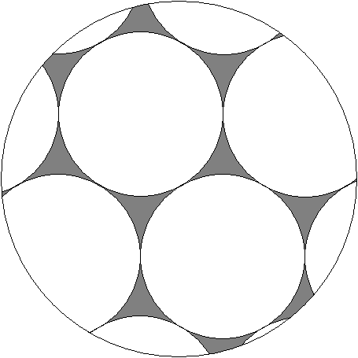
Solid support particles
Interstitial volume

Students should all agree on diffusion and flow as the processes that would account for the movement of a molecule through the interstitial regions.

4. Tswett used starch as his stationary phase.

a) What is the dominant surface functionality of starch?
Allow students a few minutes for this question. Some students may know immediately, but many have probably never considered the chemical composition of starch. Spend a few minutes talking about glucose and hydroxyl groups. Discuss the intermolecular forces relevant to this type of molecule.

b) The two other common solid stationary phases are silica gel (SiO₂) and alumina (Al₂O₃). What do you think are the surface functionalities of these materials?
Draw the structure of a few units of silica gel to give the students an idea of where to start. Some students may think that silica gel is made into a sphere in order to avoid having surface functionality. Some may suggest capping off molecule by protonating the oxygen groups.

I spend a few minutes talking about the siloxane and silanol groups found within silica gel. I discuss the polarity of the solid support and why an organic liquid would make a good mobile phase. I also ask them

What are some problems with using a non-polar organic mobile phase?
Most groups realize that many molecules we are interested in from environmental and biological samples are water-soluble and not organic-soluble.

c) Draw a plot of the distribution of enthalpies of adsorption for a molecule on the surface of starch, silica, or alumina.
Students are completely confused by this question. I begin this problem by talking about what enthalpy of adsorption is. I also indicate that what we are going to consider is the enthalpy of adsorption of a single molecule attaching to a single silanol group (we may not be able to measure this, but we can pretend we can to see what happens). And then that we are going to measure this value over and over again many times and prepare a histogram with the number of measurements at a particular value (y-axis) versus the measured enthalpy of adsorption (x-axis). Even though students may now understand what is being asked, they rarely draw the plots correctly. Many draw exponential decays either going from high to low or low to high. Some draw linear curves with either negative or positive slopes. At this point I encourage them to think about what would happen at the two extremes. Would there be an infinite number of molecules with low energy? Would there be an infinite number of molecules with high energy? Usually by this point at least one member of each group realizes that a Gaussian distribution might be a likely observation (in reality, the distribution is unlikely to be a true Gaussian but at this point, if they can come up with a Gaussian that is good enough). I then point out that the surface of silica gel would also have some disilanol and trisilanol groups, with the expectation that silanol > disilanol > trisilanol, and I then ask them:

On the same plot, draw in two additional distributions of the enthalpy of adsorption for a molecule associating at the disilanol and trisilanol groups.
It is worth reminding them that since there are fewer of these groups than silanols, the two distributions should be smaller. Most groups have some disagreement about whether the two new distributions will occur at a higher or lower average energy. It is worth discussing at the board how a disilanol group can form two simultaneous interactions with an adsorbing molecule that is likely to make the value higher on average. Then point out how the overall enthalpy of adsorption would be the sum of the three different distributions, which is not an asymmetric distribution.

d) What would a chromatographic peak look like on such a phase with such a plot of adsorption enthalpies?
Seeing the overall distribution, most of the groups readily appreciate that the peak should show tailing.

e) What is the problem with this peak?
Concluding this problem set, I discuss some examples of adsorption that occur in the natural world. I especially talk about why oil spills in soil are so hard to clean up since active sites in the soil do not readily release the oil molecules. Also, I point out how most solid surfaces seem to have a small concentration of some especially active sites, such that the distribution of the enthalpy of adsorption is rarely symmetrical and often skewed toward the high energy side of the distribution.

I then ask them to consider a similar plot where the stationary phase is now a coated liquid (partition mechanism) rather than a solid surface (adsorption).
I indicate that we are now considering the enthalpy of solvation. While students are not necessarily sure what to think about this, when prompted they cannot think of any reason why this would be something other than a Gaussian. I then summarize why chromatographic methods based on partitioning are going to be more efficient than those based on adsorption (especially if it involves a polar surface), and remind them why the first work of Martin and Synge on the use of partitioning in chromatography was significant enough to merit a Nobel Prize.

In-class Problem Set #2

Before beginning this problem set, I spend about five minutes introducing peak broadening and reminding them about the ideal chromatographic peak. I also remind them of the concept of theoretical plates, the idea that we want a plate height that is as small as possible, and propose that we will spend the next section of the course examining the question: “What contributes to peak broadening and how can we reduce it?”

Longitudinal Diffusion Broadening

1. Consider a “band” of a compound in a chromatographic column. The band had the following concentration profile:

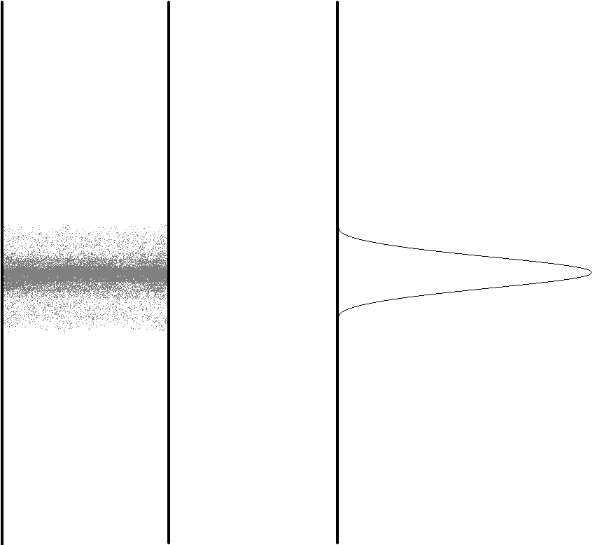
Concentration

a) What would happen to this profile if the flow of the column were stopped and the column was allow to sit?
Students may be confused about the diagram that accompanies this question. Some students may be tempted to say that band will shrink, others might say it will spread out but not realize why, others may even think that since the flow has stopped it will stay exactly the same. After allowing the students some time to consider this question, summarize how diffusion will cause this peak to become broader.

b) Would this phenomena be more significant (i.e. happen faster) in a gas or a liquid?
Students should realize right away that diffusion occurs faster in a gas, but ask them how much faster. You may get answers ranging from ten times to ten million times faster.

c) Does this phenomenon contribute more to band broadening at higher or lower flow rates?
Most groups realize that a slower flow rate means that the compounds will have more time in the column and then more time for longitudinal diffusion to occur. Students should realize that this means that there is a greater contribution to peak broadening from longitudinal diffusion at lower flow rates. I summarize this conclusion, set up the concept of how we will be developing something known as the van Deemter equation that will eventually include terms for all of the different contributions to peak broadening, and then ask them:

Should the term for the contribution to peak broadening from longitudinal broadening be multiplied or divided by the mobile phase velocity.
Even though they understand that there is a greater contribution at lower flow rates, they may have trouble understanding how to incorporate that into the equation. With a few minutes time, each group arrives at the correct form of the expression to include in the equation.

Eddy Diffusion Broadening

Consider molecules flowing through a packed bed of particles.

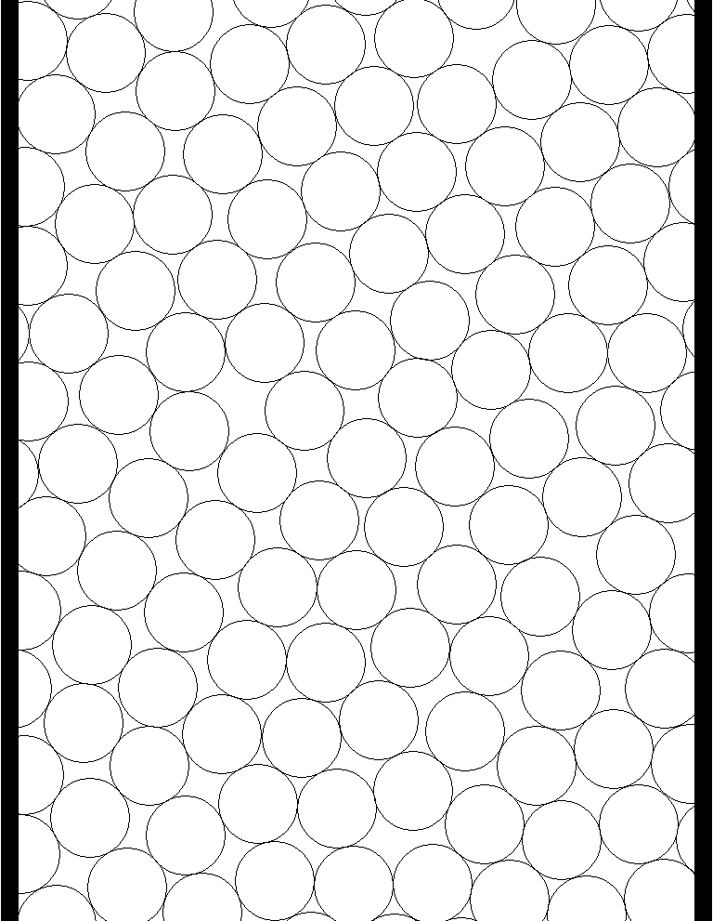

a) Would different molecules have different path lengths as they passed through the bed?
Students should have no trouble with this question.

b) Is the difference in path length between the shortest and longest path dependent at all on the diameter of the particle? If so, which particles (smaller or larger) would lead to a greater difference?
Students will immediately acknowledge that there is a dependence on particle size, but may not know which will lead to a greater difference. Some may argue that with larger particles there are fewer paths that lead straight out of the column and with smaller particles there is the possibility of zigzagging all the way across the column. If anything over the years I have taught this course, more students think that smaller particles will be worse than larger particles. I encourage them to only consider realistic paths; with the flow pushing the molecule down the column, the molecule will not zigzag across the column. Eventually we get to the point of agreement that large particles lead to the greatest differences in path length.

c) Some packed columns exhibit channeling. What do you think is meant by this term?
Some students think that channeling has to do with the large interstitial regions resulting from using large particles. Other may recognize that it has something to do with improperly packed columns. Allow them just a few minutes to think about this and then discuss streamlined paths and the problem this introduces with regards to broadening of peaks.

d) Would channeling be more likely to occur with smaller or larger particles? In other words, which is more difficult to pack efficiently, larger or smaller particles? A column is packed efficiently when the particles are in a uniform bed with the minimum amount of voids.
A majority of the students will probably argue that it is harder to pack large particles efficiently. Remind them that efficient packing has to do with minimizing the voids; just because large particles result in large voids, it doesn’t mean that the voids can’t be minimized. Encourage them to imagine trying to pack large and small objects efficiently (fitting in the most number of particles possible in the allotted space implies the tightest and most efficient packing). How easy is it to get the smaller particles perfectly settled in relative to larger particles? It may take a while for the students to be convinced that smaller particles are harder to pack efficiently.

e) Do open tubular capillary columns exhibit eddy diffusion?
Students should have no trouble with this question. They should realize that having no particles means that there is no eddy diffusion.

f) Does this phenomenon exhibit any dependence on flow rate?
This is actually a highly debated question with conflicting data and representations in the literature (see text for a further discussion). Students may initially be tempted to say that there is no dependence on flow rate, which is consistent with the initial form of the van Deemter equation. They will argue that since eddy diffusion just has to do with the difference in path length, the time that it takes to travel those paths is insignificant. Encourage them to think about this question in more depth. Won’t a slower flow rate allow the molecules to sample more of the column? Won’t a faster flow rate cause molecules to be more likely to stay in one path or channel? Allow them to debate both arguments and then discuss how this is still a greatly debated topic. Introduce the eddy diffusion term and include it in the van Deemter equation.

Stationary Phase Mass Transport Broadening

Consider a compound that has distributed between the mobile and the stationary phase within a plate in a chromatographic column. The following diagram might represent the concentration distribution profiles in the two phases (note that the compound depicted has a preference for the mobile phase).

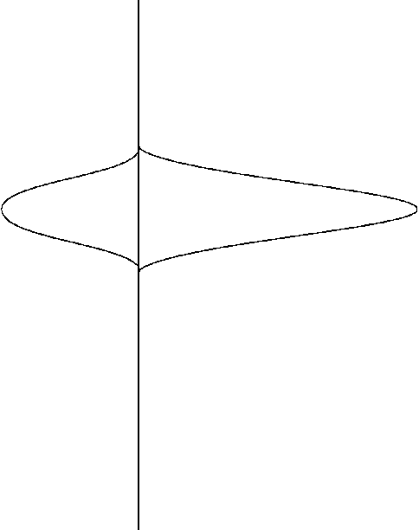
Flow
Concentration
Concentration
Stationary Phase
Mobile Phase

a) What would happen to these concentration profiles a brief instant of time later?
Allow students a few minutes to think about this problem. Some students may think that it will just stay the same. Some students may think that both concentration profiles will shift down. Remind them of the key difference between a mobile phase and a stationary phase. Encourage them to think about what would happen to molecules in the stationary phase at the top of the diagram once the molecules in the mobile phase have shifted down. What about the molecules in the mobile phase at the bottom of the diagram?

b) Will what happens in (a) contribute to band broadening? Explain.
Students should realize that this will contribute to peak broadening because the overall Gaussian distribution becomes wider. Discuss how molecules must spend a finite amount of time in the stationary phase. This is a good time to discuss that the lag in mass transport that effectively traps molecules in the stationary phase for a finite amount of time means that a chromatographic column is constantly at disequilibrium (even though we often present it as if the compound equilibrates over the section of the column where it is distributing between the two phases).

c) Does the contribution of this phenomenon to band broadening exhibit a dependence on flow rate? If so, are there any troublesome aspects to this dependence?
Students should realize that the faster the flow rate, the more broadening there will be. You may ask them to draw two profiles for the distribution in the mobile phase a brief instant of time later for one flow rate and then double that flow rate. Once students realize the correct answer, spend a few minutes summarizing the conclusions and talking about how with slower flow rates the system is able to reach a state that is closer to equilibrium. Introduce the stationary phase mass transport term for the van Deemter equation. Allow students some time to realize that they now have one term in the equation that recommends use of a faster flow rate and one term that recommends use of a slower flow rate to optimize efficiency.

d) What happens to this effect as the stationary phase coating is made thicker?
Students should realize right away that with a thicker coating, it will take longer for particles to diffuse out of the stationary phase and therefore broadening will be increased. At this point, I then ask them:

How could you create a packed column with a thinner coating of stationary phase?
Students usually decide to apply a lower percent coating, but talk about the disadvantages (reduced capacity) of doing that. Ask them to think of a method that retains the same percent loading but does not decrease the capacity. The students should eventually think of using smaller particles in order to keep the same weight of the liquid phase and solid support but increase the surface area. Discuss some of the drawbacks to using smaller particles (need to take more care in coating to insure uniform surface coverage, more care in packing to avoid channeling).

e) Capillary GC columns have very thin coatings. Describe one advantage of these columns.
After completing part (d), students realize that a thinner coating will minimize the broadening due to stationary phase mass transport. I usually spend a few minutes talking about how liquid coatings are applied to capillary columns. This is also a good time to talk about the history of capillary gas chromatography including how glass capillary columns used to be made. Also discuss the use of fused silica capillary columns and how they compare to regular glass. It would also be a good idea to mention the low capacity of these types of columns and the use of a split injection system. Talk about the role that fiber optics played in the development of capillary gas chromatography.

f) Compare the effect of this phenomenon on a uniform versus non-uniform stationary phase coating.
The groups are usually quick to realize that a non-uniform coating will be undesirable. I summarize this, spend a few minutes talking about the methods for coating particles, and remind them of the deleterious effect if the coating process leads to regions of exposed surface that will result in adsorption.

g) Is this effect of more concern in gas or liquid chromatography?
Allow the students a few minutes to consider this question. The students often focus on the difference in the mobile phases of gas and liquid chromatography, and assume that since gases diffuse faster than liquids, are tempted to say that this is more of a concern with liquid chromatography. Remind them that stationary phase mass transport broadening just has to do with the amount of time a molecule stays in the stationary phase. Once a molecule has entered the stationary phase, it doesn’t matter whether the mobile phase is a gas or a liquid. In our current understanding, the stationary phases in gas and liquid chromatography are both liquids. Challenge them to think of some other key differences between gas and liquid chromatography. Ask them what temperature a gas chromatograph oven is usually at compared to a liquid chromatography column. With this information, you can ask them the effect that the different temperatures of gas and liquid chromatographic columns will have on diffusion rates. They should now see that stationary phase mass transport broadening is likely to be more of a concern in liquid chromatography, but not as much as they originally thought when they only considered diffusion rates within the mobile phase.

At this point, I discuss the explosion of gas chromatography as an analysis method in the 1950s-70s and how that led to efforts to volatilize non-volatile compounds.

I also introduce Calvin Giddings and his paper titled, Liquid Chromatography with Operating Conditions Analogous to Those of Gas Chromatography, which concludes that ultra-small particles will be needed if LC is to have an efficiency comparable to GC (although we have not yet discussed mobile phase mass transport broadening).

What issues might there be in coating ultra-small particles with a very thin liquid coating?

What issues arise trying to keep a liquid coating on ultra-small particles when a liquid is the mobile phase?
I usually pose these two questions to the entire class rather than the groups and solicit individual student responses. We then discuss issues such as coating uniformity and degradation of the liquid coating due to physical removal from the solid support by the flowing liquid and because the liquid coating and liquid mobile phase will still have some slight solubility in each other even if they are regarded as immiscible (while oil and water don’t mix, they actually do to some small extent). I then spend some time talking about the development of bonded phases for liquid chromatography (especially C-18 phases) and the significance of this discovery to the field of liquid chromatography.
Mobile Phase Mass Transport Broadening

Consider a capillary column as shown below.


Flow
Stationary Phase

The dot represents a molecule that has just left the stationary phase is about to diffuse across the mobile phase and re-encounter the stationary phase on the other side of the column.

a) Draw a line representing the path of this molecule.
Most students realize right away to draw a line that traverses from one side of the channel to the other. Some need prompting (usually to look at what another student in the group has drawn).

b) What would this path look like if the flow rate were doubled?
Students recognize that this would result in the molecule being pulled further down the column before encountering the stationary phase again.

c) Is it important for the molecule to encounter the stationary phase? Think about a situation in which the flow was so fast that the molecule never re-encountered the stationary phase.
Students realize that without a molecule encountering the stationary phase, there is no separation and therefore no chromatography. Therefore the contribution of mobile phase mass transport broadening is more significant at higher flow rates.

d) If using capillary columns, what does this suggest about the desirable diameter for such a column?
Students realize right away that the narrower the column the better.

e) Is this phenomenon worse in gas or liquid chromatography?
Having fully developed the effect for the stationary phase, they realize right away that the much slower diffusion in liquids means that mobile phase mass transport broadening is much more significant in liquid chromatography.

f) How does the contribution to band broadening depend on flow rate?
Again, they usually realize it is exactly analogous to stationary phase mass transport broadening.

g) Would this effect be observed in a packed column? If so, how?
Generally, students realize immediately that the interstitial volume in a packed column is analogous to the open space in a capillary column.

h) How could you reduce this effect in a packed column?
Students usually immediately propose using smaller particles.

i) Say something about the length of a column needed if you undertake what you have suggested in (h), assuming that you have maintained a constant thickness of stationary phase.
I first point out that this is exactly the situation that occurs with a bonded phase liquid chromatographic column, where the thickness is set by the nature of the bonded C-18 groups and does not depend on the particle size they are bonded to. Students immediately realize that the smaller particle has a larger surface area, and then usually soon realize that this means that the capacity of a bonded phase LC column with smaller particles is greater than that with larger particles. With greater capacity they realize that, when using smaller particles in LC, you can maintain the same capacity by using a shorter column. When asked what else they will observe with a shorter column, most immediately realize that it will take less time to run the chromatogram.

I then spend a few minutes discussing plots of h versus flow rate and talk about the important differences between the plots for liquid chromatography and gas chromatography. Talk about the optimal flow rate and realistic flow rates.

In class Problem Set #3

Fundamental Resolution Equation

I introduce the fundamental resolution equation, spend a few minutes reminding them about the variables in the equation (each of which we have seen before), and provide them with a photocopy of a derivation of the equation that we quickly go through. I do not want them to know how to do the derivation, but do want them to appreciate that it is a derivable expression.

1. Describe ways in which the number of plates on a chromatographic column can be increased. Are there any tradeoffs associated with these changes?
Allow students a few minutes to consider this question. They may think of some methods such as decreasing the plate height (remind them to go back to all of the terms in the van Deemter equation and think of experimental variables they can optimize), packing the column more efficiently, using a longer column, using smaller particles, or optimizing the flow rate. Challenge them to think about what each of these changes would mean experimentally.

2. Describe ways in which the separation factor can be increased. Are there limits to the effect that increasing the separation factor has on chromatographic resolution?
Most students have probably had some experience with thin-layer chromatography. If so, they may think of changing the eluent identity to separate compounds. Spend time talking about how you might change the identity of the stationary phase in both liquid and gas chromatography. Mention that changing the identity of the mobile phase in liquid chromatography is considered changing the retention factor.

Is there is any disadvantage to having too large a selectivity factor.
If they are stumped by this, drawing a chromatogram on the board for two components with a large selectivity factor will make apparent that too much time is being spent waiting for the second peak and that the separation is too good (unless one wanted to scale this up for a preparative separation where a higher selectivity means that more compound can be isolated in each injection).

3. Describe ways in which the retention or retention or capacity factor can be increased. Are there any tradeoffs associated with those changes? Are there limits to the effect that increasing the retention factor has on chromatographic resolution?
Since we have just discussed that changing the mobile phase in liquid chromatography is considered a change in capacity, ask students to think of ways in which the mobile phase can be changed. Reminding them that the mobile phase is aqueous-based, they will usually come up with pH. Since some groups are using LC in their lab project, they also mention varying the percent organic modifier. I then spend some time talking about the effect of pH on retention time, and how it is often possible to reverse the retention order of organic acids and bases by changing the pH. We also spend a few minutes talking about the effect of changing the percent organic modifier.

It is then worth reminding them of (or having them look up) the equation we had earlier in this section that defined the retention factor. I then asking for other ways they might change the capacity in gas chromatography. Some groups immediately see that the volumes of the stationary and mobile phases are in the expression and think of changing them. At some point we have a discussion about whether it is practical to change the volume of the stationary phase (yes) or mobile phase (no) in GC. Similarly, we think about bonded phase LC materials and realize that the use of smaller particles leads to both an improvement in the number of plates and the retention factor. When prompted about GC, and variables that might affect the distribution coefficient, students talking in their groups eventually think of temperature as a variable in gas chromatography.

In order to increase the capacity of the column, would you need to increase or decrease the temperature?
While the students usually seem to want to raise the temperature as a way of “improving” the chromatography, if asked to think and reason their way through the effect that the temperature has on the retention factor and resolution (and I remind them that presumably we have two compounds that are not fully resolved and want to improve this), they usually determine that they will want to lower the temperature of the GC oven.

Is there is any disadvantage to having too large a retention factor.
The groups usually realize immediately that too large a value means a much longer analysis time.

4. Consider the following chromatogram.

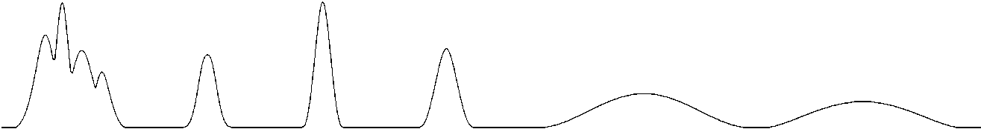

The early eluting peaks and the later eluting peaks exhibit a problem.

a) Describe the chromatographic nature (there is a particular chromatographic term that describes each) of the problem.
Let the students spend a few minutes on this problem. Students will probably be tempted to say that the early peaks exhibit an issue with the separation factor. Point out to them that the peaks have started to separate, which is a good sign. It is likely worth indicating that presumably we want to focus on terms within the fundamental resolution equation and that they may wish to go through them one by one and think about what adjusting each would do. It may be worth pointing out that the later two eluting peaks are well resolved but stay on the column too long. Eventually the groups usually get to the realization that the early eluting peaks have too small a retention factor, and that the later eluting peaks have too large a retention factor. This conclusion should be summarized for the group.

b) Propose a way in gas chromatography to eliminate both problems.
Students will most likely not think of solutions on their own. Remind them of variables that affected the retention factor that were discussed when considering the fundamental resolution equation. Eventually someone in a group usually brings up the role of temperature and I ask them to consider how temperature might be used to solve this problem. Groups eventually propose changing the temperature during the chromatogram (it is worth asking them what they would start and finish with to addresses the problem) and we then discuss running a temperature program in gas chromatography.

c) Propose a way in liquid chromatography to eliminate both problems.
When prompted as to whether there is something essentially equivalent in LC to the role of temperature in GC, most groups realize that altering the mobile phase composition (either pH or organic modifier) during the chromatogram could have a similar effect. I mention the concept of a gradient elution and ask them to determine what they would do with the percentage of organic modifier during the gradient. They are usually able to reason this out correctly, and we have a brief discussion of the difference between isocratic elution to gradient elution.

At this point in the course I use a lecture format to introduce basic aspects of liquid chromatography and the topic of steric exclusion chromatography. See the learning objectives and textbook for the topics that are covered.

In-class Problem Set #4

Ion Exchange Chromatography

I spend a few minutes introducing ion exchange chromatography, showing how it is possible to attach fixed cations or anions to polymeric resins and how these then have an exchangeable counterion.

1. Describe a scheme using ion exchange chromatography that would enable you to deionize water. Say something about the capacity of the ion exchange resins you would use for this purpose.
Allow students about few minutes to work on this problem. Students should have no trouble recognizing that you would need to run the water through a pair of columns in order to remove the anions and the cations.

What ions should be used as the counter-ions in the column?
Within a few minutes the groups can usually figure out that hydronium and hydroxide ions are needed if the goal is to deionize the water. They also realize that high capacity resins will be the best for deionizing water. I then spend time summarizing what would happen to each ion in the two-column system. I make sure that the students understand that the capacity is limited by the number of derivatized aromatic rings. I discuss the water purification systems that we use in the department and how the measurement of conductivity is used as a way to determine how well the water has been deionized.

2. Would ion exchange resins that are useful for deionizing water be useful for analytical separations?
The students will need to know what is meant by analytical separations (trace levels of ions). I also ask them to consider what it would take to be able to actually have the ions elute from the column. The groups can usually reason out that the high capacity resins used for deionizing water would lead to exceptionally long analysis times if used for trace analyses. They also propose including eluent ions in the mobile phase. I ask them to specify what ions they might use as their mobile phase counterions and they can usually come up with hydronium (hydrochloric acid) for cations or hydroxide (sodium hydroxide) for anions. I then summarize these concepts at the board.

3. What would be the order of retention for the ions Li(I), Na(I), and K(I) on a cation exchange resin? Justify your answer.
I allow students about ten minutes to consider this problem on their own. They always address this by considering how strongly the ions might associate with the resin. They may find compelling arguments for both sides including the charge density of lithium or the steric hindrance of potassium. I ask them to think about the equation that describes the electrostatic attraction of two ions, which has the two radii in it, and most eventually conclude that the lithium will associate more strongly with the resin and elute last.

After summarizing this as a reasonable prediction, I then ask them to consider mobile phase effects. In particular, I ask them to think about what they know about the structure of water and what would happen to this structure when ions dissolve in water. I also ask them to think about drawing a picture for the environment around a lithium, sodium or potassium ion in water. Students may realize that lithium is more stable in the eluent water because it causes the least disruption to the physical network of hydrogen bonds in the liquid water and has the strongest electrostatic attraction with the negative ends of the water molecules. They eventually conclude that a consideration of mobile phase effects would lead one to predict the opposite retention order.

With two opposite predictions, I suggest that we try the experiment. We don’t actually try the experiment, but I indicate that experimental data shows that for ions of the same charge, the mobile phase effects are more important and smaller ions elute first. I also introduce the concept of the solvophobic effect.

What if you had ions of varying charge but the same size (a +1 and +2 ion of similar size)? What is the retention order based on mobile phase effects? What about the retention order based on stationary phase effects?
Students can reason out that, again, the two different considerations lead to different retention orders. Experimental data shows that the +2 ion elutes last, and I discuss how ions of higher charge have much stronger association with the resin because they can bind simultaneously to two of the fixed ion sites and require two mobile phase counterions to be pushed out of the resin and migrate down the column.

4. Consider the case of separating the alkali ions in (3) on a polystyrene resin using a fairly dilute solution of hydrochloric acid as the mobile phase.

a) What is the bound ion and the mobile counter ion?
Groups can readily answer this.

b) One problem is how to detect these ions. They do not absorb ultraviolet or visible light in the accessible portion of the spectrum. They do not absorb infrared light. Conductivity might work except that the hydrochloric acid in the mobile phase produces too high of a background signal. Devise a way to remove the conductivity of the eluent ions (HCl) but retain the conductivity of the alkali ions you wish to detect.
Students understand the problem but usually struggle to come up with a way to solve it. I usually draw a representation of the column on the board and show the NaCl and HCl eluting simultaneously and indicate that the goal is to remove the conductivity of the HCl while retaining the conductivity of the NaCl. Many of the groups start to think that there should be some way of neutralizing the acid but when asked what they would use (and the typical response is NaOH), they realize that this would eliminate the conductivity of the H+ (by reacting it with OH- and converting it to water) but replace it with Na+ leaving NaCl, which has not solved the problem. Through prompting they come to the realization that they need a way to selectively replace the Cl- with OH-, which converts the HCl to water and the NaCl being analyzed to NaOH, which is still conducting. Groups then realize that running the sample eluting from the analytical column through an anion exchange column in the hydroxide form will solve the problem. I then summarize the use of suppressor columns in ion chromatography at the board. I also explain the possibility of using an indirect spectrophotometric detection method as well.

Instructor’s Manual – Capillary Electrophoresis

Before starting the in-class questions, a brief amount of time should be spent explaining the picture on the first set of questions about the instrumental features of performing capillary electrophoresis. Explain how a sample is injected, how a voltage is applied across the two ends of the capillary tube, and how the coating is omitted from the capillary in the detector region.

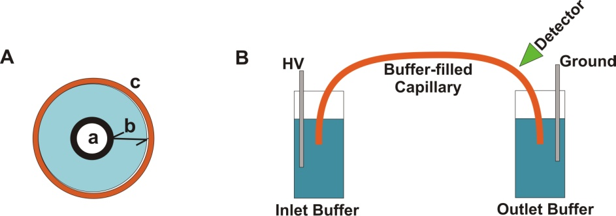
(+)
(–)

What is the functional group on the surface of a fused silica capillary column? Fused silica is a silicon dioxide (SiO₂) polymeric material.

This has likely been covered in a unit on gas chromatography or on silica gel liquid chromatography phases so students likely know the answer.

Would the nature of the interior surface of the capillary be different if the background electrolyte was at pH 2 versus pH 9?

Students can usually determine that the OH groups will likely be acidic so that they are protonated at pH 2 and deprotonated at pH 9.

Assuming the silanol groups are deprotonated to anionic silanate groups, what do you think will happen in the portion of the solution in immediate contact with the surface of the fused silica?

Students can usually determine that there will be a higher concentration of positive ions in the solution in immediate contact with the surface of the silica. The idea of having some cations in a fixed layer and others in a diffuse layer is a subtlety that it is doubtful the students will think of.

Students may also think so many cations go into the diffuse layer that you do not get a bulk solution where the concentrations of cations and anions are equivalent. If so, it should be mentioned that the concentration of buffer ions are so much higher than the concentration of silanate ions on the surface that the diffuse layer is thin compared to the capillary and the bulk solution does have equivalent concentrations of cations and anions.

What happens in the diffuse layer in the presence of this applied electric field?

Students will likely determine that with an excess of cations, they will be drawn toward the cathode. Students will likely need to be prompted to think about the consequence of having such a narrow capillary tube and that the cations drag along solvent across the entire tube to create electroosmotic flow. It will be necessary to explaining the difference in the flow profile between hydrodynamic and electroosmotic flow and how the electroosomotic flow.

Which flow profile, hydrodynamic or electroosmotic, results in greater peak broadening?

Students will likely rationalize that there is a greater difference in velocity between molecules at the wall versus those in the center for hydrodynamic flow that causes more broadening.

As previously discussed, broadening in chromatographic columns results from eddy diffusion, longitudinal diffusion, and mass transport broadening in the stationary and mobile phases. Which of these processes contribute to peak broadening in capillary electrophoresis?

It is useful to have them think through each one systematically, reminding themselves the specific process that caused each one in chromatography and whether that factor applies in CE. They may need some prompting to realize that the absence of a stationary phase means that neither of the mass transport terms are involved in CE.

What would happen to the electroosmotic flow rate at pH 2.5 versus pH 10?

Students can usually rationalize an answer to this question by considering what happened to the silanol groups as a function of pH.

Suppose the compounds being analyzed have a charge. Is there any other process that will result in analyte ions moving in the capillary column?

Students will typically propose that the charged analyte ions will be electrostatically attracted toward the appropriate electrode.

What variables influence the electrophoretic migration rate of a charged analyte?

Students will typically propose the magnitude of the charge and the size of the ion. Then pose a question about how each factor correlates with migration rate. Students usually propose that larger charges migrate faster and smaller ions migrate faster.

Imagine that four ions start in the middle of the capillary as shown below. Assuming that the ions only move as a result of electrophoresis, draw the position of the ions after 30 kV has been applied for a short time.

Cathode (-)
Anode (+)
+1
+1
-1
-1

Students are typically able to draw the proper placement of the four ions.

Now consider the separation of a sample that has anionic, cationic and neutral analytes and has both electroosomotic and electrophoretic flow. The detector is placed on the end of the capillary near the cathode as shown below. Anions, cations and neutrals are all detected. Explain.
Cathode
(-)
Anode (+)
Detector

It can be helpful to prompt them to draw arrows representing electroosmotic and electrophoretic flow for the different species as shown in Figure 81 in the text. They can figure out that anions making their way to the detector means that the electroosmotic flow must be larger than the electrophoretic flow.

What is the predicted elution order of the following five substances? In addition, draw an electropherogram of the results and explain your reasoning.
Substance A: neutral
Substance B: ̶ 1 charge
Substance C: +1 charge
Substance D: neutral
Substance E: ̶ 2 charge

Substance A, B, C, and E are all the same size. Substance D is twice as large as the others.

Students can usually predict the retention order for the charged and neutral species. They are likely to think D will migrate more slowly than A because of its larger size. Prompting them to think about the process that leads to the migration of neutral species as opposed to charged species is usually effective at getting them to realize that the two neutral ions will co-elute.

The structural formulas and relevant pK_{a} values for the four components of an Exedrin tablet are shown below. (The protonated form of the boxed group is shown.) Predict the elution order in CE with a 20 mM borate buffer at pH = 9.3.
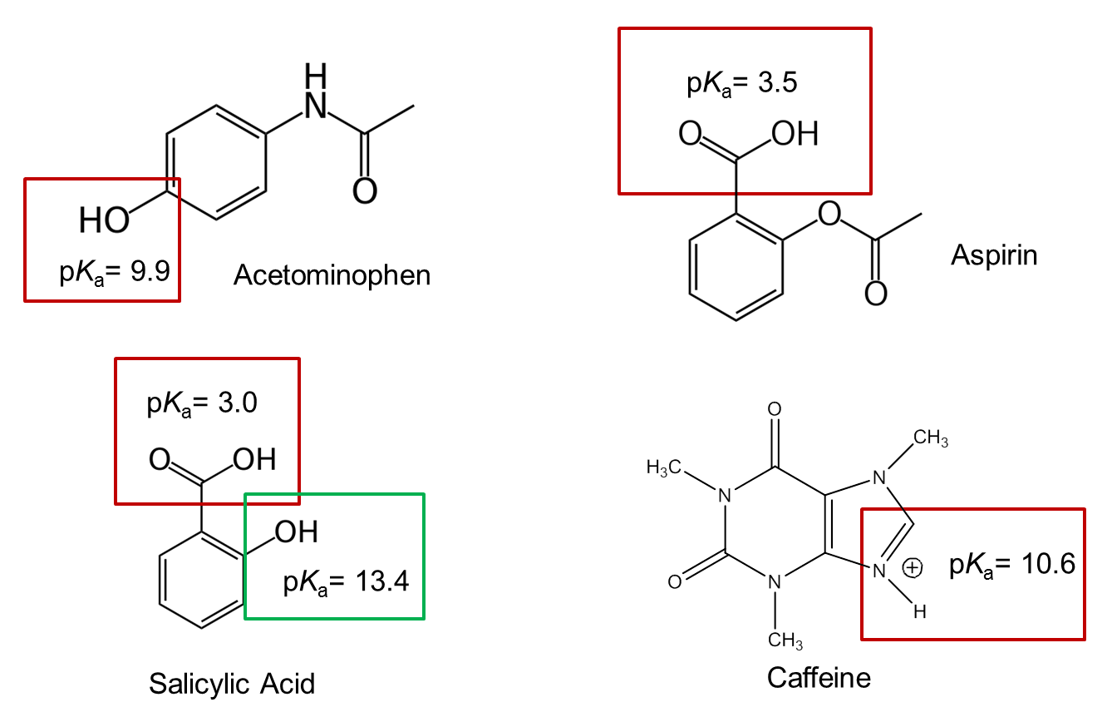

It is helpful to prompt students to think about each species and predict its charge given the pH. The acetaminophen has a subtlety as they will need to consider the time-averaged situation and may need to be prompted to think specifically about that one.

What could you do experimentally to confirm your predicted elution order?

They may first propose analyzing a single solution containing all four of the analytes and may need some additional prompting to realize that they will need to analyze each individually to confirm the retention times and order.

