Nuclear Magnetic Resonance Spectroscopy
Thomas Wenzel
Department of Chemistry
Bates College, Lewiston ME 04240
twenzel@bates.edu

The following textual material is designed to accompany a series of in-class problem sets that develop many of the fundamental aspects of NMR spectroscopy.

TABLE OF CONTENTS

Introduction 2

Quantum Mechanical Description of NMR Spectroscopy 3

Electron Shielding 13

Nuclear Coupling 17

Exchange Effects 26

Classical Description of NMR Spectroscopy 28

INTRODUCTION
A comprehensive unit covering the entirety of NMR spectroscopy could easily fill an entire semester course. The goal of this unit is to develop introductory concepts on NMR spectroscopy that are most relevant for undergraduate chemistry majors. Furthermore, there are some topics developed in this unit where a rigorous coverage would lengthen the discussion and likely confuse a beginner. In these instances, the concept under development has been simplified so that the important consequences that relate to the resulting NMR spectrum are appreciated. Development of the concepts of NMR is accomplished through an examination of the normal hydrogen (¹H) nucleus. The unit is focused on understanding what occurs in molecules and within the NMR spectrometer that causes ¹H NMR spectra to look the way they do. There is less of an emphasis on interpreting NMR spectra, although the concepts developed herein provide students with the understanding needed to begin interpreting NMR spectra. Components of both a quantum mechanical and classical description of NMR spectroscopy are developed.

It is helpful to examine the words in “nuclear magnetic resonance spectroscopy” to consider some aspects of this area. “Nuclear” indicates that the technique probes some aspect of the nuclei of atoms. “Magnetic” indicates that magnetic fields must be involved with this technique. “Resonance” indicates that some energy transition between a ground and excited state is being probed. And finally, “spectroscopy” indicates that the energy transition is excited through the use of appropriate frequencies of electromagnetic radiation.

QUANTUM MECHANICAL DESCRIPTION OF NMR SPECTROSCOPY
The first thing that must be considered is the nature of a hydrogen atom.

What makes up the nucleus of a hydrogen atom?
Hopefully you remember from general chemistry that the nucleus of a normal hydrogen atom consists of a single proton. Hydrogen has two other isotopes: (1) deuterium, which has one proton and one neutron in its nucleus, and (2) tritium, which has one proton and two neutrons in its nucleus. Our development will focus only on normal hydrogen with a single proton in its nucleus.

Thinking back to the coverage of the nature of electrons in atoms, you learned that electrons are described by a series of quantum numbers (principal, angular, magnetic, and spin) and that the electrons in atoms could be described using electronic configurations (1s², 2s², 2p⁶, etc.). It turns out that the particles in the nucleus of an atom are also described through a set of quantum numbers and that the protons and neutrons in a nucleus are described using a nuclear configuration. Understanding the exact form of a nuclear configuration is not important in understanding NMR spectroscopy (this knowledge would be of interest to a nuclear chemist studying nuclear decay processes such as alpha, beta and gamma decay). What is important is that nuclear particles spin like electrons spin and therefore nuclear particles have spin quantum numbers. The value Ι is used to denote the total spin quantum number for a nucleus.

What are the allowable spin quantum numbers for an electron?
Hopefully you remember that the two allowable spin quantum numbers are +½ and –½.

What do you think are the allowable spin quantum numbers for a proton?
Perhaps it will make intuitive sense that they will also be +½ and –½.

What is the magnitude of Ι, the total nuclear spin, for a hydrogen nucleus?
Since the hydrogen nucleus only has a single proton with a spin quantum number of ½, the value of Ι is also ½.

What do you think is produced by the spinning, charged proton that is the hydrogen nucleus?
Any spinning charged object generates a magnetic dipole (i.e., magnetic field). Magnetic fields are designated by the symbol B, so we can designate the magnetic field produced by the hydrogen nucleus as B_{p}. Magnetic fields also have an orientation to them. The orientation is determined using what is known as the right-hand rule. The proton spins about an axis as shown on the left in Figure 1. To determine the orientation of the magnetic field, curl the fingers of your right hand in the direction of the spin and the right thumb points in the direction of the magnetic field (Figure 1). Magnetic fields are represented using vectors and the vector representation for B_{p} is also shown in Figure 1.

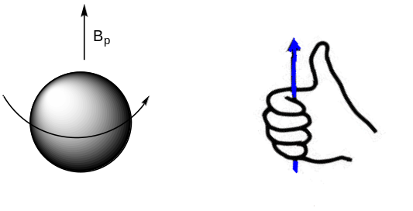
Figure 1. Representation of a spinning proton, the right-hand rule used to determine the direction of the magnetic field, and the vector representation for the field created by the spinning proton (B_{p})

NMR samples are placed in a magnet and therefore subjected to an applied magnetic field (B_{APPL}). It is important to note that the magnitude of B_{APPL} is significantly larger than the magnitude of B_{p}.

What happens when two magnetic fields (B_{p} and B_{APPL}) are in contact with each other?
At some point in your life you have probably played with two magnets and know that they interact with each other. In one orientation, the two magnets attract. In another orientation, they repel each other. This means that the proton’s magnetic field must interact with B_{APPL}. This interaction constrains B_{p} to only certain allowable orientations relative to B_{APPL}. The number of allowable orientations of a nucleus in an applied magnetic field is (2Ι + 1). Since Ι = ½ for the hydrogen nucleus, there are two allowable orientations.

What do you think are the two allowable orientations of B_{p} relative to B_{APPL}?
As shown in Figure 2, one orientation has B_{p} aligned “with” and the other has B_{p} aligned “against” the applied magnetic field. Note: the length of the vectors shown in Figure 2 is not an accurate representation of the actual magnitude of the two magnetic fields. B_{APPL} is so much larger than B_{p} that an accurate vector representing B_{APPL} would be so large it could not fit onto the page (alternatively, if the size of the vector for B_{APPL} was accurate, the vector for B_{p} would be so small it would not be visible). Also note from the pictures in Figure 2 that the two different orientations involve the proton spinning in opposite directions relative to B_{APPL}.

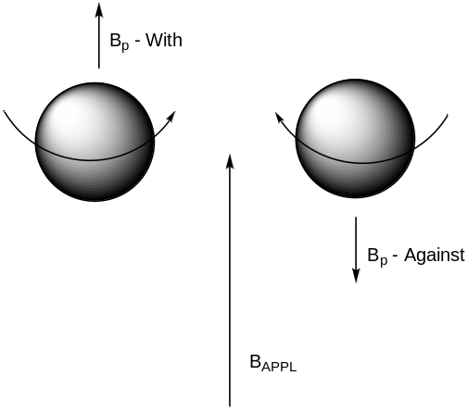

Figure 2. Two different spin states for the proton, one with the magnetic field it generates aligned “with” B_{APPL}, the other with the field aligned “against”. Note, the vector representation for the magnitude of B_{APPL} is much too short in the figure.

Do you think the two allowable orientations have the same or different energy?
Perhaps it intuitively makes sense that the two will have different energies. If the energies were not different, it would not be possible to record NMR spectra.

Which of the two do you think is lower in energy?
Again, it might seem intuitive that the orientation in which B_{p} is “with” B_{APPL} would be lower in energy, which turns out to be the case.

This now allows us to draw an energy level diagram as shown in Figure 3. In the absence of an applied magnetic field the hydrogen nucleus only has a single possible energy. In the presence of an applied magnetic field, the hydrogen nucleus has two allowable energy states: the lower energy one being the ground state, the higher energy one being the excited state. As with other energy level systems you have previously encountered, photons of electromagnetic radiation with an energy that exactly matches the energy difference between the ground and excited state have the ability to excite the nucleus from the ground spin state (B_{p} “with” B_{APPL}) to the excited spin state (B_{p} “against” B_{APPL}).

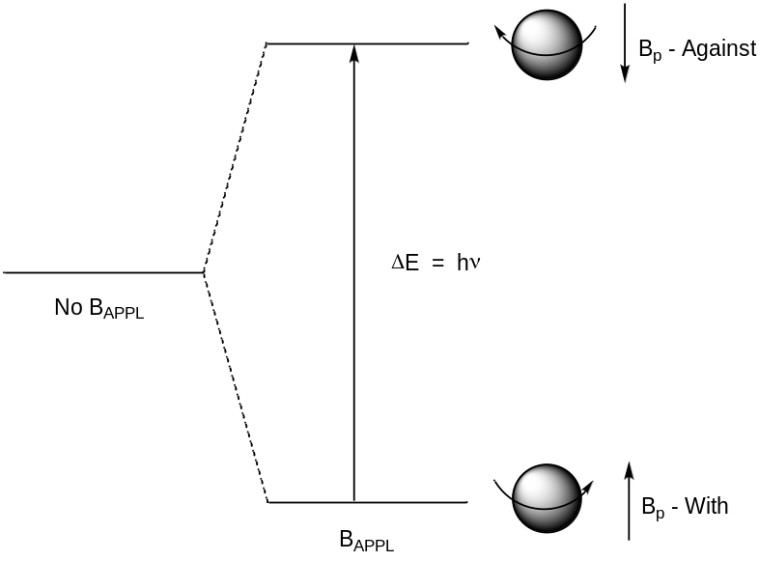

Figure 3. Energy level diagram for the two spin states of the hydrogen nucleus in the absence and presence of an applied magnetic field.

One thing worth considering is the exact nature of what happens to the proton as it is excited from the ground spin state to the excited spin state. Remember that the difference in the two states is that the proton spins in opposite directions. One possibility is that the proton literally stops spinning to reverse course and spin in the opposite direction. But another possibility is that the proton continues spinning but flips upside down relative to an external observer. To try this out, hold a ball in your hands and spin it about an axis in a particular direction, then flip it over while still maintaining the spin. You will note that, from your view, it now spins in the opposite direction. This spin flip is what actually happens to a hydrogen nucleus when it is excited from the ground to excited state.

We know from quantum mechanics that Eq 1 applies to such a system:

ΔE = hν (1)

This means that a discrete frequency of electromagnetic radiation is needed to cause the excitation transition from the ground to the excited state (flip the spin of the proton).

What frequency of electromagnetic radiation is needed to excite a nuclear spin flip?
The energy gap shown in Figure 3 for nuclear spin flips corresponds with the radiofrequency portion of the electromagnetic spectrum. Note, radio frequencies occur in the megahertz (MHz) portion of the spectrum. Perhaps your school has an FM radio station. If so, its broadcast frequency will be in the MHz range. Also, your department probably has something like a 60, 400 or 600 MHz NMR spectrometer.

Where is radiofrequency (RF) radiation on the energy scale of the electromagnetic spectrum?
RF radiation is at the very low energy end of the spectrum of electromagnetic radiation. This exceptionally small gap in energy between the ground and excited state has several significant consequences in NMR spectroscopy that will be developed in this unit. In order to understand some of these consequences, we need to consider how the energy difference between the ground and excited nuclear spin states compared to the energy that is available to any chemical system at ambient (i.e., room) temperature. This is referred to as thermal energy and is denoted by kT.

Consider the energy gap for a valance electron transition (e.g., π-π*) that occurs in the ultraviolet part of the electromagnetic spectrum as it compares to the energy gap for nuclear spin flips that occurs in the RF part of the spectrum. The energy levels in Figure 4 illustrate this difference, although the gap for the π-π* transition is actually shown much smaller than it should be so it fits onto the page.

Is the thermal energy at room temperature large or small compared to the energy of a π-π* transition and to the energy of a nuclear spin flip? What are the consequences of your answers to these questions?
The thermal energy at room temperature is small compared to the energy of a π-π* transition but is large compared to the energy of a nuclear spin flip. This observation means that thermal energy is insufficient to excite a valence electron from its ground to excited state and cannot promote an electron from a π to a π* orbital. However, thermal energy is sufficient to excite nuclear spin flips. The consequence of this observation involves the populations of the ground and excited states for the two systems. For a π-π* system, all of the species will be in the ground state because thermal energy is insufficient to cause excitation. For a nuclear spin system, thermal energy is sufficient to cause the transition from the spin-with to spin-against state and cause population of the excited nuclear spin flip state. As an example, let’s consider the possible populations in a representative system of 2,000,010 chemical species. Populations of energy states can be calculated using the Boltzmann distribution. As shown in Figure 4, for the π-π* system, all 2,000,010 are in the ground state. For the nuclear spin flip system, 1,000,010 are shown in the ground state and 1,000,000 are in the excited state.

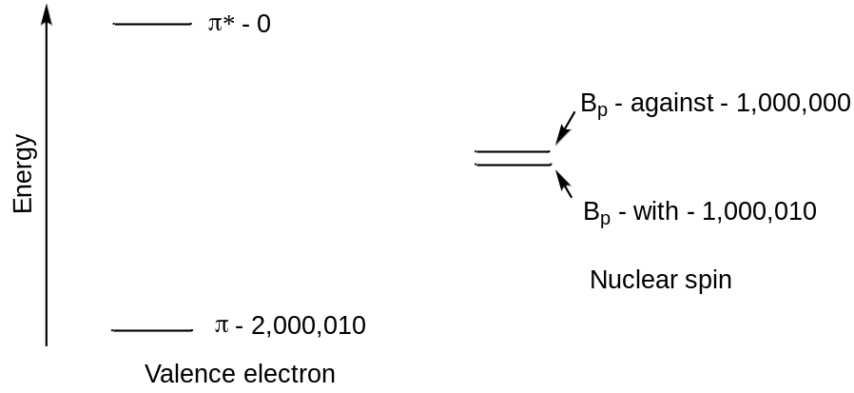

Figure 4. Representation of the energy levels and populations of the energy states associated with a valence electron transition and nuclear spin transition. Note, the energy gap in the π-π* transition should be much larger than actually represented in the diagram relative to the energy gap for the nuclear spin transition.

If thermal energy has sufficient energy to excite nuclear spin flips, why are there still more in the ground than excited state?
The reason there are still more in the ground state than the excited state is that it is lower in energy and chemical systems have a preference for lower energy states than higher energy states. But it is important to recognize that in NMR spectroscopy, the populations of the two energy states are about equal. This will have some important consequences. One relates to the sensitivity of NMR spectroscopy. Another relates to something known as coupling.

Suppose we now send in the exact frequency match to excite the nuclear spin flip illustrated in Figures 4 and 5. This will begin to excite nuclei up to the excited state, which will begin to change the populations as shown in Figure 5. Excited state nuclei have extra energy and want to decay or relax back to the ground state.

Can you think of two processes by which a specific excited state nucleus can get rid of its excess energy?
The first of these involves the loss of the energy to the surroundings as heat. This is known as spin-lattice or longitudinal relaxation and is denoted as T₁. Spin-lattice relaxation reestablishes the original populations of the two levels.

To understand the second, we need to consider that the excited state nucleus has an amount of extra energy that is exactly what is needed to excite a ground state nucleus. A process known as spin-spin or transverse relaxation can occur where this energy is essentially transferred from an excited state nucleus to a ground state nucleus. The result is that the nucleus that started in the excited state ends up in the ground state and the nucleus that started in the ground state ends up in the excited state. Note that this mechanism does not reestablish the original population distribution.

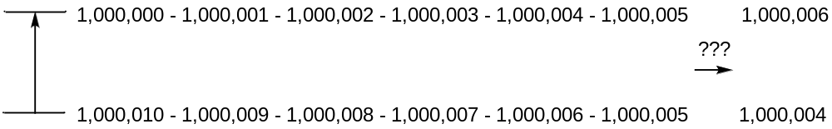

Figure 5. Populations as nuclei in the ground state absorb energy and are promoted to the excited state.

Do excited state nuclei have short or long relaxation times?
Perhaps your intuition says that, because the energy gap between the ground and excited state is so small, a nucleus does not gain much by relaxing back to the ground state so that the relaxation time is relatively long. This reasoning is correct with the observation that the typical spin-lattice relaxation time for a ¹H nucleus is on the order of 1-2 seconds.

A consequence of the long relaxation times is that, if you apply lots of photons with the frequency needed to excite the nuclei, they are excited up faster than they relax back down. The result is that the populations of the two levels quickly equalize as shown in Figure 5 where each has 1,000,005.

When the populations of the two levels are equal, can we continue to excite ground state nuclei up to the excited state such that the population of the excited state becomes larger than the population of the ground state, creating what is known as a population inversion?
Producing a population inversion is essential to the functioning of a laser, but a laser has more than the two levels (ground and single excited state) that occur with the nuclear spin flip in NMR. We need to examine this 2-level system in more detail.

At the point where the populations are equal in Figure 5, incident photons have an equal probability of interacting with a ground state or excited state nucleus. A photon that interacts with the ground state is absorbed and excitation occurs. A photon that interacts with the excited state leads to something called stimulated emission. Stimulated emission occurs when an excited state system interacts with an incident photon and the energy of the photon exactly matches the energy gap between the excited and ground state. In the process of stimulated emission, the extra energy of the excited state system is emitted as a photon and the incident photon is also emitted – so two photons of exactly the same energy come out. Figure 6 shows the process involved when an incident photon interacts with the excited state resulting in stimulated emission (left-hand side) and when the incident photon interacts with the ground state resulting in absorption (right-hand side). The net result in Figure 6 is that, when the populations of the ground and excited states are equal, two photons come in and two come out. To an external observer it now appears that no photons are being absorbed. This resonance is said to be saturated.

Figure 6. On the left-hand side, the incident photon interacts with the excited state leading to stimulated emission and two photons being emitted. On the right-hand side, the incident photon interacts with the ground state and is absorbed. The net result is that, when the populations of the ground and excited states are equal, two photons come in and two come out so there is no net change to an external observer.

A saturated resonance produces no signal because there is no net absorption of photons. One necessity to reduce the likelihood of saturating resonances is to use a low power for the RF source, which means fewer incident photons are put into the sample. Because it is so easy to saturate NMR resonances, the sensitivity of the method is much lower than other spectroscopic methods. This means that NMR measurements require more concentrated samples than other spectroscopic methods such as UV/Visible absorption spectroscopy. However, there are other factors that influence the sensitivity of NMR that are important to consider.

One important observation is that the difference in energy between the ground and excited states is proportional to the magnitude of the applied magnetic field, so that a larger applied magnetic field increases the difference in energy between the ground and excited state (Figure 7).

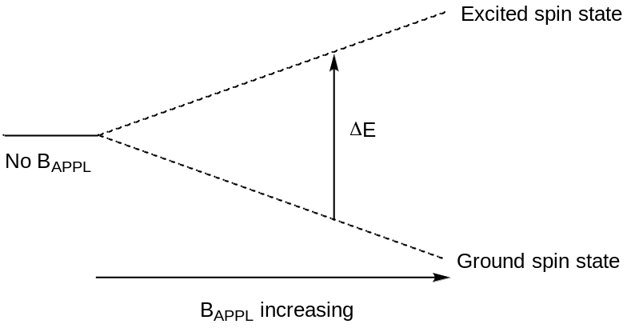

Figure 7. Representation of the increase in the energy difference between the ground and excited spin states as the applied magnetic field increases.

What happens to the population distribution as the energy gap between the ground and excited state is increased?
The population distribution is proportional to the size of the energy gap, such that using a larger applied field leads to a more favorable population distribution and more sensitivity. For example, if the magnetic field strength was high enough such that the population of the ground state was 1,000,040 and excited state 999,970, then 35 nuclei can be excited before the resonance is saturated. The enhanced sensitivity is one reason why many investigators want NMR spectrometers with a high magnetic field strength.

Another feature that can be used to enhance the sensitivity is to use microtubes (from 5 to 35 μl depending on the specific features of the instrument). The smaller volume of the microtube compared to a conventional NMR tube (about 600 μl) means that a smaller weight of sample is needed for solutions of the same concentration. This can be especially helpful for analyzing small amounts of a natural product isolated from a living organism. Another feature that enhances the sensitivity of NMR spectrometers is to use a cryoprobe. The probe is the component of the instrument containing the sample and the electronics for inputting the RF and measuring signal. “Cryo” refers to the use of very cold temperatures, either at liquid helium (4 K or −269°C) or liquid nitrogen (77 K or −195.79°C) temperature. The sample itself is not cooled but the electronic components used to transmit and receive the signal are cooled. Cooling these components leads to a significant reduction in the electronic noise thereby leading to a 2- to 5-fold enhancement in the signal-to-noise ratio (S/N). One final feature in NMR spectrometers that can be used to enhance the S/N is to record the spectrum multiple times and add these together. Since noise is random, some of the noise cancels out when several spectra are added together. Signal is additive, therefore the S/N increases.

We have already noted that ΔE = hν for the nuclear spin flip transition (Eq 1). Eq 2 shows the further relationship of the energy gap of the transition to other parameters in which γ is the magnetogyric ratio of the nucleus and B_{o} is the magnetic field experienced by the nucleus.

$ΔE= \frac{hγB_{o}}{2π}$ (2)

The magnetogyric ratio is a fundamental parameter of a nucleus and is defined as shown in Eq 3, in which μ is the magnetic moment and Ι is the total spin quantum number for the nucleus.

$γ= \frac{2πμ}{hI}$ (3)

Substituting Eq 3 into Eq 2 and rearranging to solve for only the frequency of excitation gives Eq 4.

$ν= \frac{μB_{o}}{hI}$ (4)

For Ι = ½ nuclei such as hydrogen, Eq 5 is obtained for ΔE.

$∆E=2μB_{o}$ (5)

It is important to note that the magnetic moment is constant for a particular nucleus. In other words, all ¹H nuclei, no matter what their surrounding environment, have exactly the same magnetic moment. All ¹³C nuclei, which also have a spin of ½, have exactly the same magnetic moment, but the magnetic moment of the ¹³C nucleus is only one-fourth as large as that of the ¹H nucleus. Since Eq 4 and Eq 5 also apply to ¹³C nuclei, the difference in the magnetic moment between ¹H and ¹³C means that the energy gap and resonant frequency of a ¹³C nucleus is one-fourth of the energy gap and resonant frequency of a ¹H nucleus. NMR spectrometers are designated by the frequency (e.g., 400 MHz) needed to excite the spin flips of ¹H nuclei rather than the size of B_{APPL}. Note, magnetic fields are in units of Tesla and the applied magnetic field that corresponds with a 400 MHz excitation frequency for the ¹H nucleus is 9.4 Tesla. On a 400 MHz spectrometer, the excitation frequency of ¹³C nuclei is 100 MHz because its magnetic moment is one-fourth that of the ¹H nucleus.

Since the magnetic moment is the same for all ¹H nuclei, the only term that varies in Eq 4 and Eq 5 for a ¹H nucleus is the B_{o} term. It is important to note that B_{o} is proportional to B_{APPL} but is not identical to B_{APPL}. Instead, B_{o} is the sum of all the magnetic fields that are experienced by a particular nucleus. One magnetic field to consider is that of the earth. The magnitude of the earth’s magnetic field may vary at different places but it exists and nuclei within an NMR spectrometer will experience it. So we could write Eq 6 as a first example that distinguishes B_{o} from B_{APPL}. However, since B_{Earth} will be a constant at any particular location, this term would not traditionally be included in an equation representing B_{o}.

$B_{o}= B_{APPL}+ B_{Earth}$ (6)

Consider a sample in an NMR tube. The crosshatched region in the tube in Figure 8 is the area over which signal is recorded. Why is it important that B_{APPL} be homogeneous over this entire region?

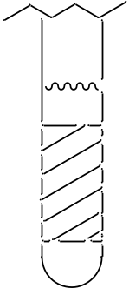

Figure 8. Diagram of the bottom of an NMR tube. The crosshatched region is where signal is recorded. It is essential that the liquid in the tube completely fill this region.

If we examine Eq 4 and Eq 5, the only variable is B_{o}, which is proportional to B_{APPL}. If B_{APPL} is different for different regions of the NMR tube, then B_{o} will be different for those regions. This means that the frequency needed to excite a specific hydrogen nucleus of a molecule varies over these regions. Differences in the frequency needed to excite a specific hydrogen nucleus means that the resonance will be broadened in the spectrum. Two steps are taken to reduce this broadening. One is to tune (also called shimming) the NMR spectrometer. Magnetic fields have a direction to them. When tuning, the X, Y and Z parameters are adjusted to optimize the homogeneity of B_{APPL} over the region of the NMR tube where signal is measured. The other step is to spin the sample. Spinning causes a specific hydrogen nucleus in a specific molecule to experience B_{APPL} over a range of sites as it spins through them. This averaging improves the homogeneity of B_{APPL} over the entire sample.

NMR spectra are usually recorded with deuterated (²H) solvents such as chloroform-d (CDCl₃). One reason for replacing normal hydrogen with deuterium in the solvent is to reduce the size of the solvent signal in the spectrum. The other is that tuning is usually done on the deuterium signal. Deuterium is an NMR active nucleus, but its magnetic moment is different from ¹H so it resonates at a different frequency on the spectrometer. This makes it possible to monitor the ²H signal to optimize the tuning while not perturbing the ¹H spectrum that is being measured. The spectrometer is also locked onto the deuterium signal so, if any drift of the signals were to occur while the spectrum is being recorded, it will be accounted for.

What “things” in a molecule generate magnetic fields that will influence B_{o} for a particular hydrogen nucleus?
Earlier in this unit we determined that spinning charged particles generate a magnetic field. Electrons and protons in molecules are charged and have spin. Therefore, we might reason that electrons and protons in molecules may generate a magnetic field that influences the magnitude of B_{o}. Electrons in molecules produce an effect known as shielding. Protons in molecules produce an effect known as coupling. Shielding determines where resonances are located in the spectrum. Coupling determines the shape of the resonance. Without these differences in the location and shape of resonances, NMR spectra would be useless for determining the structures of molecules. We can now write Equation 7 for B_{o} in which B_{e} represents the magnetic field produced by electrons and B_{p} represents the magnetic field produced by protons. However, we must consider the details of shielding and coupling to better understand the specific features of NMR spectra.

$B_{o}= B_{APPL}+ B_{e}+ B_{p}$ (7)

ELECTRON SHIELDING
While it might be tempting to think that spinning electrons generate a magnetic field that in some way is responsible for shielding, this is not the case. If we think about organic compounds, they have an even number of electrons that are paired up in molecular orbitals. The spins of two paired electrons in a molecular orbital generate opposing magnetic fields that cancel each other out. What actually happens is that the electrons in a molecule (often represented as an electron “cloud”) circulate about B_{APPL} as shown in Figure 9. A circulating charged “cloud” of electrons does create a magnetic field. This magnetic field usually opposes B_{APPL}, hence the use of the term “shielding” to describe this effect. Figure 9 also shows a vector representation for B_{e} (note, the size of the vectors for B_{e} and B_{APPL} in Figure 9 are not accurately represented as B_{e} is very much smaller than B_{APPL}).

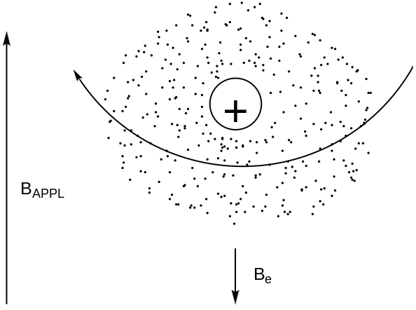

Figure 9. Circulation pattern for the electron “cloud” around a hydrogen nucleus that occurs in the presence of B_{APPL} and generates a magnetic field denoted as B_{e} that is usually in opposition to B_{APPL}. Note that the vector representing B_{APPL} is much too short in the picture.

Does electron density affect the magnitude of B_{e}? If so, what is the relationship?
Intuition likely suggests that the greater the electron density about a hydrogen nucleus, the larger the magnitude of B_{e}. This is correct. Electron withdrawing groups such as oxygen-containing moieties and halogens reduce the electron density about nearby hydrogen atoms. These reduce the shielding and the magnitude of B_{e}.

Does a more highly shielded nucleus absorb higher frequency (higher energy) or lower frequency (lower energy) radiation?
Figure 10 shows vector representations for B_{APPL}, B_{e}, and B_{o} for two different hydrogen nuclei, one of which is more shielded than the other. Note that the larger the electronic shielding, the lower the value of B_{o}, the lower the energy between the ground and excited state, and the lower the frequency of absorption.

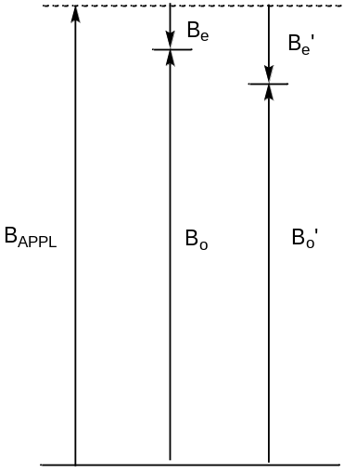

Figure 10. Vector representations for B_{APPL}, B_{e}, and B_{o} for two different hydrogen nuclei, one of which is more shielded than the other. Note, the size of the vector for B_{APPL} should actually be much larger than the size of the vectors for B_{e}.

NMR spectra are represented with the magnitude of absorbance on the y-axis and frequency on the x-axis. However, as will be seen later in this unit, it is inconvenient to report these frequencies in MHz. A better way to report the frequencies is to convert them to a parts-per-million scale, which is denoted as a δ value. In NMR spectroscopy, it is also necessary to adopt a uniform zero reference. Remember that the frequency of radiation absorbed by a particular hydrogen nucleus in a molecule is dependent on B_{APPL}. 400 MHz spectrometers have a B_{APPL} of 9.4 Tesla. However, variations in the manufacturing of each magnet mean that two different 400 MHz NMR spectrometers likely have slight differences in the magnitude of B_{APPL} (e.g., one might have a field of 9.400 Tesla while a second has a field of 9.401 Tesla). Even such a small change in the size of B_{APPL} will alter the magnitude of the frequency needed to excite a particular ¹H nucleus in a molecule; hence the need for a zero reference.

The common zero reference for samples run in organic solvents is tetramethylsilane [Si(CH₃)₄] (TMS). The methyl groups in TMS are all equivalent and appear as one singlet in the spectrum. They are also highly shielded because there are no electron withdrawing groups in the compound and because of the 3p electrons from the silicon. The position of resonances in the δ or ppm scale are normalized to the zero reference as shown in Equation 8.

$∆\left(ppm\right)= \frac{v_{samp }- v_{ref}}{v_{ref}} x {10}^{6}$ (8)

Suppose the resonant frequency of the TMS singlet on a 400 MHZ NMR spectrometer is exactly 400 MHz. What is the chemical shift in ppm for a signal that has a resonant frequency of 400,000,400 Hz?
The calculation of the chemical shift is shown in Equation 9.

$δ= \frac{400,000,400-400,000,000}{400,000,000} x {10}^{6}= \frac{400}{400,000,000} x {10}^{6}=1 ppm$ (9)

So this resonance appears at 1 ppm in the spectrum. There are two things worth noting about the outcome of this calculation. One is that it should be apparent why the ppm scale is preferable to reporting the actual frequencies of absorption. Writing 0 and 1 ppm on the x-axis is preferable to writing 400,000,400 and 400,000,000 Hz. The second is to note the very small frequency difference (400 Hz) that occurs for two resonances that are 1 ppm apart from each other. The resonances in most ¹H NMR spectra occur in the range of 0 to 10 ppm (Figure 11). On a 400 MHz instrument, this involves a frequency difference of only 4,000 Hz between the two extremes of the spectrum. Note the impressive frequency precision that can be measured on an NMR spectrometer – you would never have to dial in the frequency of a radio station to such a level of precision. These numbers show that the magnitude of B_{e}, which alters the frequency of absorption of different nuclei by only a few hundred Hertz, is so much smaller than the magnitude of B_{APPL}, which results in an energy gap of 400 MHz.

Figure 11 shows the accepted format for presentation of an NMR spectrum in which 0 ppm is to the far right and 10 ppm is to the far left. Resonances to the right in the spectrum are said to be upfield, more highly shielded, absorb at a lower frequency, and therefore have a smaller energy gap between the ground and excited spin state. Resonances to the left in the spectrum are said to be downfield, more highly deshielded, absorb at a higher frequency, and therefore have a larger energy gap between the ground and excited spin state.

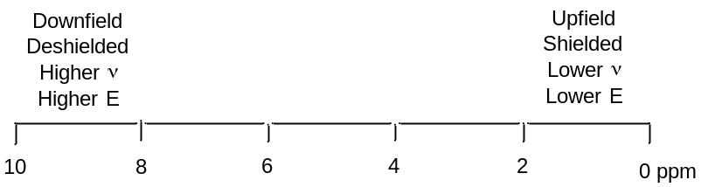

Figure 11. NMR scale in ppm identifying the downfield/upfield, deshielded/shielded, higher/lower frequency and higher/lower energy regions.
An important consideration is whether anything happens to the magnitude of B_{e} for a particular nucleus when B_{APPL} is changed. Altering the applied magnetic field ends up altering the rate at which the electrons circulate about the nucleus. At higher values of B_{APPL}, the electrons circulate faster with the result of a proportionally larger value of B_{e}. This means that a resonance with a chemical shift of 1 ppm on a 400 MHz NMR spectrometer has a chemical shift of 1 ppm on a 100 MHz or 600 MHz spectrometer.

What is different as B_{APPL} is varied?
If we consider a resonance at 1 ppm on a 600 MHz, it would be calculated as shown in Eq 10.

$δ= \frac{600,000,600-600,000,000}{600,000,000} x {10}^{6}= \frac{600}{600,000,000} x {10}^{6}=1 ppm$ (10)

Note that a 600 MHz spectrometer has 600 Hz in a ppm. From earlier we determined that a 400 MHz spectrometer has 400 Hz in a ppm. So instruments with larger magnets have more Hertz in a ppm.

There are also some unusual shielding effects that occur in compounds with double bonds and aromatic rings. In these cases, the electrons move in a specific circulation pattern in an applied magnetic field. The result of this circulation pattern is that nuclei positioned at the exterior of a double bond or phenyl ring are highly deshielded, whereas nuclei positioned over the double bond or aryl ring are highly shielded (Figure 12). The structure of norbornene is also shown in Figure 12. In norbornene, the hydrogen atom represented as H_{A} is shielded relative to that of H_{M} because it is over the double bond. The hydrogen atoms represented as H_{X} are deshielded given their position on the double bond. Many alkene hydrogen resonances occur in the range of 5-7 ppm. Many aromatic hydrogen resonances occur in the range of 7-8 ppm. These alkenyl and aryl hydrogen atoms are more highly deshielded than would be expected because of the specific circulation pattern of the electrons.

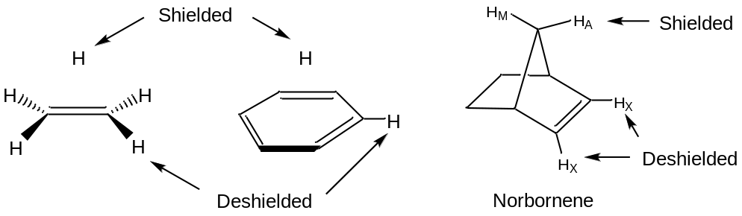

Figure 12. Representations showing that hydrogen atoms positioned at the exterior of a double bond and aryl ring are highly deshielded whereas those positioned over a double bond or aryl ring are highly shielded. This can be used to explain the unusual shielding of the H_{A} hydrogen and deshielding of the H_{X} hydrogens in norbornene.

NUCLEAR COUPLING
The second effect within molecules that influences the magnitude of B_{o} for a particular nucleus is nuclear coupling (we will develop what is known as through bond or scalar coupling). Let’s consider the two hydrogen atoms H_{A} and H_{B} in the compound shown below. The X and Y groups are not hydrogen atoms and produce no magnetic fields. In particular, let’s focus on the effect that H_{B} has on H_{A}. We can think of H_{A} “looking over” at H_{B} and ask ourselves about the magnetic field produced by H_{B}.

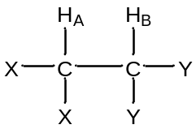

What do you know from earlier in this unit about the magnetic field produced by H_{B}?
Earlier we learned that the nuclear spin of H_{B} results in a magnetic field (B_{HB}) that is aligned either “with” or “against” B_{APPL}. Furthermore, we learned that essentially 50% of all H_{B} nuclei are aligned “with” and 50% are aligned “against”. So as H_{A} “looks over” at H_{B}, in half the molecules B_{HB} is aligned “with” B_{APPL} and in the other half of the molecules B_{HB} is aligned “against” B_{APPL}.

Is the flip of H_{B}’s spin between the “with” and “against” states rapid or slow?
This is an important question, because if the spin flips are rapid, then the effect of H_{B}’s magnetic field on H_{A} would be a time average of the two states, which would average out to zero. Earlier we learned that excited nuclear spin states have relatively long relaxation times. This means that the magnetic field of H_{B} does not rapidly flip back and forth and as H_{A} “looks over”; the field is either “with” or “against” during the time that the measurement is made. Figure 13 shows a representation of the effect of the magnetic field of H_{B} (B_{HB}) on the B_{o} value of H_{A} with the recognition that the flipping between states is slow in a particular molecule and B_{HB} is either in the “with” or “against” alignment.

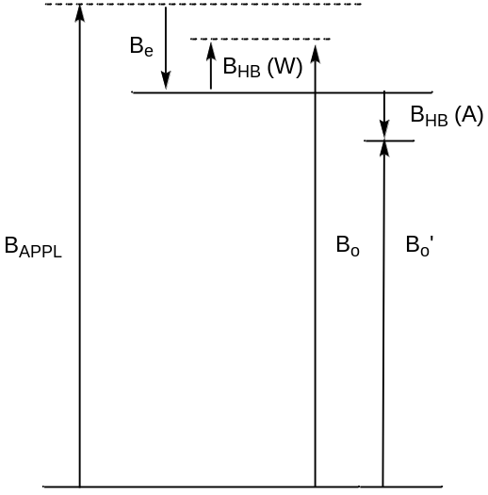

Figure 13. Representation of the effect of the magnetic field of H_{B} (B_{HB}) on the B_{o} value of H_{A} with the recognition that the flipping between states is slow and B_{HB} is either in the “with” or “against” alignment. Note, the size of the different vectors are not accurately represented relative to the true size of the different magnetic fields.

The through-bond or scalar coupling is not a through-space effect. Instead, it involves a propagating effect involving the electrons in the intervening σ bonds between the two coupled nuclei. Figure 14 shows a representation of the spin of H_{B} and then what preferentially happens with the paired electrons within the three σ bonds that separate H_{A} and H_{B}. Note how the electron spins preferentially align with the spin of H_{B} so that any neighboring set of arrows in the figure are paired up. In the case of H_{B} “with” (top of Figure 14), the closest electron to H_{A} in the σ- bond also has a “with” alignment. In the case of H_{B} “against” (bottom of Figure 14), the closest electron to H_{A} in the σ bond also has an “against” alignment.

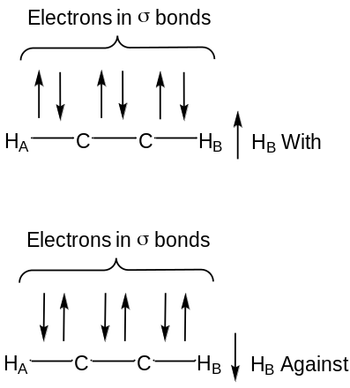

Figure 14. Representation of the preferred alignment of the electron spins in the σ bonds for the case of H_{B} “with” and H_{B} “against” cases.

What does the resonance for H_{A} look like in the NMR spectrum?
Because the magnetic field of H_{B} has two possible alignments, H_{A} now has two possible B_{o} values and these are essentially equal in population. Therefore, the resonance consists of two peaks of equal intensity and is called a doublet (see Figure 15). Note, the chemical shift (δ) of the doublet shown in Figure 15 would be the value at the exact center of the doublet.

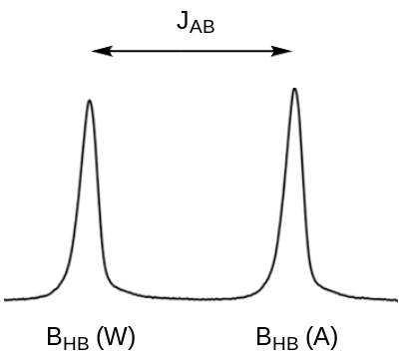

Figure 15. Representation of the doublet resonance for H_{A}. J_{AB} is the coupling constant between H_{A} and H_{B} and the peaks that go with B_{HB} “with” (W) and B_{HB} “against” (A) are shown.

Which peak in the doublet corresponds to B_{HB} “with” and which corresponds to B_{HB} “against”?
Remember that higher energy transitions occur to the left in an NMR spectrum. The peak on the left corresponds to B_{HB} “with” since the B_{o} value for H_{A} is higher when B_{HB} is “with” B_{APPL}.

The difference in chemical shift between the two peaks of the doublet is known as the coupling constant. The coupling constant is denoted by J, so the particular coupling constant in Figure 15 would be denoted as J_{AB}.

There are times when it is desirable to decouple a hydrogen atom. In this case, if we were to decouple H_{B}, then the resonance for H_{A} would no longer look like a doublet but would look like a singlet.

Can you think of a way to decouple a hydrogen atom like H_{B}?
We need to consider two prior things we learned in this unit to figure out how to decouple a hydrogen atom. One is that we observe coupling because H_{B} in a particular molecule is aligned either “with” or “against” the applied field as the measurement of H_{A} is being recorded. So, if there were some way to have H_{B} rapidly exchange back and forth between its “with” or “against” states, the net magnetic field would average to zero and the coupling would go away. The second is to remember what happens when a resonance is saturated and has equal populations of the ground and excited states. In this case, incident photons either promote ground state nuclei to the excited state or cause excited state nuclei to undergo stimulated emission and go back to the ground state. Both of these processes involve exchanges of nuclei between the two states.

So the way to decouple H_{B} is to put in a high power RF at the frequency needed to excite H_{B}. This high power RF will saturate the transition of H_{B} and promote rapid exchange of H_{B} nuclei back and forth between the two states either through absorption or stimulated emission. This rapid exchange causes the magnetic field that H_{A} experiences from H_{B} to average out to zero.

What would the H_{B} resonance look like?
The same type of arguments hold as H_{B} “looks over” at H_{A}: 50% of the molecules have B_{HA} aligned “with” and 50% have B_{HA} aligned “against”. Therefore H_{B} will also be a doublet. Also, there is only a single magnitude of coupling between two nuclei so the split between the two peaks of the doublet for H_{B} is exactly identical to that of H_{A}.

What would the resonance for H_{A} look like in the compound shown below where there are two H_{B} protons? Provide a rationale for your answer.

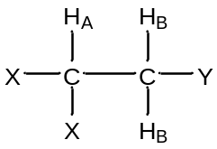

First, it is important to recognize that the two H_{B} protons are chemically equivalent because there is rapid rotation about the C-C bond. Second, each of the H_{B} protons has a 50:50 chance of having its magnetic field aligned “with” (W) or “against” (A) the applied magnetic field. This leads to four possibilities of the alignment of the magnetic fields of the H_{B} protons, each of which has an equal probability of occurrence: WW()/WA()/AW()/AA(). Note that for the center two (WA/AW), the two magnetic fields cancel each other out and, overall, there is twice the probability of this situation. The resulting resonance looks like that in Figure 16 and is said to be a 1:2:1 triplet. Note, the chemical shift (δ) of the triplet shown in Figure 16 would be the value for the center peak.

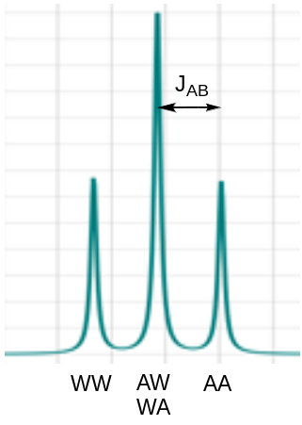

Figure 16. The 1:2:1 triplet for the H_{A} resonance in the compound represented above. The splitting that corresponds to the coupling constant (J_{AB}) is shown. The peaks that go with B_{HB} “with-with” (WW), B_{HB} “against-with” (AW) and “with-against” (WA) and B_{HB} “against-against” (AA) are shown.

The coupling constant J_{AB} would be the distance between one of the outer peaks and the center peak as shown in Figure 16. To convince yourself that this is correct, you could also think of this as a situation where one of the H_{B} protons couples to H_{A} and splits it into a doublet. Then the second H_{B} couples to H_{A} and splits each of the two peaks into a doublet as shown in Figure 17. Since the middle ones overlap, the intensity of the center peak of the triplet is twice that of the two outer peaks.

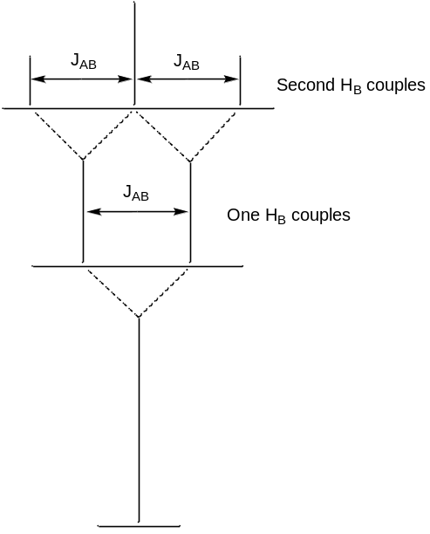

Figure 17. Representation of the resonance of H_{A} as one H_{B} couples and then the second H_{B} couples.

Which peak of the triplet corresponds to the WW and which to the AA situation?
The WW situation causes the largest value of B_{o}, the largest energy gap, and highest frequency of excitation. Therefore it is furthest to the left as shown in Figure 16.

The shape of a resonance split by any number of equivalent hydrogen atoms can be conveniently determined using what is known as Pascal’s triangle (Figure 18). To complete Pascal’s triangle, the number 1 is always put on the outside and the inner numbers are obtained by adding together the two adjoining numbers in the row above. So coupling to no hydrogens causes a singlet; coupling to one causes a 1:1 doublet; coupling to two causes a 1:2:1 triplet; coupling to three causes a 1:3:3:1 quartet, etc.

1
1:1
1:2:1
1:3:3:1
1:4:6:4:1
1:5:10:10:5:1

No coupling
One hydrogen couples
Two hydrogens couple
Three hydrogens couple
Four hydrogens couple
Five hydrogens couple
Figure 18. Pascal’s triangle showing the number and relative areas of the peaks of a resonance for different number of coupling hydrogen atoms. Note, the coupling hydrogen atoms must be chemically equivalent to apply these rules.

What factors do you think influence the magnitude of the coupling constant?
The magnitude of a coupling constant depends on two factors. One is the distance between the two nuclei that are coupled. Generally the further apart the two nuclei the smaller the magnitude of the coupling. The second is that the coupling constant has an angular dependence. For the examples we have considered above, H_{A} and H_{B} are three bonds removed from each other. These nuclei have what is known as a dihedral angle that can be determined using a Newman projection as shown in Figure 19. In this case, since there would likely be rapid rotation about the C-C bond, the dihedral angle would be a time-averaged value.

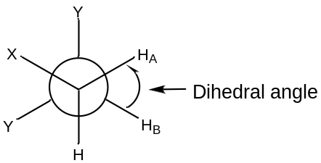

Figure 19. Newman projection showing the dihedral angle between H_{A} and H_{B} in the compound we have previously examined.

If the geometry was locked in place, as is common with rigid bicyclic organic compounds, then the Karplus correlation that is shown in Figure 20 relates the magnitude of the coupling constant to the dihedral angle. Note that there is quite an angular dependence to the coupling constant with the largest 3-bond coupling (also called vicinal coupling) occurring for two nuclei with a dihedral angle of 180º (J  13 Hz) and the smallest occurring at a dihedral angle of about 85º (J  2 Hz). There is also an angular Karplus correlation relationship for 2-bond coupling (also called geminal coupling) that is shown in Figure 21. It is important to note that the coupling constants predicted by the angular relationships shown in Figures 20 and 21 are approximations. Other facets of the compound being studied have an influence on the exact coupling constant.

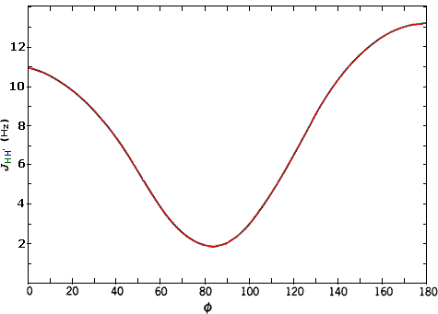

Figure 20. Karplus correlation for 3-bond (vicinal) coupling as a function of the dihedral angle.

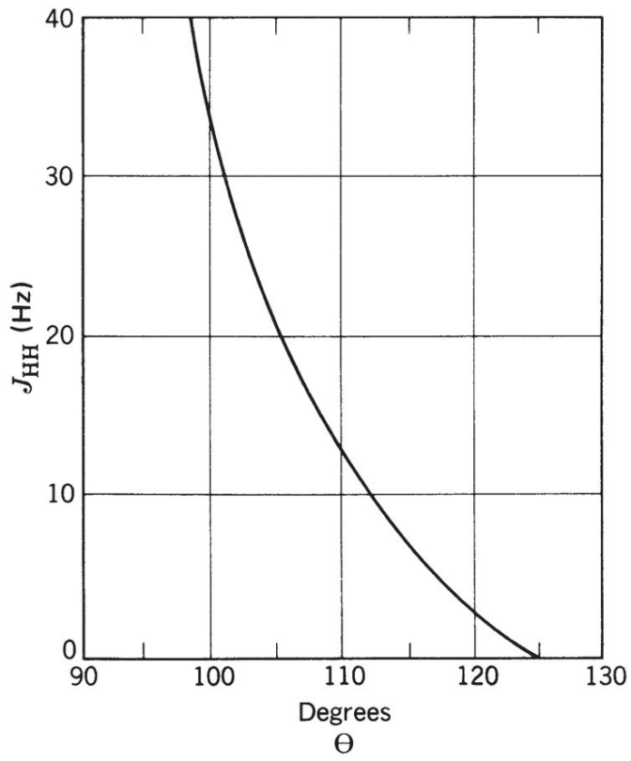
Figure 21. Angular Karplus correlation of 2-bond (geminal) coupling

Predict the coupling constants that would occur between H_{A}, H_{M} and H_{X} and the mono-substituted alkene shown below and draw the shape of each resonance.

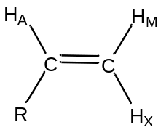

The AMX designation for hydrogen atoms is known as the Pople notation. The use of AMX indicates that the three hydrogen resonances have distinctly different chemical shifts. An ABC notation would indicate close and overlapping resonance.

The first thing to recognize is that all three of these protons are chemically different. H_{A} has 3-bond coupling to H_{M} (dihedral angle of 0º, J_{AM}  11 Hz) and 3-bond coupling to H_{X} (dihedral angle of 180º, J_{AX}  13 Hz). H_{A} would be described as a doublet of doublets and the shape of the resonance is shown in Figure 22. H_{M} has 3-bond coupling to H_{A} (dihedral angle of 0º, J_{AM}  11 Hz) and 2-bond coupling to H_{X} (angle of 120º, J_{MX}  3 Hz). H_{M} would be described as a doublet of doublets and the shape of the resonance is shown in Figure 20. H_{X} has 3-bond coupling to H_{A} (dihedral angle of 180º, J_{AM}  13 Hz) and 2-bond coupling to H_{M} (angle of 120º, J_{MX}  3 Hz). H_{X} would be described as a doublet of doublets and the shape of the resonance is shown in Figure 22. There are two interesting observations for the alkene resonances. First, all three are distinctly different because of the different magnitudes of the coupling constants such that all could be readily assigned in an NMR spectrum. Figure 22 also shows the distance in Hz between the two extreme peaks of each resonance for H_{A} (24 Hz), H_{M} (14 Hz) and H_{X} (16 Hz). Second, the geminal or 2-bond H_{M}-H_{X} coupling is smaller than the vicinal or 3-bond H_{A}-H_{M} and H_{A}-H_{X} coupling when the angle terms are considered. The example for a mono-substituted alkene provides a glimpse into the valuable information about molecular structure that can be gained by examining whether coupling occurs and the magnitude of coupling between different nuclei of a molecule.

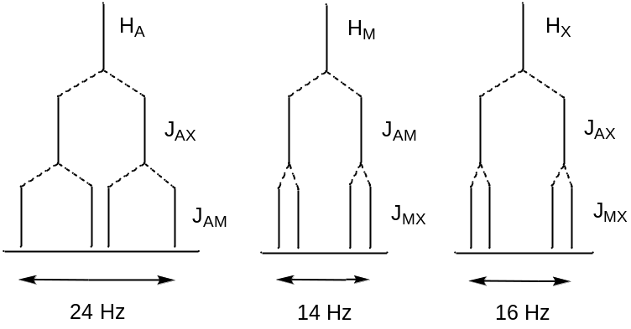

Figure 22. Representation for the three doublet of doublets resonances in a mono-substituted alkene.

An especially important observation is that the magnitude of coupling constants does not depend on B_{APPL}. One reason is that the distance and angle between two nuclei are independent of B_{APPL}. Another is that the magnetic field generated by a spinning proton is dependent on its magnetic moment and spin properties, and neither of these is dependent on B_{APPL}. The fact that coupling constants are independent of B_{APPL} has especially important consequences in NMR spectroscopy.
Consider the following compound in which J_{AB} = 10 Hz, δ_{HA} = 1.3 ppm and δ_{HB} = 1.2 ppm. Draw the resulting spectrum if the spectrum is recorded on a 100 MHz and 400 MHz spectrometer.

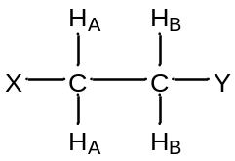

Both resonances will be 1:2:1 triplets and the outer peaks of both triplets are each 10 Hz removed from the center peak. The important distinction is that the 100 MHz instrument has 100 Hz in a ppm whereas the 400 MHz instrument has 400 Hz in a ppm. Figure 23 shows representations for the two different instruments. What is important to note is that the two resonances (one in black, one in red) will overlap on the 100 MHz instrument (Figure 23a), whereas on the 400 MHz instrument they are well separated from each other (Figure 23b). In order words, the 400 MHz instrument has much better resolution or dispersion than the 100 MHz instrument. When the difference in chemical shift between coupled hydrogen atoms is greater than their coupling constant, the spectrum is said to be first order. First order spectra are readily interpreted according to the established rules for coupling. When the coupling constant is equal to or larger than the difference in chemical shift between the coupled hydrogen atoms, the spectrum is second order and interpretation is more difficult. Because NMR spectrometers with higher field strengths have more Hertz in a ppm, the spectra are more likely to be first order. We already discussed how higher field strengths increase the sensitivity because of the more favorable population distribution between the ground and excited states. Another reason why many people want higher field spectrometers is because of the improvement in resolution over lower field instruments. The need for higher resolution is especially important for complex molecules such as many natural products and proteins.

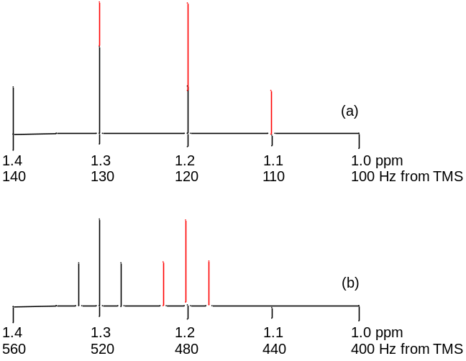

Figure 23. NMR of two coupled nuclei with δ = 1.2 and 1.3 ppm and J = 10 Hz on 100 and 400 MHz spectrometers.

One last thing to examine is the actual shape of the resonance for the example above that would appear in the spectrum recorded on a 100 MHz instrument. In Figure 23a, the resonance appears to look like a 1:3:3:1 quartet. In fact, the resonance would not look like that but would show an additional distortion that might further complicate interpretation of the spectrum. The distortion results because coupled systems are no longer independent of each other and the coupled nuclei may distort the populations of their different energy levels. The degree of distortion depends on the magnitude of the difference in their chemical shifts relative to the magnitude of the difference in their coupling constants. If the two coupled resonances are well separated in the spectrum, minimal to no distortion occurs. If they are close together, much greater distortion occurs.

An example of this distortion is most easily illustrated for two protons that split each other into doublets. In Figure 24, the two doublets have a coupling constant of 10 Hz and the different spectra correspond to frequencies of absorption that decrease by 10 Hz each going from Figure 24a to 24e. In Figure 24a, the two resonances have the largest difference in chemical shifts and both peaks look almost like regular doublets. As the chemical shifts become closer (Figure 24b-e), note the increasing distortion that occurs. This is often referred to as “leaning”; resonances “lean” toward other resonances they are coupled to. Remember, the equal intensity of both peaks in a doublet occurred because of the 50:50 probability of the “with” and “against” alignment, so the distortion represents an alteration of these populations within the coupled system. In some of the spectra (Figure 24a-b), the leaning is relatively mild such that one might recognize that it involves two coupled doublets. However, when the chemical shifts get very close (Figure 24d-e), the distortion is so great that interpretation is more difficult. For example, the spectrum in Figure 24d might easily get confused as a 1:3:3:1 quartet. If two coupled protons have identical chemical shifts, then no coupling is observed in the spectrum and the peaks would appear as a singlet.

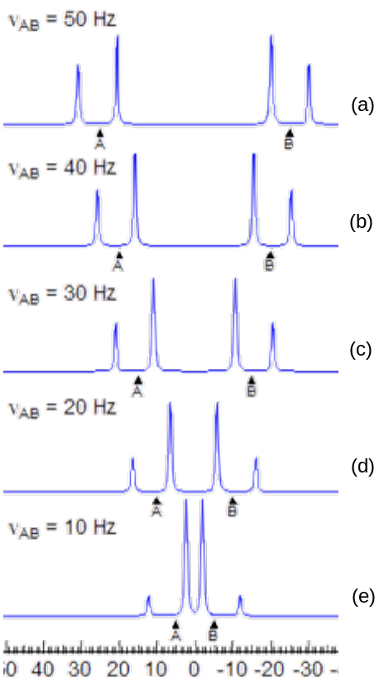

Figure 24. Shape of two coupled doublets showing the distortion of the resonances that occurs as the difference in chemical shifts between the resonances becomes smaller.
EXCHANGE EFFECTS
One final subtlety of coupling can be examined by considering the spectrum of a compound such as methanol (CH₃OH). Using the rules for coupling we have established, predict the number of resonances and identify their multiplet structure.
Methanol has two distinct hydrogen atoms, the three equivalent ones of the methyl group and the one of the hydroxyl group. These two different types of hydrogen atoms are three bonds away from each other so should couple. Therefore, the methyl hydrogen atoms should appear as a 1:1 doublet of area three and the hydroxyl hydrogen atom should appear as a 1:3:3:1 quartet of area one. In some situations, this is exactly how the NMR spectrum of methanol will appear.

However, in other situations the spectrum of methanol appears as two singlets, one of area three and the other of area one. Propose a reason why singlets are observed instead of coupled multiplets.
The important thing to recognize here is that the hydroxyl hydrogen atoms in methanol are exchangeable. The hydroxyl groups of methanol participate in hydrogen bonding and the hydroxyl hydrogen of one methanol associates with a lone pair on the oxygen atom of another methanol. Figure 25 illustrates a hydrogen bonded methanol dimer. When hydrogen bonding occurs, it is possible for the hydroxyl hydrogen atoms to exchange and leave with the other methoxy group as also shown in Figure 25. Note how the red and black hydroxyl hydrogen atoms end up with the other methoxy group in Figure 25. If the exchange rate is slow on the NMR time scale, coupling is observed because a methyl group is adjacent to a hydroxyl hydrogen atom whose magnetic field is aligned either “with” or “against” B_{APPL} during the entire time that the measurement is made. If the exchange rate is fast on the NMR time scale, during the course of the measurement, the methyl group is adjacent to many different hydrogen atoms because they are rapidly coming on and off. Considering the probabilities, half of these hydrogen atoms will be in the “with” orientation and half will be in the “against” orientation. The spectrum will be a time average with the result that the magnetic fields exactly cancel each other out such that no coupling is observed.

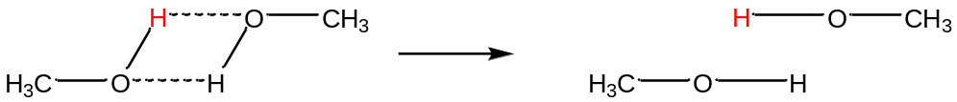

Figure 25. Hydrogen bonding and exchange of hydroxyl hydrogen atoms between different methanol molecules.

Another time-dependent aspect to consider about NMR spectra can be illustrated by considering the ¹H NMR spectrum of N,N-dimethylacetamide (DMA) shown below.

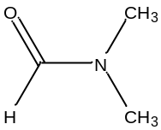

What does the NMR spectrum of DMA look like?
There are two different hydrogen atoms in DMA (methyl and acetaldehyde) that are four bonds removed from each other so there will be no coupling. Assuming rapid rotation of the carbonyl carbon-nitrogen bond, both methyl groups are equivalent. The NMR spectrum would therefore consist of two singlets, one for the methyl groups of area 6 and the other for the aldehyde hydrogen of area 1.

DMA has the following contributing resonance form. What would the NMR spectrum of DMA look like in this resonance form?

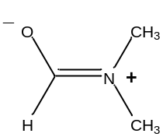

In this form, there is no rotation of the carbonyl carbon-nitrogen double bond. Now the methyl groups are chemically inequivalent because one is cis and the other trans to the oxygen atom. The NMR spectrum would now consist of three singlets, two for the methyl groups, each of area 3, and the other for the aldehyde hydrogen of area 1.

What ultimately happens is that the NMR spectra of DMA and other amides exhibit different behaviors at different temperatures. At high temperatures, the bond does undergo rapid rotation and the two methyl groups are equivalent. At low enough temperatures, the bond eventually undergoes slow rotation and the two methyl groups are inequivalent.

CLASSICAL DESCRIPTION OF NMR SPECTROSCOPY
The quantum mechanical description developed in the preceding section of this unit is useful in understanding many important concepts of NMR spectroscopy. However, to understand how the spectrum is obtained on the types of instruments in use today, it is necessary to consider what is known as the classical description of NMR spectroscopy. Earlier we mentioned that the ground spin state of a proton is one in which its magnetic field is aligned “with” B_{APPL}. In actuality, there is a subtlety to the motion of the hydrogen nucleus that we have not considered yet. The diagram in Figure 26 will help understand the actual motion that occurs. Note that the diagram in Figure 26 also places the spinning proton on a coordinate system. A coordinate system is needed because magnetic fields have a direction to them. The external applied magnetic field in an NMR spectrometer is usually considered to be on the Z-axis.

As shown in Figure 26, the actual magnetization vector (B_{P}) created on the axis of spin of the hydrogen nucleus is not perfectly aligned with B_{APPL} but instead is tipped a bit off from B_{APPL}. What also happens in addition to the spinning motion of the proton is that its magnetization vector precesses about B_{APPL}. The precessional motion effectively transcribes a cone shape as shown in Figure 26. Note that the precessional motion for the ¹H nucleus depicted in Figure 26 is opposite (clockwise) to the spinning motion (counterclockwise).

An important consideration is that there is a large ensemble of nuclei that are in the many molecules in the NMR tube. Of this ensemble, we know that a slight excess are in the ground state with their magnetic field aligned “with” B_{APPL}. So Figure 26 effectively shows the vector representations for the excess nuclei in the ground state. It is also important to recognize that this ensemble of many nuclei do not precess in phase with each other. For every nucleus that at some moment has a +X or +Y component of magnetization, there is a corresponding nucleus that at the same moment has a –X or –Y component of magnetization. The result is that the X and Y components of the magnetization cancel out over the entire ensemble of nuclei and the only finite component of magnetization is along the Z-axis. Hence, the net magnetization vector lies only on the Z-axis as shown in Figure 26.

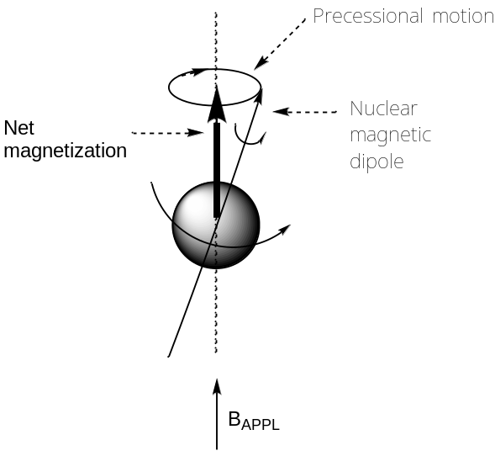

Figure 26. Movement of the spinning proton showing that its nuclear magnetic dipole does not align with B_{APPL} but is slightly off axis and precesses about B_{APPL}.

There are two things to consider about this precessional motion. Imagine yourself sitting on top of the proton’s magnetization vector as it precessed about B_{APPL}. You would have a certain precessional speed or a precessional velocity. Furthermore, as you precess about around B_{APPL} you could count how many cycles you made in a second. This would be your precessional frequency, which is also known as the Larmor frequency. The relationship that describes the precessional or Larmor frequency of a nucleus is shown in Eq 11. An important outcome is to recognize that Eq 11 for the precessional frequency in the classical description of NMR spectroscopy is identical to Eq 4 obtained in the quantum mechanical description of NMR spectroscopy.

$v= \frac{uB_{o}}{hI}$ (11)

What the classical description allows us to better understand is what happens to the nucleus when it is excited and how signal is measured on today’s instruments. When examining pictures of what occurs with a nucleus in the NMR spectrometer, two things are important to consider. One that has already been mentioned is that there is a large ensemble of nuclei that are in the many molecules in the NMR tube, and we are examining the excess within this ensemble that have their magnetic field aligned “with” B_{APPL}. The other is that it helps to examine pictures of the behavior of a nucleus by operating in what is known as the rotating frame. Operating in the rotating frame means that the observer is rotating at the same rate that the nucleus being examined is precessing. The result is that, instead of observing individual vectors precessing about B_{APPL}, only the net magnetization vector is observed. Figure 26 also shows a vector representing the net magnetization for an observer in the rotating frame. Note that the net magnetization is effectively a time average of the nuclear magnetic dipole of the precessing nucleus.

A design feature of NMR spectrometers is to place a coil of wire on the X-axis. An electrical current that oscillates at a radiofrequency is then run through the coil.

What happens when an electrical current is run through a wire coil?
It turns out that running an electrical current through a wire coil generates a magnetic field (designated B₁) as shown in Figure 27. Note that B₁ is oriented perpendicular to B_{APPL}.

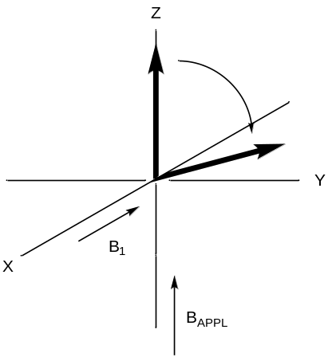

Figure 27. Representation of B₁, which is produced by the RF coil, and the torqueing of the net magnetization vector for the proton that occurs when the frequency used to generate B₁ exactly matches the precessional frequency of the proton.
Let’s consider a compound whose NMR spectrum consists only of a singlet (e.g., tetramethylsilane) so there is only one excitation frequency. If the current of electricity used to generate B₁ oscillates at a frequency that exactly corresponds to the precessional frequency of the nucleus responsible for the singlet, B₁ exerts a torque (or force) on that nucleus with the result that the nucleus now wants to precess about B₁ instead of B_{APPL}. Looking only at the net magnetization vector in Figure 27, when a matching B₁ is applied the nucleus tips off the Z-axis in the Y-Z plane as it begins to precess about B₁.

When recording an NMR spectrum, B₁ is only applied for a few microseconds (this brief application of B₁ is referred to as a pulse). Suppose B₁ is applied just long enough to tip the net magnetization vector of the proton by 90º as shown in Figure 28b and is then turned off. Note: the extent to which nuclei tip is directly dependent on the length of the RF pulse. If 10 usec resulted in a 90º tip, 5 usec would result in a 45º tip.

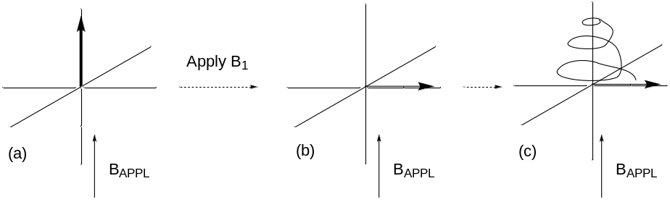

Figure 28. Representation of what happens to the net magnetization vector after (b) application of a 90º pulse. B₁ is turned on for a short period of time to tip the vector. After turning off the vector, the nucleus undergoes a “spiral-like” motion (c) as it returns to its normal precessional motion about BAPPL.

What happens to the nucleus after B₁ is turned off?
The nucleus now needs to precess about B_{APPL} but it starts the precession with its magnetization vector located in the X-Y plane. It will gradually relax back because of spin-lattice (longitudinal) relaxation in a spiral-like motion to its starting state finally forming a precessional cone about B_{APPL} as shown in Figure 28.

Remember that the diagrams in Figure 28 represent those of an ensemble of nuclei tipped during the RF pulse. In their original precessional motion, the nuclei were out of phase with each other. When the nuclei are tipped, the net magnetization of each is in phase on the Y-axis. While spin-lattice relaxation is responsible for the spiraling relaxation illustrated in Figure 28, spin-spin (transverse) relaxation results in ground and excited state nuclei swapping states. Newly excited nuclei formed through this spin-spin process are no longer in phase with the other excited nuclei. This dephasing of the nuclei through spin-spin relaxation will lead to a reduction of the recorded signal.

Suppose a wire coil is placed on the Y-axis. What happens in the wire coil as the magnetic field of the tipped nucleus is imparted on it?
Applying a magnetic field to a wire coil will generate an electrical current. In reality, instead of having a second wire coil on the Y-axis, the wire coil on the X-axis is used. In the first step, an RF pulse is applied through the coil to excite or tip the nucleus. Once the pulse is turned off, the coil can be used to measure the electric current generated by the magnetic field of the tipped nucleus.

Draw the current profile that would result in the wire coil on the X-axis as the tipped nucleus relaxes back to its ground state.
As the nucleus precesses around B_{APPL} during the relaxation process, it has alternating positive and negative components of magnetization on the X-axis. The result is the current profile shown in Figure 29a. This profile is referred to as a free induction decay (FID). The FID is a representation of the resonance of the single nucleus being excited, but it is in what is called the time domain. A mathematical technique called a Fourier transform (FT) can be used to analyze a wave form and determine the individual frequency components and their amplitudes that are needed to generate the wave. The outcome of performing an FT on an FID yields what is called the frequency domain spectrum, which is shown in Figure 29b. This is the common spectrum we see in NMR spectroscopy with the amplitude of peaks on the Y-axis and resonances reported in ppm on the X-axis.

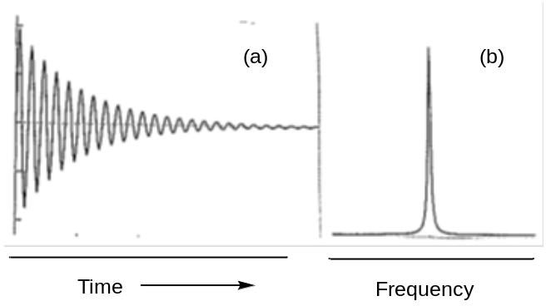

Figure 29. (a) Free induction decay (FID) for a nucleus with a single precessional frequency. The FID is known as the time-domain spectrum. (b) The frequency domain spectrum, which is a singlet, obtained by performing a Fourier transform of the FID.

In drawing the FID in Figure 29a, it might be tempting to think of each positive and negative component of the FID representing the magnetic vector of the nucleus as it is positioned on the +X and –X axis. A problem with this thinking is to consider a specific ¹H resonance occurring at 400 MHz, as we have been using in some of our examples. The vector actually oscillates between the +X and –X direction 400 million times a second, which would mean that the FID shown in Figure 29a should have 400 million oscillations in a second. This would be incredibly challenging to measure. We will not develop the details of how the measurement of the FID is actually obtained, but there is an electronic process that can be used in which the FID shows the difference in frequencies between the peaks in the spectrum and what is known as the carrier frequency. What we will see is that, when recording NMR spectra, rather than applying a single RF frequency through the wire coil on the X-axis, the instrument applies a broadband pulse of radiofrequencies that can excite all of the hydrogen nuclei at once. The carrier frequency is the center frequency of the broadband RF pulse that is applied. These differences are only on the order of a few thousand Hertz. Oscillations of a few thousand times a second are readily measured using modern digital electronics.

Draw the FID that would result if the nucleus had a much shorter relaxation time.
With a shorter relaxation time, the decay of the FID would be must faster. The FID for a nucleus of identical excitation frequency to that in Figure 29 but with a much shorter relaxation time is shown in Figures 30.

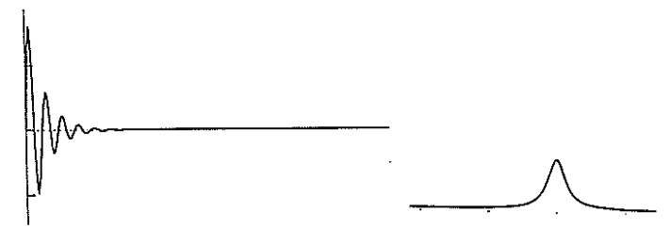
Figure 30. The FID (left-hand side) of a nucleus with the same excitation frequency as that in Figure 29 but a much shorter relaxation time. The frequency domain spectrum (right-hand side) that arises out of performing the Fourier transform of the FID. Note that the frequency domain spectrum in Figure 30 is a much broader singlet than occurs in Figure 29.

Do you see a problem with performing a FT on an FID with a very short relaxation time? If so, what would happen in the resulting frequency domain spectrum?
It will be more difficult to identify the frequency of the highly truncated FID with as much accuracy as an FID with a much slower decay. The difficulty in determining an exact frequency means that the resonance will be much broader in the frequency domain spectrum as shown in Figure 30. An outcome of the signal decay in an FID means that every peak in the frequency domain spectrum will have some amount of broadening, and the faster decay the more the broadening.

As mentioned previously, rather than applying a single RF frequency through the wire coil on the X-axis, the instrument applies a broadband pulse of radiofrequencies that can excite all of the hydrogen nuclei at once. Suppose we consider a sample whose spectrum consists of two singlets with slightly different excitation frequencies. If both are excited at once through the broadband RF pulse, the FID will consist of a composite wave that is the sum of the two contributing components as shown on the left in Figure 31. The FT can determine the frequency components and their amplitude of both contributing waves in the composite time domain wave and generate the corresponding frequency domain spectrum shown on the right in Figure 31.

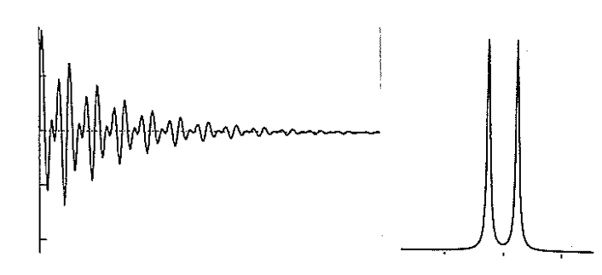

Figure 31. The left-hand side is the FID of a sample where the NMR spectrum consists of two singlets of slightly different frequency. The right-hand side is the frequency domain spectrum showing the two singlets that arises out of performing the Fourier transform of the FID.

Where is the amplitude of peaks determined in the FID?
Because of the decay and the fact that different nuclei in a molecule will have different decay rates, the amplitude of each peak must be determined using the first data point in the FID.

The typical pulse sequence used when recording standard ¹H NMR spectra is shown in Figure 32. A brief (few microsecond) broadband RF pulse is applied to tip the net magnetization of all the nuclei, the X-coil is turned on to sample the FID (about 1 second) and then there is a delay time (about 1 second). Then the sequence is repeated multiple times and the FIDs are added together.

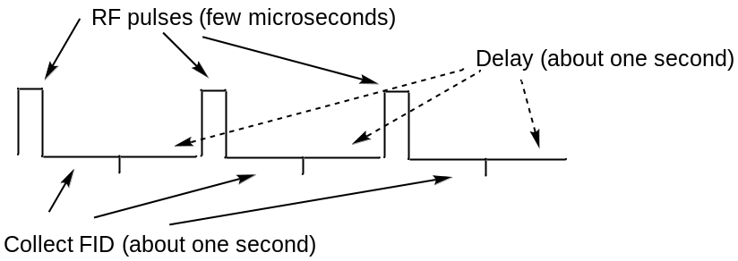

Figure 32. Diagram of the normal pulse sequence for collecting NMR spectra that involves a brief RF pulse, sampling of data to collect the FID, and a delay time.

Why is a delay time incorporated into the sequence?
The purpose of the delay time is to allow more complete relaxation of the nuclei. If the nuclei are not allowed to relax back to the ground state, the transition may become saturated and then there will be no signal to record.

So far we have developed our understanding of FT NMR using 90º pulses. In reality, 90º pulses are rarely used when obtaining routine spectra and the use of 30º pulses is more common.

Why are the advantages and disadvantages of using 30º pulses instead of 90º pulses?
As seen in Figure 33, if only a one pulse measurement is performed, a disadvantage of using a 30º pulse instead of a 90º pulse is that there is a smaller magnetization on the X-Y axes and less amplitude in the FID. That means that the signal-to-noise ratio will be smaller for the 30º pulse. However, NMR spectra are rarely recorded using a single pulse. Instead, several repetitive pulses using the sequence in Figure 32 are run and added together. The advantage of the 30º pulse over the 90º pulse is that it better insures that the nuclei have relaxed back to the ground state after each pulse so that resonances are less likely to get saturated. Clearly this is a tradeoff and whether to use a 30º pulse or 90º pulse can depend on the particular relaxation times of nuclei in the sample.

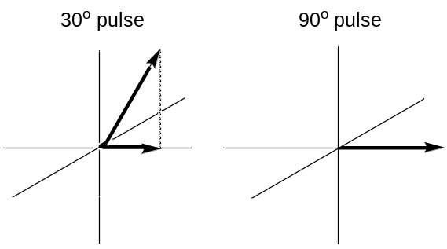

Figure 33. Comparison of 30º and 90º pulses. Note how there is much less x-component of magnetization with the 30º pulse.

What is the advantage of recording several FIDs and adding them together?
As mentioned earlier in this unit, signal is consistent from run to run but noise is random. Adding several FIDs together leads to some cancelling out of the noise but growth of the signal, thereby improving the S/N ratio.

One final thing to consider is the behavior of a nucleus with a very long spin-lattice relaxation time. ¹³C is a spin ½ nucleus and it is possible to obtain ¹³C NMR spectra. The primary mode of relaxation of ¹³C atoms is through an interaction with the nucleus of directly bonded hydrogen atoms. Carbon atoms in a compound with no directly bonded hydrogen atoms (e.g., tertiary carbon atoms, substituted aromatic carbon atoms, carbonyl carbon atoms in a ketone) can have very long relaxation times – upwards of 100 seconds.

Suppose the following pulse sequence is used to obtain the spectrum of a ¹³C nucleus with a spin-lattice relaxation time of 100 seconds (90º pulse, 1 second collection of the FID, 1 second delay). Note, carbon atoms with no directly bonded hydrogen atoms can have relaxation times as long as 100 seconds. This pulse sequence is repeated four times.
- Draw the position of the ¹³C magnetization vector after each of the four pulses.
- Draw the corresponding FID that would be obtained after each pulse.
- Draw the composite FID obtained by adding the four individual FIDs together.
- What do you observe for this carbon in the resulting frequency domain spectrum?

The important point to consider is that the ¹³C nucleus in question has almost no relaxation between each pulse. This means that the second pulse will put its net magnetization vector on the –Z axis as shown in Figure 34. The third pulse puts the net magnetization vector on the –Y axis, and the fourth pulse puts the vector back where it originally started. For pulses 2 and 4, there is no net magnetization in the XY plane so there is no signal recorded in the FID. For pulses 1 and 3, there is a net magnetization in the XY plane, but the two FIDs are exactly out of phase with each other (out of phase means that where one of the FIDs has a positive amplitude, the other has the exact same amplitude but negative) (Figure 34). Adding these four together gives a net result of no FID for this nucleus. That means that the resulting frequency domain NMR spectrum will show no peak for this carbon. What we would also say about this carbon is that we have saturated the transition.

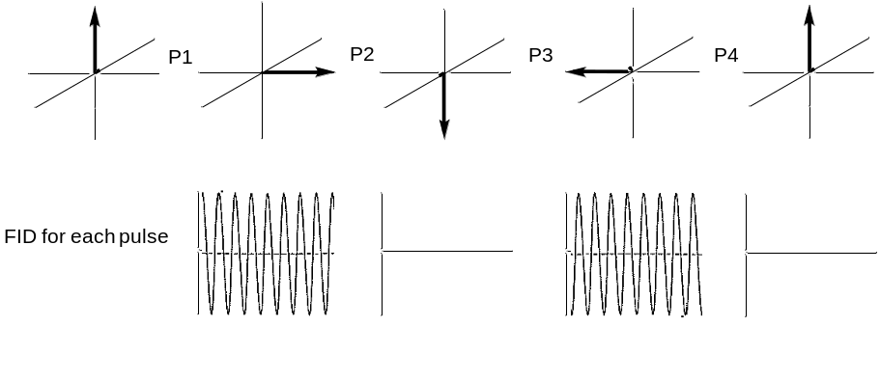
Figure 34. Top: net magnetization vector for four consecutive 90º pulses for a nucleus with an exceptionally long relaxation time. Bottom: corresponding FID for each of the four pulses.

The influence of saturation on atoms with different relaxation times is exploited in the technique magnetic resonance imaging (MRI). MRI is used to generate high quality images in humans. The signal recorded in MRI is the hydrogen resonance of water molecules. A paramagnetic complex of gadolinium(III) is often used as an image contrast agent and is consumed ahead of time by the person having the MRI. Paramagnetic substances promote nuclear relaxation so greatly shorten the relaxation times of the hydrogen atoms in water. But the paramagnetic gadolinium complex distributes differently into different tissues in the body. For example, in a cancerous brain tumor, a higher concentration of gadolinium goes into the tumor than into the surrounding tissue. That means the relaxation time of hydrogen atoms in the water in the tumor is shorter than the relaxation time of hydrogen atoms in the water outside the tumor. By carefully setting up the pulse sequence, it is possible to observe signal for water molecules inside the tumor that have faster relaxation while saturating and observing minimal signal for water molecules outside the tumor because of their slower relaxation. The ability to record NMR spectra of humans is so significant advance that it resulted in a Nobel Prize for those individuals most responsible for inventing the method.

