Section 2
Calculating the molecular weight of a protein from its electrospray ionization mass spectrum (ESI-MS)

Learning Objectives
At the end of this assignment, you should be able to:
- Calculate the charge state and mass of a protein from its ESI-MS spectrum.
- Describe the principle of operation of a quadrupole ion trap mass analyzer.

Section 2A. Electrospray and Quadrupole Ion Trap Instrumentation
Gel electrophoresis gives some indication of the molecular weight of a protein based on its migration in a gel; however, the molecular weights determined from this method are not precise. In contrast, mass spectrometry can provide accurate and precise molecular weights that aid in identification of proteins. Initially, mass spectrometry experiments were limited to small molecules that could be readily volatilized into the gas phase and ionized before entering the mass analyzer. In the late 1980s, several ionization methods were developed and applied to biomolecules that permitted analytes from condensed phase samples, such as liquids and solids, to be volatilized and analyzed by mass spectrometry. Electrospray ionization (ESI) is one such technique.
ESI is a solution-phase “soft” ionization source which converts ions in solution to gaseous ions. The mechanism of ion formation in an ESI source is depicted schematically in Figure 1. Briefly, gaseous ions are formed when a solution containing the analytes of interest (from an LC column or from a syringe infusion pump) is sprayed through a stainless steel capillary to which a high voltage is applied, creating a fine mist of droplets which are charged on their surface. As solvent evaporates from the charged droplets, the charge density on their surface increases to a critical limit, at which point electrostatic repulsion causes the larger droplets to break up into smaller charged droplets. Finally, analyte ions are ejected into the gas phase by electrostatic repulsion, and these ions enter the mass analyzer for subsequent mass analysis. You can watch a video from the Johnson lab showing the formation of a stable electrospray as the voltage applied to the tip is increased.
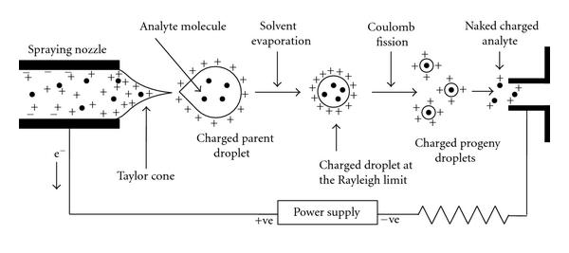
Figure 1. The mechanism of electrospray ionization (ESI). High voltage is applied to a steel capillary to produce charged droplets containing the analyte molecules. As solvent evaporates, charge accumulates until the Rayleigh limit is reached and the droplet undergoes Coulomb fission into smaller droplets. This process continues until gas phase analyte molecules enter the mass spectrometer. Figure is reproduced with permission from S. Banerjee and S. Mazumdar, Int. J. Anal. Chem., 2012, 2012, 282574 under a Creative Commons Attribution License.
For electrospray, the protein sample is prepared in a solution composed of water with acid and a low surface tension organic solvent, such as methanol. Relatively pure protein samples can be infused directly into the mass spectrometer using a syringe pump, or more complex protein and peptide mixtures may be separated by chromatography first and electrosprayed directly from the column.
Electrospray ion sources are compatible with many types of mass analyzers. For this application, we will consider the quadrupole ion trap as a mass analyzer. The quadrupole ion trap is composed of two end cap electrodes at the entrance and the exit of the trap and a ring electrode (shaped like a donut) in the middle. The voltages and AC frequencies of the applied potentials on the electrodes are varied to control the motion of ions in and through the trap. The ion trap mass analyzer is a small, relatively inexpensive mass analyzer that typically generates mass spectra with unit resolution (Δm ≈ 1) or slightly better. This video shows the operating steps involved in generating a mass spectrum using an ion trap.
Video Question
1. Summarize what you saw in the video on the ion trap. What are the operating steps used to generate a mass spectrum using an ion trap mass analyzer?
Section 2B. ESI-MS Data
One of the advantages of ESI is that it is a “soft” ionization technique in which little fragmentation of large, thermally fragile biomolecules occurs. Consequently, molecular weight information is readily obtained with this technique. Additionally, the ions formed are often multiply charged, which enables the analysis of molecular masses exceeding 100,000 Da because the multiple charges bring the m/z values into the mass range of conventional mass analyzers, such as ion traps. With proteins and peptides, the mass spectrum consists of a series of peaks, call the “peak envelope” which represents a distribution of multiply charged analyte ions.
Ubiquitin is a small protein with a monoisotopic molecular weight of 8560 Da. Electrospray ionization of this small protein typically results in major charge states of +8, +9, +10, +11, +12, and +13.
Reading Questions
1. Using this information, complete the table below, assuming that the charges on each ion come from protonation rather than sodium or potassium adducts. Round masses and m/z values to the ones place.


2. Using the data you entered in the table above, sketch an expected ESI-MS spectrum for ubiquitin. Label each peak with its charge state. What do you notice about the spacing of the peaks along the x-axis?

Based on the m/z values and peak spacing observed in the charge envelope, we can determine the charge state, z, for each peak and the molecular weight of the analyte using Equations 1 and 2,
$z=\frac{M_{2}-A}{M_{1}-M_{2}}$ (1)
$MW=\frac{(M_{1}-A)(M_{2}-A)}{M_{1}-M_{2}}$ (2)
where MW is the molecular weight of the analyte, M₁ is the m/z value for the first ion, z is the charge state of the first ion, M₂ is the m/z value for a second ion of lower m/z, and A is the mass of the adduct ion, which is usually a proton (H⁺) but can be sodium (Na⁺) or potassium (K⁺) ions from glassware or buffers used in the experiment.

Discussion Questions
1. Why do aqueous samples for electrospray typically include an acid and a low surface tension solvent such as methanol?
2. Figure 2 shows an experimentally obtained mass spectrum for ubiquitin. Compare this spectrum to the spectrum you predicted in Reading Question 2. Are there any differences? If so, what might cause these differences?
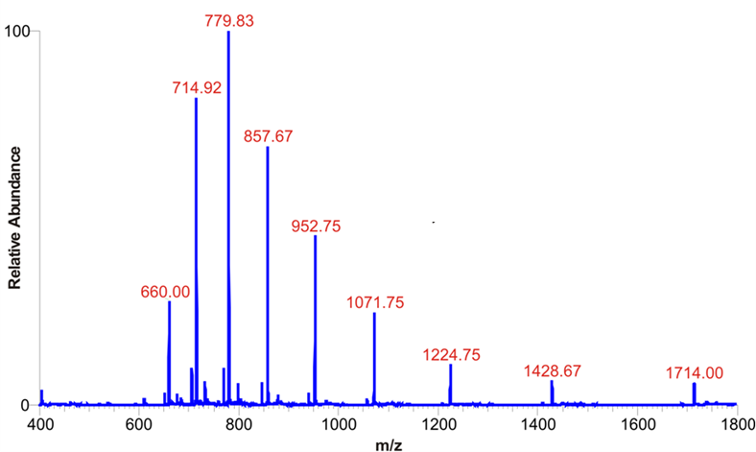

Figure 2. ESI-MS spectrum of bovine ubiquitin from Protea Biosciences (https://proteabio.com/products/PS-143)

3. Using Equation (2) and any pair of peaks from Figure 2, calculate the molecular weight of ubiquitin and its percent error compared to the theoretical monoisotopic mass of 8560 amu.

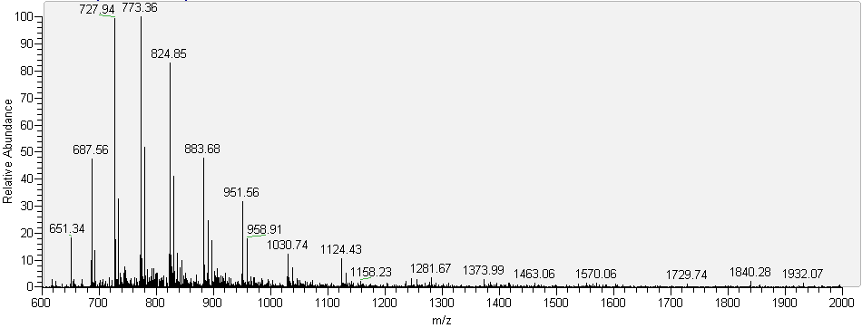
Figure 3. ESI-MS spectrum of cytochrome C. Data obtained at Trinity College.
4. Figure 3 shows the ESI-MS spectrum for cytochrome C electrosprayed from a mixture of water, methanol, and acetic acid with pH of 2.5. What is the charge state of the peak at m/z = 773.36?
5. Determine the MW of the analyte, cytochrome C, using the data in Figure 3.
6. How would you expect the mass spectrum to change if the cytochrome C sample was electrosprayed from a solution of higher pH? Explain your answer.
7. Note that in the ESI-MS spectra for ubiquitin and cytochrome C, each major peak is accompanied by a series of less intense peaks of slightly different m/z. What is the source of these peaks?
8. Compare your description of the ion trap mass analyzer video with your group mates’ descriptions. As a group, write a consensus explanation for how an ion trap works.

References and Resources
G.L. Glish and R.W. Vachet, “The basics of mass spectrometry in the twenty-first century,” Nat. Rev. Drug Discov., 2003, 2, 140-150.
C. Hendrickson, “Electrospray Ionization (ESI)”, https://nationalmaglab.org/user-facilities/icr/techniques/esi
C.S. Ho, et al. “Electrospray ionization mass spectrometry: principles and clinical applications,” Clin. Biochem. Rev. 2003, 24, 3-12.
J.R. Yates, “A century of mass spectrometry: from atoms to proteomes,” Nat. Methods, 2011, 8, 633-637.
J. Yergey, et al. “Isotopic distributions in mass spectra of large molecules,” Anal. Chem. 1983, 55, 353-358.

