CALIBRATION METHODS

OBJECTIVES

- Identify different methods to calibrate instrumentation or analytical methodologies
- Choose proper calibration method depending on sample characteristics or instrument.
- Describe how standards and/or samples are prepared for each calibration method.
- Calculate concentration from information obtained from each calibration method

INSTRUCTIONS

You must work this handout with your peers. Each section has a STOP sign. When your group reaches it, please stop and share your results. Professor will give instructions then.

This worksheet has been developed based on the book: Harvey, D. Analytical Chemistry 2.0. http://www.asdlib.org/onlineArticles/ecourseware/Analytical%20Chemistry%202.0/Text_Files_files/Chapter5.pdf

CALIBRATION METHODS

Calibration or standardization determines the relationship between the analytical response from an instrument and the analyte concentration. This relationship allows then to determine the concentration of the analyte in an unknown sample. There are several methods of calibration. This handout reviews each method and its calculations. There are direct calibration, standard addition and internal standard addition methods, among others. Each calibration method is used in different scenarios but always help to identify the concentration of the analyte.

Calibration is an integral part of quality control and quality assurance. It warrants that the instrument and/or method is working properly and as expected. Calibration curves characteristics or calibration results may be compared with previous days to identify if instrument is working as expected or signal is drifting, for example. If calibration results are not what it was expected, instrumentation or method should be reviewed before continuing.

You have done several calibrations in your undergraduate laboratories. Discuss with your peers when you have done calibrations and what they were used for. Fill out the following table.

Course | Experiment | Instrument Calibrated | How did you do it?

Share your information with your peers.



Direct Calibration

This is a very commonly used standardization method. To use it,
- Solutions of known concentration are prepared, (we call them standards).
- Instrumental signal of the standard solutions are recorded
- Instrumental signal of the samples are also recorded.
- Signal of the samples are compared with those from the standard solutions, assuming that the instrumental signal is proportional to the concentration as: S_{A} = k * C_{A}
- Either one standard or several standards, to create a calibration curve, may be used.

One standard calibration (one point calibration)

You will find this calibration method in many very well stablished methods for environmental samples analysis or even water analysis in treatment plants. This method works when it has been widely proven it is robust enough.

Answer the following questions and problem with your group. Prepare to share answers and results with the class.

- A spectrophotometric method for the quantitative determination of Pb²⁺ in blood produced a signal of 0.474 au for a 1.75 ppb standard solution. You need to report Pb²⁺ concentration in a blood drop that produces a signal of 0.361 au.

- Which one is the analyte?

- Which one is the sample?

- How much is the concentration of the standard solution?

- How much is the signal of the standard solution?

- How much is Pb²⁺ concentration in the blood sample?

- What advantages does this calibration method have?

- What disadvantages does this calibration method have?

- Will calibration results be affected if the sample was water?

Direct calibration – Multiple standard or calibration curve.

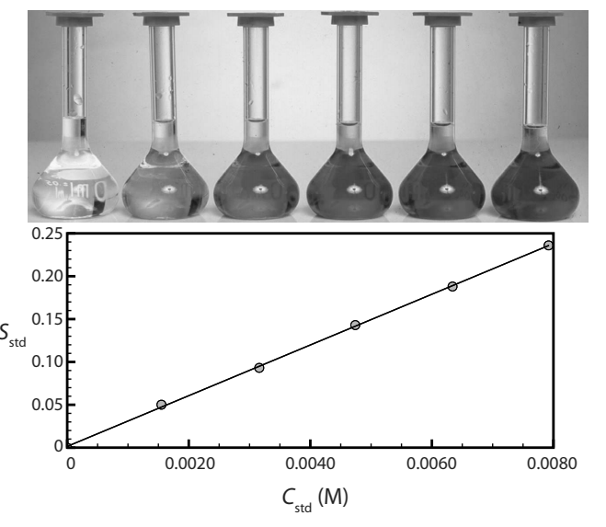
When using this method signal of several solutions are recorded and then plot in a graph of signal vs concentration. Of that plot, an equation, (usually lineal: y = mx + b) is obtained. Concentration of the samples is obtained by substituting sample signal (y) and resolving for concentration (x).

- Another spectrophotometric method for the quantitative determination of Pb²⁺ in blood uses a calibration curve with several standard solutions. Results gave a calibration like the one on the right and a linear equation:

S_{estd} = (0.296 ppb⁻¹) * C_{estd} + 0.003

  - What is Pb²⁺ concentration in a sample that produced a signal of 0.397 au?

  - What advantages does this calibration method have?

  - What disadvantages does this calibration method have?

  - Will calibration results be affected if the sample was water?

A disadvantage of the previous calibration methods are that the standard solutions need to be as similar to the sample as possible, to avoid matrix interference.

- In the determination of Pb²⁺ in blood, which is the matrix?

For example, if water is being analyzed, standards are prepared in aqueous solutions, however, if benzene dissolved in hexane is being determined; standards have to be made in hexane as solvent. Because, instruments may give different responses if aqueous or organic solvents are being used.

- Which of the following pairs may have more complex matrix:

    - Rain water or seawater ______________________

    - Blood or drinking water ______________________

- In which of those solutions, matrix interference, may affect more instrumental signal of a spectrophotometer?
    - ________________________________

    - ________________________________

- Would that affect the results?

- Will the instrumental signal be larger, smaller or the same if matrix interference is present? Can you predict it?

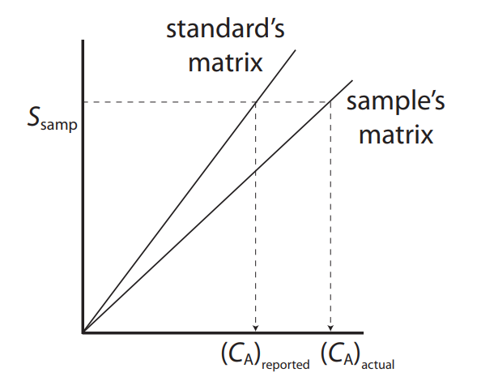
Left graph shows a calibration curve of standard solutions, one is made in aqueous solutions (standard matrix) and the other with standards prepared in matrix similar to the sample (sample’s matrix). For example: to analyze seawater the standard’s matrix may be prepared in distilled water, while the sample’s matrix standards were prepared using a saline solution.

- What differences are between the curves?

- Which one of the calibration curves is more sensible?

- If this was done to analyze seawater, would you recommend using the one or multiple calibration point method with standards prepared in distilled water?

- Does the matrix affect the response of the instrument? Will that affect the quality of the results? How?

- What would you recommend?
NOTE: To create a robust method, matrix interferences have to be tested!

Standard addition method

This method is highly recommended to evaluate/compensate for matrix interferences in the analysis and for complex matrix samples.
To use it,
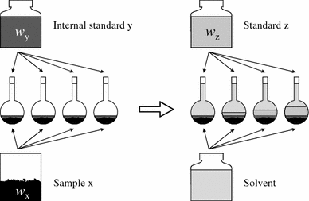
- Solutions of known concentration are prepared (standards z).
AAAAAAAA
- To each of those standards a known and similar amount of the sample (x) is added before completing volume with the solvent.
- Instrumental signal of the standard solutions are recorded
- Sample concentration by extrapolation of the lineal equation to y = 0
- Either one standard or several standards, to create a calibration curve, may be used.

A single point standard addition is done by preparing one standard with the sample, and recording the signal of this standard with the sample and the diluted sample by itself. For multiple standard addition calibration, several standards are prepared and a lineal equation is used to calculate the concentration of the sample.

One point standard addition –Single standard

- A third spectrophotometric method to determine Pb²⁺ in blood gave a signal of 0.193 when 1.00 ml of the samples was diluted up to 5 ml. To a second blood sample, 1.00 ml, 1.00 µl of the standard solution of 1560 ppb Pb²⁺ and then diluted up to 5 ml. This new sample gave a signal of 0.419.

  - How much blood did you use?

  - What was done to the first sample?

  - What different was done to the second sample?

  - What is concentration of Pb²⁺ in the blood sample?

ADDITIONAL EXERCISE…

- Ascorbic acid (vitamin C) was determined by an electrochemical method in 50.0 ml orange juice sample. A current of 1.78 µA was obtained. When a similar solution was mixed with 0.400 ml of the 0.279 M ascorbic acid, current increased to 3.35 µA. What is the concentration of the ascorbic acid in the sample?

Standard Addition with Multiple solutions.

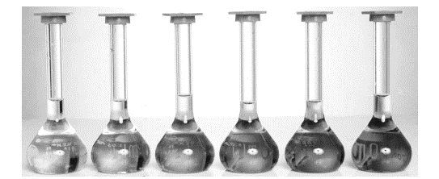
The figure on the left shows several standard solutions used for standard addition. Solvent was water and each of them contain 25 ml of the sample.

- The first solution on the left have no standard. Why does it have color?

- From left to right, each solution contains 0.00, 1.00, 2.00, 3.00, 4.00 y 5.00 ml of a 100.6 mg/l of analyte solution. Does that explain why the solution in the far right is darker? Why?

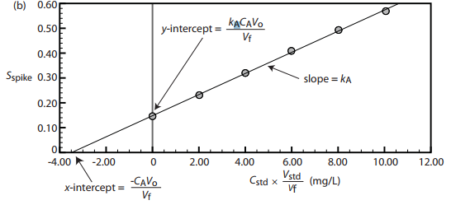
Signal of each solution was recorded and plotted vs the concentration of each solution. When observing the plot, why the line does not cut y-axis in 0 mg/l?

- To calculate the concentration of the sample, x intercept is calculated by replacing y = 0 in the line equation (y = mx + b) and solving for x.

Sometimes, the plot may be done using volume of standard added, instead of its concentration. In those cases, remember to convert the volume of the analyte in the sample to concentration.

- Another spectrophotometric method to determine Pb²⁺ in blood requires a standard addition calibration curve. Standards were prepared by adding 1.00 ml of blood to each one, and an external standard of 1560 ppb de Pb²⁺ was added. All the samples were diluted to 5.00 ml before measuring the signal. A calibration curve of signal vs volume of standard added produced an equation of:
Signal = 0.266 + 312 ml⁻¹ * V_{std}
  - What is concentration of Pb²⁺ in the blood sample?

  - Could we use the same calibration curve for other blood samples? Why?

  - Could we use the same calibration curve to determine lead in seawater?

  - What advantages does this calibration method have when compared to a direct calibration?

  - What disadvantages does this calibration method have when compared calibration?

  - Would you recommend this method to analyze any kind of blood sample: adult, baby, fly blood? Consider sample size.

Internal Standard

When the instrumental signal or experimental procedure may produce changes in the results, an internal standard may be used to compensate for those problems. This method is based on the fact that the ratio of concentration between the internal standard and the analyte remains constant, even when instrument drift or sample is lost during treatment or not completely introduced in the instrument, for example. Under those circumstances, both the sample and the internal standard are lost, but the ratio of concentrations (analyte concentration / internal standard concentration) remain the constant, and so the ratio of signals remain constant (analyte signal/internal standard signal).
To use the internal standard method:

- Solutions of known concentration of the analyte are prepared (standards z).
- To each of those standards a known and similar amount of the internal standard solution
- Similar amount of the internal standard is added to the samples too.
- Volume is completed with the solvent.
- Instrumental signal of the analyte and the internal standard are recorded
- Ratio of analyte signal/internal standard signal are plot against the concentration of the analyte in the standard solutions.
- Ratio of analyte signal in the sample / internal standard is calculated
- A linear equation (y=mx + b) is obtained. Concentration of the analyte is calculated by solving for x when y is the ratio of analyte signal/internal standard signal in the unknown sample
- Either one standard or several standards, to create a calibration curve, may be used.

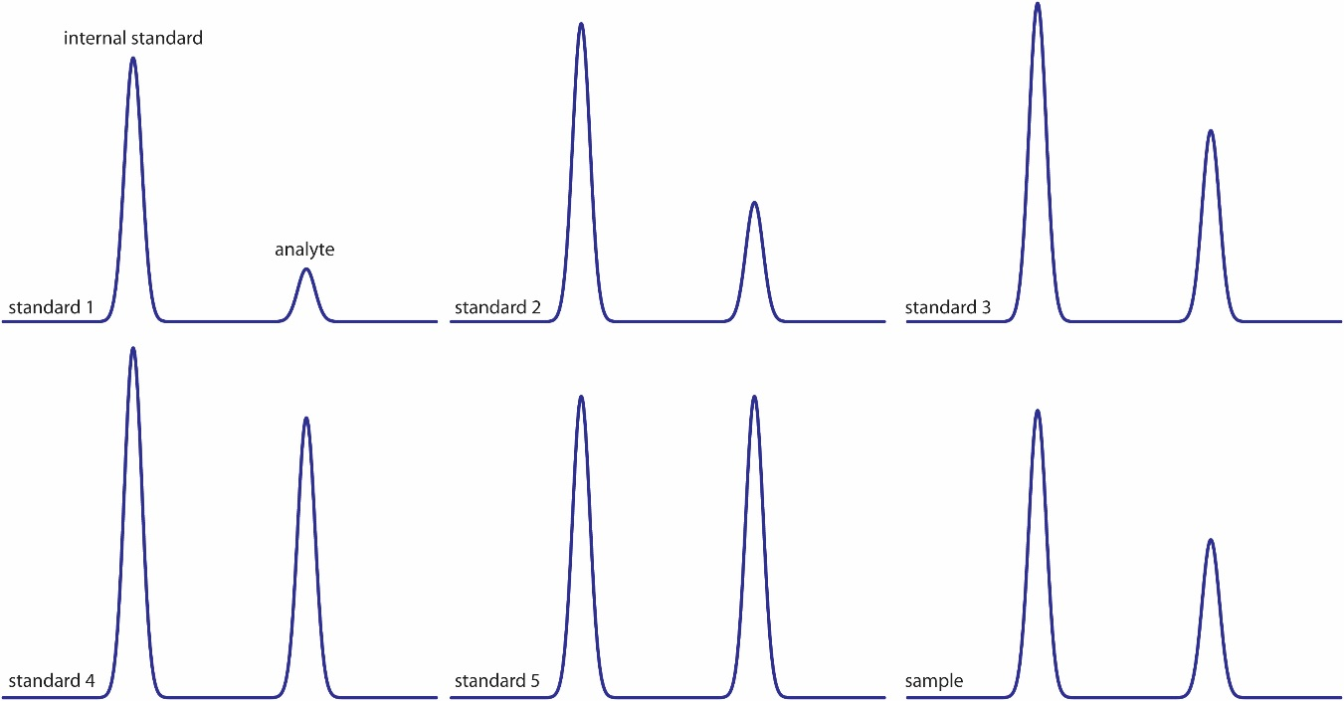

The previous image shows six chromatograms of two compounds for a calibration curve with an internal standard.
- The first peak is the internal standard. What happens to its height trough the figures?

- The second peak is the one for the analyte. What happens to its height through the figures?

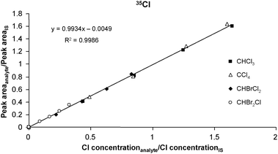
When plotting the peak area of the analyte divided by the peak area of the internal standard (IS), vs the concentration of the analyte divided the concentration of the internal standard, a calibration curve is obtained.

Internal Standard – one point

- Another spectrophotometric method for the determination of Pb²⁺ in blood uses Cu²⁺ as internal standard. A standard with 1.75 ppb Pb2⁺ and 2.25 of Cu²⁺ gives a signal ratio of 2.37. A blood sample, to which the same amount of internal standard was added, gave a S_{A}/S_{EI} de 1.80.
  - Which compound is the internal standard? Which one is the analyte standard?

  - Should you add the same amount of internal standard to the sample?

  - What advantages does this calibration method have when compared to a direct calibration?

  - What disadvantages does this calibration method have when compared calibration?

  - When would you recommend using an internal standard calibration?

  - What characteristics should the internal standard have?

  - What is the concentration of lead in the blood sample?

  - Could you use the same results for the standard with the internal standard ratio for other blood samples?

ADDITIONAL EXERCISE…

- In a chromatographic analysis, a solution was prepared with 0.0837 M Octane (A) and 0.0666 M nonane (B). Each one produced a peak area of A_{A} = 423 y A_{B} = 347.
10.0 ml of 0.146 M nonane was added to 10 ml of an unknown sample, and the sample diluted to 25 ml. The peak areas obtained were: A_{A} = 553 y A_{B} = 582.

  - Which one is the internal standard? Octane or Nonane?

  - What is the concentration of Octane in the unknown sample?

Internal Standard – Multiple standard solutions – calibration curve

- Another spectrophotometric method to determine Pb²⁺ in blood uses a calibration curve with internal standard. Several solutions were prepared with different concentrations of Pb²⁺, the same amount of internal standard Cu²⁺ was added to each one. A calibration curve was obtained:

S_{A}/S_{EI} = 2.11 ppb-1 * CA – 0.006
When the same amount of internal standard was added to the sample, the ratio of signals was: S_{A}/S_{EI} de 2.80.
  - What is the concentration of lead in the blood sample?

  - What advantages does this calibration method have when compared to other calibration methods?

  - What disadvantages does this calibration method have when compared to other calibration methods?

  - Could you use the results of the calibration curve for other blood samples? What would you need to do to those new samples?

FINAL REVIEW…

Fill up the following table:

Method | Sample treatment | Sample size needed | Advantages | Disadvantages
Direct calibration
Standard Addition
Internal Standard

