EDTA Chelation and Titrations
Reading: Chapter 13 (sections 1-6), Exploring Chemical Analysis 5th ed., D. Harris

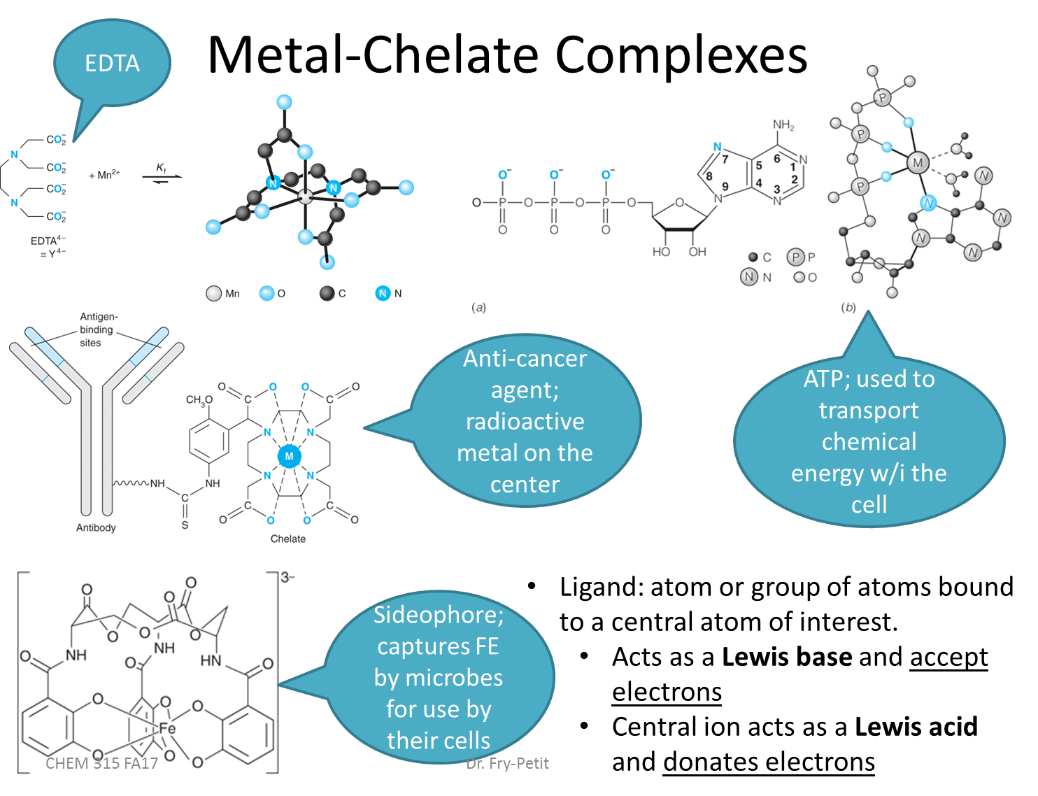
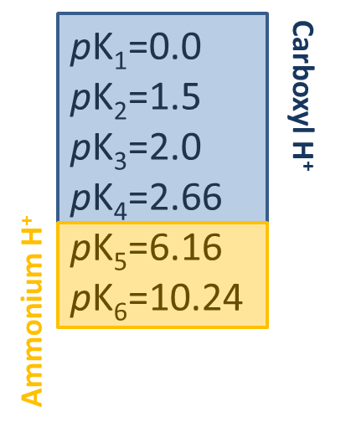
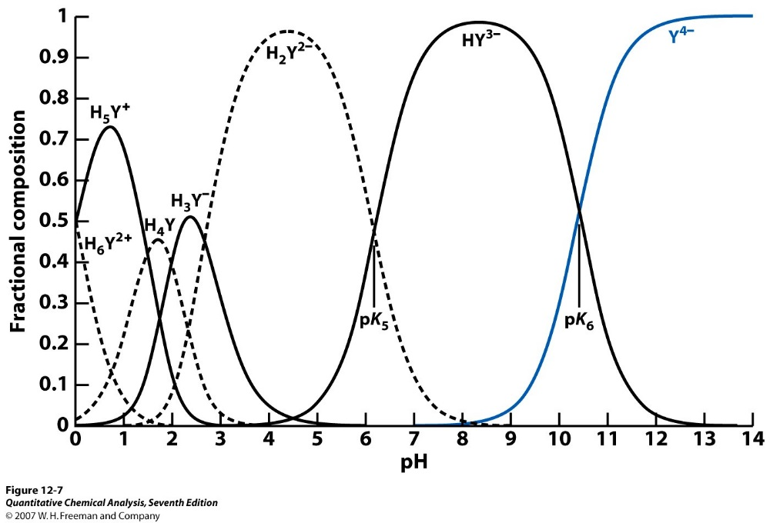
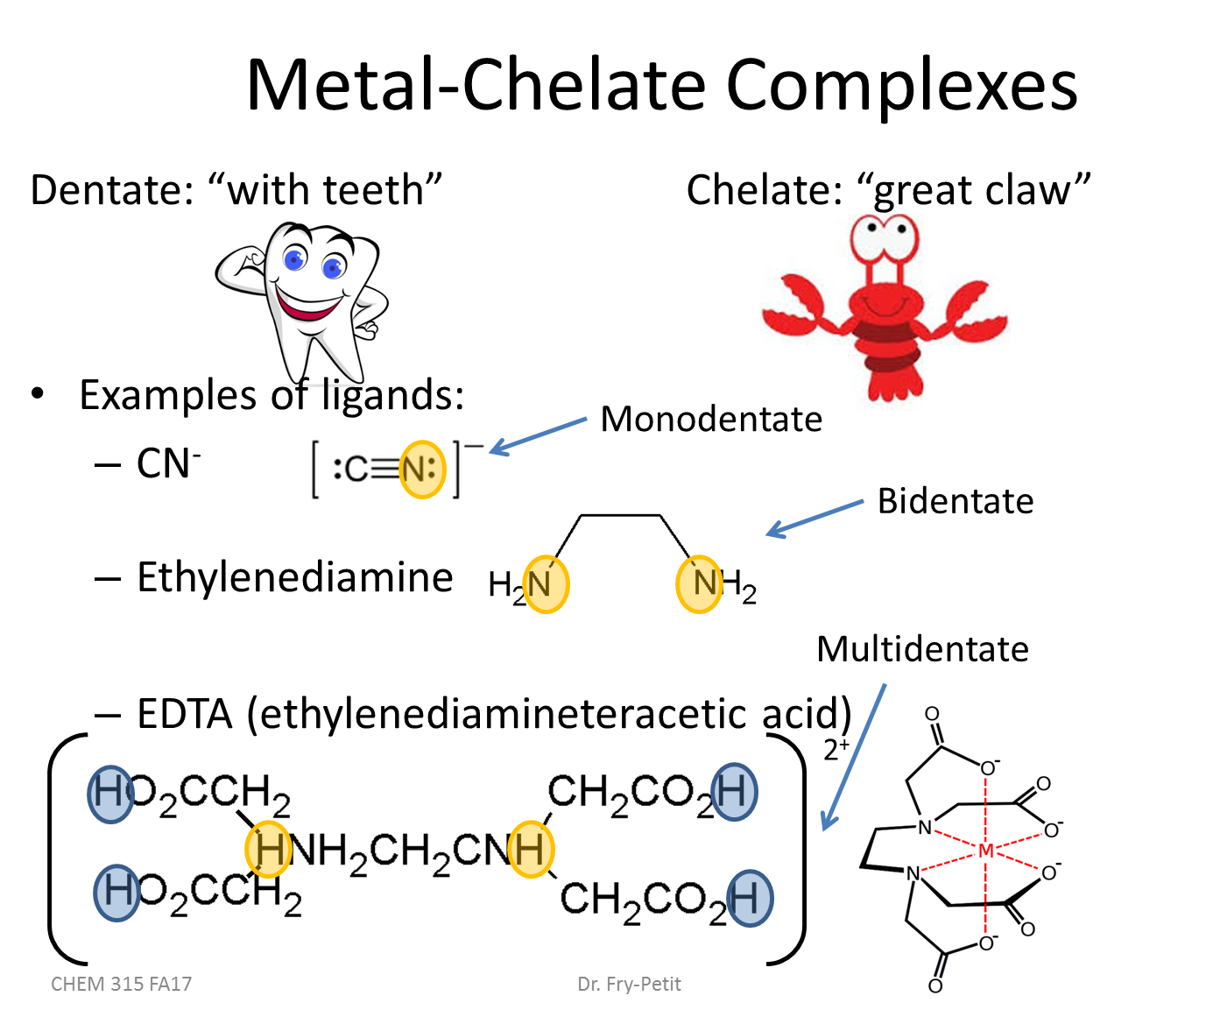

- Practically what does this fractional composition diagram mean for EDTA titrations?

STOP
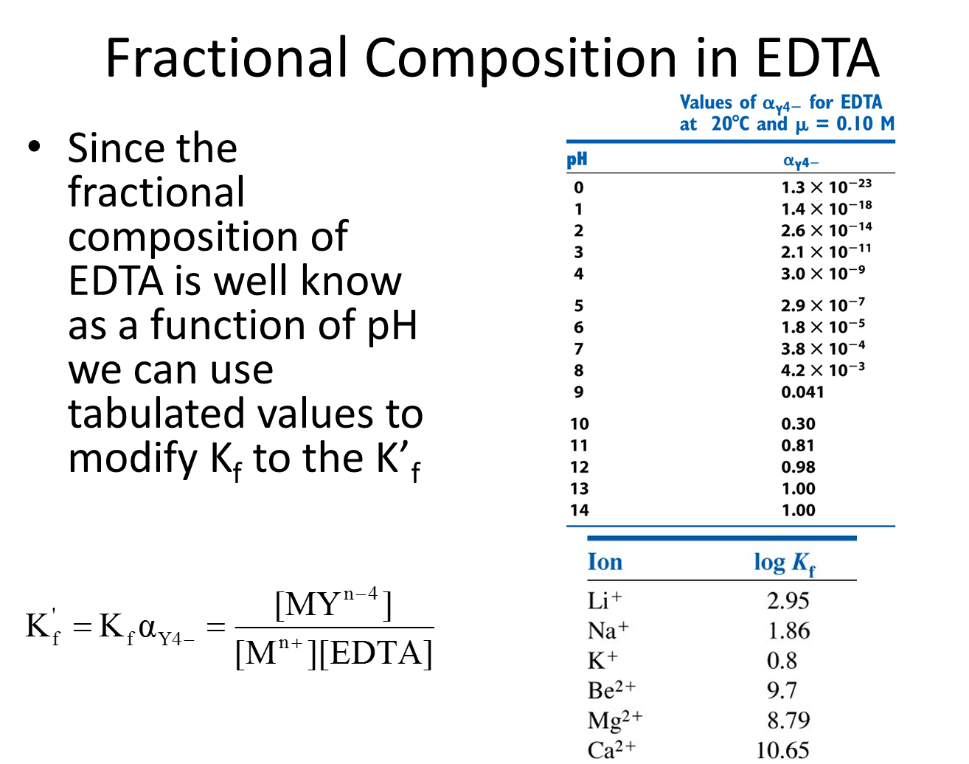

- Calculate the concentration of free Ca²⁺ in a solution of 0.10 M CaY²⁻ at pH 10.00 and at pH 6.00 with the conditional formation constant.
  - What is the rxn we are thinking about?

  - Use an ice table to determine the amount of free (uncomplexed) Ca²⁺

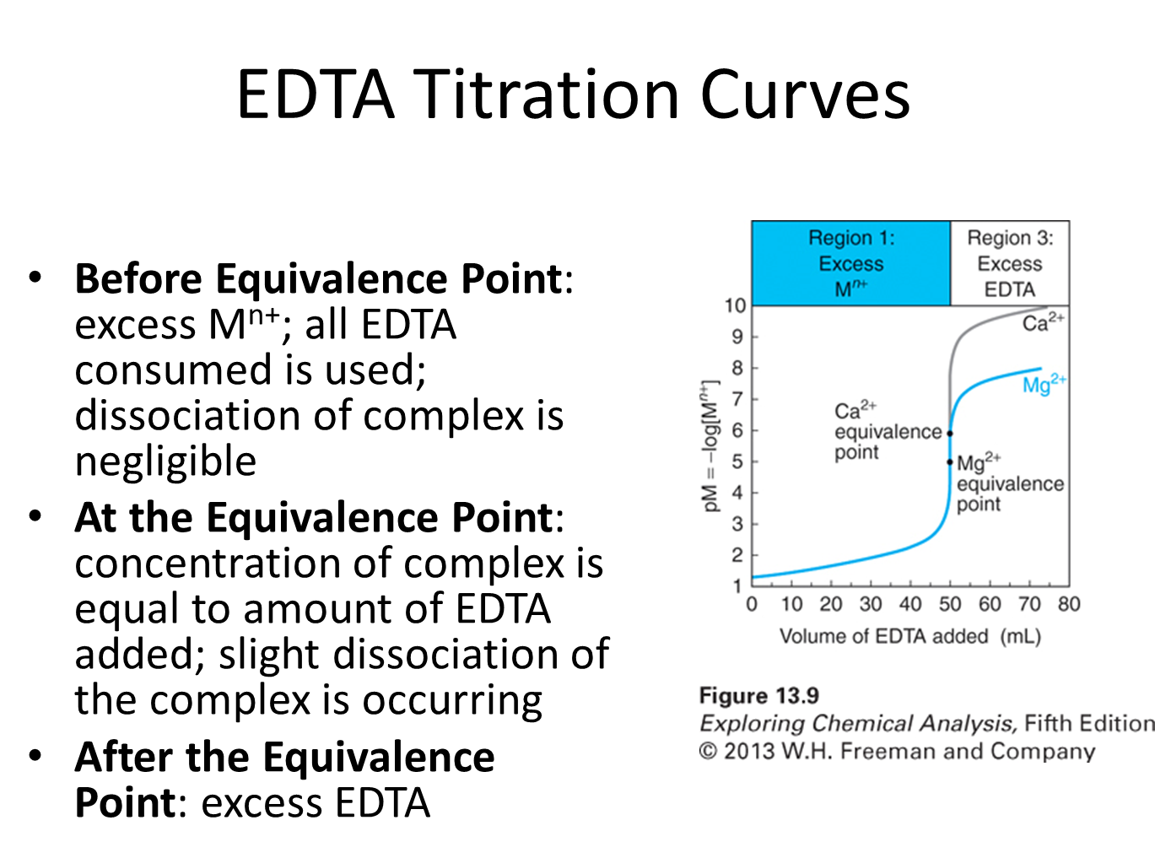
STOP
- Calculate the pCa²⁺ vs. mL EDTA for the reaction of 50.0 mL of 0.0400 M Ca²⁺, buffered to pH 10.00, with 0.0800 M EDTA at the following volumes.
  - Before the equivalence point: 5.0 mL EDTA

STOP
- At the equivalence point

STOP
- After the equivalence point: 26.0 mL

STOP
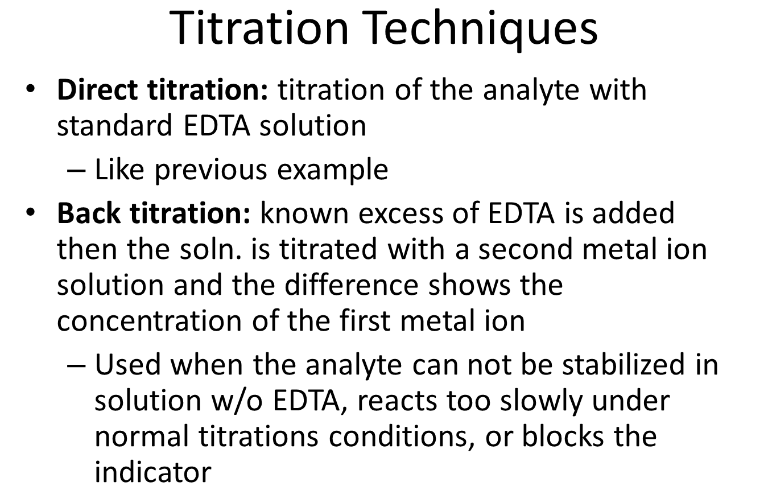
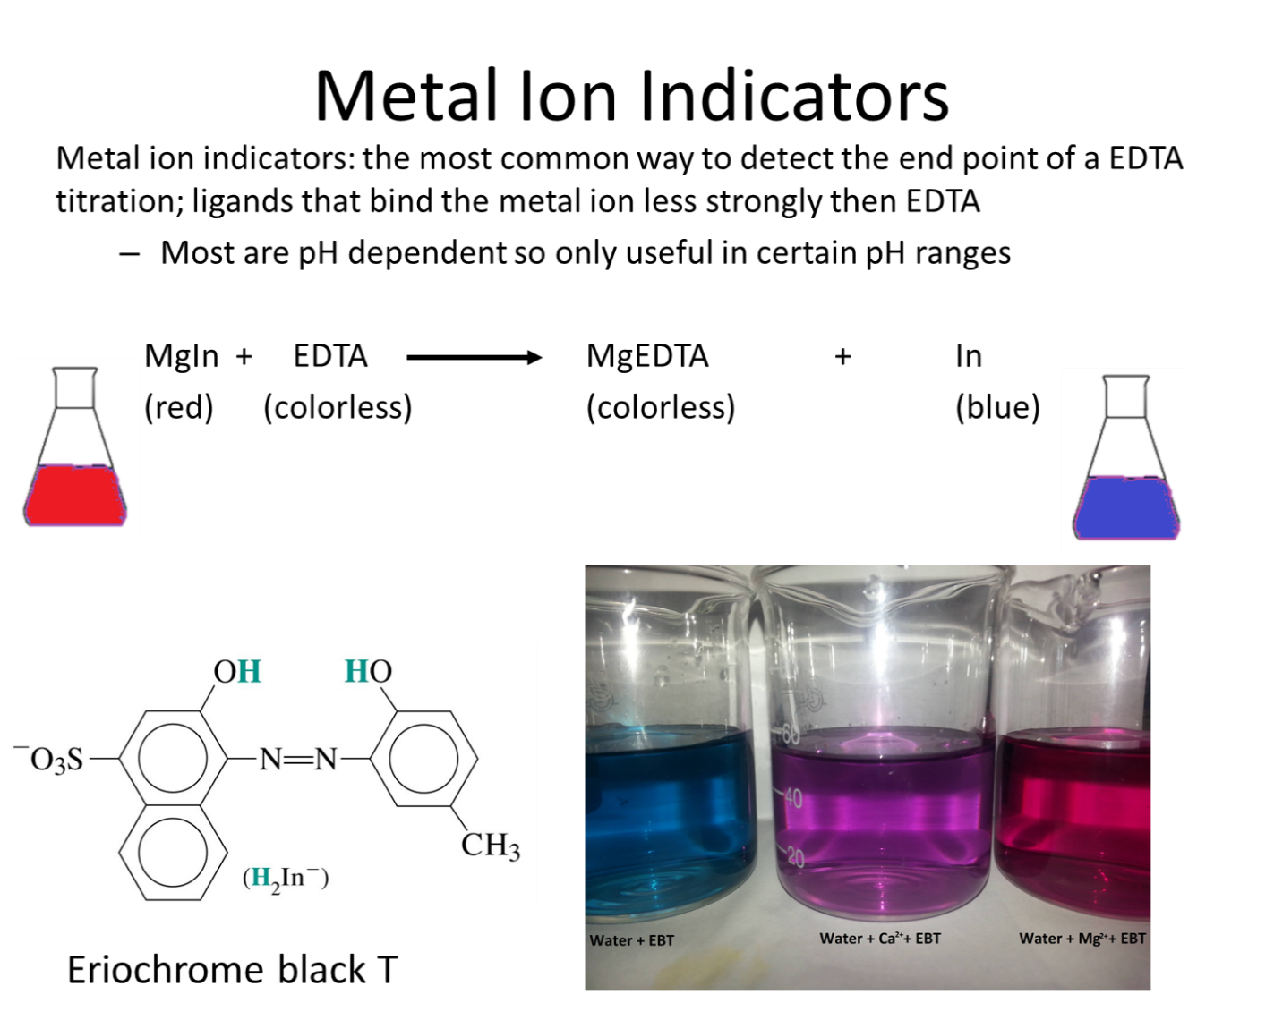
- Ni²⁺ can be analyzed by back titration, using standard Zn²⁺ at pH 5.5 w/ xylenol orange indicator. A solution containing 25.00 mL of Ni²⁺ in dilute HCl is treated w/ 25.00 mL of 0.05283 M Na₂EDTA. Titration w/ 0.02299 M Zn²⁺ requires 17.61 mL to reach the red end point. What is the molarity of the Ni²⁺?

STOP

