GC detectors
Learning Objectives
All students are expected to:
- Evaluate the suitability of three common detectors (FID, TCD, and ECD) for different analytes
- Explain the operation principle of these detectors
- Differentiate these detectors in terms of selectivity and other properties (destructive, bulk, concentration/ mass depending) with regard to their suitability for different application

Quiz GC Detectors
Provide handwritten answers and bring them to the class

- Define the limit of detection, dynamic range, linear range and also significance of these parameters when selecting a detector

- Describe how FID works, provide its significant characteristics and optimization parameters

- Describe how ECD works, and describe its typical operation parameters

- Describe how TCD works, and describe its typical operation parameters

- Define the main classifications of common chromatographic detectors and give examples in terms of:
- Concentration vs. mass flow
- Selective vs. universal
- Destructive vs. nondestructive

Flame Ionization detector (FID)
- Fill the missing labels for the FID detector diagram below.
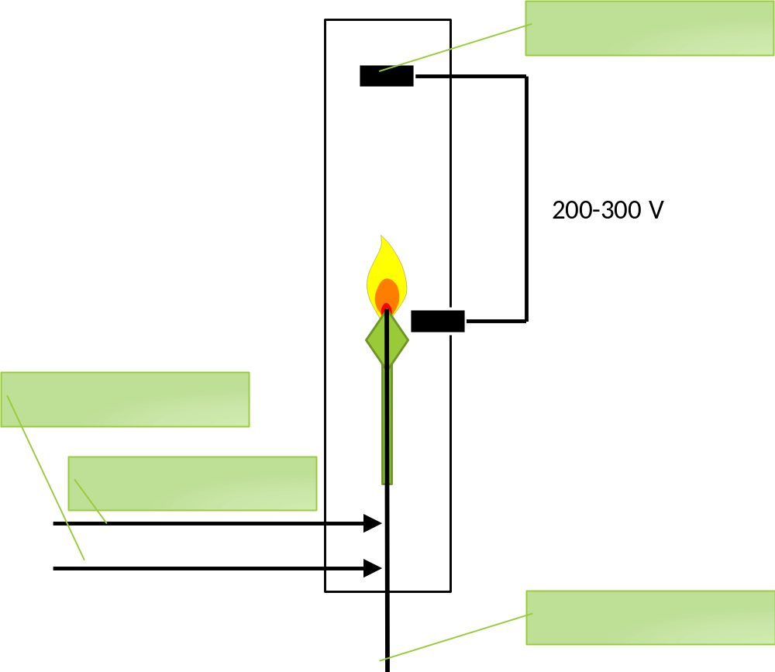

- Explain the purpose of using each gas.

- Explain the operational principle of FID.

- Which analytes can be analyzed on an FID and which cannot?

Thermal conductivity detector (TCD)
- Sketch the flow of the molecules in a single cell TCD for the 2 scenarios shown below
  - a reference gas passing through the filament
  - an analyte in a carrier gas passing through the filament

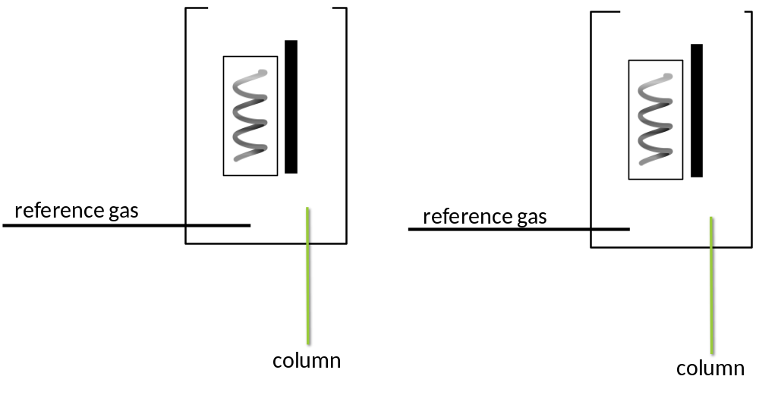
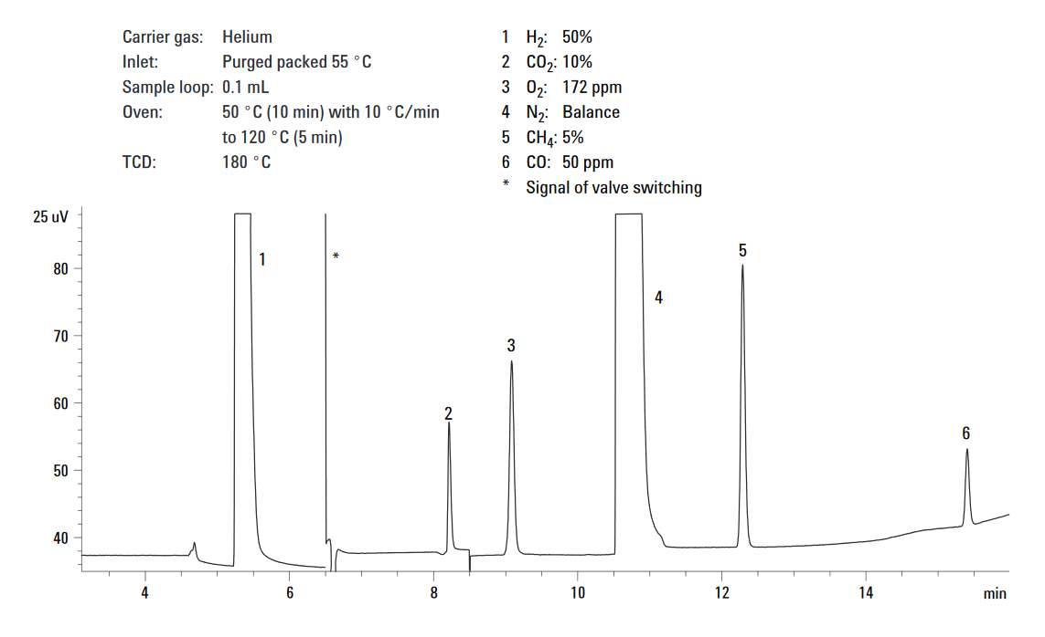
- Why is a valve switching required for the application shown below?
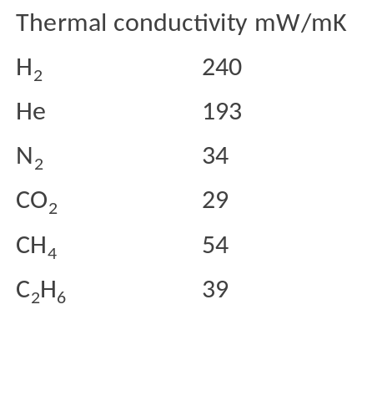

Hint: Consider thermal conductivities listed.

Electron Capture detector (ECD)
- Sketch fast β⁻ and thermal electrons e⁻, makeup gas and carrier gases, analyte species CX in the following three scenarios for ECD
  - Only the carrier gas is passing through the ECD
  - Both carrier and makeup gases are passing through the ECD
  - The carrier gas with an analyte and makeup gas are passing through the ECD
- b)
Column
N₂ or Ar with 5% CH₄
Makeup
Collector anode
⁶³Ni
Column
N₂ or Ar with 5% CH₄
Makeup
Collector anode
⁶³Ni

Column
N₂ or Ar with 5% CH₄
Makeup
Collector anode
⁶³Ni
2. Write three reactions, which occur in an ECD.

3. Which analytes can be analyzed using an ECD?
c)

GC detector characteristics
- List all possible detectors for the analytes in the following samples:

- Total petroleum hydrocarbons (TPH) in gasoline

- Nitrated polycyclic aromatic hydrocarbons (N-PAHs) extracted from air particulate matter

- Alcohol content in wine

- Chlorinated disinfectant products in water

- Polychlorinated biphenyls (PCBs) extracted from soil

- Hydrogen, CO₂, methane, ethane and propane from biofuel production

- Considering their sensitivity, highlight the detector of choice for the analytes listed above in those samples.

- What solvents used for extraction would be detrimental to the detectors proposed in response to Q2?

- Which detector is universal and would be suitable for all analytes and why is it not the detector of choice?

- For which application would it be suitable to use two detectors in series and what would be the benefits of such a setup?

