Gravimetric Analysis
Reading: Chapter 7 (sections 1, 3), Exploring Chemical Analysis 5th ed., D. Harris
Homework: Chapter 7:2-7, 9, 10, 14-16, 18, 21.a
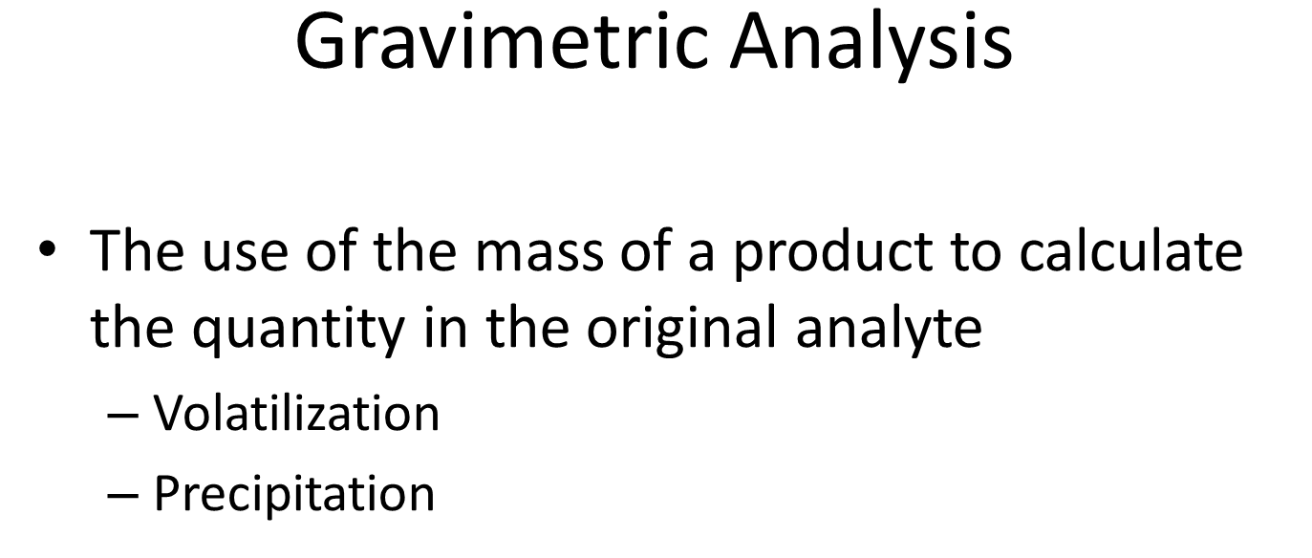
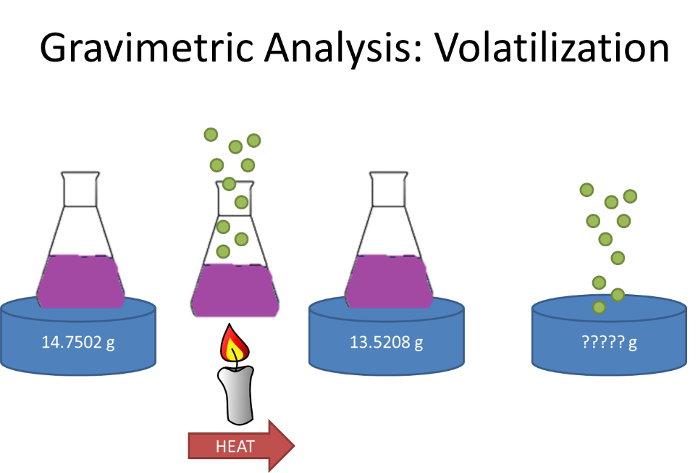

- How many moles of green K_{(g)} (FW=39.0983 g/mol) are evolved?

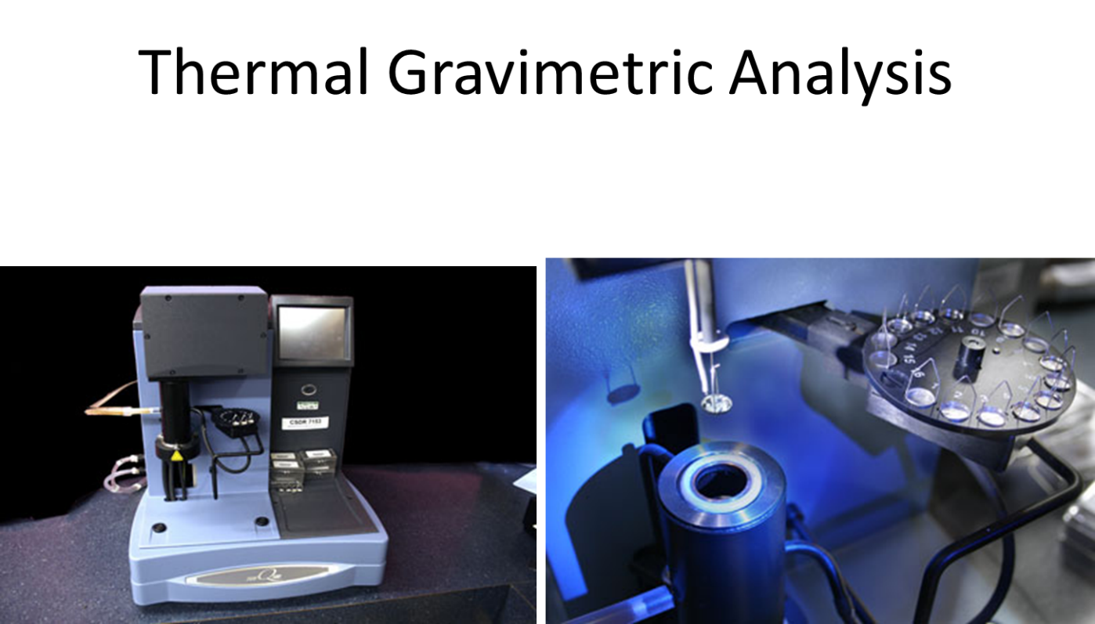
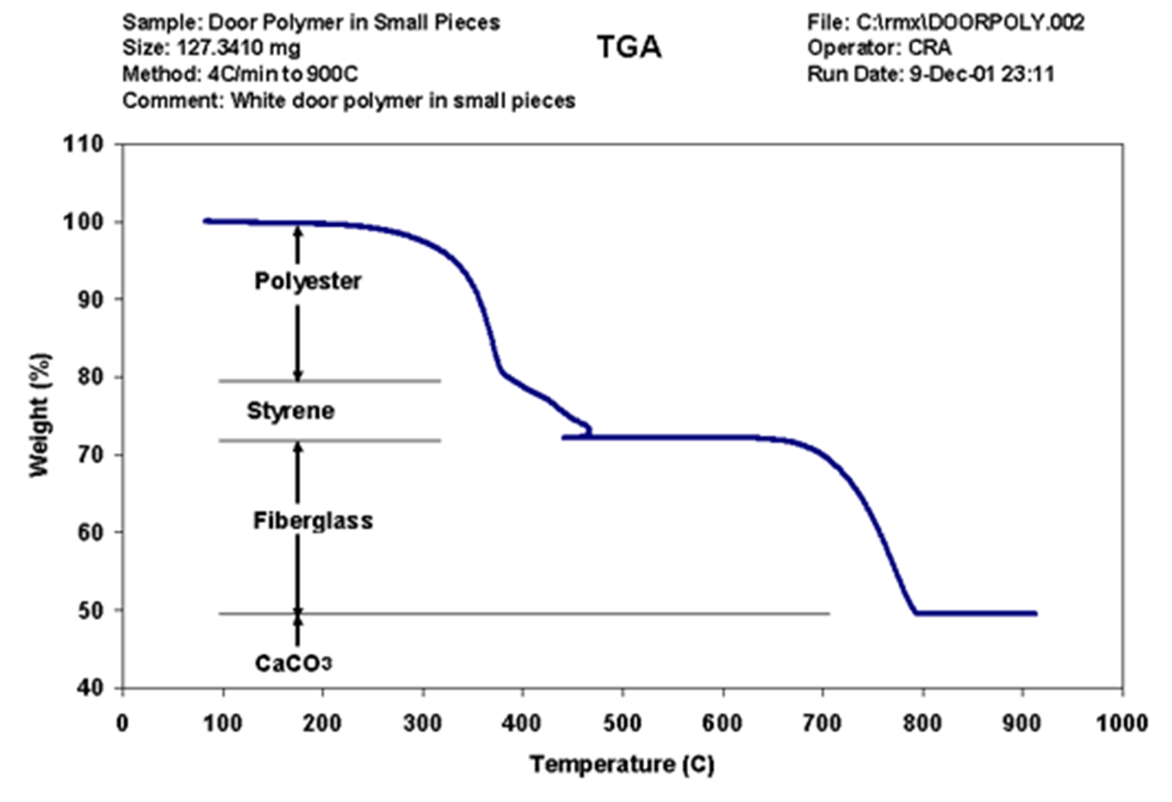
STOP
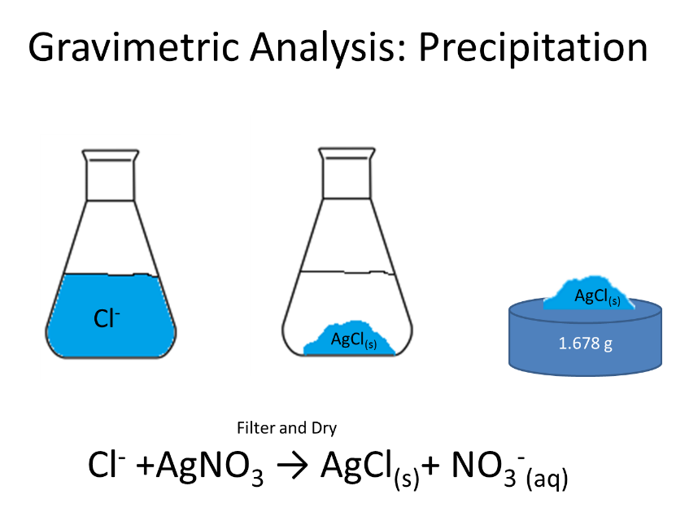
How many moles Cl⁻ were in the initial solution (AgCl, FW=143.321 g/mol) are evolved?

STOP
- As a group make a list of what you would want in a precipitate

STOP
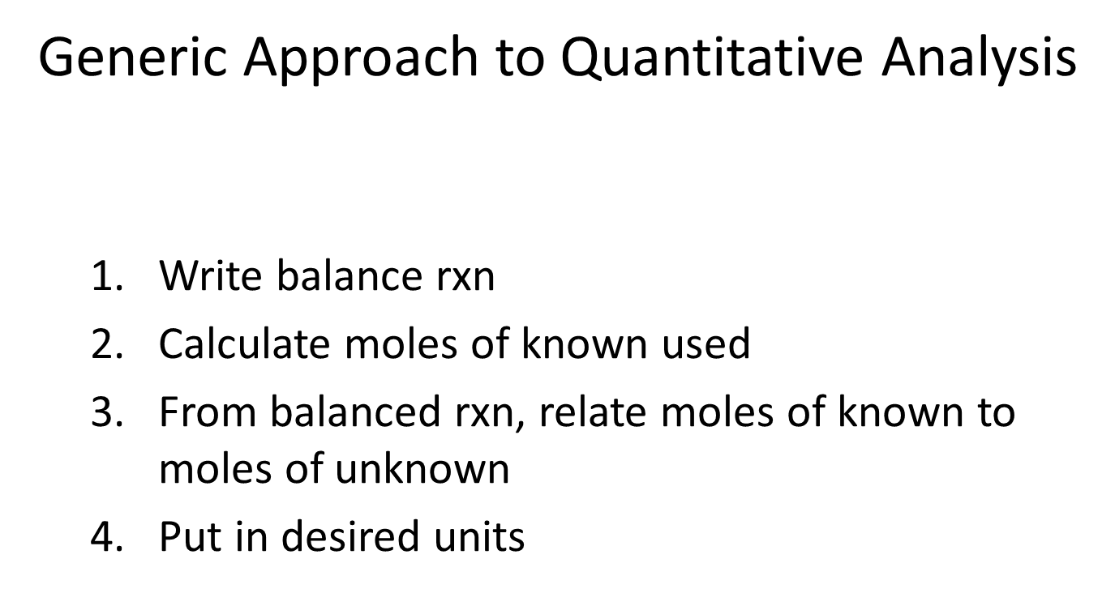
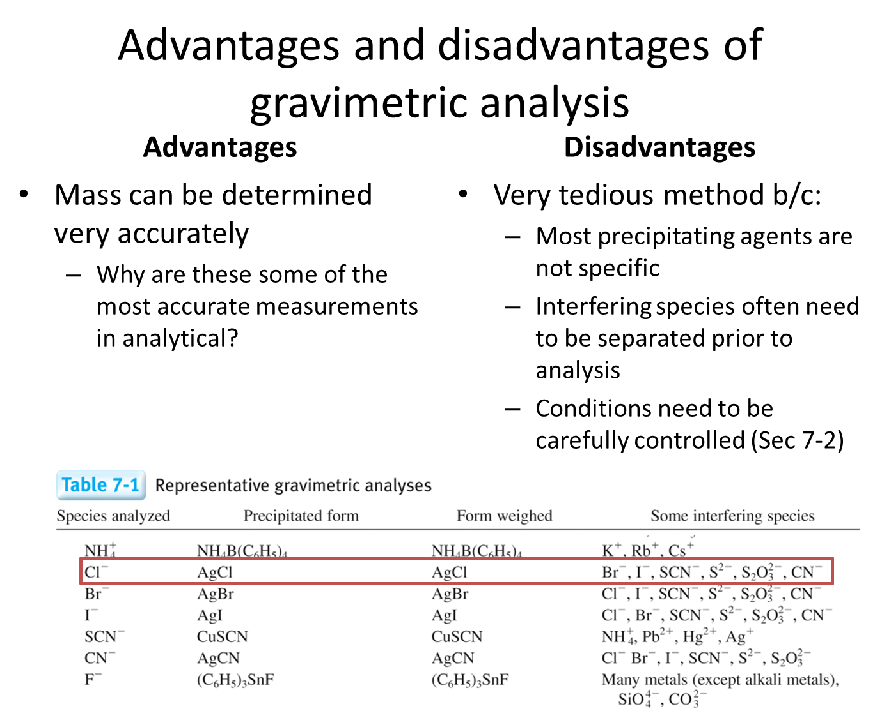
- In her Ph.D. research (Radioactive Substances, 1903), Marie Curie measured the atomic mass of the element radium, which she discovered. She knew that radium is in the same family as barium, so the formula of radium chloride is RaCl₂. When 0.09192 g of pure RaCl₂ was dissolved and treated with excess AgNO₃, 0.08890 g of AgCl precipitated. How many moles of Cl⁻ were in the RaCl₂?

STOP
- A mixture containing only Al₂O₃ (FW: 101.96) and Fe₂O₃ (FW: 159.69) weights 2.019 g. When heated under a stream of H_{2(g)}, the Al₂O₃ is unchanged, but the Fe₂O₃ is converted to metallic Fe plus H₂O_{(g)}. If the residue weights 1.774g, what is the weight percent of Fe₂O₃ in the original mixture?

STOP
- A 1.475g sample containing NH₄Cl (FW 53.492), K₂CO₃ (FW 138.21), and inert ingredients was dissolved to give 0.100 L of solution. A 25.0 mL aliquot was acidified and treated with excess sodium tetrapheylborate, Na⁺B(C₆H₅)₄⁻, to precipitate K⁺ and NH₄⁺ ions completely:
B(C₆H₅)₄⁻+K⁺ (C₆H₅)₄BK_{(s)} (FW 358.33)
B(C₆H₅)₄⁻+NH₄⁺ (C₆H₅)₄B NH_{4(s)} (FW 337.27)
The resulting precipitate amounted to 0.617g. A fresh 50.0 mL aliquot of the original solution was made alkaline and heated to drive off all the NH₃:
NH⁺₄+OH⁻NH_{3(g)}+H₂O
It was then acidified and treated with sodium tetraphenyl borate to give 0.554 g of precipitate. Find the weight percent of NH₄Cl and K₂CO₃ in the original solid.

STOP

