Solubility and Ionic Strength
Reading: Chapter 12 (sections 1-2)
Homework: Chapter 12: 2, 4, 5, 9-13.b, 14-19
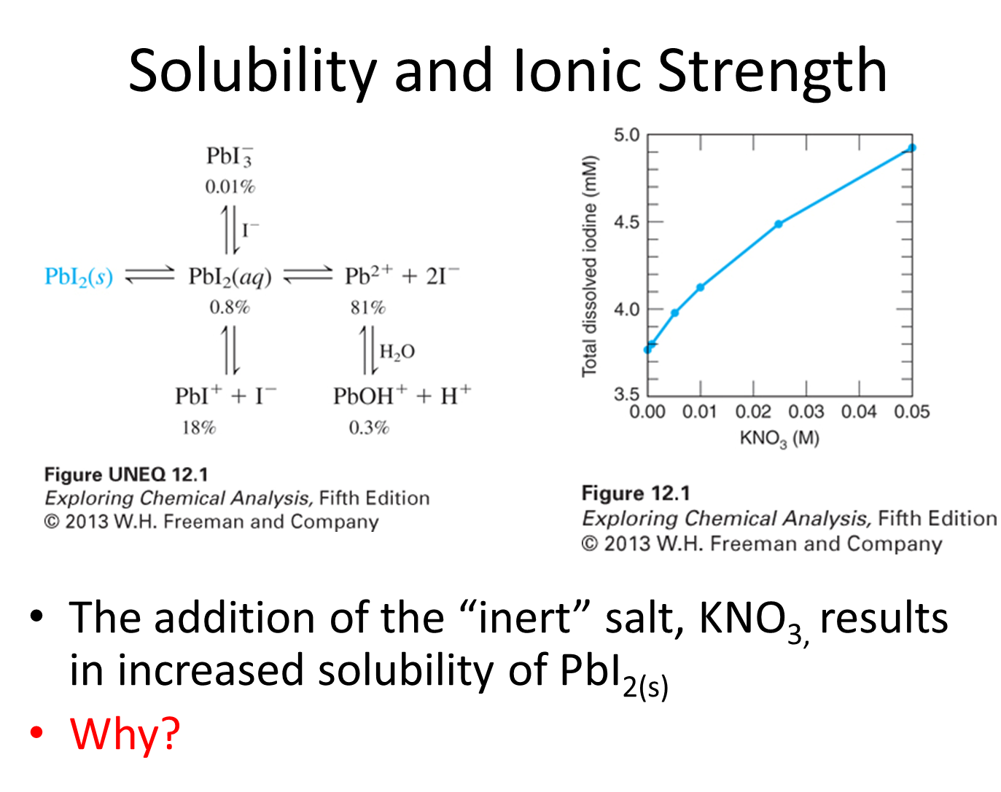
- What was the effect of NaI on the solubility of PbI₂? Why?
PbI_{2(s)}Pb²⁺+2I⁻

- What is the effect of adding KNO₃ to the above rxn? Why?

STOP
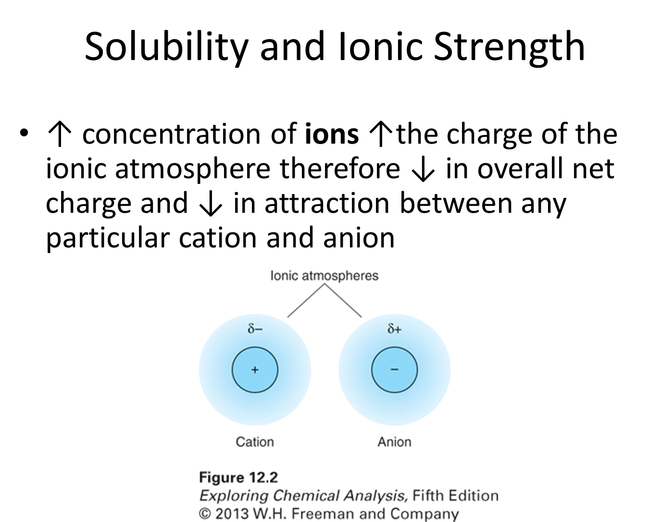

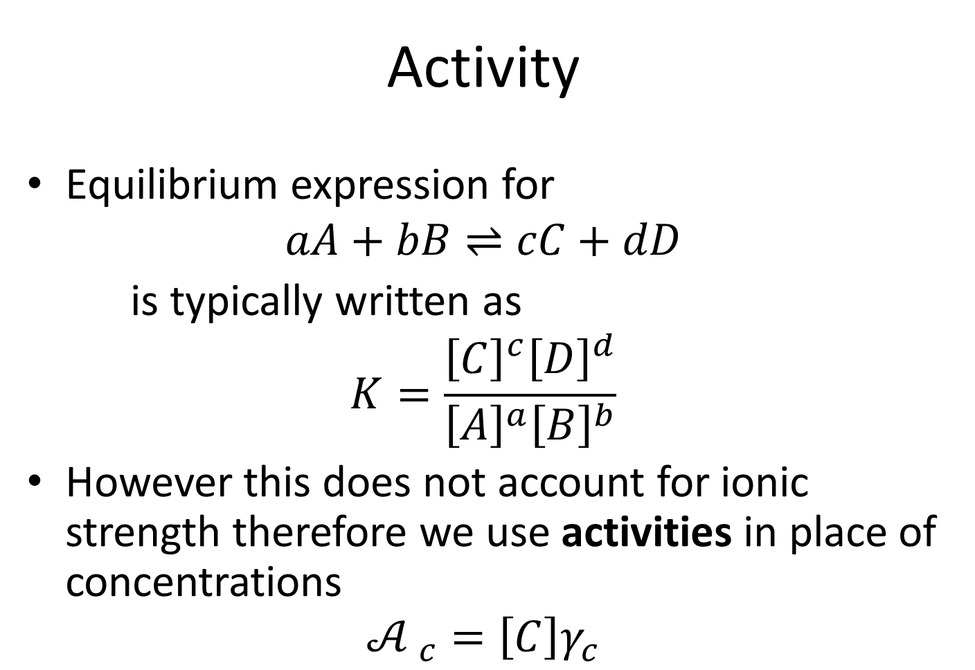
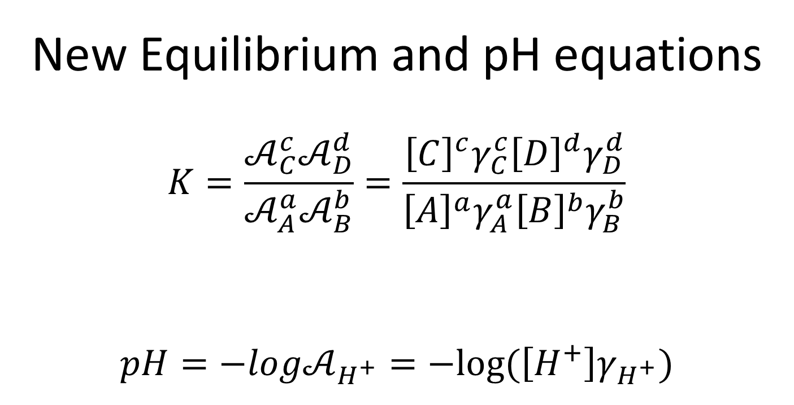

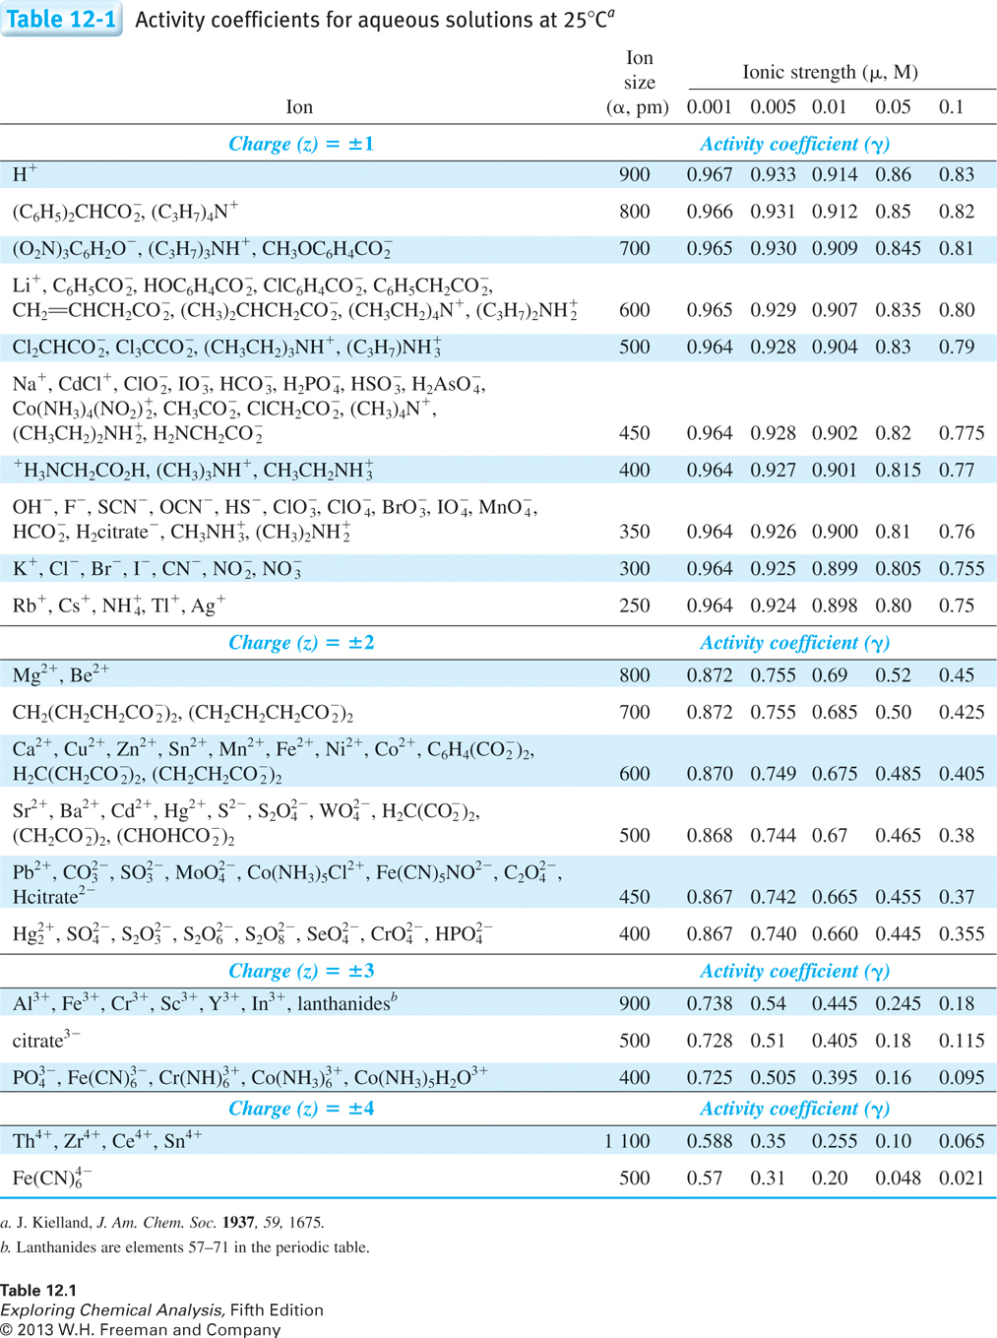
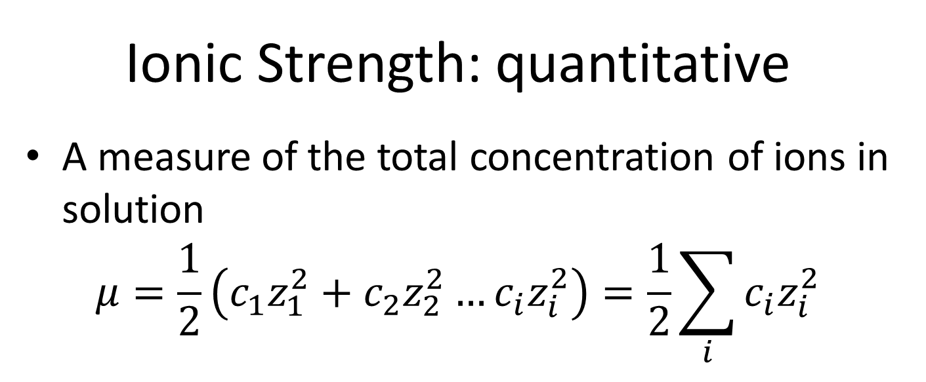
- What is the ionic strength of a 0.00333 M solution of PbI₂ and the activity coefficient of Pb²⁺ and I⁻?

STOP

- Calculate the solubility of 0.00333 M PbI₂ (K_{sp}7.9×10⁻⁹) solution with 2 different scenarios.
  - Assume PbI₂ solubility is low enough not to effect ionic strength.

  - Assume PbI₂ solubility effects ionic strength.

  - How does the solubility differ and how can you explain the difference?

STOP
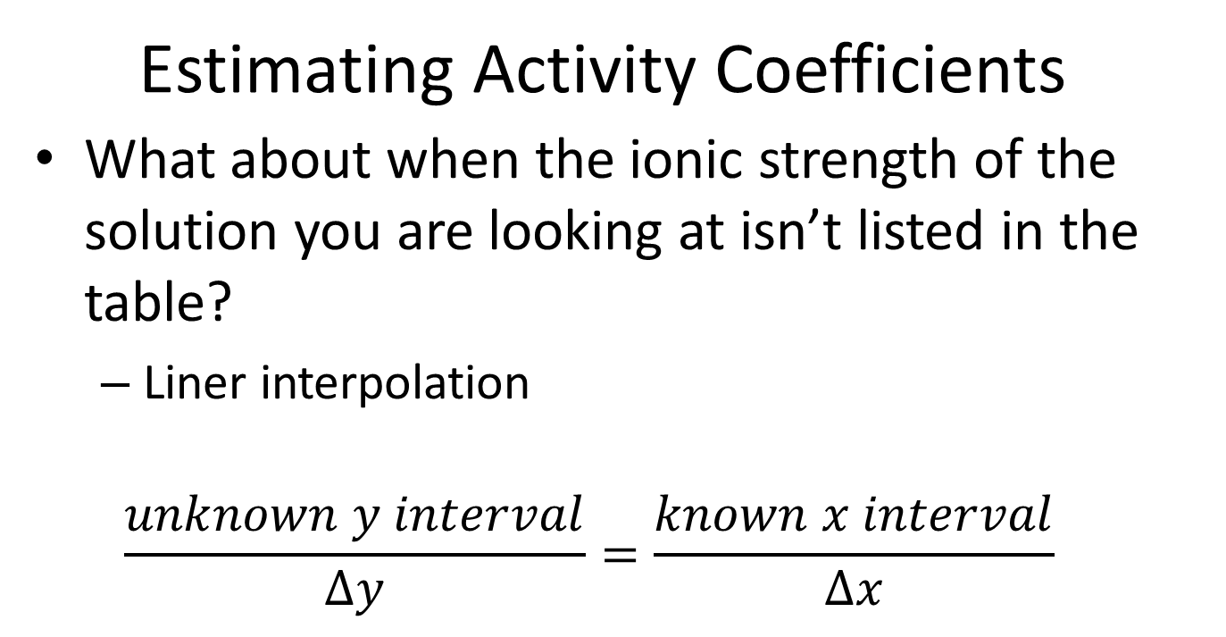
- Calculate the ionic strength and solubility of a saturated solution of 0.0125 M PbI₂ with 0.05 M NaCl. Assume PbI₂ solubility effects ionic strength.
  - Calculate the ionic strength

STOP
  - Interpolate to determine the $γ_{{Pb}^{2+}}$ and $γ_{I^{-}}$

  - Determine the solubility

