Optical Properties of Gold Nanoparticles
Background Information
Nanoparticles have diameters of 1-100 nm, so a 1 nm particle has a diameter of 1 x 10⁻⁹ m. Nanoparticle research is currently a very active field of investigation due to a large variety of applications spanning from medicine (1), optics and electronics (2) and chemical and biological detection and measurement (3). Nanoparticles are special because they display characteristics that are different from those of the same material in bulk form. In fact, one can fine tune physical and optical properties of nanoparticles by controlling their size and shape.
You are familiar with the shiny, metallic appearance of bulk gold and silver. However, reducing the dimensions of the particle drastically changes the appearance as a result of the way it interacts with light. Gold nanoparticles with diameters of 25 nm absorb green light and appear red in color. Silver nanoparticles absorb violet light and are yellow. The ability of nanoparticles to absorb or scatter light is not new knowledge. Artisans as far back as the times of Mesopotamia used nanoparticles to generate a glittering effect on ceramic pots and artists in medieval times used them for stained glass. Because nanoparticles are stable, the red and yellow color in these windows remains today. Nanostructures like those that produce bright, shimmering colors on butterfly wings are composed of multiple layers with air gaps in between that refract, diffract and reflect light generating luminous colors (4). Nanoparticle shape also affects its optical properties. For example, spherical gold nanoparticles absorb in the 500 nm spectral region while irregularly shaped nanorods and nanostars absorb in the near-infrared (5).
A large area of application of nanoparticles is in the development of optical sensors for detection and measurement of a wide array of analytes (3). Spherical gold nanoparticles change color from red to blue depending whether they are dispersed or aggregated. Thus, any ion, small molecule or even protein that can trigger gold nanoparticles to aggregate or disperse can be detected.

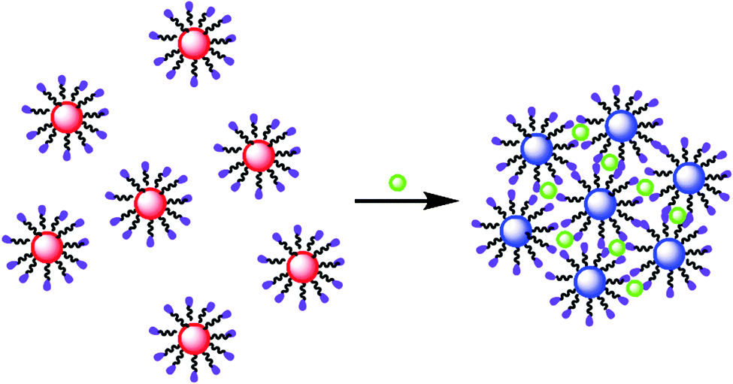
Figure 1. Example of colorimetric sensing of metal ions using gold nanoparticles functionalized with chelating agents.

For example, sensors have been developed that rely on gold nanoparticles coated with chelating agents. In the absence of the target ion, the nanoparticles are in their dispersed state and appear red. In the presence of the specific ion, the interaction between the chelating agent and the ion bring the nanoparticles together, shifting their color to blue. Similar approaches using different functional groups on the nanoparticles have extended this detection approach to small organic molecules, oligonucleotides and proteins (3).

The color change of the gold and silver nanoparticles illustrates an important concept about nanoscale science. Chemical and physical properties such as color, conductivity, and reactivity do not depend on the identity of the substance but on the size of the particle.

Exploring fundamental relationships in spectrophotometry
Solutions of gold nanoparticles appear colored which means they are absorbing light in the visible range. Since you will be investigating the optical properties of gold nanoparticles using a technique called spectrophotometry, we will briefly review how a spectrophotometric measurement takes place.
Q1. What wavelength range constitutes the visible region in the electromagnetic spectrum?
When a beam of electromagnetic radiation passes through a sample, most of the radiation is transmitted but, at specific wavelengths, the radiation may be absorbed by chemical constituents within the sample. For an atomic or molecular species, the absorption of light causes valence electrons to be excited from lower to higher energy states. For this transition to occur, the energy provided by the radiation has to match the difference in energy (ΔE) between the lower and higher energy states.
The amount of light transmitted through a sample is measured by the transmittance and is represented by the equation:
T = P/P₀.
where P₀ represents the radiant power of the beam before the sample and P the power after the sample. Another commonly used measurement is the absorbance which is related to the transmittance through a logarithmic relationship:
A = - log T = - log P/P₀ = log P₀/P
Relationship between absorbance and concentration
It is possible to make quantitative measurements using UV-VIS spectrophotometry because of the linear relationship between absorbance and concentration. This relationship is known as Beer’s law and is represented by the equation:
A = εbc
where
A is the absorbance
ε is the molar extinction coefficient (with units of M⁻¹cm⁻¹)
b is the path length of the cuvette (cm)
c is the concentration (Molarity)

The changes in absorbance with changes in concentration of a sample are measured at λmax which is the wavelength of maximum absorption in the spectrum of the compound being analyzed. By plotting A as a function of varying concentrations of the analyte, a regression curve can be established.

Q2. Draw a representative plot of A versus c.
Q3. How could you use this plot to determine the molar extinction coefficient of the analyte being investigated?
For a discussion of fundamental concepts of UV-VIS spectrophotometry check the following links:
- Analytical Chemistry 2.0 – Chapter 10
http://www.asdlib.org/onlineArticles/ecourseware/Analytical%20Chemistry%202.0/Text_Files.html
- Understanding Chemistry – UV-VIS Spectroscopy http://www.chemguide.co.uk/analysis/uvvisiblemenu.html#top

The molar extinction coefficient can be linked to the intensity of light absorption. For example, transition metals and dyes appear brightly colored because some transitions in the visible range are highly probable and have very large extinction coefficients. For example, the extinction coefficient of the bright Bromothymol Blue at 615 nm is approximately 3.5 x 10⁴ M⁻¹cm^{-1.} Gold nanoparticles are also intensely colored and their color as well as its intensity is controlled by their size (Figure 2).

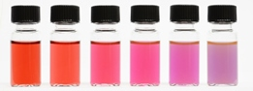
Figure 2. Colors of various sized monodispersed gold nanoparticles – Source: http://www.sigmaaldrich.com/materials-science/nanomaterials/gold-nanoparticles.html#sthash.kwu2f19v.dpuf

Table 1. Effect of particle size on maximum wavelength of absorbance and molar extinction coefficient of gold nanoparticles.
Diameter (nm) | Peak Wavelength (nm) | Molar Extinction Coefficient (M⁻¹cm⁻¹)
5 | 515-520 | 1.10 x 10⁷
10 | 515-520 | 1.01 x 10⁸
15 | 520 | 3.67x10⁸
20 | 524 | 9.21 x 10⁸
30 | 526 | 3.36 x 10⁹
40 | 530 | 8.42 x 10⁹
50 | 535 | 1.72 x 10¹⁰
60 | 540 | 3.07 x 10¹⁰
80 | 553 | 7.70 x 10¹⁰
100 | 572 | 1.57 x 10¹¹
Source:http://www.sigmaaldrich.com/materials-science/nanomaterials/gold-nanoparticles.html#sthash.kwu2f19v.dpuf

Q4. What color would a particle that absorbs in the blue-green region of the electromagnetic spectrum appear?
Q5. What trend can be identified in the molar extinction coefficient value as particle size increases? How may this trend affect the choice of particle size in a colorimetric sensor?

In this module we will explore how experimental parameters may affect the size, size distribution and related optical properties of spherical gold nanoparticles with the goal of producing nanoparticles of consistent size with a well characterized molar extinction coefficient.

Synthesis of Gold Nanoparticles

There are several different ways by which gold nanoparticles can be synthesized but the most common reaction involves the reduction of tetrachloroauric acid (HAuCl₄) to gold (Au) using trisodium citrate (Na₃C₆H₅O₇) (6). This is a red-ox reaction where gold in the tetrachloroauric acid is reduced to elemental gold while the citrate (C₆H₅O₇ ^{3–}) is oxidized to dicarboxy acetone (C₅H₄O₅) (7). Figure 3 shows the structures of these species. This reaction was first described by John Turkevich in 1951 (8) and the mechanisms of particle formation under different experimental conditions are well discussed in the literature (9).
Q6. What is the oxidation number of gold in HAuCl₄?
Q7. Write the half reaction for the reduction of HAuCl₄ to Au.
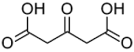
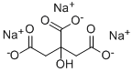
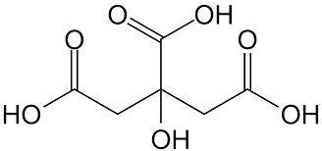

- (b) (c)
Figure 3. Chemical structure of citric acid (a); trisodium citrate (b); dicarboxy acetone (c)

Excess citrate ions not involved in the red-ox reaction are also adsorbed on the surface of the particles, thus playing a role in stabilizing the nanoparticles. They are called “capping” agents. Adsorption of citrate ions gives the gold particles an overall negative charge. Mutual repulsion of the small, negatively charged particles keeps them suspended in the solution and prevents them from coagulating to form larger particles that might eventually settle out of solution. This suspension of the gold nanoparticles is known as a colloid.
Since citric acid is a triprotic acid with distinct pKa values of 3.2, 4.8 and 6.4, pH will affect the chemical equilibrium involving the dissociation of the three hydrogens (10).
Q8. Above what pH value will citric acid (C₆H₈O₇) be completely dissociated to citrate (C₆H₅O₇^{3–})?
From an application standpoint, it is very important that particle size distribution be uniform. For example, if one was to develop a colorimetric sensor for a given analyte based on the color shift of gold nanoparticles, the optical characteristics of the nanoparticles would have to be highly reproducible to ensure repeatability of the analytical method. As you observe from data in Table 1, size strongly affects the particle wavelength of maximum absorption as well as the molar extinction coefficient which, in turns, defines the sensitivity of the analytical method.
Thus it is important to understand how different synthetic conditions influence the size and uniformity of size distribution. Controlling the size and size distribution is necessary to control the optical properties of the nanoparticles.
In the next section of this module you will explore the synthesis of gold nanoparticles using the reduction of tetrachloroauric acid (HAuCl₄) by citrate and identify experimental parameters that may affect the size, size distribution and optical properties of gold nanoparticles.

Developing an experimental design to investigate gold nanoparticle synthesis
Purpose: The purpose of this exercise is to read literature describing the synthesis of gold nanoparticles using the citrate reduction method in order to identify experimental conditions that yield gold nanoparticles of different sizes.
Learning Outcomes:
At the end of this assignment you will be able to
- Adapt experimental procedures from scholarly articles pertaining to the synthesis of gold nanoparticles by the citrate reduction method.
- Understand how different experimental parameters affect gold nanoparticle size.
Assignment:
Q9. What are some experimental parameters you think may affect the growth of nanoparticles?
There are a number of literature articles that describe how to synthesize gold nanoparticles. The following articles may be a good start but many others are available:
- Size Control of Gold Nanocrystals in Citrate Reduction: The Third Role of Citrate. J. Am. Chem. Soc. 2007, 129, 13939-13948.

Turkevich in New Robes: Key Questions Answered for the Most Common Gold Nanoparticle Synthesis. ACS Nano, 2015, 9 (7), pp 7052–7071.
Read the literature and generate a list of experimental parameters that can be varied in the course of the reaction.

Some variables that you may want to consider are:
- Ratio of reactants
- pH
- Rate of citrate addition
- Temperature
- Stir rate
In designing the experiment, remember it is best to change only one variable at any given time. Let’s, for example, focus on ratio of reactants and pH. You could design an experiment in which you vary the ratio of tetrachloroauric acid to citrate at a controlled pH value. Or you could choose a set ratio of reagents and examine the effect that pH has on the products.
A possible experimental grid is presented in Figure 4. This experiment would allow to explore nine possible combinations of reagent ratios and pH conditions. Consult your instructor on the number of combinations to use.

Initial pH | Citrate to Auric Acid Ratio
 | 2.0:1 | 4.0:1 | 7.0:1
4.2
5.4
7.0
Figure 4. Example of experimental grid.

Determining nanoparticle size and size distribution
Purpose: The purpose of this exercise is to determine the average diameter of gold nanoparticles using a Transmission Electron Microscope (TEM). In addition, the size distribution will be evaluated.
Learning Outcomes:
At the end of this assignment you will be able to
- Analyze TEM images to determine the average particle diameter.
- Determine the size distribution for each nanoparticle preparation previously synthesized.
Assignment:

- (b)
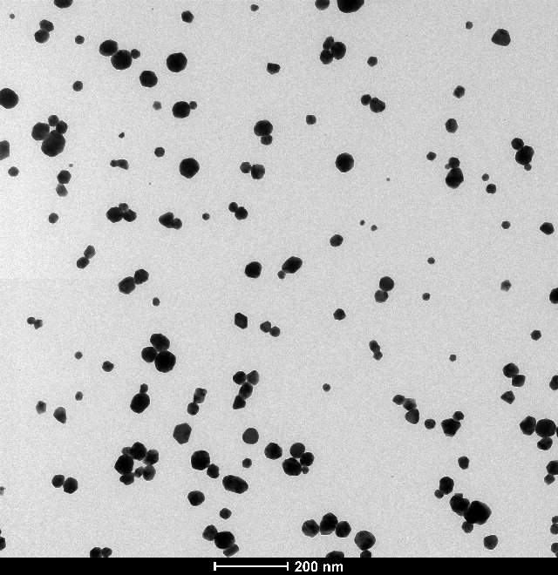
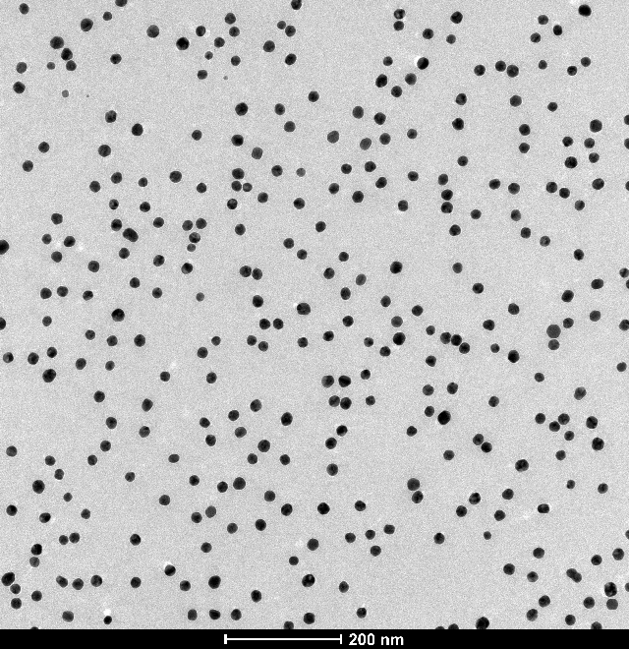
Figure 5. HRTEM images of gold nanoparticles synthesized using a pH of 5.4 and a (a) 2:1 and (b) 7:1 ratio of citrate to tetrachloroauric acid.

The images shown in figure 5 were collected using a High Resolution Transmission Electron Microscope on nanoparticles prepared using different citrate to tetrachloroauric acid ratio, at pH 5.4. Both images use the same scale of 200 nm.
Q10. Looking at the images on a qualitative basis, what differences do you observe? What can be said about the size of the particles and their size distribution at the two different experimental conditions?
To quantitatively analyze the images and extract information about particle size and size distribution, you will use a free software called ImageJ (http://imagej.nih.gov/ij/). The first task will be to determine the Feret’s diameter of the particles. Follow these instructions (link file) on how to use ImageJ.
Go to the “Experimental Data” link and download the image labeled ‘2-1 pH 5.4’. Next, load the image in ImageJ and determine the Feret’s diameter.
Q11. What is the value of the Feret’s diameter you obtained from the analysis of the image showed in Figure 5a?
In the data in Table 2, three different ratios of citrate to tetrachloroauric acid were investigated. In addition, for each ratio, three different values of pH were explored. Use the data in Table 2 to answer the following questions.
Table 2. Summary of experimental results
Citrate/Au | pH | Particle  Feret’s Diameter
2.0:1 | 4.2 | 20.00 ± 0.50
 | 5.4 | 21.73 ± 0.40
 | 7.0 | 21.22 ± 1.00
4.0:1 | 4.2 | 23.30 ± 0.78
 | 5.4 | 26.52 ± 1.57
 | 7.0 | 26.76 ± 0.99
7.0:1 | 4.2 | 31.87 ± 2.45
 | 5.4 | 33.91 ± 4.25
 | 7.0 | No particles formed

Q12. What is the effect of changing the reagents molar ratio on particle size?
Q13. What is the effect of varying the pH on particle size?
Q14. What statistical tests could you apply to determine whether differences in particle diameter are statistically different?
Q15. Summarize your findings. Is there a relationship between molar ratios of reagents and particle size?
Q16. If you wanted to synthesize particles with a diameter of approximately 20 nm, which experimental conditions would you use?
Next, you will explore the particle size distribution using again the image labeled ‘2-1 pH 5.4’. The output from the ImageJ analysis will list each detected particle and its diameter. Count all the particles of a given diameter (you may want to group them in brackets within 0.5 or 1 nm) and, using a spreadsheet, compile a chart reporting the percentage of occurrence of each particle of a given diameter.
Q17. What trends emerge from your analysis? Is there a set of experimental conditions that yield a more uniform particle distribution?
Use the particle size distribution data (see experimental data link) to continue.
Table 3 summarizes the percentage particles of a given diameter observed for gold nanoparticles synthesized using a 2:1 citrate: HAuCl₄ molar ratio at pH 5.4. As seen in Table 2, these experimental conditions yield particles with diameter 21.73 ± 0.40.

Table 3. Particle size distribution for gold nanoparticles synthesized
using a 2:1 citrate: HAuCl₄ molar ratio at pH 5.4.
Particle Diameter (nm) | Percentage
12 | 0.104058
13 | 0.208117
14 | 0.104058
15 | 0.104058
16 | 0.780437
17 | 1.040583
18 | 2.549428
19 | 6.919875
20 | 13.99584
21 | 21.12383
22 | 20.91571
23 | 15.08845
24 | 9.313215
25 | 4.942768
26 | 2.289282

Examine the data in Table 3. You may want to plot a graph to better visualize the data. Remember, we are trying to identify which experimental conditions yield a monodisperse (one uniform size) product.
Q18. What would you conclude about the distribution obtained by the specific set of synthetic parameters shown in Table 3?
In order to put into context the results of your experiment, it may be useful to take a look at the product specifications for Gold Nanoparticle Reference Materials sold by the National Institute of Standards and Technology (NIST). Go to http://www.nist.gov/pml/div683/gold_010808.cfm
Download the RM 8012, Gold Nanoparticles, Nominal 30 nm Diameter Report of Investigation which contains information about the average particle size as determined by different techniques as well as size distribution histograms.
Q19. If you purchased 30 nm gold nanoparticles from NIST, what particle size diameter would you get? Are all the particles of the same size?
Obviously, there is a relatively large variation in the particle size distribution even for a standard material sold by NIST. Continue analyzing particle distribution data (link) for nanoparticles synthesized using the experimental design described in Figure 4.
Q20. Is there an effect on the particle size distribution when changing the reagents molar ratio?
Q21. Is there an effect on the particle size distribution when varying the pH?
Q22. Summarize your findings. Is molar ratio or pH the controlling factor in ensuring a yield of uniform particles?

Estimating the concentration of nanoparticles from the particle size data
Purpose: The purpose of this exercise is to estimate the molar concentration of nanoparticles based on the particle diameter measured by TEM.
Learning Outcomes:
At the end of this assignment you will be able to
- Calculate the molar concentration of any nanoparticle preparation using the Feret’s diameter estimated through TEM image analysis.
Assignment:
The first step in estimating the molar concentration of nanoparticles is to calculate the average number of gold atoms per nanoparticle. In the specific case of gold, Liu and coworkers (11) determined the following relationship between the average number of gold atoms (N) per nanoparticle and the particle diameter (D):

N = $\frac{π \left(19.3\frac{g}{cm3}\right)D^{3}}{6\left(197\frac{g}{mol}\right)}$ (eq. 1)

This equation assumes a spherical shape and a uniform face-centered cubic (fcc) structure. In equation 1, 19.3 g/cm³ is the density for fcc gold and 197 g/mol is the gold atomic mass.
Q23. According to data from Table 2, nanoparticles synthesized with a 2:1 citrate to tetrachloroauric acid ratio and pH 5.4 have a Feret’s diameter of 21.7 nm. What is the value of N?
The next step is to calculate the molar concentration of a nanoparticle solution. This can be done by dividing the total number of gold atoms (N_{total}) equivalent to the amount of tetrachloroauric acid added to the reaction volume by the average number of gold atoms (N).

Concentration (mol/L) = $\frac{N_{Total}}{N x V x N_{A}}$ (eq. 2)

where V is the reaction volume in liters and N_{A} is Avogadro’s number. For example, for the 2:1 citrate to tetrachloroauric acid ratio, assume you reacted all the gold contained in 50.0 mL of 0.25 mM HAuCl₄.

Q24. What is the total number of gold atoms (N_{Total}) in 50.0 mL of a 0.25 mM solution of HAuCl₄?

Q25. What is the molar concentration of nanoparticles in this solution?

Now you can estimate the nanoparticle concentration in each of your experimental preparations. Complete the data in Table 4 by estimating the nanoparticle concentration for each experimental combination. The concentration value obtained in the case of reacting 2:1 citrate to tetrachloroauric acid at pH 5.4 is provided as an example of order of magnitude to be expected.

Table 4. Summary of experimental results – use this table to report nanoparticle concentration.
Citrate/Au | pH | Particle  Feret’s Diameter | Nanoparticle concentration (M)
2.0:1 | 4.2 | 20.00 ± 0.50
 | 5.4 | 21.73 ± 0.40 | 3.16 x 10⁻⁹
 | 7.0 | 21.22 ± 1.00
4.0:1 | 4.2 | 23.30 ± 0.78
 | 5.4 | 26.52 ± 1.57
 | 7.0 | 26.76 ± 0.99
7.0:1 | 4.2 | 31.87 ± 2.45
 | 5.4 | 33.91 ± 4.25
 | 7.0 | No particles formed

Determining the molar extinction coefficient of gold nanoparticles
Purpose: The purpose of this exercise is to experimentally estimate the molar extinction coefficient of gold nanoparticles and determine what effect size has on the magnitude of the coefficient.
Learning Outcomes:
At the end of this assignment you will be able to:
- Select the appropriate wavelength to collect spectra of gold nanoparticles.
- Evaluate the molar extinction coefficient of different nanoparticle preparations by applying the Lambert-Beer law.
- Determine experimentally the effect that size plays on the magnitude of the molar extinction coefficient.
Gold nanoparticles display very intense colors in the visible range. As seen in Figure 2, color varies from deep red to blue depending on size and state of aggregation. These unique optical properties are due to a phenomenon called Surface Plasmon Resonance (SPR) (12). At specific wavelengths the collective oscillation of electrons on the surface of the particle results in strong absorption (and scattering) which means that the color generated by the particle can be seen at very small concentrations. For this reason, gold nanoparticles are widely used for the development of colorimetric sensors. In order to ensure maximum sensitivity in colorimetric detection, it is important to use gold nanoparticles with high molar extinction coefficients.
Because nanoparticles appear colorful, this means that they are absorbing specific wavelengths of light while reflecting others. This property makes them excellent candidates for spectrophotometric analysis. As explained earlier in the module, a spectrophotometric analysis is performed by illuminating the sample with radiation in the visible or ultraviolet range and detecting the amount of light that reaches the detector. Depending on the chemical properties of the species in the sample, some light will be absorbed while the remainder will be transmitted to the detector where it is converted to an electrical signal that is proportional to the amount of light absorbed, called the absorbance. By constructing a standard calibration curve using known concentrations of nanoparticles under investigation, a relationship can be developed between the absorbance of the analyte at a specific wavelength and its concentration. If the nanoparticle concentration is expressed in molarity, the slope of that plot is the molar extinction coefficient.

An example of visible spectra recorded on gold nanoparticles synthesized using a citrate to tetrachloroauric acid ratio of 2:1 and pH ranging from 4.2 to 7.0 is shown in Figure 6.

Figure 6. Visible spectra recorded on gold nanoparticles synthesized using a citrate to tetrachloroauric acid ratio of 2:1 and pH ranging from 4.2 to 7.0.
Q26. At what wavelength does each nanoparticle solution exhibit the maximum absorbance? This wavelength is referred to as λ_{max}.
Q27. What wavelength would you choose to quantitatively determine the concentration of the nanoparticles? Why did you choose this wavelength?
Q28. What is the value of the absorbance at λ_{max} for each nanoparticle solution? Complete table 5 by reporting the nanoparticle concentration from Table 4 and λ_{max} estimated from the spectra found in the link to the experimental data.

Table 5. Summary of experimental results – complete this table by reporting the nanoparticle concentration from Table 4 and the value of λ_{max}
Citrate/Au | pH | Particle  Feret’s Diameter | Nanoparticle concentration (M) | λ_{max} (nm)
2.0:1 | 4.2 | 20.00 ± 0.50 |  | 520
 | 5.4 | 21.73 ± 0.40 | 3.16 x 10⁻⁹ | 520
 | 7.0 | 21.22 ± 1.00 |  | 525
4.0:1 | 4.2 | 23.30 ± 0.78
 | 5.4 | 26.52 ± 1.57
 | 7.0 | 26.76 ± 0.99
7.0:1 | 4.2 | 31.87 ± 2.45
 | 5.4 | 33.91 ± 4.25
 | 7.0 | No particles formed

Q29. How could you use a plot of absorbance vs. concentration at the wavelength chosen above to determine the molar extinction coefficient of a gold nanoparticle solution?
Preparing gold nanoparticle dilutions for molar extinction coefficient estimation
You are now going to prepare a set of dilutions and use them to calculate the molar extinction coefficient of a gold nanoparticle solution. Use the concentrations you calculated and recorded in table 4 along with the absorbance values recorded on serial dilutions of gold nanoparticle preparations (see experimental data link).
Q30: Consider the 2:1 pH 5.4 gold nanoparticle preparation. Given that the concentration of the stock solution is of the order of 3 x 10⁻⁹ M, how many milliliters of this solution will you have to pipette to prepare 5.00 mL of the following dilutions?

Nanoparticle concentration  (M) | Milliliters of stock solution to pipette
0.00
5 x 10⁻¹¹
1 x 10⁻¹⁰
2 x 10⁻¹⁰
4 x 10⁻¹⁰
8 x 10⁻¹⁰
1.5 x 10⁻⁹
3 x 10⁻⁹

Q31. What is the purpose of preparing a 0.00 M solution? How is it used in the analysis?
The following absorbance values were recorded when analyzing the eight solutions prepared above using the 2:1 pH 5.4 stock solution:
Nanoparticle concentration  (M) | Absorbance
0.00 | 0
5 x 10⁻¹¹ | 0.0501
1 x 10⁻¹⁰ | 0.0913
2 x 10⁻¹⁰ | 0.1778
4 x 10⁻¹⁰ | 0.3367
8 x 10⁻¹⁰ | 0.6364
1.5 x 10⁻⁹ | 1.172
3 x 10⁻⁹ | 2.622

Use Excel or equivalent software to plot the data above.
Q32. What relationship do you observe between the absorbance and concentration of nanoparticles?
Q33. Do any of the data points deviate from the general behavior observed in the plot?
Q34. What parameter allows us to determine whether there is a good fit between absorbance and gold nanoparticle concentration?
Q35. What is the molar extinction coefficient for this specific gold nanoparticle preparation? How does this value compare to the extinction coefficient reported in Table 1 for a gold nanoparticle of similar size?
Q36. How can you estimate the uncertainty on the molar extinction coefficient from the regression analysis?

Putting it all together
The goal of this module was to explore how experimental parameters may affect the size, size distribution and related optical properties of gold nanoparticles with the goal of producing nanoparticles of consistent size with a well characterized molar extinction coefficient.
It is time to put all the information together to draw some conclusions. Complete the data in Table 6 by filling in the nanoparticle concentration and λ_{max} as reported in Table 5 and estimating the molar extinction coefficient from the Absorbance vs. concentration plots for each experimental combination.

Table 6. Final summary of experimental results
Citrate/Au | pH | Particle  Feret’s Diameter | Nanoparticle concentration (M) | λ_{max}  (nm) | Molar extinction coefficient
2.0:1 | 4.2 | 20.00 ± 0.50
 | 5.4 | 21.73 ± 0.40 | 3.16 x 10⁻⁹
 | 7.0 | 21.22 ± 1.00
4.0:1 | 4.2 | 23.30 ± 0.78
 | 5.4 | 26.52 ± 1.57
 | 7.0 | 26.76 ± 0.99
7.0:1 | 4.2 | 31.87 ± 2.45
 | 5.4 | 33.91 ± 4.25
 | 7.0 | No particles formed

Q37. Based on the analysis of the data you summarized in Table 6, how does particle size affect the molar extinction coefficient?
Q38. How does the citrate to tetracholoroauric acid ratio affect the molar extinction coefficient?
Q39. Does pH play a role in the value of the molar extinction coefficient? Justify your answer.
Q40. If you were to develop a colorimetric sensor, what experimental conditions would you choose to synthesize nanoparticles of consistent size with a large molar extinction coefficient?

References

Guanying Chen, Indrajit Roy, Chunhui Yang, and Paras N. Prasad. Nanochemistry and Nanomedicine for Nanoparticle-based Diagnostics and Therapy. Chem. Rev., 2016, 116 (5), pp 2826–2885.

Reiss, Gunter; Hutten, Andreas (2010). "Magnetic Nanoparticles". In Sattler, Klaus D. Handbook of Nanophysics: Nanoparticles and Quantum Dots. CRC Press.
- Saha, K.; Agasti, S.; Kim C., Li, X.; Rotello, V. Gold Nanoparticles in Chemical and Biological Sensing. Chem. Rev. 2012, 112, 2739-2779
- Starkey, A. The butterfly effect. New Scientist, 2005, 187(2518), 46.
- Wenxin Niu, Yi An Alvin Chua, Weiqing Zhang, Hejin Huang, and Xianmao Lu. Highly Symmetric Gold Nanostars: Crystallographic Control and Surface-Enhanced Raman Scattering Property. J. Am. Chem. Soc. 2015, 137, 10460−10463.
- Ji, X.; Song, X.; Li, J.; Bai, Y.; Yang, W.; Peng, X. Size control of Gold Nanocrystals in Citrate Reduction: The Third Role of Citrate. J. Am. Chem. Soc. 2007, 129, 13939-13948.

Wuithschick, M., Birnbaum, A., Witte, S., Sztucki, M., Vainio, U., Pinna, N., Rademann, K., Emmerling, F., Kraehnert, R., and Polte, J. Turkevich in New Robes: Key Questions Answered for the Most Common Gold Nanoparticle Synthesis. ACS Nano, 2015, 9 (7), pp 7052–7071.
- Turkevich, J,. Stevenson, P. C., Hillier, J.A Study of the Nucleation and Growth Processes in the Synthesis of Colloidal Gold Discuss. Faraday Soc. 1951, 11, 55 – 75
- Polte, J; Ahner, T.T.; Delissen, F.; Sokolov, S.; Emmerling, F.; Thünemann, A.F.; Kraehnert R. Mechanism of gold nanoparticle formation in the classical citrate synthesis method derived from coupled in situ XANES and SAXS evaluation. J. Am. Chem. Soc. 2010, 132, 1296.
- Ojea-Jiménez, I.; Campanera, J. M. Molecular Modeling of the Reduction Mechanism in the Citrate-Mediated Synthesis of Gold Nanoparticles J. Phys. Chem. C, 2012, 116 (44), pp 23682–23691.
- Liu, X., Atwater, M. Wang, J., Huo, Q. Extinction coefficient of gold nanoparticles with different sizes and different capping ligands. Colloids and Surfaces B: Biointerfaces. 2007, 58, 3-7.
- Zeng, S.; Baillargeat, D., Ho, Ho-Pui, H., Yong, K. Nanomaterials enhanced surface plasmon resonance for biological and chemical sensing applications. Chemical Society Reviews 2014, 43 (10): 3426–3452.

