GOLD NANOPARTICLES – EXAMPLE OF LAB EXPERIMENT
The following experiment provides an example of how some of the activities described in the module may be implemented in a lab environment under the supervision of the instructor. This specific experiment was developed for a General Chemistry lab as a guided inquiry but can be modified and expanded for upper division courses. It can also be used as a dry lab. Experimental data are available (see experimental data link in this module). Several sections describe equipment specific to the chemistry department at Eastern Oregon University that will likely need to be revised for the equipment present at the user’s institution.
TABLE OF CONTENTS Page #
1. Safety and waste disposal 2
2. Reagents and equipment 2
3. Introduction 3
4. Calibrating a pH electrode 4
5. Gold nanoparticle synthesis 6
6. Visible spectroscopy 7
7. Data analysis 11
a) Nanoparticle size from ImageJ 11
b) Nanoparticle size distribution in Excel 15
c) Combining UV-Vis spectra in Excel 18
8. Discussion questions 20

1. Safety and Waste Disposal-
- Wear gloves and eye protection.
- Sodium citrate may cause irritation to skin, eyes, and respiratory tract.
- Tetrachloroauric acid causes eye and skin burns. Harmful if swallowed or inhaled.
- All reactions should be conducted under a hood.
- All leftover chemicals must be collected in the waste bottle in the waste hood.

All glassware for the AuNP synthesis must be free of contaminants and should be washed in aqua regia prior to use and rinsed thoroughly with nanopure water. Aqua regia, once prepared, can be used for approximately 4 weeks. If nanopure water is not available, commercially purchased distilled water can be substituted. When weighing gold chloride and sodium citrate, it is common practice to use a folded weighing paper and a spatula as the folded weighing paper gives better control for transferring small quantities. Students should receive instruction in proper use of pipets. Chemical waste should be properly disposed in heavy metal hazardous waste containers.

2. Reagents and Equipment:

Hydrogen tetrachloroaurate(III) trihydrate (2.5 mM)
Sodium citrate
Sodium hydroxide (0.02 M)
Hydrochloric acid
UV-VIS Spectrophotometer
NanoGrids TEM grids (Dune Sciences, Inc.) for sample preparation if a Transmission Electron Microscope is available.

3. Introduction

Synthesis and Analysis of Gold Nanoparticles by Citrate Reduction

Experimental Objective:
In this experiment, you will synthesize gold nanoparticles and explore the influence of the ratios of reactants and pH on the size of the nanoparticles as determined by transmission electron microscopy. You will also explore the influence of the size of the nanoparticles on the surface plasmon resonance measured using visible spectroscopy.

Learning Objectives:
- Explain the basic red-ox chemistry of gold involved in nanoparticle synthesis.
- Explain the relationship between reaction conditions and nanoparticle size.
- Describe the relationship between the size of nanoparticles and their visual properties.
- Manipulate data sets in order to display them in relevant and meaningful ways.
- Collaborate with other groups to expand the context of your results.

Theory:
Most chemicals have properties determined almost entirely by their chemical composition. For example, elemental gold always has the same general properties. As the size a solid decreases into the nanoscale regime, this can begin to change however. Many of the properties begin to depend on the size of the material, including the optical, electrical, chemical, and catalytic properties. Gold for example is typically a yellowish colored, lustrous material. As the size of a particle of gold shrinks below around 100 nm, it gives rise to blue to red solutions when suspended in water. The size and shape of the particle both influence the exact color which is observed. This is due to a phenomenon referred to as surface plasmon resonance. This basically refers to free electrons in the gold moving as a result if their interaction with the light shining on the particles. This leads to some of the wavelengths of light being absorbed while others are transmitted. The exact wavelengths which are absorbed are very sensitive to the exact size and shape of the particles. This effect is also highly dependent on what is surrounding the particles. Switching the solvent from water to something else like ethanol significantly alters the color of the particles. As a result, there is significant interest in using gold nanoparticles in sensing applications (among many others). In this lab, you will synthesize gold nanoparticles and explore the relationship between reaction conditions and the size of the particles as well as the influence of the size of the particles on the absorbance of light.

4. Calibrating a pH electrode:
(Note - The following procedure was developed using the MicroLab Interface. Proceed with calibrating a pH electrode according to the manufacturer protocol).
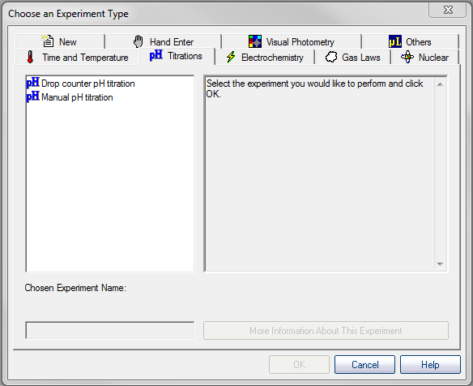
  - Turn on the MicroLab interface and select the Titration tab. Choose “Hand entered titration”.

  - Select the pH sensor and choose “Edit”.
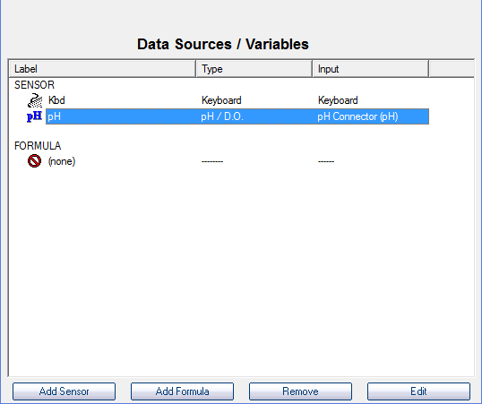
  - Click on “Perform New Calibration”.
  - Fill three disposable plastic cups approximately 2/3rds full with pH 4, 7, and 10 buffer solutions.
  - In Microlab, select “Add Calibration Point”.
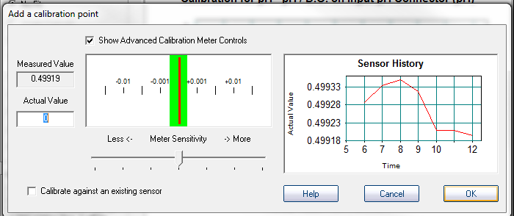
  - In the window which opens, enter the actual pH of the buffer in the box labelled “Actual Value”, and wait for the meter to stabilize. You will know it is stable when the red bar stays within the green region. Don’t worry about the graph that you see because it will autorange, meaning that once it is stable a very small range will be used, and it will appear to still be fluctuating significantly even though only very small changes are taking place.
  - Rinse the pH electrode with deionized water into a beaker, and then place it into one of the buffer solutions. Ensure that the tip is completely immersed in the solution. Allow the reading to stabilize, and then enter the value of the buffer and click “OK”.
  - Repeat the previous step for the other two buffer solutions.
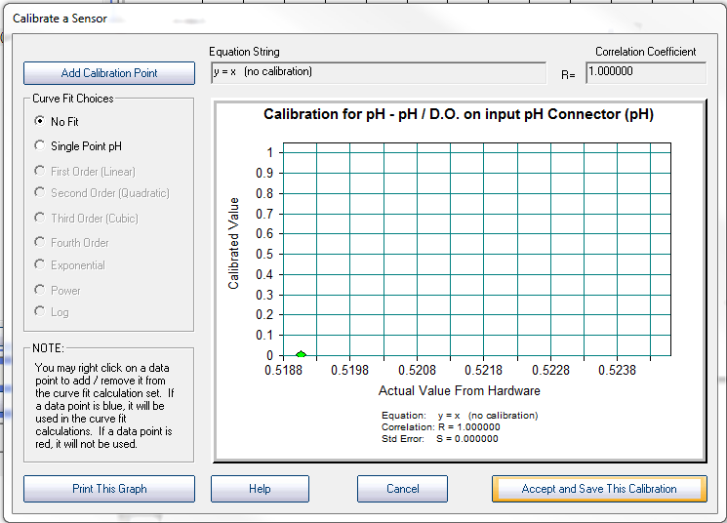
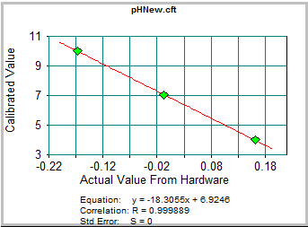
  - At this point you should have three points on the graph that form a straight line. Now select “First Order” under curve fit options, and print the resulting graph. This is your only opportunity to print your calibration curve! Click “Accept and Save This Calibration”, for units enter “pH”, and assign a filename. Be sure to record the filename and directory in your lab notebook. After saving the calibration, click “Finish”.

5. Gold Nanoparticle Synthesis
- Prepare 50 mL of 0.25 mM (millimolar) HAuCl₄. A 2.5 mM stock solution is provided. What calculation do you need to perform to prepare the new solution? (Check with instructor!).
- Note the initial pH and Citrate to Auric Acid Ratio from the table below assigned to your group.
- Add your HAuCl₄ solution to a 100 ml beaker with a magnetic stir bar and place it on a stir plate under mild stirring.
- Place a pH electrode in your solution, and add sufficient 0.02 M NaOH dropwise to achieve the desired pH. (What can you use to correct pH if you add too much NaOH? (Check with instructor!)
Initial pH | Citrate to Auric Acid Ratio
 | 2.0:1 | 4.0:1 | 7.0:1
4.2 | Group 1 | Group 2 | Group 3
5.4 | Group 4 | Group 5 | Group 6
7.0 | Group 7 | Group 8

- Based on the 0.25 mM concentration of HAuCl₄, how many moles of citrate will be needed to achieve the selected ratio? Perform the calculations and check with instructor! Now convert the number of moles into grams.
- Transfer your solution into a round bottom flask with a few boiling chips, place it in a heating mantle and connect it to a condenser column.
- Turn on the heating mantle to medium setting and bring the solution to gentle boiling, then add the calculated number of grams of sodium citrate to the solution.
- Continue boiling until the reaction is observed (an obvious color change will take place).
- Remove the solution from heat and allow it to cool back to room temperature (be careful of the hot glass).
- Once the solution is cooled, measure and record the final pH.

6. Visible Spectroscopy:
(Note - The following procedure was developed using a Varian CARY 50 Bio Spectrophotometer).

- Use a UV-VIS spectrophotometer to measure the absorbance spectrum between 300 and 700 nm.
  - In order to collect a UV-VIS spectrum, you will need a blank. What can be readily used to serve as your blank? (Check with instructor!)
  - Double click on the Cary WinUV shortcut key.
  - Double click on the "Scan" shortcut key
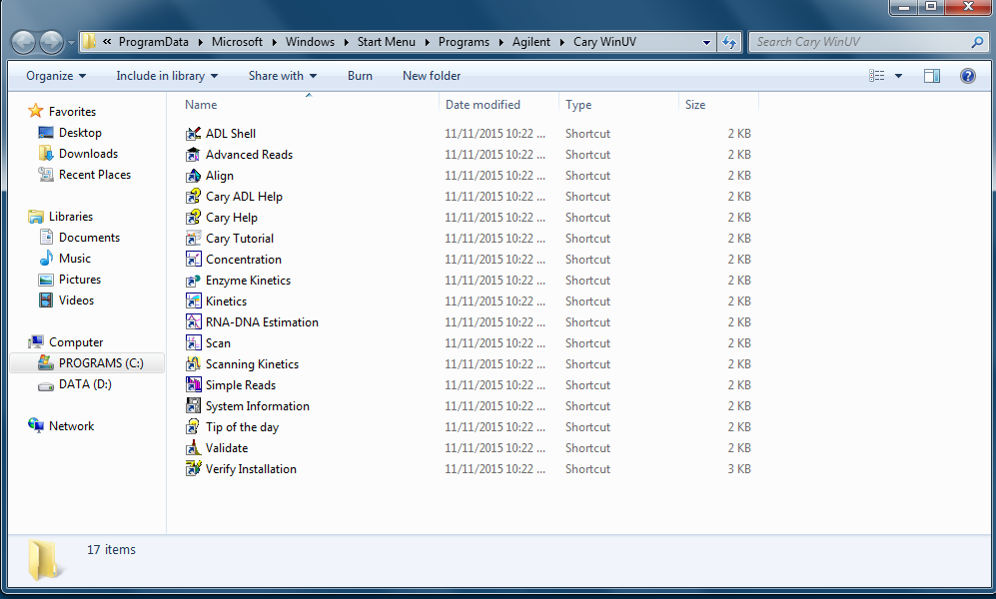
  - Click on "Setup" and under X Mode change the start to 650 nm and the stop to 400 nm and then click "OK".
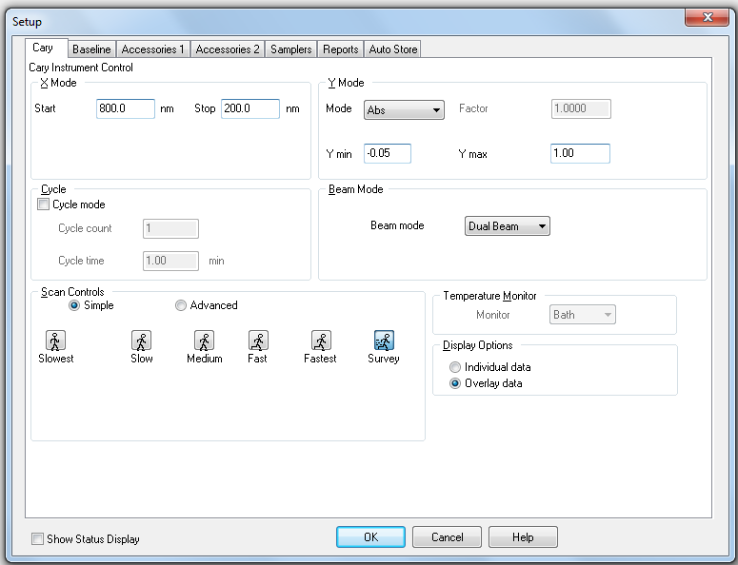
  - Insert your blank, and then click "Zero".
  - 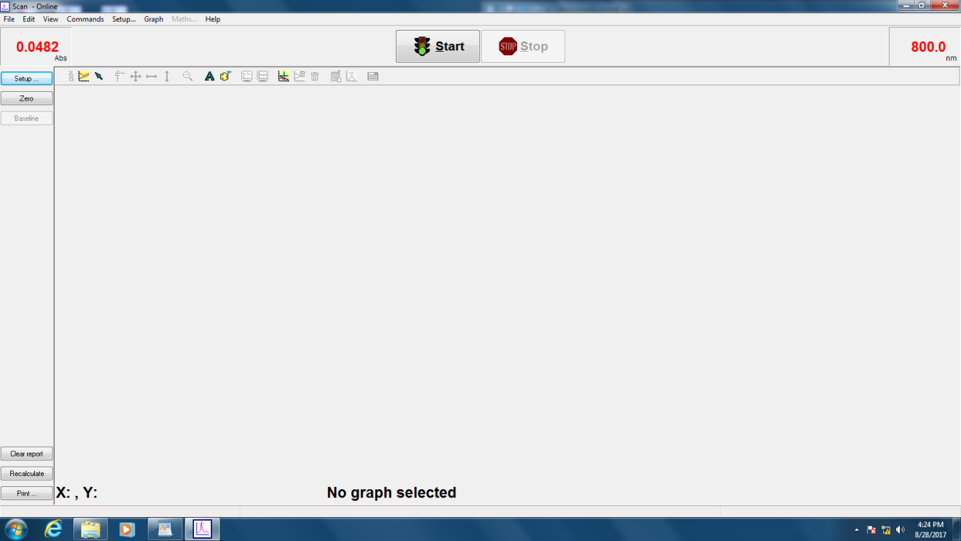
  - Click "OK" on the popup screen.
  - Fill the cuvette with your nanoparticle solution and place it in the spectrophotometer.
  - Click "Start" to collect the scan
  - 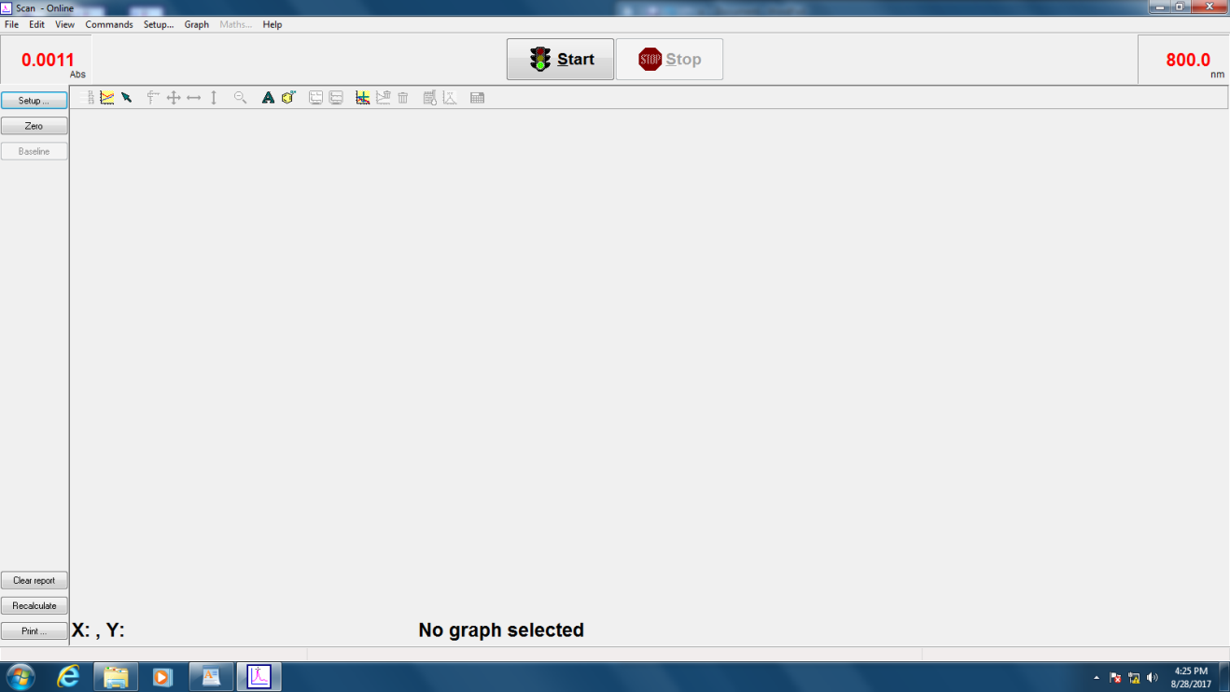
  - Navigate to an appropriate file folder, assign a filename and click "Save". Note that this saved file will contain all of the scans you make until you close the program or start a new file. You will next have the opportunity to assign a Sample ID. Once again, choose a descriptive name. Be sure to record both the filename and the Sample ID in your lab notebook.
  - Look at the absorbance spectrum to make sure that the maximum absorbance does not exceed 1. If the absorbance does exceed 1, think of ways you could fix this.
  - Once a suitable spectrum is collected, right click on the background of the graph and select "peak labels".
  - Select the box “X label”.
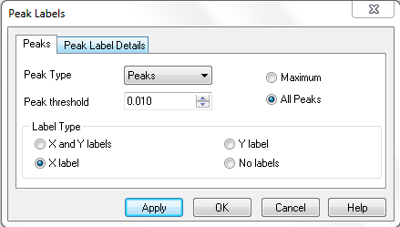
  - Print the graph and include it in your lab notebook.
  - We will now export the spectrum so that we can share the raw data with others and plot it together with the spectra from other groups. To do this, go to “File” and select “Save Data As”.

  - From the “Files of Type” pull down menu, select “Spreadsheet Ascii(*.CSV)”. CSV stands for comma separated value, which simply means that the data will be stored as a text file, with columns of data separated by commas. Save this file to one of the provided flash drive with a name that describes your synthesis parameters.

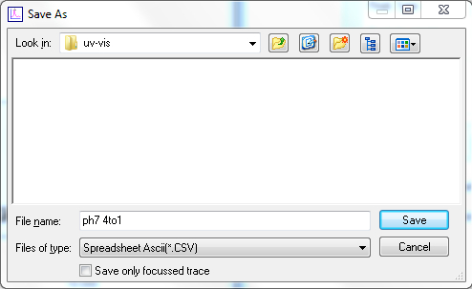
  - Dispose of the sample in the appropriate waste container.
  - Upload your spectrum file to a shared file folder.

7. Data Analysis

a) Nanoparticle size from ImageJ
Your next task is to determine the average size of the gold nanoparticles in the solution you have synthesized. Since we do not have access to a Transmission Electron Microscope, we will utilize images collected ahead of time on nanoparticle solutions previously synthesized under identical conditions.
- Double click on the ImageJ shortcut on the desktop to open the image processing software.
- Load the TEM image from the desktop that corresponds to the synthesis conditions used by your lab group. Do this by selecting “File” and then “Open”.
- The software from modern TEM instruments will embed a scale bar on the image in order to give a reference to the size of objects in the image. We will use this to tell the software how big each pixel in the digital image is, which the software can then use to calculate sizes in a more automated manner.
- Use the zoom tool (looks like a magnifying glass) or the + and – keys on the keyboard to enlarge the image until the scale bar in the image almost fills the screen. Pan around the image using the tool that looks like a hand.
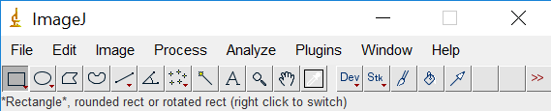

- Select the line tool from the tool bar at the top of the screen and draw a line over the scale bar (the line should extend exactly the same length as the scale bar).
- Select “Analyze” and then “Set Scale”.
- Remove any prior measurements by selecting “Click to remove scale”. 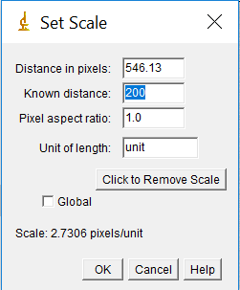
- In the box labelled “Known distance”, enter in the value on the scale bar in your image. The distance in pixels should already be filled from the line drawn. In the units box, enter the appropriate units, in this case nanometers or nm. Leave the pixel aspect ratio as the default value of 1 (this just means that the horizontal and vertical sizes of the pixels are the same). Click “OK”.
- Next be sure to zoom back out until you can see the entire image (hold control while clicking with the magnifying glass to zoom out), and then select the region of interest (where you have nanoparticles, but excluding the margins and scale bar). Do this by clicking on the rectangle tool and surrounding the area you want to use.
- Select “Image” and then “Crop”.
- You next need to adjust the image so that the software can readily distinguish between a nanoparticle and the background. To do this, you will first adjust the brightness/contrast of the image. Select “Image” followed by “Adjust” and then “Brightness/Contrast”. Sometimes the “Auto” feature is sufficient, but if not you can also play around with the sliding bars. Try to adjust them so that the nanoparticles really stand out and the background is mainly white, but make sure the size of the dots doesn’t change.
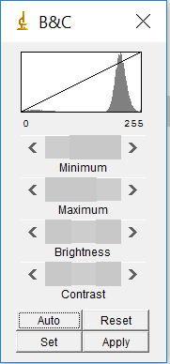
- Select “Image” followed by “Adjust” and then “Threshold”. Move the sliders until the particles you wish to analyze are red, but none of the background is red. This will set the background to be completely white to create a firm visual boundary between the nanoparticle and the background. Click “Apply”.
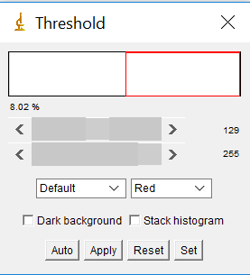
- Select “Process”, followed by “Binary” and then “Make Binary”.
- We are about to measure the size of the particles, but first, we need to tell the software what measurements we want. Go to “Analyze” followed by “Set Measurements”. Check the box “Ferret Diameter”, but none of the others.
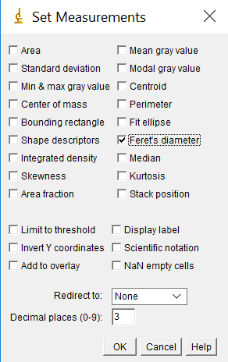
- Finally, we are ready to have the software measure the size of all the nanoparticles. To do this, select “Analyze” followed by “Analyze Particles”.
- Check the boxes “Display Results” and “Exclude on Edges” and “Summarize”. The default size from 0 to infinity is a good starting point, although it can be beneficial to put an upper and lower limit to prevent errant inclusions. For circularity, a range of 0.6 to 1 is typically acceptable.
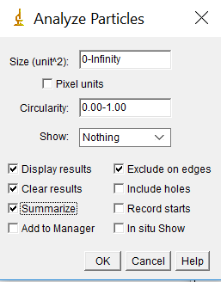
- Select OK, and two tables with your results will appear, a summary and complete table of each particle.
- Look through the results table and watch for unrealistic particle sizes (for example if the area is on the order of 1x10⁻⁴ nm², this makes no physical sense, it results from background noise being counted as a particle). You can remove these errant points by right clicking on them and selecting “clear”.
- For each window, select “File” followed by “save as” to save the table as a spreadsheet. End your filename with “.txt”. For the summary table, either print the spreadsheet or copy the results into your lab notebook.
- While the complete data table is nice, it is challenging to visualize the results in table form. Instead, we will create a histogram which shows the size distribution of our particles. In the Results window, select “Results” followed by “Set Measurements”. Select the Feret’s Diameter box (you can uncheck all the others). Then select “Results” followed by “Distribution”. Under “Parameter”, select Feret”. Uncheck “Automatic Binning” and set the number of bins to 10, and then select “OK”. Note that the binning determines how many bars are displayed on the histogram.
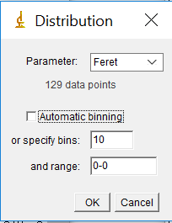

b) Nanoparticle Size Distribution in Excel
One shortcoming of ImageJ is that there is very limited ability to control the appearance of the graphs generated. As a result, it is often beneficial to instead work with the actual data in a more flexible program like Excel.
- Open Excel, and the select “File Open” and the “Browse”.
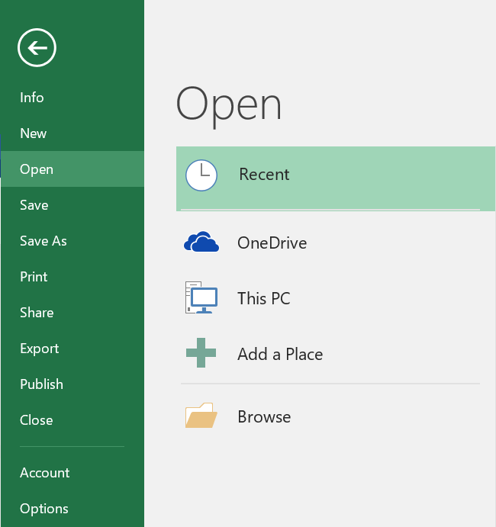

- Navigate to the folder where you saved your data, and switch the menu from Excel Files to “All Files”, at which point, you should see your results. Select the file, and click “Open”.
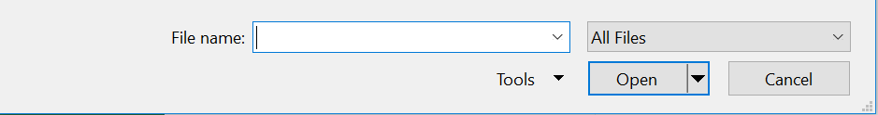
- Because your data isn’t an actual spreadsheet file, you need to give Excel some guidance so that it can open it correctly. Check the “Delimited” bullet option, and the check box “My data has headers”. Click “Next”
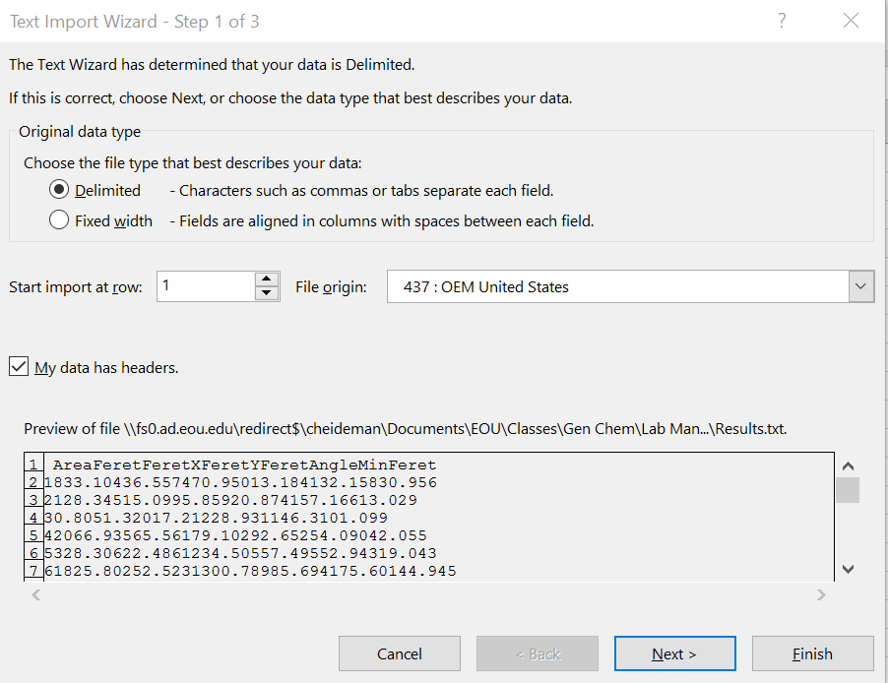
- Check the “Tab” box under Delimiters, and click “Finish”.
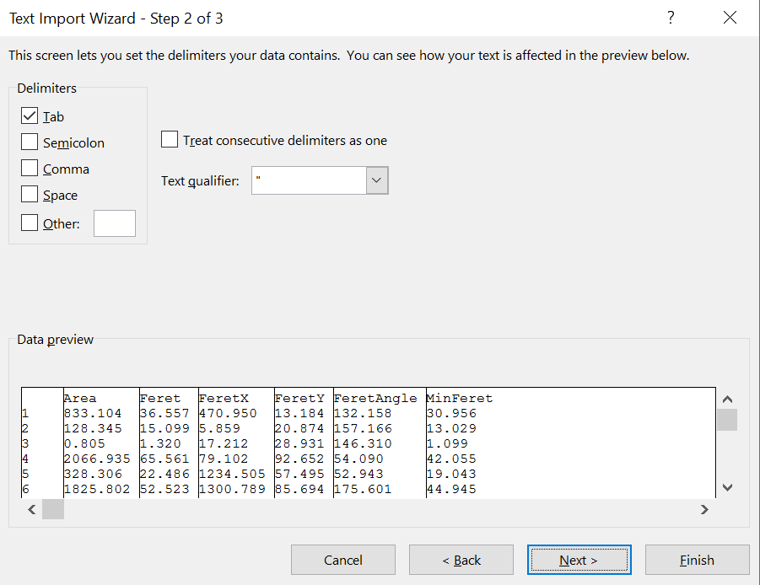
- Browse through your data to again verify that all of the data look reasonable.
- Highlight the data under “Feret”, and then go to the “Insert” tab, and click on “Recommended Charts”.
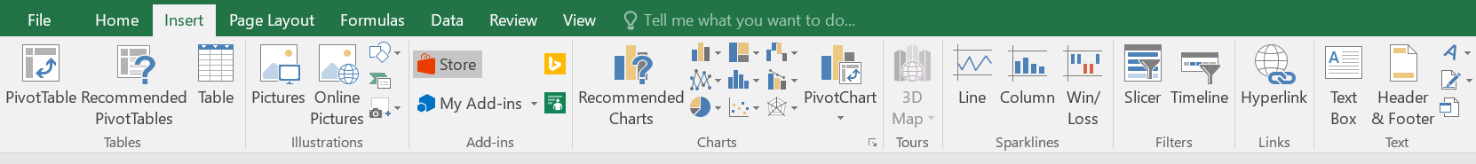
- Click the tab labelled “All Charts”, and then select histogram.
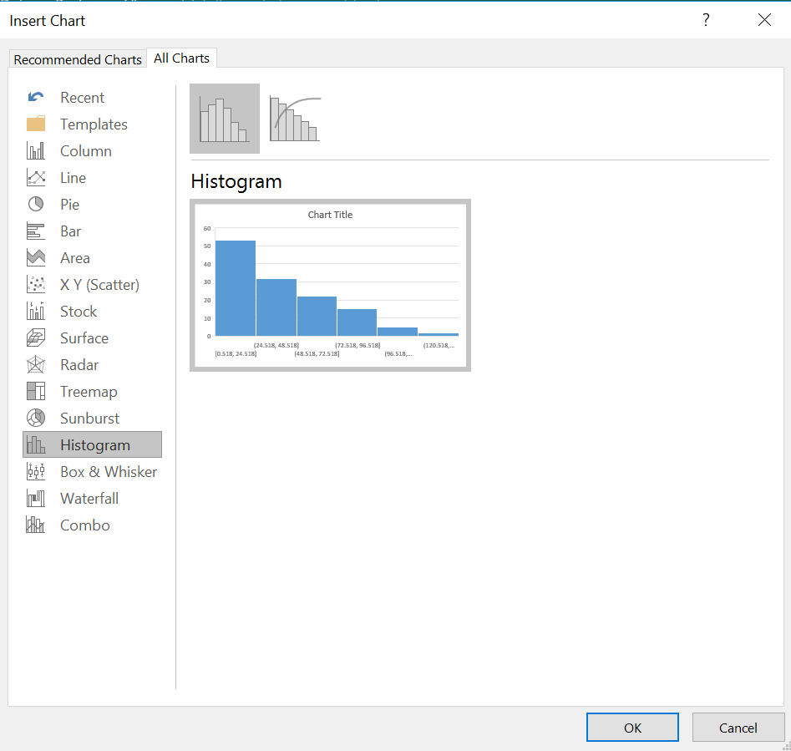
- A histogram should appear. Right click on the x-axis, and select “Format Axis”.
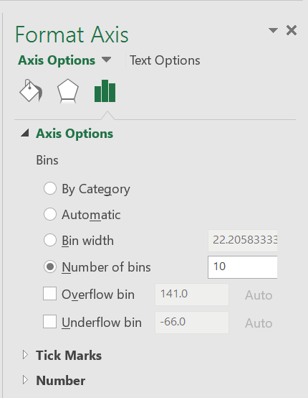
- A window will open on the right side of the screen. Set the number of bins to the same number of bars as was generated in ImageJ previously.
- Give the histogram an appropriate title, and print it.

c) Combining UV-Vis Spectra in Excel
- Go to the shared google drive folder where you previously uploaded your exported visible absorbance spectrum and download all the spectra in the folder that have been collected by your classmates.
- Open each file in Excel, and copy and paste the wavelength and absorbance data into a single spreadsheet. You should have something that looks similar to the data shown below.
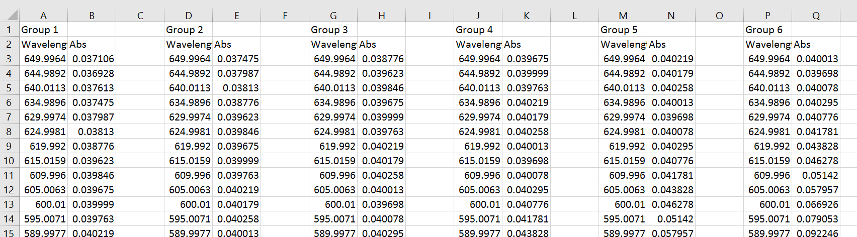
- Highlight the wavelength and absorbance columns for group 1, and select the “Insert” tab, and click on “Scatter with smooth lines”.
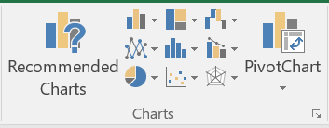
- A chart should appear on your spreadsheet. Now we need to add the rest of the data. Right click on the chart, and click on “Select Data”.
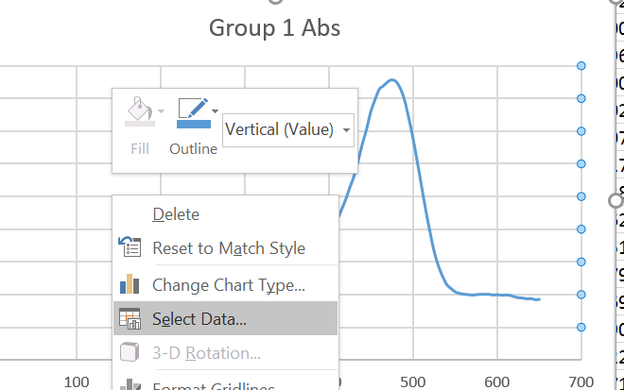
- Click on “Add”
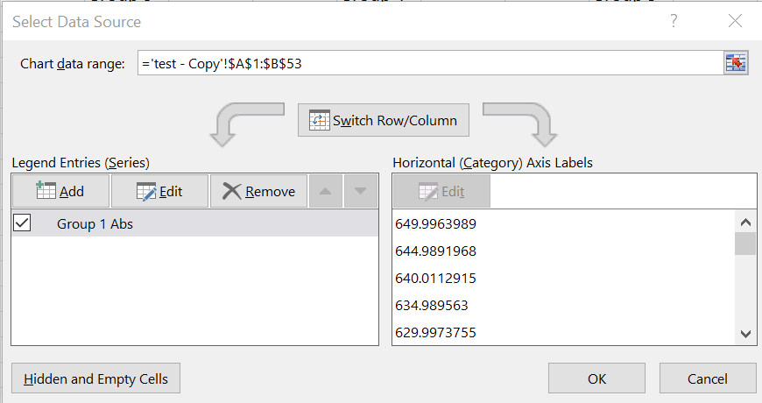
- Under Series name, type in “Group 2 Abs”.
- Under Series X values, click on the box next to the text space.
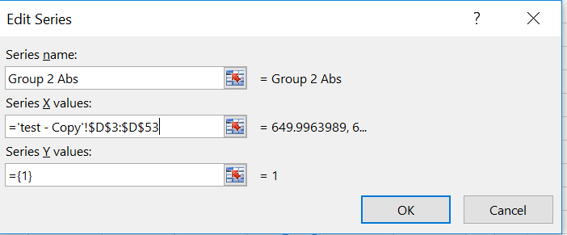
- A new window should appear. Highlight the wavelengths for Group 2 and click the box next to the text space that is now filled in.
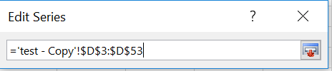
- Repeat this for the “Series Y values”.
- Repeat steps 5-9 for each additional data set and click “OK”
- You should now have all of the plots on one graph. The last thing we need to do is to make sure everything is labelled. Left click on the graph and a + should appear. Click on the + and additional menu items should appear.
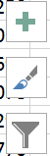
- Check the options “Axes”, “Axis Titles”, “Chart Title” and “Legend”.
- Label the Y-axis “Absorbance”.
- Label the X-axis “Wavelength (nm)”.
- Give the chart an appropriate title.
- Finally, we are going to rescale the x-axis to only cover the range of interest. Select the x-axis by clicking on it, and then right click on it and select “Format Axis”.
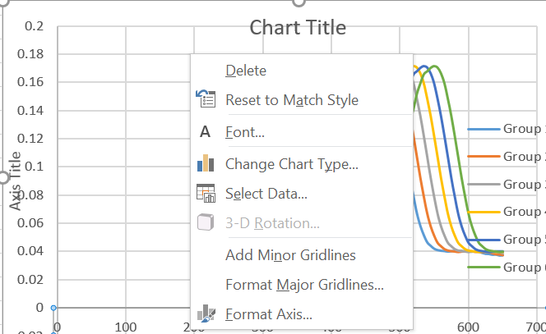
- Change the minimum bound to 400 and the maximum bound to 650.
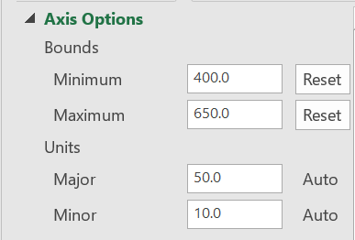
- Print a copy of the combined graph.

8. Discussion Questions

- What is the oxidation number of gold in HAuCl₄?
- What do we mean when we say that gold is being reduced?
- Obtain the particle size results from your classmates and construct a table reporting the gold nanoparticle diameter for each synthetic condition. What trends can be observed?
- Analyze all the visible spectra collected in the shared folder and expand the table constructed in part 3 to include the wavelength of maximum absorbance (λ_{max}). What relationship do you observe between λ_{max} and the particle size?
- What information do you obtain from a histogram of your particle diameter data that you would miss if you just looked at the average diameter?
- What are the benefits and limitations of characterizing nanoparticles with UV-VIS spectroscopy? What about with transmission electron microscopy? If you had access to both techniques, what would you use to best characterize the size of the nanoparticle and why?

