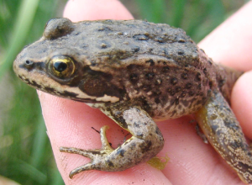
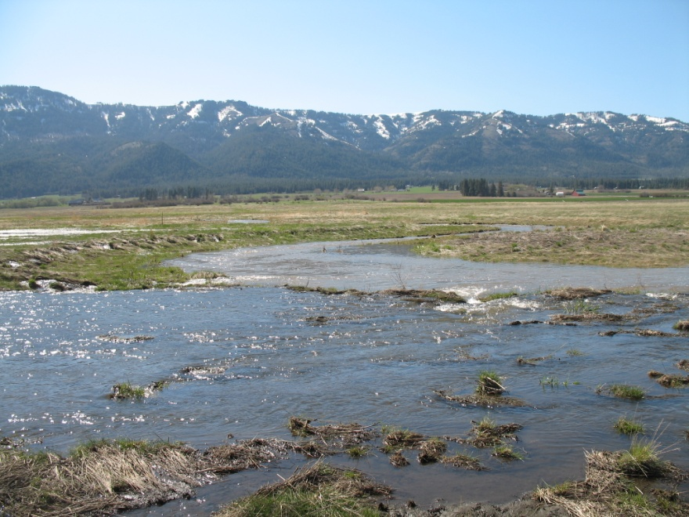
End Creek Spotted Frogs and Aquatic Snails
Introduction - A qualitative investigation of
cations and anions
Anna Cavinato
Eastern Oregon University

Adapted from “A Study of Onondaga Lake Water” – Chemistry in Context: Applying Chemistry to Society Lab Manual
The End Creek Wetland Restoration Project is located 15 km north of La Grande, in Union County, Oregon. The approximately 550 acre restored wetland embodies many qualities of high value to the community. The wetland is the only natural grassland/floodplain area of any size at the north end of the Grande Ronde Valley. It forms a natural corridor between the Blue Mountains and the Grande Ronde River as it transects through extensive, uninterrupted agricultural lands. Consequently, it protects a rare island of habitat for mammals, fish, amphibians, and reptiles and is an important harbor for threatened, endangered, or sensitive plant and animal species. The wet meadows and ponds provide stopover sites for migratory waterfowl traveling north and south through the intermountain west, and nesting and feeding habitat for those that stay. Drained and converted to agricultural land by the end of the last century and operated as a dairy farm until the mid-50s, the property became part of the Wetland Reserve Program in 2005. In 2006 plans began to restore the creek to its original sinuosity with the goals of improving fish habitat and restoring original vegetation. Creek restoration helped rebuild the water table and feed natural ponds. In 2008 Columbia Spotted Frogs were discovered in one of the ponds and a breeding population study began. However, over the following years this population has dwindled down and research shows no correlation to water quality parameters. We will therefore focus our research on aquatic snails. Three families of aquatic snails were identified but their distribution differs between ponds and seasonally. In this investigation, you will learn how to identify some metal ions and anions that are connected to water quality. The presence of these ions may play a role as to why certain ponds provide a more suitable habitat for certain types of aquatic snails. The ultimate goal will be for you to determine whether any significant difference exists in the water composition across three different ponds (North, South and East ponds) that may justify differences in snail populations. A map is provided to visualize the area.
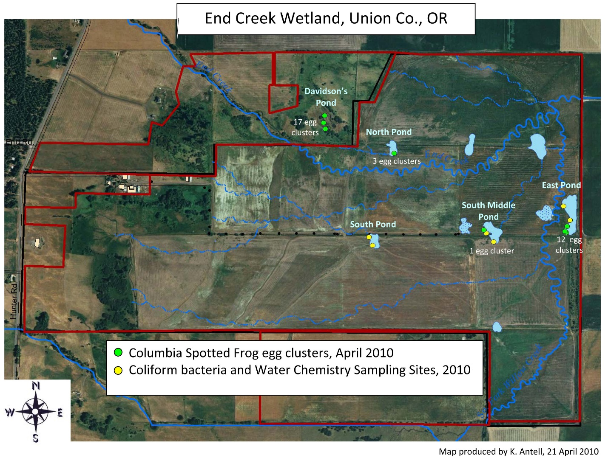

The research question that this and subsequent investigations will help answer is:
Are there differences in water chemistry that influence snail family distributions in the North, South and East ponds at End Creek?

- Background
You will be investigating the presence of positive and negative ions in water samples using a variety of chemical and physical tests. Presence of ionic species in solution will influence the conductivity. Higher concentrations of ions will result in a higher conductivity. Flame tests can be used to qualitatively identify the presence of specific ions. Much like in fireworks, when metal ions are heated in a flame, electrons from lower energy levels absorb energy and are promoted to higher levels. When these electrons relax back to the ground state, they emit light of characteristic wavelength. By observing the color emitted by known solutions of metal ions, the presence of metals can be determined in an unknown sample. In experiment 6, Atomic Emission Spectroscopy, you examined the emission spectrum of Na⁺, K⁺, Li⁺, Ca²⁺, Sr²⁺, and Cu²⁺ salts, by exciting the ions with a flame and recording the color and the wavelength.
You will also make use of chemical reactions to identify ions based on the formation of insoluble salts or highly colored compounds. You will first investigate different reagents and determine which reagent is best suited for the identification of a specific ion. Once you have developed your own analytical scheme on a set of known positive and negative ions, you will use the same chemical reactions to analyze water sampled at End Creek and determine whether there are differences in the chemical composition of the three ponds.

- Overview of tasks
- Understand the significance of a conductivity test in water.
- Analyze conductivity data collected at the three End Creek ponds.
- Research how to conduct a flame test for presence of Na⁺, Ca²⁺ and Fe³⁺ in standard samples.
- Analyze flame test data for presence of Na⁺, Ca²⁺ and Fe³⁺ in the End Creek ponds.
- Research how to conduct qualitative chemical tests on samples of known composition to identify best reagents to analyze for presence of Ca²⁺ and Fe³⁺.
- Analyze data collected on End Creek pond water for presence of Ca²⁺ and Fe³⁺.
- Research how to conduct qualitative chemical test on samples of known composition to identify best reagents to analyze for presence of Cl⁻, SO₄²⁻ and PO₄³⁻.
- Analyze data collected on End Creek pond water for presence Cl⁻, SO₄²⁻ and PO₄³⁻.
- Answer questions

- Simulated Materials Needed
Chemicals | Equipment
Dropper bottles with dilute solutions of:  - Sodium chloride  - Calcium chloride  - Iron (III) chloride  - Sodium oxalate  - Potassium thiocyanate  - Sodium sulfate  - Sodium hydrogen phosphate  - Silver nitrate  - Barium nitrate | - Plastic well plates  - Small stirring rods  - Disposable pipets  - Ni-Cr wire for flame test  - Conductivity tester  - Bunsen burner

- Simulated experimental procedure
- Conductivity and flame tests
- Research the Flynn conductivity meter at https://www.flinnsci.com/flinn-conductivity-meter/ap1493/ and take note of the scale, LED color and level of conductivity reported on the website.
- Research what color is generated when a sample of sodium chloride, calcium chloride, and iron (III) chloride are brought in a flame.

- Chemical test for positive ions
The table below will help you decide which reagent is best suited to analyze a water sample for presence of sodium, calcium and iron ions. Available reagents are sodium oxalate (Na₂C₂O₄) and potassium thiocyanate (KSCN). A suitable reagent is one that will uniquely react with the analyte of interest. Signs of chemical reactions include change of color, precipitation, evolution of gasses, etc. The following data was collected on standard solutions of Na⁺, Ca²⁺ and Fe³⁺:

Tests for Positive Ions on standard solutions:
Reagents | NaCl (Na ⁺) | CaCl2 (Ca²⁺) | FeCl3 (Fe³⁺)
Sodium oxalate (Na₂C₂O₄) | no reaction | cloudy white precipitate | no reaction
Potassium thiocyanate  (KSCN) | no reaction | no reaction | dark red color

- Chemical test for negative ions
Next, you will discover which reagent is best suited to analyze a water sample for presence of anions such as sulfate, chloride and phosphate. Available reagents are silver nitrate (AgNO₃), barium nitrate (Ba(NO₃)₂) and calcium chloride (CaCl₂). Again, look for signs of chemical reactions which may include change of color, precipitation, evolution of gasses, etc.

Tests for Negative Ions on standard solutions:
Reagents | Na2SO4 (SO4 ⁻²) | NaCl (Cl⁻) | Na2HPO4  (HPO4 ⁻²)
Silver nitrate (AgNO₃) | faint white precipitate | heavy white precipitate | cloudy yellow precipitate
Barium nitrate Ba(NO₃)₂ | cloudy white precipitate | no reaction | cloudy white precipitate
Calcium Chloride (CaCl₂) | cloudy white precipitate | no reaction | faint white precipitate

- Data from previous analyses:
The following data are a snapshot from multiple samplings conducted at End Creek in prior years. Use these data to analyze results and answer questions to complete your report.

- Conductivity and Flame Tests:
 | North Pond | South Pond | East Pond
Conductivity | Red LED: bright  Green LED: dim | Red LED: medium  Green LED: off | Red LED: dim  Green LED: off
Flame color | bright orange | orange with golden sparkles | orange

- Tests for Positive Ions at End Creek:
Reagents | North Pond | South Pond | East Pond
Sodium oxalate (Na₂C₂O₄) | cloudy white precipitate | cloudy white precipitate | cloudy white precipitate
Potassium thiocyanate  (KSCN) | no reaction | dark red color | faint red color

- Tests for Negative Ions at End Creek:
Reagents | North Pond | South Pond | East Pond
Silver nitrate (AgNO₃) | heavy yellow precipitate | heavy white precipitate | heavy white precipitate
Barium nitrate Ba(NO₃)₂ | no reaction | no reaction | no reaction
Calcium Chloride (CaCl₂) | faint white precipitate | no reaction | no reaction

EXPERIMENT REPORT SHEET
(20 points)

To complete your report, submit answers to the following questions. To obtain full credit, answers need to be full sentences.
- Research the difference between qualitative and quantitative analysis. What kind of information does qualitative analysis provide? What about quantitative analysis? Use an example to explain the difference between the two approaches.
- What do the results of the conductivity test indicate about what is present in the End Creek water samples? Is there a difference in the conductivity of the three samples?
- What color do sodium, calcium and iron ions produce in the flame? Based on the results from the flame test, which of these ions are present respectively in the North, South and East pond water samples?
- What reagent is most suitable for detecting calcium ion in water? Write the balanced chemical reaction for this test.
- What reagent is most suitable for detecting iron ion in water? Write the balanced chemical reaction for this test.
- Research the solubility rules for anions and cations. Was any reagent suitable for testing for sodium ion? Based on solubility rules, why would it be hard to devise a test for sodium based on the formation of a precipitate?
- Based on flame and positive ions chemical test, what cations are most likely present in the North, South and East ponds?
- Describe which reagents are most suitable for the analysis of sulfate, chloride and phosphate and write the balanced chemical reaction for each test.
- Based on your observations, which anions are cations are most likely present in the North, South and East ponds?
- Review all the results gathered through this exploration. Based on these results, are there any differences in water composition among the ponds at End Creek? Summarize your conclusions.

