pH and Buffer Capacity of Natural Waters
Anna Cavinato
Eastern Oregon University

- Overview
In this experiment, you will quantitatively determine the buffer capacity of water samples collected at End Creek using an acid-base titration. The buffer capacity is expressed as millimoles of HCl per liter of pond water (mmol HCl/L). In addition, you will determine the water pH using a pH electrode.

- Introduction
Where does acid rain come from?
Acid rain and snow are significant environmental concerns in both in the United States and around the world. As a result, various political measures have been taken to reduce emissions of nitrogen and sulfur oxides which cause acid rain. Sulfur dioxide is emitted into the atmosphere primarily from burning coal containing sulfur and through a series of reactions it is converted to sulfuric acid (H2SO4). Nitrogen oxide (NO) is emitted from any high temperature combustion reaction such as in a car’s engine or in a coal fired power plant is converted to nitric acid (HNO3).

The pH scale is used to express the acidity or hydrogen ion (H₃O+) concentration in solution, where

pH = -log [H₃O⁺]

A solution with pH = 7 is neutral, pH < 7 is acidic, and pH >7 is basic. Even in remote, unpolluted regions rainwater has a slightly acidic pH of approximately 5.6 due to the presence of carbon dioxide gas in the atmosphere. Carbon dioxide has a uniform concentration around the globe and dissolves in water to produce the weak acid, carbonic acid, as shown in the following reactions.

CO2 (g) + H2O (l) H2CO3 (aq)
H⁺ (aq) + HCO3⁻(aq) H2CO3 (aq) Ka1= 4.5 x 10⁻⁷
HCO3⁻(aq) H⁺ (aq) + CO3²⁻(aq) Ka2= 4.5 x 10⁻¹¹

Carbon dioxide dissolves in water and the concentration can be determined by using Henry’s Law.

[CO₂ ] = K x P(CO₂)

The solubility of CO2 in units of moles per liter (M) is equal to the product of the partial pressure of CO2 in the atmosphere, P(CO2), and the Henry’s Law constant, KH, at 25°C. The concentration of CO2 is approximately 385 ppm, therefore the partial pressure at sea level is 3.85 x 10⁻⁴ atm. KH is 3.4 x 10⁻² mol/L atm, therefore, the solubility of CO2 in water is 1.4 x 10⁻⁵ mol/L at 25°C. Since Ka1>>>Ka2, the pH of the system is primarily determined by the first equilibrium. Using a carbonic acid concentration of 1.4 x 10⁻⁵ M and solving for the concentration of H⁺ in the first equilibrium, the pH is found to be 5.60. “Acid” rain is classified as having a pH less than 5.6 and results from the reactions of the strong acids nitric and sulfuric acid in water.

H2SO4 (aq) → H⁺ (aq) + HSO⁻4 (aq)

HNO3 (aq) → H⁺ (aq) + NO⁻3 (aq)

Rain classification | pH
Unpolluted rain | 5.6
Slightly acidic | 5.0-5.6
Moderately acidic | 4.5-5.0
Highly acidic | 4.0-4.5
Extremely acidic | Below 4.0
The nature of soil in the Grande Ronde Valley

Although acid rain falls in many regions of the United State, the result is not always acidification of local bodies of water. Aquatic ecosystems in regions of the country that have rocks composed of granite are greatly harmed by acid rain. Serious effects have been documented in the Rocky Mountains due to increased acidity and increased solubility of toxic heavy metals at low pH. In the Grande Ronde Valley rock sediments are made mostly of basalt which, in turns, is composed of olivine and pyroxene (Mg,Fe)SiO₄ and plagioclase feldspar CaAlSi₃O₈.
Weathering of olivine is responsible for presence of magnesium in clays and iron oxide according to the reaction:
(Mg,Fe)SiO₄ + 4 H₂O + 3 O₂ 2 Mg(OH)₂ + 2 Fe₂O₃ + SiO₂ + 2H₂O

Presence of carbonic acid (H₂CO₃) affects plagioclase which explains the presence of calcium carbonate (calcite) in soils and sediments:
2CaAlSi₃O₈ + 2 H₂CO₃ + 9 H₂O Al₂Si₂O₅(OH)₄ + SiO₂ + 2H₂O + CaCO₃

The carbonate ion is a weak base and reacts with water according to the following reaction. The result is a slightly basic natural water system.

CO3²⁻(aq) + H2O (l) HCO3⁻(aq) + OH⁻(aq) Kb = 2.2 x 10⁻⁸

The carbonate ion reacts with acid rain to reduce the concentration of H⁺, raise the pH, and form a buffer system.

CO3²⁻(aq) + H⁺ (aq) HCO⁻3 (aq) + H⁺ (aq) H2CO3 (aq)

The overall reaction showing relevant ions and the buffer system is:

CaCO3 (s) + H2CO3 (aq) 2 HCO3⁻ (aq) + Ca²⁺ (aq) K = 4.4 x 10⁻⁵

The presence of the weak acid H2CO3 and its conjugate base HCO3⁻ create a buffer system that can resist changes in pH due to the addition of acid or base.

In this experiment you will measure the pH of water samples from End Creek using a pH probe. You will also measure the buffer capacity of these natural waters by titrating with a standard HCl solution. The buffer capacity is a measure of the amount of conjugate acid and base in solution. It is the quantity of acid or base that 1.0 L of the buffer can accommodate without undergoing a significant pH change.

Safety and Waste Disposal
- Acids and bases are irritating and corrosive to skin and eyes. Wear eye protection and appropriate clothing that covers the skin. Wearing gloves is also recommended.
- Acids and base solutions must be discarded in the appropriate containers under the hood.
- Store pH probes by submerging them in the storage solution.
- DO NOT allow the probes to dry out.

- Materials and Equipment
- Microlab unit equipped with titrant reservoir and drop counter
- pH electrode
- pH 4, 7, and 10 buffer solutions
- 250 mL beaker, one hot plate/stirrer, stir bar
- standardized HCl solution (0.01116 M)
- 100.00 mL volumetric flask
- water samples from End Creek.

- Simulated Procedure
Part I: pH Measurements

Calibration of pH Meter
The measurement of pH is made using electrodes which produce a voltage proportional to the concentration of H⁺ ions in solution. A pH probe requires calibration to ensure accuracy. First, open Microlab and go to “Experiment Builder”. Choose “Add Sensor”, “pH/DO” and proceed with the pH electrode calibration using pH 4, 7 and 10 standards. The probe is now calibrated and ready for use.

pH Measurements
Measure and record the pH of each of the pond water samples. Pour 10-20 mL of pond water in a clean disposable beaker. Swirl the solution and allow the probe to equilibrate for 30 seconds. Record the pH after the reading has stabilized. Rinse the probe with deionized water between each measurement and blot excess liquid with a Kimwipe. Repeat the measurement on two other samples from the same pond. When finished, rinse the electrode with deionized water, blot it dry and store it in the buffer solution. NEVER let the probe dry out as this will cause irreversible damage to the membrane.

Part II: Determination of Buffer Capacity
Titration with Standard HCl to Determine Buffer Capacity
- Before starting the titration, using deionized water, proceed to calibrate the drop counter.
- Add about 5-10 mL of the standardized HCl solution (~0.010M) to the reservoir. Drain to ensure the reservoir is clean and refill with standardized HCl.
- Using a volumetric flask, measure and deliver 100.00 mL of a water sample into a 250 mL Erlenmeyer flask and record the initial pH. Add a stir bar to the flask and place on a stir plate and gently stir.
- Start the experiment and add approximately 0.5 mL increments of the standard HCl solution. Continue until a pH change of two units is observed. This means that if the original pH of the water is 8.0, you will titrate until you reach pH 6.0.
- If the volume needed to reduce the pH by two units is too small, then increase the water sample size or dilute the HCl by a factor of 10 (you would be doing this step if you were actually performing the experiment!).
- Following is an example of titration curve previously recorded. Note that this is not a full titration reaching the equivalent point. By definition, the buffer capacity is the amount of strong acid (or base) necessary to produce a pH change of 1 unit when added to 100.0 mL of buffer. Data are recorded over two pH units to decrease error.
- Using the equivalent volumes provided below, calculate the buffer capacity of the each water sample in units of millimoles of HCl per liter of water (see example below).

- Data from previous analyses:
The following curve represents an example of buffer capacity determination using Microlab and standardized HCl.

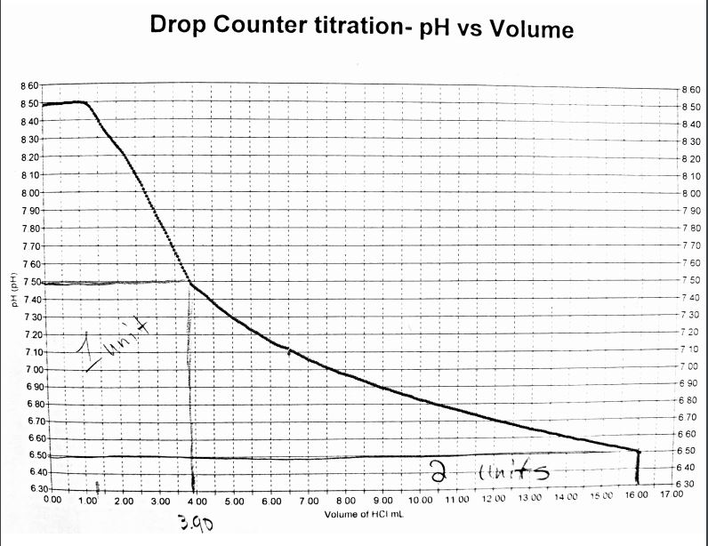

The graph shows that 16.00 mL of 0.0100M HCl produced a pH change of 2 unit when added to 100.0 mL of water.

16.00 mL × 0.0100 mol/L = 0.0160 mmol HCl.

Because the buffer capacity is defined based on change of 1 pH unit, we divide the result by 2. Therefore the buffer capacity for acid is 0.0800 mmol/0.10000L = 0.800 mmol HCl/L

Data were collected at three different ponds on the End Creek restoration area in prior years. The following data represent equivalent volumes as mL of HCl to observe a change of 2 pH units in 100.00 mL of pond water. Use these data to determine the buffer capacity in each water sample.

Equivalent volume (mL) of 0.01116M HCl (replicate measurements)
North Pond | South Pond | East Pond
16.50 | 17.01 | 15.40
15.58 | 16.85 | 14.95
15.95 | 17.35 | 15.35
16.75 | 17.05 | 15.40

Analysis of pH data
 | pH as determined by ten independent measurements
 | North pond |  | South pond |  | East pond
 | 7.45 |  | 7.61 |  | 7.05
 | 7.39 |  | 7.60 |  | 7.05
 | 7.38 |  | 7.67 |  | 6.99
 | 7.50 |  | 7.56 |  | 6.97
 | 7.42 |  | 7.62 |  | 7.07
 | 7.54 |  | 7.59 |  | 7.12
 | 7.45 |  | 7.63 |  | 6.98
 | 7.43 |  | 7.61 |  | 7.00
 | 7.43 |  | 7.57 |  | 7.02
 | 7.45 |  | 7.60 |  | 7.04

- Your Results:
- For each water sample report the pH as the average of the ten replicate measurements and the standard deviation.
- Calculate the buffer capacity for each water sample expressed as mmol HCl/L from each titration and report the average value with the standard deviation.

- Lab report guidelines:

The lab report should include the following sections:

Introduction – Explain the significance of water buffer capacity. Why is it important to measure the buffer capacity for an open waterbody such as a pond? Where does the ‘buffer capacity’ originate from? You may want to discuss buffer capacity in light of the Grande Ronde Valley soil composition.

Procedure – Briefly summarize the steps you would have taken if you had conducted this experiment in a laboratory setting.

Results – Calculate the buffer capacity from each titration and express the final result as average and standard deviation. Prepare a table summarizing the buffer capacity and pH values observed at each of three ponds.
Discussion – Discuss the meaning of buffer capacity measurement. Do your water samples have high or low buffer capacity? Typical values range from 0.05 to 2 mmol (HCl)/L. Discuss any trends you observe in the data. Are there large differences in pH and buffer capacity across the three ponds? Is the pH indicative of the soil chemistry in the Grande Ronde Valley? What sources of errors could limit the accuracy and reproducibility of these measurements?

Conclusion – Briefly summarize your findings.
References – Cite any references you used to write this report. References should follow APA style.

A.C. 4/30/2020

References
“Analytical Chemistry 2.0” by David Harvey
http://www.asdlib.org/onlineArticles/ecourseware/Analytical%20Chemistry%202.0/Welcome.html
pH - https://www.epa.gov/sites/production/files/2015-06/documents/stream.pdf

