Print, build and use your own LED photometer

These directions are set up for you to be able use these directions as a whole or cut and paste what is needed into a lab procedure to measure the absorbance of analyte from about 380 nm through about 1000 nm. The end result will give you a spectrometer in a sense that you can trade out LEDs to measure absorbance at different wavelengths with a total cost of about $10 per system. The system has been tested using Red #1 food-dye and a blue LED, which gave the results seen below.

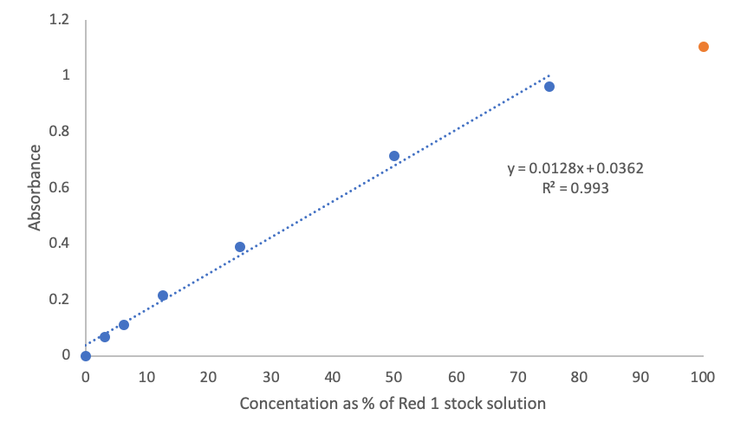
There is rollover at absorbance values around 0.8-0.9 and is much more pronounced when the absorbance is above 1. This is probably due to stray light and a non-linear signal correlation when low amounts of radiation traverse the photoresistor.

Note the design for the absorbance photometer is modeled after Dr. Lon Porter’s fluorometer design which was published in the Journal of Chemical Education. I have added some interior baffles to further reduce stray light and scattering that was occurring. The general schematic is identical to the general design seen in Figure 3 of a review in the Journal of Chemical Education by Kovarik, Clapis and Romano-Pringle entitled, “A Review of Student-Built Spectroscopy Instrumentation Projects.” That figure can be seen below (used with permission):

light source
detector
sample

Needed Components

3D printed parts using the included files:
- body with cuvette holder
- end cap for LED
- end cap for photoresistor
- cap for cuvette holder

Other components:
- Multimeter (least expensive options are here or here)
- Cuvettes (system is designed for 5mm cell width (perpendicular to the light) cuvettes)
- LED – pick a color based on the radiation wavelength absorbed by the sample
As per the Thorlabs web page and note these are approximate with a bandwidth usually on the order of 10 nm: https://www.thorlabs.com/newgrouppage9.cfm?objectgroup_id=3836

405 nm – UV | 420 nm – violet | 455 nm – royal blue | 470 nm – blue
490 nm – blue | 505 nm – cyan | 530 nm – green | 565 nm – green yellow
590 nm – amber | 617 nm – orange | 625 nm – red | 660 nm – deep red

- Photoresistor (5mm works better to reduce stray light, but any will do) Amazon option
- 9V battery
- 9V battery connector with two bare wires or plug that allows you to draw power
- Prototyping breadboard (2-inch board should be fine) Amazon option
- Wiring Amazon option
- Scotch Tape

3D printing the devices

You have access to the .stl files, which can be converted the proper code using a program such as Ultimaker Cura 4.6.1 -- https://ultimaker.com/software/ultimaker-cura

Note the software is free. You will have to set up the software with the parameters of the material you are using (PLA, ABS and there are others) as well as the brand/specifications of the 3D printer you are using for the print. Key items are filament extruding temperature, bed temperature, nozzle diameter and several others. It is suggested that you are somewhat familiar with 3D printing before trying to print big, complex objects as there are many opportunities to be unsuccessful in printing. Practice based on what is provided by your manufacturer guidelines moving forward. Note all of these pieces were printed using ABS, which is a little more difficult to use than PLA. Then most importantly you need to transfer the file from your computer to the printer.

Images of the 3D printed are on the following page with some cost specs giving you some idea on cost to print one spectrometer.

Body with the cuvette holder
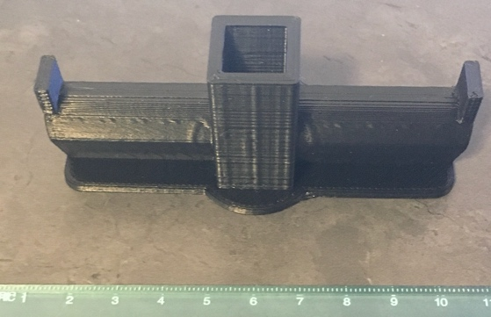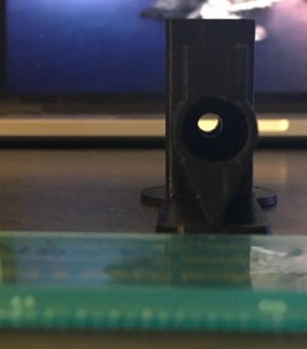
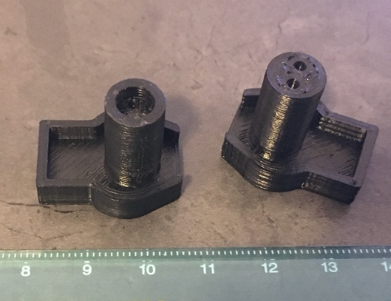
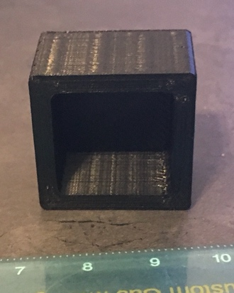
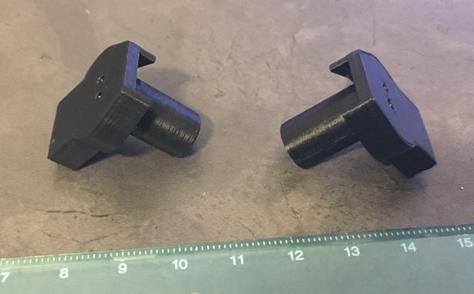

Cap for cuvette holder End caps for LED and photoresistor (this is the print file from Porter)

Costs and time to print using Rostock v2 3D printer:
Piece | Time | Mass and cost of filament ($21.99 for 1.75 kg)
Cap for cuvette holder | 45 minutes | 5 grams, $0.09
Body with cuvette holder | 2 hours, 40 minutes | 17 grams, $0.33
End cap for LED | 31 minutes | 2 grams, $0.05
End cap for photoresistor | 33 minutes | 2 grams, $0.05

How to assemble the device

Here is the circuit needed to power the LED and the photoresistor:
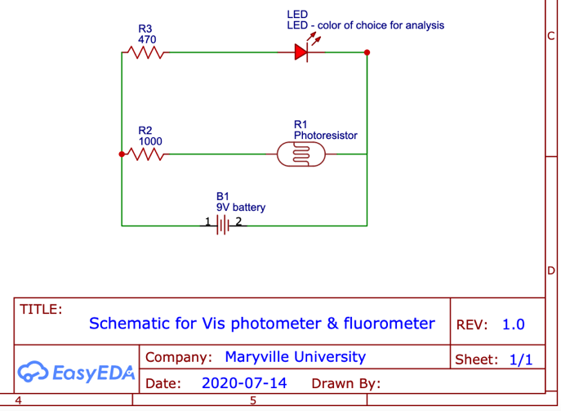

And it can be built as seen below:
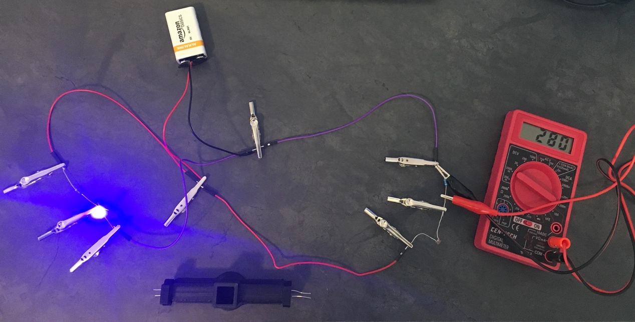
Signal in mV
1000 ohm resistor – voltage measured across it
Wires: red are positive, black /purple are negative
LED w/ long pin connected to resistor
photoresistor
470 ohm resistor
You can see the 470 ohm resistor on the far left acting as a ballast resistor to limit current through the LED so it doesn’t burn out. The LED is attached to the resistor on the long pin as that identifies the positive end of the LED. For the photoresistor, order of the resistors or orientation for connection do not matter.

Below is a picture showing the setup for orientation for the LED photometer:
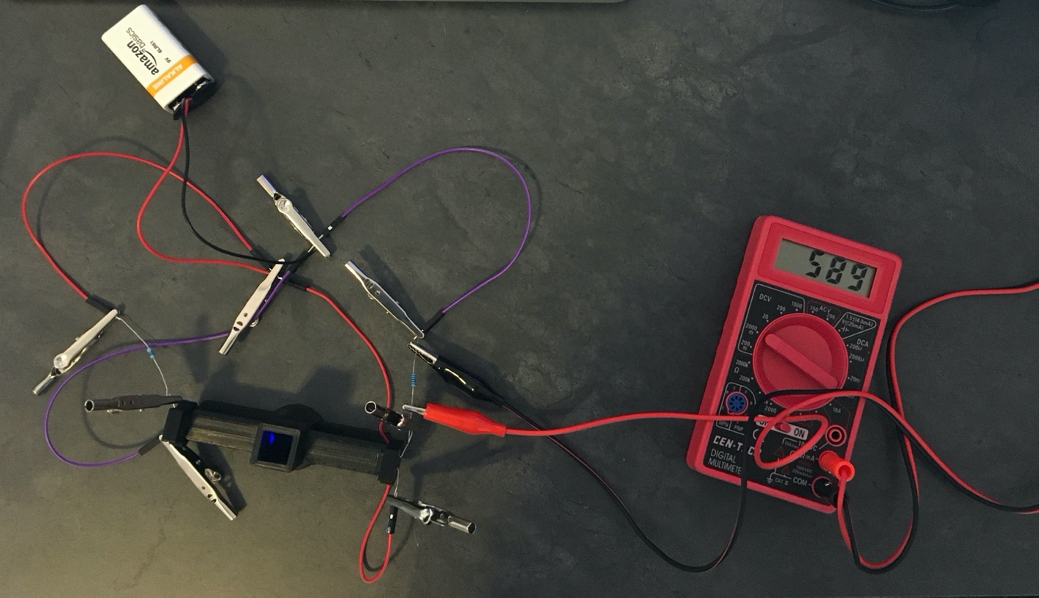
Signal in mV
photoresistor
LED

What are you measuring?

For any measurements, please use the cap as it will help to reduce stray light in the system. You need to obtain a blank measurement in mV, which is P₀. All the other solution measurements will be P.

Remember that:

$T=\frac{P}{P_{0}}$ and $A=-\log{T}$

Setting up a spreadsheet will usually help completing any data analysis.
Troubleshooting? Consider this link for options:
https://www.youtube.com/watch?v=JPVmp_gsycE

Note the board is the same, but the electronics are soldered onto a breadboard.

References:
Porter, Lon A., Cole A. Chapman, and Jacob A. Alaniz. “Simple and Inexpensive 3D Printed Filter Fluorometer Designs: User-Friendly Instrument Models for Laboratory Learning and Outreach Activities.” Journal of Chemical Education 94, no. 1 (January 10, 2017): 105–11. https://doi.org/10.1021/acs.jchemed.6b00495.

(accepted) Kovarik, Michelle L., Julia R. Clapis, and K. Ana Romano-Pringle. “A Review of Student-Built Spectroscopy Instrumentation Projects.” Journal of Chemical Education. https://dx.doi.org/10.1021/acs.jchemed.0c00404.

