Analysis of Phosphate
Anna Cavinato
Eastern Oregon University

- Overview

In this experiment, you will determine, quantitatively, the amount of phosphate
(PO₄³⁻), expressed as phosphorous P in mg/L, present in water samples collected at End Creek using an ascorbic acid/spectrophotometric-based method.

- Introduction

The phosphate ion is an essential plant nutrient, and is also essential to life. However, it is often depleted in soil, and hence phosphorus is the main component in most fertilizers. Runoff from fertilizer in aquatic ecosystems may thus lead to abnormally high phosphate levels, leading to a pollution hazard.

The chemistry of phosphate is much more complicated than that of most polyatomic ions. There are many different forms of phosphorus as an ion, so the simplest one, PO₄³⁻, is termed orthophosphate. The amount of orthophosphate present may be determined by the ascorbic acid/molybdenum blue method. In this method, ammonium paramolybdate, (NH₄)₆Mo₇O₂₄∙4H₂O, reacts with orthophosphate in acidic solution and in the presence of potassium antimonyl tartrate, C₈H₄K₂O₁₂Sb₂, to produce phosphomolybdic acid, H₃[P(Mo₃O₁₀)₄]. This acid, in turn, reacts with ascorbic acid, C₆H₈O₆, to produce intensely colored molybdenum blue. “Molybdenum blue” is actually not a single compound, but a complex mixture of polyoxomolybdate (POM) ions. The role of potassium antimonyl tartrate is as a catalyst.

12 Mo₇O₂₄⁶⁻(aq) + 7 PO₄³⁻(aq) + 93 H⁺(aq) 7 H₃[P(Mo₃O₁₀)₄](aq) + 36 H₂O(l)
H₃[P(Mo₃O₁₀)₄](aq) + C₆H₈O₆(aq) “molybdenum blue” + C₆H₆O₆(aq)

Once each orthophosphate sample has been converted into molybdenum blue, you will then use UV/Visible spectrophotometry to measure the concentration of molybdenum blue. Recall that the absorbance (A) of a colored sample is directly related to the molar concentration (c) of the colored species according to Beer’s Law.

A = εbc (1)

In Equation (1), ε is the molar absorptivity, characteristic of a particular species, and b is the path length of the cuvette. The molar absorptivity depends on the wavelength used; for molybdenum blue, an optimal wavelength is 880 nm. To determine ε, you will plot the absorbance of a series of standards with known orthophosphate concentration, and construct a calibration curve between the absorbance of molybdenum blue and the concentration of orthophosphate. Then, using the calibration curve, you will determine the amount of orthophosphate present in the water sample (expressed as total phosphorus P in mg/L).

Because phosphate is such a ubiquitous ion, care must be taken to handle glassware and other containers very carefully, to prevent inadvertent contamination of natural water samples with phosphates found in the lab. All glassware must be acid-washed before it comes in contact with any phosphate standard or water sample.

- Materials and Equipment

- Water samples from End Creek
- Five phosphorous standards (mg/L): 0.05 mg/L, 0.10 mg/L, 0.20 mg/L, 0.30 mg/L, 0.40 mg/L.
- 5 M H₂SO₄
- Phenolphthalein indicator solution
- Potassium antimonyl tartrate solution
- Ammonium molybdate solution (20 g ammonium paramolybdate tetrahydrate/500 mL water)
- Ascorbic acid solution (0.1 M)
- 10% HCl solution
- Agilent Cary 60 UV-VIS spectrophotometer

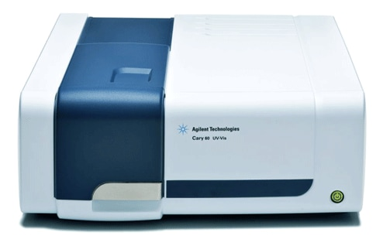

- Simulated Procedure

NOTE: Use latex gloves when handling glassware and in all subsequent steps, for your protection and to prevent contamination of the glassware with phosphates from your hands.

The outline of the procedure is as follows:
- Acid wash all glassware.
- Prepare the molybdenum blue reagent.
- For the water sample and for each of the five orthophosphate standards, perform the spectrophotometric analysis of molybdenum blue. This result will yield the amount of total dissolved reactive phosphorus.
- Using the data from the standards, construct a calibration curve relating absorbance to concentration of orthophosphate.
- From the calibration curve, determine the concentration of orthophosphate (expressed as P in mg/L) in the water sample.

Procedure for Acid Washing of Glassware

For each piece of glassware you will be using for this analysis:

- Wash with a clean brush and phosphate-free detergent.
- Rinse three times with cold tap water.
- Rinse with a solution of 10% HCl.
- Rinse three times with deionized water.

Procedure for the Preparation of the Molybdenum Blue Reagent with Ascorbic Acid

Using a graduated cylinder, measure 17.5 mL of molybdenum blue reagent w/o ascorbic acid and transfer to a beaker. Add 7.5 mL deionized water to the pre-weighed ascorbic acid (0.132 g). Mix well and add to the previously measured molybdenum blue reagent. You should have a total of 25.0 mL of reagent.
This solution is only stable for 4 hours. Thus, you must act quickly after preparing this reagent!

Procedure for Spectrophotometric Analysis of Orthophosphate

- Analyze water from one site at least in triplicate measurement.
- Prepare nine dry 50-mL Erlenmeyer flasks.
- Label one flask “blank” and using the 10.0 mL volumetric pipette, transfer 10.00 mL of deionized water.
- Label five flasks with the concentration of the five phosphate standards and pipette 10.00 mL of each standard in each designated flask.
- Label the remaining three flasks as “water sample” and transfer 10.00 mL of water from a specific site collected at Ladd Marsh.
- Add 1 drop of phenolphthalein indicator. If the solution turns pink, add 5 M H₂SO₄ dropwise to just discharge the color. (Make sure the eyedropper has also been acid-washed!)
- Using a pipette, add exactly 1.60 mL of molybdenum blue reagent to every flask and mix thoroughly.
- After at least 10 minutes, but not longer than 30 minutes, measure the absorbance of the solution at 880 nm.

- Data from previous analyses:
The following absorbance values were recorded on phosphate standards. Please notice that the standards concentration is expressed as phosphorus (P) in mg/L. Use these data to construct the calibration plot:

Phosphate (P) calibration data
Phosphate (P) concentration (mg/L) | Absorbance
0.00 | 0.0000
0.05 | 0.0164
0.10 | 0.0421
0.20 | 0.0758
0.30 | 0.1257
0.40 | 0.1657

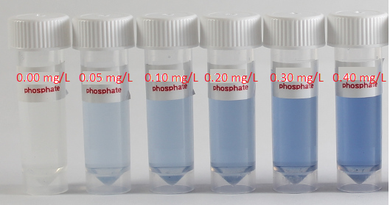
Data were collected at three different ponds on the End Creek restoration area in prior years. Use these data to determine the phosphate (as P in mg/L) concentration in unknown water samples:

Absorbance values in unknown water samples (replicate measurements)
North Pond | South Pond | East Pond
0.0372 | 0.0299 | 0.0534
0.0375 | 0.0258 | 0.0395
0.0337 | 0.0248 | 0.0406

- Your Results:
Using the calibration data provided, prepare a calibration curve in Excel or comparable program to by plotting A (absorbance) on the y-axis and c_{P} (concentration of P in mg/L) on the x-axis for the orthophosphate standard solutions. Fit the data to a straight line and record the calibration equation, y = mx + b, where y is the absorbance A and x is the concentration of P in mg/L.

Next, using the calibration curve equation and the absorbance values measured on each water sample, determine and report the concentration of phosphate in mg/L P. Calculate the mean of the replicate measurements for each water sample and also report the standard deviation.

- Lab report guidelines:

The lab report should include the following sections:

Introduction – explain the significance of a phosphate measurement in water. Why are we concerned about presence of phosphates in a fresh water pond? Does the EPA regulate the amount of phosphate in surface water by posing limits to the amount of phosphate in a water body? Include an explanation of spectrophotometric analysis which is the basis for this experiment.

Procedure – briefly summarize the steps you would have taken if you had conducted this experiment in a laboratory setting.

Results – Report the calibration plot and the calibration equation. Prepare a table summarizing the amount of phosphorous in mg/L calculated in each sample along with the average and standard deviation for each of the three ponds.

Discussion – discuss any trends you observe in the data. Are there large differences in phosphate content across the three ponds? What sources of errors could limit the accuracy and reproducibility of these measurements?

Conclusion – briefly summarize your findings.

References – cite any references you used to write this report. References should follow APA style.

A.C. 4/22/2020

