Chemistry 371 Laboratory Fall, 2020

HPLC Simulation Using Excel Macros

Introduction. Analyte separation in liquid chromatography is the result of differing affinities of the solutes (analyte and solute will be used interchangeably) for two mutually immiscible phases: a stationary phase, typically bound to the surface of microporous spherical particles of silica packed inside a stainless steel or glass column, and a liquid mobile phase that is pushed through the column at a constant flow rate. In what is referred to as reversed-phase chromatography, the most common type of liquid chromatography, a non-polar stationary phase is used in conjunction with a more polar mobile phase.
For the simplest case, non-polar solutes interact more strongly with the non-polar stationary phase than with the mobile phase. As it moves through the column, the relative amount (concentration or mass) of a solute in each of the two phases is described by its partition constant, K, given by
K = C_{s} / C_{M}
The larger the value of K, the more time the solute spends in the stationary phase relative to the mobile phase.
The point on the column where a partition occurs between phases is referred to as a “plate”, with the number of plates on a column determining its ability to efficiently separate one component of a mixture from another. This gives rise to the concentration ratios at each “plate” and the relative speed with which analyte moves through the column.
In this exercise, Excel macros are used to illustrate the movement of one or more solutes through the length of a liquid chromatographic column. Adjacent columns in the spreadsheet are used to represent a single plate. At the beginning of the simulation, a fixed amount of each solute is distributed between the two phases (adjacent columns) at the first plate according to its value for K. The amount in the mobile phase then “progresses” down the column by a distance represented by one plate or partition event, represented by moving down one cell position in the spreadsheet. The concentration in each of the phases at this plate is then recalculated to satisfy the ratio given by K. Each partition event is represented by the values in the two columns in a single Excel row corresponding to the two phases.
By repeating these calculations in each cell going down a column, the movement of the solute “plug” through the column can be visualized with conditional color intensity formatting available in the program. While each partition is not in reality a discrete event and equilibrium is not necessarily reached at each “plate”, the simulation offers an effective introduction to many of the concepts necessary to understand column chromatography.^{1,2}
As you work your way through these exercises, you should record your observations in a Word or Google doc. You should also take a “screen shot” of each of the plots that result from simulation so that they might be used to illustrate the report you will write later.

Isocratic Elution. For isocratic elution, the composition of the mobile phase does not change during the experiment. Later in this exercise you will be introduced to gradient elution in which some characteristic of the mobile phase, for example the percentage of an organic solvent relative to water, is changed during the experiment to enhance separation between analytes.
1. Open the file labeled “figure_2_isocratic”. The file name relates to figure 2 in the original journal report. You should observe the spreadsheet shown below. Examine its layout. You will see that K values are given for two analytes, denoted X and Y, in Rows 3 and 4 of Column D. These values can be varied in subsequent runs of the macro.

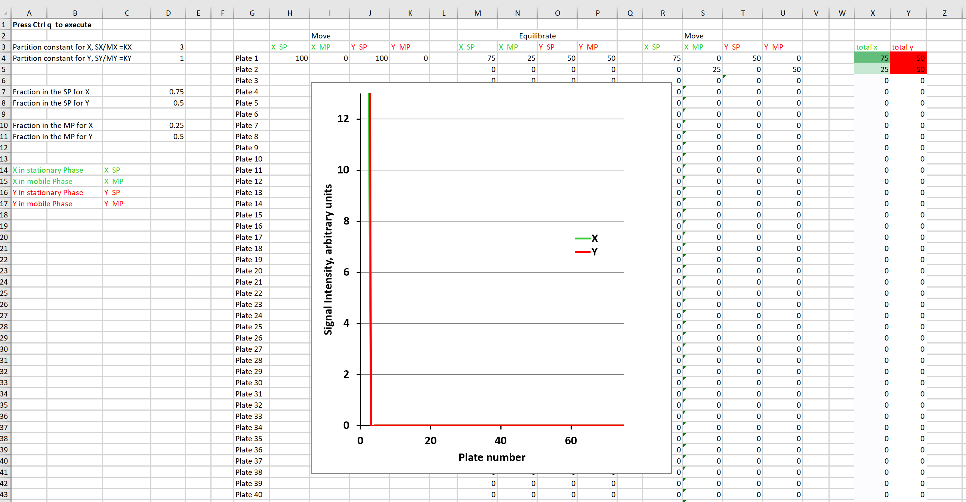
In Column D of Rows 7 and 8, you will see the fraction of each analyte in the stationary phase for the first “plate”. (How was this value arrived at?) In Rows 10 and 11, the corresponding fraction of material in the mobile phase is given.

Change the values for K in Column D, Rows 3 and 4 and observe what happens to the values in Rows 10 and 11. Does this make sense to you? Notice that the calculated values for Plate 1 across Row 4 also change to match the values you entered for K.

The initial “concentration” of each analyte is given by the entries in Row 4, Columns H and J. This value is 100 (arbitrary units) for both X and Y for the original macro conditions.

2. Return each K to its initial value (3 for X and 1 for Y). It is now time to observe the first simulation. The initial conditions written into the macro include 50 iterations of partitioning for each solute. Start the run by simultaneously pressing “Ctrl” and “q”. You will see the concentrations in each of the columns change as solute reaches each plate. At the far right you will see a moving representation of the real time concentration of each solute in each plate as it makes its way through the column. The center of the band is darkest in color, with lower concentrations appearing lighter. Notice that it takes multiple equilibration events at each plate to completely clear the plate of analyte.

3. The resolution between chromatographic peaks is best described by the extent of overlap in the area beneath the two signals. This overlap should be minimized if quantitation of the analytes is needed. As previously described, the extent of separation depends upon the differences between the values for K for two analytes. It is also a function of the number of partitions made by a solute during its time on the column. “Baseline” resolution is achieved when no overlap exists between the signals for the two peaks.
In general, the resolution for two closely spaced, symmetric chromatographic peaks is given by³
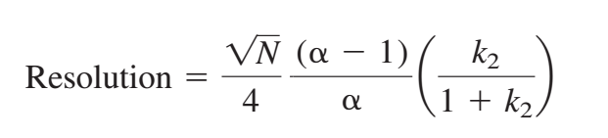
where N is the number of partitions, α is the relative retention between the peaks (= K₂/K₁, where K₂ >K₁), and k₂ is the retention factor for the later eluting peak (= K₂ V_{s}/V_{M}, with V_{s} and V_{M} denoting the volumes of each phase). For simplicity, the macro assumes that the volumes of the stationary and mobile phases at each plate remain equal (V_{s} = V_{M}).

Calculate the value for R between the peaks for X and Y after 50 partitions. Was “baseline” resolution achieved for this number of partitions?
4. The macro can be edited to allow any number of partitions. To make this change, start by closing the file you have open, and then reopening it to return the initial conditions. Next, select the “Developer” tab at the top of the spreadsheet, followed by “Macros”. (If the “Developer” tab is not available in your copy of Excel, go to “File\Options\Customize Ribbon” and check the “Developer” box on the right-hand panel that appears.) Select “Macro 1” followed by “Edit”. The following screen should appear.
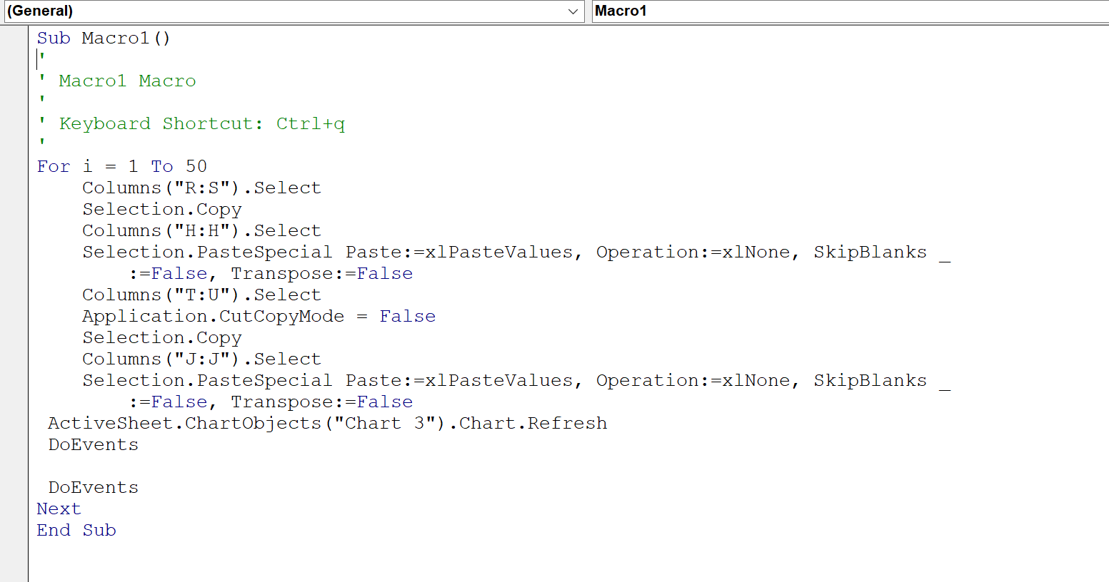
The number of iterations is given by “For i = 1 To 50”. Highlight the 50 and enter a value of 75. “x” out of the macro window, then close the “edit” window to return to the spreadsheet.
Run the simulation using the edited macro. Was baseline resolution achieved? If not, repeat the process using additional partitions until baseline resolution is found. You will need to reload the spreadsheet each time following a run to reset. How many partitions did it take? Calculate the value of R for this number of partitions. Take a screen shot of the resultant chromatogram. (If needed, you can change the maximum number of plates that show up on the plot by double clicking on any of the numeric values along the x-axis and re-entering new maximum value at right of screen.)
5. Increasing the number of partitions without changing other chromatographic parameters requires that the length of the column be increased. Most times in lab, we do not have a very large number of column lengths to choose from, and resolution will have to be increased by changing other parameters. For example, a different solvent system used as mobile phase will affect the values of K for most analytes.
Open a new copy of the spreadsheet to obtain initial conditions, including 50 iterations of the macro. Using this value for partition number, systematically change the values of K for X and Y until you find values that allow for baseline resolution between the analytes.
Gradient Elution. A separation that makes use of a mobile phase whose composition changes from the beginning to the end of a run is called a gradient elution. The reason that a gradient, or changing mobile phase, is necessary for many separations is defined by the general elution problem, which states that isocratic mobile phase conditions can almost always be found that lead to good separation between early eluting compounds or late eluting compounds, but not both.

A typical gradient involves an increase in the mobile phase strength over the course of the separation. An increase in mobile phase strength is defined for reversed-phase chromatography as a decrease in mobile phase polarity. Most mobile phases in reversed-phase are a mixture of water and a miscible organic solvent like methanol or acetonitrile. Thus, mobile phase strength is increased as the percentage of organic component is increased relative to that of water. In general, this increase will lead to faster elution times for the later eluting compounds in the mixture.

1. Open the file labeled “figure_5b_linear_gradient”. The macro is written to simulate the separation of a three-component mixture, allowing for changes in the mobile phase during the run. As before, K values are given for each component (which will change as the mobile phase composition does), along with the calculated fraction of each in both the stationary phase and the mobile phase. You will also see values for “Phi” and “T”, which represent the volume fraction of the organic component of the mobile phase relative to water and the absolute temperature.

Notice that there are now two plots on the screen: a column view and a detector view. Up until now, we have viewed only the movement of solute from the front of the column to the end, with peaks “disappearing” at the right of the screen as they elute (column view). The late eluting compounds are at left of screen in this view.

The additional screen, the detector view, will display the solutes as they pass through the detector (located at the end of the column). In this view early eluting compounds will be seen at the left of the screen while the late eluting compounds will be at the right. Not at all confusing.

2. Use the “Developer” and “Macros” tabs to open “Macro 1” shown below.

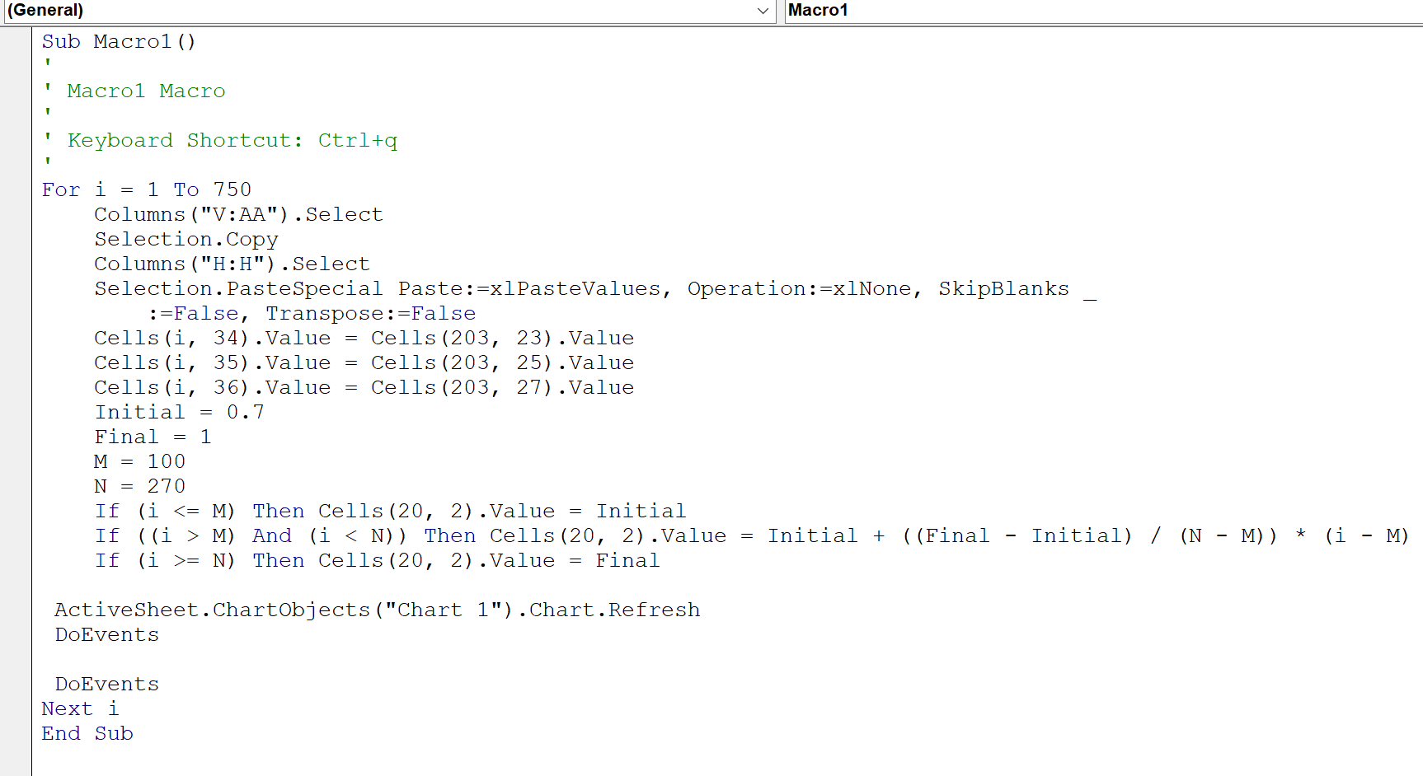

The number of iterations still appears in the first line. Conditions for the gradient elution are now included. “Initial” is the organic fraction at the beginning of the run (0.7 = 70% organic/30% water), and “Final” is its fraction at the end of the run (1 = 100% organic). “M” gives the iteration at which the gradient begins to increase in a linear fashion, with “N” being the iteration at which the final fraction is reached. Any additional iterations occur with the fraction at the value given in “Final”.

A graphical representation of the linear gradient given in the initial conditions for this macro is shown below.
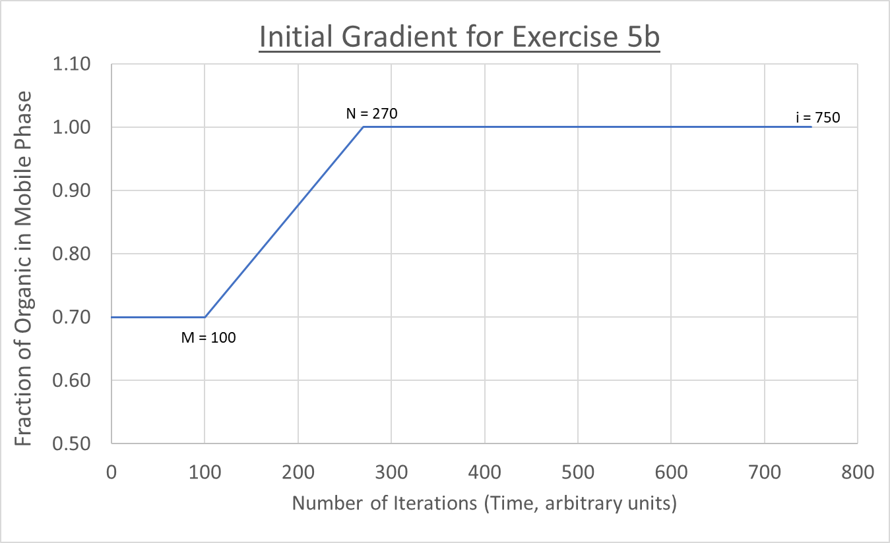

3. Demonstration of the General Elution Problem. Open the macro window and change the “Final” value to 0.7 (70% organic). “x” out of the macro and Visual Basic windows to return to the spreadsheet. You now have created conditions where the initial and final mobile phase composition are the same, which of course is an isocratic elution. For this case, the mobile phase strength is at the minimum value for which the gradient was designed.

What analyte type would you expect to elute first in this isocratic run? Last?

Run the macro and observe what happens. Describe in a sentence or two what is good about the separation and what might be considered less than optimal.

Close the spreadsheet and re-open to obtain initial conditions. Re-edit the macro and set the initial and final values for mobile phase composition to 1.0 (100% organic). The mobile phase strength is now at its maximum value.

What analyte type would you expect to elute first in this isocratic run? Last?

Run the macro and observe what happens. Describe in a sentence or two what is good about the separation and what might be considered less than optimal.

4. OK, now for the magic of the gradient elution. Open a fresh copy of the spreadsheet that contains the initial conditions for the gradient run. Run the macro.

Comment on the behavior of each analyte observed at several different points in the run as the mobile phase strength is increased.

Next, as you did for both the isocratic runs in step 3, describe what is good about the gradient elution and what might be considered less than optimal. How might you improve on this separation?

5. As partitioning is related to K, which is an equilibrium constant, temperature will also affect the rate at which partitioning occurs. Under the initial conditions of this macro, the temperature is fixed at 323 K (25 ºC).

Predict what the effect on the gradient separation will be if the temperature is increased or decreased from the initial value. Test your hypothesis by doing several runs of the macro by changing only the temperature from the initial conditions.

Step Gradients. Under some conditions, a more efficient separation may be achieved with a “step” gradient as opposed to a linear one. For example, if a rapid separation between the components in a mixture is achieved quickly under the initial gradient conditions, a quicker switch to a stronger mobile phase may “hurry” late eluters along, resulting in a faster separation without loss in resolution. The more complex a mixture, the more “steps” that might be required to achieve adequate separation.

1. Open the file labeled “figure_5c_step_gradient”. The macro is written to simulate the separation of the same three-component mixture, while utilizing a five-step methanol gradient. The initial conditions for the macro are as follows: 70%, steps 1-100; 80%, steps 101-150; 90%, steps 151-200; 95%, steps 201-250; 99%, steps 251-300; and 100%, steps 301-700.

The code for this macro is shown below. Each of the “step” points is designated by a letter between M and Q, with the conditions for each change shown below the list of entries. Note that the value for % organic solvent in the mobile phase are located in Row 20, Column B of the spreadsheet, denoted as “Cells (20, 2)” in the macro code itself.

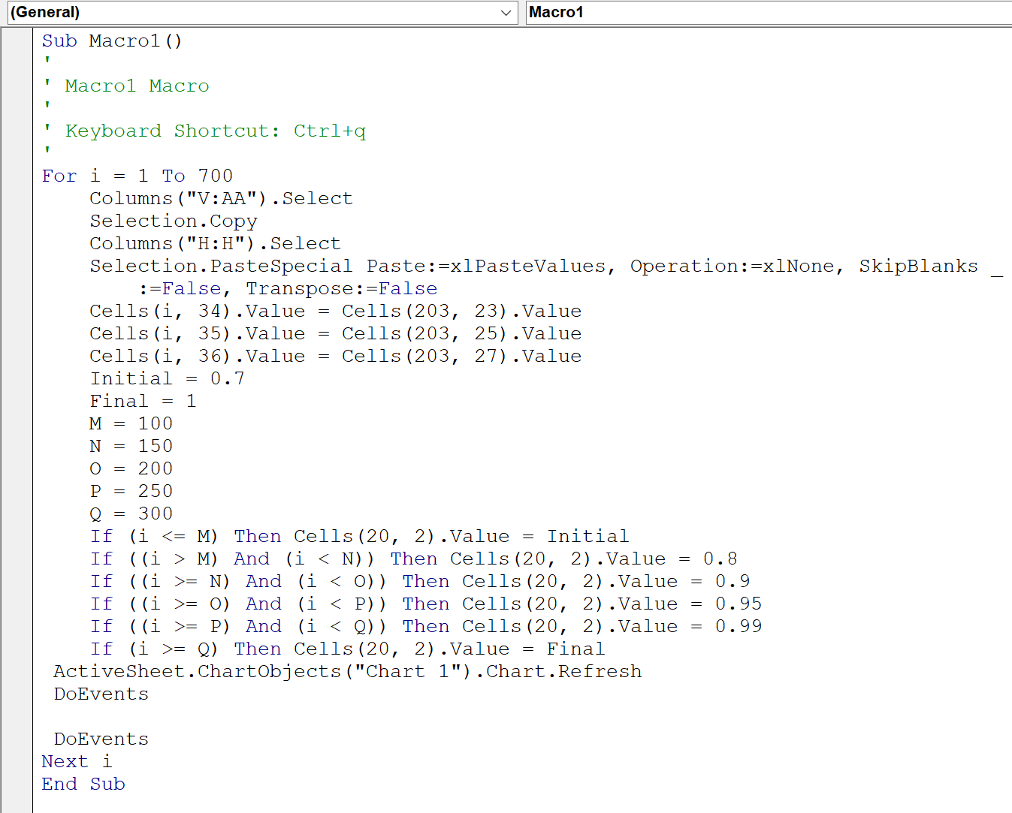

2. Next, run the macro using the initial conditions in “figure_5c_step_gradient”.

Do you see any advantages to using this gradient over that you used in “figure_5c_linear_gradient”.

3. Close the spreadsheet and re-open to obtain the initial conditions. Try your hand at editing the macro, removing all but one of the steps. You many delete any lines in the code that you do not need. Set up the run so that you begin with an initial of 0.7 and end with a final of 1.0, with the step occurring after 150 iterations.

Run the macro and compare the results to that of the five-step gradient you did in step 2.

4. Design your own three-step gradient using values for mobile phase composition of your choosing, with locations of each step in the run that you think might be most effective at achieving a complete separation in less time than the original.

Challenge. Using what you have learned so far, see if you can design a gradient run, either linear or step, that results in baseline separation of the three components while completely eluting all three in under 600 time units. Limit your changes to gradient composition, timing (when and how fast to make the change in conditions from initial to final) and temperature. Comment on what changes you made in each attempt and why you made them. Include in your report the graphical results of your best attempt.

Non-ideal Behavior. To this point, we have assumed that the partitioning of solute between the mobile and stationary phases was adequately described by the partition constant, K. We have also considered that enough stationary phase sites exist to accommodate the amount of solute introduced to the column. Under these conditions, a plot of C_{s} as a function of C_{M} for increasing concentrations of injected solute (at fixed T) is linear with a slope equal to the value for K. This plot is referred to as a distribution isotherm.⁴
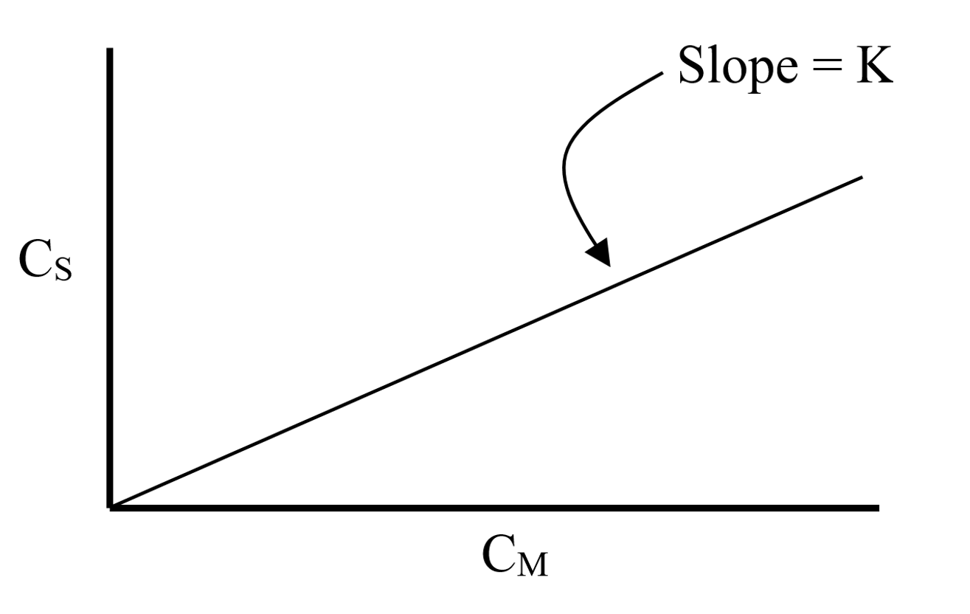
When the isotherm is linear, the partition constant is independent of solute concentration and the observed peak shape is symmetrical around the maximum, or Gaussian. This is known as ideal behavior.

In reality, the volume of the stationary phase is normally significantly smaller than that of the mobile phase, with a fixed number of sites available for partitioning into the stationary phase. This means that the stationary phase can be saturated at high concentrations of injected solute, causing the isotherm to deviate from the ideal case.

If the isotherm bends downward at high concentrations of solute, it is referred to as a Langmuir isotherm, while the opposite case is referred to as anti-Langmuir. Both of these non-ideal isotherms lead to peak shapes that are not Gaussian, but rather exhibit either “tailing”, where the peak rapidly reaches a maximum followed by a very gradual, drawn out return to baseline, or “fronting”, in which the peak is drawn out before the peak, and falls rapidly after the peak (see figures below⁴). These asymmetries are responsible for increased peak width and decreased resolution. In general, column overloading leads to “fronting” for GC and “tailing” in HPLC.

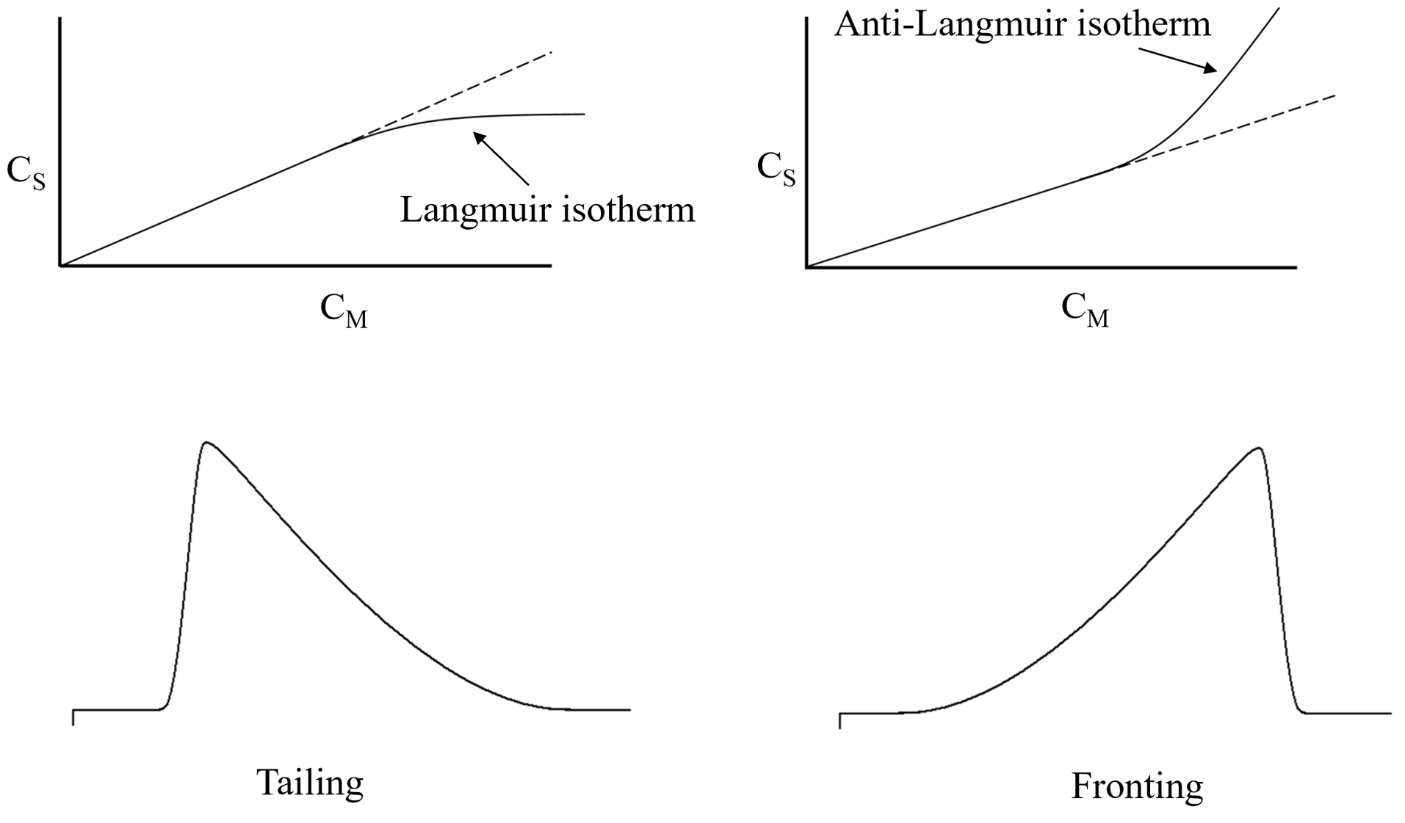

The Langmuir Isotherm.

1. Open the file labeled “figure_6a_langmuir_isotherm”. The macro simulates the behavior of column overloading for a single solute which follows the Langmuir isotherm, shown above. The isotherm is described by the equation¹
C_{s} = (K C_{M})/(1 + K C_{M})

The initial file conditions are for K = 0.5 (Row 3, Column D) and an initial concentration of 100 units (Row 6, Column I). Change the value for concentration from 100 to 1. Change the scale of the y-axis of the plot to be a maximum value of 0.10. (Double click on any of the numerals on the y-axis, and enter the value in the “bounds/maximum” box that appears at the right of the screen. Hit enter, and x-out of the “format axis” window). Run the macro with the new conditions.

You should observe a chromatogram with nearly Gaussian symmetry. What does this imply about the relative concentration of C_{M} to that of C_{S}? Do you see any overloading at this concentration.

Make note of the peak retention time (given in units of plate number), and save a screen shot of the chromatogram.

2. Close the file and reopen to obtain initial conditions. For several values between 1 and 100, modify the amount of solute introduced to the column in Row 6, Column I. Change the scale of the y-axis of the plot to be a maximum value that is 10% of each concentration value in turn. This will allow you to better compare the chromatograms obtained at each concentration.

Recall that the “column view” shown in this macro is the mirror image of the detector view. This means that in this view the leading edge (first out of the column) is at the right of the plot while the trailing edge (last out of the column) is at the left.

3. For the chromatograms you collected in steps 1 and 2, comment on the general appearance for each and how it changes with increasing concentration. Do they exhibit the characteristics you expect for a Langmuir isotherm. Explain.

How does the peak retention time (in units of plate number) change as the concentration increases? Can you explain this behavior?

Adsorption at Active Sites. As we have seen, reversed-phase HPLC involves the partitioning of a solute in a liquid mobile phase into a stationary phase covalently attached to spherical silica. Common bound phases like octadecyl (C₁₈) and octyl (C₈) provide a liquid-like environment which leads to partitioning based on the dissolution of the solute into another liquid phase (“like dissolves like”). In contrast, normal phase chromatography, which employs a polar stationary phase like underivatized silica, involves physical adsorption/desorption of solute to affect separation.

Typical silica is composed of a network of interlinked SiO₂ functionalities, in which each silicon atom is bound to four oxygen atoms in a tetrahedral arrangement. Oxygen atoms at the edges of this network that cannot bind with silicon will terminate as silanol (Si-OH) groups.⁴ These very polar groups are capable of forming hydrogen bonds with polar solutes that can lead to significant tailing. Column manufacturers will generally reduce the number of these silanol groups by a process called “end-capping”, in which the silanol is reacted with ClSi(CH₃)₃ to produce an inactive site. Additional active sites can be formed by hydrolysis at low pH of bonded stationary phase groups, which are attached via a siloxane linkage (Si – O – SiR).

1. Open the file labeled “figure_6c_active_site”. In this macro, K values are supplied for a “non-active” and an “active” site (Rows 4 and 5, Column D), along with an initial solute concentration (Row 5, Column I).

Run the macro with the initial conditions. Adjust the y-axis maximum to 20. What do you observe? Explain your observations.

2. Close and re-open the file to return to initial values. Perform a series of runs with increasing values of K_{active}. Adjust the y-axis maximum as before. Summarize your observations. Do they make sense to you? Explain.

3. Finally, perform several runs of the macro with changing initial concentrations. Summarize your observations. Can you explain what you see?

References
1. Kadjo, A., Dasgupta, P. K. Tutorial: Simulating chromatography with Microsoft Excel Macros; Analytical Chimica Acta 2013, 773, 1-8.
2. Ott, L. S. Chem 483: Chromatography Simulation. California State University – Chico; 2020.
3. Harris, D. C., Lucy, C. A. Quantitative Chemical Analysis, 10th Edition, 2020; p. 652.
4. Wenzel, T. Separation Science, Analytical Sciences Digital Library, 2018. Available at http://community.asdlib.org/activelearningmaterials/separation-science/, accessed 6/29/2019.

Chemistry 371, Quantitative Analysis
East Stroudsburg University
R. S. Kelly; June, 2020
rskelly@esu.edu

