Quantitative Acid-Base Titration in the Kitchen

Student Procedure

Everyday we are in contact with various chemicals and often we don’t recognize the nature of the chemistry that surrounds us. In this analysis we will explore how a quantitative acid-base titration can be conducted with items that can be commonly found in your household.

You may be asking yourself how it could be possible to quantitative analysis with household items without access to the instruments and tools that we have in our teaching labs. Yet one only needs a few key items to conduct a quantitative analysis: a known standard, a means of making reliable measurements, and way to identify the end point of the analysis. The rest of the materials used need not be very precise.

For this acid-base titration we will use a spice, a baking ingredient, and a balance as our respective indicator, standard, and measurement tool. The titrant will be a cleaning product, and as an analyte you will be quantifying the acid content of a lemon or lime concentrate.

The Indicator

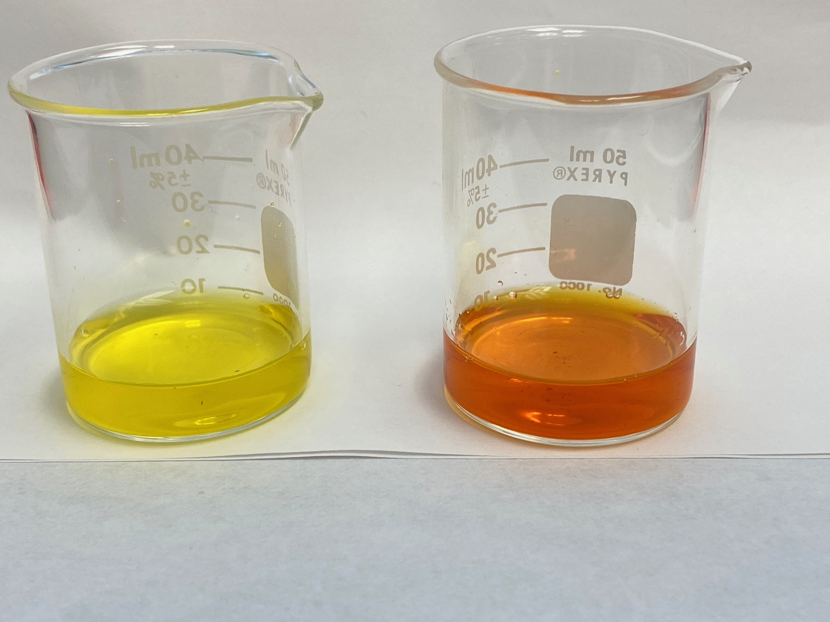
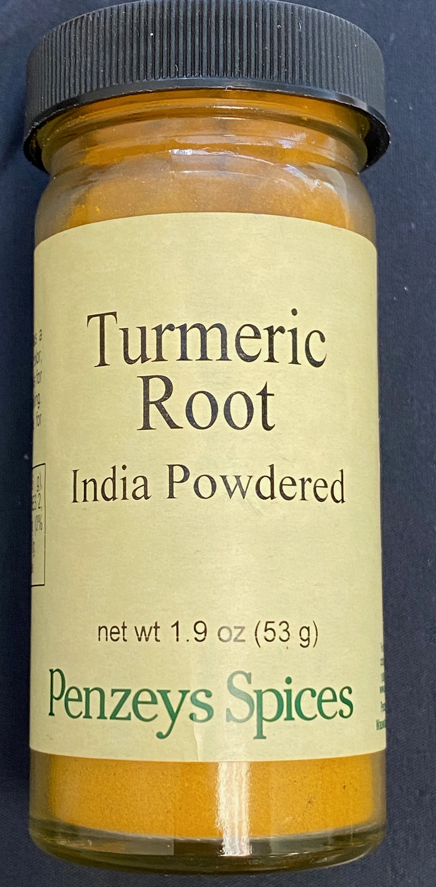
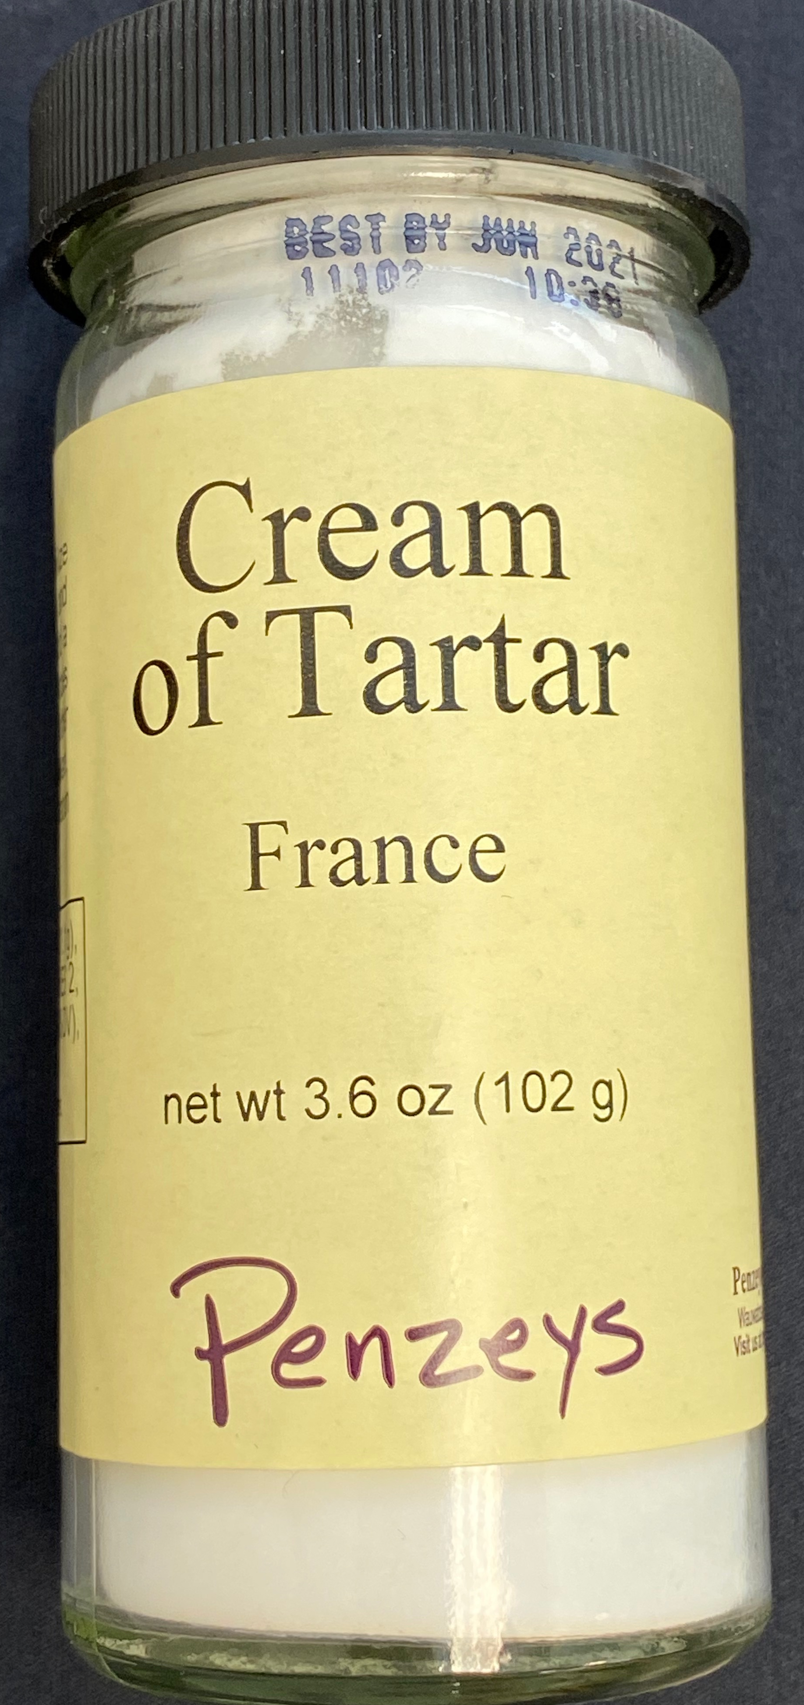
For the indicator we will make use of powdered turmeric root, a bright orange colored spice that is used frequently in Asian dishes. Along with providing a unique flavor to the foods it is added to, the spice also imparts the foods with a golden yellow color. This golden yellow color comes from the presence of curcumin in the spice, and this compound will be our indicator. The curcumin molecule, which is also fluorescent under UV light, is yellow colored in acid solutions, and becomes reddish-brown in solutions with a pH above ~8.
Turmeric indicator in (A) acidic and (B) basic solutions.
(A)
(B)

The Standard

For the standard we need to find a pure compound that can be accurately measured. Again we will look to the spice cabinet to find the solution to this challenge in the form of potassium bitartrate, better known as cream of tartar. This acidic salt is a byproduct of wine making, where the low solubility of the acid causes the potassium acid salt to crystalize on the casks as the grapes are fermented. The crystals are collected and used in several baking applications. We will use the cream of tartar as our acid standard. By accurately weighing the solid we can know the number of moles of acid involved in subsequent titrations, and use that to calibrate our titrant.

The Measurements

Making accurate measurements in the kitchen may seem challenging, after all you don’t have your calibrated volumetric glassware (volumetric flasks, pipettes, and burette). However volumetric measurements aren’t the only way to do a titration, we can also do titrations by mass as well. By accurately recording the mass of all components of a solution, and by weighing the amount of titrant delivered in a titration we can accurately calibrate our titrant and measure our unknowns. To this end your kit will include a small portable scale (along with a calibration weight) which is accurate to 0.01 g.

Materials

Your kit for this lab will contain the following chemicals and equipment:

Equipment
    - A digital balance - max capacity 200 g
      - A spare pair of AAA batteries
      - A 200.00 g calibration weight
    - A plastic weighing stand - circular bowl with notched edges
    - Several plastic 10 mL syringes
    - Several plastic micropipette tips (for use with the syringes)
    - Five 100 mL beakers (glass or plastic).
    - One spatula

Chemicals
    - Cream of tartar (solid)
    - Borax (solid) or ammonium (liquid)
    - Turmeric (liquid)
    - Unknown acid (lime or lemon concentrate)
    - 1 liter of Distilled water

Procedure

As you do not have any accurate volumetric glassware all measurements will need to be made by mass. However, to simplify some of your calculations you can make a somewhat accurate assumption: that 1 mL of water = 1 g. This way if you need to make a solution in a certain concentration range you can use a desired volume (in mL), and simply weigh out the equivalent mass of water. Just remember that the maximum weight that the scale can measure is 200 g.

Calibrate the scale

Using the 200.00 g calibration weight and following the instructions in the lid of the scale ensure that the scale is calibrated. Be sure to place the scale on a flat surface when making measurements and try not to move it once it has been calibrated. If desired you can recalibrate the scale during the analysis.

Prepare the Acid Standard

The cream of tartar is only slightly soluble in water, and it dissolves slowly, so you should prepare this solution first, and be patient in letting the solution dissolve.

Prepare a roughly 100 mL solution of cream of tartar with a concentration of potassium bitartrate between 10-14 mM.

Record both the mass of the cream of tartar and the mass of water used in preparing this solution.

Stir the solution to help dissolve the acid, and do not use the acid until all the solid has dissolved. If some solid will not dissolve recheck your math to ensure you aren’t above 14 mM concentration; you may also be able to add a little more water to help dissolve the acid, be sure to record the mass of any added water and add this to the original mass.

Prepare your titrant

Select the titrant preparation protocol that corresponds to the titrant solution that you have been provided.

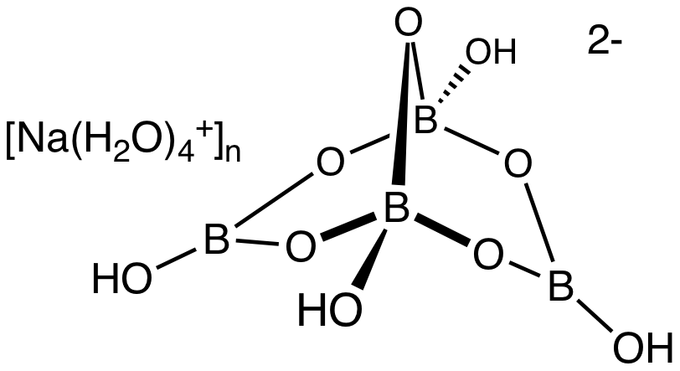

Sodium tetraborate
Borax

Borax is often used as a cleaning product, or added to other cleaners to improve their efficacy. It is also used in making “slime” when mixed with white glue. Borax is the common name for sodium tetraborate, a salt with a rather complex structure. The complex has the formula Na₂H₄B₄O₉•nH₂O, where n is typically 0, 5 or 10. Given that you are using a commercial product and not a standardized chemical it is unknown what form, or mixture of forms, of borax you have. Fortunately, you are going to standardize the solution you prepare by titrating your acid standard with it.

Borax forms a base when dissolved in solution via the following steps:

  - Na₂H₄B₄O₉ → 2Na⁺ + H₄B₄O₉^{2–}
  - H₄B₄O₉^{2–} + 10H₂O ⇄ H₁₂B₄O₁₂ + 2OH– Note: H₁₂B₄O₁₂ = 4B(OH)₃

With these reactions in mind, determine how much borax you will need to weigh to produce approximately 100 g of solution that is ~25 mM OH–. For simplicity, assume that you are working with the anhydrous (n =0) form of Borax.

Though the mass of Borax and water do not need to be explicitly know, as you are unsure of the chemical formula for the Borax, it is crucial that all the solid Borax has dissolved before you use the solution as a titrant. Be patient as it can take some time to fully dissolve

Ammonia

Ammonia is another common cleaner that is also a suitable base for doing titrations. The preparation of ammonia for commercial cleaning solutions is done by bubbling ammonia gas through pure water. The ammonia dissolves, forming ammonium hydroxide an excellent base for acid-base titrations (see reaction below).

NH_{3(g)} + H₂O ⇄ NH₄⁺ + OH–

Much like with the Borax, it is difficult to know the exact concentration of ammonia in commercial ammonia solutions. Typically solutions of ammonia are between 5% and 10% ammonia by weight. So for your analysis assume that the ammonia cleaning solution you have is 7.5% (w/w) NH₃ in water. Use this information, and the equilibrium above to prepare about 100 g of a titrant solution that will be ~20 mM NH₄OH. As with other measurements, you will need to weigh the amount of ammonia cleaner and the amount of water that you mix with it.

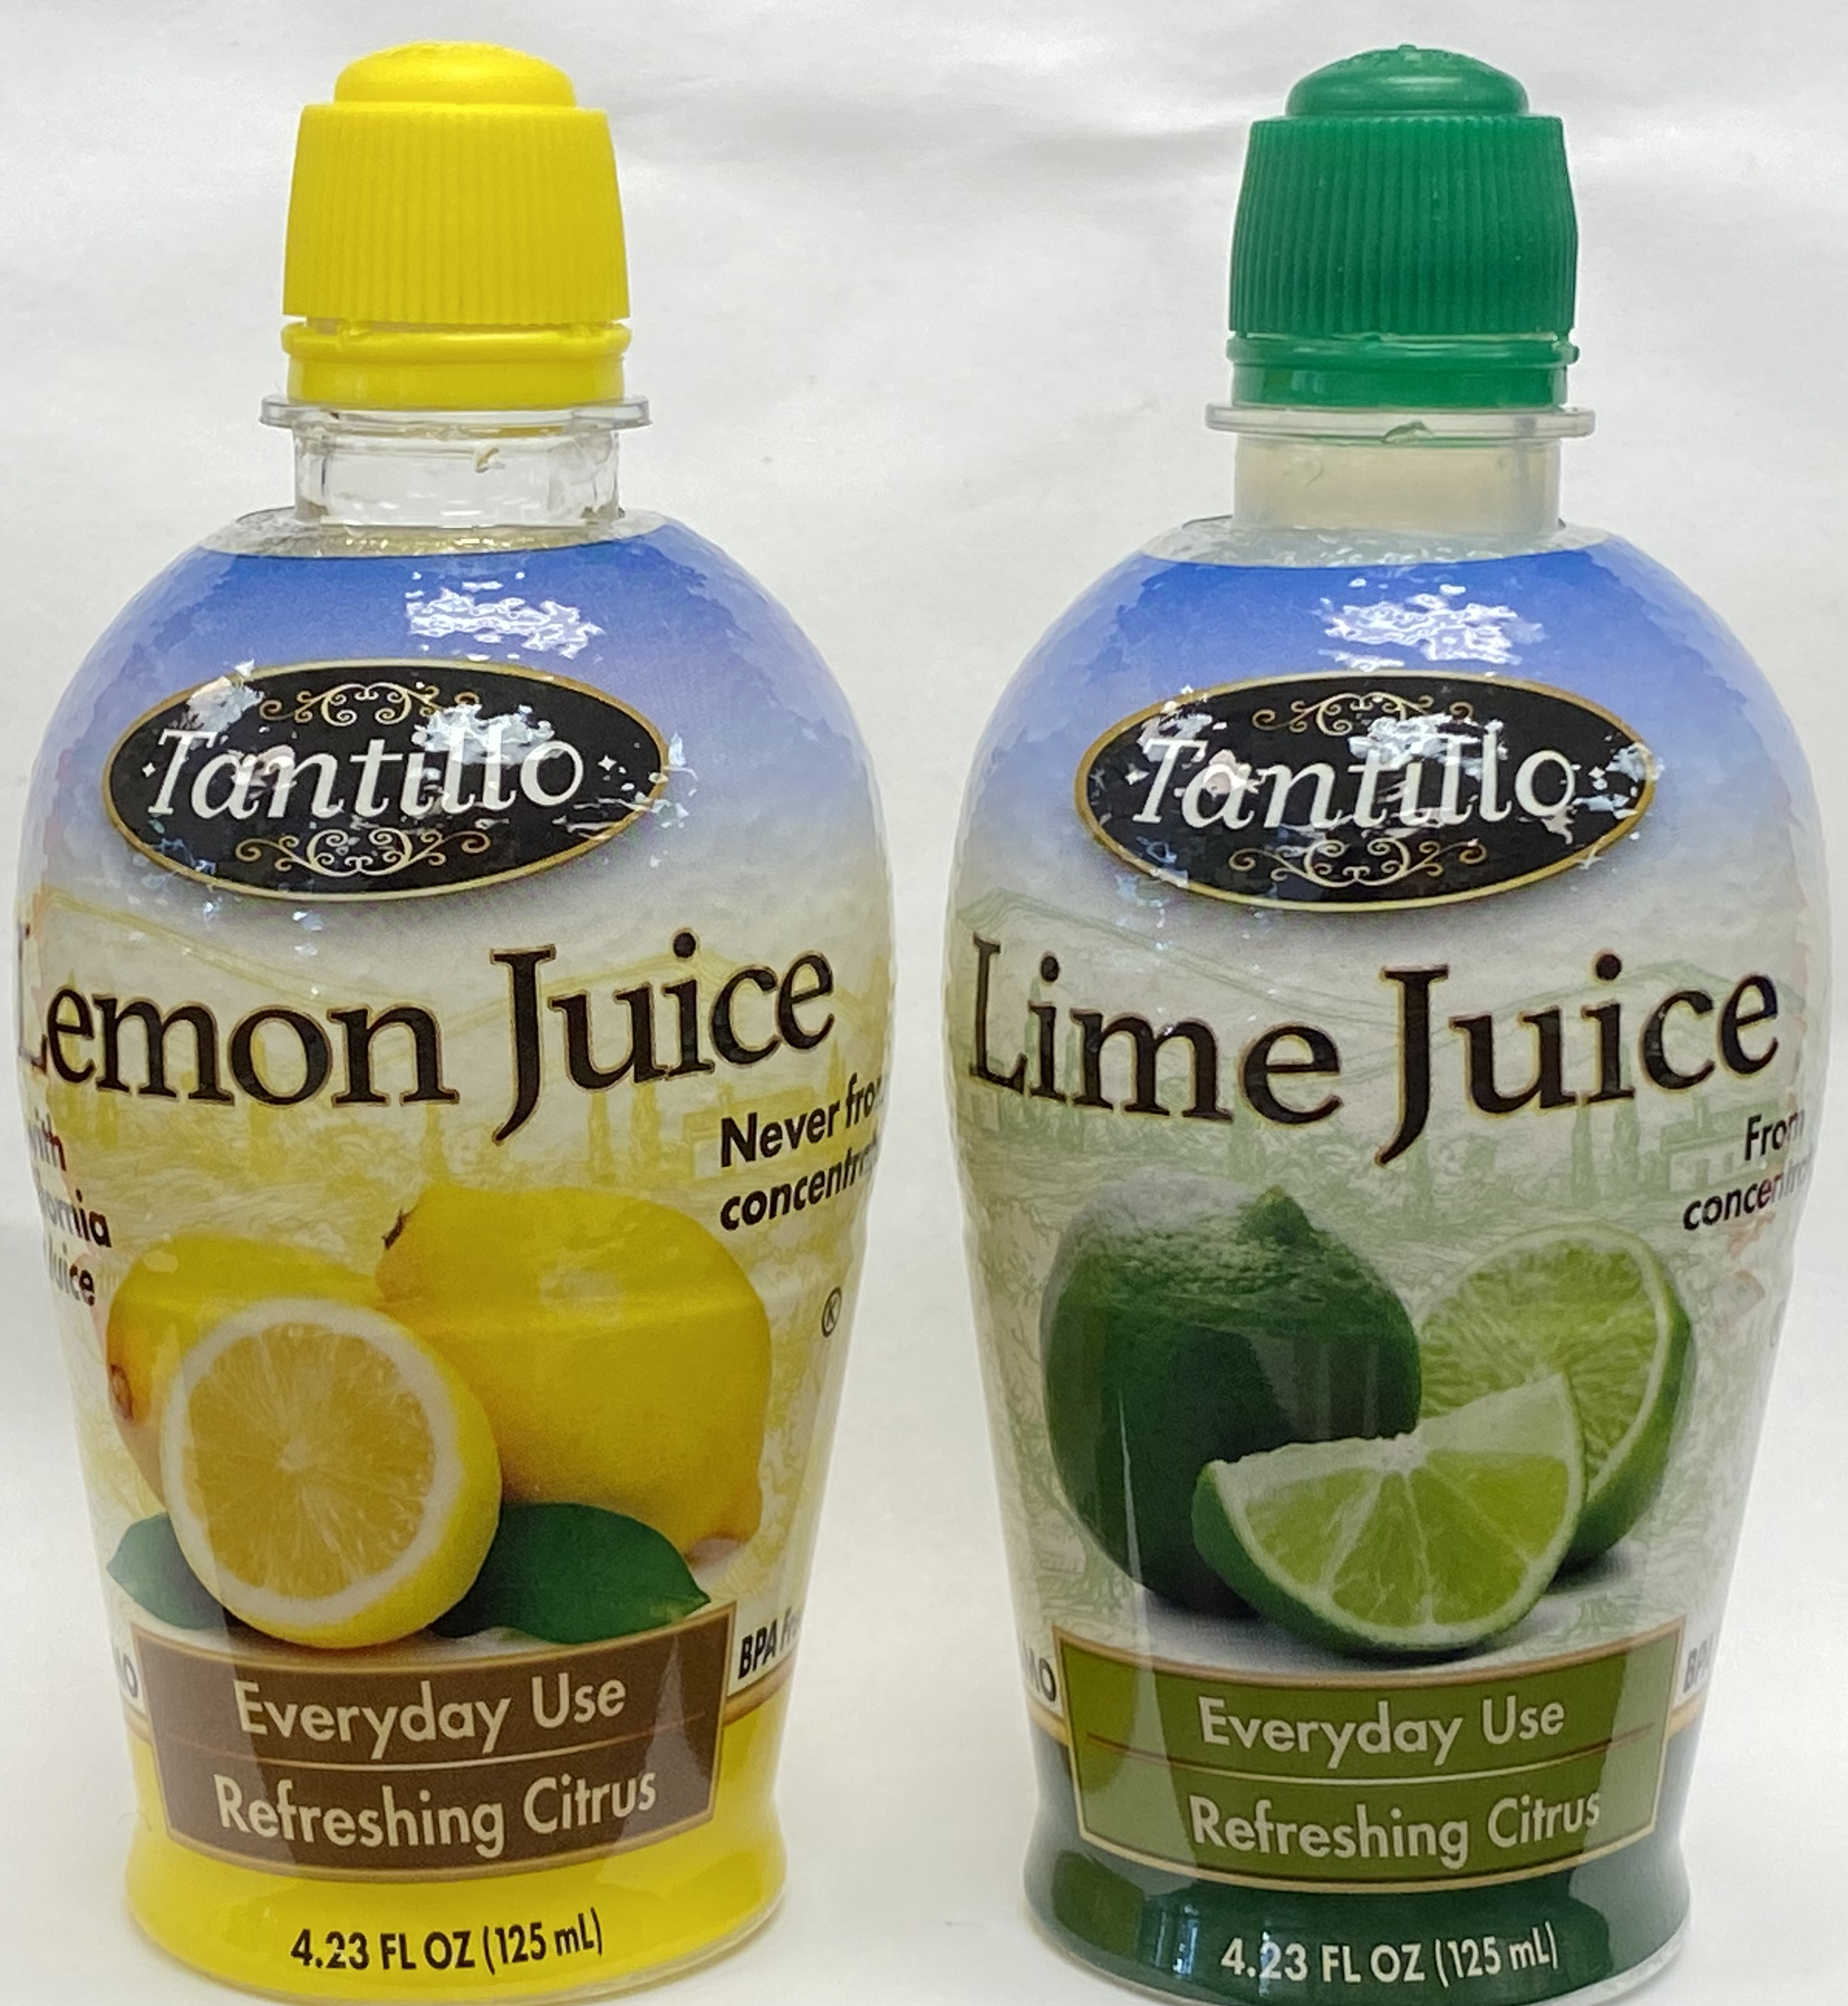
Unknown preparation

For your unknown you will be given either a lime or a lemon concentrate solution. These solutions are very acidic, as they are prepared from concentrated (evaporated) citrus juices. In fact, the concentrates are much more concentrated than your titrant and standard acid solutions. As such you will need to dilute the citrus concentrate in order to have a solution that can be titrated with a reasonable amount of titrant.

To do this dispense some of the citrus concentrate into a clean weighed beaker, and record the exact mass of citrus concentrate delivered. Then add distilled water until the acid has been diluted by a factor of 50 to 75 fold, record the mass of water added to the acid.

Syringe Preparation

For this lab you will be using syringes to controllably dispense the analyte and titrant solutions. Your kit will contain several 10 mL syringes, label three of them as: Standard Acid, Titrant, and Unknown Acid (or something equivalent). Only use the designated syringe with the respective solution to avoid contamination.

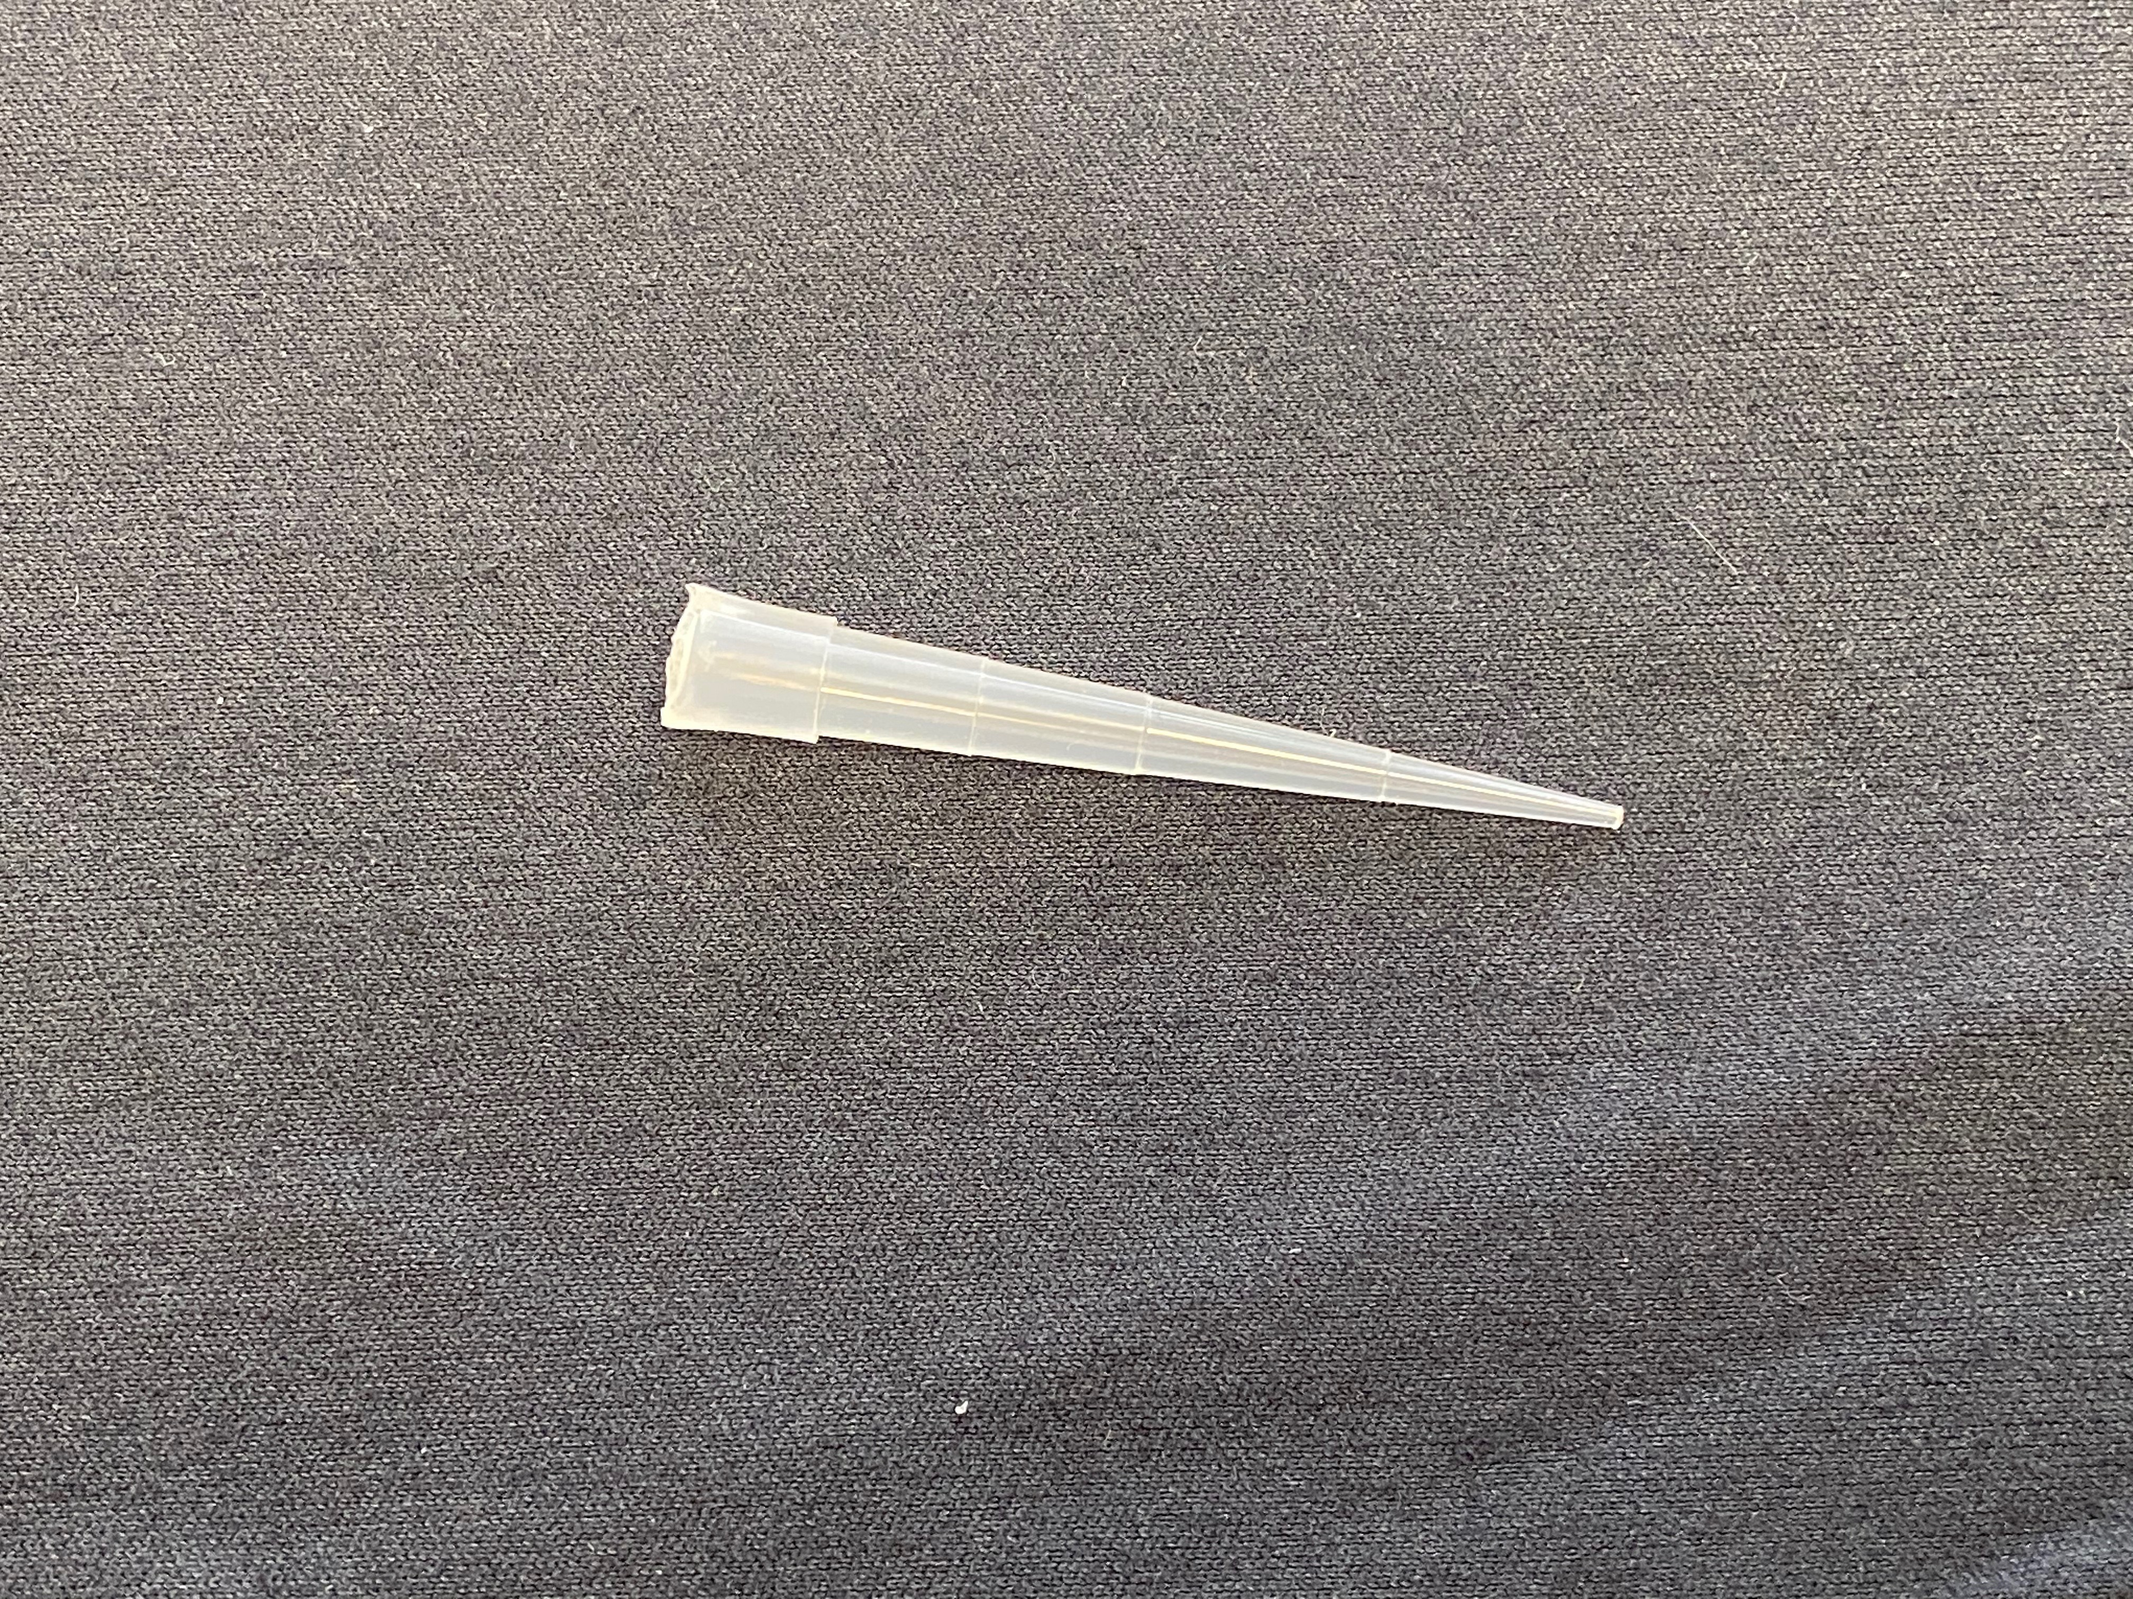
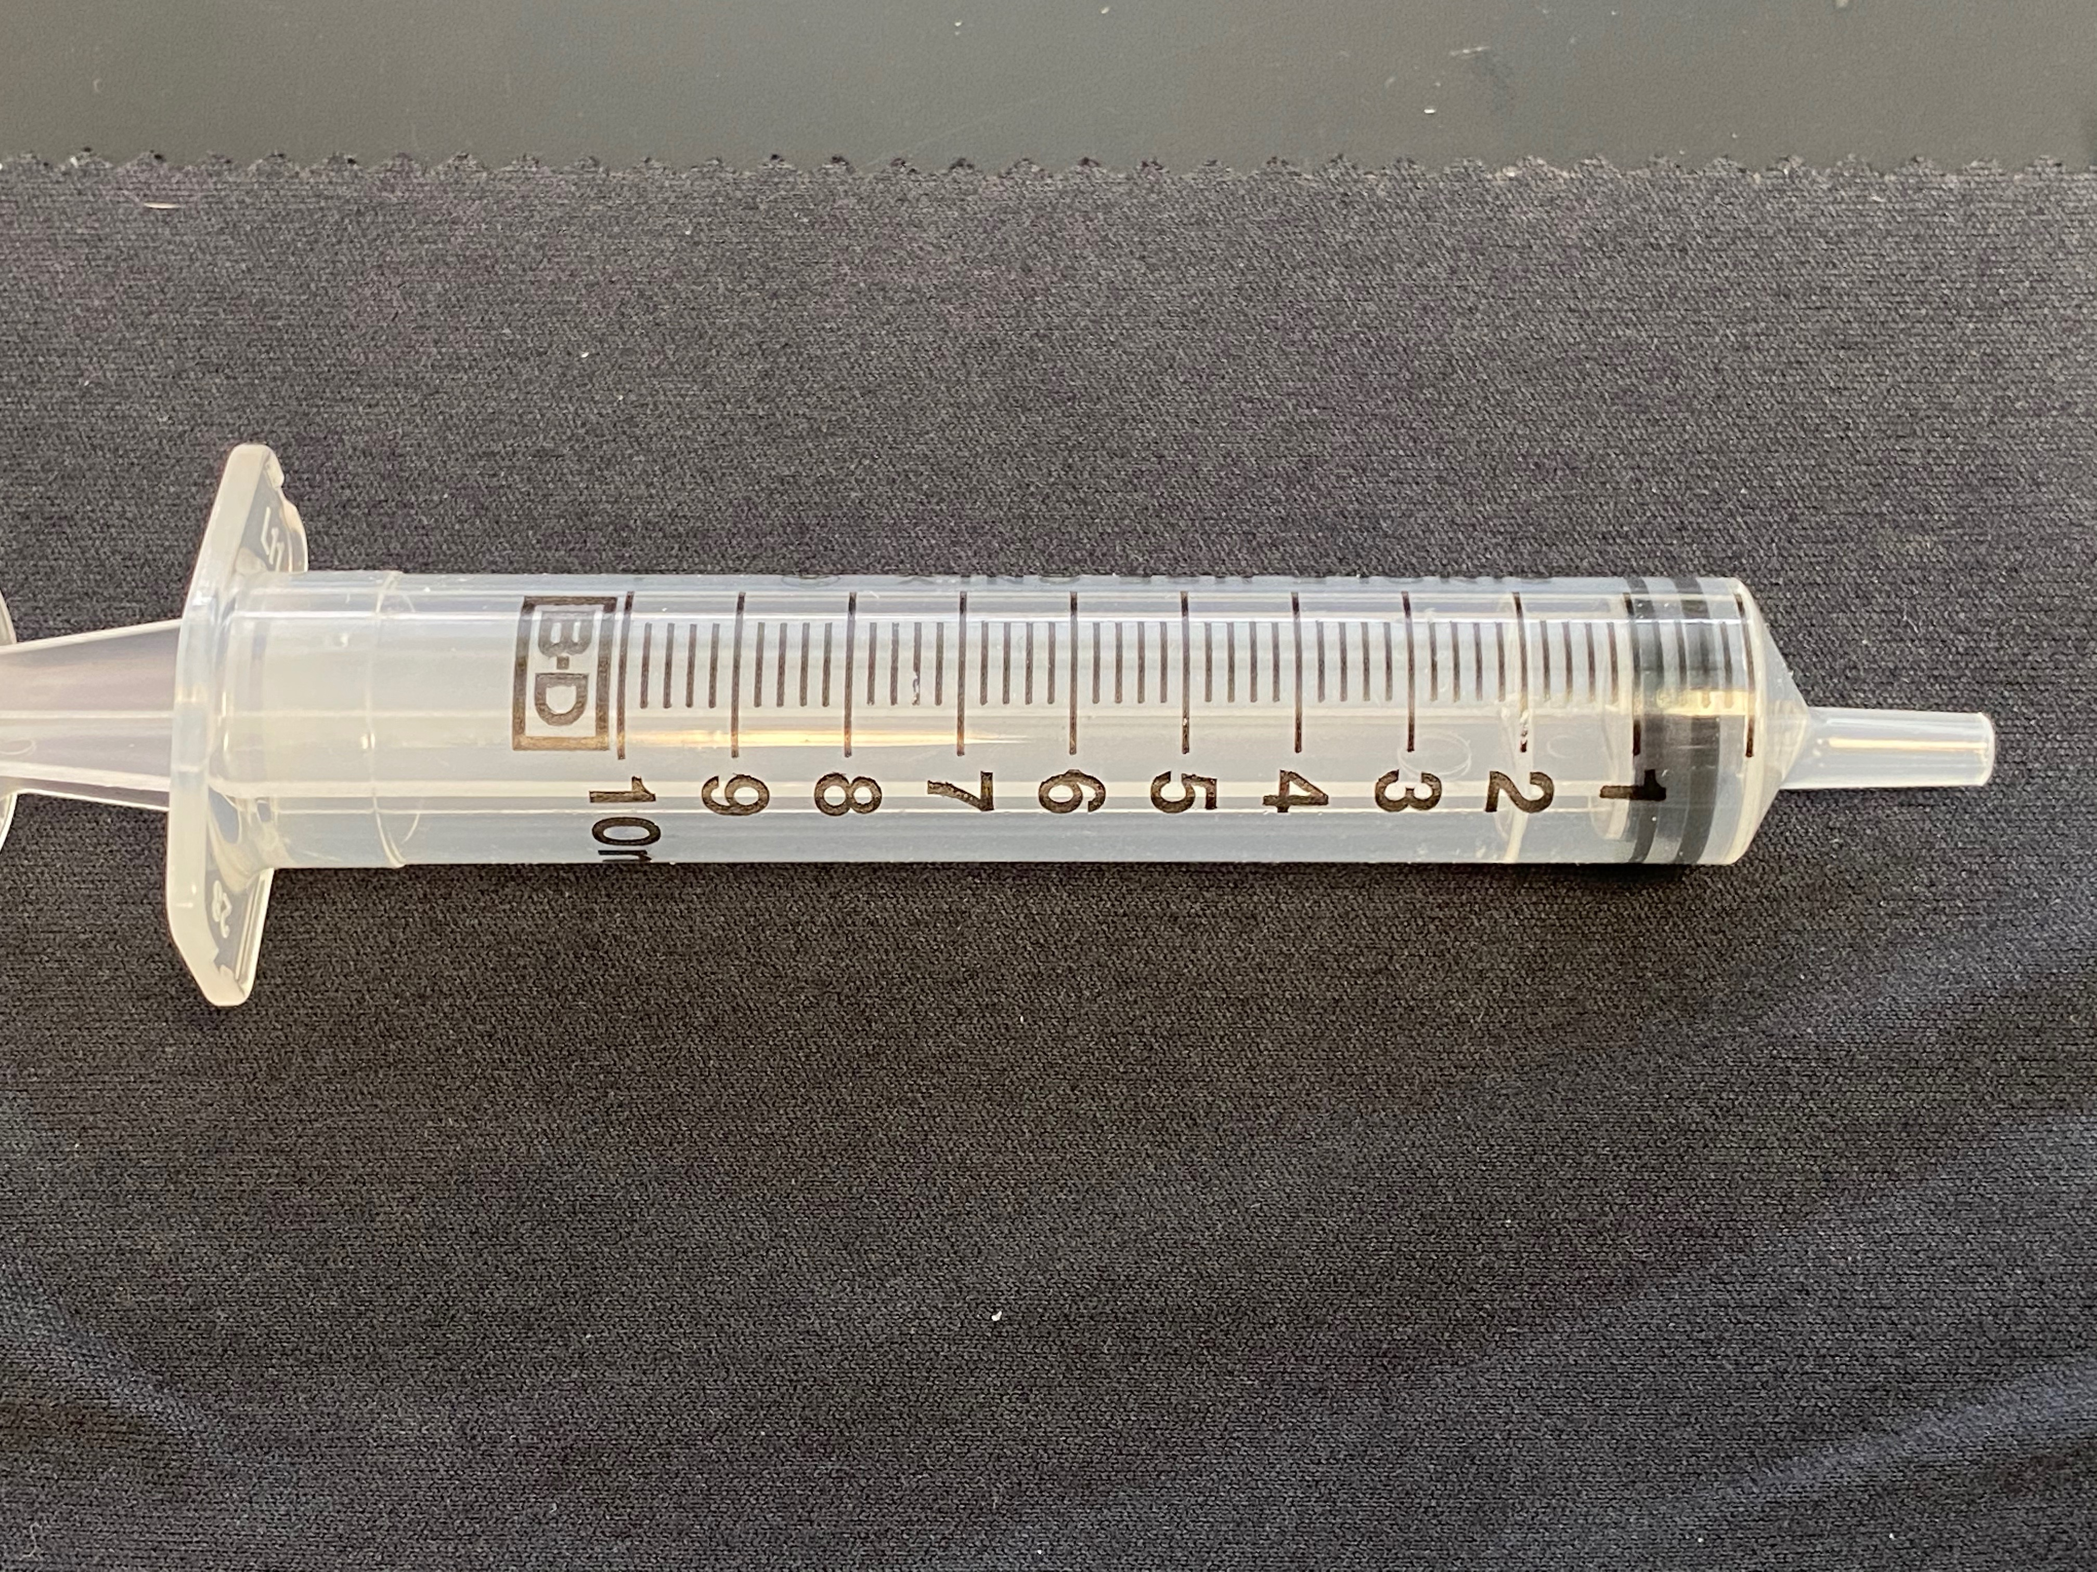
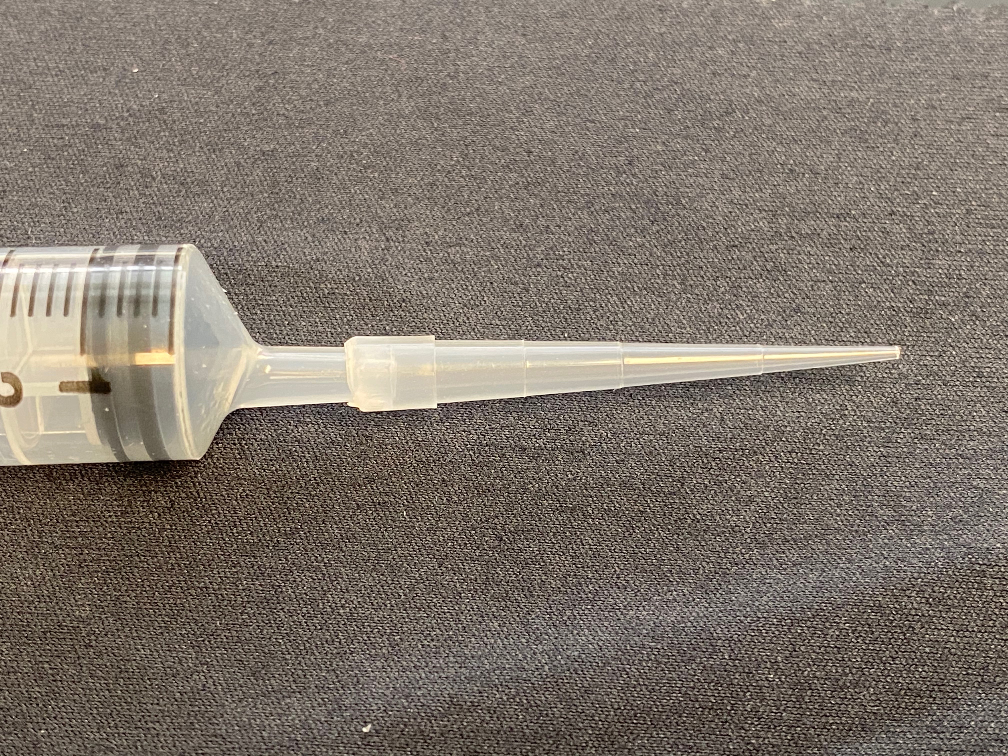
To better control the delivery of liquid from the syringes you have been given several plastic “tips” for the syringes. These will fit tightly on the tip of each syringe and allow you to deliver very small droplets of solution if you desire.

Once each solution is prepared and fully dissolved, and the syringes are assembled rinse each syringe with their respective solution. You are encouraged to draw the solution up into the syringe and dispense it back into the same stock container several times if you wish to get a feel for how smoothly the syringe plungers move.

One advantage of using a syringe is that you can draw droplets back into the syringe if you do not want them to fall from the tip.

Also note that drawing air into the syringe will not change the mass of the syringe and any liquid inside of it.

Indicator color check

It is advisable to observe the color of the indicator in both acidic and basic solutions before starting your titrations. Add a small amount (4-5 mL) of your stock acid to a clean beaker and add to this ~1 mL of the indicator. In a separate clean beaker repeat this process with a small amount of your titrant. You may find it easier to see the colors by placing a white background under the beakers.
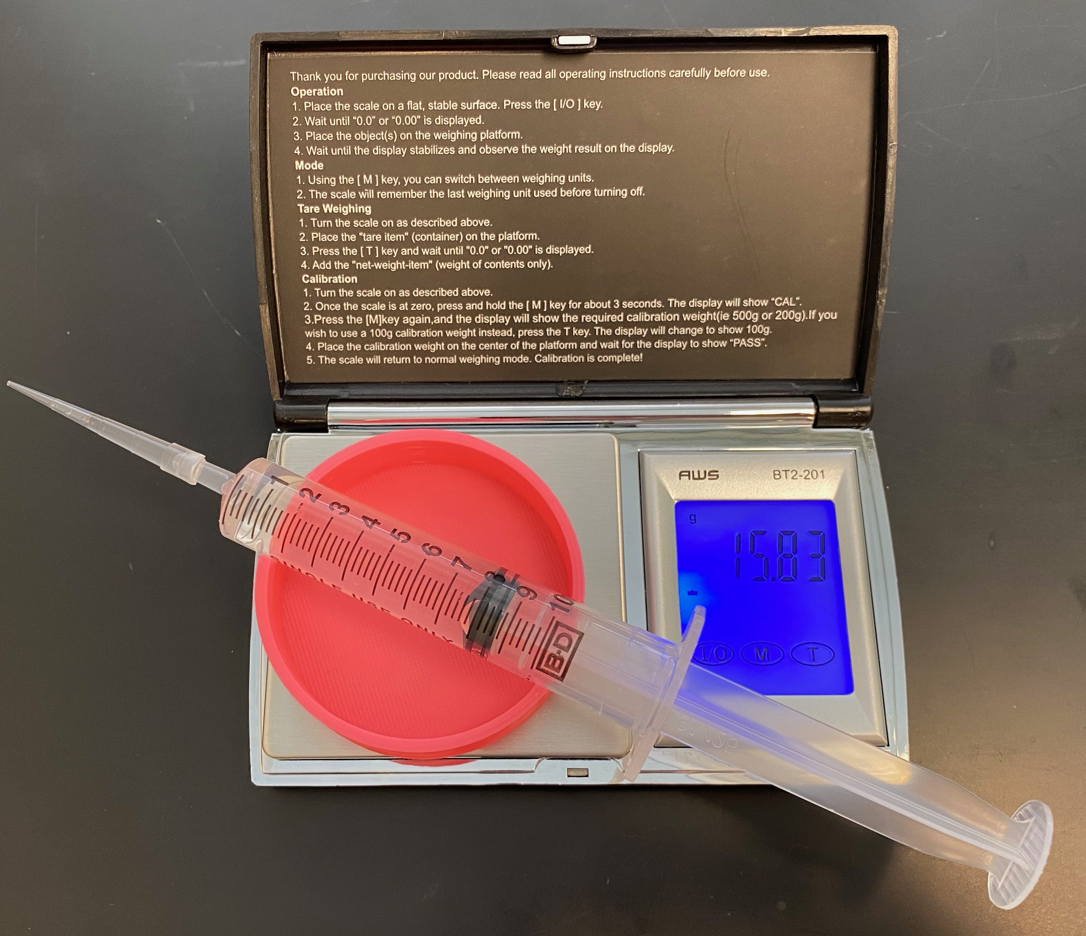
Titrant Standardization

Once your cream of tartar has fully dissolved draw 8-10 mL of the solution into your standard acid syringe. Record the mass of the syringe and solution using the digital scale and syringe stand. Dispense some (3-5 mL) of the solution into a clean beaker and record the new mass of the syringe and solution, the difference is obviously the amount of solution that was dispensed.

Now add about 1 mL of the turmeric indicator and place the beaker on a white sheet of paper, paper towel or napkin to help you see the color. If the color seems too faint you can add a few more drops of indicator solution.

Draw 8-10 mL of your titrant solution into titrant syringe and record the mass. Slowly dispense the titrant solution into your measured acid solution, swirling the beaker to ensure proper mixing. Continue to add titrant until you see the appearance of a red/brown color. When your titration is complete record the new mass of your titrant syringe.

Repeat this titration at least three times, however you should continue to do titrations until you are confident in your results. Note that for replicate titrations the mass of titrant required will be proportional to the mass of acid used. So if you use a larger amount of acid, you will need a larger amount of titrant to reach the equivalence point. You can perform a quick check to approximate how much titrant you will need by making a ratio of the mass of acid used to the mass of titrant used in a successful titration.

Unknown Titration

For the titration of your diluted citrus concentrate repeat the same process as with the acid standard. Record the mass of the unknown added to a clean beaker, add the indicator solution, and record the mass of titrant required to reach the endpoint. Repeat this titration at least three times, however you should continue to do titrations until you are confident in your results.

If for your first titration you do not reach the endpoint before you use all the solution in your titrant syringe you can take either option below to make the next titrations successful:
    - Use half as much of the unknown solution for your next titration (e.g. ~1 gram instead of ~2 grams).
    - Make a new unknown solution, using less of the citrus concentrate and more water.

Calculations

Unlike volumetric titrations the calculations for this lab will be done primary by mass, as such you will get some unusual units (i.e. mol/g) as concentrations. However so long as you pay close attention to the units that you are using you will find that they will cancel out much as volumes do in volumetric titrations.

For this analysis you are tasked with determining the concentration of acid in the citrus concentrate. You are to report your answer in moles equivalents of acid per gram of concentrate solution (mol/g). We can only report the equivalent number of moles of acid as we are unsure what the exact acids are that are present in the concentrate, certainly citric acid is present, but other acids are also present in citrus fruits (e.g. malic acid, oxalic acid, succinic acid…).

Waste Disposal

As all these chemicals are either food or cleaning products there is no harm in disposing of them down your kitchen sink. It is advisable to dispose of them with copious amounts of water, as the turmeric indicator can temporarily stain some surfaces.

