Instructor Notes for
Wikiproject
Revision 7.17.2020
- Using Google Sheets (or some similar management tool) is highly suggested to keep track of projects, usernames and web addresses. A single file shared with the entire class is especially useful for this purpose. A screenshot of an example setup for the file is shown below.
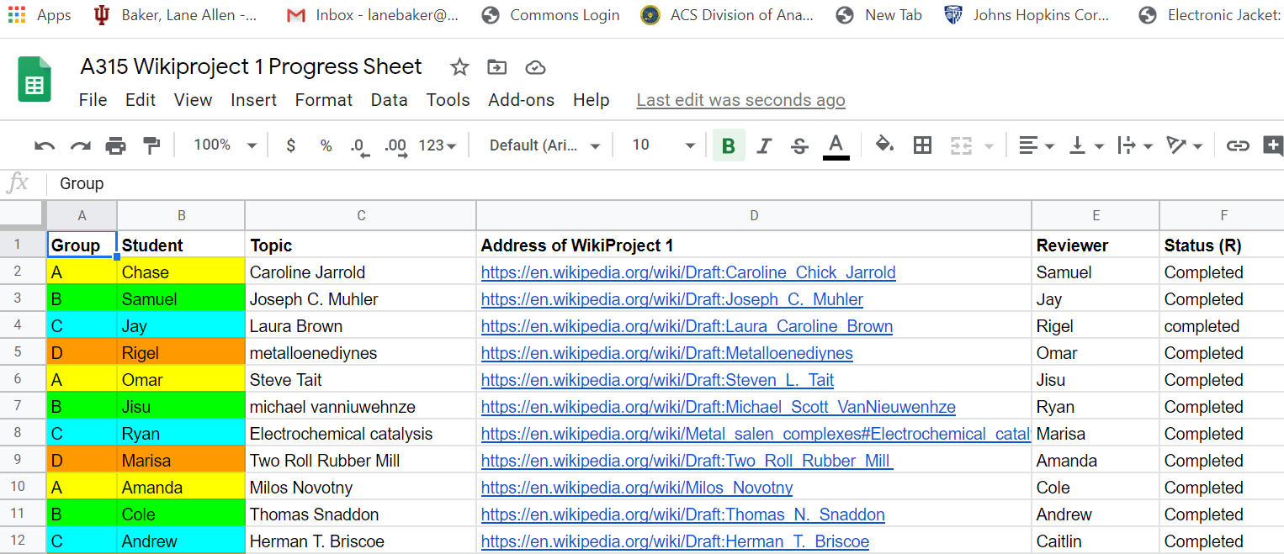

- One 15-minute interactive Zoom session with your class can go over how to navigate the Wikipedia interface. (This of course requires that you familiarize yourself with the interface.) One suggestion is to watch one of the many videos available on YouTube for creating entries on Wikipedia. (Two good examples are provided in the student handout.)

- Wikiedu has an extensive, involved project on incorporating Wikipedia content generation into courses. They offer special software interfaces and opportunities that can go well beyond what is given here, and if you have time, it can be a highly worthwhile program to join. (The rubric included in this material is from a Wikiedu exercise.)

Wikiedu (https://wikiedu.org/) provides very good guidance on setting expectations for assignments like this. The following text is from https://wikiedu.org/blog/2018/01/24/setting-expectations-for-your-wikipedia-assignment/, and describes setting expectations for Wikipedia editing projects, this is useful to consider in setting up your assignment.

Setting expectations for your Wikipedia assignment
By Helaine Blumenthal on January 24, 2018
https://wikiedu.org/blog/2018/01/24/setting-expectations-for-your-wikipedia-assignment/
While most students in the Classroom Program have written innumerable term papers, few had ever contributed to Wikipedia before joining our program. The Wikipedia assignment differs from the more traditional writing assignment in several key ways, which is why it’s critical to set expectations early on in the term. While Wikipedia is based on a plethora of policies and standards, the Wikipedia assignment is more flexible than the traditional writing assignment. To help your students understand the more open-ended nature of the Wikipedia assignment, keep the following tips in mind.
- Unlike a term paper, it’s difficult to set minimum standards, such as word counts, for your Wikipedia assignment. How much a student can contribute to an article will depend on available sources on a given subject and Wikipedia’s existing coverage of that topic. It’s far more important to focus on sourcing, so you may wish to require students to use a minimum number of verifiable sources rather than a minimum number of words.
- Creating a new article is not more work than contributing to an existing entry. The vast majority of our students contribute to existing articles on Wikipedia rather than creating entirely new articles from scratch. These are equally valuable endeavors, and we provide instructions on how to achieve both.
- Contributing to Wikipedia can be more time intensive than writing for a traditional assignment. A 500 word contribution to Wikipedia is actually quite substantial. Try not to equate the length of a term paper with that of a Wikipedia contribution.
- There are many ways a student can improve Wikipedia. While one student may create an entirely new entry, others may contribute a new section to an existing article with critical information on that subject. Other students may improve sourcing, while others may restructure an article to improve its accessibility. The Wikipedia assignment is a perfect opportunity for your students to demonstrate their strengths as writers and researchers.
- Never grade student work based on what sticks! You should always grade a student’s contribution based on its quality rather than whether it remains on Wikipedia. Work can be reverted for a number of reasons, and you and your students will always be able to access this work in their contribution history.
While you shouldn’t grade your student work based on whether it remains on Wikipedia, we understand that grading is an important part of setting expectations. To help guide you in this process, we’ve developed a sample assessment rubric that you can customize and distrubute to your students early on in the assignment.
A Wikipedia assignment is as much about the process as it is about the final product. When your students contribute to Wikipedia, they learn critical media literacy skills that will help them both in and beyond the classroom. Quality is far more important than quantity when it comes to Wikipedia assignments, and we encourage you to help your students begin thinking of themselves as producers as well as consumers of knowledge.

