 | Wikiproject  A group / individual project for science classes  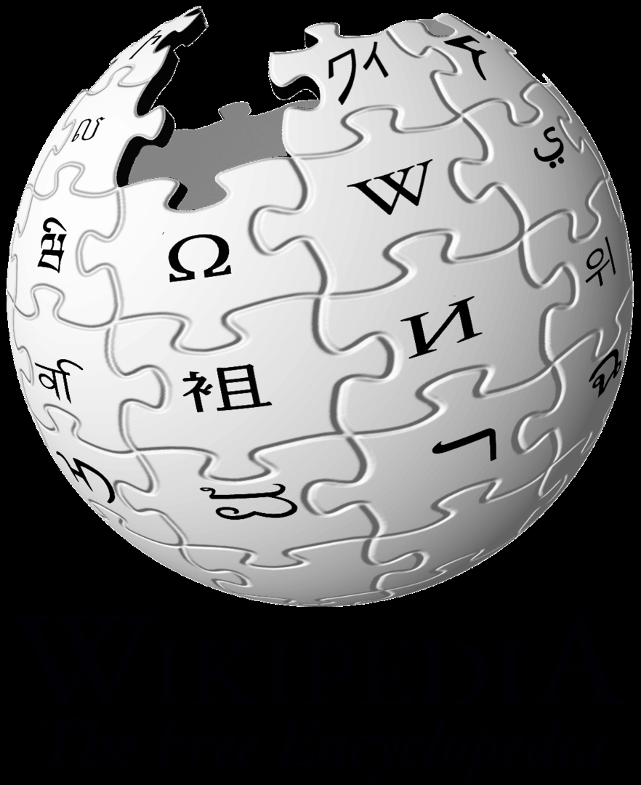  CC BY-SA 3.0, https://commons.wikimedia.org/w/index.php?curid=301583  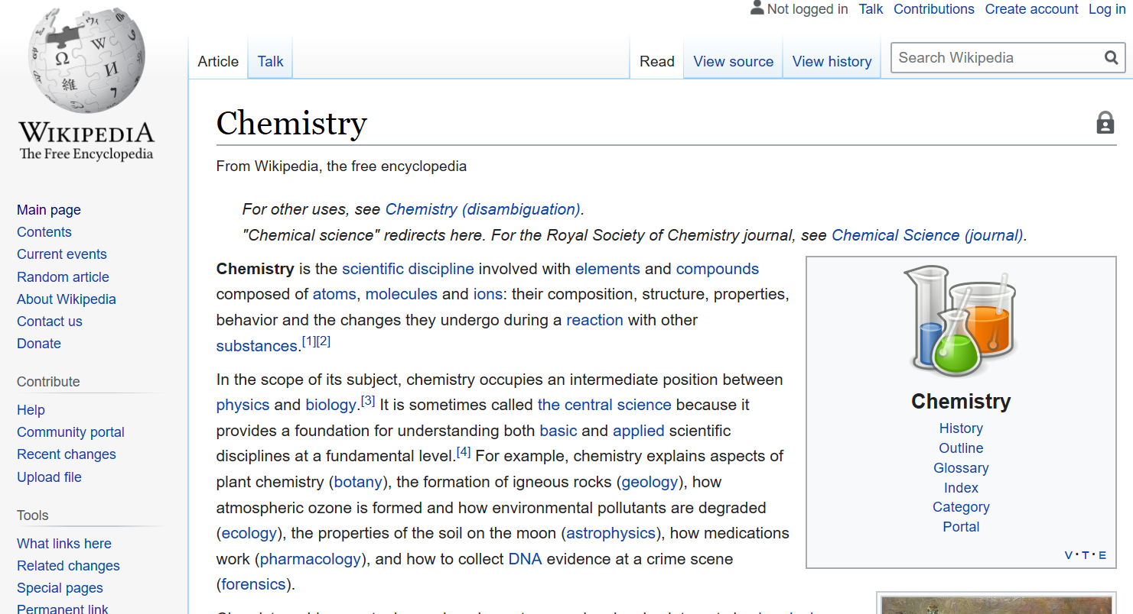  https://en.wikipedia.org/wiki/Chemistry
    - Student Version
  Instructor Name
  Course / Semester
  Background
  Topic Selection
  - Biographical Wikipedia Entry
  - Scientific Wikipedia Entry
  Procedure
  - Signing up for Wikipedia
  - Assignments
  Editing / Peer Review
  Rubric / Scoring
  Things to Remember

 | The Wikiproject  This exercise has two components, a “Biographical Entry” and a “Scientific Entry”. In the first component, the “Biographical Entry”, you will address the Wikipedia entry for a scientist, either a faculty member, historical figure, or group of scientists. In the second component, the “Scientific Entry”, you will add scientific content – gleaned from the primary literature – to Wikipedia. The goals of this project are:  - To increase your knowledge of both scientists and science  - To synthesize material from the primary literature into a digestible form suitable for an encyclopedic entry  - To add to the body of knowledge that can be easily accessed by the public on science and the implications of science  Background  A Career Column published in Nature in 2018 by Wade and Zaringhalam¹ provided a compelling argument in the value of editing Wikipedia pages, specifically for women. Wade and Zaringhalam stated;  “Marie Curie is one of the most famous women in science. But her first page on Wikipedia was shared with her husband — until someone pointed out that, perhaps, her scientific contributions were notable enough to warrant her own biography.  That’s the beauty of Wikipedia. It is the fifth most popular website in the world and notches up more than 32 million views a day. A community of volunteer editors collaboratively edit, update and add content to democratize access to a common and constantly updating collection of knowledge. But as with any democracy, results are determined by those who choose to participate. Who edits Wikipedia — and the biases they carry with them — matters.”  and further added -  “Wikipedia allows us to write and edit history as it’s happening, highlighting the work of women and people in under-represented minority groups in the moment, rather than looking back at a dated textbook decades in the future. A Wikipedia biography can give a scientist credibility: the encyclopedia is indexed so regularly by Google that it appears at the top of the page and is regularly used by journalists looking for sources. With a Wikipedia biography, scientists can become a lot more human than they are on a university website — complete with their public engagement, personal stories and out-of-office-hours experiences.  Editing Wikipedia is easy, free and rewarding. It’s a thing to do with friends or your community, and might well fill out your CV. All you need is a Wi-Fi connection, a Wikipedia account and a bunch of neutral, reliable sources, along with a couple of hours to spare.”  With this introduction in mind, editing Wikipedia provides a route to convey the knowledge we know to the community and expand our own knowledge through research in primary sources. Editing Wikipedia is relatively straightforward, an important thing to remember for scientific entries is to provide an unbiased, factual report that will stand up to peer scrutiny.  Topics  A. Biographical Wikipedia Entry  In consultation with your instructor, you will choose a scientist who either does not have a Wikipedia entry, or who has a Wikipedia entry that is incomplete, or a stub. For the example described above by Wade and Zarlinghalam, a compelling argument for the need to add female scientists to Wikipedia was made. This same need can be extrapolated to other under-represented groups in the sciences. Your instructor will provide guidance on suitable candidates for your entry. Keep in mind, you will need references for all entries on Wikipedia.  For inspiration, examples of Wikipedia pages created in previous years are found below. You may notice the subjects in these examples are quite different people, however, the material developed in each case resulted in an entry that contributes greatly to our collective knowledge and personal story for these two individuals. Further, a search on Google ranks these entries in the top five hits, which demonstrates the potential impact your entry can have.  Dennis Gail Peters (created in 2018) https://en.wikipedia.org/wiki/Dennis_G._Peters  Cassandra Quave (created in 2018)  https://en.wikipedia.org/wiki/Cassandra_Quave  B. Scientific Wikipedia Entry  This time (again, in consultation with your instructor), you will choose a scientific topic that either does not have a Wikipedia entry, or who has a Wikipedia entry that is incomplete, or is a stub. Important factors to consider in selecting your scientific topic.  - Your instructor will determine parameters for your topic selection. For instance, if you are in an instrumental analysis laboratory, you may be asked to select a new innovation in chemical instrumentation as a topic.  - There should be multiple primary sources of literature that you can use to synthesize the text for a Wikipedia entry from. You must reference these sources. You will need to verify that these sources are appropriate.  - Your personal writing on this entry is important, simply regurgitating text from a primary source is not sufficient.  - Your instructor may choose to provide a list of acceptable topics.  For inspiration, examples of Wikipedia pages created in previous years are provided. In the first case, “Surface-Induced Mass Spectrometry”, the article was a “stub” as defined by Wikipedia and is found under the topic of “Tandem Mass Spectrometry.” In the second case, Single-entity Electrochemistry, the article was a new entry created from the class.  Surface Induced Dissociation Tandem Mass Spectrometry (2019)  https://en.wikipedia.org/wiki/  Tandem_mass_spectrometry#Surface_induced_dissociation  Single-Entity Electrochemistry (2019)  https://en.wikipedia.org/wiki/Single-entity_electrochemistry  Procedure  A. Signing up for Wikipedia  Signing up for an account on Wikipedia is relatively straightforward.  - First go to the Wikipedia home page at: https://en.wikipedia.org/wiki/Main_Page  - In the upper right hand corner there is a link to “Create account”  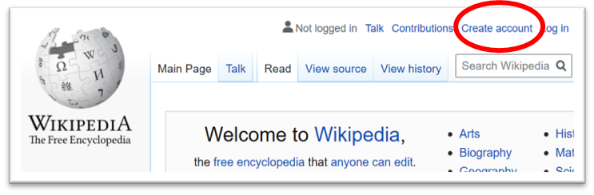  - This will take you to an account sign-up page. You should come up with an unidentifiable username, as this name will be present in the material you add to Wikipedia. You will need to share this name with your course instructor so they can monitor your work.  - The next resource you should consult is the Wikipedia guide to adding content, which is found here: https://en.wikipedia.org/wiki/Help:Your_first_article A special wizard is also available that will help enter content the first time (details on page 6).  - You will want to work in the sandbox prior to publishing your work, and when completed submit your article for acceptance.  - The Wikipedia webpage guide above are fairly clear. If you learn more effectively via video, there are excellent walk-throughs on YouTube for the process of creating content. Several good examples are available below.  “How to Make a Wikipedia Page”  https://www.youtube.com/watch?v=T_k_VbCDm2Y  “How to Create a Wikipedia Page”  https://www.youtube.com/watch?v=eJ1lbXKjDfA  B. Assignments  Your writing assignments will be made by your course instructor. In most instances, the first assignment, the “Biographical Wikipedia Entry” will be an individual assignment and the “Scientific Wikipedia Entry” will be a group assignment.  You have made a Wikipedia account in item (A) and informed your instructor of your account username. With this information, your instructor can follow your individual contributions to different Wikipedia articles. Suggested assignments are as follows.  - Biographical Wikipedia Entry.  - In consultation with your instructor identify the subject of your biographical entry.  - Prepare a well-written entry of no less than 500 words.  - Include at least one figure or graphic.  - Be sure to reference appropriate sources for all information.  - Enter items a – d into a Wikipedia sandbox. A template exists specifically for biographies that might be of use https://en.wikipedia.org/wiki/Template:Biography  - Submit your entry for approval.  In writing your article the Wikipedia wizard will make the process much easier. https://en.wikipedia.org/wiki/Wikipedia:Article_wizard/version1  - Scientific Wikipedia Entry  - In consultation with your instructor identify the subject of your biographical entry.  - Prepare a well-written entry of no less than 1000 words.  - Include at least three figures or graphics.  - Be sure to reference appropriate sources for all information. Sources for this entry should be primary literature from reputable scientific sources and journals.  - Complete steps e,f as above.  It is important to use primary sources for this entry. A primary source is identified as sources that:  - Documents the results of original research  - Are written by those who have conducted the research  - Includes firsthand information about their methodologies, data, results, or conclusions.  A good example of a primary source is a research article in a journal, such as Analytical Chemistry, or The Journal of the American Chemical Society. A review article is not a primary source (but can be used to identify primary sources).  Editing and Peer Review  Your instructor will assign other student’s articles from the class that you will be assigned to review and edit. You must make at least three edits to assignments. If the content of articles does not need corrections, you may add material to expand the articles.  The edits you make will be recorded by Wikipedia in looking at the changes tab on each article and correlating edits to usernames.  Rubric / Scoring Sheet  A rubric for article development is present on the following pages. The rubric may be downloaded directly from Wikicommons, at: https://commons.wikimedia.org  /wiki/File:Wiki_Education_Classroom_Program  _example_grading_rubric.pdf  Things to remember  Several key points are worth remembering.  - Wikipedia and editing Wikipedia is meant to be an exercise which anyone can participate in, so there are many, many sources of help available on-line. Both in the links in this document and through secondary sources (e.g. YouTube). There is no penalty for getting help in the mechanics of navigating Wikipedia.  - The approval process for articles submitted to Wikipedia can sometimes take several months, so a final, publically available version might not be approved during your course. Your instructor can still evaluate your work.  - Pay attention to reference formatting and to copyright on images, these are two of the most common mistakes that delay article acceptance.  Finally – Create something you are passionate about that you can share with the world. Have fun!
    - Tips
  This Wikiproject describes the procedure for creating Wikipedia entries, editing entries, tips on selecting topics and potential problems that might be encountered in publishing your entries.
  ¹ Wade, J.; Zaringhalam, M. “Why we’re editing women scientists onto Wikipedia”, Nature (Career Column), 2018, accessed May 2020, http://dx.doi.org/
  10.1038/d41586-018-05947-8
  Stub - A stub is an article deemed too short to provide encyclopedic coverage of a subject. https://en.wikipedia.org/
  wiki/Wikipedia:Stub
  The Wikipedia entry you prepare can have a significant impact! Google searches on subjects covered from previous entries made through this exercise consistently rank in the top five hits.
  A list of stubs that exist in Wikipedia in the subject of “Chemistry” can be found at : https://en.wikipedia.org/
  wiki/Category:
  Chemistry_stubs
  Sandbox - A user work area designed for testing and experimenting with wiki syntax and the VisualEditor. https://en.wikipedia.org/
  wiki/Wikipedia:
  About_the_sandbox

