Chromatograms
All Analgesics, 55% pH=7 0.025M phosphate buffer
C18, Black Trace 245 nm, Green Trace 195nm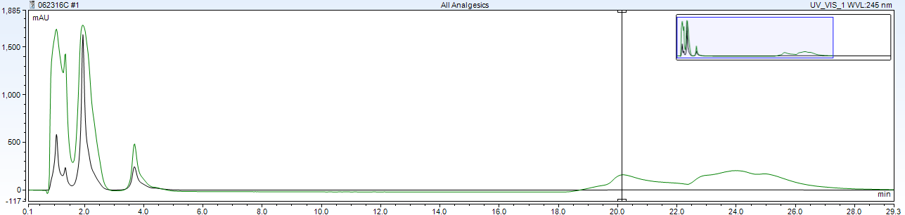
RP-Amide, Black Trace 245 nm, Green Trace 195nm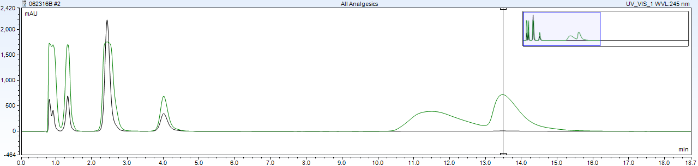
C18-PFP, Black Trace 245 nm, Green Trace 200nm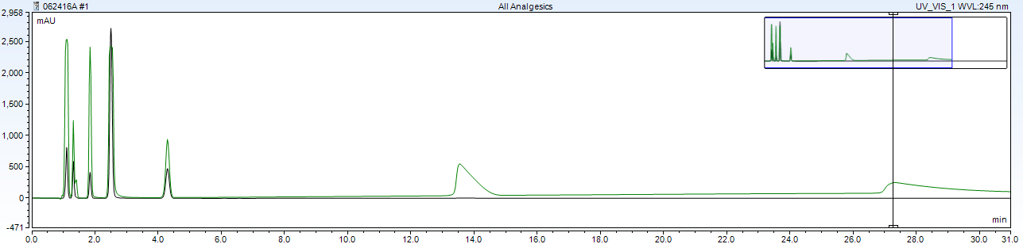

RP-Amide, 55% pH=5 0.025M phosphate buffer
Mix A (order: aspirin and caffeine, salicyclamide, phenacetin), Black Trace 245 nm, Green Trace 220nm
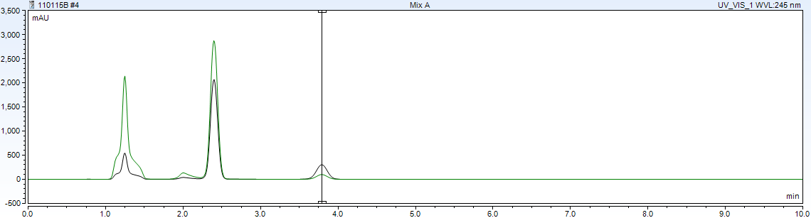

Acetaminophen, Black Trace 245 nm, Green Trace 195nm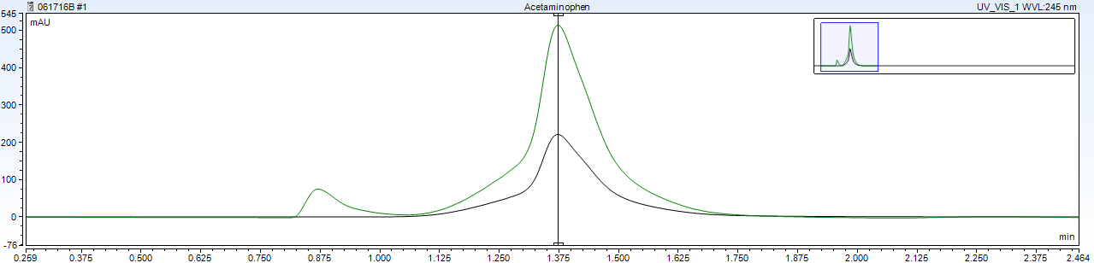

Ibuprofen, Black Trace 245 nm, Green Trace 195nm
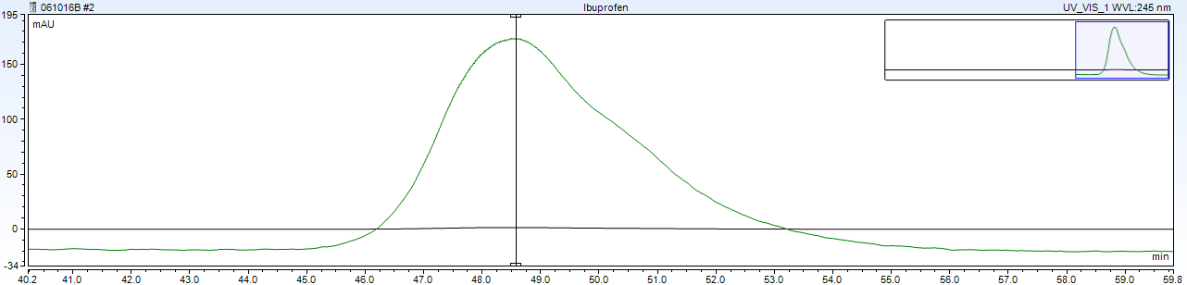

Diphenhydramine, Black Trace 245 nm, Green Trace 195nm
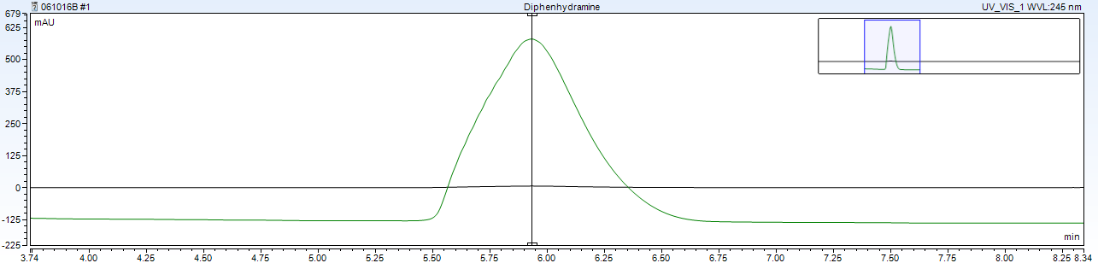

All Analgesics, 195nm 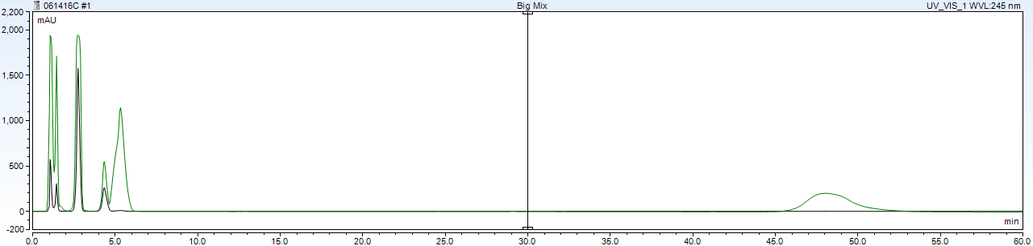
RP-Amide, 55% pH=7 0.025M phosphate buffer
Mix A, Black Trace 245 nm, Green Trace 220nm: aspirin, caffeine, salicyclamide, and phenacetin, respectively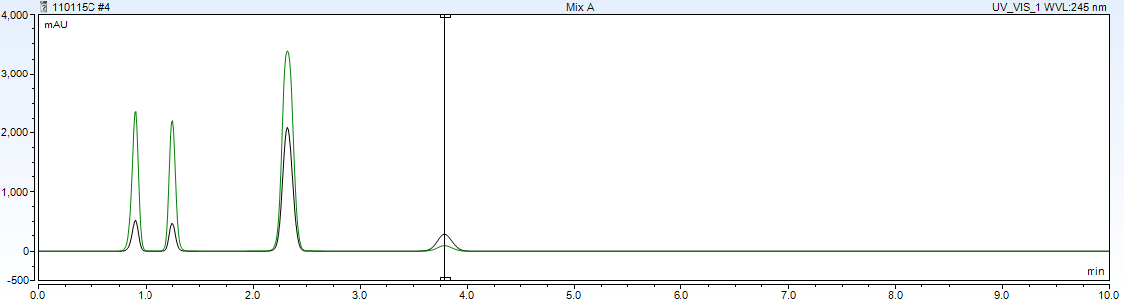
Acetaminophen, Black Trace 245 nm, Green Trace 195nm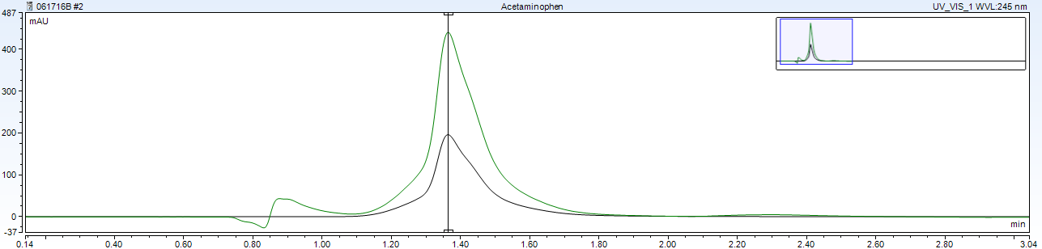

Ibuprofen, Black Trace 245 nm, Green Trace 195nm
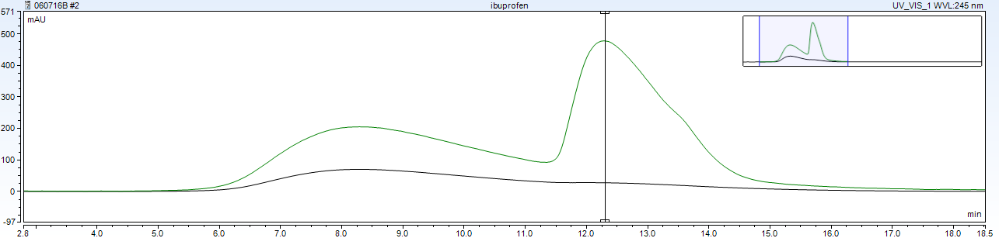

Diphenhydramine, Black Trace 245 nm, Green Trace 195nm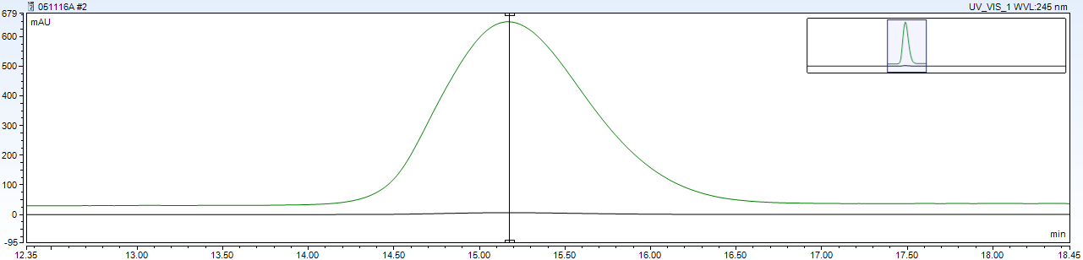

All Analgesics, Black Trace 245 nm, Green Trace 195nm

RP-Amide, 55% pH=9 0.025M phosphate buffer
Mix A (order aspirin, caffeine and salicyclamide, phenacetin) Black Trace 245 nm, Green Trace 230nm 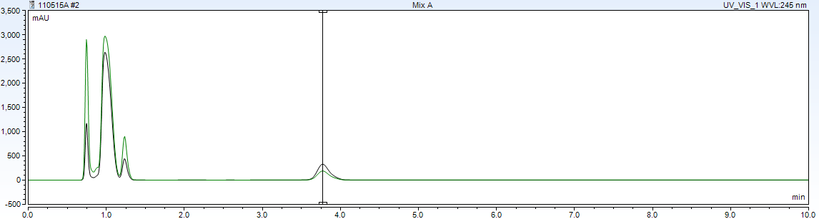
Ibuprofen, Black Trace 245 nm, Green Trace 195nm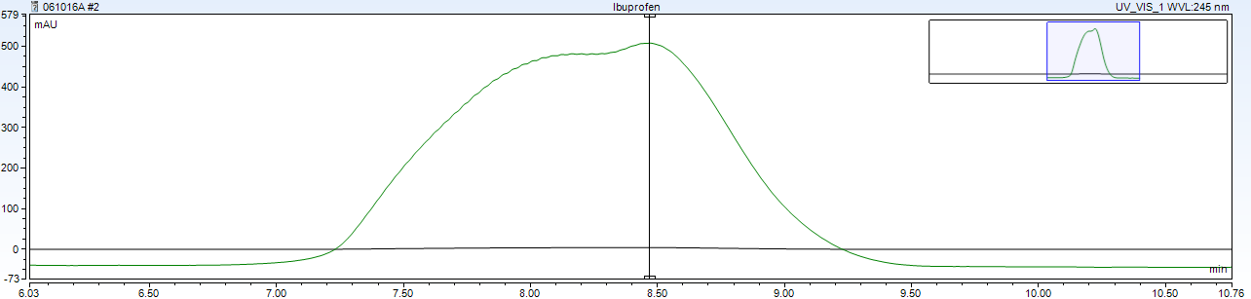
Diphenhydramine, Black Trace 245 nm, Green Trace 195nm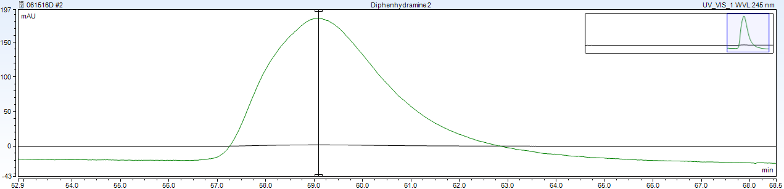
All Analgesics, Black Trace 245 nm, Green Trace 200nm 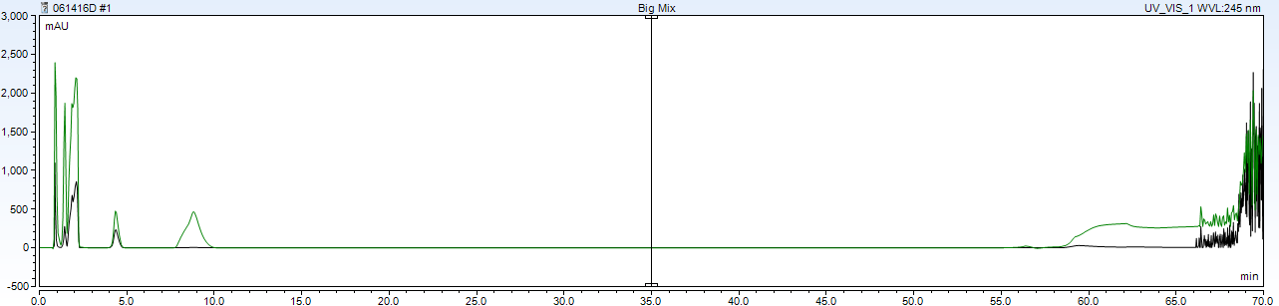

C18-PFP, 55% pH=5 0.025M phosphate buffer
Mix A (aspirin, caffeine, salicyclamide, phenacetin) Black Trace 245 nm, Green Trace 213nm 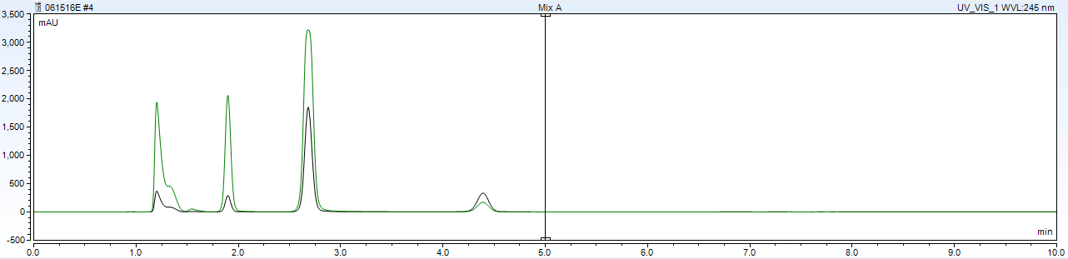
Acetaminophen, Black Trace 245 nm, Green Trace 195nm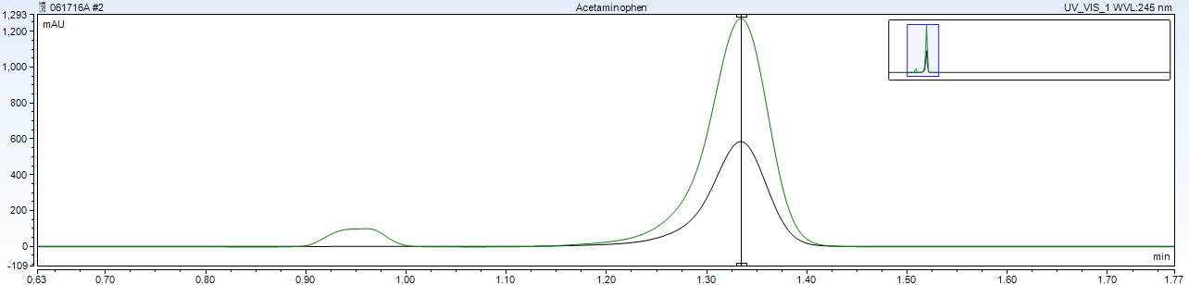
Ibuprofen, Black Trace 245 nm, Green Trace 195nm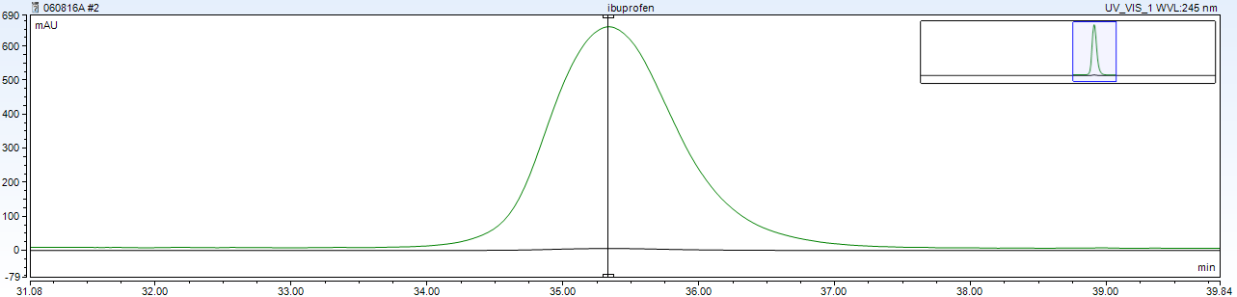
Diphenhydramine, Black Trace 245 nm, Green Trace 195nm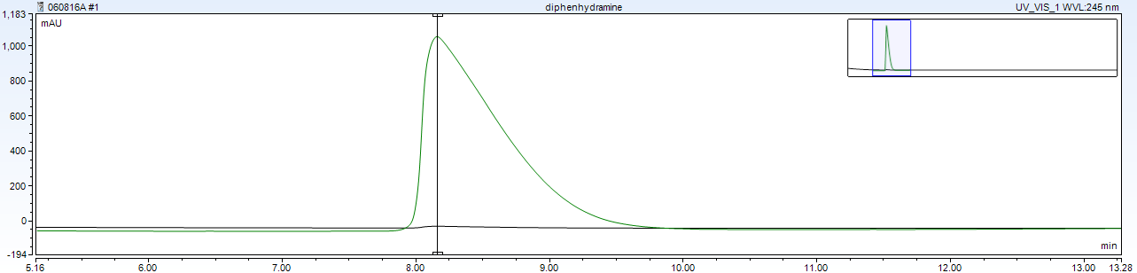
All Analgesics, Black Trace 245 nm, Green Trace 195nm 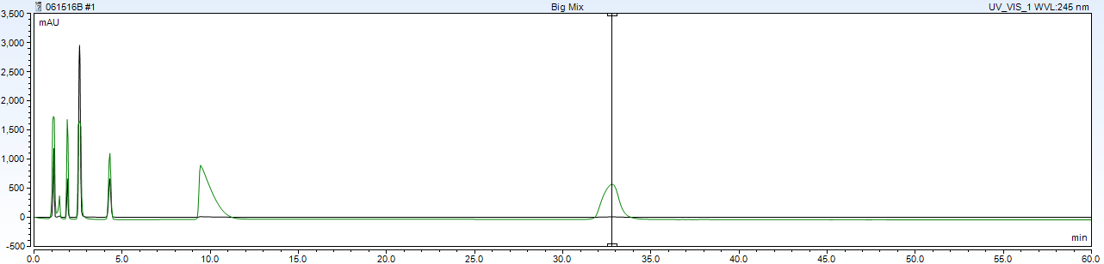
C18-PFP, 55% pH=7 0.025M phosphate buffer
Mix A (order aspirin, caffeine, salicyclamide, phenacetin), Black Trace 245 nm, Green Trace 225nm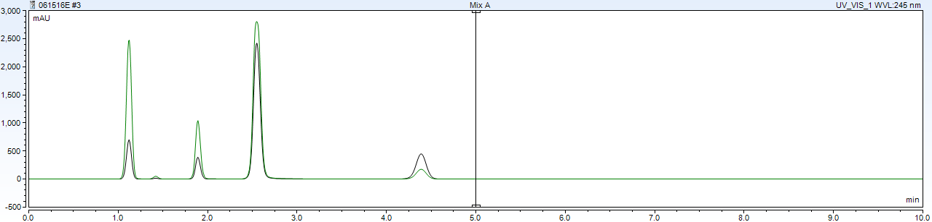

Acetaminophen, Black Trace 245 nm, Green Trace 195nm
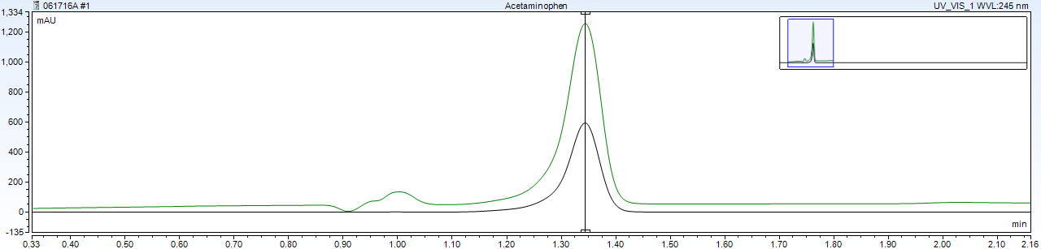

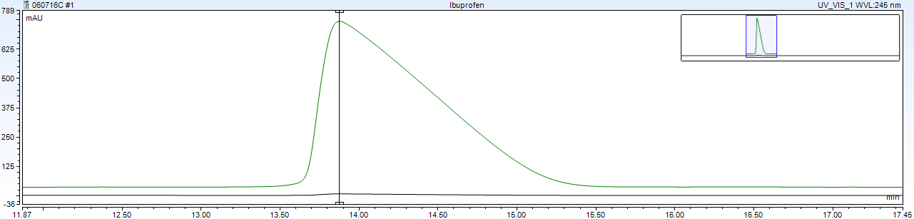
Ibuprofen, Black Trace 245 nm, Green Trace 195nm
Diphenhydramine, Black Trace 245 nm, Green Trace 195nm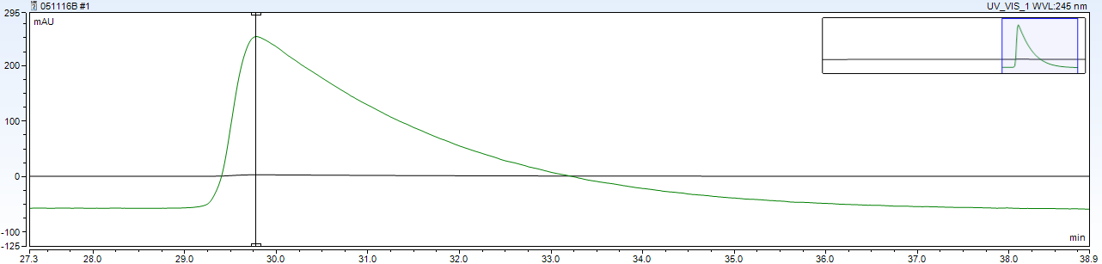

All Analgesics, Black Trace 245 nm, Green Trace 200nm

C18-PFP, 55% pH=9 0.025M phosphate buffer
Mix A (order aspirin, caffeine and salicyclamide, and phenacetin) Black Trace 245 nm, Green Trace 210nm 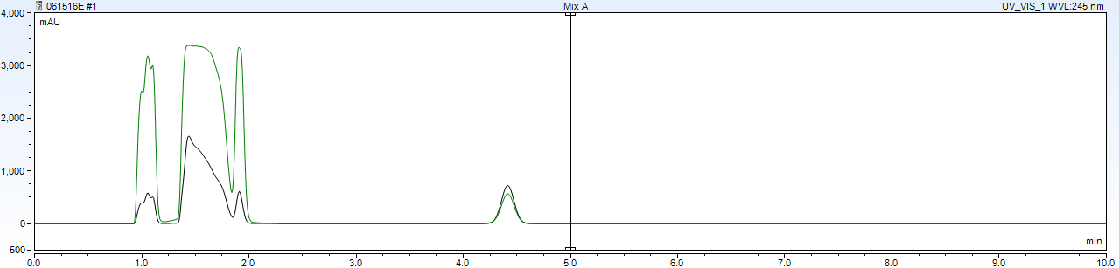
Ibuprofen, Black Trace 245 nm, Green Trace 195nm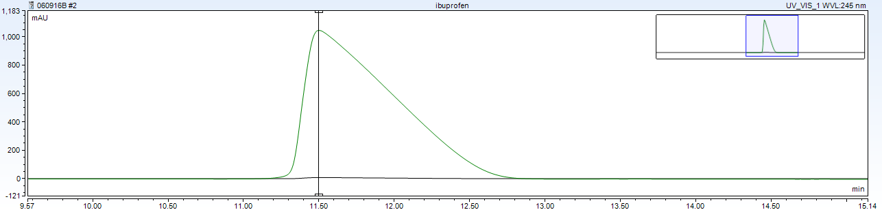
Diphenhydramine, Black Trace 245 nm, Green Trace 195nm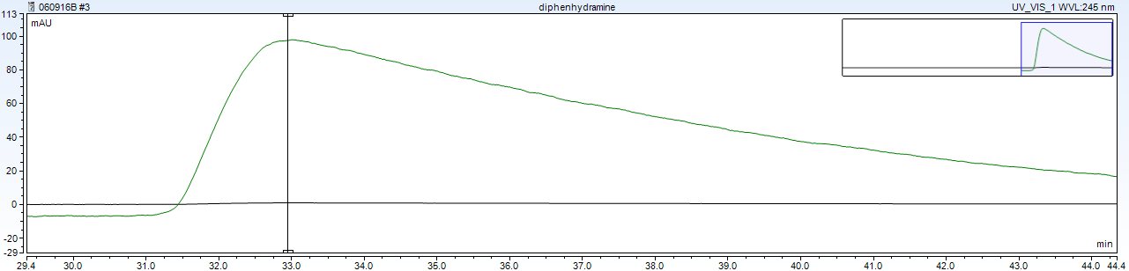
All Analgesics, Black Trace 245 nm, Green Trace 200nm 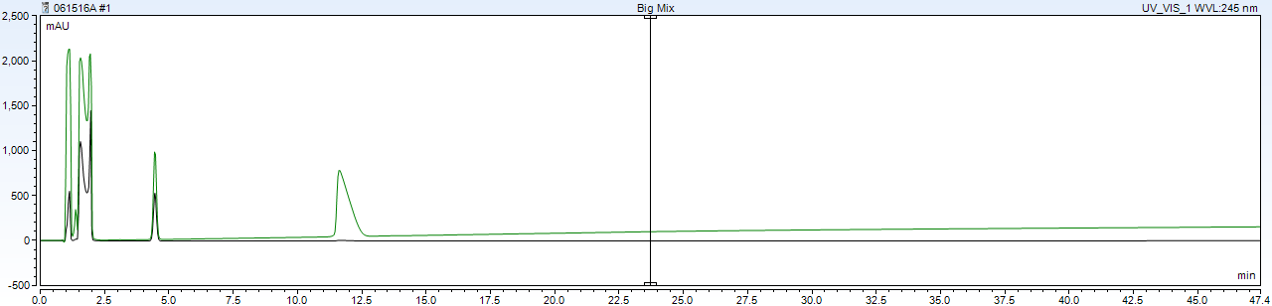

Unknown Tablets on C18-PFP, 55% pH=7 0.025M phosphate buffer
Unknowns were crushed, dissolved in 250 mL water, and filter with 0.45 micropore filters, followed by a 1:10 dilution in methanol.
Tablet 1, Black Trace 245 nm, Green Trace 195nm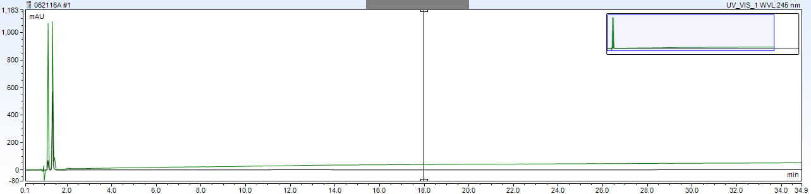
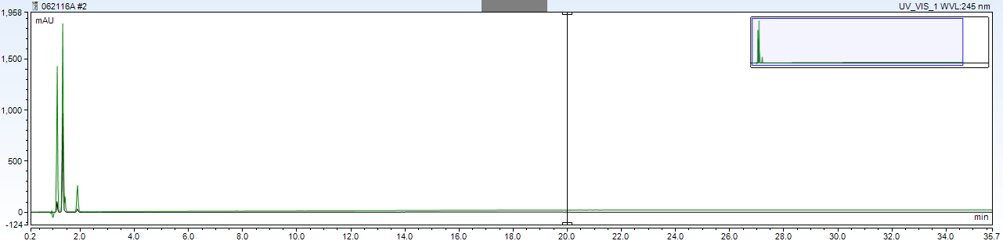
Tablet 2, Black Trace 245 nm, Green Trace 200nm

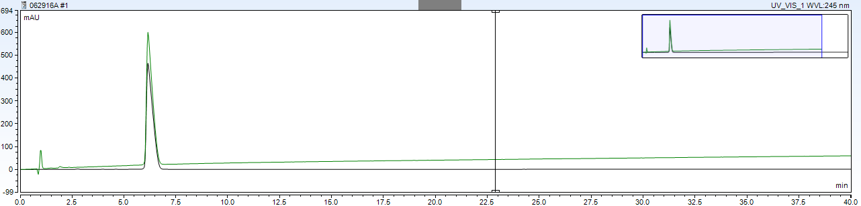
Tablet 3, Black Trace 245 nm, Green Trace 200nm

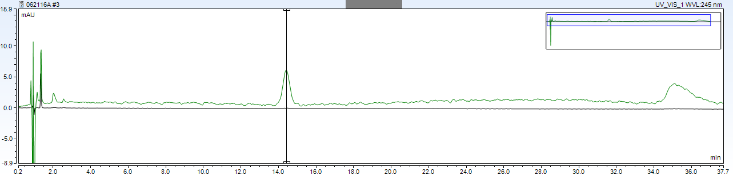
Tablet 4, Black Trace 245 nm, Green Trace 200nm

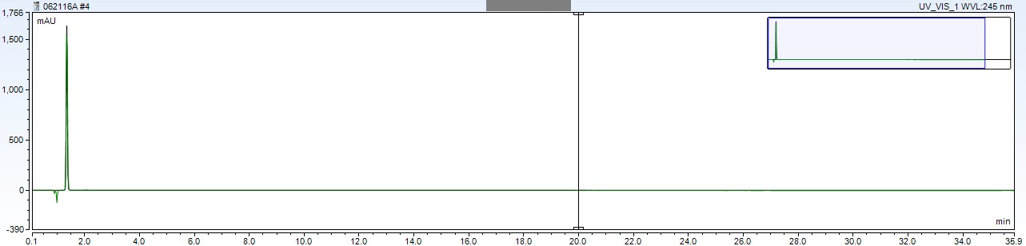
Tablet 5, Black Trace 245 nm, Green Trace 195nm

Supplemental Information
All stock solutions were made by dissolving weight listed of analgesic in 50.0 mL methanol
Stock Compounds  (Amount in Stock) | pKa | Melting Point | Structure
Aspirin (acetylsalicyclic acid)  90mg | 3.49 | 134-6˚C | 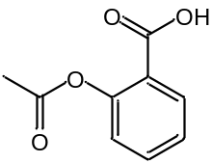
Caffeine  30 mg | 10.4 | 238˚C | 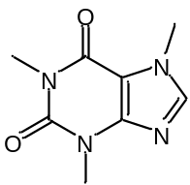
Salicyclamide  90 mg | 8.37 | 140-4˚C | 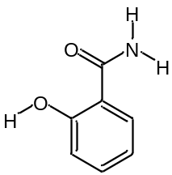
Phenacetin  12 mg | 2.2 | 133-8˚C | 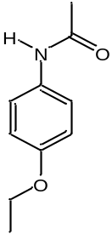
Acetaminophen  5 mg | 9.38-9.9 | 169˚C | 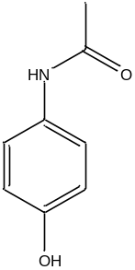
Ibuprofen  50 mg | 4.91-5.2 | 76˚C | 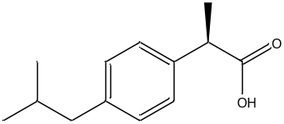
Diphenhydramine HCl  50 mg | 9-10.10 | 166˚C | 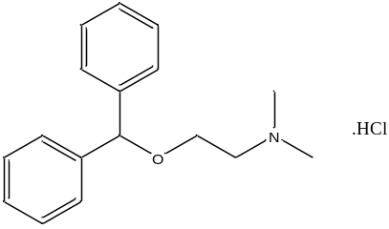
Column Chemistries
C18 particle surface
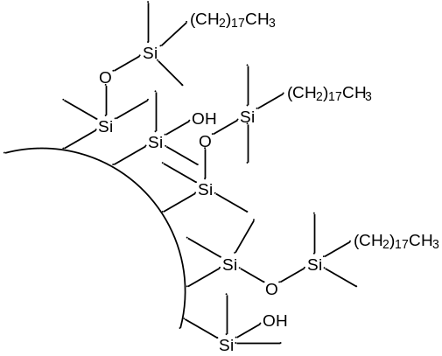
RP-Amide particle surface (polar embedded group)
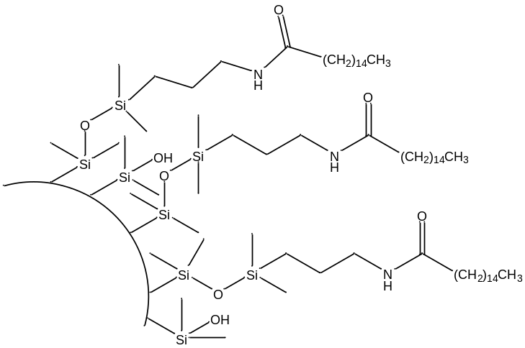
C18-PFP particle surface (polar endcapped)
