Selection of Separation Methods
PART 1: On the large sheet provided, create a flow chart showing the steps you would take in order to choose a method of separation and detection for a set of analytes. You should show GC, LC, and CZE at some point in the chart, showing specific choices for stationary phases along the way. You do not need to consider mass spectrometry yet. You should consider volatility, polarity, ionic nature, chirality, molecule size, need for elemental determination, etc. There is no “right” answer but there will be some paths that are better than others. You should decide on the main branches first and then focus on the more detailed branches within them. You can work with a neighbor or independently, but when done compare with another group or neighbor.
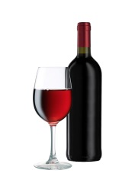
PART 2: For each of the following scenarios, determine the best analysis technique from those we have discussed and justify your choice. Assume you do not have access to mass spectrometers, so no GCMS or LCMS.
- A group of researchers in Cognac, France wanted to analyze the compounds responsible for deterioration in red wine flavor. Premature aging of red wines is mainly associated with the formation of an intense off-flavor reminiscent of prunes. They found three compounds that had a strong odor of prunes in the wines: γ-nonalactone, β-damascenone, and 3-methyl-2,4-nonanedione. What type of chromatography do you think was performed? Explain.

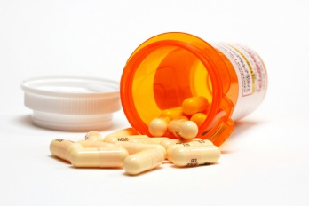
- A forensic chemist at the State Police Lab is analyzing a blood sample taken from a deceased victim in a suspected homicide case. The police found a number of empty prescription medicine bottles, including muscle relaxers, anti-depressants, and opioid-based painkillers. What type of chromatography and detection would you suggest to start analyzing the blood for these medicines and their metabolites?

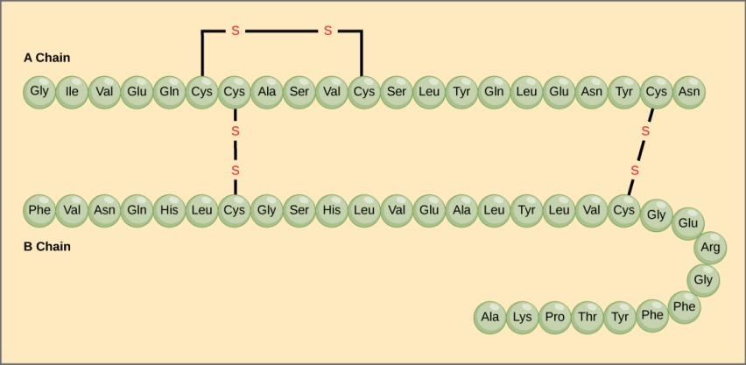
- Insulin is composed of two peptide chains referred to as the A chain and B chain. A and B chains are linked together by two disulfide bonds, and an additional disulfide is formed within the A chain. In most species, the A chain consists of 21 amino acids and the B chain of 30 amino acids. What separation and detection method would you suggest to separate the intact protein insulin from the A and B chains in a mixture of of insulin ?

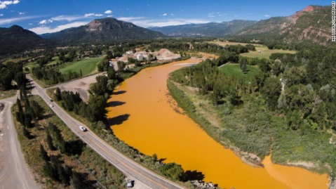
- In August of this year (2015), the EPA accidently diverted toxic mine waste into the Animas River in Colorado. The waste water, filled with heavy metals like iron, zinc, copper, arsenic, and cadmium, was supposed to be pumped out of the mine to be treated. However, the waste water was diverted into a tiny creek running into the river, causing an estimated 1 million gallons of waste water to turn about 80 miles of the river orange. This river flows on to larger tributaries like the Colorado river. Clearly the effort to clean up this river will take some time and lots of money. How will the EPA determine when levels of the heavy metals are within safe quantities for humans? (We only had spectroscopic methods when I asked this question before. Do you change your choice of method now that we have chromatographic methods in our toolbox?)

