Qualitative Analysis via GC/MS CHEM 420 – Environmental Analysis
In-class assignment on understanding EI mass spectra P.T. Palmer, SF State University

TRICHLOROMETHANE (AKA CHLOROFORM)

- Predict all possible elemental compositions and corresponding integer masses of your compound. Hint – look up a table of isotopic abundances of the elements and take into account all of the naturally occurring isotopes of the different elements in your compound.
Consider all permutations of elements and isotopes (¹²C or ¹³C, ¹H or ²H, ³⁵Cl or ³⁷Cl)

- What is the most likely elemental composition of the M+1 ion (where M corresponds to the molecular ion)?

- What is the most likely elemental composition of the M+2 ion?

- What is the most likely elemental composition of the M+4 ion?

- Look up the EI mass spectrum of your assigned compound (http://webbook.nist.gov/chemistry/).
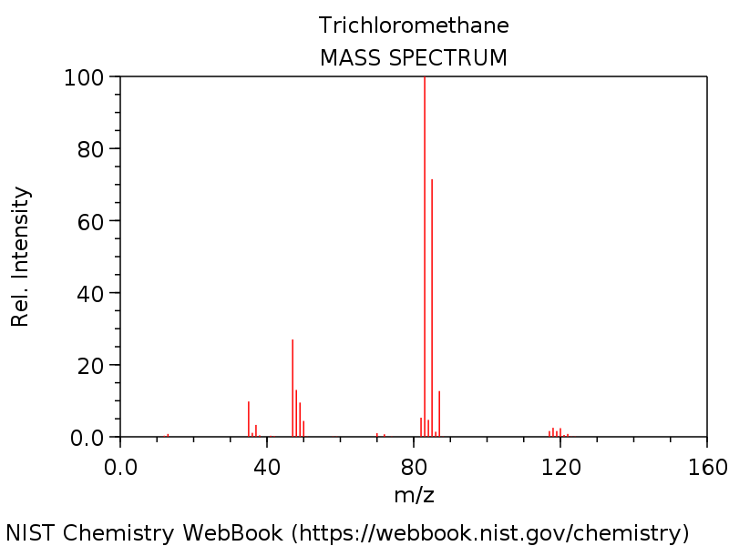
What is m/z value of the base peak in the mass spectrum?
What is the elemental composition of the ion corresponding to the base peak
Write a balanced reaction showing the formation of this species.
Why is this ion the base peak? Hint – consider its stability.

DICHLOROBROMOMETHANE
- Predict all possible elemental compositions and corresponding integer masses of your compound. Hint – look up a table of isotopic abundances of the elements and take into account all of the naturally occurring isotopes of the different elements in your compound.
Consider all permutations of elements and isotopes (¹²C or ¹³C, ¹H or ²H, ³⁵Cl or ³⁷Cl, ⁷⁹Br or ⁸¹Br)

- What is the most likely elemental composition of the M+1 ion (where M corresponds to the molecular ion)?

- What is the most likely elemental composition of the M+2 ion?

- What is the most likely elemental composition of the M+4 ion?

- Look up the EI mass spectrum of your assigned compound (http://webbook.nist.gov/chemistry/).
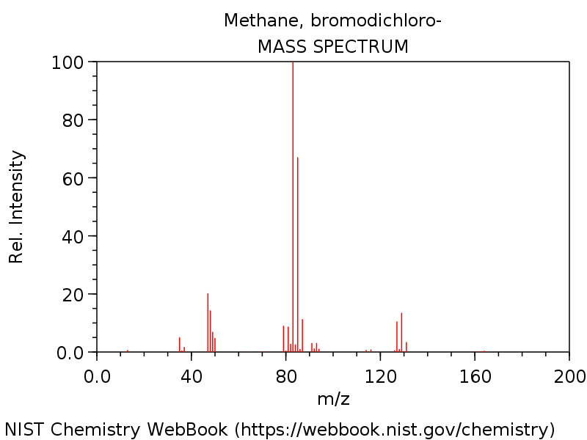
What is m/z value of the base peak in the mass spectrum?
What is the elemental composition of the ion corresponding to the base peak
Write a balanced reaction showing the formation of this species.

Why is this ion the base peak? Hint – consider its stability.

CHLORODIBROMOMETHANE

- Predict all possible elemental compositions and corresponding integer masses of your compound. Hint – look up a table of isotopic abundances of the elements and take into account all of the naturally occurring isotopes of the different elements in your compound.
Consider all permutations of elements and isotopes (¹²C or ¹³C, ¹H or ²H, ³⁵Cl or ³⁷Cl, ⁷⁹Br or ⁸¹Br)

- What is the most likely elemental composition of the M+1 ion (where M corresponds to the molecular ion)?

- What is the most likely elemental composition of the M+2 ion?

- What is the most likely elemental composition of the M+4 ion?

- Look up the EI mass spectrum of your assigned compound (http://webbook.nist.gov/chemistry/).
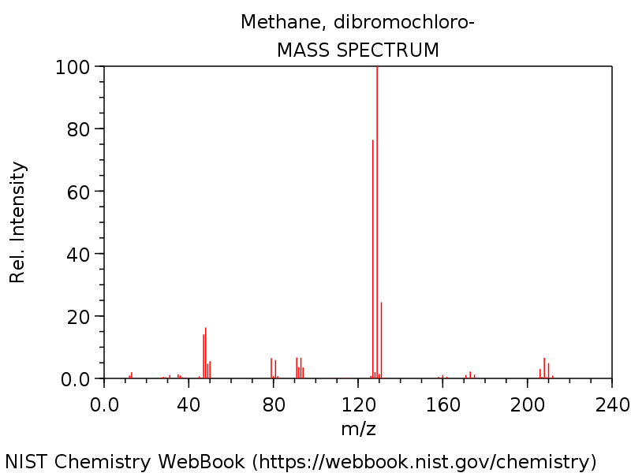
What is m/z value of the base peak in the mass spectrum?
What is the elemental composition of the ion corresponding to the base peak
Write a balanced reaction showing the formation of this species.

Why is this ion the base peak? Hint – consider its stability.

TRIBROMOMETHANE (AKA BROMOFORM)

- Predict all possible elemental compositions and corresponding integer masses of your compound. Hint – look up a table of isotopic abundances of the elements and take into account all of the naturally occurring isotopes of the different elements in your compound.
Consider all permutations of elements and isotopes (¹²C or ¹³C, ¹H or ²H, ⁷⁹Br or ⁸¹Br)

- What is the most likely elemental composition of the M+1 ion (where M corresponds to the molecular ion)?

- What is the most likely elemental composition of the M+2 ion?

- What is the most likely elemental composition of the M+4 ion?

- Look up the EI mass spectrum of your assigned compound (http://webbook.nist.gov/chemistry/).
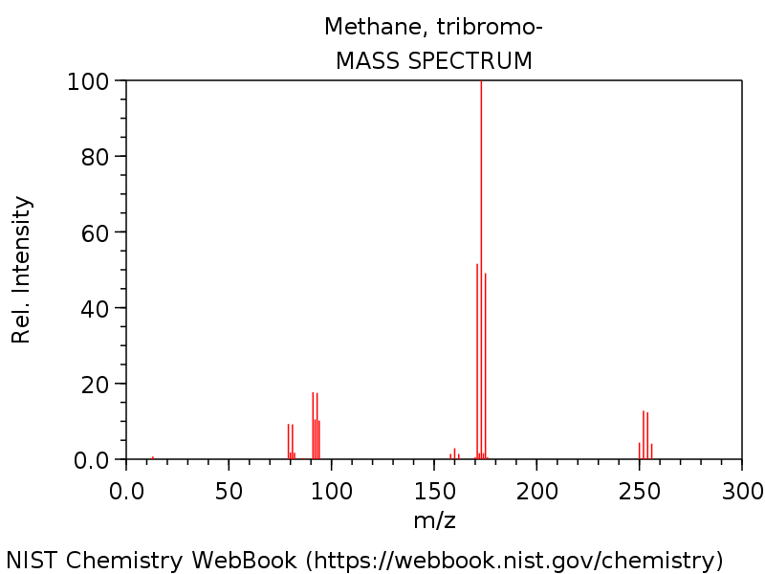
What is m/z value of the base peak in the mass spectrum?
What is the elemental composition of the ion corresponding to the base peak
Write a balanced reaction showing the formation of this species.

Why is this ion the base peak? Hint – consider its stability.

Qualitative Analysis via GC/MS CHEM 420 – Environmental Analysis
In class assignment on understanding EI mass spectra P.T. Palmer, SF State University

FLUOROBENZENE

- What is the molecular formula of fluorobenzene?

- What is the average molecular weight of fluorobenzene?

- What is the nominal (integer) molecular weight (M) of fluorobenzene in which the C, H, and F atoms are all in the form of the most common isotopes?

- Predict all possible elemental compositions and corresponding integer masses of fluorobenzene. Hint – look up a table of isotopic abundances of the elements and take into account all of the naturally occurring isotopes of the different elements in your compound.
Consider all permutations of elements and isotopes (¹²C or ¹³C, ¹H or ²H, ¹⁹F)

- What is the most likely elemental composition of the M+1 ion of fluorobenzene?
Hint - there must be an isotope in here - which is the most likely possibility?

- Look up the EI mass spectrum of fluorobenzene (http://webbook.nist.gov/chemistry/)
- What is m/z value of the base peak in the mass spectrum?

- Write a balanced reaction showing the formation of this species.

- Why is the molecular ion the base peak? Hint – consider its stability.

