Chem 4090
1st day of class – adapted from unpublished course notes of Jill Venton, University of Virginia

Lesson plan

- Introductions [15 min] – me, TA, students, course setup
- Break into groups of four [5-6 min] – introduce selves to each other
  - Groups are pre-assigned based on a pre-course survey to mix up levels of preparation

ACTIVE PART

Group question [students write on boards in groups]:
  - What are some chemicals/samples that are useful to measure? For example, measuring [CO2] in air. Creatinine in urine.
Many students have prior knowledge of this and it gets the class participating.
  - For each measurement, if you know what technique could be used to measure it, list that too.

Followup discussion led by me:
- These are all applications of analytical chemistry!
  - Applications are broad: environmental, space, biomedical, etc applications
- Point out that analytical chem contains both qualitative and quantitative analysis, and also "characterization" of samples
- Potential techniques include spectroscopy, separations, electrochemistry, and mass spec
  - We will cover each of these techniques in class this semester

Group question [on boards]: [25 min including followup]
Suppose you are interested in the amount of lead in water, or a protein in blood. From a scientific perspective, how might you go about developing a method to measure the molecule in this sample?
- I'm not asking you to name a technique or actually design a method. Rather, think at a meta level about how you would approach this challenge.
- What information do you need to gather before you can even get started?
- What decisions do you need to make?
- Hint: Think about the scientific method. Tailor it to analytical chemistry… the science of measurement and detection.
- Hint: consider whether the process is unidirectional or might loop back at some point.

They write on their boards, I circulate and comment; we eventually discuss as a group

This is the "analytical approach to solving problems" … aka Analytical method development

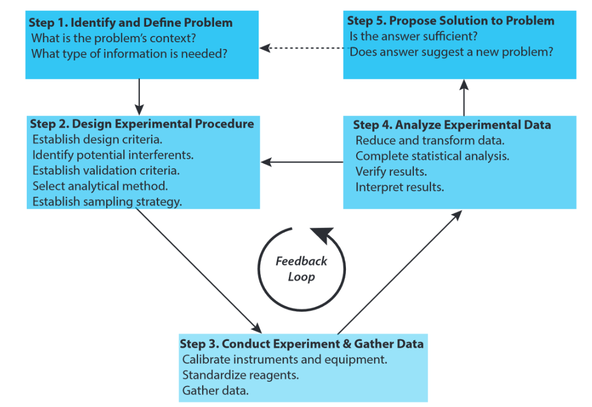

Follow up:
- Draw the cycle on the board as the students name parts of it.
- Point out that the most creative part of an analytical chemist's work may be step #1 and #2 -- defining the problem and designing the method. After that, conducting it might be routine, unless the method requires the development of new technology.
- BS level job = #3 + #4
- PHD level job = all five steps and cycle repeatedly

