Pre-class Handout
Let’s adapt our model of the analytical approach to the development of a simple, inexpensive, portable device for completing bioassays in the field. Before continuing, locate the article “Simple Telemedicine for Developing Regions: Camera Phones and Paper-Based Microfluidic Devices for Real-Time, Off-Site Diagnosis” by Andres W. Martinez, Scott T. Phillips, Emanuel Carriho, Samuel W. Thomas III, Hayat Sindi, and George M. Whitesides. You will find it on pages 3699-3707 in Volume 80 of the journal Analytical Chemistry, which was published in 2008.

Let the following questions guide you in your reading of the article:

- Using only the information in the title and abstract, answer the following questions about this work. The goal is to see how much you can glean from just these sections.
  - What did the authors do?

  - Why did they do it?

  - How did they do it?

  - What did they find?

- Analytical method development papers often start with an assessment of available methods versus the proposed method. Fill in the table below using the information from the introduction.
 | Author’s proposed assay | Standard clinical assays
Advantages
(Potential or definite)
Disadvantages

- Toward the end of the introduction, often in the last paragraph, it is common to transition from background information to a brief summary of the specific question or goal addressed in the manuscript. What question or goal did these authors want to address?

- This particular paper does not have a traditional Materials and Methods section. Instead, it has an Experimental Design section that focuses on the rational for each choice in the assay design. What type of assay did the authors select to measure glucose and albumin concentration (one word answer), and why?

_________________________ assay

Reason:

- In this article, where can you find the technical details that are normally included in a Methods section, such as the concentration of components in the artificial urine solution?

Record the pH to which the artificial urine solution was adjusted, and state where you found this info.

6. In the Results & Discussion, the authors discuss several experiments that logically and sequentially describe the development of this assay and tests its usefulness. In the section titled “Quantitative Assays with Samples of Known Volume,” look at the corresponding figure.

- The y-axes are labelled “Mean Intensity,” which is a vague term. Based on your reading of the article and the method that they were using, what intensity are they talking about? State what type of analysis was used to make the measurement.

- Why do you think the authors spiked the standards into a complex artificial urine sample instead of spiking them into water or a simple saline solution?

In-class Handout
“Simple Telemedicine for Developing Regions: Camera Phones and Paper-Based Microfluidic Devices for Real-Time, Off-Site Diagnosis” by Andres W. Martinez, Scott T. Phillips, Emanuel Carriho, Samuel W. Thomas III, Hayat Sindi, and George M. Whitesides.
Learning goals for discussion of this paper:
Students will
- Become familiar with what to look for to understand a published analytical paper
- Map key elements of a written paper to the “analytical approach to problem solving”
- Interpret data designed to measure figures of merit
- Recognize how figures of merit are used to assess an analytical method

Part I. Become a paper-reading whiz.
- Look at Figure 3 and the accompanying section of text that refers to it (“Preparation of devices”). Is it easier to understand the overall message from the figure or from the text? Why?

- Is it possible to understand the paper just from its title, figures, and captions? Try “reading” the paper this way and summarize the purpose and main findings of the paper. How well does this understanding compare with actually reading the text of the paper?

- Try re-reading the paper as in #2 (title, figures, captions) and add in a reading of the bold headers. To what extent does this improve your understanding of what was done? Are there other specific elements of the paper that are worth reading for a quick understanding of the main points of the paper?

Part II. The analytical approach is the underlying story
Consider again the analytical approach to problem solving, summarized in the graphic below.
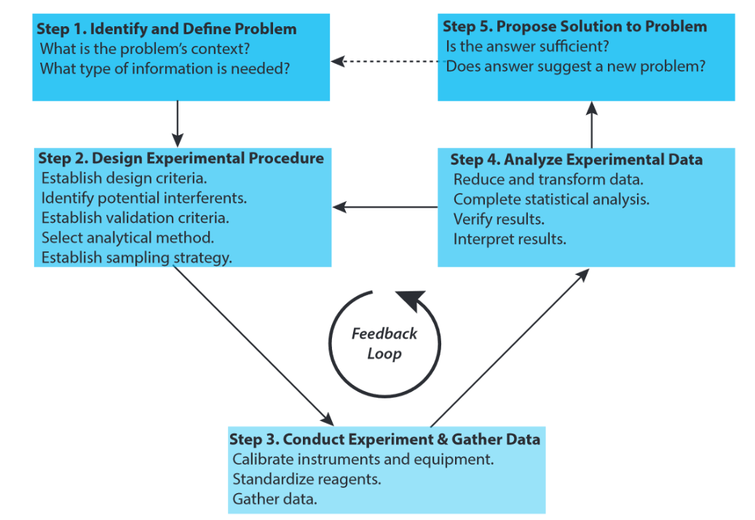
Image credit: Harvey, Analytical Chemistry 2.0, Chapter 1
Briefly answer each of the questions below. Spend no more than 2 – 3 minutes per question.
- For this paper, what is the analytical problem and why is it important?

- What criteria did the authors consider in designing their experiments?

- What was the basic experimental procedure?

- What interferences were considered and how did they overcome them?

- How did the authors calibrate the assay?

- How did the authors validate their experimental method?

- Is there evidence that steps 2, 3, and 4 of the analytical approach were repeated?

- Was there a successful conclusion to the analytical problem? What was it?

Fill in the table below, noting where in the paper you found evidence that each of the above steps was completed:
Problem solving step | Location(s) in paper
Define the analytical problem (purpose and context)
Establish design criteria
Establish experimental procedure
Calibrate assay experimentally
Validate assay experimentally
Make conclusions
Pose further questions

Part III. Interpreting data and figures of merit
- What figures of merit do the authors measure or describe for their paper-based assays? Fill in the table below.
Figure of merit |  | How it was measured

- When discussing linear range and limit of detection, the authors do more than just provide numbers. What do they say about their results, and why is what they say useful for the reader?

