Mass spec imaging – lesson plan summary

- Finish MALDI worksheet from last class (10 min)
- Short lecture on:
  - MALDI (summarize method, with schematic)
  - SIMS
  - DESI
- Compare the three methods – ACTIVE PART
- Applications to mass spec imaging – ACTIVE PART
  - Brief look at leaf and petal paper together on projector

Comparing MS imaging methods:
We built a chart on the board of the three methods:
- Give students the rows, and let them try to fill in the details

 | Ambient | Vacuum | Vacuum
 | DESI | MALDI | SIMS
Spatial Res | 150 um | 10 um | 0.1 um
Soft or hard | Soft | Soft | Hard
Sensitivity (high/low) | Lower? | Lower? | Higher?
Other | Non-destructive (can reuse sample) | Good for proteins.  Not good for small molecules. | Deeper penetration.

My notes:
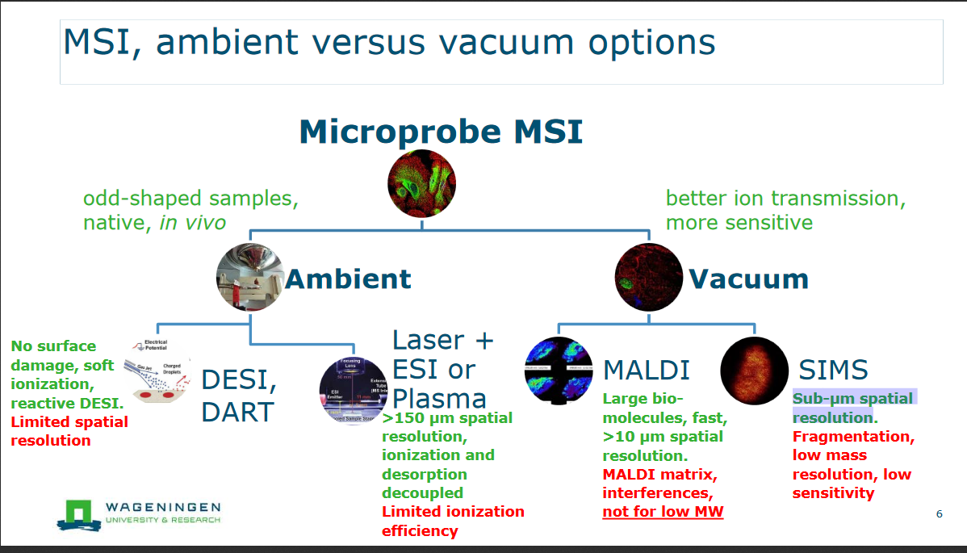

Dozens of ambient ionization options:

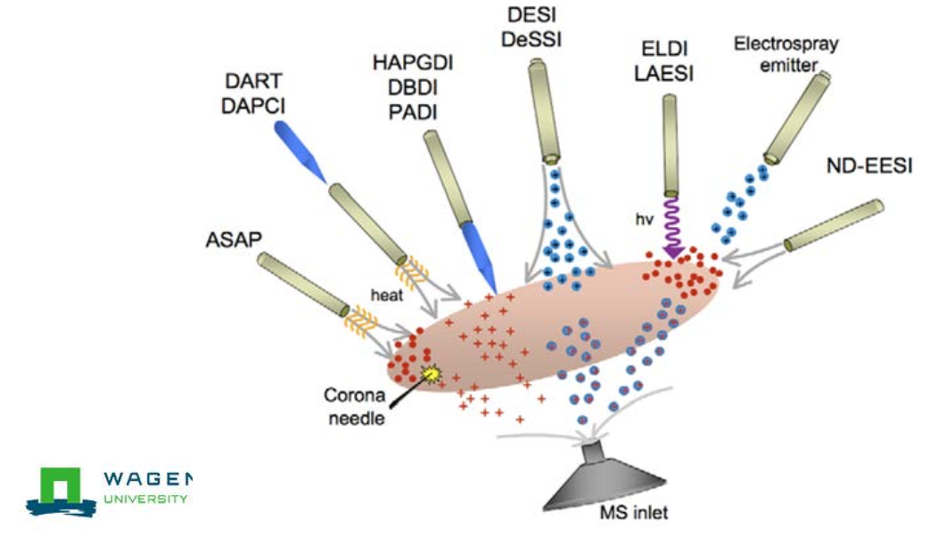
https://www.wur.nl/upload_mm/6/4/6/2b526c3e-2a83-4b32-ae25-3d082b611966_20171005-Intro_Ambient_MSI_Nielen_LR.pdf

Next, we briefly looked at this paper to see what they did –
Students pull it up on their laptops

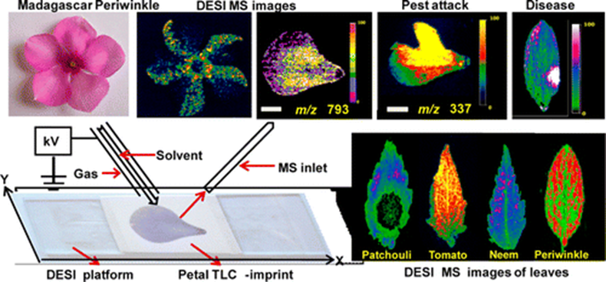

J. Agric. Food Chem., 2013, 61 (31), pp 7477–7487
https://pubs.acs.org/doi/full/10.1021/jf4011998

Q: What MS imaging technique did they use?
Ambient or vacuum?
Resolution achieved?
Why might they have done it this way?

Final Activity (15 min):
- Had students pull up a computer and get online
- Search for "mass spec imaging" for a topic they are interested in
  - e.g. biomedical, drug distribution, brain
  - e.g. art conservation, forensic science
  - e.g. food or agriculture
- Find a paper
  - Which ionization method do they use, and why?
  - How was the sample prepared (live, fixed, stored)?
- Last 5 - 10 min, have some students share with the class what they found

This was fun! Students were very engaged and excited to find such cool science.

