Developing an Analytical Method

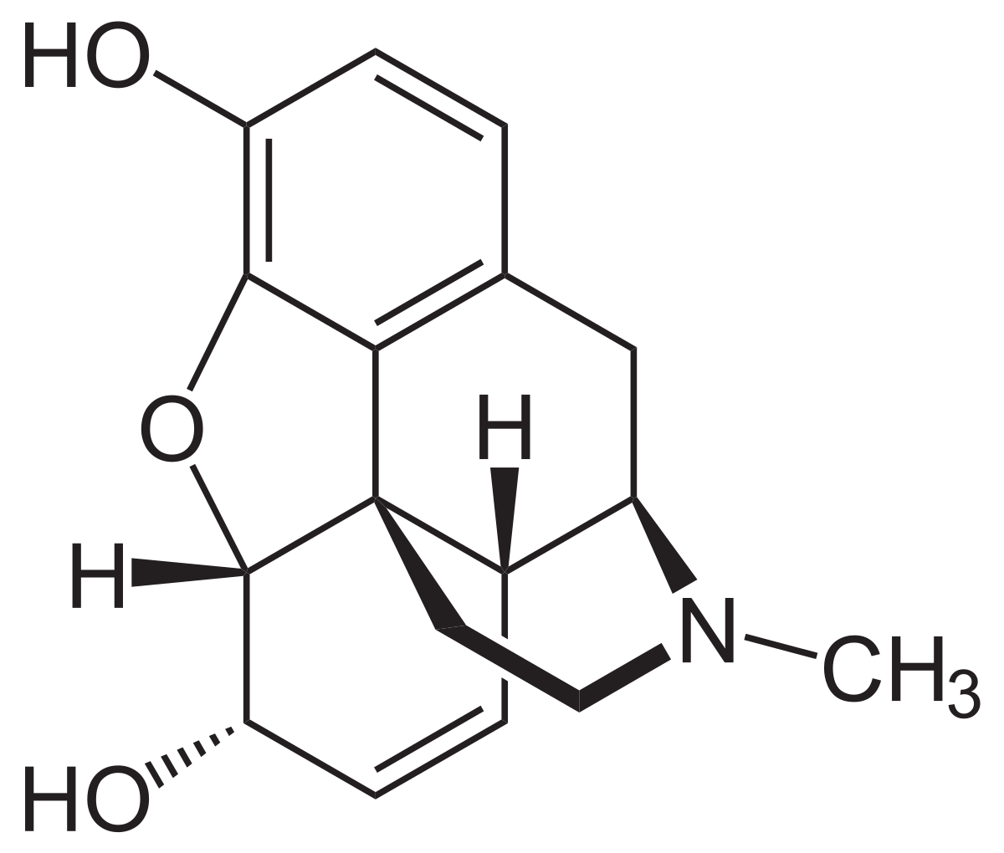
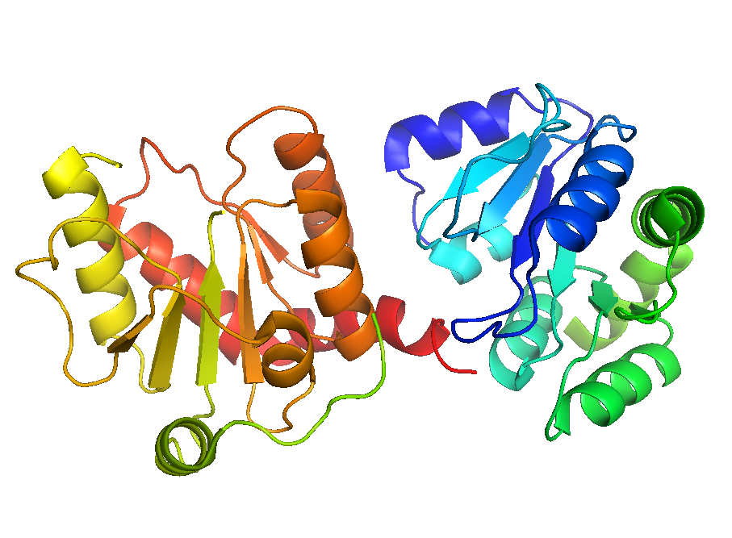
Background. Morphine is metabolized in the body to produce two metabolites – M3G (morphine-3-glucoronide; representing about 90% of the metabolized species) and M6G (morphine-6-glucoronide; representing about 10% of the metabolized species). The primary metabolic pathway involves the glucoronidation (addition of a sugar molecule) of morphine via several isoforms of glucoronosyltransferase enzymes. The UGT2B7 enzyme is the primary isoform responsible for glucoronidation of morphine. Following oral administration of morphine, the ratio of the metabolites to morphine can range from 9:1 to 50:1.¹
morphine
M3G
M6G
90%
10%
UGT2B7
Glucoronidation of morphine by enzyme UGT2B7.

Analytical Challenge. Suppose you work at a drug testing facility and you are tasked with quantifying the concentration of morphine and its metabolites in urine to test for opioid abuse in chronic pain patients. In groups, develop a list of questions that would be essential to answer in order to develop an efficient and reliable method of analysis.

