Introduction to Sampling and Sample Preparation*
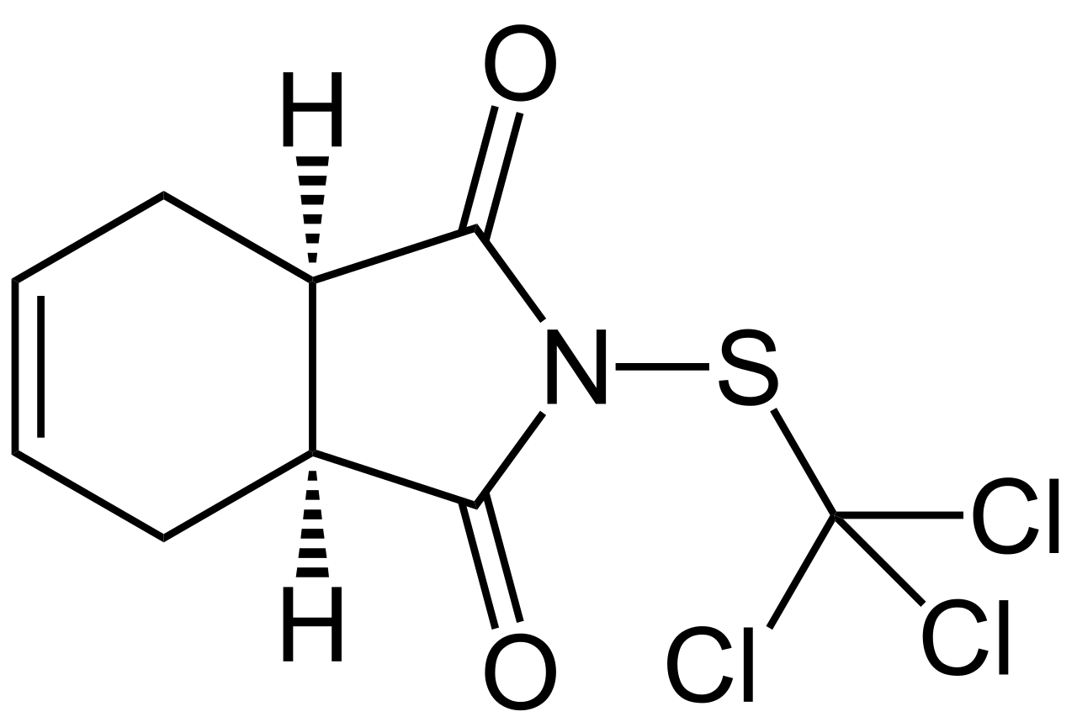
Background. Captan (pictured on the right) is a general use fungicide that is frequently used to protect orchard crops. It is often used in combination with other pesticides and fungicides and sprayed on crops. Captain also improves the appearance of the crops by giving them a brighter, “healthier-looking” finish. The biodegradation half-life of the compound is approximately 1 day. The compound has a melting point of 178°C and is not water soluble.

Analytical Challenge. Suppose you have been asked to determine the concentration of captan on the skin of apples at our local Linvilla Orchards in Media, PA. (1) Describe a method for sampling the apples that includes discussion of your sampling approach and how you will obtain a field blank. (2) Brainstorm ideas for how you will prepare your sample for analysis using liquid chromatography.
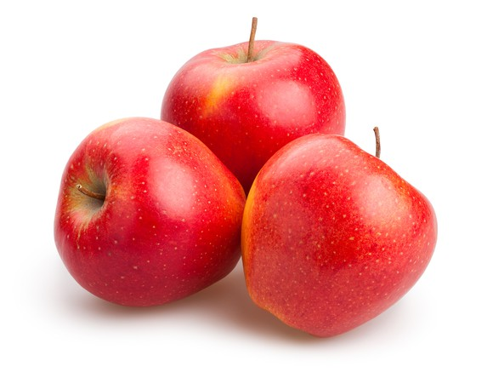

That is, how will you go from this: to this:

*This activity is a modification of one developed by Dr. Alison Holliday at Moravian College

