Chromatography Basics using HPLC Simulator

Chromatography terms review and introduction to HPLC simulator:
- Go to http://www.multidlc.org/hplcsim (You should open HPLC simulator at the start of each class so that it is available for in-class activities.) The simulator will appear as below.

- Find t_{R} in the data table.
- Click on nitrobenzene to highlight its peak. Note its retention time both in table and on chromatogram: t_{R} = _____ min.
- In the left menus click on Column Properties where you will find Void time, which is another name for t_{M}: t_{M} = _____ s = ______ min.
- In the table under the chromatogram, note the k (retention factor) for nitrobenzene: k = ______.
- Calculate k of nitrobenzene based on t_{R} and void time, and compare it to the value in the table (item 4): k = ______.

Retention control introduction:
- Slide left scroll bar up so that you can see Mobile Phase Composition, and click on it to open.
- Adjust the blue slide bar for Solvent B fraction (%v/v) to 100% acetonitrile.
- What is t_{R} for nitrobenzene? t_{R} = _____ min.
- What is the void time? (open Column Properties menu at left side of screen, and scroll to bottom to find Void time) t_{M} = _____ s = _____ min.
- Compare the void time at 100% acetonitrile (last question) with that at 40% acetonitrile (question 3 of last exercise = ____min). Justify the values you obtain.

- In the table under the chromatogram, note k (retention factor) for nitrobenzene for 100% acetonitrile: k = ______.
- How does the retention time (t_{R}) and retention factor (k) of nitrobenzene compare to those of the other compounds when using 100% acetonitrile?
8) As a group, discuss whether the retention time of a compound can be ever be less than the void time t_{M}?

9) As a group, discuss why the separation of the five compounds is so poor using 100% acetonitrile.

Flow rate introduction:
- Go to http://www.multidlc.org/hplcsim If simulator was already open, click the Reset button at upper left, beside HPLC Simulator to reset to default conditions (Solvent B Fraction = 40%).
- Click on nitrobenzene in table to highlight this peak.
- Click on Chromatographic Properties to open this menu. Change Flow Rate to 0.5 mL/min. (Need to type in “0.5” rather than use the up/down arrows.)
- What is retention time (t_{R}) of nitrobenzene? t_{R} = ________min
- What is retention factor (k) of nitrobenzene? k = _______
- Click on General Properties to open its menu. Uncheck “Automatically determine time span.” Final time should be “763.2” s.
Flow Rate (mL/min) | t_{R} (min) | k
0.5
1.0
2.0
5.0
- Complete the following table for nitrobenzene:

- What is the relationship between flow rate and retention time? Is this reasonable? Explain.

- What is the relationship between flow rate and retention factor? Is this reasonable? Explain.

Retention, Efficiency, and Resolution with HPLC Simulator:
- Go to http://www.multidlc.org/hplcsim If simulator was already open, return to default conditions using upper left Reset button.
- Open the Mobile Phase Composition menu, and change Solvent B fraction (% v/v) in 1% increments from 40% to 35%. What are the two least resolved compounds in the chromatogram? _____________ and ______________
What happens to the resolution between these two compounds as the Solvent B Fraction is adjusted from 40% to 35% acetonitrile?

- Repeat step 2 noting the retention time t_{R} and standard deviation σ for the two least resolved peaks. Four σ equals the baseline width of the peak (w = 4σ). Use the equation below to determine the resolution between these peaks at one flow rate studied in step 3. Each group member should perform the calculation for a unique Solvent B fraction. Show an example calculation. Hint: ensure t_{R} and w are in same units.
Resolution: 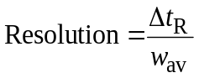

Complete the following table for Question 3:

Solvent B  (%) | t_{R,1} (min) | σ₁ (s) | w₁ (min) | t_{R,2} (min) | σ₂ (s) | w₂ (min) | Resolution  (unitless)
40
39
38
37
36
35

- A resolution value of 1.5 or greater is considered baseline resolution. Is baseline resolution achieved with any of these mobile phases? What does baseline resolved mean?

- With Solvent B Fraction (% v/v) of 38% acetonitrile, use retention time t_{R} and σ (s) for nitrobenzene to determine plate number N. The width at baseline w equals 4σ. Other group members should calculate N for 35% acetonitrile.
Plate number: 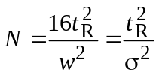

- Resolution is governed by the Purnell equation.
Purnell equation: Resolution = 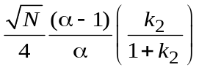
where N is the plate number, k₁ and k₂ are the retention factors of the two peaks, and α is the separation factor which equals α= k₂/k₁ where k₂ ≥ k₁. For two different Solvent B Fractions (35% and 38%), record the values of k₁ and k₂ under the two sets of conditions. Calculate the separation factor (α= k₂/k₁). Calculate the plate number (use N from question 5), separation factor term, and retention factor term of the Purnell equation. Compare with the resolutions determined in question 3.

Solvent B  (%) | k₁ | k₂ | α | $$\sqrt{N}/4$$ | (α–1)/α | k₂/(1+ k₂) | Resolution  (unitless)
38
35
Change (%)

What term (N, α, or k) is most responsible for the improvement in resolution between 38% and 35% acetonitrile? Explain your answer.

- Adjust Solvent B Fraction (% v/v) to 38% acetonitrile. Using Chromatographic Properties to change the flow rate, examine the resolution of the two closest peaks at 0.5, 1.0, 2.0, 3.0, 4.0 and 5.0 mL/min. Which flow rate provides the best resolution?
Optimal flow rate = ________ mL/min
- Using the resolutions determined in questions 2 and 3, guestimate the resolution at one of the flow rates studied in question 7. Each student should guestimate the resolution at a different flow rate.

van Deemter Behavior using HPLC Simulator
Plate height, H, is proportional to the variance of a chromatographic band (i.e., varience = σ², where 4σ = baseline width of peak). The smaller the plate height, the narrower the peak. The van Deemter equation tells us how the column and linear velocity u_{x} affect plate height:
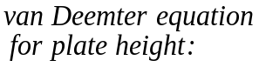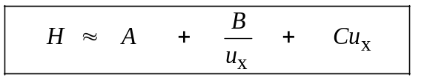
Multiple Longitudinal Mass
paths diffusion transfer

A, B, and C are constants for a given column and stationary phase.
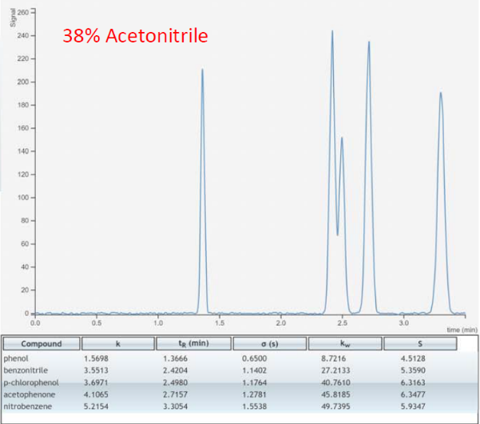
- Go to http://www.multidlc.org/hplcsim If simulator was already open, return to default conditions using upper left Reset button. Under Mobile Phase Composition, change Solvent B Fraction to 38% so that benzonitrile and p-chlorophenol are partially resolved. Your chromatogram should appear as below.

- Open the Chromatographic Properties menu, and find H (plate height).
H = _______cm
Plate height H = L/N where L is the column length (found under Column Properties menu) and N is the Plate number (found under Chromatographic Properties). Use L and N to calculate the plate height.
H = ________ mm = ________ cm

- Mobile phase velocity in a chromatographic system can be described in a number of different ways. Commonly we use linear velocity = u_{x} = L/t_{M} where L is the column length and t_{M} (also called Void time).
Use the Length and Void time found under the Column Properties menu to determine the linear velocity u_{x}. u_{x} = __________cm/s

Within the Chromatographic Properties menu, which Flow velocity term refers to the linear velocity u_{x}? ___________________________

- Under Chromatographic Properties, adjust Flow Rate from 0.2 to 5 mL/min. At each flow rate, record H (plate height) and Plate number (N) which are reported at the bottom of the Chromatographic Properties menu. Also record the linear velocity u_{x}.
Flow rate  (mL/min) | Linear velocity  (cm/s) | N (unitless) | H (cm)
0.2
0.5
1.0
2.0
3.0
4.0
5.0
- Plot H versus flow rate (or linear velocity) to create a plot of the van Deemter behavior.
- Open the Column Properties menu. Record the values of the van Deemter parameters A, B, and C which are at the bottom of the menu.
A = multiple path broadening = _____
B = longitudinal diffusion broadening = ______
C = finite time for equilibrium (resistance to mass transfer) broadening = _______
- We will now investigate each individual source of band broadening. This is not something that you can do with a real chromatograph. Each group member should select one van Deemter to study: group member A should leave A at its default value in part 6 and type in B = 0.001 and C = 0.001 (The simulator does not accept a value of 0); group member B should leave B at default and type in A = 0.001 and C = 0.001; and group member C should leave C at default, and set A = 0.001 and B = 0.001. Adjust Flow Rate from 0.2 to 5 mL/min, and record N, H and u_{x}.
 |  | A only |  | B only |  | C only
Flow rate  (mL/min) | Velocity  (cm/s) | N | H (cm) | N | H (cm) | N | H (cm)
0.2
0.5
1.0
2.0
3.0
4.0
5.0
- Plot H versus flow rate (or linear velocity) for the three cases studied in step 7 to show the contribution of each term in the van Deemter equation to the overall peak broadening.

- Explain why each term in the van Deemter plot has a different dependence on the flow rate and linear velocity. Summarize the discussion below.

- Based on the van Deemter plot, state whether the B or C term is more significant at each flow rate or linear velocity.
 |  | Bigger term?
Flow rate  (mL/min) | Velocity  (cm/s) | B | C
0.2
0.5
1.0
2.0
3.0
4.0
5.0
- What is the significance of the flow rate (linear velocity) at which the dominant contribution to band broadening changed in question 10?

- Return A, B, and C to the default values in question 6. As a group discuss what you think will happen to the optimum flow rate (optimum linear velocity) if the C-term is reduced to 0.02.

