Reversed Phase Liquid Chromatography In-class Activities
High-performance liquid chromatography (HPLC) uses high pressure to force solvent through closed columns containing fine particles that give high-resolution separations. Reversed-phase chromatography (RPLC) is the most common mode of HPLC. Its stationary phase is nonpolar or weakly polar and the solvent is more polar. HPLC simulator will be used to introduce you to HPLC and reversed-phase liquid chromatography.
Introduction to HPLC simulator and Reversed Phase LC:
- Go to http://www.multidlc.org/hplcsim (Open HPLC simulator at the start of each class so that it is available for in-class activities.) There are a number of menus on the left. Click on the Mobile Phase Composition and Chromatographic Properties labels to open their menus. The simulator will now appear as below.

- Typical mobile phases in RPLC are a mixture of water and a miscible organic solvent. Water is often referred to as Solvent A, and the organic solvent as Solvent B. Under the Mobile Phase Composition menu, for Solvent B click on the downward arrow to learn what organic solvents are typically used in RPLC. ______________ ____________
- Ensure Solvent B is set to its default solvent: acetonitrile. At any time HPLC Simulator can be returned to its default conditions by clicking Reset which is beside HPLC Simulator at the upper left.
- The Solvent B Fraction within the Mobile Phase Composition menu can be changed using the blue slide bar, by typing in a number in the text box just below the slide bar, or using the up/down arrows at the right side of the text box. Try changing the Solvent B Fraction. Note how much the chromatogram to the left changes. The table below the chromatogram identifies the peak (determined using standards), the retention factor k, the retention time t_{R}, and the standard deviation of the peak σ (4σ = baseline width). The k_{w} and S are experimentally-determined parameters used to predict the retention times. These will be investigated in later activities.

- Reset HPLC Simulator to its default conditions by clicking Reset which is beside HPLC Simulator at the upper left. In the Chromatographic Properties menu, the column Temperature can be adjusted using the slide bar or numerical text box. Try changing the Temperature. Which parameter changes retention more in RPLC, Solvent B Fraction or Temperature? _______________________
Why do you think that variable is the more important of the two?

- 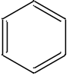Consider the following five compounds.
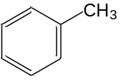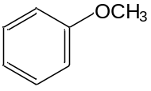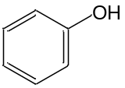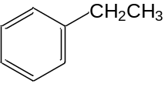 Phenol Anisole Benzene Toluene Ethylbenzene

The column used in the simulator has a non-polar C-18 stationary phase. The mobile phase consisting of water and acetonitrile is polar. The combination of non-polar stationary phase and polar mobile phase is known as reversed-phase liquid chromatography (RPLC). Discuss what analyte characteristics govern the order in which these compounds will elute and predict their retention order in an RPLC separation.

- Click on Manage Compounds. Click on the check marks to deselect all 5 default compounds. Click on the empty box beside the five compounds:
Phenol Anisole Benzene Toluene Ethylbenzene

Run the chromatogram (clicking on a compound name in the table will highlight its peak in the chromatogram) and see if your group had the correct retention order. If not, what modifications are necessary to the decisions you made in your prediction?

- Now predict the elution order of: benzene, benzyl alcohol, naphthalene, propylbenzene, p-xylene. Once you have your prediction, select these compounds from the Manage Compounds menu to see if you were right. If not, what modifications are necessary to the decisions you made in your prediction?

Mobile Phase Effects in Reversed-Phase LC with HPLC Simulator
In a reversed-phase chromatography, mobile phase strength decreases as the solvent becomes more polar. Mobile phase polarity is adjusted by mixing two (or more) miscible solvents; typically water and either acetonitrile or methanol. It is customary to call the aqueous solvent A and the organic solvent B. The polarity index (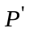) of the mixture is
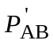= Φ_{A}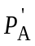+ Φ_{B}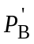
where Φ_{A} and Φ_{B} are the volume fraction of solvents A and B. The next few questions explore this behavior.

- Open HPLC Simulator at http://www.multidlc.org/hplcsim. Use Reset to ensure HPLC Simulator is under default conditions. Hint: the chromatogram can be simplified by opening Manage Compounds and deselecting compounds not being studied. Under Mobile Phase Composition, the Solvent B Fraction can be used to adjust the volume fraction of the mobile phase that is acetonitrile. Record the retention factor k for phenol and p-chlorophenol at 60%, 50%, 40%, 30%, 20% and 10% B. Complete the following table in which Δk_{phenol} = k_{phenol}(10%)/k_{phenol}(20%). The selectivity value (α) is k₂/k₁ where k₂ is the retention factor of the second eluting peak. After completing the table, graph the retention factor k versus %B for each of the two compounds.

%AcCN | k_{phenol} | k_{chlorophenol} | α | Δk_{phenol} | Δk_{chlorophenol}
10
20
30
40
50
60

- What happens to the retention factors as the percentage of organic modifier is raised? Explain why this observation is reasonable.

- Compare the α-values for the different mobile phases. Explain

- Approximately how much does retention increase for each 10% decrease in percent acetonitrile?

- Increase Solvent B Fraction to 95%. What is the retention time t_{R} for phenol? _____ min

Based on your graph in question 1, why is the retention time not 0?

Linear solvent strength model: The empirical linear-solvent-strength model supposes a logarithmic relationship between retention factor k for a given solute and the mobile phase composition Φ:
log k ≈ 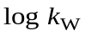 – SΦ
where log 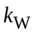 is the extrapolated retention factor for 100% aqueous eluent. This relationship has implications for both retention and resolution. The experimentally-determined values of and S for each compound are listed in the results table below the chromatogram.

- For the data in question 1, plot log k versus the Solvent B Fraction. Describe the plots you obtain.

- Now we want to examine the behavior for the compounds benzonitrile and p-chlorophenol. Either re-open HPLC Simulator at http://www.multidlc.org/hplcsim or use Reset to ensure HPLC Simulator is under default conditions. Under Mobile Phase Composition, the Solvent B Fraction can be used to adjust the volume fraction of the mobile phase that is acetonitrile. Complete the following table for benzonitrile and p-chlorophenol from 60% B to 10% B. (Note: you already have results for p-chlorophenol from question 1). Hint: the chromatogram can be simplified by opening Manage Compounds and deselecting compounds not being studied. Draw a graph of retention factor k versus %B for the two compounds.

%AcCN | k_{phenol} | k_{chlorophenol} | α | log k_{phenol} | log k_{chlorophenol}
10
20
30
40
50
60

- Draw a graph of log k versus % B solvent for the compounds in question 7. Compare this plot with your earlier plot for phenol and p-chlorophenol.

- From the experiments in questions above, what is the effect of mobile phase on the selectivity factor α for (1) phenol and p-chlorophenol and (2) benzonitrile and p-chlorophenol?

- Discuss what analyte characteristics might cause a change in elution order and hence α-values as the fraction of Solvent B is altered.

Type of Solvent B

Acetonitrile and methanol are both commonly used Solvent B in reversed-phase liquid chromatography, but each influences the separation slightly differently. The next few experiments will explore some of these similarities and differences.

- Either re-open HPLC Simulator at http://www.multidlc.org/hplcsim or use Reset to ensure HPLC Simulator is under default conditions. Under Compounds select: phenol; p-chlorophenol; benzene; and ethylbenzene. Under Mobile Phase Composition, the Solvent B can be toggled between Acetonitrile (default) and Methanol. With Solvent B as Acetonitrile, adjust Solvent B Fraction to find the %ACN for which each of the four compounds has a retention factor k of ~5.0. (Mobile phase percentage will be different for each compound.)
% acetonitrile at which phenol has k of ~5.0 = _________%
% acetonitrile at which p-chlorophenol has k of ~5.0 = _________%
% acetonitrile at which benzene has k of ~5.0 = _________%
% acetonitrile at which ethylbenzene has k of ~5.0 = _________%

- Change Solvent B to Methanol, and find the % methanol that yields a retention factor k of ~5.0 for each compound.
% methanol at which phenol has k of ~5.0 = _________%
% methanol at which p-chlorophenol has k of ~5.0 = _________%
% methanol at which benzene has k of ~5.0 = _________%
% methanol at which ethylbenzene has k of ~5.0 = _________%

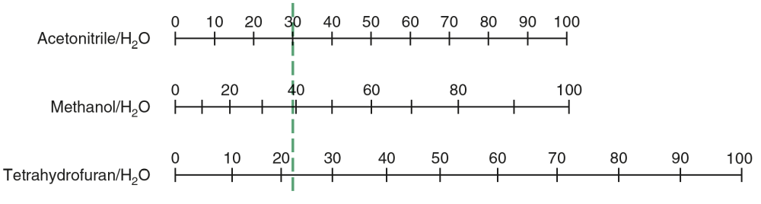
- The nomograph below shows the volume percentage of solvents having the same mobile phase strength. The dashed green line indicates that 30% acetonitrile/70% water has the same mobile phase strength as 40% methanol/60% water or 22% tetrahydrofuran/78% water.

Figure 25-31 from Harris and Lucy, Quantitative Chemical Analysis, 10th edition, (Macmillan, 2020). [Data from L. R. Snyder, J. J. Kirkland, and J. L. Glajch, Practical HPLC Method Development (New York: Wiley, 1997).]

What Methanol/H₂O percentage would be predicted for phenol; p-chlorophenol; benzene; and ethylbenzene based on the % acetonitrile found in question 2? How well do your results in step 2 agree with the nomograph?

Predicted % methanol for phenol = _________ %
Predicted % methanol for p-chlorophenol = _________ %
Predicted % methanol for benzene = _________ %
Predicted % methanol for ethylbenzene = _________ %

- Either re-open HPLC Simulator at http://www.multidlc.org/hplcsim or use Reset to ensure HPLC Simulator is under default conditions. Under Mobile Phase Composition, leave Solvent B as Acetonitrile and adjust Solvent B Fraction so that all 5 compounds are baseline resolved.
% acetonitrile that gives baseline resolution = ______% acetonitrile
What is the range of retention factor for this separation? ____–_____

- Using the nomograph in question 3, predict the percent methanol that would provide similar retention times to the acetonitrile mobile phase found in question 4.
% methanol that gives similar retention = _____% methanol
Perform the separation using this percent methanol. What is the range of retention factor for this separation? ____–_____

- Compare the acetonitrile separation in step 4 and the methanol separation in question 5. Discuss how the separations are similar, and how they differ. Which organic modifier would you select for performing the analysis? Justify your answer.

Van Deemter Behavior in Reversed-Phase LC with HPLC simulator

- Go to http://www.multidlc.org/hplcsim Open Column Properties and find Particle Size. Each group member should study a different particle size: 2.0, 3.0, and 5.0 μm particle sizes.
Adjust Flow Rate to create a van Deemter curve from 0.2 to 5 mL/min. H (plate height) and Plate number (N) are reported at the bottom of the Chromatographic Properties menu. Visually estimate the resolution between benzonitrile and p-chlorophenol separation by comparison with the figure below. Also note the Backpressure (at bottom of the Chromatographic Properties menu) and run time for each flow rate.
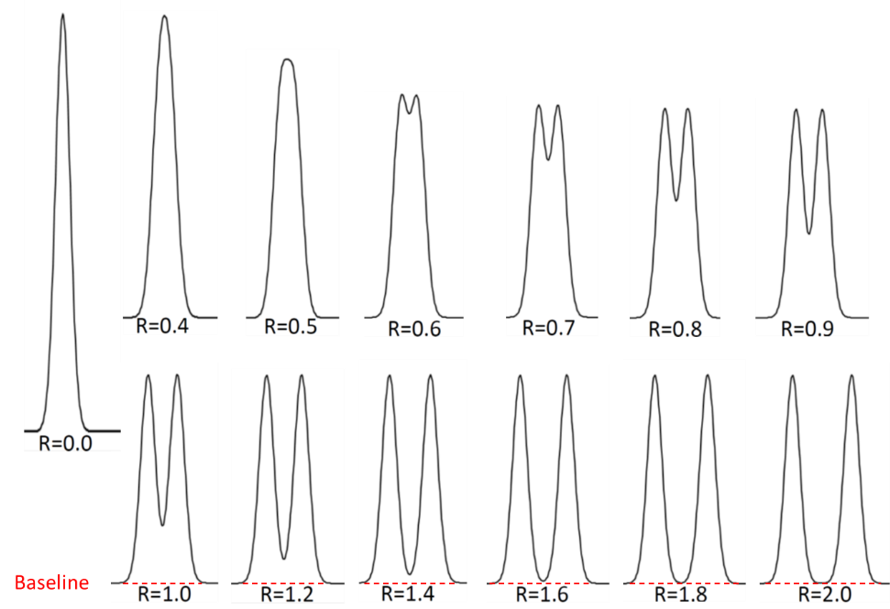
Particle size = d_{p} = ____ μm
Flow rate  (mL/min) | Velocity  (cm/s) | N (unitless) | H (cm) | Pressure  (bar) | Run time  (min) | Approx. resolution
0.2
0.5
1.0
2.0
3.0
4.0
5.0

Resolution between two peaks of same size. Generated by C. A. Lucy, University of Alberta.

- Prepare van Deemter curves for the three different particle sizes studied by plotting H versus flow rate.

- What is the effect of particle size on the B and C terms in the van Deemter equation?

- Which particle size would allow you to perform faster analyses? Explain your answer.

- What is the effect of increasing flow rate (linear velocity) on the observed back pressure in question 1? Explain why this effect occurs.

- What is the effect of decreasing particle size on back pressure in question 1? Explain why this effect occurs.

- HPLC instruments typically have a pressure limit of 400 bar. What is the maximum flow rate that could be run on the 100 × 4.6 mm column packed with 2.0 μm particles?
Maximum flow rate = ________ mL/min
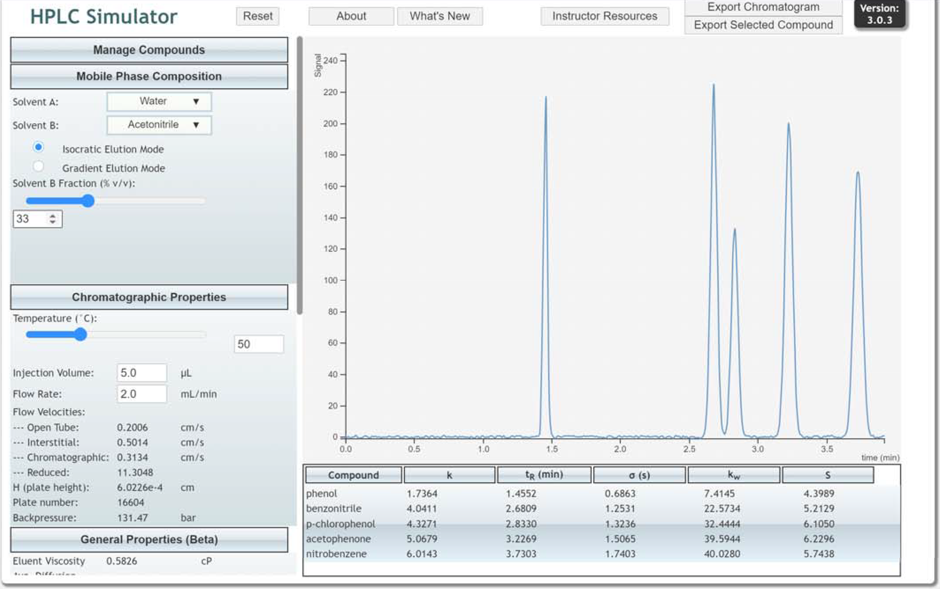
- Use Reset to revert HPLC Simulator to default conditions. Under Mobile Phase Composition, change Solvent B Fraction to 33% and under Chromatographic Properties adjust temperature to 50°C. Benzonitrile and p-chlorophenol should be baseline resolved as shown below.

- Keeping pressure below ~20 MPa (200 bar) for HPLC and ~60 MPa (600 bar) for UHPLC prolongs the life of the pump, valves, seals, and autosampler. Pressure increases during the life of a column because of progressive clogging of the inlet frit. Establishing an operating pressure of ≤200 bar or ≤600 bar during method development allows for column degradation. The optimum flow rate (flow rate which gives smallest H) for each particle size can be determined from your graphs in question 2 (2 μm = 2.7 mL/min 3 μm = 1.8 mL/min, 5 μm = 1.1 mL/min), determine what is the longest column that could be used with that particle size and still have a pressure ≤200 bar. Note the run time and observe the resolution for the critical (i.e., least resolved) pair of peaks for each particle diameter and optimum flow rate and length. Use the figure in question 1 to estimate the resolution.

    - What effect does particle size have on optimal flow rate and plate height?

    - What effect does particle size have on the maximum column length and run time at the optimal flow rate for a given maximum pressure?

    - What effect does particle size have on the maximum plate number and resolution achievable for a given maximum pressure? Are there any tradeoffs associated with having a higher plate number?

Extra-column broadening using HPLC Simulator
The van Deemter equation describes broadening that occurs within the column. Broadening may also occur outside the column, due to the injector, connecting tubing, detector flow cell, and electronics.
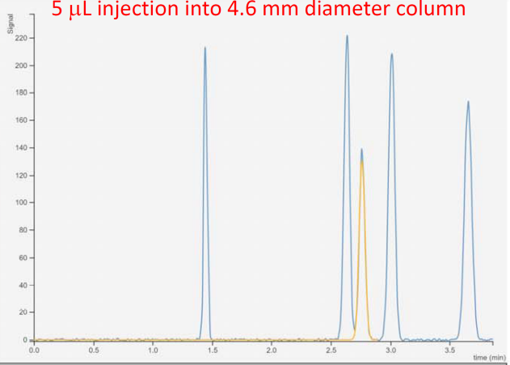
- Go to http://www.multidlc.org/hplcsim or use Reset to ensure HPLC Simulator is under default conditions. Under Mobile Phase Composition, change Solvent B Fraction to 36% so that benzonitrile and p-chlorophenol are near baseline resolved. Your chromatogram should appear as below.

- Under Chromatographic Properties, note the Injection Volume. From the chromatogram record the height of the nitrobenzene peak. Also visually estimate the resolution of the critical pair of peaks by comparison with the figure in the Van Deemter exercise (no calculation needed).
Injection volume = ____ ____μL
Height of nitrobenzene peak = ________
Minimum resolution = ______

- Change the Injection Volume to 20 μL and then to 100 μL. What effect does changing the injection volume have on the height of the nitrobenzene peak and resolution between the critical pair of peaks?
Injection volume Height (benzonitrile) Critical resolution (estimate)
5
20
100

- Narrower diameter columns are often used to reduce solvent consumption. This can have consequences for extra-column broadening. Set Injection volume to 5.0 μL. Under Chromatographic Properties, note the Flow Rate and Flow velocity (chromatographic). Under Column Properties note the column Inner diameter. Finally from the chromatogram, note the run time.
Flow rate = _______ mL/min
Flow velocity (chromatographic) = ________ cm/s
Inner diameter = ________ mm
Run time = ________ min

- If the Inner diameter is reduced to 2.3 mm, while keeping the linear velocity constant, predict what will happen to retention times, retention factors, band broadening and resolution.

- Under the Column Properties menu, adjust the Inner Diameter to 2.3 mm. What Flow Rate setting (in Chromatographic Properties) is needed to match the Flow velocity (chromatographic) in question 4?
Flow rate = ________ mL/min
- Does the chromatogram match your prediction in question 5? If not, revisit your discussion in question 5.

- What is the mathematical relationship between flow rate and column inner diameter? Hint: comparing the ratio of the flow rates to the ratio of the column inner diameters will help in determining the mathematical relationship.

- Calculate the volume of mobile phase used for the separation on the 4.6 mm and 2.3 mm inner diameter columns. Which of these volumes is preferable?

- For the 2.3 mm column, change Injection Volume from 5.0 μL to 20 and 100 μL. What effect does changing injection volume have on the height of the nitrobenzene peak and resolution between the critical pair of peaks?
Injection volume Height (benzonitrile) Critical resolution (estimate)
5
20
100
Compare the impact of increasing the injection volume on resolution to what you observed previously on the 4.6 mm column in question 3. Justify any differences in the observations between the two columns.

Isocratic Method Development in Reversed Phase LC using HPLC Simulator
This exercise introduces you to the steps involved with developing an isocratic reversed-phase liquid chromatography method. First, we work through the terms in the Purnell equation to achieve adequate resolution.
Purnell equation: Resolution = 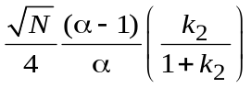
If the method is to be run many times, we may investigate whether the method can be performed faster and with less mobile phase consumption.

- Go to http://www.multidlc.org/hplcsim or use Reset to ensure HPLC Simulator is under default conditions. The default conditions reflect typical settings for an HPLC separation. Record the following settings:
Column type: ___________________
Column dimensions (length × diameter, mm): _____×_____ mm
Particle size: _______ μm
Solvent B: ________________
Column temperature: _____ °C
Injection volume: ______ μL
Flow rate: ______ mL/min
Justify why each of these conditions is a good place to start.

- The next step is to adjust retention so that all compounds have 0.5 ≤ k ≤ 20. Explain why k < 0.5 is undesirable. Why is k > 20 undesirable? Hint: Consider the Purnell equation for resolution.

- What variable should be adjusted to control retention?

4) Adjust the Solvent B Fraction (under Mobile Phase Composition) of acetonitrile to achieve retention of 0.5 ≤ k ≤ 20 for all compounds. Note the minimum and maximum percent acetonitrile that elutes all compounds within this range. Record the separation time.
Weakest mobile phase: _____ % acetonitrile, _____ ≤ k ≤ ____, run time = _____ min
Strongest mobile phase: ____% acetonitrile, ____ ≤ k ≤ ____, run time = _____ min

5) Your method development probably started with a column either already installed in the HPLC or with one that you found in the lab. Either way you don’t know if the column is still in good condition. Before you invest too much time in developing your method, you want to ensure your column is working well. Plate number (near optimum flow rate) is predicted by:
N ≈ 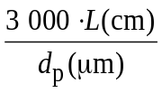
Check your plate number using this equation. Is your column providing the plate number that it should?

6) What other characteristics of the chromatogram might you consider when deciding the column is good?

- Now that the N and k terms of the Purnell equation have been optimized, the last term to optimize is the separation factor (α). Suggest four variables that could be adjusted to change the separation factor. Rank these in terms of their power and convenience.

- Separation factor (α) can be adjusted by fine-tuning the mobile phase composition (%B). Explain whether this would work better with for a mixture of compounds with the same functional group or a mixture of compounds with different functional groups.

- 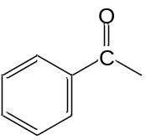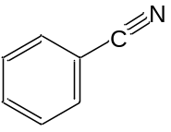In the Mobile Phase exercise, the separation factor (α) between p-chlorophenol and benzonitrile changed as the Solvent Fraction B was changed. Predict whether the separation factor (α) between benzonitrile and acetophenone will change with % acetonitrile.
Benzonitrile Acetophenone

- Adjust Solvent Fraction B to test your prediction. Does behavior match your prediction in question 9? If not, revisit your discussion in question 9.

11) Fine-tune Solvent B Fraction to optimize the separation factor (i.e., optimize the resolution). Within the acetonitrile range determined in question 4, what % acetonitrile yield baseline separation of all compounds?
___________% acetonitrile

12) Using a percent acetonitrile within the range found in question 11, adjust temperature between 25 and 60°C. What effect does temperature have on retention and the separation between the peaks?

13) Changing organic solvent can change the separation factor and thereby alter the separation. Using 40°C, compare the separation using an optimized percent acetonitrile found in question 11 and a comparable percent methanol predicted using the nomograph in the Type of Solvent B exercise.
Retention: _______ % acetonitrile ≈ _____ methanol
Resolution between peaks?________________

14) If a method is to be run many times, the separation time should be minimized. Using 40°C and the optimum percent methanol from question 13, adjust the column length to determine the length that provides adequate resolution (e.g., resolution ≥ 2 between all compounds) in the minimum amount of time. Typical commercially available lengths include 50, 75, 100, 150, and 250 mm.
Length that gives adequate resolution in shortest time = ______ mm

Gradient Elution Reversed-Phase LC using HPLC Simulator

- Go to http://www.multidlc.org/hplcsim or use Reset to ensure HPLC Simulator is under default conditions. Under Manage Compounds deselect nitrobenzene and acetophenone, and add benzene, toluene, and ethylbenzene. Within Mobile Phase Composition, using Isocratic Elution Mode adjust Solvent B Fraction to 43% (selected to give 0.5 ≤ k ≤ 20). Record the retention time and peak width (as standard deviation σ) of the first and last peaks.
First peak: compound = _______________; t_{R} = ______ min; σ = ________ s

Last peak: compound = _______________; t_{R} = ______ min, σ = ________ s

- Within the Mobile Phase Composition menu, click on the radio button for Gradient Elution Mode. Record the retention time and peak width (as standard deviation σ) of the first and last peaks for the gradient running from 5%B to 95%B over 5 minutes.

First peak: compound = _______________; t_{R} = ______ min; σ = ________ s

Last peak: compound = _______________; t_{R} = ______ min; σ = ________ s

- For gradient elution, the average retention factor k* for each solute is the value of k when that solute is halfway through the column:
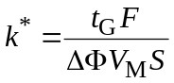
where t_{G} is gradient time (min), F is flow rate (mL/min), ΔΦ is the change in solvent composition during the gradient, V_{M} is the volume of mobile phase in the column (mL), and S is the slope in the linear-solvent-strength model. Analogous to the resolution equation for isocratic separations, resolution in gradient separations is proportional to k*/(1+k*). The table under the Gradient Elution Mode radio button states the percent acetonitrile at the start of the gradient (5% B at 0 min). The %B increases linearly until reaching the maximum % acetonitrile (95%) at the gradient end time (5 min). Increase gradient end time to 10 min. What effect did this change have on resolution?

Under Chromatographic Properties adjust flow rate to 1.0 mL/min. What effect did this change have on resolution?

- Explain the observed behavior in step 3.

- Reversed-phase LC method development often starts with a scouting gradient which is a broad gradient (e.g., 5 to 95% acetonitrile) over a long gradient time (e.g. 40 min). With a flow rate F of 1.0 mL/min adjust the final gradient time t_{G} to 40 min. Determine the retention time difference (Δt) between the first and last peak in the chromatogram. Retention time of final peak = __________ min
Retention time of first peak = _________ min
Δt = __________ min

- The criterion to choose whether to use a gradient is
Use a gradient if Δt/t_{G} > 0.40
Use isocratic elution if Δt/t_{G} < 0.25
Should gradient or isocratic elution be used for this sample?

- A gradient method can be improved by using a shallower gradient (i.e., a smaller change in percent acetonitrile over the gradient). A guide to the initial %B is the percent acetonitrile at the retention time of the first peak. A guide to the final %B of the shallower gradient is the percent acetonitrile at the retention time of the last peak. Determine initial %B and final %B to try based on your scouting gradient in step 5.

- Perform a 40 min gradient with the initial and final %B determined in step 7.

- If resolution is greater than baseline separation in step 8, so some resolution could be sacrificed to obtain a quicker separation. Adjust the gradient time to half the k*. Show the resultant separation.

- A touch of reality. The last peak in your chromatogram in step 9 should have eluting just before the end of the gradient. What would happen if the peak didn’t fully elute before the end of the gradient? Reduce the gradient time t_{G} until something weird happens to the chromatogram. What is the cause of the artifact in chromatogram? Hint: k_{e} in the results table under the chromatogram is the retention factor of each component when it is eluted from the column.

