GC Simulator Virtual lab Activity
Developed at Universidad Nacional Autónoma de Honduras. Part of materials discussed in R. M. Valle-Suárez, G. L. Calderón-Mendoza, N. A. Lanza-Sorto, and H. D. Ponce-Rodríguez, “Teaching Instrumental Analytical Chemistry in the Framework of COVID-19,” J. Chem. Ed. 2020, in press, DOI: 10.1021/acs.jchemed.0c00707
Gas Chromatography (GC) is a powerful mode of chromatography used in a wide variety of applications. It is fast, simple, sensitive, and generally requires only a small of sample for analysis. Gas chromatography can be used for the separation of volatile and semi-volatile organic compounds.
The critical parameters for good GC separations are the column and stationary phase, the carrier gas flow rate, and the temperature or temperature program. However, unlike liquid chromatography, in GC, the mobile phase is only a carrier gas that acts primarily as a transport medium. There are almost no selective interactions between the analytes and the carrier gas, or between carrier gas and the stationary phase. Therefore, in GC, the choice of the sorbent is a critical stage. GC simulator will show you the application of GC chromatography for the analysis of a complex mixture of different types of pesticides, simulating the operations that you need to do with the instrument.
Introduction to GC simulator:
- Go to https://www.restek.com/restekuser2/login (Open Pro EZGC® Chromatogram Modeler). In the first instance, you must register on the website. Then, you must open the resource "Pro EZGC® Chromatogram Modeler," where the following screen will appear:
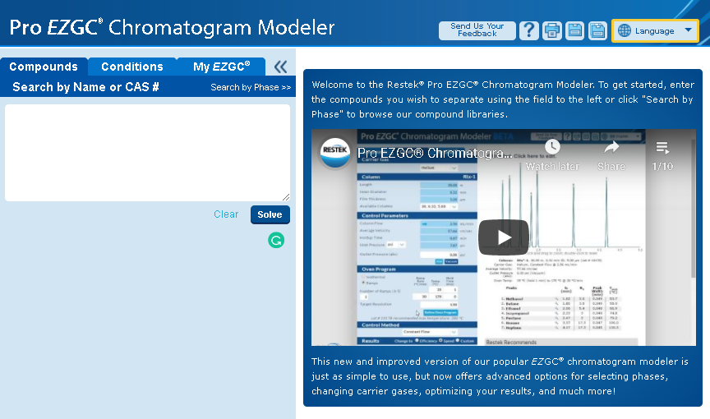
- Initially, you will write the compounds that were previously assigned to you. Once you have entered all compounds, press the "Solve" button. As an example, we consider the following nine compounds:
DDT; DDD; DDE; Methoxychlor; Dieldrin; Aldrin; Mirex; Kepone; Lindane; Benzene hexachloride
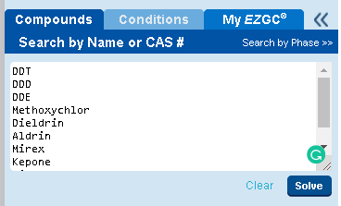
HINT:
You can introduce the CAS number of the compound to facilitate the search in the database.

A. Fundamentals in GC chromatography
- A screen with the recommended stationary phases for these compounds will appear. You can choose one of those that manage to separate all or the most significant number of the compounds. Once selected, press the "Conditions" button.
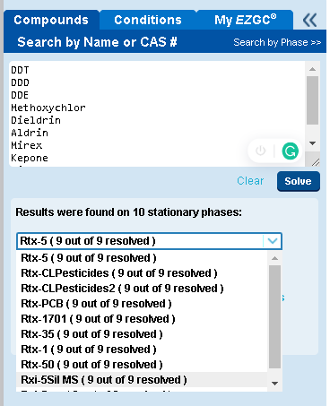
Task 1:
Using your knowledge of the polarities of the stationary phases used in GC, order the stationary phases that appear as options in the simulator in decreasing order of polarity.

Task 2:
What characteristics of the compounds do you consider to be most influential in GC: polarity or volatility? Explain your answer.

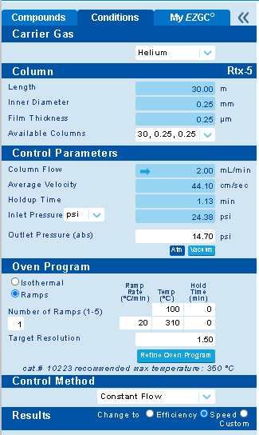
- The “Conditions” menu will appear. In it, you must modify the “Carrier gas” and “Results” conditions that were previously provided to you.
Task 3:
What does theory state about the use of helium, hydrogen, and nitrogen as carrier gases in GC?

Task 4:
What types of GC detectors do you consider suitable for the study of these compounds? Explain your answer.

B. Optimization of the chromatographic separation and Resolution calculation
- Next, you will modify the conditions of the "Oven Program" to successfully separate all the compounds with acceptable efficiency and in the shortest possible time. To do this, you must carry out temperature ramps, modifying the "ramp rate," "temperature," and "hold time." Every time you modify these conditions, the chromatogram will change. Likewise, in the table below the chromatogram, you should observe that the Resolution values (Rs) will be modified. Remember that Rs values must be ​​greater than 1.5 for baseline separation. If the resolution between two peaks is less than 1.5, it will turn red in the table.

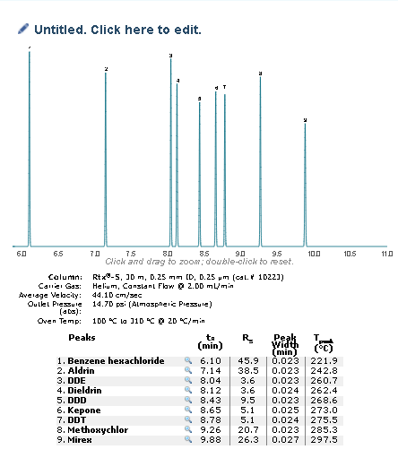
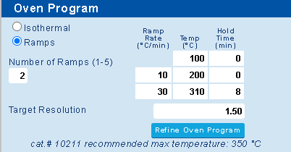
Task 5:
Using the data collected in the table and applying the chromatographic resolution formula, confirm that the resolution values ​​provided are correct.
Hint: You can use the spreadsheet used in the HPLC simulator activity.
- Once you find the best separation of the assigned compounds, you should modify the chromatogram's name and press the "OK" button. Finally, you must save the chromatogram in PDF format. For this, press the "Print" button, a window will open, and you must keep the file with the correct name.
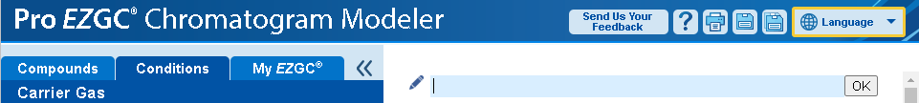
C. Study of the effects of column dimensions on resolution
- Task 6: Length. Using the separation conditions optimized in the previous step, you will proceed to evaluate the effect of column length on efficiency and resolution. For this, it is necessary to exchange the available columns following the specifications in the following table:

Column dimensions  Length (m);  Inner Diameter (mm);  Film Thickness(µm) | Resolution values |  |  |  |  |  |  |  | Total analysis time (min)
 | Analyte 1 | Analyte 2 | Analyte 3 | Analyte 4 | Analyte 5 | Analyte 6 | Analyte 7 | Analyte 8 | Total analysis time (min)
15 / 0.25 / 0.1
30 / 0.25 / 0.1
60 / 0.25 / 0.1

What happens to the resolution as the column length increases? Explain why this behavior occurs?

What happens to the analysis time as the column length increases? Explain why this behavior occurs?

- Task 7: Inner Diameter. Using the separation conditions optimized in step number 6, you will proceed to evaluate the effect of column inner diameter on efficiency and resolution. For this, it is necessary to exchange the available columns following the specifications in the following table:

Column dimensions  Length (m);  Inner Diameter (mm);  Film Thickness(µm) | Resolution values |  |  |  |  |  |  |  | Total analysis time (min)
 | Analyte 1 | Analyte 2 | Analyte 3 | Analyte 4 | Analyte 5 | Analyte 6 | Analyte 7 | Analyte 8 | Total analysis time (min)
60 / 0.32 / 1.0
60 / 0.53 / 1.0

What happens to the resolution as the column inner diameter increases? Explain why this behavior occurs?

What happens to the analysis time as the column inner diameter increases? Explain why this behavior occurs?

- Task 8: Film thickness. Using the separation conditions optimized in step number 6, you will proceed to evaluate the effect of column film thickness on efficiency and resolution. For this, it is necessary to exchange the available columns following the specifications in the following table:

Column dimensions  Length (m);  Inner Diameter (mm);  Film Thickness(µm) | Resolution values |  |  |  |  |  |  |  | Total analysis time (min)
 | Analyte 1 | Analyte 2 | Analyte 3 | Analyte 4 | Analyte 5 | Analyte 6 | Analyte 7 | Analyte 8 | Total analysis time (min)
60 / 0.53 / 0.25
60 / 0.53 / 1.5
60 / 0.53 / 5.0

What happens to the resolution as the column film thickness increases? Explain why this behavior occurs?

What happens to the analysis time as the column film thickness increases? Explain why this behavior occurs?

D. Study of the effect of the gas carrier on resolution
- Task 9: Carrier gas. Using the separation conditions optimized in step number 6, you will proceed to evaluate the effect of different carrier gas on efficiency and resolution. For this, it is necessary to exchange the carrier gas following the specifications in the following table:

Carrier gas | Resolution values |  |  |  |  |  |  |  | Total analysis time (min)
Carrier gas | Analyte 1 | Analyte 2 | Analyte 3 | Analyte 4 | Analyte 5 | Analyte 6 | Analyte 7 | Analyte 8 | Total analysis time (min)
Helium
Hydrogen
Nitrogen

What is the behavior of the resolution of the analytes as a function of the carrier gas? Explain why this behavior occurs. Hint: You can use what you learned in task 3.

What is the behavior of the analysis time as a function of the carrier gas? Explain why this behavior occurs. Hint: You can use what you learned in task 3.

Did the order of elution of the analytes change when using different carrier gas? How is this explained? Hint: You can use what you learned in task 2.

