Virtual-lab Activity with GC Simulator
A collaborative learning activity using the on-line free Pro EZGC® Chromatogram Modeler (https://www.restek.com/restekuser2/login) developed by Restek Corporation.
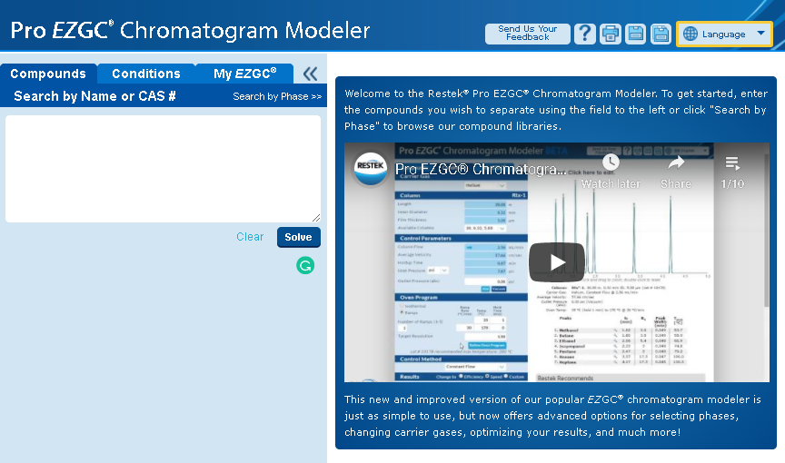

The Gas chromatography separation activities explore commercial column selection for GC analysis and simulates the typical conditions that must be optimized in GC analysis using organochlorine and organophosphorus pesticides as model molecules. The students evaluate different parameters that can be modeled, as the effects of column length (L), internal diameter (d_{col}), film thickness (d_{f}), carrier gas, flow rate (F), and temperature program (up to 5 ramps).

The activity is intended for use as a virtual lab by students working in reduced groups (4 students) under the pandemic Covid-19 framework. An instructor’s manual detailing the background of the simulator and the course for which this activity was developed is provided as well.

Finally, a solution manual (for instructors only) is available upon request. It provides solutions, typical mistakes, additional background comments, tips for how to use the in-class exercises, and prompts that the instructor can use to encourage further discussion.

Developed by:
Análisis Químico Research Group
Facultad de Ciencias Químicas y Farmacia
Universidad Nacional Autónoma de Honduras
henry.ponce@unah.edu.hn

