Analysis of pharmaceutical compounds by CZE
Developed by Davy Guillarme and Jean-Luc Veuthey, University of Geneva.
Translated by Charles Lucy, University of Alberta.

Introduction
Capillary zone electrophoresis (CZE) is an inexpensive technique that requires low consumption of solvents and can be used for quality control in hospitals. This technique has, for example, replaced liquid chromatography at the Geneva University Hospitals for the separation of adrenaline and isoprenaline [1].
The goal of this practical work is to become familiar with the fundamental principles of "CZE" mode capillary electrophoresis and to apply these principles to the identification of an unknown active pharmaceutical ingredient. This lab is divided into two independent parts:

- The first part uses simulation software (PeakMaster). In this part, the fundamentals of CZE are introduced and the influence of the parameters specific to CZE (pH of the buffer solution, applied voltage, and injection) on the separation of a mixture of four model compounds is evaluated.
- The second part is practical and takes place in the laboratory. The objective of this section is to learn about the Agilent 3D-CE capillary electrophoresis instrument which is typically used in hospital settings, and to understand the mechanisms governing the separation of compounds by the analysis of simple mixtures.
[1] S. Fleury-Souverain, S. Nussbaumer, J. Schappler, P. Bonnabry, J.L. Veuthey, Interest of capillary electrophoresis for the quality control of pharmaceutical formulations produced in hospital pharmacy, Eur J. Hosp. Pharm-S. P. 17(4) (2011) 32-3

2. Fundamental Principles in CZE
The objective is to understand the mechanisms and parameters governing electrophoretic migration through simulations and calculations. No practical manipulation is to be carried out in this first part (except for use of the PeakMaster software).

2.1 Electroosmotic flow (EOF)
The analysis is carried out using a capillary of 64.5 cm in total length (L_{tot}), 56 cm in effective length (L_{eff}, length from injection to detector) and 50 µm inner diameter. A 5% (v / v) acetone solution is injected into each of the buffers below, and separation takes place using an applied voltage of + 30kV.
Under each of the following conditions, a peak is detected at the migration time indicated:
- 67 mM phosphate buffer with 46 mM NaOH: 28.3 min
- 123 mM acetate buffer with 50 mM NaOH 50 mM : 15.7 min
- 105 mM MES with 50 mM NaOH: 6.78 min
- 70 mM MOPS with 50 mM NaOH: 4.06 min
- 75 mM CHES with 50 mM NaOH: 3.21 min

For each of the buffers used:
- Estimate the pH using PeakMaster
- Using the appropriate equations, calculate the electroosmotic flow mobility (in m²·V⁻¹·s⁻¹)
- Plot EOF mobility as a function of pH, and describe the curve obtained.
- Briefly explain the observed phenomenon. What is the role of acetone?
2.2 pH Effect
A mixture of the 4 compounds is injected into each of the buffers under the same experimental conditions as in Section 2.1. Use the electroosmotic flow mobility, calculated in the first exercise.
For each of the buffers used in Section 2.1:
- Estimate the migration time t_{m} (min) of procaine, bupivacaine, aspirin, and salicylic acid using PeakMaster

Buffer |  | Phosphate | Acetate | MES | MOPS | CHES
pH
Migration times (min) … | Procaine
Migration times (min) … | Bupivacaine
Migration times (min) … | Aspirin
Migration times (min) … | Salicylic acid

How does the migration time vary depending on the pH?
Explain the influence of pH on the migration of compounds in CZE.

2.3 Effect of Voltage
Using the MES buffer, vary the applied voltage from +10 kV to +30 kV.
For each of the applied voltages:
- calculate the electric field E (V/m) using the appropriate equations
- estimate the migration time of the electroosmotic flow using PeakMaster
- calculate the flow generated by the electroosmotic flow.

Voltage in kV | +10 | +20 | +30
Electric field (V/m)
Migration time of EOF marker (min)
Flow generated (nL/min)

What is the effect of the applied voltage on the:
- migration time?
- peak efficiency?
Suggest an explanation of the observed behavior using the appropriate mathematical equations.
What other physical property is also influenced by voltageth? How does it vary depending on the applied voltage?

2.4 Effect of capillary dimensions
Use the MES buffer and an applied voltage of +30 kVF. Use total capillary lengths (L_{tot}) from 32.5 to 86.5 cm.
For each of the total capillary lengths studied:
- given that the distance between the outlet of the capillary and the UV detector is fixed, calculate the effective length of the capillary
- calculate the electric field E using the appropriate equation
- determine the migration time (min) of each of the pharmaceutical compounds PeakMaster.
Total capillary length (cm) |  | 32.5 | 64.5 | 86.5
Effective length (cm)
Electric field (V/m)
Migration times (min) … | Procaine
Migration times (min) … | Bupivacaine
Migration times (min) … | Aspirin
Migration times (min) … | Salicylic acid

What is the effect of the effective length and/or the total length on the:
- migration times?
- peak efficiencies?
- resolution?
- current ?

Analysis of pharmaceutical compounds by CZE

This practical part of this experiment is performed in the lab using an Agilent 3D-CE instrument.
Two separations will have to be developed, namely the separation of 3 local anesthetics (lidocaine, procaine and bupivacaine), as well as the separation of the constituents of a pharmaceutical formulation, Vascord® containing amlodipine, hydrochlorothiazide and olmesartan.

Precautions for using the capillary
The capillaries used in this lab must first be cut, and then a detection window is created using a burner. The alignment interface that contains the capillary is finally inserted into the CE cassette. Any new capillary must be conditioned using the procedure indicated in the user manual (paragraph 5).

It is essential to use Millipore type ultra pure water for the rinsing steps and the preparation of the solutions.

3.1 Development of the separation of the mixture of local anesthetics

The aim of this part of the work is to develop a separation of three local anesthetics by CZE.
In a first step, stock solutions of lidocaine, procaine and bupivacaine at approximately 1 mg/mL in MeOH (a volume of 10 mL is sufficient) should be prepared using the available glassware (pasteur pipettes and volumetric flasks). From these stock solutions, a 25 mL solution containing 40 µg/mL each of the three local anesthetics should be prepared using Millipore water.

A 1-mL polypropylene vial will be approximately 2/3 full with this diluted solution for analysis. The analysis will use the following conditions:

Capillary: Type TSP (polyimide), total length (L_{tot}) 64.5 cm, effective length (L_{eff}) 56 cm, inner diameter 50 µm
Injection: hydrodynamic, 50 mbar for 10 s (1% of the capillary, i.e. 12 nL)
Voltage: + 30 kV
Analysis time: 10 min
Detector: 200 nm

Creation of the analysis method is carried out using the instructions for use of the capillary electrophoresis instrument.

Based on the physico-chemical properties of the three local anesthetics to be analyzed (see www.chemicalize.org), the most suitable separation buffer (BackGround Electrolyte or BGE) among the following choices must be selected:

- 50 mM phosphate buffer pH 2.5 (use phosphoric acid and adjust pH with a pH meter using 1 M NaOH)
- 50 mM borate buffer pH 10 (use boric acid and adjust pH with a pH meter using 1 M NaOH)
- 50 mM phosphate buffer pH 12 (use phosphoric acid and adjust pH with a pH meter using 1 M NaOH)

The choice of BGE should be discussed in the report. Next prepare 100 mL of the BGE that seems most appropriate to you (a discussion with the teaching assistant is welcome at this stage). Finally, perform the analysis in duplicate on the CZE system available in the laboratory under the chosen conditions and copy the best of the 2 electropherograms obtained in the report.

3.2 Development of the separation of the constituents of the pharmaceutical formulation VASCORD®

The aim of this part of the experiment is to develop a method for the separation of the constituents of the pharmaceutical formulation VASCORD®, which nominally contains 10 mg of amlodipine, 25 mg of hydrochlorothiazide and 40 mg of olmesartan. The combination of the three active ingredients contained in this formulation aim to control high blood pressure (hypertension).
In a first step, one tablet of Vascord HCT 40/10/25 mg® will be crushed in a mortar, using a pestle. The crushed tablet will then be transferred to a 10 mL volumetric flask. The flask is then brought to volume with methanol and placed in an ultrasonic bath for approximately 15 minutes, to completely dissolve the active ingredients. As some of the excipients are not soluble in methanol, the solution obtained will need to be filtered using a 0.45 µm syringe filter in order to be used as a stock solution. This stock solution will then be diluted with Millipore water to obtain an aqueous solution of 10 mL in which the three active ingredients are at the following concentrations (amlodipine: 100 µg/mL, hydrochlorothiazide 250 µg/mL and olmesartan 400 µg/mL).

Fill a CZE vial 2/3 full with this solution. The analysis will take place under the following conditions:

Capillary: Type TSP (polyimide), total length (L_{tot}) 32.5 cm, effective length (L_{eff}) 24 cm, inner diameter 50 µm
Injection: hydrodynamic, 50 mbar for 3 s (1.1% of the capillary, i.e., 7 nL)
Voltage: + 20 kV
Analysis: 4 min
Detector: 200 nm

Creation of the analysis method is carried out using the instructions for use of the capillary electrophoresis instrument.

Based on the physico-chemical properties of the three active ingredients contained in the formulation to be analyzed (see www.chemicalize.org), the most suitable separation buffer (BackGround Electrolyte or BGE) among the following choices must be selected:

- 25 mM phosphate buffer pH 2.5 (use phosphoric acid and adjust pH with a pH meter using 1 M NaOH)
- 25 mM phosphate buffer pH 7.3 (use phosphoric acid and adjust pH with a pH meter using 1 M NaOH)
- 25 mM phosphate buffer pH 12 (use phosphoric acid and adjust pH with a pH meter using 1 M NaOH)

The choice of BGE should be discussed in the report. Then prepare 100 mL of the BGE that seems most appropriate to you (a discussion with the teaching assistant is welcome at this step).
Finally, perform the analysis in duplicate on the CZE system available in the laboratory under the conditions chosen and copy the best of the 2 electropherograms obtained in the report.

In order to more easily identify the peaks observed on the electropherogram, a 10% aqueous acetone solution should also be injected under the same conditions. This solution can be used by the 3 groups. It should also be noted that a fairly intense peak with a longer migration time than the 3 active ingredients will be systematically observed during the injection of the CZE formulation.
This latter peak corresponds to a UV-active excipient, and should therefore not be considered when identifying the peaks in the electropherogram.

Procedure for using PeakMaster 5.3 software
4.1 Experimental Parameters
To carry out a simulation, it is necessary to set the following parameters:
- Total length of the capillary
- Effective length of the capillary (i.e., length between injection and detector)
- Applied voltage and polarity of voltage
- To set the EOF mobility, for “EOF”, use the pulldown menu that appears to change “No EOF” to “Mobility”. A line with “EOF mobility” appears below the “EOF” line, allowing entry of a numerical value for the EOF mobility. Note, the units of mobility are 10⁻⁹ m²V⁻¹s⁻¹.

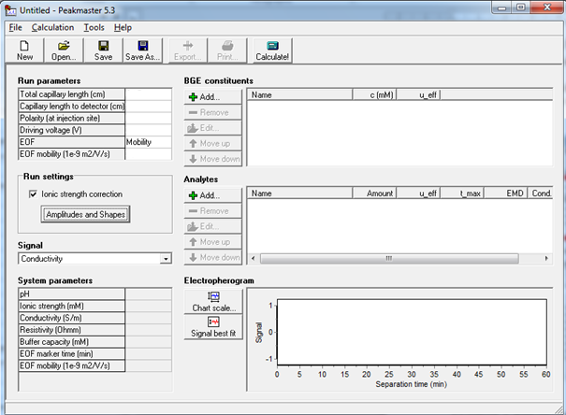

4.2 Addition of Background Electrolyte (BGE)
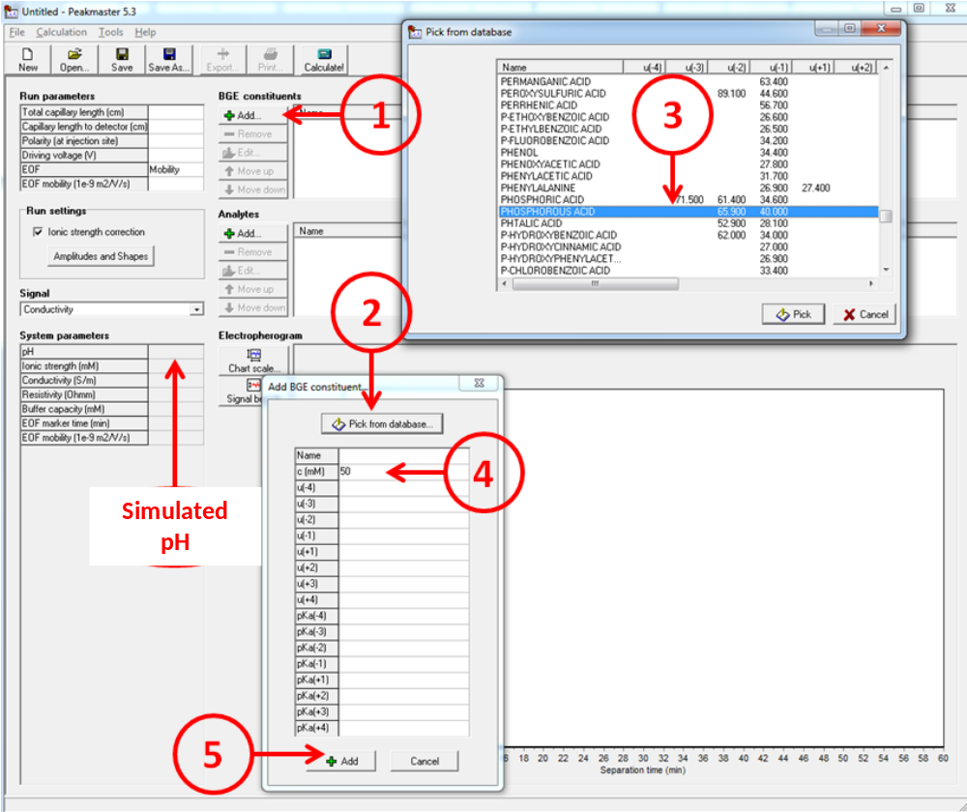

First insert the buffer species (step 1 to 5). For the CHES buffer, if it does not appear in the list, then you must type "CHES" to find it.
To adjust the pH, insert the counter-ion in the same way (e.g. sodium hydroxide). To add sodium hydroxide, choose "sodium" which in the database. Adjust its concentration to obtain the desired pH.

  - Addition of Analytes
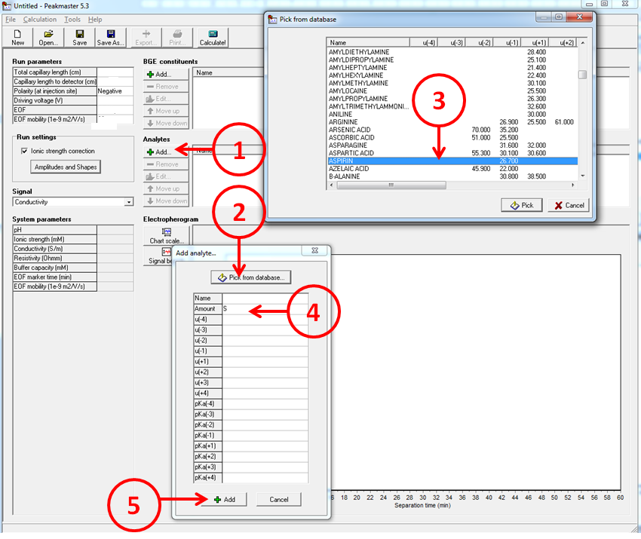

For each analyte, repeat steps 1 to 5.
In the “Amount” box, choose S (i.e., small) using the pulldown menu that appears.

  - Simulation

