

Molar Mass Determination by Freezing Point Depression
HIGH SCHOOL
Green Chemistry & Sustainable Science

Teacher Background:
This experiment involves the determination of the freezing point of a pure solvent and a solution of an unknown organic substance dissolved in the solvent. The molar mass of the unknown is calculated based on the freezing point depression of the solution. Organic solvents are typically used in this experiment, such as ethylene glycol, 2-methyl-2-propanol or cyclohexane. Unknowns are used, such as naphthalene, p-nitrotoluene, or a similar halogenated aromatic compound. The organic solvents have high flammability and many of the unknowns have high human health hazards associated with them.

The greener version of the colligative properties laboratory exercise uses fatty acids to measure the freezing point depression of a fatty acid as an unknown is added. This experiment is adapted from a Journal of Chemical Education article describing a laboratory experiment for the undergraduate chemistry course (McCarthy, S. M., and Gordon-Wylie, S. W., “A Greener Approach for Measuring Colligative Properties”, J. Chem. Ed., 82 (1), 2005, 116-119).

Materials:
- 18 x 150 mm test tube
- 25 x 150 mm test tube
- paper towel
- thermometer
- 9 grams stearic acid
- 2 grams of unknown (myristic, palmitic or lauric acid)
- 600 mL beaker
- Test tube stand

Student Objectives: Students will…
- Define colligative properties
- Calculate freezing point
- Determine molecular weight of unknown substances

Time: 1 x 80 min class

Standards: NGSS
HS-PS1-5. Apply scientific principles and evidence to provide an explanation about the effects of changing the temperature or concentration of the reacting particles on the rate at which a reaction occurs.
HS-PS3-4. Plan and conduct an investigation to provide evidence that the transfer of thermal energy when two components of different temperature are combined within a closed system results in a more uniform energy distribution among the components in the system (second law of thermodynamics).

New York State Chemistry Standards: 4.2 Explain heat in terms of kinetic molecular theory. i distinguish between heat energy and temperature in terms of molecular motion and amount of matter ; ii explain phase change in terms of the changes in energy and intermolecular distances ; iv calculate the heat involved in a phase or temperature change for a given sample of matter

Molar Mass Determination by Freezing Point Depression: Student Sheet

Pre-Lab Questions

- A common practice in cooking is the addition of salt to boiling water (kb = 0.52 °C kg /mole). One of the reasons for this might be to raise the temperature of the boiling water. If 1.50 kg of water is boiling at 100 °C how much NaCl (MW = 58.44 g / mole) would need to be added to the water to increase the boiling point by 1 °C?

- A researcher takes 5.00 g of tridecanoic acid (MW = 214.34 g / mole) and dissolves it in 20.0g of stearic acid (kf = 4.5 °C kg / mole). What is the observed change in the freezing point from the pure stearic acid to the stearic acid with tridecanoic acid added? Assume the compound is molecular, i.e. cannot dissociate.

- Do colligative properties depend on the number of particles dissolved, the identity of the particles dissolved, or both?

Student Lab Procedure

- Prepare an insulating jacket by wrapping a piece of paper towel around an 18 x 150 mm test tube, A, and fitting it in a 25 x 150 mm test tube, B. Remove the 18 x 150 mm test tube, A, and reserve the 25 x 150 mm test tube, B, and the paper towel as the insulating jacket (see Figure A). The insulating jacket prevents premature cooling due to contact with the skin or other surface.
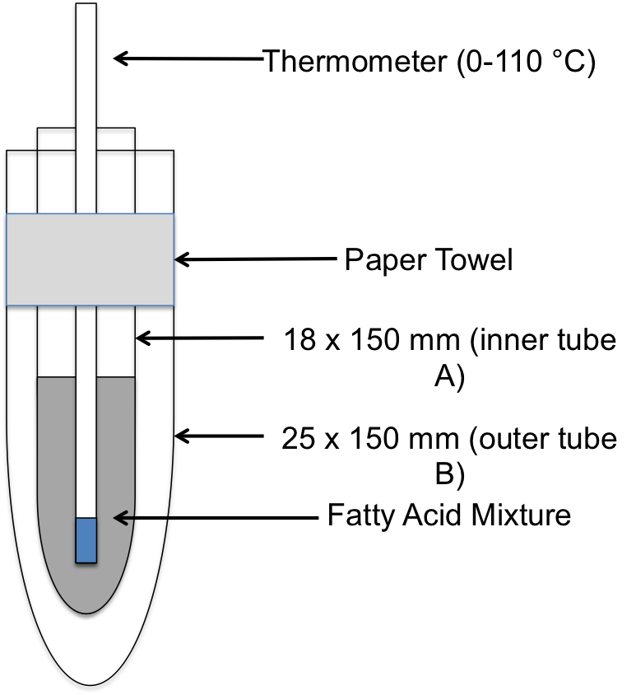
Figure A: Schematic for the construction of an insulating jacket.

- Determine the mass of the 18 x 150 mm test tube removed from the insulating jacket on an analytical balance.
- Fill the test tube approximately 3/4 full, about 9 grams, with stearic acid and reweigh the test tube and its contents to determine the exact amount of stearic acid employed.
- Prepare a hot water bath by filling a 600 ml beaker 3/4 full with tap water and heating with a hot plate.
- Immerse the 18 x 150 mm test tube containing the fatty acid sample in the hot water bath to melt the fatty acid. After the fatty acid sample has completely melted, place the thermometer in the fatty acid sample and heat until the sample reaches 85 °C. From this point on, the thermometer is not removed from the fatty acid sample to prevent loss of material and contamination of bench tops with fatty acids. Remove the test tube from the water and dry the outside.
- Place the 18 x 150 mm test tube containing the fatty acid sample in the previously prepared insulating jacket. Stirring constantly with the thermometer, record the temperature of the sample every 30 seconds for 8-10 minutes. Temperatures are collected until the temperature of the sample remains constant, changing by less than 0.1 °C per reading, for 3 minutes, 6 readings. Perform a second trial using the same sample.
- To the fatty acid sample used above, add approximately 1 g of an unidentified sample. Exactly 1 g is not needed, but you must know the mass added to the nearest 0.1 mg.
- Repeat steps 5 and 6 on this fatty acid sample. Two trials of this sample are performed.
- To the same fatty acid sample, an additional 1 g of the same unidentified sample is added. Again, exactly 1 g is not needed but you must know the mass added to the nearest 0.1 mg.
- Repeat steps 5 and 6 on this fatty acid sample. Two trials of this sample are performed.

Molar Mass Determination by Freezing Point Depression: Student Data Sheet

Mass of small test tube (Tube A):______________________
Mass of small test tube and stearic acid:___________________
Mass of stearic acid:____________________

Temperature data of pure stearic acid:
Starting temperature (Time = 0):_______________
Time | Temperature | Time | Temperature
0.5 min. |  | 6.5 min.
1 min. |  | 7 min.
1.5 min. |  | 7.5 min.
2 min. |  | 8 min.
2.5 min |  | 8.5 min.
3 min. |  | 9 min.
3.5 min. |  | 9.5 min.
4 min. |  | 10 min.
4.5 min. |  | 10.5 min.
5 min. |  | 11 min.
5.5 min. |  | 11.5 min.
6 min. |  | 12 min.

Mass of small test tube and stearic acid:________________________
Mass of small tube, stearic acid and ~1g of an unknown sample:___________________
Mass of the unknown sample:_________________________

Temperature data of stearic acid with 1 g unknown:
Starting temperature (Time = 0):_______________
Time | Temperature | Time | Temperature
0.5 min. |  | 6.5 min.
1 min. |  | 7 min.
1.5 min. |  | 7.5 min.
2 min. |  | 8 min.
2.5 min |  | 8.5 min.
3 min. |  | 9 min.
3.5 min. |  | 9.5 min.
4 min. |  | 10 min.
4.5 min. |  | 10.5 min.
5 min. |  | 11 min.
5.5 min. |  | 11.5 min.
6 min. |  | 12 min.

Mass of small test tube with fatty acid mixture:___________________
Mass of small test tube with fatty acid mixture + 1 g additional unknown sample:__________________
Mass of the additional unknown sample:_________________________
Total mass of unknown sample:_________________________

Temperature data of stearic acid with 2 g unknown:
Starting temperature (Time = 0):_______________
Time | Temperature | Time | Temperature
0.5 min. |  | 6.5 min.
1 min. |  | 7 min.
1.5 min. |  | 7.5 min.
2 min. |  | 8 min.
2.5 min |  | 8.5 min.
3 min. |  | 9 min.
3.5 min. |  | 9.5 min.
4 min. |  | 10 min.
4.5 min. |  | 10.5 min.
5 min. |  | 11 min.
5.5 min. |  | 11.5 min.
6 min. |  | 12 min.

Plotting the cooling curves:
To accurately determine the freezing points of pure stearic acid and each of the solutions, “cooling curves” of temperature (y-axis) versus time (x-axis) are plotted. Data where the temperature changes by more than 0.5 °C per 30 seconds is plotted as one series and data where the temperature changes by less than 0.5 °C per 30 seconds as a second series. A best fit line is then calculated for each series and the freezing point is obtained by finding the intersection of the two best fit lines, see Figure B.
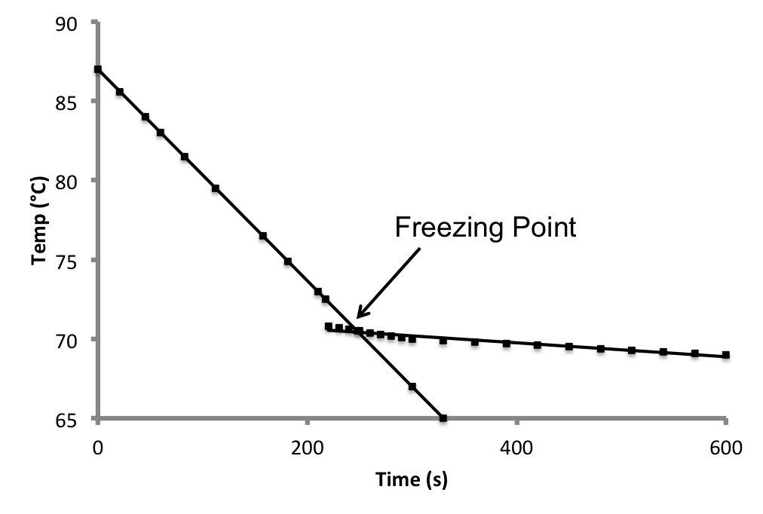
Figure B: Example of the cooling curves and identification of the Freezing Point.

Plot your data of the 3 different cooling curves to identify the freezing point using the following graphs:



Table 1: Pure stearic acid

Table 2: Stearic acid with 1 gram of unknown

Table 2: Stearic acid with 2 grams of unknown

Calculations
- Average the freezing points for each of the three samples tested. Find the change in freezing points, ΔTf, for the mixtures by comparing the freezing point of each to the freezing point of pure stearic acid.
- Use this to find the molality of each solution.
- Use the molality to determine the moles of unidentified sample added in each trial. NOTE: For the second addition of unidentified sample you are finding the total number of moles added.
- Determine the molecular weight of the unidentified sample.
- Determine the average molecular weight and identity of your unidentified sample using the list below.
Myristic Acid C₁₄H₂₈O₂
Palmitic Acid C₁₆H₃₂O₂
Lauric Acid C₁₂H₂₄O₂

Teacher Key

- A common practice in cooking is the addition of salt to boiling water (kb = 0.52 °C kg /mole). One of the reasons for this might be to raise the temperature of the boiling water. If 1.50 kg of water is boiling at 100 °C how much NaCl (MW = 58.44 g / mole) would need to be added to the water to increase the boiling point by 1 °C?

ΔTb = ikbm
ΔTb = 1.00 °C
i = 2
kb = 0.52 °C kg / mole
1 °C = (2)*(0.52 °C kg / mole) m
m = 0.962 mol NaCl / kg H2O
There are 1.5 kg of water, therefore
moles of NaCl needed = (0.962 mol NaCl / kg H2O)*(1.50 kg) = 1.44 moles of NaCl
Converting moles of NaCl to grams of NaCl
grams of NaCl needed = (1.44 moles NaCl)*( 58.44g / mole) = 84.15 g of NaCl needed

- A researcher takes 5.00 g of tridecanoic acid (MW = 214.34 g / mole) and dissolves it in 20.0g of stearic acid (kf = 4.5 °C kg / mole). What is the observed change in the freezing point from the pure stearic acid to the stearic acid with tridecanoic acid added? Assume the compound is molecular, i.e. cannot dissociate.

First find the molality
20 g stearic acid = .020 kg stearic acid
convert grams of tridecanoic acid to moles
(5.00 g tridecanoic acid) / (214.34 g / mole) = 2.33 x 10-2 moles of tridecanoic acid
m = 2.33 x 10-2 / 0 .020 kg = 1.17 moles tridecanoic acid / kg stearic acid
Δ Tf = ikf m
Δ Tf = ?
i = 1
kf = 4.5 °C kg / mole
m = 1.17 moles / kg
Δ Tf = (1)*(4.5 °C kg / mole)*(1.17 moles / kg) = 5.3 °C

- Do colligative properties depend on the number of particles dissolved, the identity of the particles dissolved, or both?

Colligative properties depend only on the number of particles dissolved, not on the identity of the particles.

Mass of stearic acid: 9.0128 g

Mass of 1st addition of unidentified sample: 1.0125 g

Mass of 2nd addition of unidentified sample: 1.0056 g

Freezing point of stearic acid: 69.0 °C

Freezing point after 1st unidentified sample addition: 66.5 °C

Freezing point after 2nd unidentified sample addition: 64.0 °C

Calculations
(Show all work)

1) molality of unidentified sample

ΔTf = kf m
Trial 1: m = 2.5 °C / 4.5 °C kg / mole = .555 mole / kg
Trial 2: m = 5.0 °C / 4.5 °C kg / mole = 1.11 mole / kg

2) moles of unidentified sample

Trial 1: ( .555 mole / kg ) * ( .0090128 kg ) = 5.00 x 10-3 moles
Trial 2: ( 1.11 mole / kg ) * ( .0090128 kg ) = 1.00 x 10-2 moles

3) molecular weight of unidentified sample

Trial 1: MW = ( 1.0125 g ) / (5.00 x 10-3 moles) = 202.5 g / mole
Trial 2: MW = ( 1.0125 g + 1.0056 g ) / (1.00 x 10-2 ) = 201.8 g / mole

Average Molecular Weight 202.1g/mol

