Separation Science - Chromatography Unit
Thomas Wenzel
Department of Chemistry
Bates College, Lewiston ME 04240
twenzel@bates.edu

The following textual material is designed to accompany a series of in-class problem sets that develop many of the fundamental aspects of chromatography.

TABLE OF CONTENTS

Liquid-Liquid Extraction 2

Chromatography – Background 6
Introduction 6
Distribution Isotherms 14
Adsorption Compared to Partition as a Separation Mechanism 16

Broadening of Chromatographic Peaks 21
Longitudinal Diffusion Broadening 23
Eddy Diffusion (Multipath) Broadening in Chromatography 25
Stationary Phase Mass Transport Broadening 30
Mobile Phase Mass Transport Broadening 39
Concluding Comments 43

Fundamental Resolution Equation 46
N- Number of Theoretical Plates 46
α – Selectivity Factor 47
k – Retention or Capacity Factor 48

Liquid Chromatographic Separation Methods 51
Steric Exclusion Chromatography 53
Ion-Exchange Chromatography 58
Bonded-Phase Liquid Chromatography 67

Gas Chromatographic Separation Methods 71
Detection Methods 75

Capillary Electrophoresis 80

Appendix 1. Derivation of the Fundamental Resolution Equation 89

LIQUID-LIQUID EXTRACTION

Before examining chromatographic separations, it is useful to consider the separation process in a liquid-liquid extraction. Certain features of this process closely parallel aspects of chromatographic separations. The basic procedure for performing a liquid-liquid extraction is to take two immiscible phases, one of which is usually water and the other of which is usually an organic solvent. The two phases are put into a device called a separatory funnel, and compounds in the system will distribute between the two phases. There are two terms used for describing this distribution, one of which is called the distribution coefficient (D_{C}), the other of which is called the partition coefficient (D_{M}).

The distribution coefficient is the ratio of the concentration of solute in the organic phase over the concentration of solute in the aqueous phase (the V-terms are the volume of the phases). This is essentially an equilibration process whereby we start with the solute in the aqueous phase and allow it to distribute into the organic phase.

solute_{aq} = solute_{org}

$${\text{D}}_{\text{C}}\text{ = }\frac{{\text{[solute]}}_{\text{org}}}{{\text{[solute]}}_{\text{aq}}}\text{ = }\frac{{{\text{mol}}_{\text{org}}}/{{\text{V}}_{\text{org}}}}{{{\text{mol}}_{\text{aq}}}/{{\text{V}}_{\text{aq}}}}\text{ = }\frac{{\text{mol}}_{\text{org}} \text{×} {\text{V}}_{\text{aq}}}{{\text{mol}}_{\text{aq}} \text{×} {\text{V}}_{\text{org}}}$$

The distribution coefficient represents the equilibrium constant for this process. If our goal is to extract a solute from the aqueous phase into the organic phase, there is one potential problem with using the distribution coefficient as a measure of how well you have accomplished this goal. The problem relates to the relative volumes of the phases. For example, suppose the volume of the organic phase was very small compared to the volume of the aqueous phase. (Imagine using 100 mL of organic solvent relative to a volume of water equal to that in an Olympic-sized swimming pool). You could have a very high concentration of the solute in the organic phase, but if we looked at the amount of solute in the organic phase relative to the amount still in the water, it might only be a small portion of the total solute in the system. Since we really want as much of the solute in the organic phase as possible, this system has not yet achieved that outcome.

The partition coefficient is the ratio of the moles of solute in the two phases, and is a more effective means of measuring whether you have achieved the desired goal. The larger the value of D_{M}, the more of the solute we have extracted or partitioned into the organic phase.

$${\text{D}}_{\text{M}}\text{ = }\frac{{\text{mol}}_{\text{org}}}{{\text{mol}}_{\text{aq}}}$$

Note as well how we can relate D_{C} to D_{M}:

$${\text{D}}_{\text{C}} \text{= }\frac{{\text{mol}}_{\text{org}}\text{ × }{\text{V}}_{\text{aq}}}{{\text{mol}}_{\text{aq}}\text{ × }{\text{V}}_{\text{org}}}\text{ = }{\text{D}}_{\text{M}}\left(\frac{{\text{V}}_{\text{aq}}}{{\text{V}}_{\text{org}}}\right)$$

From experience you have probably had in your organic chemistry lab, you know that the approach that is often used in liquid-liquid extraction is to add some organic phase, shake the mixture, and remove the organic phase. A fresh portion of the organic phase is then added to remove more of the solute in a second extraction. As we will see shortly, this distribution of a solute between two immiscible phases forms the basis of chromatographic separations as well.

Next we want to examine some general types of extraction procedures that are commonly used. The first is a classic example of an extraction procedure that can be used to separate acids, bases, and neutrals.

An aqueous sample contains a complex mixture of organic compounds, all of which are at trace concentrations. The compounds can be grouped into broad categories of organic acids, organic bases and neutral organics. The desire is to have three solutions at the end, each in methylene chloride, one of which contains only the organic acids, the second contains only the organic bases, and the third contains only the neutrals. Devise an extraction procedure that would allow you to perform this bulk separation of the three categories of organic compounds.

Two things to remember:

- Ionic substances are more soluble in water than in organic solvents.
- Neutral substances are more soluble in organic solvents than in water.

The key to understanding how to do this separation relates to the effect that pH will have on the different categories of compounds.

Neutrals – Whether the pH is acidic or basic, these will remain neutral under all circumstances.

Organic acids – RCOOH

At very acidic pH values (say a pH of around 1) – these are fully protonated and neutral
At basic pH values (say a pH of around 13) – these are fully deprotonated and anionic

Organic bases – R₃N

At very acidic pH values (say a pH of around 1) – these are protonated and cationic
At very basic pH values (say a pH of around 13) – these are not protonated and neutral

Step 1: Lower the pH of the water using concentrated hydrochloric acid.

Neutrals – neutral
Acids – neutral
Bases – cationic

Extract with methylene chloride – the neutrals and acids go into the methylene chloride, the bases stay in the water.
Step 2: Remove the water layer from step (1), adjust the pH back to a value of 13 using a concentrated solution of sodium hydroxide, shake against methylene chloride, and we now have a solution of the organic bases in methylene chloride. (SOLUTION 1 – ORGANIC BASES IN METHYLENE CHLORIDE)

Step 3: Take the methylene chloride layer from step (1) and shake this against an aqueous layer with a pH value of 13 (adjusted to that level using a concentrated solution of sodium hydroxide).

Neutrals – neutral
Organic acids – anionic

The neutrals stay in the methylene chloride layer. (SOLUTION 2: NEUTRALS IN METHYLENE CHLORIDE) The acids go into the water layer.

Step 4. Take the water layer from Step (3), lower the pH to a value of 1 using concentrated hydrochloric acid, shake against methylene chloride, and the neutral organic acids are now soluble in the methylene chloride (SOLUTION 3: ORGANIC ACIDS IN METHYLENE CHLORIDE).

Devise a way to solubilize the organic anion shown below in the organic solvent of a two-phase system in which the second phase is water. As a first step to this problem, show what might happen to this compound when added to such a two-phase system.

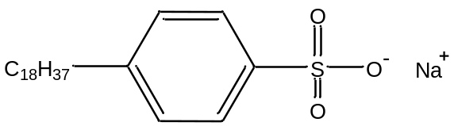

This compound will align itself right along the interface of the two layers. The non-polar C₁₈ group is hydrophobic and will be oriented into the organic phase. The polar carboxylate group is hydrophilic and will be right at the interface with the aqueous phase.

One way to solubilize this anion in the organic phase is to add a cation with similar properties. In other words, if we added an organic cation that has a non-polar R group, this would form an ion pair with the organic anion. The ion pair between the two effectively shields the two charged groups and allows the pair to dissolve in an organic solvent. Two possible organic cations that could be used in this system are cetylpyridinium chloride or tetra-n-butylammonium chloride.

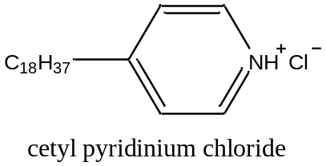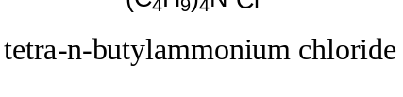

A somewhat similar procedure can often be used to extract metal complexes into an organic phase. Metal salts with inorganic anions (halide, sulfate, phosphate, etc.) are generally water-soluble but not organic-soluble. It is possible to add a relatively hydrophobic ligand to the system. If the ligand complexes with the metal ion, then the metal complex may be organic-soluble. Usually it helps to form a neutral metal complex. Also, remember back to our examination of the effect of pH on the complexation of metal ions with ligands. The extraction efficiency of a metal ion in the presence of a ligand will depend on the pH of the aqueous phase. Adjustment of the pH is often used to alter the selectivity of the extraction, thereby allowing different metal ions to be separated.

CHROMATOGRAPHY – BACKGROUND

Chromatography refers to a group of methods that are used as a way of separating mixtures of compounds into their individual components. The basic set up of a chromatographic system is to have two phases, one stationary and one mobile. A compound, which we will usually call the solute, is introduced into the system, and essentially has a choice. If it is attracted to the mobile phase (has van der Waal attractions to the mobile phase), it will move through the system with the mobile phase. If it is attracted to the stationary phase, it will lag behind. It’s easy to imagine some solute compounds with some degree of attraction for both phases, such that these move through the system with some intermediate rate of travel.

The first report of a chromatographic application was by Mikhail Tswett, a chemist from Estonia, in 1903. (A list of important literature articles is provided at the end). Undoubtedly other people had observed chromatography taking place, but no one until Tswett recognized its applicability for the separation of mixtures in chemistry. Tswett was interested in separating the pigments in plants. He packed a glass column that might have been comparable to a buret with starch, mashed up the plant and extracted the pigments into a solvent, loaded the solution onto the top of the starch column, and ran a mobile phase through the starch. Eventually he saw different color bands separate on the column, hence the term chromatography. Rather than eluting the colored bands off of the column, he stopped it, used a rod to push out the starch filling, divided up the bands of color, and extracted the individual pigments off the starch using an appropriate solvent. Twsett used a solid stationary phase (starch) and a liquid mobile phase.

Chromatographic systems can use either a gas or liquid as the mobile phase. Chromatographic systems can use either a solid or liquid as the stationary phase. A solid stationary phase is easy to imagine, as we have already seen for Tswett’s work. Another common example is to use paper as the solid (actually, paper is made from a compound called cellulose). The sample is spotted onto the paper as shown in Figure 1a, and the bottom of the piece of paper is dipped into an appropriate liquid (note that the spot is above the liquid – Figure 1b). The liquid mobile phase moves up the paper by capillary action, and components of the mixture can separate into different spots depending on their relative attraction to the cellulose or chemicals that make up the liquid (Figure 1c).
(c)
(a)
(b)

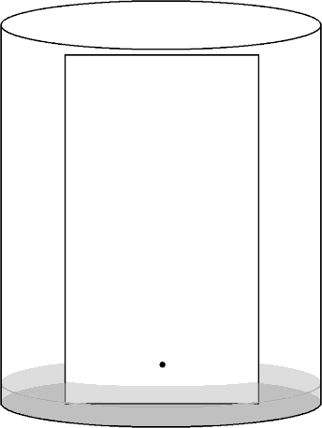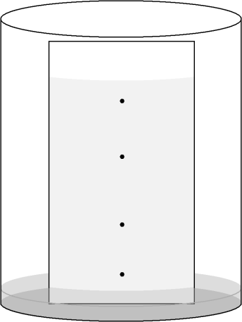
Solvent Front
Sample Spot

Figure 1. Paper chromatography

Another type of chromatography that you may be familiar with is thin layer chromatography (TLC). This is very similar to paper chromatography, although the stationary phase is usually a coating of small particles of a material known as silica gel (silica gel is a polymer with the formula SiO₂, although a bit later we will talk in more detail about the exact chemical nature of this material) on a glass or plastic plate. Similarly, we could take these silica gel particles and pack them into a glass column, and then flow a liquid through the column. If we used some gas pressure to force the liquid through the silica gel column more quickly, we would have a common technique known as flash chromatography that synthetic chemists use to separate relatively large amounts of materials they have prepared. Another common solid to use in column chromatography is alumina (Al₂O₃ is the general formula, although we will say more later about its exact chemical nature).

These methods we have just been talking about are examples of liquid-solid chromatography. If we used gas as the mobile phase, injected either a gaseous sample or liquid sample into a high temperature zone that flash volatilized it, with some solid as the stationary phase (there are a range of possible materials we could use here), we could perform gas-solid chromatography. If we thought about how a solute compound would interact with such a solid stationary phase, we would realize that it must essentially “stick” to the surface by some intermolecular (van der Waal) forces. This sticking process in chromatography is known as adsorption.

Earlier I said that it is also possible to use a liquid as the stationary phase. This might seem odd at first, because it would seem as if the flowing mobile phase would somehow push along a liquid stationary phase. The way to use a liquid as the stationary phase is to coat a very thin layer of it onto a solid support, as illustrated in Figure 2.
Solid Support
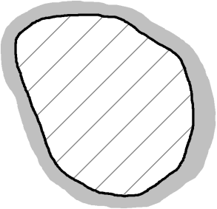
Liquid Coating

Figure 2. Liquid phase coated onto a solid support.

Alternatively, it is possible to coat a liquid phase onto the inside walls of a small-diameter, open-tubular column (known as a capillary column) as shown in Figure 3.


Liquid
Coating
Flow

Figure 3. Liquid phase coated onto the inside walls of a capillary column.
The liquid coating has some attractive forces for the underlying solid surface, such that it sticks to the surface and stays in place. We could probably see how we could easily have a gas flowing around a packed bed of such particles and, so long as the liquid coating did not evaporate, it would stay in place on the particles. Flowing a liquid around it might be a bit more problematic, and we will examine that in length later in this unit. Suffice it to say, though, that it can be done. This would lead to gas-liquid and liquid-liquid chromatographic methods. The interaction of a solute compound with a liquid stationary phase is different than with the solid stationary phases discussed above. It will still depend on having attractive intermolecular forces, but instead of sticking to the solid surface by adsorption, the solute molecule will now dissolve into the liquid stationary phase. If a solute molecule dissolves into a liquid stationary phase in a chromatographic system, we say that the molecule partitions between the two phases.

These two terms are so important in chromatographic systems that it is worth summarizing them again:

Adsorption – describes the process of a solute molecule adhering to a solid surface

Partition – describes the process of a solute molecule dissolving into a liquid stationary phase

There are two terms we can describe in chromatography that are analogous to those we already described for liquid-liquid extraction. One of these is the distribution constant (K_{C}) that is the ratio of the concentration of the solute in the stationary phase (C_{S}) to that in the mobile phase (C_{M}).

$${\text{K}}_{\text{C}} \text{= }\frac{{\text{C}}_{\text{S}}}{{\text{C}}_{\text{M}}}\text{ = }\frac{{{\text{mol}}_{\text{S}}}/{{\text{V}}_{\text{S}}}}{{{\text{mol}}_{\text{M}}}/{{\text{V}}_{\text{M}}}}\text{ = }\frac{{\text{mol}}_{\text{S}} \text{×} {\text{V}}_{\text{M}}}{{\text{mol}}_{\text{M}}\text{ × }{\text{V}}_{\text{S}}}$$

But just like in liquid-liquid extraction, a problem with this ratio is that the volumes of the stationary and mobile phases might be significantly different from each other. With a solid stationary phase, V_{S} is comparable to the surface area of the particles. With a liquid stationary phase, the coating is usually so thin that V_{M} would be much larger than V_{S}. In many cases, a more useful term is the partition coefficient (K_{X}), which is the ratio of the moles of solute in each of the two phases.
$${\text{K}}_{\text{X}}\text{ = }\frac{{\text{mol}}_{\text{S}}}{{\text{mol}}_{\text{M}}}$$

Notice that we can relate K_{C} to K_{X} because the mole ratio shows up in both. That allows us to write the following:
$${\text{K}}_{\text{C}}\text{ = }{\text{K}}_{\text{X}}\left(\frac{{\text{V}}_{\text{M}}}{{\text{V}}_{\text{S}}}\right)$$

There are also some other fundamental figures of merit that we often use when discussing chromatographic separations. The first is known as the selectivity factor (α). In order to separate two components of a mixture, it is essential that the two have different distribution or partition coefficients (note, it does not matter which one you use since the volume terms will cancel if K_{C} is used). The separation factor is the ratio of these two coefficients, and is always written so that it is greater than or equal to one. K₂ represents the distribution coefficient for the later eluting of the two components.
$$\text{α = }\frac{{\text{K}}_{\text{2}}}{{\text{K}}_{\text{1}}}$$

If α = 1, then there will be no separation of the two components. The larger the value of α, the greater the separation. One thing to realize is that there is some limit as to how large we want an
α -value to be. For example, the chromatogram in Figure 4b has a much greater α value than that in Figure 4a. But the two components are fully separated so that the extra time we would need to wait for the chromatogram in Figure 4b is undesirable. In most chromatographic separations, the goal is to get just enough separation, so that we can keep the analysis time as short as possible.

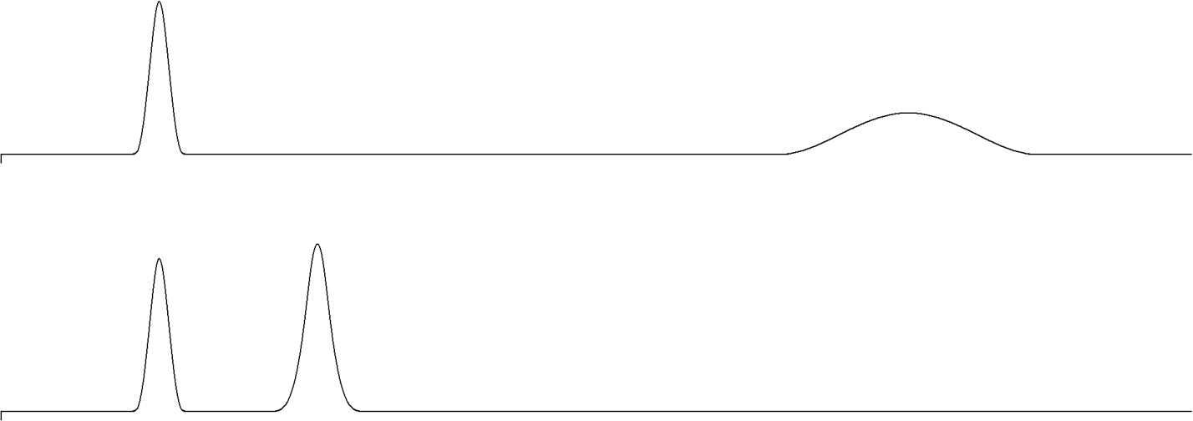
(a)
(b)
INJ
INJ

Figure 4. Elution of compounds where the α-value in (b) is much greater than the α-value in (a).

Another important figure of merit in chromatographic separations is known as the retention factor (k), which is a measure of the retention of a solute, or how much attraction the solute has for the stationary phase. The k term was formerly known as the capacity factor. The retention factor is actually identical to the partition coefficient.

$$\text{k = }\frac{{\text{mol}}_{\text{S}}}{{\text{mol}}_{\text{M}}}\text{ = }\frac{{\text{C}}_{\text{S}}{\text{V}}_{\text{S}}}{{\text{C}}_{\text{M}}{\text{V}}_{\text{M}}}\text{ = }{\text{K}}_{\text{C}}\left(\frac{{\text{V}}_{\text{S}}}{{\text{V}}_{\text{M}}}\right)$$

We can determine k values from a chromatogram using the following equation:

$$\text{k = }\frac{{\text{t}}_{\text{R}}- {\text{t}}_{\text{0}}}{{\text{t}}_{\text{0}}}$$
t_{R}
t₀

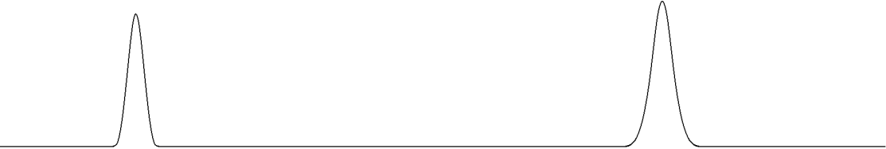

Figure 5. Chromatographic information used to calculate the k value for a peak.

As seen in Figure 5, the term t_{R} is the retention time of the compound of interest, whereas t₀ refers to the retention time of an unretained compound (the time it takes a compound with no ability to partition into or adsorb onto the stationary phase to move through the column). Since t₀ will vary from column to column, the form of this equation represents a normalization of the retention times to t₀.

Another important figure of merit for a chromatographic column is known as the number of theoretical plates (N). It turns out that one helpful way to think of a chromatographic column is as a series of microscopically thin plates as shown in Figure 6. Using the picture in Figure 6, we

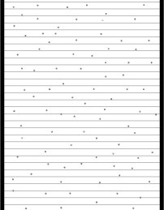

Figure 6. Representation of a chromatographic column as a series of microscopically thin plates.

could imagine a compound moving down the column as a series of steps, one plate at a time. The compound enters a plate, distributes according to its distribution coefficient between the stationary and mobile phase, and then moves on to the next plate. Now it turns out that chromatographic systems never really reach equilibrium, and in fact are not steady state systems, but things like the distribution and partition coefficients, which are equilibrium expressions, are useful ways to examine the distribution in chromatographic systems. A compound with less favorable solubility in the stationary phase would then move through the series of plates faster. The only way to separate two compounds is to have enough plates, or enough equilibrations, to exploit the difference in partition coefficients between the two compounds. A column with more theoretical plates is more likely to separate two compounds than one with fewer.

We can determine the number of plates for a compound as shown in Figure 7.

$$\text{N = 16}{\left(\frac{{\text{t}}_{\text{R}}}{\text{W}}\right)}^{\text{2}}$$
t_{R}

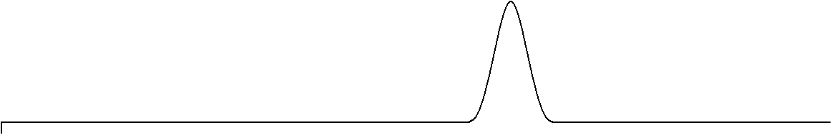
W
INJ

Figure 7. Chromatographic information used to determine N for a column.

W is the width of the peak where it intersects with the baseline. The important thing to remember is to use the same units when measuring W and t_{R} (e.g., distance in cm on a plot, time in seconds, elution volume in mL – which is common in liquid chromatography). It should be pointed out that a column will have a set number of plates that will not vary much from compound to compound. The reason for this is that a compound with a longer retention time will exhibit a larger peak width, such that the ratio term is correcting for these two effects.
If we determine the number of plates for a column, dividing the column length (L) by the number of plates leads to the height equivalent to a theoretical plate (H). Note that the smaller the value of H the better. It actually turns out the H is the important figure of merit for a column.

$$\text{H = }\frac{\text{L}}{\text{N}}$$

The chromatograms in Figure 8 show the distinction between a column with a smaller value of H (Figure 8a) and one with a much larger value of H (Figure 8b).

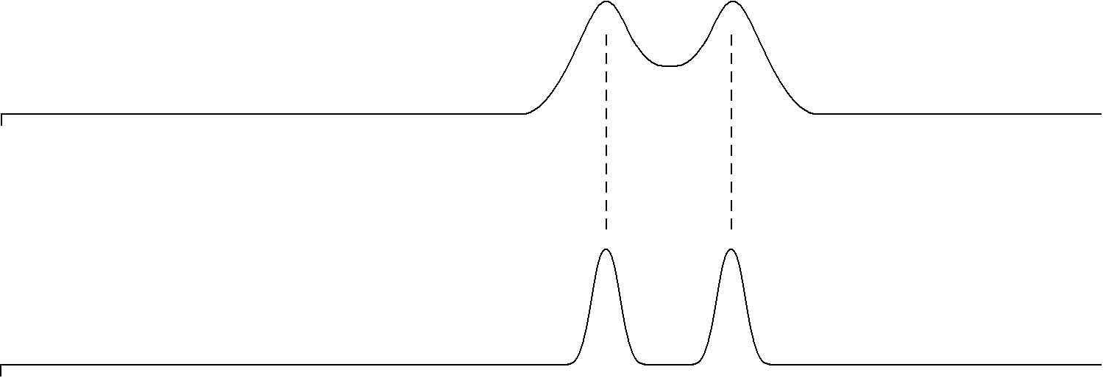
(b)
(a)
INJ
INJ

Figure 8. Chromatograms for a column with (a) a smaller value of H and (b) a larger value of H.

Usually today, though, people refer to something called the reduced plate height (h) for a column. The reduced plate height is defined as shown below, in which d_{p} is the particle diameter of the packing material used in the column (or the internal tube diameter if an open tubular capillary column is used).
$$\text{h = }\frac{\text{H}}{{\text{d}}_{\text{p}}}$$

You will also come across a term known as the reduced velocity (ν) in the chromatographic literature. The reduced velocity is defined as follows, in which v is the mobile phase velocity, and D_{M} the diffusion coefficient of the solute in the mobile phase.

$$\text{v}\text{ = }\frac{{\text{d}}_{\text{p}} \text{×} \text{v}}{{\text{D}}_{\text{M}}}$$

Finally, we can define an equation for the resolution (R_{S}) of two compounds. This will be a measure of how much two compounds in a chromatogram are separated from each other.

$${\text{R}}_{\text{S}}\text{ = }\frac{\text{2(}{\text{t}}_{\text{2}}- {\text{t}}_{\text{1}}\text{)}}{{\text{W}}_{\text{1}}\text{ + }{\text{W}}_{\text{2}}}$$

The terms t₂ and t₁ refer to the retention time of the two compounds, and W₁ and W₂ to the width of each peak at baseline.

Figure 9 shows the separation of two peaks at resolution values of 0.75 (Figure 9a), 1.0 (Figure 9b) and 1.5 (Figure 9c). The better separation of A and B that occurs with increasing resolution is obvious. It is also worth noting that the analysis time is longer the higher the resolution. Chromatographic analyses are always a compromise between the degree of separation of the peaks and how long it takes to perform the analysis. In many cases, the goal is to get just enough separation in the shortest period of time.

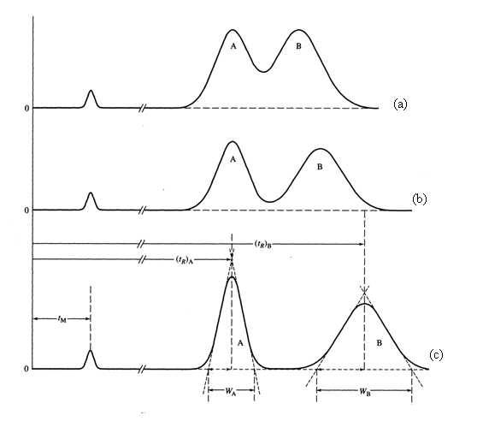

Figure 9. Separation of two peaks with resolution values of (a) 0.75, (b) 1.0 and (c) 1.5.

Distribution Isotherms (Isotherm means constant temperature):

We have used the distribution and partition coefficients as ways to express the distribution of a molecule between the mobile and stationary phase. Note that these equations take the form of equilibrium expressions, and that K_{C} is a constant for the distribution of a solute compound between two particular phases. (K_{X} depends on the relative volumes of the two phases.)

Suppose that we plotted C_{S} versus C_{M}, as shown on the coordinate system in Figure 10.

C_{S}

C_{M}

Figure 10. Coordinate system with the concentration of analyte in the stationary phase (C_{S}) shown on the y-axis and the concentration of analyte in the mobile phase (C_{M}) shown on the x-axis.

Notice that C_{M} plus C_{S} would give the total amount of the solute injected. So as you move to the right on the C_{M} axis, it means that more sample is being injected into the chromatograph. If we have the expression for the distribution coefficient:

$${\text{K}}_{\text{C}}\text{ =} \frac{{\text{C}}_{\text{S}}}{{\text{C}}_{\text{M}}}\text{ = constant}$$

The idealized form of the plot of the distribution isotherm is shown in Figure 11. If we inject more sample into the column, it distributes according to a set ratio of the distribution coefficient. The result would be a straight line, with the slope being the distribution coefficient.

Slope = K_{C}

Ideal Behavior
C_{S}

C_{M}

Figure 11. Idealized plot of the distribution isotherm.

If we examine this in more detail, though, we will realize that the volume of stationary phase is some fixed quantity, and is usually substantially less than the volume of the mobile phase. It is possible to saturate the stationary phase with solute, such that no more can dissolve. In that case, the curve would show the behavior shown in Figure 12, a result known as the Langmuir isotherm (Langmuir was a renowned surface scientist and a journal of the American Chemical Society on surface science is named in his honor). If we get a region of Langmuir behavior, we have saturated the stationary phase or overloaded the capacity of the column.

C_{S}
Langmuir Isotherm

C_{M}

Figure 12. Plot of the Langmuir isotherm.

We might also ask whether you could ever get the following plot, which is called anti-Langmuir behavior (Figure 13).
C_{S}

Anti-Langmuir Isotherm

C_{M}

Figure 13. Plot of the anti-Langmuir isotherm.

There are actually two ways this could happen. One is if the solute dissolves in the stationary phase, creating a mixed phase that then allows a higher solubility of the solute. This behavior is not commonly observed. Another way that this can occur is in gas chromatography if too large or concentrated a sample of solute is injected. At a fixed temperature, a volatile compound has a specific vapor pressure. This vapor pressure can never be exceeded. If the vapor pressure is not exceeded, all of the compound can evaporate. If too high a concentration of compound is injected such that it would exceed the vapor pressure if all evaporates, some evaporates into the gas phase but the rest remains condensed as a liquid. If this happens, it is an example of anti-Langmuir behavior because it appears as if more is in the stationary phase (the condensed droplets of sample would seem to be in the stationary phase because they are not moving).

The last question we need to consider is what these forms of non-ideal behavior would do to the shape of a chromatographic peak. From laws of diffusion, it is possible to derive that an “ideal” chromatographic peak will have a symmetrical (Gaussian) shape. Either form of overloading will lead to asymmetry in the peaks. This can cause either fronting or tailing as shown in Figure 14.

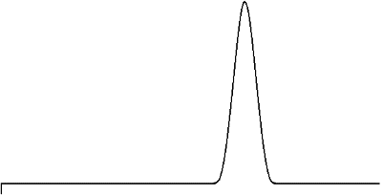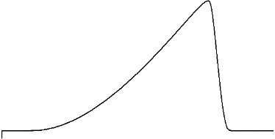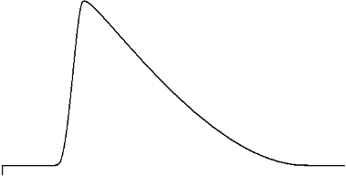
Ideal
INJ
INJ
Fronting
Tailing
INJ

Figure 14. Representation of a chromatographic peak exhibiting ideal peak shape, fronting, and tailing.

Adsorption Compared to Partition as a Separation Mechanism

If we go back now and consider Tswett’s first separation, we see that he used solid starch as the stationary phase, and so solutes exhibited an adsorption to the surface of the starch. A useful thing to consider is the nature of the chemical groups on the surface of starch. Starch is a carbohydrate comprised of glucose units. The glucose functionality of starch is shown below, and we see that the surface is comprised of highly polar hydroxyl groups.

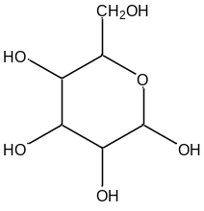
Glucose

Silica gel (SiO₂) and alumina (Al₂O₃) were mentioned previously as two other common solid phases. If we examine the structure of silica gel, in which each silicon atom is attached to four oxygen atoms in a tetrahedral arrangement (this corresponds to two silicon atoms sharing each of the oxygen atoms), we run into a problem when you try to create a surface for this material. If we have an oxygen atom out on the edge, we would then need to attach a silicon atom, which necessitates more oxygen atoms. We end up with a dilemma in which we can never wrap all of these around on each other and only make something with the formula SiO₂. Some of these groups are able to do this and some of the surface of silica gel consists of what are known as siloxane (Si–O–Si) groups. But many of the outer oxygen atoms cannot attach to another silicon atom and are actually hydroxyl or silanol (Si–OH) groups.

–Si–O–Si– –Si–OH

Siloxane units Silanol units

What we notice is that the surface of silica gel consists of very polar hydroxyl groups. It turns out that the same thing will occur for the surface of alumina.

If we consider a solute molecule (S), and have it adsorb to the surface of silica gel, we could write the following equation to represent the process of adsorption.

Si–OH + S  Si–OH - - - S

With any reaction we can talk about its enthalpy and entropy. So in this case, we could talk about the enthalpy of adsorption (ΔH_{ADS}). Suppose now we took one solute molecule and millions of surface silanols, and went through one by one and measured ΔH_{ADS} for this one solute molecule with each of these millions of surface silanols. The question is whether we would get one single ΔH_{ADS} value for each of the measurements. Hopefully it might seem intuitive to you that we would not get an identical value for each of these individual processes.
Instead, it seems like what we would really get is a distribution of values. There would be one value that is most common with other less frequent values clustered around it. For some reason, some silanol sites might be a bit more active because of differences in their surrounding microenvironment, whereas others might be a bit less active. Suppose we entered all these measurements in a spreadsheet and then plotted them as a histogram with number of measurements of a particular value versus ΔH_{ADS}. But another important question involves the nature of this distribution of ΔH_{ADS} values. Would it be symmetrical as shown in Figure 15, or would it have some asymmetry?

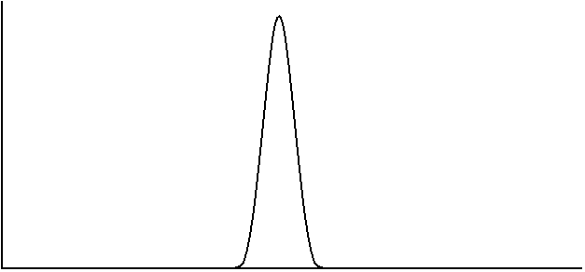
High
Energy
ΔH_{ADS}
Low
Energy
Frequency of
Occurrence

Figure 15. Representation of a symmetrical distribution for ΔH_{ADS}

The easiest way to think of this is to examine the nature of the silanol groups on the surface of silica gel. One thing we could ask is whether there are different types of silanols, as shown below (are there also disilanols and trisilanols?).

–Si–OH –Si–(OH)₂ –Si(OH)₃

It turns out that we will get some di- and trisilanols, although these are far fewer in number than the monosilanols. It should make sense that even if the distribution about a monosilanol were symmetrical, that the di- and trisilanols will have different distributions of ΔH_{ADS}. Assuming that ΔH_{ADS} is larger for the di- and trisilanols, that might lead to the plot shown in Figure 16 for each of the individual distributions and then the composite drawing for the overall distribution.
Overall
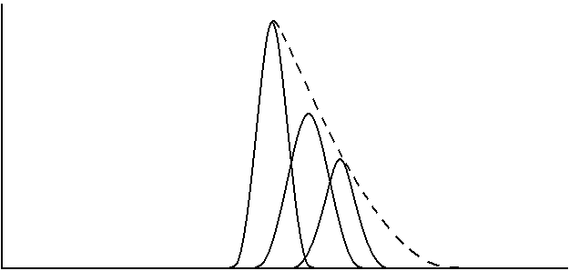
Trisilanol
Disilanol
Silanol
High
Energy
ΔH_{ADS}
Low
Energy
Frequency of
Occurrence

Figure 16. Representation of the distribution of ΔH_{ADS} values for a surface that contains silanol, disilanol and trisilanol groups.

Notice the asymmetry in the plot in Figure 16 with a smaller number of highly active sites. Something to realize is that even if we had only monosilanols, there is still experimental data that shows a small proportion of highly active sites that produced an asymmetric distribution. It is important to realize that not everything in nature occurs in a symmetrical manner.

The key question for us to ask is what a chromatographic peak would look like for a solute traveling through this stationary phase. Hopefully it seems reasonable to predict that the peak for the solute would also be asymmetric. Those solute molecules adsorbed at the highly active sites would essentially get stuck on the column and take much longer to elute. The asymmetric peak observed in Figure 17 exhibits tailing. Note that tailed peaks are undesirable in chromatographic separations because they are more likely to overlap with each other and interfere with the separation. Unless the solid surface is highly deactivated, all chromatographic separations based on adsorption will exhibit peak tailing. This causes an inherent inefficiency in adsorption methods.

INJ

Figure 17. Tailed peak shape in adsorption chromatography

One last thing before we move on is to understand that strong adsorption by molecules on active solid surfaces has a profound implication in environmental chemistry. Consider a leaking, underground tank of gasoline at a service station. The soil around the tank gets contaminated by the leaking gas and it is desirable to clean it up. One way is to remove all the contaminated soil, heat it in a very high temperature oven that combusts all the hydrocarbon components of the gasoline, and recycle the soil. This is a common remediation procedure. But suppose the soil exists over a very large area (say the soil surrounding an old hazardous waste dump). This may be too large a volume of soil to use the removal and combustion method. The chemicals may have leached far away from the original site, contaminating nearby drinking wells.

Based on our knowledge of chromatography, and essentially using the ground as something similar to a chromatographic column, we could imagine pumping lots of clean water in from wells outside the contaminated area, and removing contaminated water from wells internal to the contaminated region. After some time of pumping, all the contaminants ought to migrate by a chromatographic-like process from the outside to the inside and be removed. If you do this, you eventually see that the level of contaminants in the water coming out of the inner wells drop considerably (maybe even to acceptable levels). But if you allow the system to sit for quite a while, you start to discover elevated levels of contaminants in the water again. What has happened is that some of the contaminants adsorbed quite strongly to the solid surfaces in the ground and were unavailable to the water. As the system sat, these slowly began to come off the surface into the water, raising the concentration. This kind of treatment process has generally proven ineffective as a way of completely treating such ground water contamination. It does get rid of a lot of the contaminants, but the strong adsorption requires enormous lengths of time before the levels would drop low enough.

Chromatographic methods languished under these inefficient methods for many years until Martin and Synge reported the first application of a partition separation in chromatography in 1941. Recognizing that WWII was taking place in 1941, there was a considerable need for wool clothing for soldiers from England fighting in the war. Wool is rather unique as a fabric since it retains much of its warmth even if wet. In fact, so much wool was needed that England did not have enough sheep to provide the volume of wool clothing that was necessary. Martin and Synge were interested in seeing whether it was possible to make artificial wool, and sought to examine the amino acid content of the proteins that make up wool fibers as a first step in understanding the chemical nature of wool. What they also realized, though, was that separating amino acids using adsorption chromatographic methods available at that time was going to be a difficult process. They therefore investigated whether it would be possible to take a solid particle and coat it with a liquid stationary phase, and perform the separation based on partitioning. What they found was that it was possible, and that the chromatographic efficiency was improved considerably when compared to methods based on adsorption.

The important thing to realize here is that we no longer have an adsorption process, but the dissolution of the solute into another liquid solvent. The relevant enthalpy to consider here is the enthalpy of solvation (ΔH_{SOLV}). It turns out that ΔH_{SOLV} of a particular solute in a particular solvent will also show a distribution of values; however, in this case, the distribution is a symmetrical one. Therefore, a chromatographic peak for a solute being separated entirely by a partitioning mechanism between the mobile and stationary phases ought to be symmetrical as well. This will greatly enhance the efficiency of the chromatography. This work was so important that it was recognized with the Nobel Prize in 1952. The only problem was that there were still other important issues with liquid chromatography such that it really could not flourish as an analytical method (we will examine these other issues later in our unit on chromatography).

One intriguing aspect of Martin and Synge’s 1941 paper is the last sentence, which predicted that it should be possible to use gas as the mobile phase (i.e., gas chromatography), and that some of the limitations that restrict the efficiency of liquid chromatography should not occur in gas chromatography. What was also interesting is that it was not until 1951, that James and Martin published the first report in which gas chromatography was described as an analysis method. Much of the delay was because of WWII and the need for scientists to devote their research to areas of immediate national concern related to the war effort.

The introduction of gas chromatography revolutionized the entire field of chemical analysis. One thing, as we will develop in the next substantial portion of this unit, is that gas chromatographic methods had certain fundamental advantages over liquid chromatographic methods when it came to column efficiency. It was possible, using gas chromatography, to separate very complex mixtures of volatile chemicals in very short periods of time. Before gas chromatography, no one even considered that it might be possible to separate as many as 50 to 100 constituents of a sample in only an hour. The other thing that prompted an explosion of interest in gas chromatography as an analysis method was the development of some highly sensitive methods of detection in the 1950s and 1960s. People were now able to sense levels of molecules that were not detectable in other, conventional solution-phase systems. Part of the problem with solution-phase analysis is the overwhelming volume of solvent that can interfere with the technique used to perform the measurement. Gas phase measurements, where the overall density of molecules is very low, do not have as much potential for interference from gases other than those being measured.

What we now need to do is develop an understanding of what created the inherent advantage in efficiency of gas chromatographic columns, and then understand what took place to improve the efficiency of liquid chromatographic columns. When we talk about the efficiency of a chromatographic column, what we really refer to is the width of the chromatographic bands of solutes as they migrate through the column.

BROADENING OF CHROMATOGRAPHIC PEAKS

One of the most important occurrences in chromatographic systems is the broadening of peaks as compounds move through the chromatographic column. For example, if we examine Figure 18 in which both sets of peaks have the same retention times but different extents of broadening, we see that the set of conditions that produce the narrower set of peaks (Figure 18b) resulted in “better” or more efficient chromatography. What we observe in the chromatogram with less peak broadening is that the peaks are fully resolved and that we could fit more peaks into a similar window of time in the chromatogram. An ideal chromatographic system would therefore produce peaks that were straight line spikes in which no broadening occurred (Figure 18a).

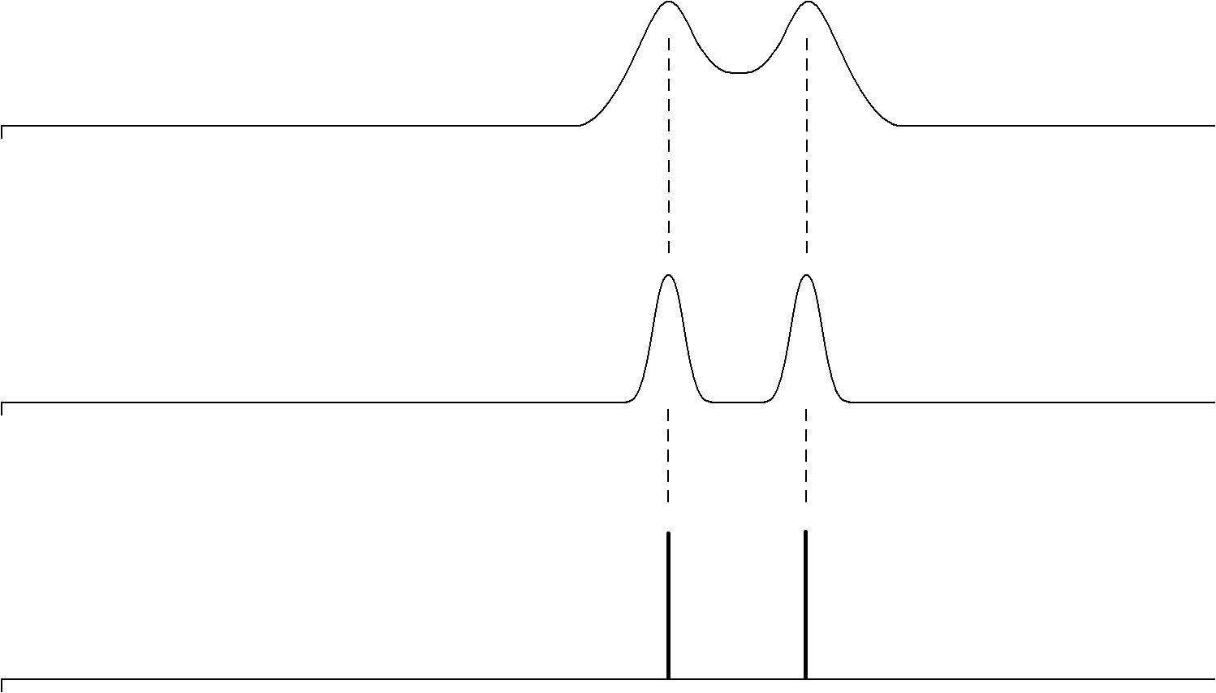
(a)
(b)
(c)
INJ
INJ
INJ

Figure 18. Representation of chromatographic peaks in which the broadening increases going from (a) to (c).

There are specific processes that occur in chromatographic systems that cause peaks to broaden. It also turns out that these processes are often influenced by experimental variables that we may have some control over. Contributions to broadening in chromatographic systems can be divided into two broad areas of concern. One is the contribution from what is known as dead volume. Dead volume refers to all the volume in a chromatographic system from the injector to the detector other than the column. Remember, the separation only occurs in the column. All other volumes (tubing used to connect components, volume within the detector cell, etc.) have the ability to contribute to peak broadening but not to the separation. One general goal then is to try to reduce the total dead volume to as small a quantity as possible. In liquid chromatography this involves using very narrow internal diameter tubing and short lengths of tubing to connect the components, using small-volume detector cells, etc. The fittings that are used to connect pieces of tubing together or components to each other have been designed specifically to reduce the dead volume to minimal levels and in ways that do not promote mixing and broadening.

The other source of broadening is within the column. If you were to examine state-of-the-art columns that are used today in gas and liquid chromatography, it turns out that there are several features of their design that lead to significant reductions in peak broadening. In other words, these columns represent the best we can do today to reduce the broadening of peaks, and therefore represent the most efficient column technology. It is worth taking the time to understand the various contributions to peak broadening that occur within the chromatographic column and to examine the ways in which current gas and liquid chromatographic columns have been designed to minimize these effects.

There are four general contributions to broadening within chromatographic columns. These are known as:

- longitudinal diffusion

- eddy diffusion

- mass transport broadening in the stationary phase

- mass transport broadening in the mobile phase

Before moving on, it is worth remembering back to two fundamental criteria we talked about with regards to chromatographic columns, the number of theoretical plates (N) and the reduced plate height (h). Remember that a column with more plates, or better yet a column with a small reduced plate height, was more efficient and provided better separations. We can therefore use the reduced plate height as a determining measure of the efficiency of a chromatographic column. The smaller the value of h, the more efficient the column. What we will develop as we analyze the four contributions to broadening above is an equation, which was first known as the van Deemter equation (J. J. van Deemter described the first treatment of this for chromatographic systems in 1956), that relates these four terms to the reduced plate height.

Longitudinal Diffusion Broadening in Chromatography

Consider a band of a compound in a chromatographic column. The band has the concentration profile shown in Figure 19.
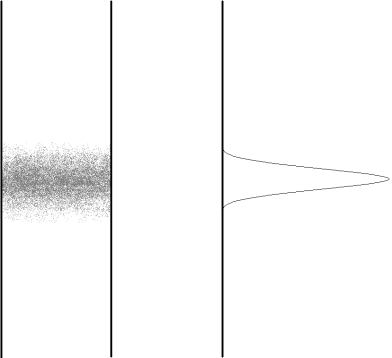

Figure 19. The representation on the left shows a band of a compound on a chromatographic column. The representation on the right shows the concentration profile of the band. The concentration is greatest at the center of the band.

The first thing to consider is what would happen to this profile if the flow of the column was stopped and the column was allowed to sit. We know from the random process of diffusion that there is a statistical preference in which more molecules diffuse away from regions of high concentration to regions of low concentration. If we were to allow this band to sit stopped in the column, it would slowly diffuse out from its central region and lead to a broadening of the concentration profile as shown in Figure 20.

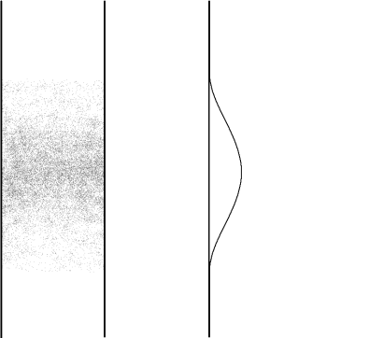

Figure 20. Representation of band or peak broadening that results from longitudinal diffusion. Compare to the concentration profile in Figure 19.

This observation of diffusion from a region of high concentration to one of low concentration will occur whether the band of material is sitting stationary in a column or is flowing through the column. A molecule flowing through a column has two means of movement. One is the physical flow that is taking place. But the other is still its ability to diffuse in a random manner from one point to another. All compounds moving through a chromatographic column must exhibit some degree of longitudinal diffusion broadening. Therefore, we can never get the idealized chromatogram shown in Figure 18a.

An important thing to consider is whether this phenomenon is more significant (i.e., happens faster and therefore causes more broadening, everything else being equal) in gas or liquid chromatography. To consider this, we would need to know something about the relative rates of diffusion of gases and liquids. A substance with a faster rate of diffusion will broaden more in a certain amount of time than something with a slower rate of diffusion. So the relevant question is, which diffuses faster, gases or liquids? I suspect we all know that gases diffuse appreciably faster than liquids. Just imagine yourself standing on the opposite side of a room from someone who opens a bottle of a chemical with the odor of a skunk. How fast do you smell this odor? Compare that with having the room full of water, and someone adds a drop of a colored dye to the water at one side of the room. How fast would that color make its way across the water to the other side of the room? In fact, gases have diffusion rates that are approximately 100,000 times faster than that of liquids. The potential contribution of longitudinal diffusion broadening to chromatographic peaks is much more serious in gas chromatography than in liquid chromatography. In liquid chromatography, the contribution of longitudinal diffusion broadening is so low that it’s really never a significant contribution to peak broadening.

Finally, we could ask ourselves whether this phenomenon contributes more to band broadening at higher or lower flow rates. What we need to recognize is that longitudinal broadening occurs at some set rate that is only determined by the mobile phase (gas or liquid) and the particular molecule undergoing diffusion. In the gas or liquid phase, it would be reasonable to expect that a small molecule would have a faster rate of diffusion than a large molecule. If we are doing conventional gas or liquid chromatography using organic compounds with molecular weights from about 100 to 300, the differences in diffusion rates are not sufficient enough to make large differences here. If we were comparing those molecules to proteins with molecular weights of 50,000, there might be a significant difference in the rate of diffusion in the liquid phase. If the longitudinal diffusion occurs at a set, fixed rate, then the longer a compound (solute) is in the column, the more time it has to undergo longitudinal diffusion. The compound would be in the column a longer time at a slower flow rate. This allows us to say that the contribution of longitudinal diffusion to overall peak broadening will be greater the slower the flow rate. If we use the term B to represent longitudinal diffusion broadening and v to represent flow rate, and want to relate this to h, we would write the following expression:
$$\text{h = }\frac{\text{B}}{\text{v}}$$

Remember that the smaller the reduced plate height the better. At high flow rates, B/v gets smaller, h is smaller, and the contribution of longitudinal diffusion to peak broadening is smaller.

We can also write the following expression for B: B = 2ϕD_{M}

In this case, D_{M} refers to the diffusivity (diffusion coefficient) of the solute in the solvent. Notice that this is a direct relationship: the faster the rate of diffusion of the solute, the greater the extent of longitudinal diffusion. ϕ is known as the obstruction factor, and occurs in a packed chromatographic column. In solution, a molecule has an equal probability of diffusion in any direction. In a packed column, the solid packing material may restrict the ability of the solute to diffuse in a particular direction, thereby hindering longitudinal diffusion. This term takes this effect into account.

Eddy Diffusion (Multipath) Broadening in Chromatography

Consider a group of molecules flowing through a packed bed of particles (Figure 21). Another way to think of this is to imagine you and a group of friends following a river downstream in a set of inner tubes. The river has a number of rocks in the way and a variety of different flow paths through the rocks. Different people go in different channels either because they paddle over to them or get caught in different flows of the current as they bounce off of obstacles.

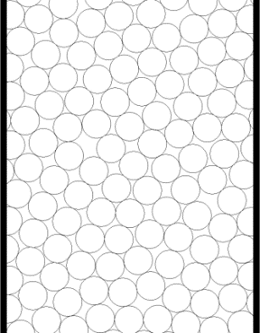

Figure 21. Representation of a chromatographic column packed with particles.

The question we need to consider is whether different molecules would have different path lengths as they passed through the bed. Would each person traveling down the river travel a slightly different distance, or would everyone travel the exact same distance? I suspect we can see that different molecules would end up traveling paths with different lengths as shown in Figure 22. One molecule (Molecule 1) might find a relatively straight shot through the packed bed, whereas another might encounter more particles that needed to be circumvented (Molecules 2 and 3). If we watched a group of molecules pass through a packed bed, and then mapped out each path with a length of string, we would see if we then stretched out all the strings, that there was a distribution of path lengths with some being shorter and some being longer. If that were the case, the molecule with the shortest path length would move through the column more quickly (Molecule 1). The molecule with the longest path length would move through the column more slowly (Molecule 3). If we have a distinction between the time it takes a set of molecules to move through the column based only on different path lengths, we have broadened the peak. This is known as eddy diffusion.

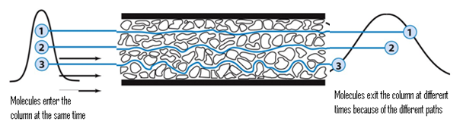
Figure 22. Representation of the different paths of three different molecules traveling through a packed bed of particles.
A key factor to consider when examining eddy diffusion is to ask whether the difference in length between the shortest and longest path depends at all on the diameter of the particles.
If it is, we could then ask which particles (smaller or larger) would lead to a greater difference in path length?

Almost everyone who is asked the first question seems to intuitively realize that the size of the particles must somehow make a difference. It just seems too coincidental to think that the difference between the shortest and longest path would be identical if the particle sizes are different. But interestingly enough, almost everyone, when they first consider this, seems to select the wrong answer when figuring out which particle (small or large) would lead to a greater difference in path length between the shortest and longest path. Remember, the important distinction is the size of the difference between the shortest and longest path, not whether one column would uniformly have longer path lengths than the other.

To help with this assessment, two columns are pictured in Figure 23, one with small particles, the other with larger particles.

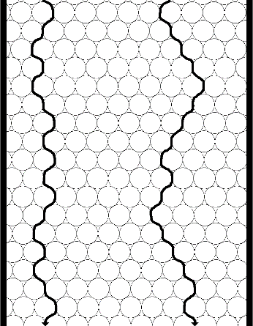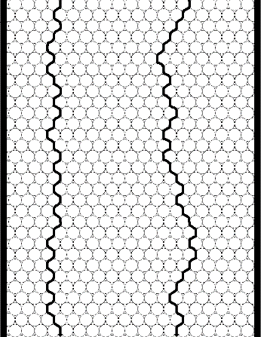

Figure 23. Representation of two columns with different size particles.

Note that the greatest distinction will occur between two molecules, one of which has found a relatively straight shot through the column, the other of which has encountered a lot of particles and so has to travel around them. Also note that the distance a molecule needs to travel around a larger particle is larger. Now you might be inclined to say that if we have to travel around lots of small particles, wouldn’t that eventually add up to the larger distance of travelling around one larger particle? Turns out that it doesn’t! The conclusion is that smaller particles will reduce the contribution of eddy diffusion to peak broadening (although we will add a proviso in just a bit). In other words, the distribution of path lengths of a set of molecules travelling through a packed bed is more uniform for a bed containing smaller particles than it is for a bed made up of larger particles. Thus, regarding eddy diffusion, there is a theoretical advantage to using smaller particles. That is the reason we use the reduced plate height (h = H/d_{p}) instead of the plate height for an overall assessment of column efficiency. If we had two people pack a column with the idea of seeing who packed a better one, if one person used smaller particles they would have a competitive advantage if we only compared the plate height (H).

It is also worth realizing that the flow profile shown in Figure 24 for a molecule would not occur (okay, there’s probably some infinitesimally small possibility that this could occur, but it’s so small that we could ignore it) in a chromatographic column. There is a physical flow pushing the material through the column and when a molecule reaches a flowing area, it will generally be swept downstream.
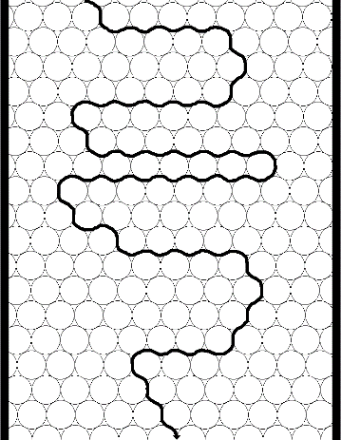

Figure 24. Unrealistic representation of the flow profile for a molecule through a packed chromatographic column.

Some packed columns exhibit channeling, and channeling leads to a significant and undesirable amount of eddy diffusion. The illustration in Figure 25 shows a column with a channel and compares two flow paths, one of which goes through the channel.

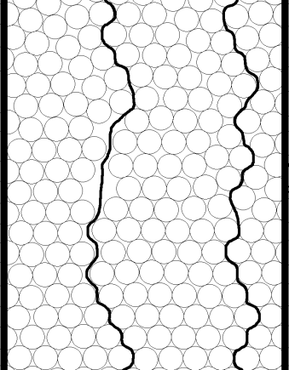
Channel

Figure 25. Representation of a packed chromatographic column with a channel.

Channels provide a straight path through a portion of the column and molecules in a channel avoid any need to move around any particles. A molecule moving through a channel will have a much more streamlined or shorter path than a molecule in an adjacent part of the column that has to move through the packed bed. Channels occur when the particles stick together in some way and separate from each other, instead of nesting together in a packing arrangement with every particle closest together. A liquid chromatographic column that has dried out (all of the mobile phase is allowed to evaporate) will likely develop channels during the drying process that will never close back up if it is rewetted. Channels in chromatographic columns are undesirable and introduce a lot of broadening into the system.
Another key thing to ask then is whether channeling is more likely to occur with smaller or larger particles. Channeling will occur if a column is poorly packed. There are very specific procedures that have been developed for packing gas and liquid chromatographic columns that are designed to minimize the chance that channeling will occur. One key to packing a good column is to slowly lay down a bed of particles so that they nest into each other as well as possible. In packing a gas chromatographic column, this will usually involve slowly adding the particles to the column while vibrating it so that the particles settle in together. Liquid chromatographic columns are usually packed slowly under high pressure. A column is packed efficiently when the particles are in a uniform bed with the minimum amount of voids. Given a particular particle size, the goal is to fit as many of them as possible into the column. We can then ask which is more difficult to pack efficiently, larger or smaller particles.

One way to think about this is if you were asked to fill a large box (say a refrigerator box) with basketballs or tennis balls. The goal is to fit as many of either one in as possible. You could imagine readily taking the time to carefully lay down each basketball into the refrigerator box, layer by layer, and fitting in as many basketballs as possible. You might also be able to imagine that you would start slowly with the tennis balls, laying in one in a time, and quickly lose patience at how long this would take to fill the entire box. If you then sped up, say by slowing dumping in balls from a pail while a helper shook the box, you would probably create more voids in the box. Also, because the interstitial volumes between the tennis balls will be smaller than that with the basketballs, any channels become more significant. The result is that it is more difficult to avoid the formation of channels with smaller particles. Recapping, smaller particles have a theoretical advantage over larger particles, but more care must be exercised when packing smaller particles if this theoretical advantage in column efficiency is to be realized.

Do open tubular capillary columns exhibit eddy diffusion? Capillary columns do not have packing material. Instead, they are long, narrow diameter tubes that have a coating of a liquid stationary phase on the internal walls of the column. A representation of a capillary column with a uniform coating of a liquid on the walls is shown in Figure 26.

Liquid
Coating
Flow

Figure 26. Representation of a coated capillary column.

Because there is no packing material to move around, there would not be any eddy diffusion in such a column. The absence of eddy diffusion broadening is one advantage that capillary columns have when compared to packed columns.

Finally, we could ask whether eddy diffusion exhibits any dependence on the flow rate. This actually turns out to be a difficult question to answer with conflicting opinions and data about whether there is a flow dependence, and if so, exactly what the dependency is. If we go back to van Deemter’s initial development of peak broadening in chromatography in 1956, we would see that van Deemter believed that the contribution of eddy diffusion to peak broadening did not depend in any way on the flow rate. This is a reasonable argument if we thought that we could draw a variety of different flow paths through a packed bed, and the difference in length between the shortest and longest flow path would be fixed irrespective of how fast the molecules were moving through the path.

But let’s return to our river analogy to see how the flow rate might get involved in this. Suppose the river had a relatively fast flow rate, such that different people in different inner tubes got locked into particular flow channels and stayed in those all the way down the river. Under that situation, each path would have a preset length and even if we slowed down the flow, so long as you were locked into a particular path, the difference in distance would be invariant. But suppose now we slowed down the flow so much that there were opportunities to drift around at points and sample a variety of flow paths down the river. This might lead to some averaging and the amount of sampling of different flow paths would be greater the slower the flow. This same thing can happen in a chromatographic column and leads to conflicting data and opinions about the nature of any flow rate dependence on eddy diffusion. Also, the exact point at which there is a crossover between a rapid flow that locks in a flow path versus a slow one that allows each molecule to sample many different flow paths is impossible to determine. This point is still not fully resolved, and literature on band broadening show different terms for eddy diffusion. We usually denote eddy diffusion by the term A. If you look at van Deemter’s initial treatment of peak broadening, you would see (note, van Deemter also did not use the reduced plate height, but we could write h = A as well):

H = A
(where A = 2λd_{p})

Note how the particle diameter (d_{p}) is included in this equation for A, so that the smaller the particle diameter, the smaller the contribution of eddy diffusion to the reduced plate height.

Another common conclusion today is that the contribution of eddy diffusion broadening does exhibit a slight dependence on flow rate. The usual form of this is that the dependence is v^{1/3}, and you might often see books or articles that include the following term in the overall band broadening equation.
h = A v^{1/3}

Still other people throw up their hands at all the confusion regarding eddy diffusion and show overall band broadening equations that do not have any A-term in them. We will develop another broadening term that has to do with processes going on in the mobile phase (and note that eddy diffusion only involves the mobile phase - none of what we talked about even requires the presence of a liquid stationary phase), so some people lump the eddy diffusion term into this other mobile phase term.

Stationary Phase Mass Transport Broadening

Consider a compound that has distributed between the mobile and stationary phase within a plate in a chromatographic column. Figure 27 might represent the concentration distribution profiles in the two phases (note that the compound, as depicted, has a slight preference for the mobile phase).
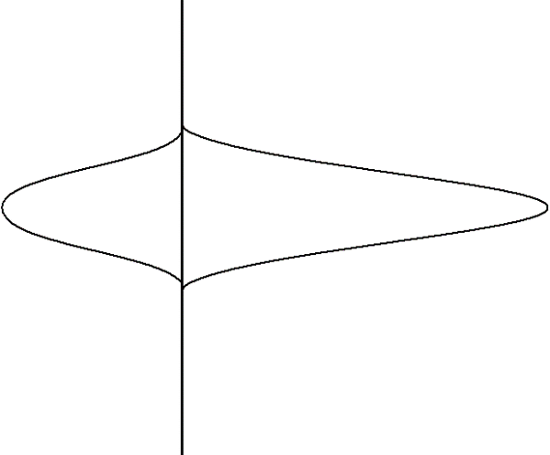
Concentration
Concentration
Mobile Phase
Stationary Phase
Flow

Figure 27. Representation of the concentration profiles for a compound distributed between the stationary (left) and mobile (right) phases of a chromatographic column. Note that the compound has a preference for the mobile phase.

What we want to do is consider what would happen to these two concentration profiles a brief instant of time later. Since the mobile phase is mobile and the solute molecules in it are moving, we could anticipate that the profile for the mobile phase would move ahead a small amount. Figure 28 illustrates this.

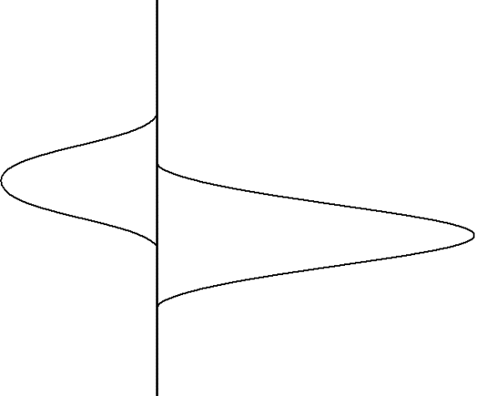
Concentration
Concentration
Mobile Phase
Stationary Phase
Flow

Figure 28. Representation of the two concentrations profiles in Figure 27 a brief instant of time later. Note that the mobile phase profile has moved ahead of the stationary phase profile.

What about the concentration profile for the solute molecules in the stationary phase? Consider the picture in Figure 29 for two solute molecules dissolved in the stationary phase of a capillary column and let’s assume that these are at the trailing edge of the stationary phase distribution.

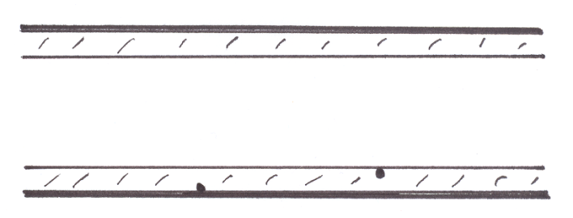
#1
Liquid Coating
#2
Figure 29. Two molecules dissolved in the liquid stationary phase of a capillary column.

What we observe is that the molecule labeled 1 is right at the interface between the stationary and mobile phase and provided it is diffusing in the right direction, it can transfer out into the mobile phase and move along. The molecule labeled 2, however, is “trapped” in the stationary phase. It cannot get out into the mobile phase until it first diffuses up to the interface. We refer to this process as mass transport. The solute molecules in the stationary phase must be transported up to the interface before they can switch phases. What we observe is that the solute molecules must spend a finite amount of time in the stationary phase. Since the mobile phase solute molecules are moving away, molecules stuck in the stationary phase lag behind and introduce a degree of broadening.

If we then consider the leading edge of the mobile phase distribution, we would observe that the molecules are encountering fresh stationary phase with no dissolved solute molecules and so these start to diffuse into the stationary phase when they encounter the surface. We can illustrate this in Figure 30 with arrows showing the direction of migration of solute molecules out of the stationary phase at the trailing edge and into the stationary phase at the leading edge.
Mobile Phase
Stationary Phase
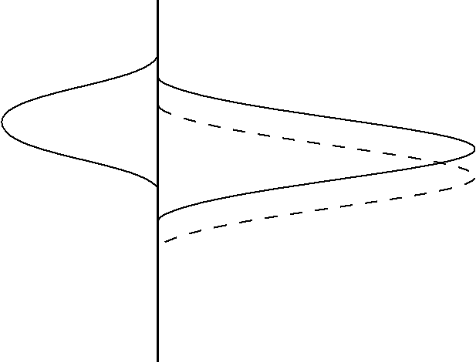
Concentration
Concentration
Flow

Figure 30. Representation of the movement of analyte molecules at the leading and trailing edge of the concentration distribution.

Hopefully it is obvious from Figure 30 that the finite time required for the molecules to move out of the stationary phase leads to an overall broadening of the concentration distribution and overall broadening of the peak.
A critical question to ask is whether the contribution of stationary phase mass transport broadening exhibits a dependence on the flow rate. Suppose we go back to the small amount of time in the first part above, but now double the flow rate. Comparing the first situation (solid line in the figure above) to that with double the flow rate (dashed line) leads to the two profiles. Hopefully it is apparent that the higher flow rate leads to a greater discrepancy between the mobile and stationary phase concentration distributions, which would lead to more broadening.

The term used to express mass transport broadening in the stationary phase is C_{S} (not to be confused with the C_{S} that we have been using earlier to denote the concentration of solute in the stationary phase). If we wanted to incorporate this into our overall band broadening equation, recognizing that higher flow rates lead to more mass transport broadening and reduced column efficiency (higher values of h), it would take the following form:

h = C_{S} v

Something we might ask is whether the flow rate dependency of the stationary phase mass transport term has any troublesome aspects. An alternative way to phrase this question is to ask whether we would like to use slow or fast flow rates when performing chromatographic separations. The advantage of fast flow rates is that the chromatographic separation will take place in a shorter time. Since “time is money”, shorter analysis times are preferred (unless you like to read long novels, and so prefer to inject a sample and then have an hour of reading time while the compounds wend their way through the column). If you work for Wenzel Analytical, we’re going to try to perform analyses as fast as possible and maximize our throughput. The problem with speeding up the flow rate too high is that we begin to introduce large amounts of stationary phase mass transport broadening. The shortening of the analysis time begins to be offset by broad peaks that are not fully separated. Ultimately, stationary phase mass transport broadening forces us to make a compromise between adequate efficiency and analysis time. You cannot optimize both at the same time.

Another thing we need to think about is what effect the thickness of the stationary phase has on the magnitude of stationary phase mass transport broadening. The pictures in Figure 31 for one wall of a coated capillary column serve to illustrate this point.

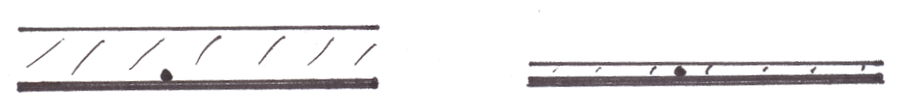

Figure 31. Representation for one wall of a coated capillary column with a thicker (left) and thinner (right) stationary phase coating.

Remember that the key point is that solute molecules spend a finite amount of time in the stationary phase, and since solute molecules in the mobile phase are moving away, the longer this finite time the worse. Therefore the thicker the phase, the more broadening will occur from stationary phase mass transport processes. This says that the ideal stationary phase coating ought to be microscopically thin, so that molecules rapidly diffuse into and out of the stationary phase, thereby reducing how far ahead mobile phase molecules can move in this finite amount of time. We should also be able to realize that the optimal coated phase ought to have a uniform thickness. If we have thin and thick regions as shown in Figure 32, we see that the time spent in the stationary phase by solute molecules will vary considerably, an undesirable situation. Compound 1 will likely spend less time in the stationary phase than compound 2.

#2
#1
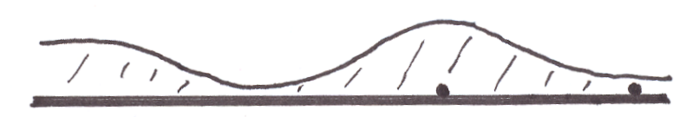

Figure 32. Representation of one wall of a coated capillary column with non-uniform thickness of the coating.

While microscopically thin coatings reduce stationary phase mass transport broadening, there are two problems with microscopically thin coated phases. If we consider the picture in Figure 31, where we have two capillary columns with different thickness coatings, the capillary column with the thinner coating will have much lower capacity than the one with the thicker coating. This means that there is much less weight of stationary phase over a theoretical plate for the column with the thinner coating and much less analyte dissolves into the stationary phase. Increasing the thickness of the coating or capacity of the column has several advantages. One is that it helps in the separation of the mixture (something we will learn more about later in the course). The other is that it is easy to overload or saturate a column that has a very low capacity.

This raises the question of whether you could design a column that has a thin stationary phase coating but high capacity. For coated capillary columns, this is not possible. A thinner coating in a capillary column means less capacity. For a coated packed column; however, it is possible to retain a high capacity while thinning the coating. Accomplishing this involves using smaller particles but the same weight of coating. Imagine taking large solid support particles and crushing them into a bunch of smaller particles. What you should realize is that the smaller particles have a much larger surface area. If we then coated the same amount of stationary phase (e.g., 5% by weight) relative to the weight of solid support, because of the larger surface area a thinner coating results. What we see is that the use of smaller particles has a theoretical advantage over the use of larger particles for coated stationary phases.

Another problem with coating microscopically thin phases is the risk of leaving some of the surface of the underlying solid support uncoated. These exposed solid surfaces (Figure 33) provide highly active sites for adsorption of solute molecules, and we have already seen how adsorption is an inefficient process that leads to peak tailing. While thin coatings have an advantage, great care must be taken in coating these phases to insure a complete coverage with uniform thickness of the surface.

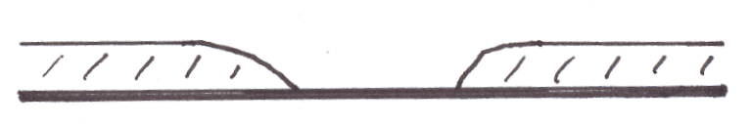
Exposed Solid
Surface
Figure 33. Representation of the wall of a coated capillary column showing an exposed solid surface.

Open tubular capillary columns are common in gas chromatography because it is possible to coat their inside walls with an exceptionally thin, uniform stationary phase. Today, it is also possible to chemically bond the liquid phase onto the interior surface of the capillary column. In the early days of capillary gas chromatographic columns, these were made of glass tubing that was approximately the same diameter as a melting point capillary that you are familiar with from organic chemistry. These columns were stretched from thick-walled glass tubes that were heated in an oven. As the capillary tube was stretched out, it was coiled in a coiling oven. It was common to use 30-meter lengths, essentially a 30-meter long glass slinky. The most common process for coating a capillary column involves what is known as the “moving plug” technique. As illustrated in Figure 34, the liquid stationary phase is dissolved in a plug of solvent that is pushed through the column using pressure from an inert gas. As the plug moves, it coats a very thin layer of liquid onto the inside walls of the column. As the solvent evaporates, a very thin layer of liquid stationary phase remains on the walls of the column. A systematic process is used to treat the inside walls of the column prior to coating to ensure that the liquid wets the surface well and is deposited uniformly over all of the interior surfaces.

Stationary Phase
in Solvent

Flow

Figure 34. Moving plug technique for coating a capillary column.

One problem with these glass columns was their fragility. Many frustrated workers broke the columns trying to mount them into a gas chromatograph with leak-proof fittings. The fittings used with these glass columns are usually made of graphite, a soft substance that often can be molded around the tube without breaking it (but if you’re not careful, it’s easy to break it). Another problem is caused by the chemical nature of glass. We think of glass as a silicate material (SiO₂), but it actually turns out that most silicate glasses contain other metal ions as constituents (aluminum, magnesium, calcium, and iron oxides are some of the other metals present). In some glasses, these other metals can be as much as 50% of the glass. These metals are positively charged centers, and if some of the surfaces are not coated by the liquid phase (an inevitable occurrence), these metal ions provide active sites for adsorption that cause tailing of compounds (especially oxygen- and nitrogen-containing compounds that have dipoles).

The capillary columns used in gas chromatography today are known as fused silica columns. Fused silica is pure silicon dioxide (SiO₂) and lacks the metal ions in regular glass. The surface of fused silica is considerably less active than the surface of regular glass. Fused silica is widely used in the production of devices known as fiber optics. Fiber optics are thin, solid glass fibers. Light is shined into one end of the fiber at an angle that causes complete internal reflection of the light as shown in Figure 35.

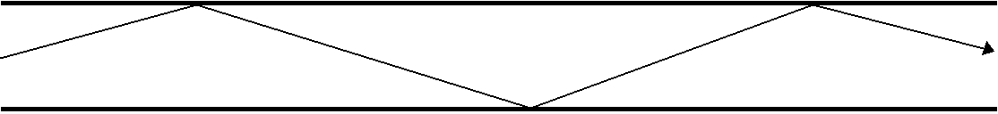

Figure 35. Complete internal reflection of a light beam inside a fiber optic.

Light going in one end (e.g., New York City) exits out the other end (e.g., Los Angeles, CA). The light can be pulsed (sent in small bursts) and the speed of light allows for very rapid communication. It turns out to be easy to make fiber optic-like devices with a hole in the center (in fact, it took people a while to learn how to make glass fibers without the hole since the fibers tend to cool from the outside to the inside, leading to contraction and a hole in the center). The hole in the center of fused silica capillary columns is so small you cannot see it with the naked eye (we will see later that this very small opening has advantages in chromatographic applications). Also, these capillary columns are incredibly flexible. They can be tied into knots, and more importantly for chromatographic applications, leak-tight fittings can be attached without breaking the columns. The deactivated surface, flexible nature making them easy to install and use, and chromatographic efficiency (partly because of the deactivated surface, partly because of how well they can be coated with thin phases, and partly because of the small diameter) make them the column of choice for most gas chromatographic applications today. The only drawback to these columns is that they have very small capacities. Gas chromatographs built to use fused silica capillary columns usually have what are known as split injection systems. A typical injection size for a gas chromatographic sample is 1 µL. Even this amount is too much for a fused silica capillary column, but reproducibly injecting smaller volumes is very difficult. Instead, the flow from the injector is split, and only a small part (often 1 in 50 to 1 in 100) is actually sent into the capillary column. The rest is vented away and never enters the column.

Another thing we need to examine under the topic of stationary phase mass transport broadening is the nature of the stationary phase used today in liquid chromatography. In 1963, Calvin Giddings published a significant paper titled “Liquid Chromatography with Operating Conditions Analogous to Those of Gas Chromatography” (Analytical Chemistry, 1963, 25, 2215). At this point in time, gas chromatography was the method of choice when performing analyses because existing gas chromatographic columns were far more efficient than the liquid chromatographic columns that were available. In fact, gas chromatography was so preferable to liquid chromatography that many publications of the 1960s and 1970s described ways of preparing volatile derivatives of non-volatile compounds so that they could be analyzed by gas chromatography. The extra steps involved in the derivatization were worthwhile since liquid chromatographic methods were not good enough to separate most compounds in complex mixtures.

What Giddings did in this paper was show that it was theoretically possible to perform liquid chromatography at the efficiency of gas chromatography. The key feature, which we have not yet fully developed because we have one more contribution to broadening to examine, was to use exceptionally small particles with exceptionally thin coatings in liquid chromatographic columns. Of course, these exceptionally thin coatings cause several problems. One is how to coat them so that none of the surface of the solid support is exposed. If you can coat them uniformly, another problem in a liquid chromatographic system is that there might be locations in the column where the flowing liquid mobile phase can physically wash away regions of the coated phase thereby exposing the underlying solid surface. Finally, there is no such thing as two liquids that are completely immiscible in each other. It’s true that oil and water don’t mix, but it’s also true that a little bit of oil will dissolve in water. Over time, the coated stationary phase will gradually dissolve away in the mobile phase, eventually exposing the underlying solid surface. Even though Giddings showed in 1963 how to perform liquid chromatography at the efficiency of gas chromatography, the phases that were needed could not be coated in a way that it was a widely practical method.

It was not until the late 1970s, when bonded liquid chromatographic stationary phases were introduced, that it was finally practical to do liquid chromatography with the same efficiency as gas chromatography. Bonded phases relied on silica gel, something we already encountered when we first talked about solid phase, adsorption chromatography. Silica gel is an excellent support for liquid chromatographic phases. It is physically robust, stable at pH values from about 2 to 8, and can be synthesized in a range of particle sizes including the very small particle sizes needed for liquid chromatography. The chemistry used in preparing bonded phases is shown in Figure 36. Basically this involves the surface derivatization of the silanol groups on the surface of the silica gel with chlorodimethyloctadecylsilane. The C₁₈ or octadecylsilane (ODS) phase shown in the scheme are the most common ones used. The pyridine is added to remove the HCl produced in the reaction.
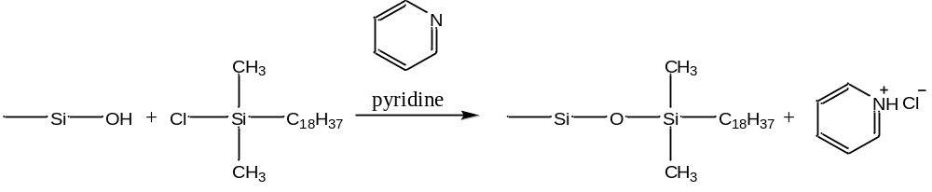
Figure 36. Scheme for bonding C₁₈ groups to the surface of silica gel.

Other common bonded phases use C₈ or C₁ surface groups. You can also purchase bonded phases with phenyl groups, C₃H₆NH₂ (aminopropyl) groups, and C₃H₆CN groups. But the C₁₈ phases are so common, and so versatile, that we will examine these in more detail.

The first thing to realize is that attaching the C₁₈ groups converts a highly polar surface (the silanol groups can form hydrogen bonds) into a non-polar surface. In effect, this is like attaching a one-molecule thick, oily skin to the surface of silica gel. There is some question about the exact conformation of the attached C₁₈ groups. Figure 37 shows two forms, one with the C₁₈ groups extended, the other with the C₁₈ groups collapsed. There is substantial evidence to support the idea that if the non-polar C₁₈ phase is in contact with a mobile phase that is very polar (e.g., water), that the C₁₈ groups are in the collapsed form. Putting the C₁₈ phase in contact with a less polar mobile phase (e.g, methanol) leads to more extension of the C₁₈ groups.

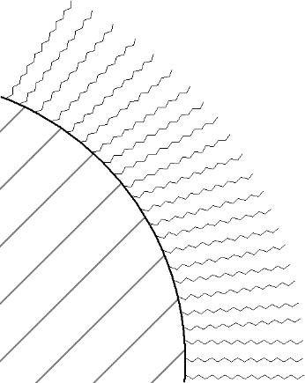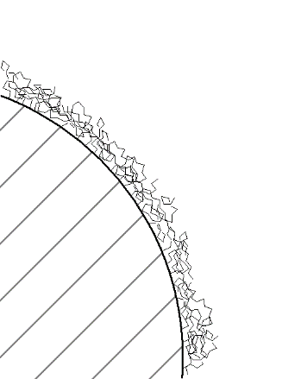
Collapsed Form
Extended Form

Figure 37. Extended and collapsed forms of C₁₈ groups bonded to the surface of silica gel.

If we examine the extended form of the C₁₈ phase, it is interesting to consider the nature of this material at the outer regions. Even though the C₁₈ groups are attached to a solid, are they long enough such that the outer edges are “fluid” enough to behave more like a liquid than a solid? If so, then molecules might distribute into these phases by a partitioning mechanism. If not, then molecules adsorb to the surface. We previously learned that adsorption was undesirable when compared to partitioning, but that was adsorption on a polar surface. The non-polar, deactivated nature of the C₁₈ surface does not provide strong adsorption sites so peak tailing is quite minimal with C₁₈ bonded phases.

If you look at most liquid chromatograms, though, you will see that the peaks tail more than in gas chromatography. The likely reason for this is that some of the surface silanol groups remain underivatized. Crowding of the C₁₈ groups during the derivatization process makes it unlikely that all of the silanols can be reached and deactivated. In an effort to minimize the number of unreacted silanol groups, some commercially available C₁₈ phases are end-capped. End capping involves exhaustively reacting the C₁₈ phase with a much smaller silane such as chlorotrimethylsilane (ClSi(CH₃)₃).

Because of the covalent bonds, the C₁₈ groups cannot wash or dissolve off of the solid support. With regards to mass transport in the stationary phase, we said that we want the stationary phase as thin as possible. C₁₈ bonded phases are essentially one-molecule thick. We could never coat a one-molecule thick chromatographic phase that was uniform and had no exposed solid surfaces. Therefore, we could never really make a liquid chromatographic phase with faster stationary phase mass transport properties than the bonded silica phases.

Until recently, the common particle sizes to find in commercially available C₁₈ columns had diameters of 3, 5, and 10 µm. Columns using particles of these sizes are commonly referred to as high performance liquid chromatography (HPLC). Recently columns with 1.7 or 1.8 um particles have become commercially available and there use is referred to as ultra-high pressure liquid chromatography (UPLC). Smaller particles will require higher pressures to force a liquid through the column and UPLC columns can run at pressures up to 15,000 psi. In gas chromatography, we observe that smaller particles usually have thinner coatings because they have more surface area. Note that for these bonded phases the thickness of the stationary phase with the 1.7, 3, 5, and 10 µm particles is always identical. What does change is the surface area. A column packed with 3 µm particles will have more surface area than a column of the same length packed with 5 or 10 µm particles. This increased surface area leads to an increase in the column’s capacity. If the columns are the same length, the increased capacity will lead to increased separation of compounds and lengthen the retention times. The usual approach is to use shorter columns with the smaller particles. The shorter column reduces the analysis time because there is less volume of mobile phase in the column. Typically C₁₈ columns packed with 10 µm particles are 25 cm long; 5 µm particles are used in columns that are 15 cm long; and 3 µm particles are used in columns that are 3 cm long. These $\text{3×3}$ columns can have very short analysis times. A negative aspect is that they are more susceptible to fouling by contaminants in the sample. Also, a difficulty with ultra-small particles involves packing the columns so that there are no channels. Because of the small particles, liquid chromatographic columns require highly specialized packing procedures. Finally, the particles need to have uniform sizes (the smaller the particle, the smaller the tolerance on the range of particle sizes that can be used). A mixture of particles of different sizes is known as an aggregate. Concrete is an excellent example of an aggregate. The problem with an aggregate is that the smaller particles fill in the voids between the larger particles, making it very difficult to get a liquid to flow through the bed.

One last thing we can consider is whether stationary phase mass transport broadening is more significant in gas or liquid chromatography. We have to be careful here, because it’s a somewhat subtle distinction. What we need to consider is the diffusion rate of the solute in the stationary phase. In gas chromatography, we have a gaseous molecule dissolved in a liquid coating. The important thing is that it is a dense liquid with a molecule dissolved in it. The diffusion rate is therefore rather comparable in this stationary phase to that of a liquid. Of course, a liquid chromatographic column is usually at room temperature whereas a gas chromatographic column is usually at some elevated temperature that is often higher than 100ºC. We know that diffusion rates are temperature dependent, so that the rate ought to be faster in gas chromatography, and mass transport broadening in the stationary phase ought to be more significant in liquid chromatography, assuming everything else is equal. Just realize that this is not a 100,000-fold difference, because the stationary phase in gas chromatography is not a gas, but a heated liquid. It is also possible to operate liquid chromatographic columns at higher temperatures to speed up the rate of diffusion and improve the mass-transport broadening.

Mobile Phase Mass Transport Broadening

It’s going to turn out that a similar mass transfer effect occurs within the mobile phase. The thing to consider here is that we want solute molecules to encounter the surface of the stationary phase as quickly as possible so that they can immediately undergo a distribution between the two phases.

For example, if we reconsider the picture for mass transport broadening in the stationary phase (Figure 38), we realize that we want the molecules at the leading edge of the mobile phase profile to quickly encounter and enter the stationary phase, otherwise they will move further ahead and broaden the distribution.
Mobile Phase
Stationary Phase
Flow
Concentration
Concentration

Figure 38. Representation of the movement of analyte molecules at the leading and trailing edge of the concentration distribution.

Another way to examine mobile phase mass transport broadening is to consider a capillary column as shown in Figure 39.
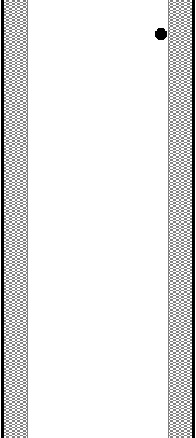
Flow
Stationary Phase

Figure 39. Capillary column showing a molecule (black dot) that has just left the stationary phase.

The dot represents a molecule that has just left the stationary phase and is about to diffuse across the mobile phase and re-encounter stationary phase on the other side of the column.
It is helpful to draw a line representing the path of the molecule, and then draw a second line for the path of the molecule if the flow rate were doubled (Figure 40). We could also imagine a situation in which the flow was so fast that the molecule never re-encountered the stationary phase. This would be a problem since it’s important for the molecule to encounter the stationary phase if we are to ever have a distribution occurring that leads to a separation of two compounds.

Flow
Stationary Phase

Figure 40. Representation of the movement of a molecule as it diffuses through the mobile phase. The longer the arrow, the higher the flow rate.

If we are using capillary columns in a chromatographic system, what does this observation above suggest about the desirable diameter for such a column? Hopefully it would be apparent that a much smaller column diameter would lead to much faster encounters with the stationary phase. So we want capillary columns of very small diameter. That is one of the reasons why the fused silica columns used today in gas chromatography are so efficient. We can not even see the opening in these columns with the naked eye. They really approach the limit of how narrow we are able to make chromatographic capillary columns.

Next we need to ask whether this effect occurs in a packed column. If we think about a packed column, we should realize that there are voids, or interstitial volume, between the particles that make up the packing (Figure 41). Solute molecules need to diffuse across these voids to encounter the stationary phase. The larger the void, the more time it takes to diffuse across, and the more significant the mobile phase mass transport broadening. How can we reduce the voids? If we use smaller particles, they will pack closer together and reduce the interstitial volume between the particles. Once again, we see how small particles offer a theoretical advantage when compared to large particles. Note that this has happened in every instance when particle size made a difference. Using a packing material with smaller particles is better, provided we pack a good column with minimal to no channeling.

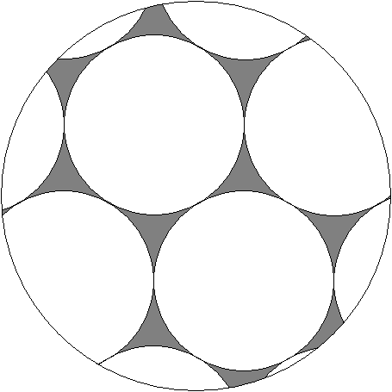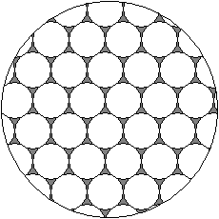
Interstitial
Volume

Figure 41. Representation of a packed column showing the interstitial regions.

Another critical question to consider is whether mobile phase mass transport broadening is more significant in gas or liquid chromatography. To answer this, we need to realize that we want the solute compound to diffuse across regions of mobile phase as fast as possible. If we remember that gases diffuse about 100,000 times faster than liquids, we realize that the impact of mobile phase mass transport broadening is significantly lower for gases than it is for liquids. In fact, mobile phase mass transport broadening is the most important distinction between gas and liquid chromatography. Gases diffuse far more quickly across regions of mobile phase than do liquids. That means in liquid chromatography we need far smaller mobile phase voids to reduce the magnitude of this term. When Giddings published his important paper in 1963 on doing liquid chromatography with the efficiency of gas chromatography, this was a critical realization put forward in this paper.

What does this mean for practical applications of liquid chromatography? If we were to try to perform capillary liquid chromatography, it would mean that we ought to have columns with much smaller internal diameters than we use for gas chromatography. But gas chromatography already uses fused silica columns, which essentially reach the limit of practical internal diameters (remember, if we reduced this diameter even smaller, we introduce a problem of not having enough sample capacity in the column and would have a very difficult time actually introducing sample into the column), so capillary liquid chromatography is not a practical method and does not offer the same advantages of capillary gas chromatography. There are researchers who investigate aspects of capillary liquid chromatography, but it is not a commercial method and is not used widely by practitioners in the field. As far as packed column liquid chromatography, we have already seen how we end up using very small particles (1.7, 3, 5, and 10 µm). The real value of these small particles is that they reduce the interstitial volume of mobile phase between the particles, thereby reducing the time required for mobile phase mass transport. Gas chromatography can be done with much larger particles because of the much faster mobile phase mass transport.

Another aspect of the particles used in most liquid chromatographic phases is that they are totally porous. In many ways, they resemble a sponge with pores going throughout the structure. With such a highly porous structure, it is reasonable to expect that there could be some “dead-end” pores. Such pores would fill with mobile phase and essentially provide regions within the particle of “immobile” mobile phase. Solute diffusion through these regions would represent a similar mass transport problems as solute diffusion within the stationary phase. So mass transport within these stagnant regions of mobile phase is a significant problem. A way to improve the broadening is to use something called a core-shell particle (Figure 42). In these particles, the inner part is a solid material without any pores. Only a small outer shell is porous and has the bonded C₁₈ groups. Core-shell particles have much faster mass transport than totally porous particles and therefore much smaller plate heights and narrower peaks. Core-shell particles also lead to improvements in the Eddy Diffusion term as well. Core-shell particles will have less stationary phase than totally porous particles, meaning they have lower capacity and the columns can be more easily overloaded.

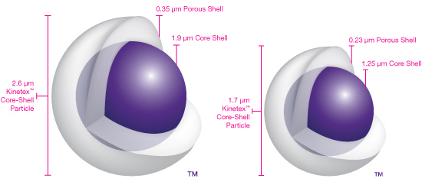

Figure 42. Representation of core-shell liquid chromatographic phases.

The last thing we could consider about mobile phase mass transport broadening is whether its overall contribution to band broadening depends on flow rate. If we go back to our initial picture of the capillary column, we know that we want the solute molecules to encounter stationary phase as often as possible. The faster the flow, the fewer encounters, so a faster flow makes this contribution worse (this is analogous to the leading edge of the mobile phase distribution moving ahead more per unit time, thereby causing more broadening of the overall distribution). If we needed to write a term to go into our equation for h, and we represent mobile phase mass transport broadening as C_{M} (be careful not to confuse this with C_{M} the concentration of solute in the mobile phase that we have used earlier), the term would take the following form:

h = C_{M} v

Notice how the relationship is analogous to what we saw with mass transport broadening in the stationary phase.

Concluding Comments – Peak broadening in Chromatographic Systems
Can you now draw a generalized plot of h versus flow rate?

We have now developed all four contributions to peak broadening in chromatographic systems, compared their significance in gas and liquid chromatography, and seen how current state-of-the-art columns have been designed to minimize band broadening effects. We can now pull together all four of the contributions into one equation that reflects overall contributions to peak broadening. It is shown below, using one common way of expressing the eddy diffusion term:

h = Av^{1/3} + B/v + C_{S} v + C_{M} v

It is worthwhile examining the overall form of this expression. First note how the longitudinal diffusion term (B/v) will become very large at very low flow rates. Note how the mass transport terms (C_{S} v and C_{M} v) will become very large at very high flow rates. This implies that this equation will have a minimum at some intermediate flow rate. A generalized plot of this equation for a gas chromatographic packed column is shown in Figure 43. The general contributions of the longitudinal diffusion and mass transport terms to the equation are also represented. The optimal flow rate for a gas chromatographic packed column is around 15 to 20 mL/minute. A lot of times people actually run these at higher flow rates of about 30 mL/minute. The reason for this is to shorten the analysis time. Some column efficiency is sacrificed, but the entire separation process is a balance between chromatographic efficiency and analysis time, where there is a desirability to shorten this if possible.

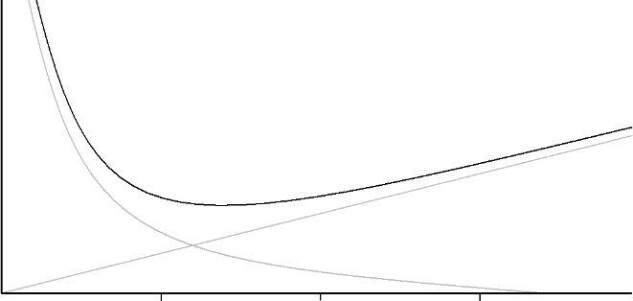
B/v
10
30
20
(C_{S} + C_{M}) v
h
Flow Rate (v) (mL per minute)

Figure 43. Generalized van Deemter plot for a packed gas chromatographic column.

A similar plot is shown in Figure 44 for liquid chromatography. Notice in this case that extremely low flow rates must be used before longitudinal diffusion becomes a significant contribution to broadening. This means that the optimal flow rate for liquid chromatographic separations is very slow, which is undesirable because of the long analysis times this would create. Instead, a common flow rate for a packed C₁₈ liquid chromatographic column is in the 1.0 to 1.5 mL/minute range.

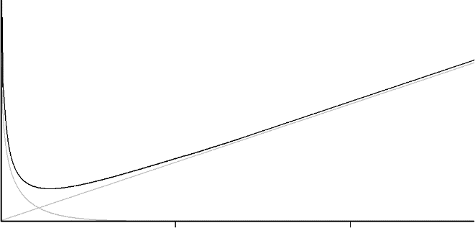
B/v
1.0.5
2.0
(C_{S} + C_{M}) v
h
Flow Rate (v) (mL per minute)

Figure 44. Generalized van Deemter plot for a packed liquid chromatographic column.

Earlier we learned that smaller particles are preferable and provide more efficient liquid chromatographic columns by virtue of reducing the contributions of eddy diffusion and mobile phase mass transport to peak broadening. Figure 45 shows a van Deemter plot for liquid chromatographic columns three porous silica particles with diameters of 5, 3.5 and 1.8 um and fused-core particles with a diameter of 2.7 um. The enhanced efficiency, as evidenced by reductions in the plate height, for smaller particles and the fused-core particles are apparent.

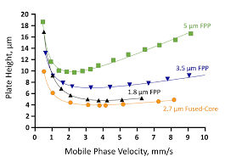
Figure 45. van Deemter plot for a packed liquid chromatographic column containing porous silica particles with diameters of 5, 3.5 and 1.8 um and fused-core particles with a diameter of 2.7 um.

For capillary GC columns, which are more commonly used today than packed GC columns, instead of setting a column flow rate you often set the column head pressure to a value recommended by the instrument manufacturer. By adjusting the pressure of the carrier gas (usually helium) at the beginning of the column, this insures an adequate flow of gas through the column. The desired head pressure depends on the length and internal diameter of the capillary column. Longer or narrower columns will require higher pressures to maintain adequate flow. One observation is that the pressure of the gas drops from the beginning to the end of the column, such that the flow rate changes over the column as well. Instead of measuring a flow rate for a fused silica capillary column in mL/min, it is more common to measure the carrier gas velocity (u) in cm/sec. Since this value changes as well over the column, an average value is obtained by dividing the column length in cm by the retention time in seconds of an unretained compound.

u (cm/sec) = | ___column length (cm)___
u (cm/sec) = | RT of unretained peak (sec)

A plot of the plate height versus carrier gas velocity for a column that is 25 m long and has a 0.25 mm internal diameter is shown in Figure 46. The characteristic observation of an optimum velocity as which to minimize peak broadening is observed.

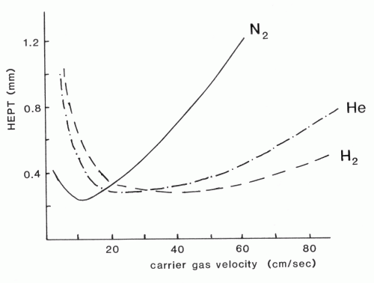

Figure 46. van Deemter plots for a capillary gas chromatographic column.

Why is the plot different for nitrogen versus helium as the carrier gas? The key difference between nitrogen and helium is the viscosity of the two gases. Nitrogen, as a heavier molecule, will have a higher viscosity than helium. The higher viscosity of nitrogen slows down the diffusion rates and increases the contribution of mobile phase mass transport broadening. Using helium as the carrier gas leads to improved efficiency because of the reduction in mobile phase mass transport broadening relative to nitrogen. Also, the u_{opt} for helium is at a higher flow rate meaning that the analysis time can be shortened. This plot shows that hydrogen would actually be a better carrier gas than helium. Hydrogen is rarely used as a carrier gas because of its explosion risk.

FUNDAMENTAL RESOLUTION EQUATION

Another important equation in chromatographic separations is the fundamental resolution equation. The equation relates the resolution of two compounds (R_{S}) to the number of theoretical plates (N), retention or capacity factor (k), and selectivity factor (α). Appendix I shows the derivation of the fundamental resolution equation. Since we would usually be interested in separating two compounds that are close to each other in a chromatogram, and therefore possibly not resolved, we usually think of applying this equation when we want to improve the resolution of two adjacent components.

$${\text{R}}_{\text{S}}\text{ = }\left(\frac{\sqrt{\text{N}}}{\text{4}}\right)\left(\frac{\text{α}-\text{1}}{\text{α}}\right)\left(\frac{{\text{k}}_{\text{2}}}{\text{1 + }{\text{k}}_{\text{2}}}\right)$$

The interesting part about this equation is that it is possible to examine a chromatogram with poor resolution, decide which of the three terms is causing the most serious problem, and then make systematic experimental changes to improve the results. It is worth examining the types of experimental changes that can be made to influence each of these terms. Notice that in each case, making the term larger will improve the resolution.

N - Number of theoretical plates

One obvious way to increase the number of plates is to increase the length of the column. Doubling the length doubles the number of theoretical plates. One cautionary note about this is to consider the square root dependency on the number of plates in the equation. Doubling the column length will double the analysis time, but will not double the resolution. We would need a column four times longer to achieve a doubling of the resolution. Increasing the number of plates will always give better resolution, but there are diminishing returns when the increased analysis time is considered.

Another thing to examine is factors that influence the band broadening equation. That equation related broadening to h, and the smaller the value of h, the more plates in a column. One thing we could do is optimize the flow rate of the system. We mentioned how it was common to use a flow rate higher than the optimal one to shorten the analysis time. Slowing down the flow rate may provide enough gains in efficiency to separate two compounds that are not fully resolved.

Another change to make is to use smaller particles. In gas chromatography, this will lead to a thinner coating, improving mass transport broadening in the stationary phase. In both gas chromatography and liquid chromatography, smaller particles will reduce the interstitial volume and reduce mobile phase mass transport broadening. Smaller particles, provided they are packed well, also will reduce broadening contributions from eddy diffusion.

α - Selectivity factor

The first thing to notice about this term is that there are diminishing returns to resolution as it is made excessively large. Table 1 provides values of α and (α – 1)/ α.

Table 1. Values of α and (α – 1)/ α.

α (α – 1)/α

1 0
2 ${\text{1}}/{\text{2}}$
3 ${\text{2}}/{\text{3}}$
4 ${\text{3}}/{\text{4}}$
5 ${\text{4}}/{\text{5}}$
6 ${\text{5}}/{\text{6}}$

Notice that the (α – 1)/α term approaches a value of 1 at high values of α. Optimal α-values for most separations are between 2 and 5.

Remember that the α-value refers to the ratio of the two partition coefficients for the two components. If we wanted to make a substantive change in α, we need to change the partition coefficient of one component but not the other (or we need to change both appreciably but differently to impact the ratio). There is really only one way to do this and it involves changing the identity of the stationary phase. This would involve using a different liquid phase in gas chromatography. As we will see, there are many available liquid phases for use in gas chromatography, so changing the nature of this phase and hence the α-values is a common procedure.

In liquid chromatography, this would mean switching from a C₁₈ to some other bonded phase. Since the range of bonded phases is more limited and changes of questionable utility in many instances, this is not done that frequently. One thing you might wonder about is whether changing the nature of the mobile phase in liquid chromatography would be viewed as constituting a change in α. This is easily done and is the most common way in liquid chromatography to improve the resolution of two substances that are not fully resolved. It turns out that changes to the mobile phase are generally regarded as changes to the retention or capacity factor. Usually this might involve altering some aspect of the mobile phase so that all the compounds exhibit a higher capacity, stay on the column longer, and exhibit better resolution.

k – Retention or capacity factor

Similar to the α-value term in the fundamental resolution equation, the term with k also approaches 1 at higher values of k, as seen by the data provided in Table 2. Therefore we can say that optimal k values are also between 2 and 5. Also, larger k values will always lead to longer retention and analysis times.

Table 2. Values of k₂ and k₂/(1 + k₂).

k₂ k₂/(1 + k₂)

0 0
1 ${\text{1}}/{\text{2}}$
2 ${\text{2}}/{\text{3}}$
3 ${\text{3}}/{\text{4}}$
4 ${\text{4}}/{\text{5}}$
5 ${\text{5}}/{\text{6}}$

Remember that we defined k earlier in the course as:

$${\text{k}}_{\text{2}}\text{ = }{\text{K}}_{\text{2}}\left(\frac{{\text{V}}_{\text{S}}}{{\text{V}}_{\text{M}}}\right)$$

So anything that alters any of the terms of this equation will lead to a change in k. As we already mentioned above, the most common way to change k in liquid chromatography is to alter the constituents of the mobile phase. This will change the distribution constant (K₂), and if the correct change is made, make K₂ larger and k larger. The analog to this in gas chromatography is to change the temperature. Recall that:

$${\text{K}}_{\text{2}}\text{ = }\frac{{\text{C}}_{\text{S}}}{{\text{C}}_{\text{M}}}$$

We could consider what happens to this ratio as the temperature is changed. The stationary phase is a liquid. The mobile phase is a gas. Hotter temperatures reduce the solubility of a gas in a liquid (warm soda will go flatter faster). Thermal pollution refers to the reduction in the concentration of dissolved oxygen gas when warm water from a power plant or industrial cooling process is added to a river or lake. So hotter temperatures will reduce C_{S}, reduce K₂ and reduce k. This would actually make the resolution worse. So by cooling down a gas chromatographic column, we increase the retention factor and improve the resolution. Of course, this also lengthens the analysis time, which may be undesirable.

If we examine the volume terms, we realize that it is difficult to change V_{M}, the volume of the mobile phase. V_{M} is the interstitial volume and is essentially fixed for a particular particle size. There is no way to crunch the particles closer together to reduce V_{M}. In gas chromatography, it is easy to alter V_{S}, the volume of the stationary phase. This would involve coating a thicker loading (e.g., instead of 3% liquid coating, raise it to 5%). Changing V_{S} in liquid chromatography really is not an option since we have bonded C₁₈ groups and do not coat different thickness phases. If we change the particle size from 5 µm to 3 µm, and keep everything else, we do create more capacity in the column (because the 3 µm particles have more surface area), but we create more plates as well.

Consider the chromatogram in Figure 47. We observe two problems with this separation. The first few compounds come out of the column very quickly and are not fully resolved. The latter compounds are fully resolved but stay in the column too long and are very broad.

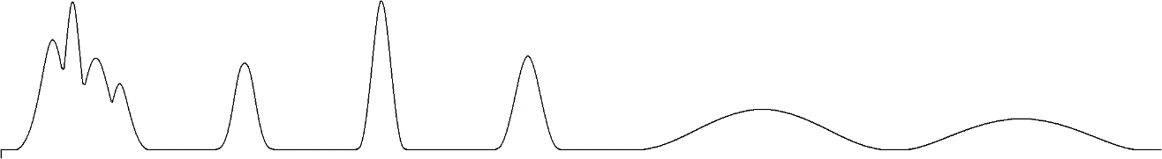
INJ

Figure 47. Chromatogram with non-optimal k values for the earlier and later eluting compounds.

What problem exists in this separation? If we were to enlarge N to improve the resolution of the first few compounds, we would lengthen the retention time of the latter ones as well, which would be unacceptable. If we changed α, it might resolve some of the overlapped constituents but might cause some that are already resolved to now overlap with each other. We have a capacity problem (k) in this chromatogram. The first few compounds do not have enough capacity and would benefit by spending more time in the stationary phase. The latter few have too high a retention factor and are spending too much time in the stationary phase. What we say is that a chromatogram has a limited peak capacity. In other words, it is only possible to separate a certain amount of compounds within a fixed period of time in the chromatogram. There is only some number of peaks that can be fit in side by side before they start to overlap with each other.

In gas chromatography, there is a way to address these problems during the chromatogram so that all of the constituents are chromatographed at a k value that is more optimal. If we lowered the temperature during the early portion of the chromatogram, we would raise the retention factor of these constituents of the sample and they would stay on the column longer. If we raised the temperature during the latter portion of the chromatogram, we would lower the retention factor of these constituents and they would come off of the column faster. This systematic raise in temperature during the chromatogram is known as a temperature program. Most gas chromatograms are obtained using temperature programming rather than isothermal conditions. The temperature program chromatogram for the same mixture is shown in Figure 48.

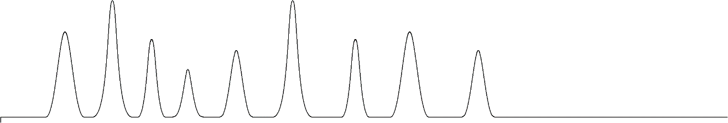
INJ

Figure 48. Chromatogram with more optimal k values.

There is an analogous procedure in liquid chromatography that is known as gradient elution. In this technique, you start with a mobile phase that causes the constituents of the sample to have a high retention factor and then systematically vary the mobile phase during the run to lower the capacity of the constituents. The exact nature of the changes that might be made to accomplish this will be discussed later in our unit.

LIQUID CHROMATOGRAPHIC SEPARATION METHODS

Liquid chromatographs are fairly simple pieces of equipment. There is a solvent reservoir that holds the mobile phase, a high pressure pump, an injection valve, a column, and a detector (Figure 49).

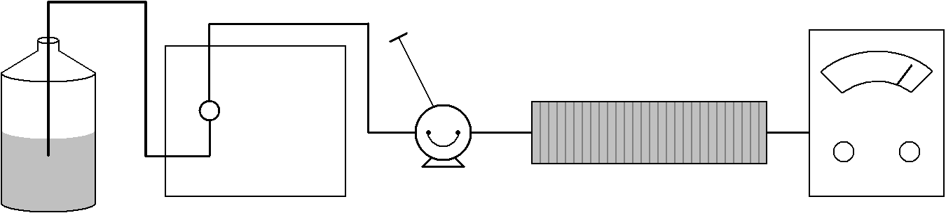
Column
Detector
Injection Port
Pump
Solvent
Reservoir

Figure 49. Components of a liquid chromatograph.

The pumps are usually reciprocating small-volume pumps that use inlet and outlet check valves (Figure 50). There is a small cylinder with a sapphire piston. The inlet and outlet valves essentially have a moveable ball in them. When the cylinder is full of fluid and pushing it into the chromatograph, notice how the ball in the inlet check valve will move down and block the opening to the solvent reservoir. Also notice how the ball in the outlet check valve will pop up, allowing flow into the column. When the cylinder is almost empty and the piston recycles to fill (this recycle step is very fast), the ball in the inlet check valve pops up and allows flow from the solvent reservoir to the cylinder. The ball in the outlet check valve moves down, blocking the hole, and prohibiting flow back from the column. The flow out of a reciprocating small volume pump such as this is pulsed (when the piston recycles to fill, flow is stopped). Many liquid chromatographs employ some form of a pulse-dampening device to reduce these pulses.

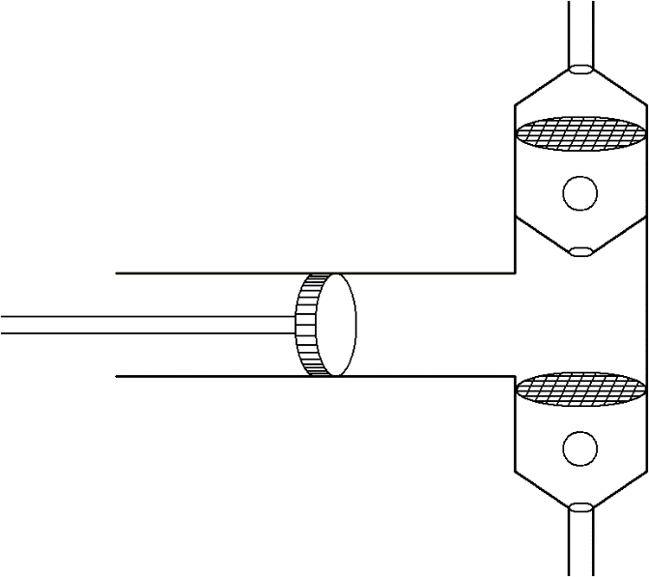
Inlet Check Valve
(from solvent reservoir)
Outlet Check Valve
(to column)

Figure 50. Diagram of the pump head of a reciprocating small-volume pump.

The injection valve is usually a six-port, two-way valve with a sample loop (Figure 51). In one position (the load position), the flow comes in from the pump through one port and goes out another port to the column. The other two ports connect the syringe adapter to a sample loop and a vent. A common sample loop size is 20 µL. Usually you inject about 100 µL of sample into the loop. The first 80 µL cleans the loop and goes out the vent. The last 20 µL are retained in the loop and ready for injection in the system.

In the second position (the inject position), the flow from the pump now goes through the sample loop and then to the column. Moving the valve to this position allows the mobile phase to sweep the sample into the column for analysis.

Pump In
Inject
Load

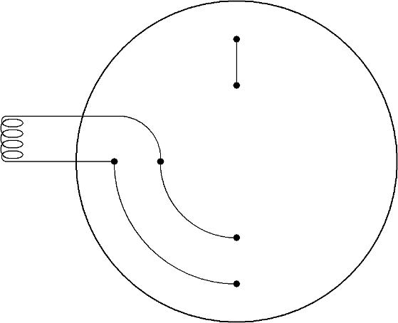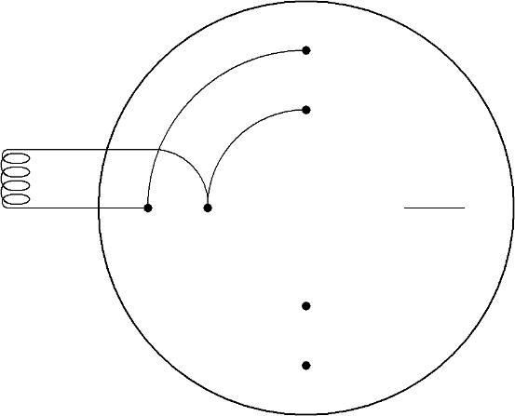
Vent
To Column
Inject

Figure 51. Flow diagram of a six-port injection valve.

We have already discussed most of the important features of liquid chromatographic columns. The column lengths are usually 3, 15, or 25 cm depending on the particle size used. The internal diameter of conventional liquid chromatographic columns is 4.5 mm (about ¼ inch).

Many methods have been used for detection in liquid chromatography. The most common detection method is to use ultraviolet absorption. Fluorescence spectroscopy is also used for certain classes of compounds. More recently people have figured out ways to adapt mass spectrometers to liquid chromatographs. The large volume of solvent in liquid chromatography is incompatible with conventional mass spectrometric methods, so these techniques are quite specialized. Also, micro columns with smaller diameters and less solvent are often used with liquid chromatographic-mass spectrometers. One advantage of mass spectrometry over most other detection methods is that the mass spectrum provides information that may allow you to identify the chemical structure of an eluting compound.

Steric Exclusion Chromatography

Steric exclusion chromatography is a technique that separates compounds solely on the basis of size. In order for the results of steric exclusion separations to be meaningful, there can be no directed forces between the compounds being separated and the surface of the particles used as the stationary phase. Instead, the particles are prepared with well-characterized pore sizes. Figure 52 shows a particle with one pore in it. Figure 52 also shows representations for several molecules of different size (note, the pore size and molecule size are not representative of the scale that would exist in real steric exclusion phases – the pore is bigger than would actually occur and the molecules would never have sizes on the order of that of the particle).

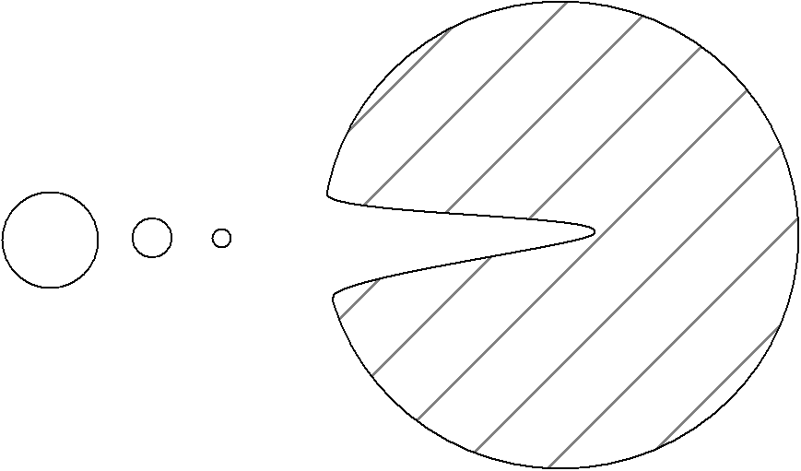
Molecules
Pore
Particle

Figure 52. Representation of a particle with a pore.

The smallest molecule is small enough to fit entirely into all regions of the pore. The largest molecule is too big to fit into the pore. The intermediate sized one can only sample some of the pore volume. Provided these molecules have no interaction with the surface of the particle and are only separated on the basis of how much of the pore volume they can sample, the largest molecule would elute first from the column and the smallest one last.

Suppose we took a molecule that was even larger than the biggest one in the picture above. Note that it would not fit into any of the pores either, and would elute with the biggest in the picture. If we wanted to separate these large species, we would need a particle with even larger pores. Similarly, if we took a smaller molecule than the smallest pictured above, it would sample all of the pore volume and elute with the smallest one pictured above. To separate these two compounds, we would need particles with smaller pores.

Steric exclusion chromatography requires large compounds, and is not generally effective on things with molecular weights of less than 1000. It is commonly used in biochemistry for the separation of proteins and nucleic acids. It is also used for separation or characterization purposes in polymer chemistry (a polymer is a large compound prepared from repeating monomeric units – polyethylene is a long, linear polymer made of repeating ethylene units).

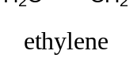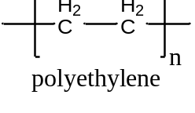

One critical question is how to remove the possibility of an attractive force between the compounds being separated and the surface of the porous particles. The way this is done is to use a particle with very different properties than the compound being separated, and to use a solvent that the solutes are very soluble in. For example, if we want to separate proteins or nucleic acids, which are polar and very soluble in water, we would need to use porous particles made from an organic material that had a relatively non-polar surface. If we wanted to separate polyethylenes of different chain lengths, which are non-polar, we would dissolve the polyethylene in a non-polar organic solvent and use porous particles made from a material that had a highly polar surface. This might involve the use of a polydextran (carbohydrate), which has hydroxyl groups on the surface of the pores.

The classic organic polymer that has been used to prepare porous particles for the steric exclusion separation of water-soluble polymers is a co-polymer of styrene and divinylbenzene.

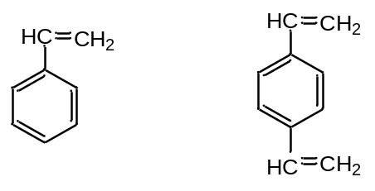
Styrene Divinylbenzene

If we just had styrene, and conducted a polymerization, we would get a long, single-bonded chain of carbon atoms with phenyl rings attached to it. Linear polystyrenes are soluble in certain non-polar organic solvents. The divinylbenzene acts as a cross-linking agent that bridges individual styrene chains (Figure 53). A typical ratio of styrene to divinylbenzene is 12:1. The cross-linking serves to make the polymer into particles rather than linear chains. The cross-linked polymer is an insoluble material with a very high molecular weight. By controlling the reaction conditions including the amount of cross-linker and rate of reaction, it is possible to make polystyrenes with a range of pore sizes.

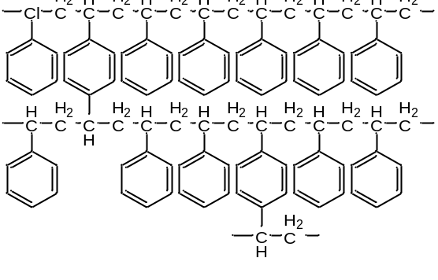
Figure 53. Cross-linked styrene-divinylbenzene copolymer.
If we think about what is inside the column, there are four important volume terms to consider. One is the total volume of the column (V_{T}). The second is the interstitial volume between the particles (V_{I}). The third is the volume of all of the pores (V_{P}). The last one is the actual volume occupied by the mass of the material that makes up the particles.

It turns out that V_{I} is usually about 0.3 of V_{T} for a column. There is simply no way to crunch the particles closer together to reduce this term appreciably.

V_{I} = 0.3 V_{T}

It turns out that the maximum pore volume that can be achieved is about 0.4 of V_{T}. If you make this larger, the particles have more pores than structure, become excessively fragile, and get crushed as you try to push a liquid mobile phase through the column.

V_{P} = 0.4 V_{T}

Totaling this up, we can write that:

V_{I} + V_{P} = 0.7 V_{T}

Since there are no directed forces in a steric exclusion column, this means that all of the separation must happen in one column volume, or in 0.7 V_{T}. If we then showed a chromatogram for a series of compounds being separated on a steric exclusion, it might look like that shown in Figure 54.
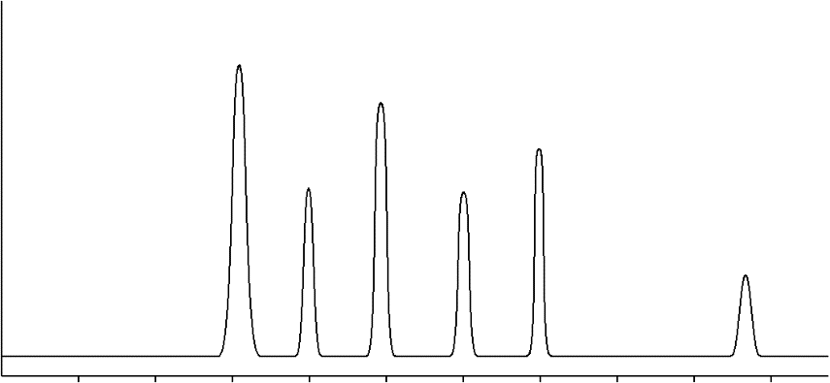
6
5
4
3
2
1
0.7 V_{T}
0.3 V_{T}
Elution Volume

Figure 54. Representation of a chromatogram on a steric exclusion column.

The peak labeled 1, which has the shortest retention time (0.3 V_{T}), corresponds to all molecules in the sample that had a size that was too large to fit into the pores. It cannot be known whether this is one compound or a mixture of large compounds. The peak labeled 5, which has the longest retention time (0.7 V_{T}), corresponds to all molecules in the sample that had a size small enough to sample all of the pore volume. It cannot be known whether it is one compound or a mixture of two or more small compounds. The peaks labeled 2 through 4 sample some of the pore volume depending on their size. The peak labeled 6 elutes with a retention volume that is greater than 0.7 V_{T}. How would we explain the elution volume of this peak? The only way we can do so is if there are attractive forces between this molecule and the surface of the particles. This is a serious problem and we would need to examine this system and eliminate the cause of this attractive force.

Note that this method separates things on the basis of their size. What people try to do when using steric exclusion chromatography is equate size with molecular weight. The two representations for the shape of a molecule shown in Figure 55 point out a potential problem with equating size with molecular weight. One molecule is spherical. The other is rod shaped. The spherical molecule probably has a larger molecular weight, because it does occupy more volume. However, the size of a molecule is determined by what is known as its hydrodynamic radius. This is the volume that the molecule sweeps out in space as it tumbles. If you took the rod shaped molecule below and allowed it to tumble, you would see that its size is essentially comparable to that of the spherical molecule.

Figure 55. Representation of the molecular size of spherical (left) and rod-shaped (right) molecules.

When performing steric exclusion chromatography, you need to use a series of molecular weight standards. It is essential that these standards approximate the molecular features and shapes of the molecules you are analyzing. If you are analyzing proteins, you need to use proteins as standards. The same would apply to nucleic acids, or to particular organic polymers. Figure 56 shows the typical outcome of the calibration of elution time with molecular weight (always plotted on a log scale) for a steric exclusion column.

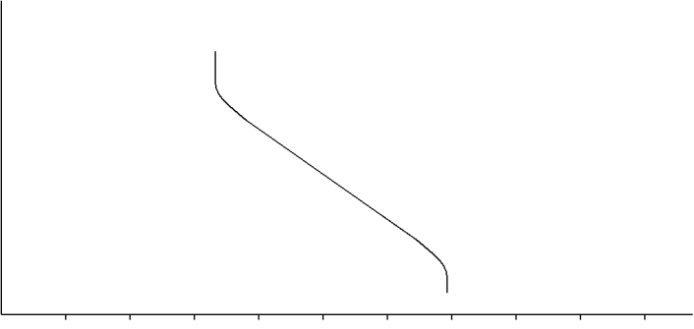
0.7 V_{T}
0.3 V_{T}
log(MW)

Elution Volume

Figure 56. Generalized calibration curve for a steric exclusion column.

Note that excessively large molecules never enter the pores and elute together at 0.3 V_{T}. Excessively small molecules sample all of the pore volume and elute at 0.7 V_{T}. There is then some range of size (or molecular weight) where the compounds sample some of the pore volume and elute at volumes between 0.3 and 0.7 V_{T}.

The plots that would occur for particles with the next larger (dashed line) and smaller pore sizes (dotted line) are shown in Figure 57.

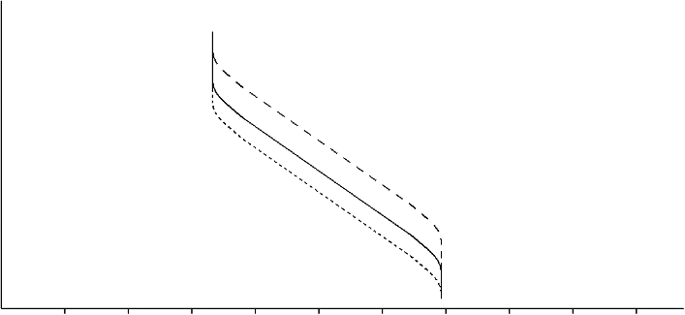
log(MW)
0.3 V_{T}
0.7 V_{T}
Elution Volume

Figure 57. Calibration curves for a steric exclusion column. The dashed line is the column with the largest pore sizes. The dotted line is the column with the smallest pore sizes.

Ion-Exchange Chromatography

A second sub-category of liquid chromatography is known as ion-exchange chromatography. This technique is used to analyze ionic substances. It is often used for inorganic anions (e.g., chloride, nitrate, and sulfate) and inorganic cations (e.g., lithium, sodium, and potassium). It can also be used for organic ions, although this is less common with the advent of reversed phase liquid chromatographic methods that will be described later. Another significant application of ion-exchange chromatography is as a step in the purification of proteins. Some of the substituent groups of amino acids are charged (the total charge for a particular protein is a function of the pH of the solution), which makes ion exchange a suitable method for protein purification.

The approach is to attach fixed ionic groups to the surface of a solid support. One common support used in the formation of ion exchange resins is polystyrene-divinylbenzene copolymers. The fixed ions are attached through a derivatization of the phenyl rings of the polystryene. Common fixed ions involve either sulfonate groups or quaternary amines as shown in Figure 58. The aromatic sulfonate groups are strong enough acids that they are deprotonated at all but highly acidic pH values (pH < 1).

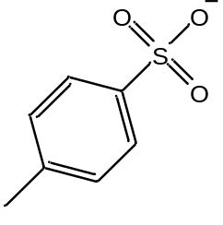
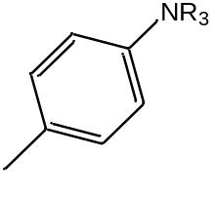

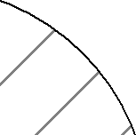

Sulfonate group Quaternary amine

Figure 58. Polystyrene polymer derivatized with fixed ionic groups.

Since we must preserve neutrality in such a system, there must also be an exchangeable counterion associated with each of these fixed groups. In the case of the sulfonate group, the counterion is a cation and this is a cation exchange resin. With the quarternary amine phases, the exchangeable counterion is an anion and this is an anion exchange resin. These counterions can be exchanged with each other. For example, this would enable you to have a cation exchange resin in the sodium form or the hydrogen form as seen in Figure 59

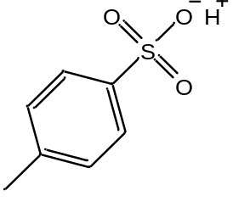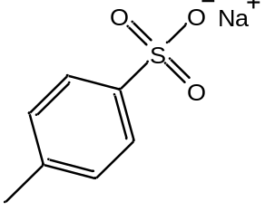

Sodium form Hydrogen form

Figure 59. Sulfonate cation exchange resin with sodium and hydrogen counterions.

An anion exchange resin could be in the hydroxide form (${\text{OH}}^{-}$) or chloride form (Cl–).
One common use of ion exchange resins is in the deionization of water. It is useful to consider a scheme using ion exchange resins that would enable you to deionize water. If for example, we had water with sodium chloride in it (Na⁺Cl–), we would need a way of removing both cations and anions. If we first passed the water through a cation exchange resin in the hydrogen form, the sodium ions would exchange with the hydrogen ions as shown in the top picture of Figure 60. If we then passed the water through an anion exchange resin in the hydroxide form, the chloride ions would exchange with the hydroxide ions as shown in the bottom picture of Figure 60.

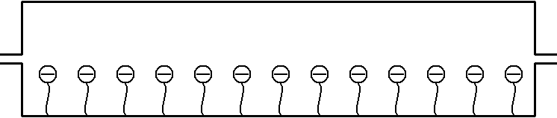
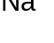
Cation exchange resin

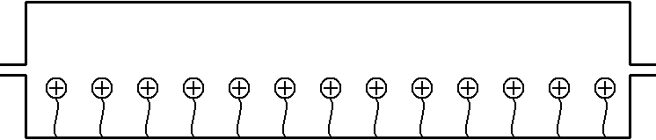
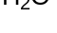
Anion exchange resin

Figure 60. Use of a cation (top) and anion (bottom) exchange resin to deionize water.

The H⁺ and ${\text{OH}}^{-}$ given off by the two resins would combine to form water. Eventually the resin will fill up with impurity ions (Na⁺ and Cl– in this case), and we would either need to replace the resin or reactivate it. We can reactivate the cation exchange resin by passing relatively concentrated hydrochloric acid through it to remove all the Na⁺ and replace it with H⁺. We can reactivate the anion exchange resin by passing a relatively concentrated solution of sodium hydroxide through it to remove all the Cl– and replace it with ${\text{OH}}^{-}$. To minimize how often we need to replace these resins or how frequently we need to recharge them, it’s best to have resins with as high an ion exchange capacity as possible (the capacity is determined by the number of phenyl rings that have been derivatized with fixed ions).

The capacity of ion exchange resins used for deionizing water is too high for analytical purposes. Presumably, the concentrations of ions in samples that we want to analyze are relatively low. If we use high capacity resins, the retention times will be much too long. One of the early impediments to the use of ion exchange as an analytical method was the lack of methods to reproducibly synthesize resins with low capacities. One of the first groups of people to figure out a way to do this was chemists at Dow Chemical. They were motivated by a need to measure inorganic anions and cations at low levels and realized that ion-exchange chromatography would be an ideal method for doing so.

With any chromatographic method, it helps to know some basic rules for predicting retention order. An interesting example to consider in ion-exchange chromatography is the retention order for the ions Li⁺, Na⁺, and K⁺ on a cation exchange resin.

One thing we can consider is whether these ions have different strength interactions with the fixed anion in the resin. All three ions have the same charge. What should also be apparent is that lithium is the smallest ion with the densest charge, potassium the largest with the most diffuse or fluffiest charge. Figure 61 shows a representation of the attraction of these ions to the anionic group of the stationary phase.

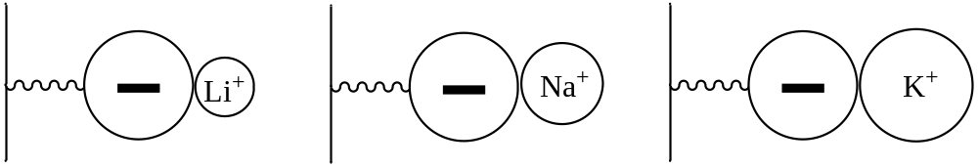

Figure 61. Representation of the attraction between Li⁺, Na⁺, and K⁺ and the anionic group of the resin. Note: The comparative sizes of the ions may not be rigorously accurate.

We therefore might predict that the attraction of the lithium ion for the sulfonate groups in the resin is the strongest of the three ions because of the shorter distance. The equation that is used to determine ionic attraction is shown below and has the charges of the two ions in the numerator (q₁ and q₂) and the radii for the two ions in the denominator (r₁ and r₂). Therefore, the closer the two ions, the stronger the attraction. Lithium being the smallest is effectively closer to the sulfonate and has the strongest attractive force of the three for the resin.

$$F \sim \frac{q_{1}q_{2}}{r_{1}r_{2}}$$

This would suggest a retention order with potassium eluting first, sodium second, and lithium last as shown in Figure 62.

Na⁺
Li⁺
K⁺
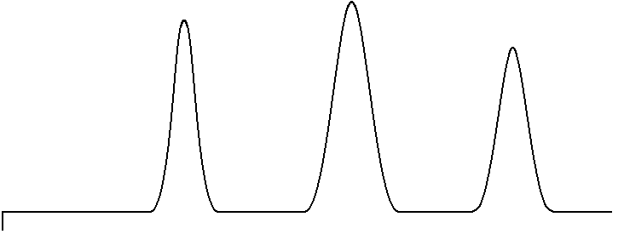

INJ

Figure 62. Retention order of Li⁺, Na⁺ and K⁺ on a cation-exchange column based on stationary phase effects.

But there is also a mobile phase in chromatographic separations, and it is useful to examine whether these ions have different relative stabilities in the mobile phase. If one of the three is most stable in the mobile phase, it might be expected to stay in the mobile phase more than the others and elute first. What might affect the stability of these ions in the mobile phase?

The mobile phase in this separation will be an aqueous phase. There are two things to consider for Li⁺, Na⁺, and K⁺ dissolved in water. First, the cations will be surrounded by the oxygen atoms of water molecules because of electrostatic attraction between the positive cation and slightly negative charge on these oxygen atoms. This interaction is shown in Figure 63. Using the equation above for the strength of this interaction, lithium would have strongest attractive forces for the water molecules and potassium would have the weakest attractive forces.

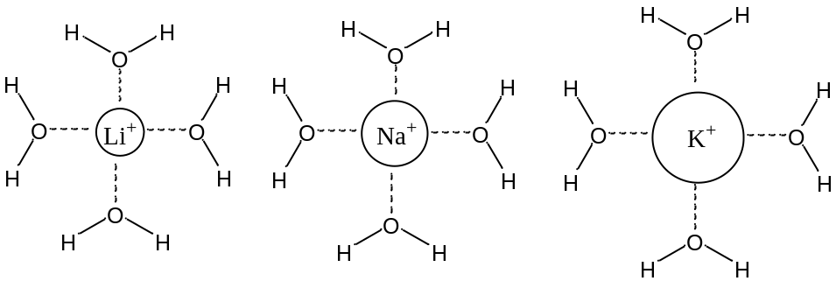

Figure 63. Electrostatic attraction between the negatively charged oxygen atoms of water molecules and Li⁺, Na⁺ and K⁺.

Second, we know that water is unusual in having a very elaborate network of hydrogen bonds. Any ion that dissolves in water will cause some disruption of this network. The question to consider is which ion would be the most disruptive of the three to the hydrogen bond network? Since the charges of these three ions are identical, this decision will be based on the size. The larger potassium ion will be more disruptive of the hydrogen bonds, and more difficult for water to accommodate.

Considering both the attractive electrostatic force and degree of disruption of the hydrogen bond network of water, you could conclude that Li⁺ is more stable in the water, stays in the mobile phase more, and elutes first. You could phrase this another way by saying that the K⁺ is least stable in the aqueous mobile phase, and so is “forced” into the resin by the mobile phase and elutes last. Sometimes the chromatographic literature refers to this as the solvophobic effect. The K⁺ fears the solvent and so spends more time in the resin. The relative retention order based on mobile phase effects would be lithium first and potassium last, as shown in Figure 64, the exact opposite of what was predicted above based on stationary phase effects.
Na⁺
K⁺
Li⁺

INJ

Figure 64. Retention order of Li⁺, Na⁺ and K⁺ on a cation-exchange column based on mobile phase effects.

With conflicting predictions, the only way to know which one is more important is to inject the ions and determine the retention order. In this case, the measurements show that the Li⁺ elutes first and the K⁺ elutes last. The mobile phase effects are more significant in determining the retention order.

Now suppose we had two ions with exactly the same size, but one had a charge of 1+ and the other a charge of 2+. Examining stationary phase effects, the equation that describes the attraction between two ions has the charges of both ions in it. The greater the charge of the ions, the greater the attraction. We would therefore expect the 2+ ion to show greater attraction for the fixed sulfonate anions and elute later than the 1+ ion as shown in Figure 65.
+1
+2
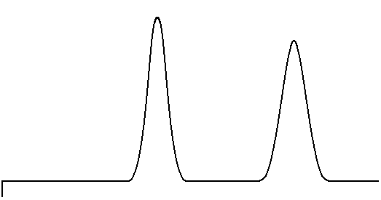

INJ

Figure 65. Retention order on a cation exchange column for ions of the same size but different charge based on stationary phase effects.

Examining mobile phase effects, both ions would have a similar extent of disruption of the hydrogen bond network since both have the same size. What we then need to consider is the strength of the attraction between the positive ion and the sphere of water molecules that surround it (remember, these cations would be surrounded by the slightly negative oxygen atoms of water molecules). This represents an electrostatic attraction, and again is dependent on charge. Therefore the 2+ ion is more stable in the water and ought to elute first as shown in Figure 66, the exact opposite of what was predicted based on stationary phase effects.
+1
+2

INJ

Figure 66. Retention order on a cation exchange column for ions of the same size but different charge based on mobile phase effects.

Faced with conflicting predictions, it’s necessary to perform the experiment and see which comes out first. In this case, the measurements show that the 1+ ion elutes first, the 2+ ion elutes second. The stationary phase effects are more important in this case in determining the retention order. The likely reason why the stationary phase effects are more significant is that the 2+ ion can actually bind simultaneously at two adjacent sulfonate sites as shown in Figure 67.
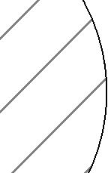
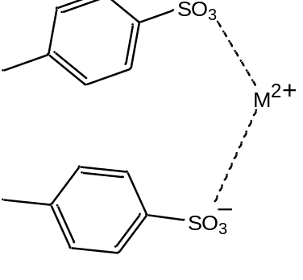

Figure 67. Representation of a +2 ion associating at two anionic sites on the resin.

The likelihood that this occurs can be observed if a lanthanide(III) ion is added to these resins. In this case, the resin particles actually shrink in size as the lanthanide ion is added. The reason for the compression is that the binding of three sulfonate groups to the lanthanide causes the polymer to collapse in a bit to fit these groups around the lanthanide.

The separation of Li⁺, Na⁺, and K⁺ described in the prior problem would often be done on a polystyrene resin using a fairly dilute solution of hydrochloric acid (perhaps 0.1 M) as the mobile phase. The bound ions would be sulfonate groups and the mobile counter ion would be the H⁺ ion. An important issue is how to detect these ions. They do not absorb ultraviolet or visible light in the accessible portion of the spectrum. They do not absorb infrared light. Conductivity is one possibility for performing the measurement. The conductivity of a solution is a measure of the extent to which the solution conducts electricity. Dissolved ions are needed for a solution to conduct electricity, and the higher the concentration of ions, the higher the conductivity. We can measure the conductivity of a solution quite sensitively. In fact, this is the reading that is performed on water that has been purified by passage through a MilliQ water purification device to see just how well the water has been deionized. The only problem with trying to apply a direct conductimetric measurement is that the hydrochloric acid in the mobile phase produces too high a background signal. The chemists at Dow who had developed low capacity ion exchange resins recognized this problem as well and devised an ingeneous way to remove the conductivity of the eluent ions (HCl) but retain the conductivity of the alkali ions they wanted to detect.

What they did was use a device called a suppressor column. If we imagine measuring Na⁺ in a solution containing sodium chloride (Na⁺Cl–), we first start with a cation exchange resin in the H⁺ form and would have Na⁺Cl– and H⁺Cl– eluting out the end of the column when the sodium band comes off as shown in Figure 68.

Inject
Sample
Cation exchange resin

Figure 68. Effluent from the analytical column when analyzing a sample containing sodium. H⁺Cl– is the eluent ion.

Note that there is still a high concentration of HCl mixed with the NaCl as it elutes from the column. This HCl will interfere with the measurement of conductivity. Suppose we took the column eluent and then passed it through an anion exchange resin in the hydroxide form as shown in Figure 69. The Cl– ion of the Na⁺Cl– would exchange with the hydroxide, converting this into sodium hydroxide (Na⁺${\text{OH}}^{-}$), a conducting electrolyte because it stays ionized. The Cl– ion of the HCl would exchange with the hydroxide, converting this into H⁺ and ${\text{OH}}^{-}$, which is non-conducting water. We can therefore measure a conductivity that only relates to the amount of sodium ion in the original sample. An analogous scheme, which had the columns reversed, could be used to measure the conductivity of anions that were separated on an anion exchange column in the hydroxide form.

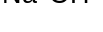
Anion exchange resin

Figure 69. Effect of the suppressor column on the eluent from the column in Figure 68.

Eventually, the hydroxide counterions in the suppressor column will all become replaced with chloride ions and the device would not work anymore. The suppressor column must be periodically regenerated in the hydroxide form.

Today, instead of using suppressor columns to remove the conductivity of the eluent ions, membrane-based electrolytic neutralization devices are employed. The electrolysis of water can be used to generate hydronium and hydroxide ions, and by proper design, the desired ion can be generated in such a way to pass through a membrane and suppress the conductivity of the eluent ions. In some instruments, similar electrolytic strategies are used prior to the analytical column to generate the eluent ions as well. The use of this eluent generation technology leads to less background conductivity and better sensitivity, making it especially useful for the analysis of low levels of ions.

One other way of detecting the ions, and especially anions, was also developed by the chemists at Dow. It involved the use of indirect spectrophotometric detection. In this procedure, an anion such as the phthalate anion is used as the counterion in the mobile phase. The material is usually added as potassium phthalate, and maintained at a concentration of 0.001 M. The phthalate ion absorbs ultraviolet light. The background measurement in the system then consists of a high absorption reading of UV light.

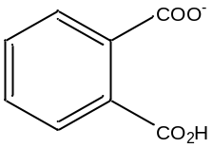
phthalate anion

Suppose we were separating Cl– in a sample containing sodium chloride. Figure 70 shows the end of the column with the chloride ions in the resin, just about to elute in the column. At this point, the concentration of phthalate ion leaving the column is 0.001 M. But what happens when a chloride ion is displaced from the resin to exit the column? This will only happen if a phthalate ion replaces it in the resin. The replacement that occurs will cause the concentration of phthalate ion to drop below 0.001 M.

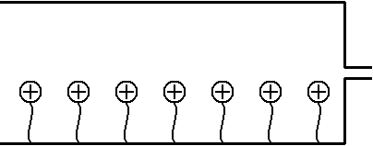
Phthalate in mobile phase displaces Cl– from resin
Flow

Figure 70. Representation of an anion exchange column when using phthalate ion for indirect spectrophotometric detection.

In other words, when the chloride elutes from the column, what you observe in the mobile phase is that the total concentration of anions equals 0.001 M (this has to happen in order to preserve neutrality in the system).
[Cl–] + [pht– ] = 0.001 M

If the concentration of phthalate ion drops proportionally to the concentration of chloride eluting from the column, the UV absorption drops proportionally as well, as shown in Figure 71. The name indirect spectrophotometric detection is aptly chosen since the value of the UV absorption drops as analyte anions elute from the column.

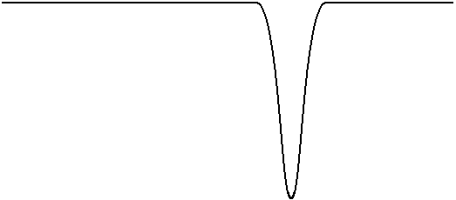
UV
Absorption
“Negative” Peak

Figure 71. The negative peak for the chloride ion in indirect spectrophotometric detection.

The scientists at Dow Chemical who developed the ion exchange methods for some analyses they needed to perform realized that there were others who would want to be able to measure the same species, and that the device has commercial potential. A company called Dionex, which is still the leading vendor of ion chromatographs, was created to market their invention.

Bonded-phase Liquid Chromatography

In our development of band broadening, we talked extensively about the C₁₈ columns that are the most common in use today. We already mentioned that less common bonded phases including those with C₈, C₁, aminopropyl (C₃H₆NH₂) and cyanopropyl (C₃H₆CN) groups are also commercially available. Prior to the introduction of the C₁₈ columns, the normal way to do liquid chromatography involved the use of a polar stationary phase like silica gel and a non-polar mobile phase. When the C₁₈ columns were first reported, they constituted a non-polar stationary phase, and so a polar mobile phase could be employed. Since this configuration of polarities of the phases was the reverse of what was normally done, the use of C₁₈ columns became known as reversed-phase liquid chromatography. Even though today almost everyone uses these reversed-phase methods, the name has stuck.

We have already seen how the deactivation of the surface with the C₁₈ groups has a very positive effect on the chromatographic efficiency. Another significant advantage of using C₁₈ stationary phases is that aqueous-based mobile phases are used with them. Water is the ideal mobile phase for liquid chromatography because so many substances are soluble in water. Water is the solvent of the environment. Water is the primary solvent of living systems. Many pharmaceutical agents need to possess water solubility to enter the body. Since many organic compounds are not that soluble in water, organic pharmaceuticals that are not water-soluble usually have ionic groups incorporated into them to render them water-soluble.

It’s rare to use only water as the mobile phase with a C₁₈ column. Instead, an organic modifier (methanol, acetonitrile, and tetrahydrofuran are the three most common) is added in some amount to the mobile phase. Compared to water, the chemical properties of the organic modifier are more like that of the C₁₈ phase. The presence of the organic modifier therefore shortens the retention time compared to a mobile phase that was only water. Raising the concentration of the organic modifier will further shorten the retention time of almost all compounds. We mentioned the concept of a gradient elution earlier in the unit when we discussed the problem of having a limited peak capacity in a chromatogram. Remember the goal was to start with a high retention factor and systematically change the system so that the retention factor got shorter as the chromatogram progressed. One possible gradient procedure might be to start with a mobile phase that is 80:20 water-methanol and gradually change is to 20:80 water-methanol during the chromatogram. The increased concentration of methanol will reduce the retention factor of the later eluting components.

Experimentally, it is easy to carry out a gradient. Using two pump heads, one pumps the initial phase and the other the final phase. A special mixing chamber exists to adequately mix the output from the two pumps. During the chromatogram, a computer systematically slows down the pump rate of the initial phase and ramps up the pump rate of the final phase.

Another important variable with an aqueous mobile phase is the pH of the system. C₁₈ silica gel phases are stable over the range of 2 to 8 (although 3 to 7 really represents a safer window). If the pH is too acidic, the surface C₁₈ groups will be hydrolyzed off. If the pH is too basic, the silica gel itself will decompose. This pH range is one that can be used to change the nature of many acids and bases. For example, carboxylic acids at pH 3 might mostly be in their protonated (neutral) form, whereas at pH 7 they are likely to be in their deprotonated (anionic) form. Since we would expect the neutral form to have more solubility in a C₁₈ phase then the anionic form, the retention time for most carboxylic acids would be longer at pH 3 than at pH 7. If we consider nitrogen bases, we note that at pH 3 they are likely to be in their protonated (cationic) form, whereas at pH 7 they are likely to be in their deprotonated (neutral) form. Organic bases therefore would have a longer retention time at pH 7 than at pH 3. You might also recollect how we used a similar process to distinguish acids and bases in an acid/base/neutral extraction procedure discussed at the beginning of this unit. This is the same behavior and rationale going in liquid chromatography. Another gradient procedure that could be used to advantage in liquid chromatography is a pH gradient.

There is some debate in the literature on liquid chromatography about the exact nature of the separation procedure (adsorption on a deactive surface versus partitioning), and whether stationary phase or mobile phase (solvophobic) effects are most important in determining retention properties. It actually turns out that either one usually leads to the same conclusion as to retention order, and for our purposes, thinking about which compound of a pair has a greater attraction for the stationary phase is sufficient to predict which will come out first and which second. We have already examined the two pairs below as a function of pH.

RCOOH RCOO–
pH = 3 (longer t_{R}) pH = 7 (shorter t_{R})

R₃NH⁺ R₃N
pH = 3 (shorter t_{R}) pH = 7 (longer t_{R})

How about a comparison of the retention order of pyridine and tert-butylpyridine on a reversed-phase column? If you thought that the presence of the tert-butyl group on the pyridine would make that compound more attractive to the C₁₈ groups, thereby causing it to have the longer retention time of the two, you are correct. In fact, in all likelihood, there is some preference of the association of these two compounds with a C₁₈ phase as shown in Figure 72. The non-polar portion of the molecule is likely oriented toward the C₁₈ phase, whereas the polar nitrogen atom is oriented toward the mobile phase.

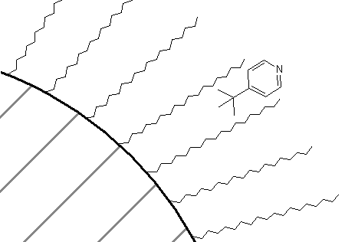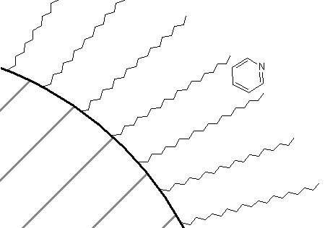

Figure 72. Representation of the association of tert-butylpyridine (left) and pyridine (right) with a C₁₈ bonded phase.
Lastly, picking up on another technique we learned with regards to liquid-liquid extractions, we could ask how we might lengthen the retention time of organic cations on a C₁₈ column. For example, there are a series of neurotransmitters such as dopamine that are based on aromatic amine derivatives.
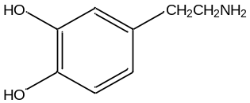
dopamine

Dopamine and other similar derivatives may well be protonated under the separation conditions, and because of the protonation, have short retention times that do not facilitate the separation of the similar analogues. Can you think of a way to lengthen the retention time that does not involve adjustment of the pH? A way to do this is to add a “greasy” anion such as heptylsulfonate to the mobile phase (note, since this is added to the mobile phase the anion is continuously pumped through the system).

${\text{C}}_{\text{7}}{\text{H}}_{\text{15}}\text{S}{\text{O}}_{\text{3}}^{-}$ = heptylsulfonate

One way to think of this is that, just like in liquid-liquid extraction, the sulfonate anion can form an ion pair with the cation and the ion pair would have more solubility in a C₁₈ phase than the cation by itself. An alternative way to view this is that some of the sulfonate salt distributes into the C₁₈ phase as shown in Figure 73. This serves to create a pseudo ion exchange material that the organic cations are attracted to. Detailed studies have shown that the latter mechanism (pseudo ion exchange resin) is the one that actually operates.

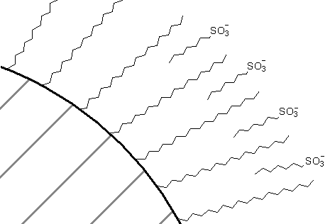

Figure 73. Formation of a pseudo ion exchange material with heptylsulfonate on a C₁₈ column.

One other important category of bonded phases involves the attachment of optically pure groups to silica gel. The compound dinitrobenzoyl-L-leucine is one example of such a phase. These types of phases are used for the separation of enantiomers.
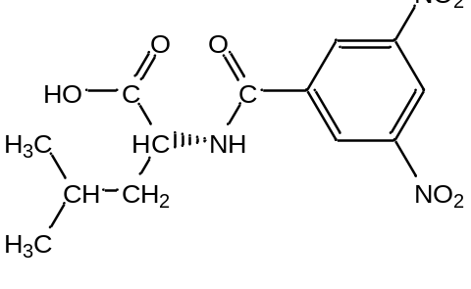
Dinitrobenzoyl-L-leucine

The distinction of enantiomers is analogous to the distinction that would occur if you considered putting your feet into only one of your shoes. If you put your left foot into your left shoe, it feels fine. If you put your right foot into your left shoe, it does not fit quite as well, and even in the dark, you would notice that something isn’t right. If we expressed this as a reaction with an equilibrium constant, we could say that the association of your left foot with your left shoe is higher than the association of your right foot with your left shoe. If we had bonded the left shoes to silica gel, your right foot would elute faster from the column, your left foot slower. The compound pictured above has a number of groups that can form intermolecular interactions with enantiomeric solutes. The amide functionality is a site with dipoles and the potential for hydrogen bonding. The electron-deficient dinitrobenzoyl ring can undergo what is known as pi-stacking with electron-rich aromatic rings. The isobutyl group of the leucine provides steric hindrance. Other chiral liquid chromatographic phases are designed to have similar groups that provide sites for intermolecular attraction, π-stacking, and steric constraints.

GAS CHROMATOGRAPHIC SEPARATION METHODS

A gas chromatograph typically has a carrier gas (it is common to refer to the mobile phase in gas chromatography as the carrier gas since the mobile phase has no influence at all over the separation – its only purpose is to carry the solutes through the column), heated injection port, column in a heated oven, and detector.

The carrier gas must be inert and helium or nitrogen is used for most gas chromatographic applications. Sample injection is most commonly accomplished through the use of a small-volume syringe (1 μL is a typical injection volume). The liquid sample is injected into a hot zone that is sealed with a polymer septum. The syringe pierces the septum, and on injection the liquid sample is flash-volatilized in the heated injection port and flushed into the column by the carrier gas. With fused silica capillary columns, 1 μL of liquid sample will overload the column so the injector is designed with a splitter. Adjusting the flow of the splitter gas allows you to calibrate the split ratio. Ratios of 50:1 to 100:1 (only the one part is injected) are common. Most injection ports of this type have glass liners. Different glass liners are inserted under the septum depending on whether you are doing split or splitless injections.

Another gas chromatographic injection technique that is used in certain applications involves thermal desorption from a polymer trap. The technique is illustrated in Figure 74 for the analysis of organic chemicals in air. Assume that we have a small piece of tubing filled with a polymer. The polymer is a material that organic chemicals will adsorb to. Water in the air will pass through unretained. A polymer that is used quite frequently for this application is Tenax. Tenax is a p-polyphenylene oxide polymer that is stable at very high temperatures. In the adsorption step, we use a pump to draw some large volume of air (this might be as high as 15 liters of air) through the Tenax trap, which is held at room temperature. The organic chemicals from the air will adsorb onto the polymer.

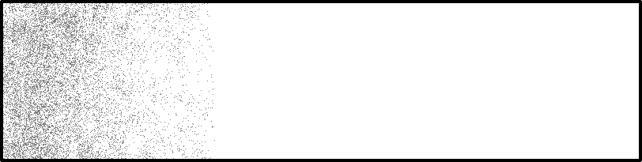
Pump
Water
Air (organics, water)

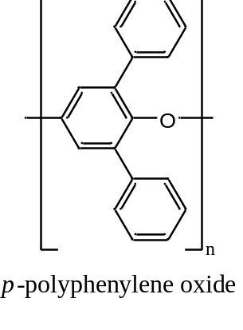

Figure 74. Use of a sorbent trap to remove organic compounds from an air sample.
The organic chemicals can be desorbed from the Tenax trap by heating the gas under a flow of helium. The illustration in Figure 75 shows how the Tenax trap is desorbed in a backflush mode (the end that had the higher concentrations of organic chemicals is put closer to the gas chromatograph). Switching valves comparable to liquid chromatographic injection valves make it easy to redirect the flow of gases through these Tenax traps between the adsorption and backflushing orientation.


Δ
Helium

Figure 75. Desorption of a sorbent trap in a backflush mode.

Desorption might typically be done at a temperature of 225ºC over a period of five minutes. One thing to realize is that we would never be able to tolerate a five-minute injection of a sample, since this would mean that all of the peaks might be as long as five minutes. It is essential to maintain a “plug” injection, which is achieved by thermal focussing. Thermal focussing is accomplished by cooling a region in the injector (or in older gas chromatographs, the entire oven) to a temperature of –50ºC. This cooling is accomplished using either liquid carbon dioxide or liquid nitrogen. At –50ºC, the organic compounds that desorb from the Tenax trap freeze in a small band at the head of the column. Rapid heating of this frozen band injects the sample at a comparable rate to a normal syringe injection.

Sorbent traps are frequently used for the analysis of trace levels of volatile organic chemicals in water as well. In this case, the method is known as a purge and trap technique and is shown in Figure 76. A sample of water is taken (usually 5 mL – too large to ever inject into a gas chromatograph) and purged with helium gas. After exiting the water, the helium gas flows through a Tenax trap. The helium gas bubbling through the water displaces the dissolved volatile organic chemicals, which adsorb onto the Tenax trap. The Tenax trap is desorbed as described above for the analysis of volatile organic chemicals in air.
He

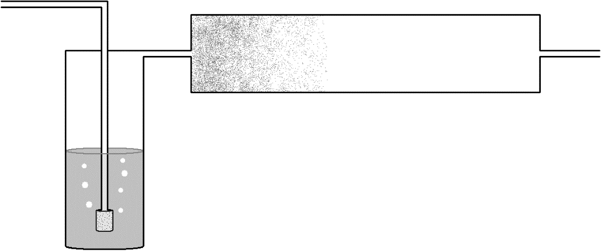

Figure 76. Purge and trap device used to analyze volatile organic compounds in water.
Another adsorption technique analogous to the sorbent traps discussed above involves the use of solid phase microextraction (SPME). SPME employs a specially designed syringe in which the metal barrel that is inserted through the septum of the injection port is wider in diameter than a usual GC syringe. Inside this wider barrel is a small fiber and a suitable solid adsorbent is coated onto the fiber. A common SPME procedure would involve the analysis of volatile organic compounds dissolved in water. A known volume of the water is put into a special vial that has a cap with a septum. The vial is not filled completely but has a layer of air between the solution and cap (this is known as the headspace). The syringe needle is inserted through the septum and a device on the syringe is used to push the fiber out of the syringe barrel. Depending on the particulars of the analysis, the fiber can be either in the headspace or in the liquid sample. After a specific adsorption time, the fiber is drawn back into the barrel of the syringe. The sample is injected into the GC by inserting the syringe through the septum on the injection port and pushing the fiber out to allow desorption to occur.

Information on a variety of commercially available gas chromatographic stationary phases is provided in Table 3. The distinction between different stationary phases is based on a comparison of their polarity. Five different compounds are typically used to represent different types of functional groups. Individual indices for these five compounds are measured, and a composite value (P) is determined as well. These polarity indices are referred to as Rohrschneider constants. The higher the number the more polar the phase. In reality, a sampling of four or five stationary phases would be good enough to span the range of polarities that is needed for gas chromatographic separations.

Table 3. Rohrschneider constants for gas chromatographic liquid phases

Liquid phase Max T ºC X' Y' Z' U' S' P
Squalane 100 0 0 0 0 0 0
Apiezon L 250 32 22 15 32 42 29
SE-30 300 15 53 44 64 41 43
OV-1, methyl gum 350 16 55 44 65 42 44
OV-3, 10% phenyl 350 44 86 81 124 88 85
OV-7, 20% phenyl 350 69 113 111 171 128 118
Dioctyl sebacate 125 72 168 108 180 123 130
Dilauryl phthalate - 79 158 120 192 158 141
Dinonyl phthalate 150 83 183 147 231 159 161
OV-17, 50% phenyl 375 119 158 162 243 202 177
Versamid 930 150 109 313 144 211 209 197
Trimer acid 150 94 271 163 182 328 218
OV-25, 75% phenyl 350 178 204 208 305 280 235
Polyphenylether 225 182 233 228 313 293 250
Triton X-305 200 262 467 314 488 430 392
Carbowax 20M 225 322 536 368 572 510 462
Carbowax 1540 175 371 639 453 666 641 554
Diglycerol 100 371 826 560 676 854 657
Ethylene glycol phthalate 200 453 697 602 816 872 688
Diethylene glycol succinate 200 496 746 590 837 835 701
Tetrahydroxyethylenediamine 150 463 942 626 - 893 731
Hexakis(2-cyanoethoxycyclohexane) 150 567 825 713 978 901 797
N,N-bis(2-cyanoethyl)formamide 125 690 991 853 1110 1000 929

X' = benzene; Y' = butanol; Z' = 2-pentanone; U' = nitropropane; S' = pyridine, P = (X' + Y' + Z' + U' + S')/5
If we consider what governs retention order in gas chromatography, there are two important parameters. One is the volatility of the compound, with the observation that more volatile compounds (those with a higher vapor pressure or lower boiling point) elute first. The other is the attractive forces between the compound and the stationary phase. If we consider the homologous series of alcohols listed in Table 4, it’s interesting to note that the boiling point goes up by approximately 20ºC for each additional methylene group (CH₂) in the chain. The increase in boiling point with each additional methylene group is a little higher for the series of alkanes. The alcohols have higher boiling points than the corresponding alkanes because they can hydrogen bond with each other.

Table 4. Boiling points for homologous series of alkanes and primary alcohols.

Hydrocarbon Boiling Point (ºC) Alcohol Boiling Point (ºC)

Pentane 36 1-Pentanol 137
Hexane 69 1-Hexanol 157
Heptane 98 1-Heptanol 176
Octane 126 1-Octanol 196
Nonane 151 1-Nonanol 215
Decane 174 1-Decanol 231

If we consider a homologous series, it turns out that the boiling points are actually determined by the molar volumes of the molecules. Just as we observed with the size of molecules in steric exclusion chromatography, the molar volume of a molecule is the volume swept out by the molecule as it tumbles. Molecules with larger molar volumes have higher boiling points, provided the molecules being compared have identical intermolecular forces (you cannot compare hydrocarbons to alcohols). An interesting comparison is observed by looking at the boiling point of n-octane and iso-octane (2,2,4-trimethylpentane).

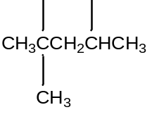

n-octane (bp = 126ºC) iso-octane (bp = 98ºC)

The branched iso-octane would have a smaller molar volume than the linear n-octane, and this is clearly reflected in the boiling points of the two compounds.

When predicting retention order in gas chromatography, the overriding factor is a comparison of the boiling points. The compound with the lowest boiling point elutes first. Only when two compounds have very close boiling points (within 5ºC or less) does it become important to consider the polarity of the compounds and the polarity of the stationary phase. Remember that like dissolves like, so a polar stationary phase will show more retention of a polar compound. The Rohrschneider values are used to determine the polarity of the stationary phase.
Detection Methods

As mentioned previously, highly sensitive detection methods were developed for gas chromatography in the 1950s and 1960s that facilitated its use as an analytical method.

One of the most useful detection methods is known as the flame ionization detector (FID). The flame ionization detector is highly sensitive and involves burning the sample in an air-hydrogen flame. Molecules with a CH bond will form CH⁺ ions in the flame, and these are measured using a negatively charged collector above the flame. When these positive ions strike the negatively charged collector, a current proportional to the amount of ions is measured. This detector is essentially universal, as it is able to measure all organic compounds. It is not sensitive toward compounds like water and carbon dioxide, which is advantageous.

Another important detector in the development of gas chromatography is the thermal conductivity detector. This is a universal detector, but not nearly as sensitive as the FID. A resistance circuit called a Wheatstone bridge is used. The bridge has two halves, and the resistance of these halves is compared. Instruments with a thermal conductivity detector need two matched columns. One column has only carrier gas flowing through it. The other has carrier gas and sample. Changes in the thermal conductivity of the gas change the resistance reading over the Wheatstone bridge. Some representative values for thermal conductivities of gases are listed below. The value for butane is representative of most organic compounds. Since we need to measure a difference in thermal conductivity, we need a carrier gas with as different a thermal conductivity as possible from most organic compounds. This would suggest the use of hydrogen gas as a carrier gas, however hydrogen is too much of an explosion risk for this purpose. Helium is therefore the carrier gas of choice. Thermal conductivity detectors tend to be used on less expensive pieces of equipment like the gas chromatographs used for the analysis of the purity of compounds prepared in organic chemistry instructional labs.

Thermal conductivity values: Hydrogen 471
Helium 376
Nitrogen 66
n-Butane 43

One of the most important gas chromatographic detectors ever developed was the electron capture detector. This device, which is illustrated in Figure 77, was invented by James Lovelock. The device has a radioactive foil (usually containing tritium or radioactive nickel) that emits beta particles. Beta particles are high-energy electrons emitted by a nuclear decay process (a neutron decays into a beta particle and a proton). The opposite side of the device is positively charged so the beta particles stream across the tube. As the high-energy beta particles strike carrier gas molecules (usually either nitrogen or an argon/methane mixture), they create a cascade of lower energy electrons, which generate a current that can be measured. If we had a compound coming out of the gas chromatograph that could capture some of these low-energy electrons, the current would drop. The drop in current can be related to the concentration of electron capturing compound in the sample. What is especially impressive about this detector is the level of sensitivity that can be achieved for certain classes of compounds.

Eluent

Beta Emitter
(–)
Collector
(+)

Figure 77. Representation of an electron capture detector.

What types of compounds ought to have the ability to capture electrons? Remembering back to your knowledge of periodic properties, you should predict that halogen-containing compounds (compounds with a chlorine, fluorine, or bromine atom) ought to be very effective at capturing electrons. What are especially significant are the classes of compounds that contain halogens. These include the following (with their respective application or concern):

- Chlorofluorocarbons (or freons) – ozone layer destruction
- Chloroform – potential carcinogen formed in drinking water from water chlorination
- Dioxin – by-product of combustion and certain industrial processes
- Chlorinated pesticides such as DDT
- Polychlorinated biphenyls – used in electronic devices (transformers)

These are only some examples, but they form an extensive array of compounds of environmental significance. The invention of the electron capture detector facilitated the discovery that freons were making their way to the stratosphere and leading to the destruction of the ozone layer. Without this detector, this discovery would have been delayed by many years.

Mass spectrometric detection is especially important because it provides information that can be used for compound identification. Most gas chromatograph-mass spectrometers (GC-MS) use fused silica capillary columns, and the column effluent can go straight into the mass spectrometer. What happens in the mass spectrometer is that the column effluent is bombarded with a high-energy beam of electrons. As these electrons strike the sample, they generate ions. These can be anions or cations, but most mass spectrometers are designed to draw off only the cations for analysis. Usually almost all the cations have a +1 charge. If we consider the molecule acetophenone, we can illustrate what will take place (three functional groups within the molecule are labeled A, B, and C).

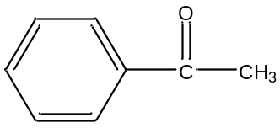
A B C
Acetophenone

If an electron struck this molecule and knocked out one other electron, we would have the entire molecule with a +1 charge. This ion is referred to as the molecular ion, and we would show this as ABC⁺. It’s usually very desirable to have a molecular ion in the spectrum. The other valuable observation in mass spectrometry when you use an electron beam for ionization is that you get fragment ions as well. Possible fragments we could get from acetophenone are listed in Table 5, along with their masses. Actually, what is really measured is the mass-to-charge ratio, denoted as m/e. If all of the ions have a charge of +1, the mass equals the mass-to-charge ratio.

Table 5. Possible fragment ions from acetophenone using A, B and C to denote pieces of the molecule.

Ion m/e
ABC⁺ 120
AB⁺ 105
AC⁺ 92
A⁺ 77
BC⁺ 43
B⁺ 28
C⁺ 15

A good question to ask is whether we would ever get AC⁺ as a fragment? This would require an intramolecular reaction to take place. This does happen with some molecules, but not the one we are using as an example. Similarly, it might be very unlikely to get a B⁺ ion, which would require the loss of two groups. If you were to examine a book on reaction mechanisms that occur in a mass spectrometer, you would notice that it would look very similar to an organic chemistry textbook. The two things we observe is that different fragments have different weights, but they also have different intensities. For example, if a molecule has a good leaving group, it will tend to leave in the mass spectrometer. Depending on which fragment is more stable as a positive ion, the relative intensity of the two ions will vary. The most intense ion is given a value of 100 and the intensity of each other ion is reported relative to it. The mass spectrum for acetophenone obtained through the National Institute of Standards and Technology (NIST) is provided in Figure 78. It is worth noting that there will be many more ions in the spectrum than these. For one thing, isotope effects show up. It turns out that 1% of all carbon is carbon-13 so one out of every hundred molecules weighs one more (meaning that we will see a small peak at m/e = 121). Note that the mass spectrometer does not measure an average molecular weight based on isotopic abundance, but the exact weight of each ion.

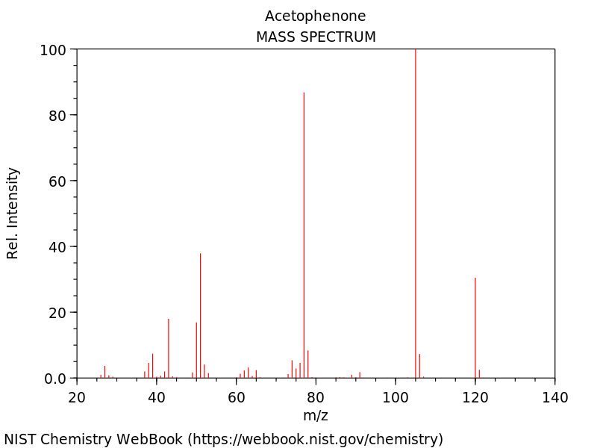

Figure 78. Mass spectrum of acetophenone.

Notice how we could use these masses to determine a possible molecular formula for the compound, and the masses of fragments to determine possible groups that are found in the molecule. The compound below (benzeneacetaldehyde) has the exact same molecular weight (120) as acetophenone, but you might appreciate that it would probably have a different mass spectrum because it would form fragments of different weights than those from acetophenone. Figure 79 shows the mass spectrum of benzeneacetaldehyde, which you will not is quite different from that of acetophenone.
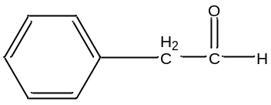

benzeneacetaldehyde

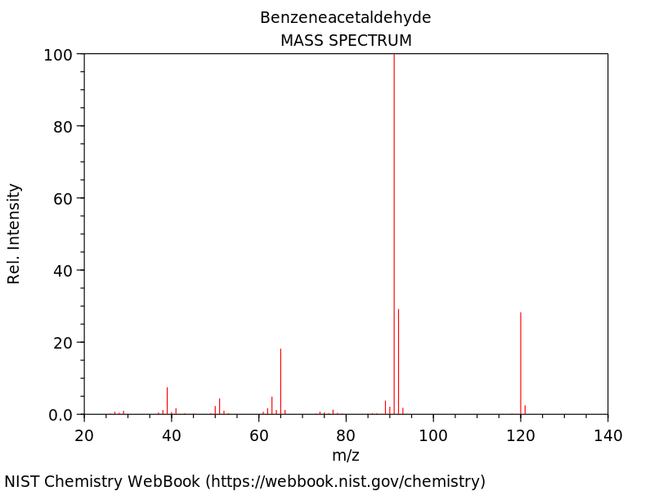

Figure 79. Mass spectrum of benzeneacetaldehyde.
Mass spectra are relatively difficult to interpret and to assign an unequivocal structure to. What is usually done instead is that the mass spectrometers with a GC-MS come with a library of spectra of known compounds. The computer will compare your measured mass spectrum to those in the library and report the ten best matches. The top match does not confirm the assignment. To do that, you would need an authentic sample of that compound and would have to show that it has the same retention time and mass spectrum on your instrument. With those two matches, you can be assured that you have identified the compound. GC-MS is commonly used for drug testing at sports events like the Olympics.

CAPILLARY ELECTROPHORESIS

The design of a capillary electrophoresis (CE) instrument is shown in Figure 80. The separation is performed in a fused silica capillary column that is about 50 cm long with an internal diameter of 25-75 um. We have previously discussed the use of fused silica capillary columns for gas chromatographic separations. Two important distinctions for the capillary used in CE is that (1) it is much shorter than those used in GC-MS, which are typically 30-60 meters, and (2) the inside in CE is usually not covered with a stationary phase and is typically the bare surface of the fused silica glass. Note that there are times when the capillary walls are coated with a substance or derivatized to change the elution behavior. The development in this unit will only consider CE separations using bare silica surfaces. As with the GC capillary, the outside is coated with a polyimide polymer to protect the column from degradation caused by handling.

By removing the end of the capillary in the inlet buffer, placing it in a sample vial and applying pressure to the vial, a small plug of sample can be introduced into the capillary. The end of the capillary with the sample plug is then put back into the inlet buffer. Migration and separation is achieved by applying an electric field across the capillary as indicated in Figure 80 (Note the (+) and (-) potentials at the different ends of the capillary column). Understanding the mechanism for how species migrate in the capillary and are separated will require a consideration of several factors.

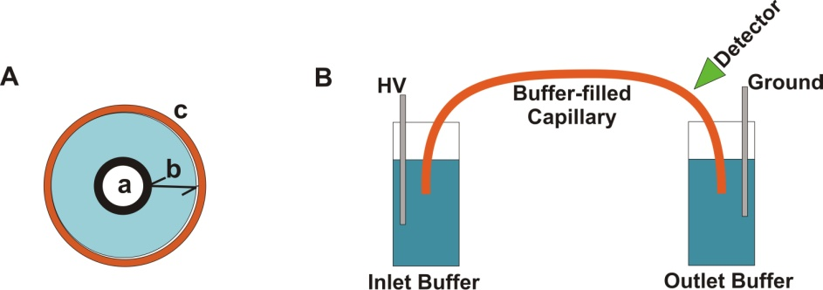
(+)
(–)
Figure 80. Diagram of a capillary electrophoresis instrument.

Detection is often accomplished using UV absorbance or fluorescence. The section of the capillary shown in the detector in Figure 81 has the polyimide coating removed to allow UV/Visible radiation to pass through the capillary.
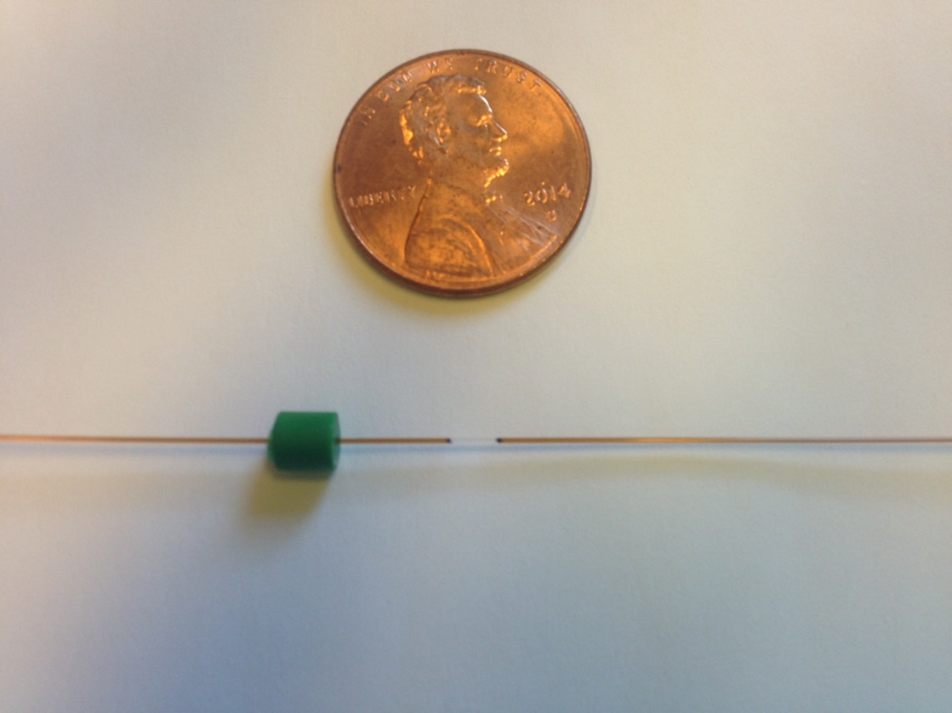
detection window

Figure 81. A fused silica capillary with an inner diameter of 50 μm. The polyimide coating is removed at the detection window.

What is the functional group on the surface of a fused silica capillary column? Fused silica is a silicon dioxide (SiO₂) polymeric material.
While fused silica is very different in physical appearance from the silica gel that is used for liquid chromatographic bonded phases, as a form of silicon dioxide it contains the same functionalities. Therefore, the surface would consist of many silanol (-Si-OH) groups.

Would the nature of the interior surface of the capillary be different if the background electrolyte was at pH 2 versus pH 9?
Silanol groups are mildly acidic and therefore can be deprotonated. At pH 2, most of the silanols would be protonated and therefore neutral. At pH 9, many of the silanol groups would be deprotonated resulting in anionic silanate groups on the surface of the glass.

As seen in Figure 79, CE separations are performed using a background electrolyte. The background electrolyte is an appropriate buffer and therefore contains positive and negative ions.

Assuming the silanol groups are deprotonated to anionic silanate groups, what do you think will happen in the portion of the solution in immediate contact with the surface of the fused silica?
Because of the negative charge of the surface, an excess of cations from the mobile phase buffer will congregate near the walls of the capillary. Figure 82 shows a representation of the inside of the capillary. Some of the cations are tightly associated with the silanate ions forming what is known as the fixed layer. Note that the fixed layer represented in Figure 82 has a net negative charge as there are more silanate ions than tightly associated cations. Adjacent to the fixed layer is something known as the diffuse layer. Note that the diffuse layer in Figure 82 has a net positive charge as there is a higher concentration of buffer cations than anions. To convince you of this, count the number of cations (10) and anions (6) in the diffuse layers in Figure 82 and compare it to the number of cations (12) and anions (12) in the bulk solution. Together the fixed and diffuse layers are known as the double layer. It is important to note that the concentration of ions in the buffer is large compared to the concentration of silanate ions in the fixed layer (The cartoon in Figure 82 does not properly represent how much higher the concentration of buffer is relative to silanate ions). This means that in CE done using the capillary dimensions referred to at the beginning of this unit, the formation of the diffuse layer will not deplete the bulk solution of cations. As a result, the bulk solution in the center of the capillary has equivalent concentrations of cations and anions.

Figure 82 also indicates the electric field that has been applied across the capillary with a resulting cathode (-) and anode (+).
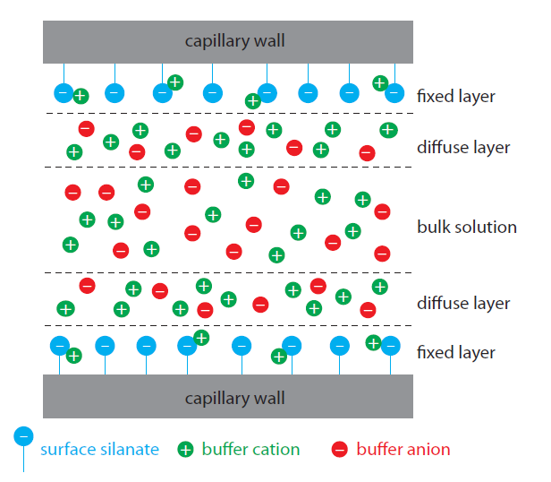
(+)
Anode
(–)
Cathode
Figure 82. Schematic diagram showing the origin of the double layer within a capillary tube. Although the net charge within the capillary is zero, the distribution of charge is not. The walls of the capillary have an excess negative charge, which decreases across the fixed layer, reaching a value of zero in the bulk solution. (Figure from Analytical Chemistry 2.0, David Harvey, http://community.asdlib.org/activelearningmaterials/analytical-chemistry-2-0-online-textbook/).

What happens in the diffuse layer in the presence of this applied electric field?
The net positive charge in the diffuse layer means that the cations will be drawn toward the cathode. Because these cations are solvated, they drag along solvent molecules and the rest of the solution with them. Because the internal diameter of the capillary is so small, the net result is that both the diffuse layer and bulk solution flow toward the cathode in what is known as the electroosmosis.

Figure 83 shows the profile for electroosmotic and hydrodynamic flow in a capillary tube. Hydrodynamic flow occurs in a capillary when pressure is used to push the liquid through the tube. Hydrodynamic flow has a parabolic cross-section because friction at the surface means that molecules at the capillary walls travel more slowly than molecules in the center of the capillary. Note that the flow velocity in electroosmosis is nearly constant across the capillary and is very different from the profile in hydrodynamic flow. This occurs because in electroosmosis the flow originates at the surface with cations in the diffuse layer.

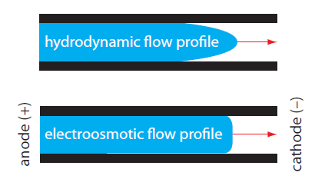

Figure 83. Comparison of hydrodynamic flow and electroosmotic flow. The nearly uniform electroosmotic flow profile means that the electroosmotic flow velocity is nearly constant across the capillary. (Figure from Analytical Chemistry 2.0, David Harvey, http://community.asdlib.org/activelearningmaterials/analytical-chemistry-2-0-online-textbook/).

Which flow profile, hydrodynamic or electroosmotic, results in greater peak broadening?
Hydrodynamic flow causes greater broadening because there is a larger difference in velocity between molecules at the center of the tube and those at the walls of the capillary tube when compared to electroosmotic flow.

As previously discussed, broadening in chromatographic columns results from eddy diffusion, longitudinal diffusion, and mass transport broadening in the stationary and mobile phases. Which of these processes contribute to peak broadening in capillary electrophoresis?
Since this is an open tubular capillary column without packing, there is no eddy diffusion. Since there is also no stationary phase, there cannot be any mass transport broadening in the stationary phase. Mobile phase mass transport broadening occurred because of the time it took for the analytes to encounter the stationary phase. With no stationary phase, there is also no mobile phase mass transport broadening. Therefore, the only contribution to peak broadening occurs from longitudinal diffusion. Even under the influence of electrophoretic and electroosmotic flow, analyte molecules still have random diffusion in all directions that causes the peaks to broaden. Because of the limited contributions to broadening in CE, peaks tend to be quite sharp and separations have high numbers of theoretical plates.

What would happen to the electroosmotic flow rate at pH 2.5 versus pH 10?
At pH 2.5, very few of the silanols are deprotonated to silanates so the diffuse layer only has a small net positive charge. At pH 10, almost all of the silanols are deprotonated to silanates and the diffuse layer has a much greater net positive charge. Because of the higher positive charge at pH 10, the electroosmotic flow rate will increase.

Suppose the compounds being analyzed have a charge. Is there any other process that will result in analyte ions moving in the capillary column?
Because there is an applied electric field, analytes with a positive charge will migrate toward the negatively charged cathode and those with a negative charge will migrate toward the positively charged anode. This movement is known as electrophoresis.

What variables influence the electrophoretic migration rate of a charged analyte?
The electrophoretic migration rate of a substance depends on its charge and size. A species with a higher charge has a greater electrostatic attraction for either the cathode or anode and will migrate faster than a species with a lower charge. Similarly, an ion with a smaller size will migrate faster than an ion with a larger size.

Imagine that four ions start in the middle of the capillary as shown in Figure 84.

Cathode (-)
Anode (+)
+1
+1
-1
-1

Figure 84. Representation of four ions in the middle of a capillary prior to the beginning of migration.

Assuming that the ions only move as a result of electrophoresis, draw the position of the ions after 30 kV has been applied for a short time.
With only electrophoresis, the negative ions would move toward the positively charged anode and the positive ions would move toward the negatively charged cathode. Also, the ions with the smaller size would move faster and therefore further than the larger ions. The result after applying the voltage for a short period of time is shown in Figure 85.

Cathode
(-)
Anode (+)
+1
+1
-1
-1

Figure 85. Representation of four ions in the capillary a brief period of time after applying an electric field. Remember, the ions in this picture only experience electrophoretic migration.

Now consider the separation of a sample that has anionic, cationic and neutral analytes and has both electroosmotic and electrophoretic flow. The detector is placed on the end of the capillary near the cathode as shown in Figure 86. Anions, cations and neutrals are all detected. Explain.
Cathode
(-)
Anode (+)
Detector

Figure 86. Representation of capillary showing the placement of the anode, cathode and detector.

To explain this observation, the total velocity (v_{tot}), which is the sum of the electrophoretic migration (v_{ep}) and electroosmotic flow (v_{eo}), must be considered (v_{tot} = v_{ep} + v_{eo}).
- For cations, the electrophoretic migration and electroosmotic flow both are in the direction of the cathode.
- For anions, the electrophoretic flow is toward the anode but the electroosmotic flow is toward the cathode. In order for anions to pass through the detector, the electroosmotic flow must be greater than the electrophoretic migration.
- Neutral compounds only experience electroosmotic flow. Therefore, they will flow toward the cathode and pass through the detector.

Figure 87 shows arrows representing the different flow contributions for cations, neutrals and anions.
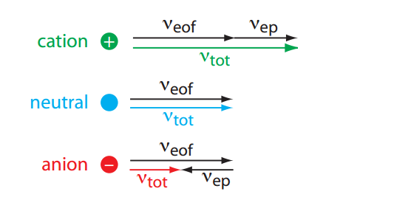
Figure 87. Visual explanation for the general elution order in capillary electrophoresis. Each species has the same electroosmotic flow. Neutrals have no electrophoretic velocity. The electrophoretic velocity of cations and anions are in opposite directions. (Figure from Analytical Chemistry 2.0, David Harvey, http://community.asdlib.org/activelearningmaterials/analytical-chemistry-2-0-online-textbook/).

What is the predicted elution order of the following five substances?
In addition, draw an electropherogram of the results and explain your reasoning.
Substance A: neutral
Substance B: ̶ 1 charge
Substance C: +1 charge
Substance D: neutral
Substance E: ̶ 2 charge
Substances A, B, C, and E are all the same size. Substance D is twice as large as the others.

Figure 88 shows the electropherogram for the analysis of A-E. Substance C, which is the only species with a positive charge, elutes first as its velocity is a combination of the electroosmotic and electrophoretic flow. The two anions B and E elute last because they have an electrophoretic flow in the opposite direction from electroosmotic flow. Substance E with a –2 charge is the last because it has a larger electrophoretic migration than Substance B with a –1 charge. Neutral species A and D only move because of electroosmosis. Unlike electrophoresis, electroosmotic flow is independent of size so A and D will coelute.
C
A,D
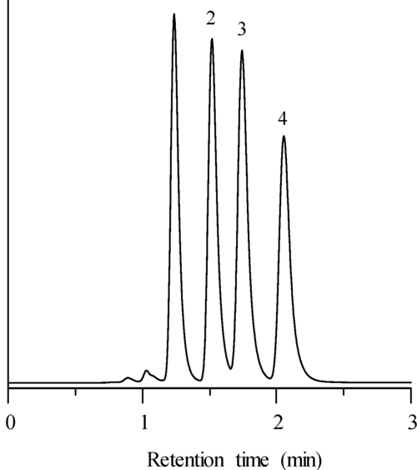
B
E

Figure 88. Electropherogram for substances A-E.

The structural formulas and relevant pK_{a} values for the four components of an Exedrin tablet are shown in Figure 89. (The protonated form of the boxed group is shown.) Predict the elution order in CE with a 20 mM borate buffer at pH = 9.3.
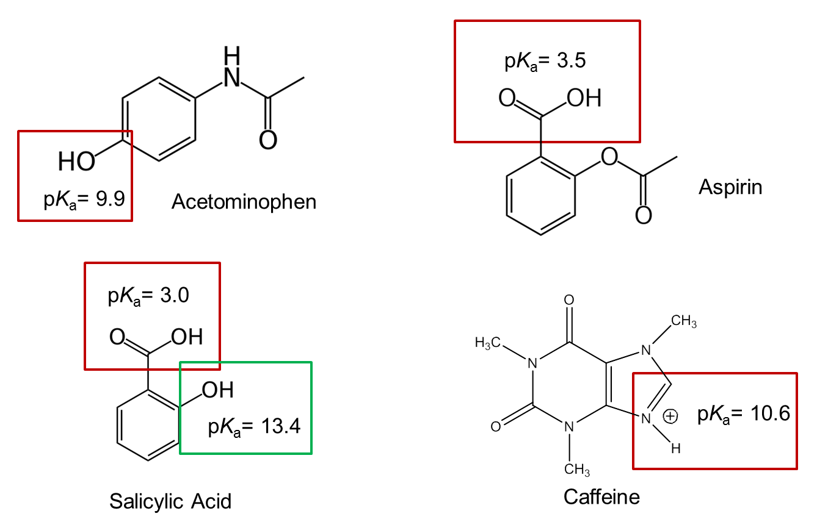

Figure 89. Structures and pKa values of the four primary constituents of Excedrin

The important thing to consider is whether the acidic or basic functional groups are protonated or deprotonated at pH 9.3 to determine the overall charge of the species.
- For aspirin, the carboxylic acid group with a pKa of 3.5 will be “fully deprotonated” so will have a –l charge. The words “fully deprotonated” are put in quotes because a very small amount must be protonated to satisfy the Ka expression, but it is so small that it can be ignored.
- For caffeine, the nitrogen atom with a pKa of 10.6 will be “fully protonated” so will have a charge of +1.
- For acetaminophen, the hydroxyl (phenol) group with a pKa of 9.9 is only 0.6 units from the pH of the buffer. In this case, only a portion of the acetaminophen will be deprotonated at any given moment and there will be a rapid exchange between protonated (neutral) and deprotonated (anionic) forms. Therefore, it will have a charge that can be considered as between 0 and –1.
- For salicylic acid, the carboxylic acid group with a pKa of 3.5 will be “fully deprotonated” whereas the hydroxyl group with a pKa of 13.4 will be “fully protonated”. The overall charge will be –1.

To summarize, at pH 9.3, the species would have the following charges:
Aspirin: –1 charge
Caffeine: +1 charge
Acetaminophen: Average charge between 0 to –1
Salicylic acid: –1 charge

The system is set up such that cations elute first, followed by neutrals and finally followed by anions. Therefore, caffeine elutes first. Acetaminophen elutes second because it has the smallest negative charge of the three anionic species. Aspirin and salicylic acid have identical charges but differ slightly in size with aspirin being slightly larger than salicylic acid. Because aspirin is larger its electrophoretic migration is less than that of salicylic acid and since the electrophoresis of anions is opposite of the direction of electroosmotic flow needed for elution, aspirin elutes before salicylic acid.

What could you do experimentally to confirm your predicted elution order?
You would need to make up solutions with one each of the four compounds and carry out the analysis to determine their retention time.

An actual electropherogram of this sample at pH 9.3 is shown in Figure 90.

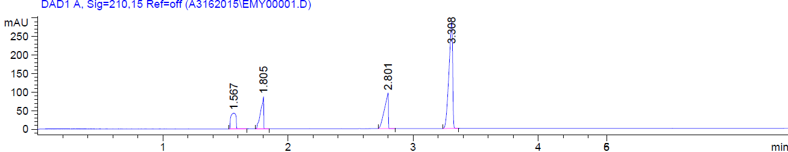

Figure 90. Electropherogram of the four constituents of Excedrin at pH 9.3: caffeine (1.567 min), acetaminophen (1.805 min), aspirin (2.801 min) and salicylic acid (3.308 min).

Appendix I: Derivation of the Fundamental Resolution Equation

(1)
$${\text{R}}_{\text{S}}\text{ = }\frac{\text{2}\left({\text{t}}_{\text{2}}-{\text{ t}}_{\text{1}}\right)}{{\text{W}}_{\text{1}}\text{ + }{\text{W}}_{\text{2}}}$$

$${\text{W}}_{\text{1}} \text{≅}{\text{ W}}_{\text{2}}$$

$$\text{W = 4σ}$$
$${\text{R}}_{\text{S}}\text{ = }\frac{\text{2}\left({\text{t}}_{\text{2}}- {\text{t}}_{\text{1}}\right)}{{\text{8σ}}_{\text{2}}}\text{ = }\frac{{\text{t}}_{\text{2}}- {\text{t}}_{\text{1}}}{\text{4}{\text{σ}}_{\text{2}}}$$
(2)

$$\text{N = }{\left(\frac{{\text{t}}_{\text{2}}}{{\text{σ}}_{\text{2}}}\right)}^{\text{2}} {\text{σ}}_{\text{2}}\text{ = }\frac{{\text{t}}_{\text{2}}}{\sqrt{\text{N}}}$$
(3)
$${\text{R}}_{\text{S}}\text{ = }\frac{{\text{t}}_{\text{2}} - {\text{t}}_{\text{1}}}{\text{4}\left(\frac{{\text{t}}_{\text{2}}}{\sqrt{\text{N}}}\right)}$$
(4)
$${\text{R}}_{\text{S}}\text{ = }\left(\frac{\sqrt{\text{N}}}{\text{4}}\right)\left(\frac{{\text{t}}_{\text{2}} - {\text{t}}_{\text{1}}}{{\text{t}}_{\text{2}}}\right)=\left(\frac{\sqrt{\text{N}}}{\text{4}}\right)\left(\text{1} - \frac{{\text{t}}_{\text{1}}}{{\text{t}}_{\text{2}}}\right)$$

Write an expression for the fraction of material in the mobile phase (φ_{M}):
(5)
$${\text{φ}}_{\text{M}}\text{ = }\frac{{\text{C}}_{\text{M}}{\text{V}}_{\text{M}}}{{\text{C}}_{\text{M}}{\text{V}}_{\text{M}}\text{ +}{\text{ C}}_{\text{S}}{\text{V}}_{\text{S}}}$$
(6)
$${\text{φ}}_{\text{M}}\text{ = }\frac{\frac{{\text{C}}_{\text{M}}{\text{V}}_{\text{M}}}{{\text{C}}_{\text{M}}{\text{V}}_{\text{M}}}}{\frac{{\text{C}}_{\text{M}}{\text{V}}_{\text{M}}}{{\text{C}}_{\text{M}}{\text{V}}_{\text{M}}}\text{ + }\frac{{\text{C}}_{\text{S}}{\text{V}}_{\text{S}}}{{\text{C}}_{\text{M}}{\text{V}}_{\text{M}}}}\text{ = }\frac{\text{1}}{\text{1 + k}}$$

Express the average migration velocity of component 2:
(7)
$${\text{v}}_{{\text{S}}_{\text{2}}}\text{ = }{\text{φ}}_{\text{M}}\text{v}$$

(where v is the mobile phase velocity)
(9)
(8)
$${\text{v}}_{{\text{S}}_{\text{2}}}\text{ = }\frac{\text{L}}{{\text{t}}_{\text{2}}} \text{v = }\frac{\text{L}}{{\text{t}}_{\text{0}}}$$
(10)
$$\frac{\text{L}}{{\text{t}}_{\text{2}}}\text{ = }\frac{\text{L}}{{\text{t}}_{\text{0}}}{\text{φ}}_{\text{M}}$$

(11)
$${\text{t}}_{\text{2}}\text{ = }\frac{{\text{t}}_{\text{0}}}{{\text{φ}}_{{\text{M}}_{\text{2}}}} {\text{t}}_{\text{1}}\text{ = }\frac{{\text{t}}_{\text{0}}}{{\text{φ}}_{{\text{M}}_{\text{1}}}}$$
(12)
$${\text{t}}_{\text{2}} \text{= }\frac{{\text{t}}_{\text{0}}}{\left(\frac{\text{1}}{\text{1 + }{\text{k}}_{\text{2}}}\right)} {\text{t}}_{\text{1}}\text{ = }\frac{{\text{t}}_{\text{0}}}{\left(\frac{\text{1}}{\text{1 + }{\text{k}}_{\text{1}}}\right)}$$
(13)
${\text{t}}_{\text{2}}\text{ = }{\text{t}}_{\text{0}}\text{(1 +}{\text{ k}}_{\text{2}}\text{) }{\text{t}}_{\text{1}}\text{ =}{\text{ t}}_{\text{0}}\text{(1 +}{\text{ k}}_{\text{1}}\text{)}$
(14)

$$\frac{{\text{t}}_{\text{1}}}{{\text{t}}_{\text{2}}}\text{ = }\frac{{\text{t}}_{\text{0}}\text{(1 +}{\text{ k}}_{\text{1}}\text{)}}{{\text{t}}_{\text{0}}\text{(1 +}{\text{ k}}_{\text{2}}\text{)}}\text{ = }\frac{\text{1 +}{\text{ k}}_{\text{1}}}{\text{1 +}{\text{ k}}_{\text{2}}}$$

Substitute (14) into (4):
(15)

$${\text{R}}_{\text{S}} \text{=} \left(\frac{\sqrt{\text{N}}}{\text{4}}\right)\left(\text{1 }- \frac{\text{1 +}{\text{ k}}_{\text{1}}}{\text{1 +}{\text{ k}}_{\text{2}}}\right)$$

Consider the $\left(\text{1 }- \frac{\text{1 +}{\text{ k}}_{\text{1}}}{\text{1 +}{\text{ k}}_{\text{2}}}\right)$ term:
(15a)

$$\left(\text{1}-\frac{\text{1 +}{\text{ k}}_{\text{1}}}{\text{1 +}{\text{ k}}_{\text{2}}}\right)=\left(\frac{\text{1 +}{\text{ k}}_{\text{2}}}{\text{1 +}{\text{ k}}_{\text{2}}} - \frac{\text{1 +}{\text{ k}}_{\text{1}}}{\text{1 +}{\text{ k}}_{\text{2}}}\right)$$
(15b)
$$=\frac{{\text{ k}}_{\text{2}} \text{–} {\text{ k}}_{\text{1}}}{\text{1 +}{\text{ k}}_{\text{2}}}$$
(15c)
$$\text{=} \frac{{\text{ k}}_{\text{1}} \left(\frac{{\text{ k}}_{\text{2}}}{{\text{ k}}_{\text{1}}} -\text{1}\right)}{\text{1 +}{\text{ k}}_{\text{2}}}$$
(15d)
$$\text{= }\frac{\left(\frac{{\text{ k}}_{\text{2}}}{{\text{ k}}_{\text{1}}}\right){\text{k}}_{\text{1}}\left(\frac{{\text{ k}}_{\text{2}}}{{\text{ k}}_{\text{1}}} -\text{ 1}\right)}{\left(\frac{{\text{ k}}_{\text{2}}}{{\text{ k}}_{\text{1}}}\right)\left(\text{1 +}{\text{ k}}_{\text{2}}\right)}\text{ = }\frac{{\text{k}}_{\text{2}}\left(\frac{{\text{ k}}_{\text{2}}}{{\text{ k}}_{\text{1}}} -\text{ 1}\right)}{\left(\frac{{\text{ k}}_{\text{2}}}{{\text{ k}}_{\text{1}}}\right)\left(\text{1 +}{\text{ k}}_{\text{2}}\right)}$$
(15e)
$$\text{= }\left(\frac{{\text{k}}_{\text{2}}}{\text{1+ }{\text{k}}_{\text{2}}}\right)\left(\frac{\frac{{\text{ k}}_{\text{2}}}{{\text{ k}}_{\text{1}}} -\text{ 1}}{\frac{{\text{ k}}_{\text{2}}}{{\text{ k}}_{\text{1}}}}\right)$$

$$\text{α = }\frac{{\text{ k}}_{\text{2}}}{{\text{ k}}_{\text{1}}}$$
(15f)
$$\text{= }\left(\frac{{\text{k}}_{\text{2}}}{\text{1+ }{\text{k}}_{\text{2}}}\right)\left(\frac{\text{α }-\text{ 1}}{\text{α}}\right)$$
Substitute (15f) into (15):

$${\text{R}}_{\text{S}} \text{=} \left(\frac{\sqrt{\text{N}}}{\text{4}}\right)\left(\frac{\text{α }-\text{ 1}}{\text{α}}\right)\left(\frac{{\text{k}}_{\text{2}}}{\text{1} \text{+ }{\text{k}}_{\text{2}}}\right)$$

Relationship to retention time:

$${\text{v}}_{{\text{S}}_{\text{2}}}\text{= }\frac{\text{L}}{{\text{t}}_{\text{2}}} {\text{t}}_{\text{2}} \text{=} \frac{\text{L}}{{\text{v}}_{{\text{S}}_{\text{2}}}}$$
(16)
$${\text{v}}_{{\text{S}}_{\text{2}}}\text{= }{\text{φ}}_{\text{M}}\text{v = }\left(\frac{\text{1}}{\text{1} \text{+}{ \text{k}}_{\text{2}}}\right)\text{v}$$

$$\text{H} \text{=} \frac{\text{L}}{\text{N}}\text{ L =} \text{HN}$$
(17)
$${\text{t}}_{\text{2}}\text{ = }\frac{\text{HN(1 + }{\text{k}}_{\text{2}}\text{)}}{\text{v}}$$

Rearrange the fundamental resolution equation to solve for N:

$$\text{N} \text{=} \text{16}{{\text{R}}_{\text{S}}}^{\text{2}}{\left(\frac{\text{α}}{\text{α} - \text{1}}\right)}^{\text{2}}{\left(\frac{\text{1} \text{+} {\text{k}}_{\text{2}}}{{\text{k}}_{\text{2}}}\right)}^{\text{2}}$$
(18)
$${\text{t}}_{\text{2}}\text{ = }\left(\frac{\text{16}{{\text{R}}_{\text{S}}}^{\text{2}}\text{H}}{\text{v}}\right){\left(\frac{\text{α}}{\text{α }-\text{ 1}}\right)}^{\text{2}}\left(\frac{{\left(\text{1 + }{\text{k}}_{\text{2}}\right)}^{\text{3}}}{{\left({\text{k}}_{\text{2}}\right)}^{\text{2}}}\right)$$

