Directions This assignment will constitute your first electronic lab notebook entry! You can call it "Week 1: Using Excel for Graphical Analysis of Data" or something equally catchy. Simply read through the procedure, working in Excel as you go, and wherever you see Take a screenshot or Record in your notebook, be sure to save that information in your notebook, whether it's numerical or an image of a graph. When you're finished, convert your lab notebook pages to PDF files and upload here. Click here (Links to an external site.) for help converting OneNote pages to PDF files. There will be a quiz!

Using Excel for Graphical Analysis of Data
Adapted from Chem Libretexts as contributed by Santa Monica College and Khan Academy
In many of your upcoming labs, a primary goal will be to determine the mathematical relationship between two variable physical parameters. Graphs are useful tools that can elucidate such relationships. First, plotting a graph provides a visual image of data and any trends therein. Second, via appropriate analysis, they provide us with the ability to predict the results of any changes to the system.
An important technique in graphical analysis is the transformation of experimental data to produce a straight line. If there is a direct, linear relationship between two variable parameters, the data may be fitted to the equation of line with the familiar form y = mx + b through a technique known as linear regression. Here m represents the slope of the line, and b represents the y-intercept, as shown in the figure below. This equation expresses the mathematical relationship between the two variables plotted, and allows for the prediction of unknown values within the parameters.
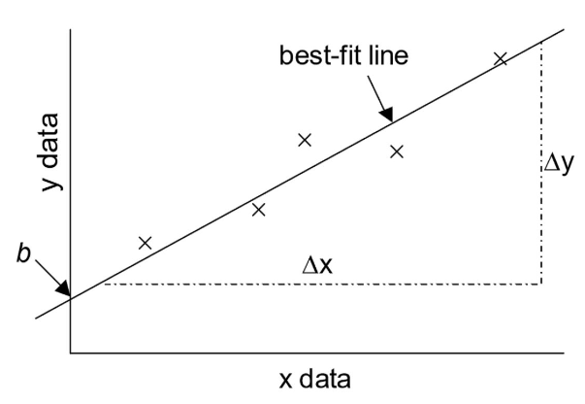

The equation for a best-fit line is
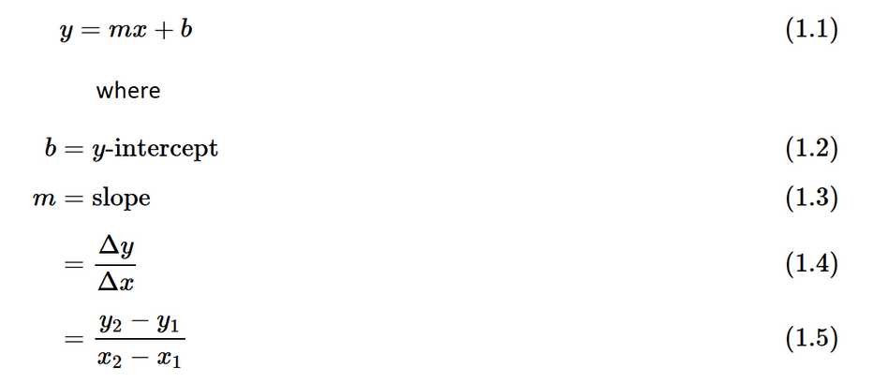
Computer spreadsheets are powerful tools for manipulating and graphing quantitative data. In this exercise, the spreadsheet program Microsoft Excel© will be used for this purpose. In particular, you will learn to use Excel in order to explore a number of linear graphical relationships.

Procedure

Part 1: Simple Linear Plot
Scenario: A certain experiment is designed to measure the volume of 1 mole of helium gas at a variety of different temperatures, while keeping the gas pressure constant at 758 torr:
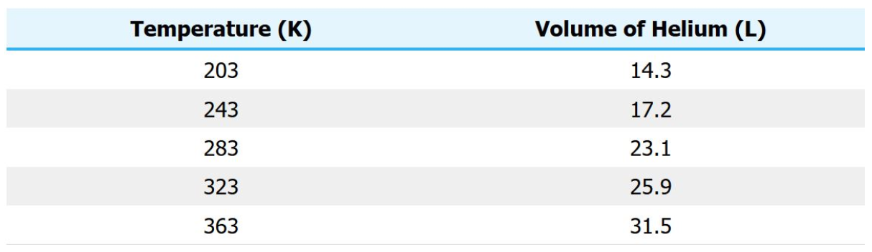
- Launch the program Microsoft Excel© on your iPad. Note: if you are using a Windows desktop computer, please use the directions here instead.
- Enter column labels and the above data into the first two columns in the spreadsheet.
  - The x values must be entered to the left of the y values in the spreadsheet. Remember that the independent variable (the one that you, as the experimenter, have control of) goes on the x-axis while the dependent variable (the measured data) goes on the y-axis. Go here to spend 2 minutes reviewing independent vs. dependent variables.
- Highlight the set of data (not the column labels) that you wish to plot:
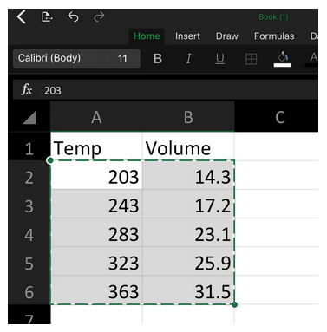
4. Click on Insert > Charts > X Y (Scatter):
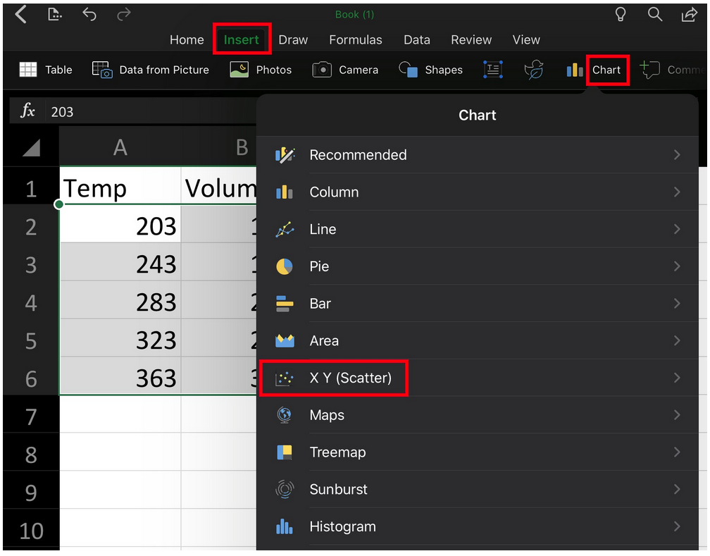

- You should now see a scatter plot:
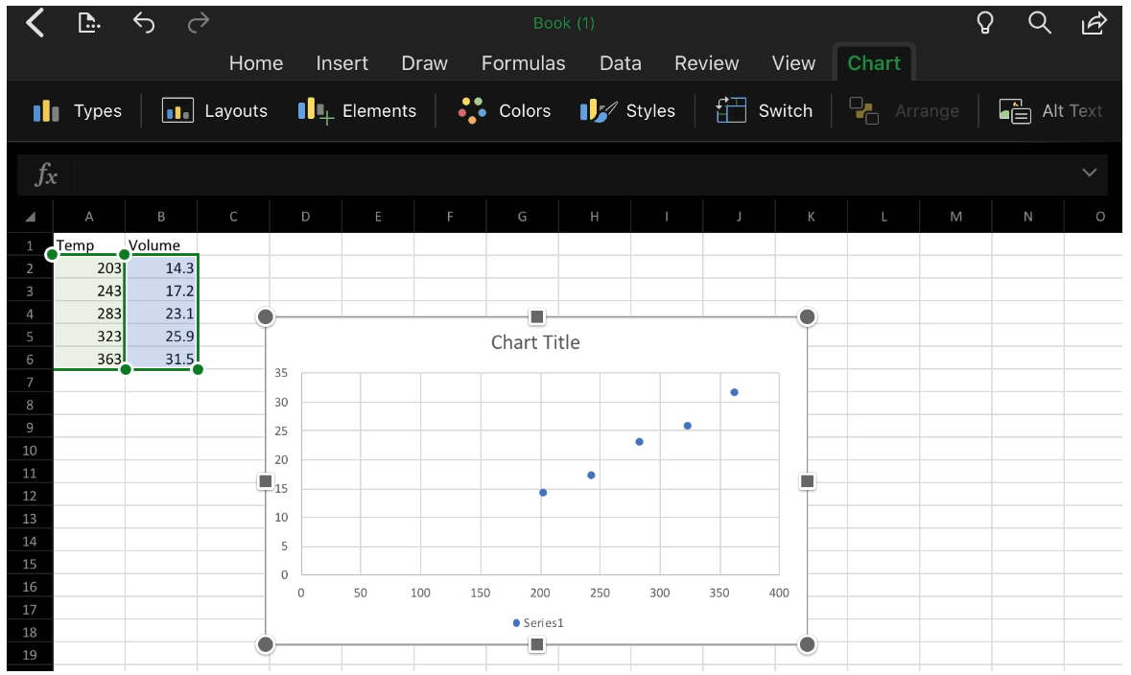

- If all looks well, it is time to add titles and label the axes of your graph.
  - Click on Chart > + Elements > Axis titles and Chart title:
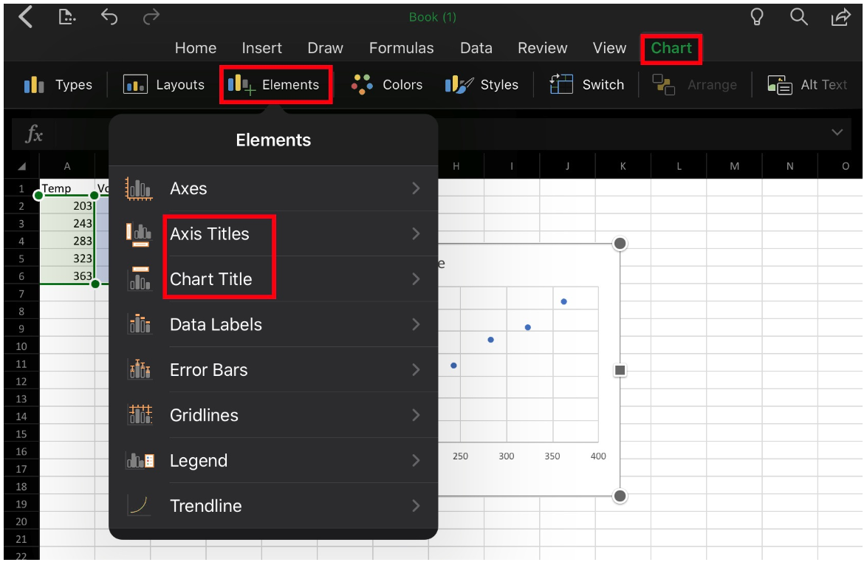
  - The graph should be given a meaningful, explanatory title that starts out “Y versus X" followed by a description of your system.
  - Click on Axis Titles (select Primary Horizontal Axis Title and Primary Vertical Axis Title) to add labels to the x- and y-axes. Note that it is important to label axes with both the measurement and the units used.
  - To change the titles, click the text box for each title, highlight the text and type in your new title.

- Your next step is to add a trendline and best fit line equation to the plotted data points. A trendline represents the best possible linear fit to your data. To add a trendline, click Chart > Layouts > scroll down to the option that includes a trendline + best fit line equation:
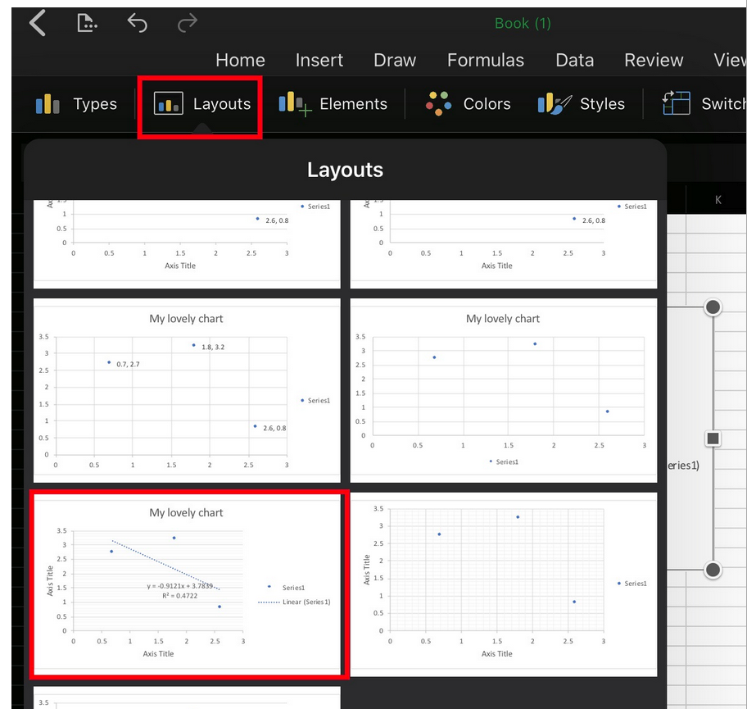

- The equation that now appears on your graph is the equation of the fitted trendline. The R² value gives a measure of how well the data is fit by the equation. The closer the R² value is to 1, the better the fit. Generally, R² values of 0.95 or higher are considered good fits. Note that Excel will always fit a trendline to the data no matter how good or awful the data is. You must judge the quality of the fit and the suitability of this type of fit to your data set.

- Take a screenshot of your finished graph. Then record in your notebook the following information:
  - the equation of the best-fit trendline to your data
  - the slope of the trendline
  - the y-intercept of the trendline
  - whether the fit of the line to the data is good or bad, and why.
By graphing the five measured values, a relationship is established between gas volume and temperature. The graph contains a visual representation of the relationship (the plot) and a mathematical expression of the relationship (the equation). It can now be used to make certain predictions.
For example, suppose the 1 mole sample of helium gas is cooled until its volume is measured to be 10.5 L. You are asked to determine the gas temperature. Note that the value 10.5 L falls outside the range of the plotted data. How can you find the temperature if it doesn't fall between the known points? There are two ways to do this: one is to extrapolate and one is to use your best fit line equation:
Plug the value for volume into the equation of the trendline and solve for the unknown temperature (think about it: Which variable is y and which is x?). Do this and record in your notebook your answer. Note that this method is generally more precise than extrapolating and "eyeballing" from the graph.

Part 2: Statistical Analysis and Simple Scatter Plots
When many independent measurements are made for one variable, there is inevitably some scatter (noise) in the data. This is usually the result of random errors over which the experimenter has little control.
Scenario: Ten different students at two different colleges each measure the sulfate ion concentration in a sample of tap water:
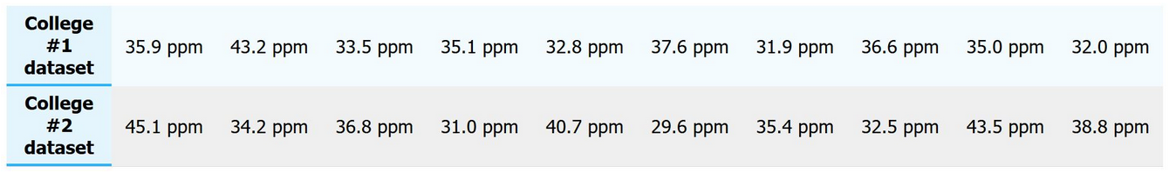
Simple statistical analyses of these datasets might include calculations of the mean and median concentration, and the standard deviation.
The mean (x) is simply the average value, defined as the sum (∑) of each of the measurements (x_{i}) in a data set divided by the number of measurements (N):
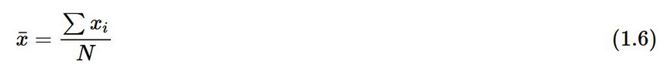
The median (M) is the midpoint value of a numerically ordered dataset, where half of the measurements are above the median and half are below. The median location of N measurements can be found using:
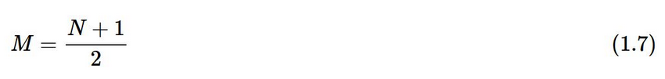
When N is an odd number, the formula yields a integer that represents the value corresponding to the median location in an ordered distribution of measurements. For example, in the set of numbers (3 1 5 4 9 9 8) the median location is (7 + 1) / 2, or the 4th value. When applied to the numerically ordered set (1 3 4 5 8 9 9), the number 5 is the 4th value and is thus the median – three scores are above 5 and three are below 5. Note that if there were only 6 numbers in the set (1 3 4 5 8 9), the median location is (6 + 1) / 2, or the 3.5th value. In this case the median is half-way between the 3rd and 4th values in the ordered distribution, or 4.5.
Mean and median both try to measure the "central tendency" in a data set. The goal of each is to get an idea of a "typical" value in the data set. The mean is commonly used, but sometimes the median is preferred. It all depends on which value is more representative of the data's central tendency.
Take 5 minutes to complete this Khan Academy tutorial on Choosing the best measure of center. When you're done, explain in your own words how to determine the best measure of center and record your response in your notebook.

Standard deviation (s) is a measure of the variation in a dataset, and is defined as the square root of the sum of squares divided by the number of measurements minus one:
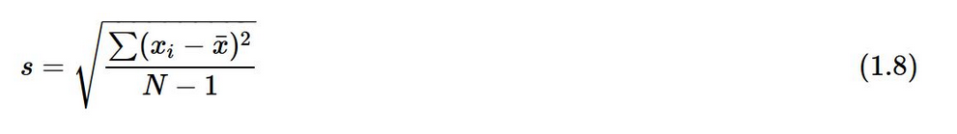
The larger the value of the standard deviation, the greater the variation in the data, and the lower the precision in the measurements.
While the mean, median and standard deviation can be calculated by hand, it is often more convenient to use a calculator or computer to determine these values. Microsoft Excel© is particularly well suited for such statistical analyses.
- Enter the data acquired by the students from College #1 (only) into a single column of cells on a fresh page (Sheet 2) in Excel:
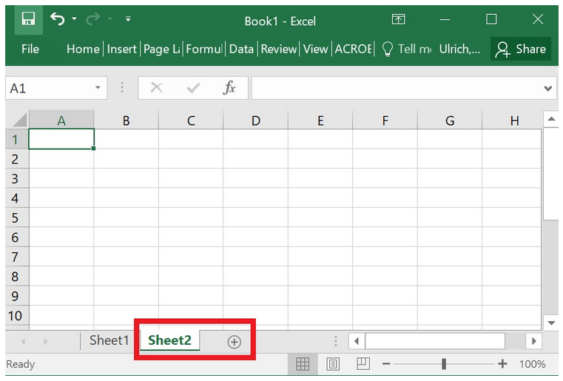
- Then in any empty cell (usually one close to the data cells), instruct the program to perform the required functions on the data. To compute the mean or average of the data entered in cells a1 through a10, for example, you must:
  - click the mouse in an empty cell
  - type "=average(a1:a10)"
  - and press return
To obtain the median you would instead type “=median(a1:a10)”. To obtain the standard deviation you would instead type "=stdev(a1:a10)".
3. Record in your notebook: The Excel calculated mean, median and standard deviation for the College #1 dataset.

Rejecting Outliers
Do all the measurements in the College #1 data set look equally good to you, or are there any values that do not seem to fit with the others? If so, are you allowed to reject these measurements?
Outliers are data points which lie far outside the range defined by the rest of the measurements and may skew your results to a great extent. If you determine that an outlier resulted from an obvious experimental error (e.g., you incorrectly read an instrument or prepared a solution), you may reject the point without hesitation. If, however, none of these errors is evident, you must use caution in making your decision to keep or reject a point.
One rough criterion for rejecting a data point is if it lies beyond two standard deviations from the mean (average).
- Using the above criteria, determine if there are any outliers in the College #1 dataset.
  - Record in your notebook these outlier measurements. Show all your work.
  - Then, excluding any outliers, re-calculate the mean, median and standard deviation of this data set. Record in your notebook the new values.
Rejecting data points cannot be done just because you want your results to look better. If you choose to reject an outlier for any reason, you must always include documentation in your lab report which clearly states:
- that you did reject a point
- which point you rejected
- why you rejected it
Failure to disclose this could constitute scientific fraud.

