The following Virtual Lab Experiments were carried out by Food Engineering students from the National University of Luján in the context of preventive, social and mandatory isolation decreed in Argentina to contain the COVID-19 pandemic.
The simulator of a spectrofluorometer, FluSpec, which can be downloaded free of charge from the link detailed below, was used.
The development of the activities can be found in the "Experiments" tab, to adapt it to our course we make some modifications.
The guide that we send to our students is shown below.

Fluorescence spectrophotometry

This activity uses a simulator of a spectrofluorometer. In order to use it, they must download it on their PC.
Download link: https://github.com/stephenbigger/FluSpec/releases

Download the file according to the operating system you have. If you have MacOS, download the first file (the 13.5 MB) and if you have Windows, the second (6.48 MB). Once downloaded, they just have to open the file that has the icon of a green leaf.

Exercise 1 - Guide to use the simulator
This first exercise is a guide to familiarize you with using the simulator and to encourage you to explore its various controls. Therefore, the user must "experiment" with the simulator before embarking on the formally structured experiments that follow.

(1) To enter the fluorescence spectrometer simulator click on the "FluSpect" tab. When you enter the simulator, it is automatically set to run the fluorescence emission spectrum of a 2.4 × 10⁻⁷ M solution of Rhodamine B (RhB) with ethanol as solvent. Note that moving the active “RhB Conc” slider to the left will decrease the RhB concentration and to the right will increase it.
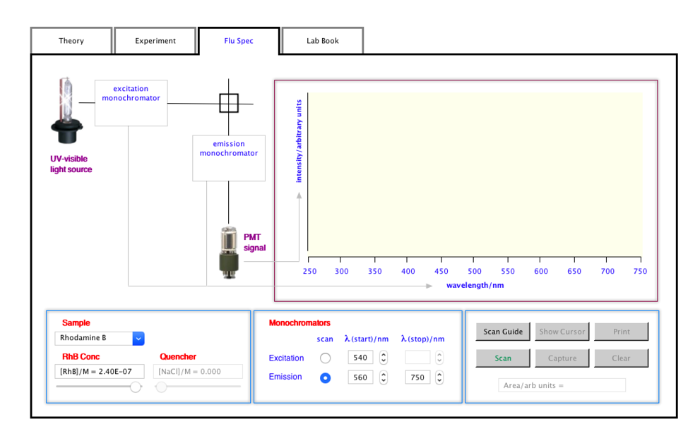
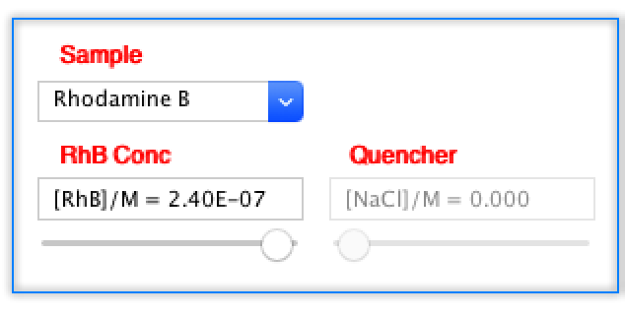

(2) Check the current monochromator settings by clicking the “Scan Guide” button. This opens a window that provides relevant information and suggested wavelength ranges for scanning the samples. In the case of RhB, it can be seen that it has a maximum absorption of 540 nm (this will be confirmed experimentally later by running its fluorescence excitation spectrum) and the suggested wavelength scanning range for observing RhB emission is 560 to 750 nm. Therefore, by default, the fluorometer is set to scan for RhB fluorescence emission according to the suggestions in the “Scan Guide”.

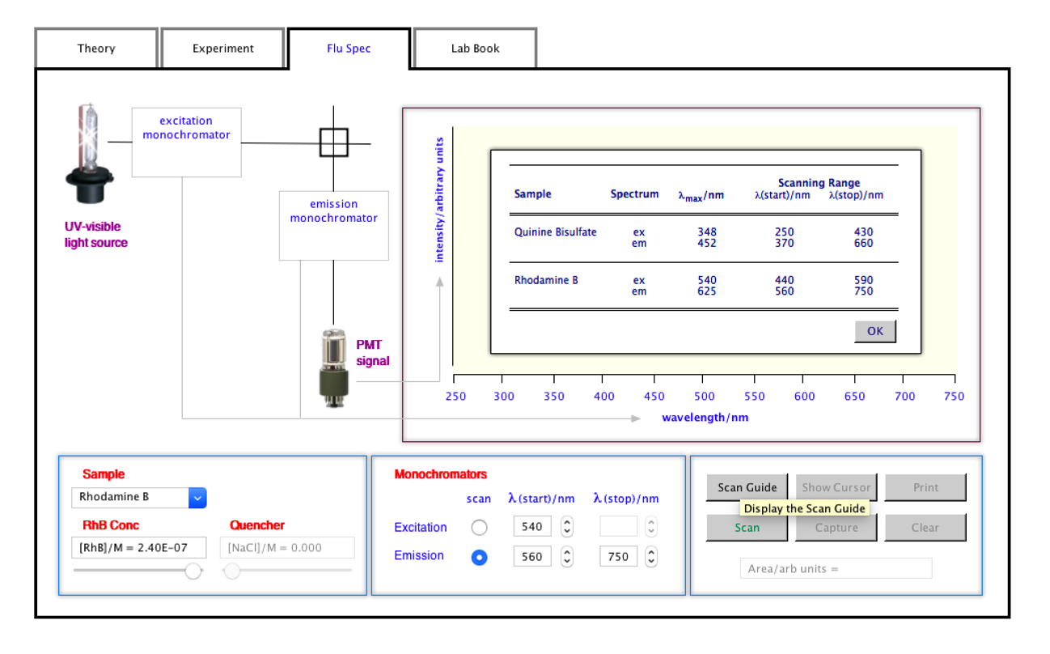

(3) You can save the information by clicking the OK button or clicking the “Scan Guide” button again. Don't worry if you forget to do this before starting a subsequent run because the information window will automatically hide when the scan begins.

(4) Click the "Scan" button to start scanning the spectrum. Note that the label for this button changes to "Abort" as soon as the scan begins and therefore this button can also be used to cancel a run.
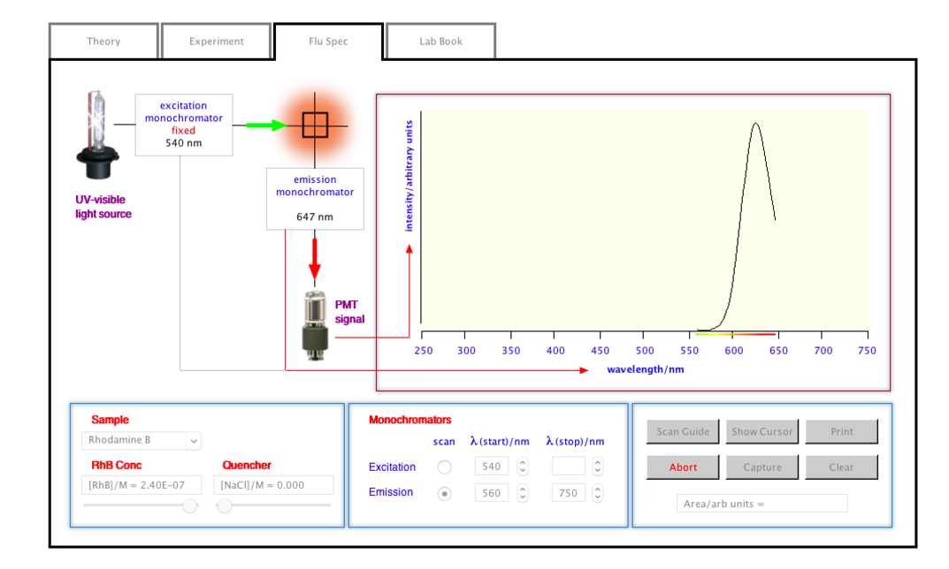

(5) Note that during scanning, the emission monochromator is sequentially passed through the wavelengths in the set emission range (i.e. the emission from the scattered sample is being emitted at its component wavelengths and, as such, it is said to be "scanned") and the intensity signal from the photomultiplier tube (PMT) detector is displayed as a function of wavelength to produce the "fluorescence emission spectrum" in the exit window.

(6) Click the “Show Cursor” button to show the cursor and drag along the horizontal axis to confirm that the maximum emission of fluorescence of RhB in ethanol occurs at approximately 625 nm according to the information provided in the “Scan Guide” Note that the name of this button changes to “Hide Cursor” when the cursor is revealed and can therefore be used to toggle the appearance and disappearance of the cursor.
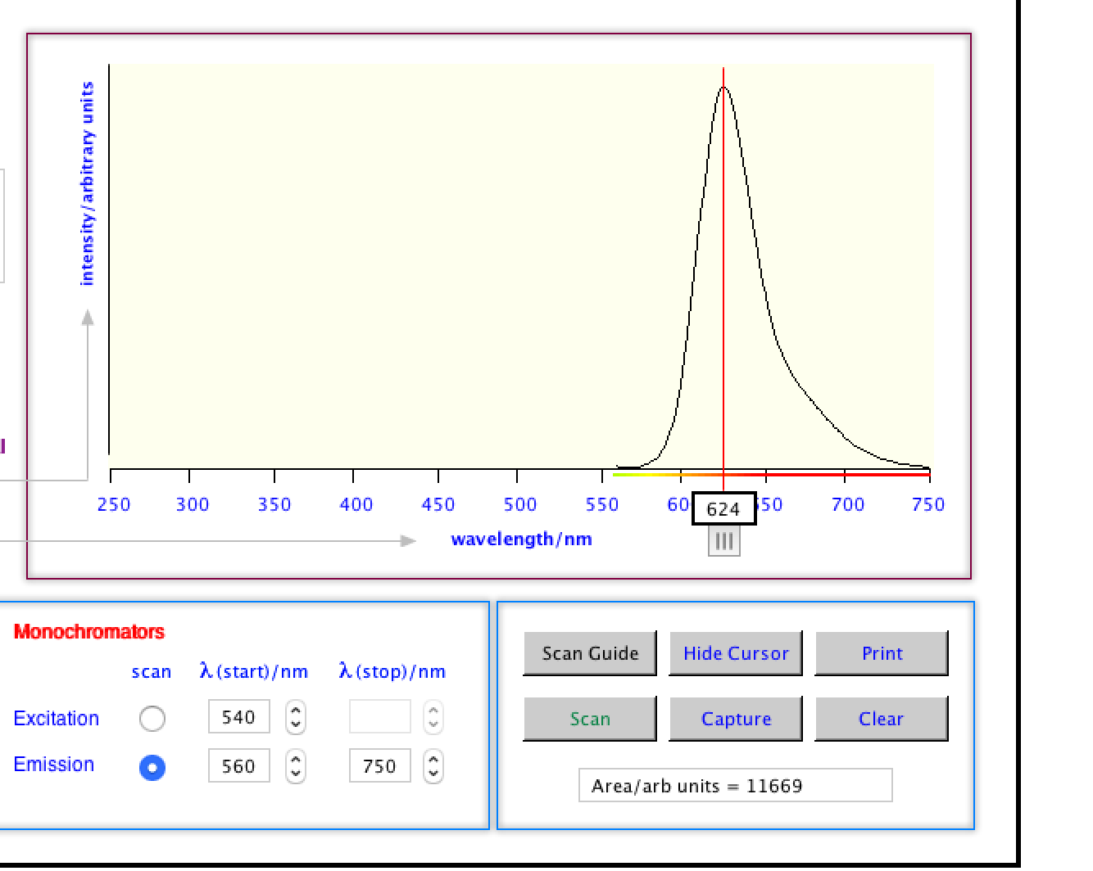

(7) At any time after the scan is complete, a copy of the screen with its current content can be printed. To do this, click the Print button which will display the usual system print menu to enable printing.

(8) Each time the Capture button is clicked, the Clipboard is updated with the data comprising the spectrum along with the relevant instrument settings and conditions in which the spectrum was recorded. This allows the data to be pasted into a suitable spreadsheet program for later viewing and manipulation if the user wishes. There, the fluorescent power value at the maximum emission length must be searched. These data will be used to perform the quantification.

(9) The "Clear" button clears all the spectra currently displayed in the simulator output window. This button does not delete any data files created with the “Capture” button nor does it affect the entries that appear in the Lab Book.

(10) Wavelength settings for monochromators can be made by typing the required settings in the appropriate edit field or by clicking the up (∧) or down (∨) control buttons that appear next to the settings fields. edition. These controls will increase or decrease the setting in steps of 1 nm. The simulator only accepts wavelengths that are within the range of 250 to 750 nm (inclusive).
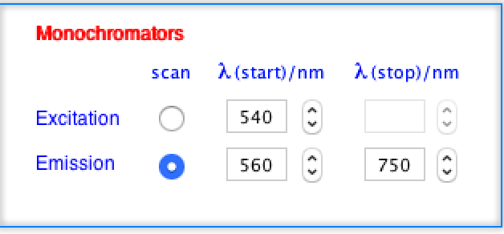

(11) The sample can be changed to a 4.4 × 10⁻⁶ M quinine bisulfate (QBS) solution formed in 0.5 M H₂SO₄ by clicking the sample drop-down menu. When QBS is selected as the sample, the quencher concentration slider is activated. This control allows the inhibitory NaCl to be added to the test solution in concentrations from zero to 0.100 M.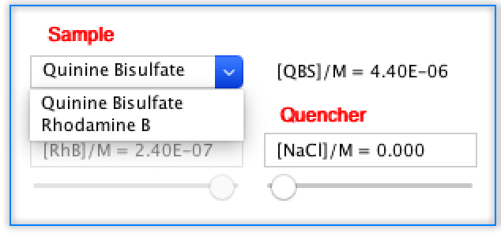

Exercise 2 - Exploring the fluorescence emission and excitation spectra

Fluorescence emission spectrum of rhodamine B

(1) After familiarizing yourself with how the simulator works and exploring its various functions in the previous exercise, clear all Lab Book entries and displayed spectra that may remain in the simulator output window.

(2) Set up the instrument to record the fluorescence emission spectrum of 2.4 × 10⁻⁷ M RhB in ethanol.
Initially select 250 nm as the excitation wavelength and measure the emission spectrum of the sample in a range between 250 and 700 nm, by clicking on "Scan". In the viewer you can see a spectrum, which will present a maximum, to know it you must click on "Show cursor" and you will see a red line that can be moved horizontally to determine the wavelength (with "Hide Cursor" you hide the red line). Once the emission wavelength has been selected, indicate it in the simulator by selecting it under "emission" and with it determine the excitation spectrum, by clicking on "Scan". Once the excitation is known, select it in "excitation" and determine the final emission spectrum, and from this identify the working emission spectrum.

Questions and exercises

(1) Compare the λmax (ex) with λmax (em). If there is a ΔE between the ground state and the excited state, why is the excitation λmax different than the fluorescence emission λmax. What is this displacement called? How is the behavior in general regarding the absorption and emission spectra of fluorescence and phosphorescence?

(2) Use the two data files created during this exercise to generate a graph showing each of the spectra collected on the same set of axes. Label each spectrum and indicate λmax (ex) and λmax (em).

Exercise 3 - Quantitative analysis

(1) Clear the simulator output window and set the sample to RhB.

(2) Taking into account the data obtained in the previous exercise, configure the instrument by selecting the maximum excitation length and an interval containing the maximum emission length, to record the fluorescence emission spectrum of 2.4 × 10⁻⁷ M RhB in ethanol (We are only interested in knowing the intensity at the emission λmax. It is not necessary to scan “the whole” spectrum). Scan the spectrum and when the scan is complete, capture the data. Take note of the fluorescent power at the wavelength of maximum emission.

(3) Repeat the experiment using RhB concentrations of 1.8, 1.2, 0.6 and 0.1 × 10⁻⁷ M. In each case, make sure that you have recorded the fluorescent power at the wavelength of maximum emission.

(4) Repeat steps (2) and (3) using excitation wavelengths that are not absorption maxima. Use as λ abs: (i) 525 nm and (ii) 558 nm.

Questions and exercises

(1) Plot intensity vs RhB concentration for each λ (ex) (λmax (ex), 525 nm or 558 nm). Obtain the three equations of the line.

(2) Comment on the results obtained. Explain why it is more convenient to quantify by selecting the maximum absorption / emission wavelengths?

Exercise 4 - Quenching or quenching fluorescence

(1) Clear the simulator output window and set the sample to QBS (Quinine Bisulfate).

(2) Determine the max of emission and excitation in the same way as you did for Rhb and then configure the simulator with these parameters. Make sure the NaCl concentration is set to zero when scanning the spectra.

(3) Clear the simulator output window and scan the QBS sample at max emission and excitation. Take note of the fluorescent power at the wavelength of maximum emission.

(4) Repeat the scan but with the addition of increasing concentrations of NaCl to the QBS solutions. Use NaCl concentrations of 0.006, 0.018, 0.050, and 0.100 M. Note the fluorescent power at the wavelength of maximum emission.

Questions and exercises

(1) Look up the structure of the Quinine molecule. Please indicate why it fluoresces
(2) What effect does the addition of sodium chloride have on the fluorescence of quinine? Make a list of compounds that might have a similar effect.
(3) Construct a table with the QBS intensity for each NaCl concentration. Plot these values. Interpret the graph.

