The following Virtual Lab Experiments were carried out by Food Engineering students from the National University of Luján in the context of preventive, social and mandatory isolation decreed in Argentina to contain the COVID-19 pandemic.
The simulator of a spectrophotometer (Bertrand's UV-visible spectrophotometer) was used, which can be freely accessed from the link detailed below.
The development of the practical work they propose is indicated in "Experiment", to adapt it to our course we make some modifications. The guide that we send to our students is shown below.

UV-Visible Spectrophotometry
Determination of the concentration of two dyes in a mixed solution
In this practical work a simulator will be used, it can be accessed through this link
http://web.mst.edu/~gbert/Color_Lg/color.html?455

The instrument in this simulation is a dual-beam ultraviolet / visible light spectrophotometer. It compares the intensity of light (I) that passes through a cell containing a sample (a dye in this case) with the intensity (Io) that passes through an identical cell that contains only the solvent (water in this case). The instrument output can be selected as T % [100 (I / Io)] or A [log10 (Io / I)].

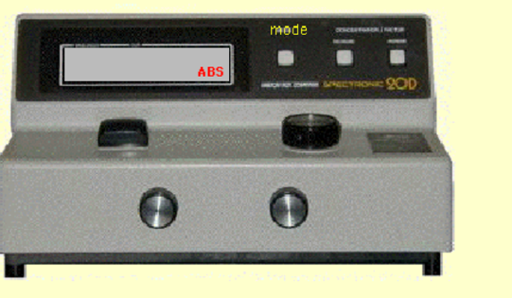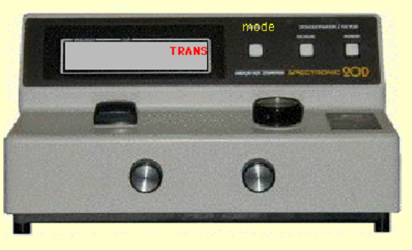

In this experiment, the instrument is configured to scan wavelengths of light in the visible region, 400 to 680 nanometers (nm), and to record % Transmittance or Absorbance every 10 nm.
How do you use the simulator?
(1) Preparation of standard and dye solutions
The arrows next to the colored squares in the upper right, allow the preparation of solutions of known concentrations of the red and blue dyes as standards. There is a stock solution of blue dye, another of red dye and distilled water. Click the arrows to prepare the desired composition, then click the spray bottle to pour the solution into the next empty bucket. Click on "dump solutions" to correct errors or prepare new solutions. This does not affect the solutions in cuvettes # 0, # 4, and # 5. Cuvette # 0 contains distilled water (used for blank), # 4 contains red or blue dye of unknown concentration (ppm), and # 5 contains a mixture of red and blue dyes of unknown concentrations.
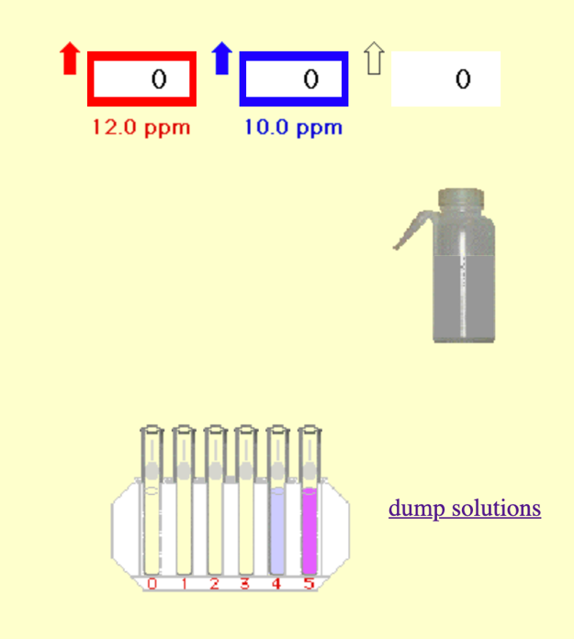

(2) Using the spectrophotometer
Click on a cuvette in the rack to send it to the empty cell. There are three white buttons on the vertical panel at the rear of the instrument. In this simulation, only the left button is operative, to toggle between TRANSMISSION and ABSORPTION modes (when you move the mouse, “mode” is written in yellow, click there).
When the mouse is over one of the three knobs, yellow arrows appear showing the direction the knob will rotate in response to clicking the mouse. A click in the lower half of the knob turns it faster than a click in the upper half.
Click on the cell compartment cover to open or close it. If there is a cuvette in the cell compartment, it will be returned to the rack
.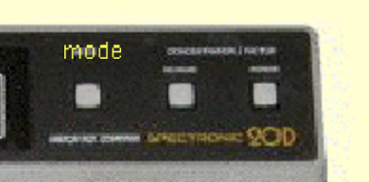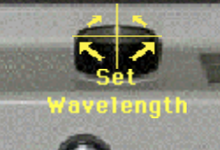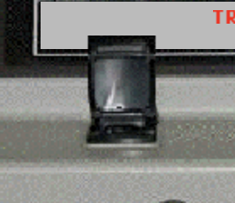

Experiment:
- Determination of the concentration of two dyes in a mixed solution
A. Selection of the working wavelengths (absorption spectra)
1. Turn on the instrument
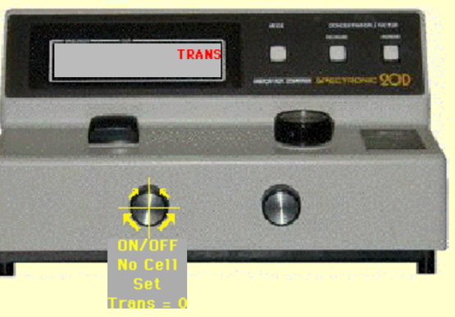
2. Prepare two solutions. One of red dye making a medium dilution and another of blue dye also making a medium dilution.
3. Select the transmission working mode
4. Operate the left knob to bring the TRANSMISSION READING TO 0.0.
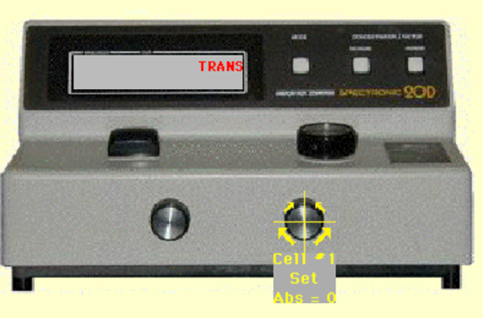
5. Select the work mode in absorption
6. Select the wavelength to measure (start at 400nm). Operate the large knob on the top (platform) of the instrument to set the desired wavelength. Alternatively, click on "set wavelength" and type the desired value.
Click on the reference cuvette at position # 0 to send it to the cell compartment. Bring the reading to 0.000 absorbance with the knob on the right. Alternatively, this can be done with a click on “AutoZero”. The instrument should be zeroed with the reference solution at EACH wavelength.
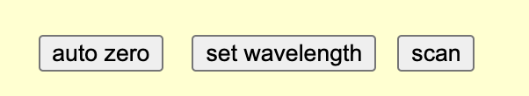

7. Click on the cell compartment to remove the reference cell. Click on the red dye dilution cuvette to send it to the cell. Record the ABSORBANCE reading and the wavelength. Repeat this to measure the absorbance of the blue dye
8. Repeat steps 6 through 8 for each wavelength. They should be tested from 400 to 680 nm in 10 nm intervals.
Scan function:
The simulator is capable of scanning a sample at wavelengths between 400 and 680 nm. However, the unknowns (cells 4 and 5) cannot be scanned. Perform steps 1 and 2 above, if you haven't already. Click on a sample to send it to the cell compartment. Click scan.
A table appears listing the absorbances at 10 nm intervals between 400 and 680 nm. This table can be printed from the File menu on the toolbar. The scan is saved for later viewing with all scans displayed.
Plot the absorption spectra for each dye. (Absorbance vs. Wavelength). Choose as working wavelength those where the absorption maximums are presented for each dye, preferably with minimum absorption for the other dye)

B. Prepare calibration curves of the dye solutions (separately) to know the relationship between absorbance and concentration for each dye at the selected wavelengths.
1. Prepare three standard solutions of the red dye using the stock solution, one half dilution and one quarter dilution.
2. Set the first selected wavelength on the equipment.
3. Zero with the target
4. Read the absorbances of the three standards
5. Plot Absorbance vs. Concentration (ppm) and obtain the equation of the line.
6. Repeat the procedure for the second selected wavelength.
7. Repeat the procedure for three solutions of the blue dye using the stock solution, one half dilution and one quarter dilution at the two wavelengths.
8. At the end of this stage of the experience, you should have 4 representations of Beer. Two for each dye, each at each wavelength.

C. Determine the absorbances of the sample at the two selected wavelengths
1. Select the wavelength,
2. zero with the bank and
3. Read the absorbance of each sample (# 4 and # 5).
4. Repeat 1 to 3 for the second wavelength.

D. Calculate the concentration of each dye in the mixed solution
1. Replace the values ​​obtained in Beer's equations for both wavelengths and calculate the concentration of each dye in each sample.
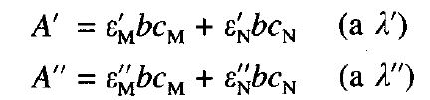

Make a report with the experimental data obtained. Include:
Absorption spectra, Beer's representations, Equations used and concentrations of Blue and Red dye in samples # 4 and # 5.

