Determination of Glucose in Beverages Using a Blood-Glucose Meter and Test Strips

Erin Gross, Creighton University

Overview

This experiment was designed to be utilized as an “at home” lab experiment where students use a commercial glucometer and test strips to design an experiment to measure glucose (a.k.a. dextrose) in sports drinks, given some information about how to use the meter and its concentration linear range. This work is based on an experiment and information reported in an article by J. Wang and C. Maccà “Use of blood-glucose test strips for Introducing Enzyme Electrodes and Modern Biosensors” J Chem Ed 1996, 73(8), 797-799.(1)

The experiment reported here describes how to use and calibrate a specific brand of glucometer (TrueMetrix).(2) However, the basic principles could be applied to just about any commercial electrochemical meter. The meter is calibrated with glucose solutions prepared in an ~ pH 7 buffer. Then a sample of a sports drink is diluted and analyzed for its glucose content. The experiment could be performed by students in a similar fashion. For an “active learning” experience, students could be given some basic instructions on how to use the meter and test strips then design their own experiments. Ideas for experiments are summarized below. This document also lists all of the materials and supplies needed for the experiment, along with costs.

This document does not provide a "cookbook" lab procedure, but provides instructions, calibration and sample analysis data on using a commercial glucometer and test strips to measure glucose (also known as dextrose, Figure 1A) in sports drinks or other drinks with added sweetener. The information provided can be used to guide students in an at home or in lab project or for faculty to quickly produce an experiment for students.

Active Learning: Students could design studies that

- Evaluate the linearity of the instrument
- Compare external calibration versus standard addition
- Evaluate the precision of the instrument
- Measure the glucose content in sports drinks or other sugary drinks
- Evaluate the specificity of the biosensor by adding interferents
- Evaluation of the biosensor as a function of pH (Sigma-Aldrich info says that the optimal activity of glucose oxidase is at pH 5.5 and its working range is pH 4-7.) I’d assume that sensitivity would increase and detection limits would decrease at the more optimal pH’s. Students could test this hypothesis.
- Test and compare two different brands of devices with the same samples
- Perform statistical analysis on their and other student data (see next section)

Topics of discussion and data analysis:

- Discussion of analytical figures of merit (specificity, accuracy, precision, robustness)
- Data and statistical analysis – comparison of different lot numbers of electrodes or other variables
- Discussion of redox reactions and the biochemistry involved in the biosensor
- Point of care analytical devices or biosensors

Background and Relevance

In addition to all of the things about analytical chemistry and data analysis that students can learn from this experiment, they should also find it interesting because of its applications to healthcare or to beverage analysis. I’ve included some basic background information.

Diabetes. Here are some facts from the American Diabetes Association (ADA).

In type 1 diabetes, the body does not produce insulin. Insulin is a hormone that your body needs to get glucose from your bloodstream into the cells of your body, where carbohydrates you eat are broken down into blood sugar is used for energy. The Center for Disease Control estimates that nearly 1.6 million Americans have Type 1 diabetes, including about 187,000 children and adolescents. Type 1 diabetes occurs at every age, in people of every race, and of every shape and size. Insulin therapy and other treatments, along with a healthy diet and exercise are used to treat type 1 diabetes. In Type 2 diabetes, a person’s body doesn’t use insulin properly. It is the more common form of diabetes and is managed with a healthy diet and exercise and sometime with medication.

The ADA generally recommends the following target blood sugar levels:

Target before meals | Target after meals (2 hours)
80 to 130 milligrams per deciliter (mg/dL) (4.4 to 7.2 mM) | < 180 mg/dL  (10.0 mM)

Both type 1 and 2 diabetics can monitor their blood-glucose with a home glucometer and test strips. It is estimated that glucose biosensors are 85% of the total biosensor market.(3-5) When a person with diabetes makes blood-glucose measurements at home, their results are used to make critical decisions about their insulin dosing and food consumption. Therefore, it is important that devices are both robust and sufficiently accurate.

The FDA recently updated guidance (6) for self-monitoring blood glucose test systems (SMBG’s). Companies must show that 95% of all results are within +/- 15% of the comparator results across the entire claimed measuring range of the device and that 99% of all results are within +/- 20% of the comparator results across the entire claimed measuring range of the device.

A | B  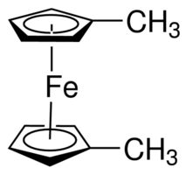
Figure 1. Chemical structures of D-(+)-glucose (dextrose) (A) and the mediator 1,1’-dimethylferrocene (B). Note this is the reduced form of this mediator and the Fe is in the +2 oxidation state.

Measurement of Glucose in Drinks. Why is glucose added to food and drinks? Glucose and dextrose (Figure 1A) are chemically equivalent. Glucose is the name for this sugar in the blood and dextrose is the name of this sugar derived from corn. Dextrose is also a component in high-fructose corn syrup, whereas pure corn syrup is 100% dextrose. It is added to many food and beverage products as a sweetener. For more information, see the FDA website. Most nutritionists recommend limiting your consumption of foods and beverages with added sugars, so it is important to read labels!

How do these biosensors work? More detailed information on how glucose test strips work can be found in references 1 and 3-5. Instructors could provide students with this background information or have them look it up and report on it (or some combination of this). Brief background information is given here.

Although glucose oxidase (Gox) oxidizes glucose (as its name implies), it cannot directly transfer electrons to the working electrode. Therefore, mediators have been developed to shuttle electrons from the redox center of Gox to the surface of the electrode, where the analytical signal is generated. The blood-glucose test strip has both Gox and a mediator immobilized onto the working electrode (screen-printed carbon) surface. Note that the mediator is in its oxidized form. The following reactions occur. A picture of this mechanism is shown in Figure 2.

- Enzymatic reaction. Glucose in solution oxidized to gluconic acid by the enzyme Gox, which is temporarily reduced. Two electrons are transferred. Note that red and ox, note the reduced and oxidized forms, respectively.

Glucose + GOx(ox) gluconic acid + GOx(red)

- Mediator reaction. The reduced enzyme next reacts with the oxidized form of the mediator, Med(ox), transferring a single electron to each of two mediator ions. Note that the original active form of the enzyme is regenerated, , and the two Mox are reduced to Mred.

GOx(red) + 2Med(ox) GOx(ox) + 2Med(red)

- Amperometric reaction. At the electrode surface, a potential is applied and the reduced form of the mediator is oxidized back to its original form and the measured current is used to determine the concentration of glucose in the sample.

Med(red) Med(ox) + e⁻

Figure 2. Mechanism of glucose detection on a test strip/meter. The mediator (Med) shuttles electrons from glucose/Gox (right) to the electrode surface (left).

Mediator species are usually 1,1’-dimethylferricinium (the oxidized form of 1,1’-dimethylferrocene, Figure 1B) or ferricyanide (Fe(CN)₆³⁻). In both of these species, the iron has an oxidation state of +2 in the reduced form and +3 in the oxidized form.

Materials

- True Metrix self-monitoring blood glucose system, it advertises “proven accuracy”, “features triple sense technology” and “precise, fast results” (2)
- Test strips that go with this meter (see Table 1)
- Buffer: 0.1 M PBS pH 7.5 + 0.1 M NaCl
- Volume measurement: Micropipettes / syringe / pocket balance
- Glassware or plastic centrifuge tubes (1.5-mL) for solution containers

Table 1: Links to and Prices of Chemicals and Supplies

Item | Cost or CAS
Control Solution (Level 1, low) for True Metrix | $6.20 at Amazon
True Metrix meter + 50 test strips | $12.75 at Amazon
Extra test strips – 6 boxes of 50 - | $32.00 at Amazon
D-(+)-Glucose, Sigma-Aldrich, ACS reagent, 25 g | $30.60
Buffer materials and pH meter  Sodium phosphate monobasic dihydrate  Sodium phosphate dibasic heptahydrate  NaCl  HCl or NaOH for adjusting pH | Typically in lab  CAS 13472-35-0  CAS 7782-85-6  CAS 7647-14-5
1.5-mL plastic centrifuge tubes, Thermo-Fisher | $22.00 for 500
Potential interferent species:  D-(−)-Fructose, 100-g  L-Ascorbic acid , 100-g  OR  Pure Fructose Powder, 200-g / 7-oz  Vitamin C Crystals Ascorbic Acid, 227-g / 8-oz  Table sugar (sucrose) | May have in lab already  $42.90 at Sigma-Aldrich  $46.30 at Sigma-Aldrich  $7.99 at Amazon  $9.83 at Amazon  Grocery store or home

Experimental

Stock Glucose Solution Preparation. Students could be given this stock solution if this is to be used as an “at home” experiment. If doing the experiment in lab, they could prepare this solution. I first prepared 50.0-mL of a 24 mM stock standard glucose solution.

Glucose Working Standards. Next, prepare working standard glucose solutions as shown in Table 2. Students could be given instructions or could determine the linear range on their own, given some information about the meter. The data I show later was generated from solutions prepared using a 100-μL and a 1000-μL pipette. These solutions were prepared in 1500-μL centrifuge tubes. Note that if the solutions are scaled up to at least 1200-μL, a series of standards between 2 and 8-mM could be prepared with only the 1000-μL pipette.

If I was sending a kit home with a student, I am thinking I could send the following in the kit with students: 5-mL stock glucose, 10-mL buffer, centrifuge tubes, micropipettes, plastic transfer pipettes and small weigh boats. If we didn’t want to send the micropipettes, students could measure volume with a syringe or by mass with a pocket balance. They may need to scale up the solution volumes then and would need larger centrifuge tubes (e.g. 5-mL or larger tubes could be used).

Table 2: Glucose Standard Solution Preparation

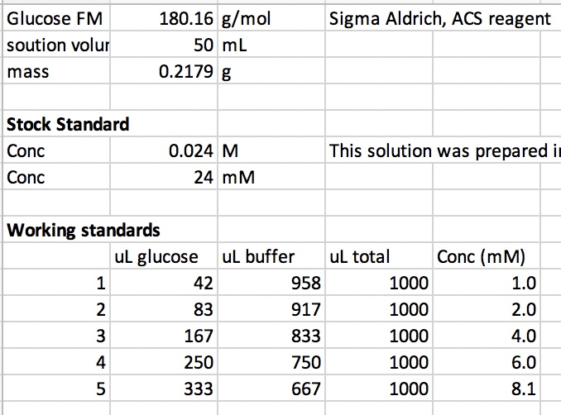

Glucose Measurement Procedure

- First I read through the manual and learned how to use the meter. I’ve added some tips and screenshots of the specific meter I used to this procedure. The manual or an online link (7) could be given to students. This 3 minute video (8) also shows the basics of using the meter. Students can be directed to ignore the part about pricking their fingers. The lancets used to do this should be removed from the SMBG kit before giving to students.

Some things I learned:

  - This device is smart – it knows when you try to re-use a test strip; it also gave me errors when I put a cold sample on the strip and when I diluted a sample with water rather than buffer/electrolyte.
  - When you remove a test strip from the storage container, you must quickly insert and use it. Somehow the meter senses when a strip has been sitting out, even if you haven’t used it. Only take test strips out right when you plan on using them – don’t take a few out and let them sit.
  - Running the check solution. I will have students to this first as a practice. It has a dye in it so they can see it being wicked up the channel to the electrodes. As shown in the video (8), only a 0.5 μL sample is required.
  - Insert the electrode all the way in. Then the devices gives some cues that it is working and ready for a measurement.

- Place a drop of the solution to be tested on any hydrophobic surface. The manual recommended Al foil. I used small weighboats from the lab as shown in Figure 3.

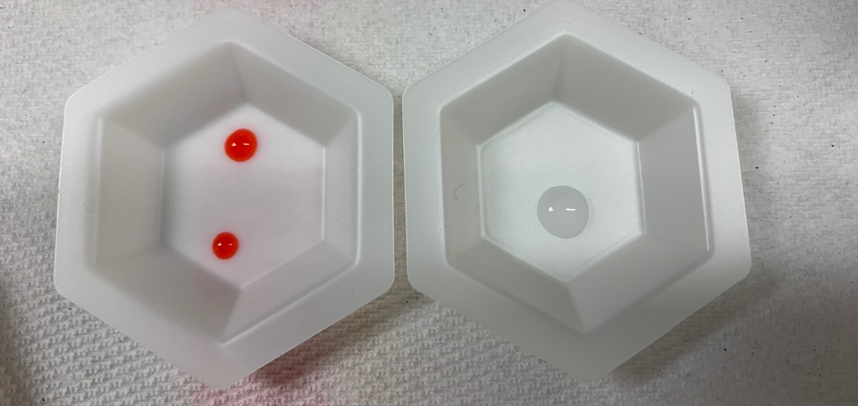
Figure 3. Drops of check solution (left) and glucose standard (right) on weighboats.

Remove a test strip from storage and place into the meter. The meter should show the full display (Figure 4A) then the time and indication that its ready to make a measurement (Figure 4B).

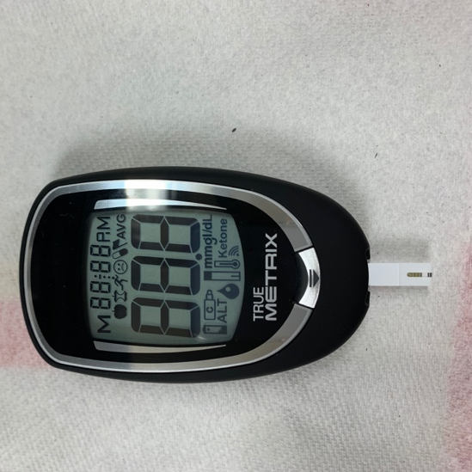  A | 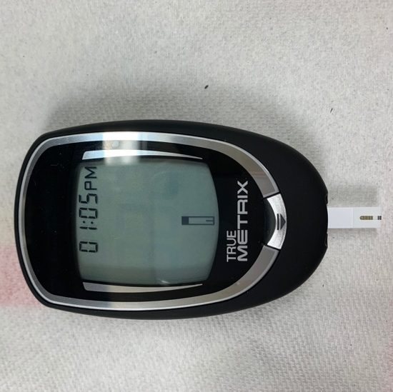  B
Figure 4. Meter display after properly inserting the test strip into the meter. First it will show the full display (A) then the time and indication that its ready to make a measurement (B).

When the meter is ready, briefly (~1sec) touch the test strip to the drop as shown in Figure 5A. Note that the test strip only requires 0.5-μL of sample. The meter will take a few seconds to make the measurement. Everything is working okay if you see it in the measurement mode as shown in Figure 5B. When the measurement is complete, you will see a readout in units of mg/dL (Figure 5C).

If you do not get the screen shown in Figure 5B, you will likely get an error code and can look it up in the manual.

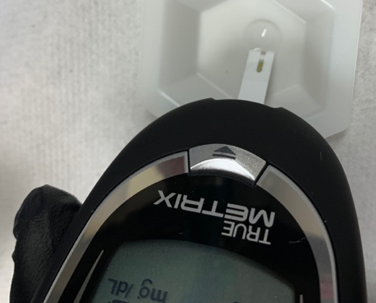  A | 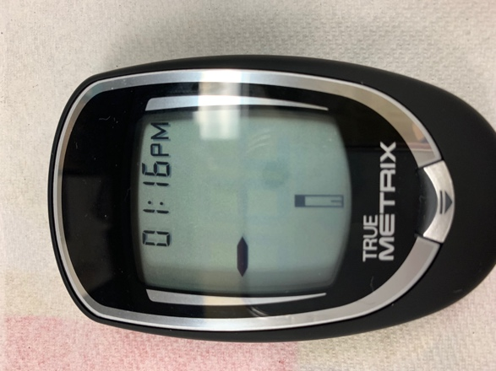  B | 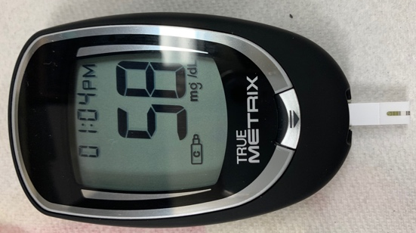  C
Figure 5. Proper technique for quickly dipping the end of the test strip into a drop of sample (A) and the meter display while the measurement is being made (B) and showing the reading in mg/dL after the measurement has been made (C).

I performed the process above for the check solution (red) and for all standards. I recorded the signal as “mg/dL” as was done in reference 1. For each measurement, I dropped the solution on the weigh boat with a plastic transfer pipet, removed a test strip from the storage container, inserted the strip into the meter, then made the measurement. Due to differences between the glucose solutions and blood samples (ionic strength, viscosity, etc.) the units of mg/dL are not absolute for the glucose solutions made in lab and the meter must be calibrated.

Results

Calibration curves and precision. I only had 4 test strips from the first lot (MT1825) so ran the check solution and the 2, 4, and 6 mM standards (Figure 6). I then used the second lot (MU2323) to take readings on all of the standards I prepared (Figure 7) and on the buffer.

The calibration curve generated from the first lot of test strips is shown in Figure 6. Despite the test strips being expired (but stored properly) the linearity was quite good. I will purchase new test strips for the students. It is helpful to know that expired test strips still function properly.

The calibration curve generated from the second lot of test strips and over a wider concentration range is shown in Figure 7. Despite the test strips being expired (but stored properly) the linearity was quite good. I also ran a buffer blank and the readout was “Lo” and the 24-mM solution and the readout was “Hi”.

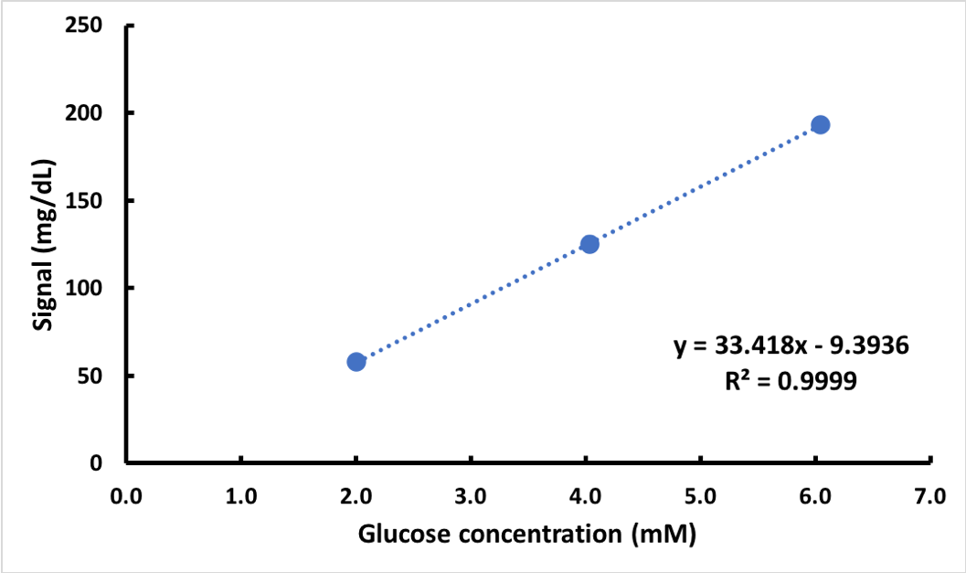
Figure 6. Calibration curve generated with test strips from lot MT1825. Glucose solutions were prepared in pH 7.5 PBS (0.1 M) plus 0.1 M NaCl.

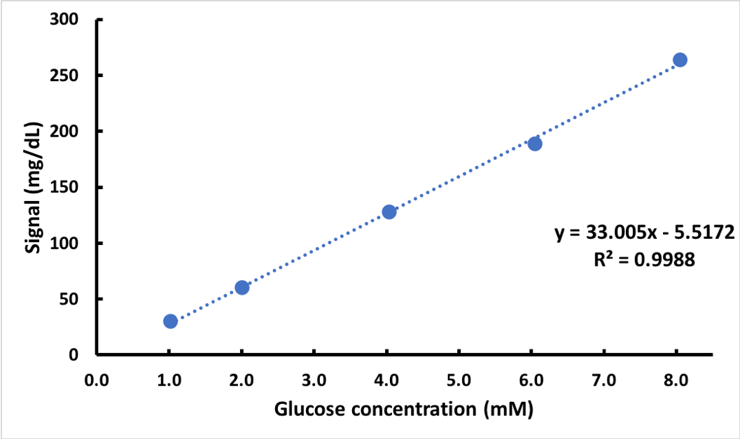
Figure 7. Calibration curve generated with test strips from lot MU2323. Glucose solutions were prepared in pH 7.5 PBS (0.1 M) plus 0.1 M NaCl.

I also evaluated the precision of the meter/test strips. Because the meter does not allow you to re-use test strips, I made 5 measurements of the same solution (4-mM glucose) on 5 different test strips sequentially. The %RSD was 2.2% (mean reading 130 mg/dL with a standard deviation = 2.9 mg/dL). This data is shown in Figure 8.

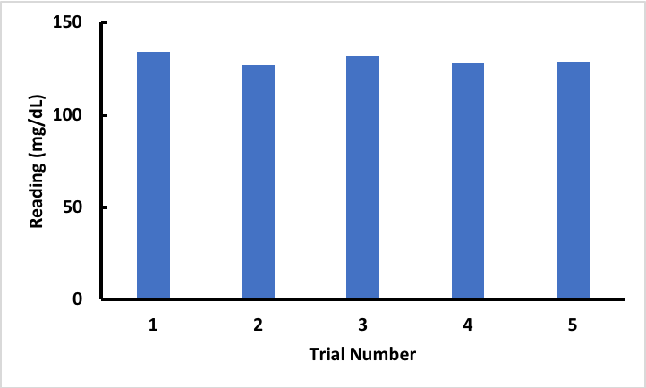
Figure 8. Five sequential measurements of the same solution (4 mM glucose) using 5 different test strips. The %RSD = 2.2%.

The next step is to try this out on a real sample, such as Gatorade. Wang’s J. Chem. Ed. article (1) gives the glucose content and dilution estimates for a variety of sugary drinks. I’m listing a few in Table 3. For a full list, consult the reference. Note that this data is from 1996 so some of the glucose content may have changed.

Table 3: Dilutions and glucose levels for sugary drinks*

Sample | Glucose Content measured (g/L) | Sample Dilution Factor
Gatorade | 19 | 20-40
Coca Cola | 46 | 50-75
Sunkist | 71 | 75-100
*Determined from Reference 1

What I tested (what I had on hand at home):

I diluted a sample of Orange Gatorade by a factor of 20 (50μL Gatorade + 950μL buffer) as recommended by Wang’s paper (1). This sample gave a signal of 124 mg/dL so was within the calibration range. This correlated to around 4 mM concentration of the diluted sample. After accounting for the dilution and converting the units to g/L, I calculated around 14 g/L glucose in the original Gatorade sample. This is somewhat close to Wang’s value of 19 g/L reported above. Has Gatorade changed in the past 20+ years? I looked around the Gatorade website (8) and on the label. They show that this Gatorade has 21 g added sugars per 360 mL, which gives a “sugar” concentration of 58 g/L. Looking at the ingredient list, Gatorade contains sugar (assume sucrose, a disaccharide of glucose and fructose) and dextrose (chemically equivalent to glucose). The number I obtained and Wang’s number are certainly reasonable, especially since dextrose is the second most abundant sugar. Reference 10 also reports an experiment where students measure the glucose concentration in sports drinks using homemade enzyme electrodes. They did not report any specific values, but did mention that the enzyme electrode results were generally higher than a spectrophotometric solution assay.

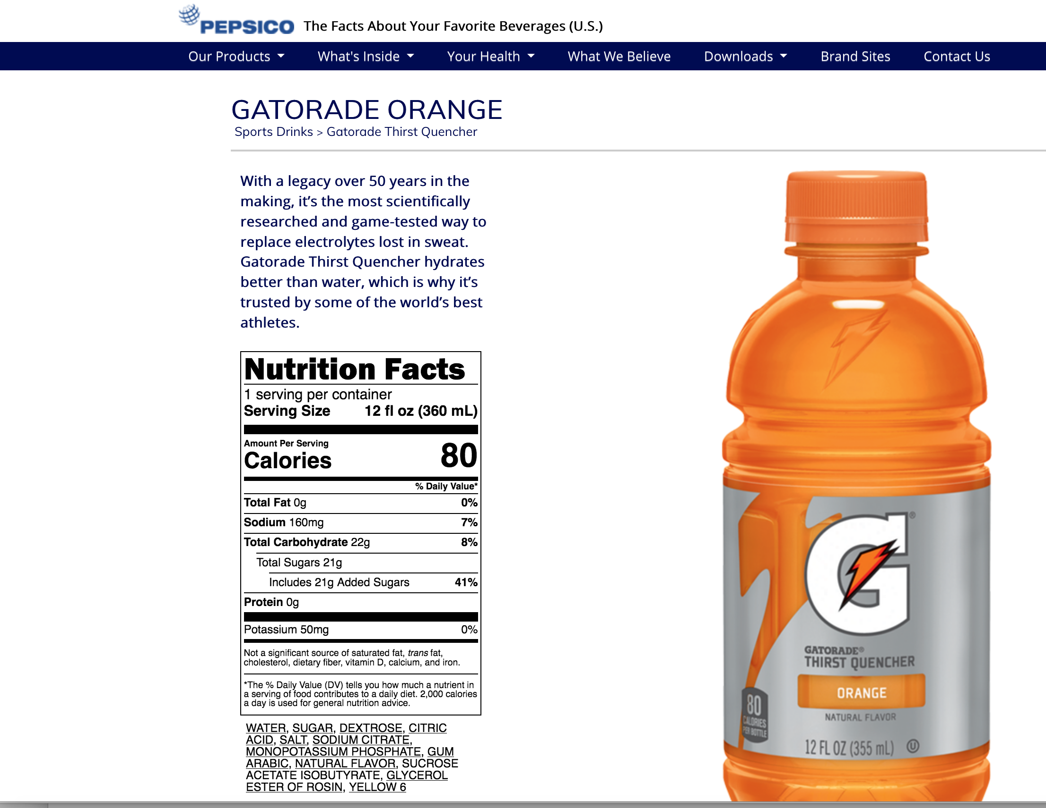
Figure 9. Gatorade label from reference 9.

Conclusion. Over the counter self-monitoring blood glucose test systems (SMBG’s) can safely be used by students in analytical chemistry courses for at-home lab experiments.

References

- Joseph Wang and Carlo Macca “Use of Blood-Glucose Test Strips for Introducing Enzyme Electrodes and Modern Biosensors” Journal of Chemical Education 1996 73 (8), 797-800. DOI: 10.1021/ed073p797
This was the primary reference that I used to plan the solutions for the calibration curves and to properly dilute the Gatorade sample.
- https://www.trividiahealth.com/products/blood-glucose-meters-test-strips/true-metrix/
TrueMetrix blood-glucose meter website, accessed July 14, 2020
- O. Amor-Gutiérrez, E. C. Rama, M. T. Fernández-Abedul, and A. Costa-García “Bioelectroanalysis in a Drop: Construction of a Glucose Biosensor” Journal of Chemical Education 2017 94 (6), 806-812 DOI: 10.1021/acs.jchemed.6b00948
This is an experiment where students fabricate a glucose biosensor. It has helpful information on how the test strips work.
- Joseph Wang “Electrochemical Glucose Biosensors” Chemical Reviews 2008 108 (2), 814-825. DOI: 10.1021/cr068123a
This is a review article on glucose biosensors. It has helpful background information.
- Wang, Hui-Chen; Lee, An-Rong Recent developments in blood glucose sensors. Journal of Food and Drug Analysis 2015, 23 (2), 191-200. https://doi.org/10.1016/j.jfda.2014.12.001
This is a review article on glucose biosensors. It has helpful background information.
- https://www.fda.gov/media/119828/download
FDA guidance on over-the-counter blood-glucose meters.(p. 16)
- https://www.trividiahealth.com/wp-content/uploads/2019/02/TRUE_METRIX_Owners_Booklet_RE4TVH03r52.pdf
TrueMetrix manual, accessed July 14, 2020
- https://youtu.be/eOjCUI6OXlM
TrueMetrix instructional video, accessed July 14, 2020
- https://www.pepsicobeveragefacts.com/Home/product?formula=33876&form=RTD&size=12&PBF
Ingredient information about Gatorade, accessed July 14, 2020.
- J. J Gooding, Wenrong Yang, and Manihar Situmorang “Bioanalytical Experiments for the Undergraduate Laboratory: Monitoring Glucose in Sports Drinks” Journal of Chemical Education 2001 78 (6), 788-790. DOI: 10.1021/ed078p788
This is an experiment where students fabricate a glucose biosensor. It also has helpful information on how glucose test strips work.

Acknowledgements

This work was made possible with support from the Creighton University Chemistry Department and grants from the National Institute for General Medical Science (NIGMS) (5P20GM103427), a component of the National Institutes of Health (NIH), and its contents are the sole responsibility of the authors and do not necessarily represent the official views of NIGMS or NIH.

